ToolsFree.org
Developer Niche SEO Article Pack
5 detailed articles with featured images for direct upload or seeding.

Included topics:
- 1. JSON Formatter and Validator: Complete Guide for Developers
- 2. URL Encoding and Decoding Explained for Developers
- 3. Password Generation and Security: A Practical Guide for Modern Developers
- 4. HEX, RGB, and HSL Color Conversion Guide for Web Designers and Developers
- 5. Unit Conversion Made Simple for Developers, Engineers, and Everyday Users

1. JSON Formatter and Validator: Complete Guide for Developers
Slug | json-formatter-validator-complete-guide
Excerpt | Learn how JSON formatting and validation improve API reliability, reduce debugging time, and help developers work with cleaner data structures.
Meta Title | JSON Formatter and Validator: Complete Guide | ToolsFree.org
Meta Description | Understand JSON syntax, formatting, validation, common errors, and best practices for APIs, web apps, and developer workflows.

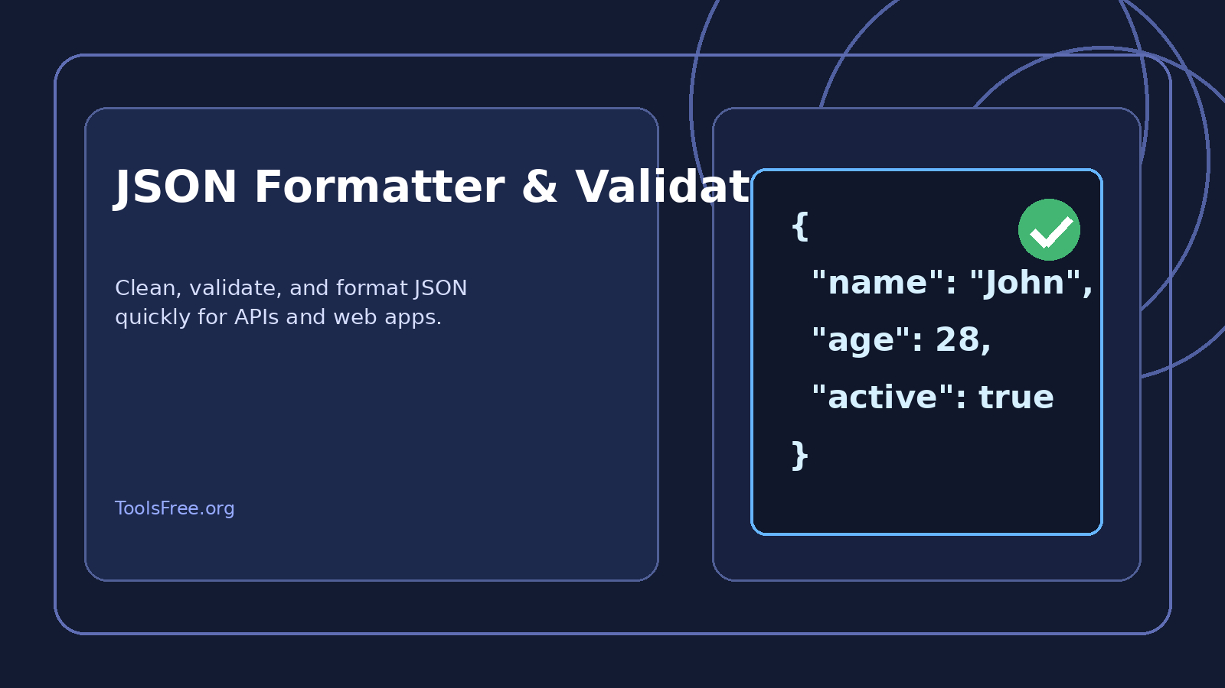
Featured image for the article

Introduction
JSON is one of the most common data formats in modern development. It is used in REST APIs, configuration files, frontend state, logging, and countless integrations between systems. Its simplicity is the reason developers like it, but that same simplicity can hide frustrating syntax mistakes that break requests, stop data parsing, or make debugging harder than it should be.
A JSON formatter and validator solves this problem. Formatting makes the structure readable. Validation checks whether the content follows the JSON specification. Together, they help developers spot mistakes quickly and save time during development, testing, and production debugging.

What JSON Actually Is
JSON stands for JavaScript Object Notation. It is a lightweight text format for storing and exchanging structured data. Despite the name, JSON is not limited to JavaScript. It is supported by PHP, Python, Node.js, Java, Go, C#, Ruby, and almost every other mainstream programming language.
A JSON document is built from objects, arrays, strings, numbers, booleans, and null values. Property names must use double quotes, strings must use double quotes, and the structure must be balanced with matching braces and brackets. These strict rules make JSON predictable for machines, but they also make it easy to break with a tiny syntax mistake.

Why Formatting Matters
Unformatted JSON is technically valid, but it is painful to read when the structure becomes large. API responses may contain nested objects, arrays of records, pagination metadata, and deeply repeated keys. Without indentation and spacing, it becomes difficult to understand what belongs where.
A formatter organizes the content into a clean hierarchy. That matters because developers usually do not inspect JSON once and move on. They review it again and again while debugging API responses, checking webhook payloads, comparing request bodies, and documenting integrations for a team. Clean formatting makes all of that faster and less error-prone.

Common JSON Errors
The most common JSON errors are surprisingly small. A missing comma between properties, a trailing comma after the last item, a single quote instead of a double quote, or a missing closing brace can make the whole document invalid. The problem is that the error is often not where the parser first complains. One bad character can cause the parser to fail several lines later, which makes manual debugging annoying.
Developers also run into problems with wrong nesting, invalid escape sequences, and accidentally placing comments inside JSON. Standard JSON does not allow comments. That means people who are used to JavaScript object syntax or configuration files often paste code that looks normal but fails validation immediately.

Where Developers Use JSON
JSON appears everywhere in development. Backend services return JSON responses to frontend applications. Mobile apps consume JSON from APIs. Webhooks deliver JSON payloads from third-party services. Even many settings files and CI/CD workflows use JSON or JSON-like structures.
In a Laravel application, JSON is often returned directly from controllers. In React, JSON is frequently fetched and rendered in components. In Node.js, JSON is used in package files, logs, and API communication. Because it is so universal, being able to read and validate JSON quickly is a basic productivity skill.

Best Practices
Use a formatter whenever you need to inspect large data blocks. Validate before you ship payloads to production. Keep property names meaningful and consistent. Do not store sensitive secrets inside shared sample JSON. When you receive third-party JSON, inspect the entire structure before mapping it into application logic.
It also helps to keep the distinction between formatting and validation clear. Formatting changes the appearance. Validation checks correctness. A pretty-looking document can still be invalid, and a minified document can still be perfectly valid. Good tools should handle both.

Conclusion
A JSON formatter and validator is one of those tools that looks simple but saves real time every day. It reduces manual inspection, catches syntax problems early, and makes API work much easier. For teams building modern web applications, JSON handling is not optional. It is part of the core workflow.
For ToolsFree.org, this topic is a strong article because it aligns directly with developer intent and with the tool itself. Readers searching for JSON help usually want a fast solution, a clear explanation, and practical examples they can trust.

Frequently Asked Questions
- Why is this topic important? Because it appears in daily development work and affects accuracy, usability, and debugging speed.
- Who is this article for? It is written for developers, site owners, and users who need practical explanations and a tool they can trust.
- How can ToolsFree.org help? It can provide quick browser-based tools that save time and reduce manual mistakes.

Conclusion
This article is designed to work as a strong evergreen SEO page. It explains the concept in practical language, gives real-world context, and naturally connects the content to the developer tools that ToolsFree.org offers.

2. URL Encoding and Decoding Explained for Developers
Slug | url-encoding-decoding-explained-developers
Excerpt | Learn how URL encoding works, why it matters in query strings and APIs, and how to safely encode and decode links in real projects.
Meta Title | URL Encoding and Decoding Explained | ToolsFree.org
Meta Description | A practical guide to URL encoding, percent-encoding, decoding, query strings, API safety, and common mistakes developers should avoid.

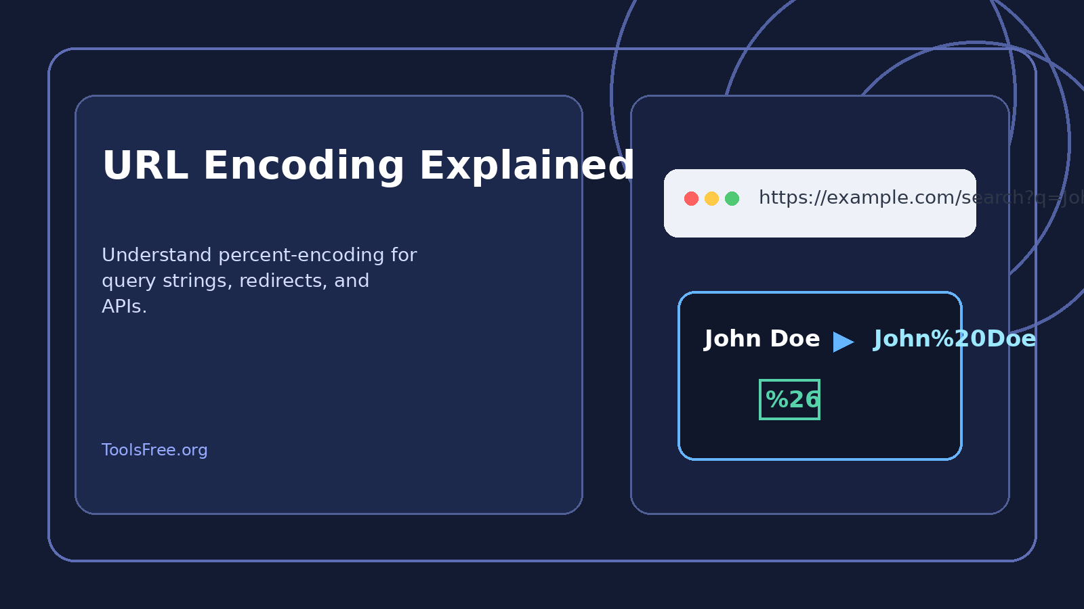
Featured image for the article

Introduction
Every link on the web depends on URLs, but URLs are stricter than most people realize. They can only contain a limited character set. When raw text includes spaces, symbols, or non-English characters, the browser and server may interpret the data incorrectly. URL encoding exists to solve that problem.
For developers, understanding URL encoding and decoding is essential because it affects search pages, redirect URLs, API query parameters, email links, payment flows, analytics tags, and many other parts of an application. A single unencoded character can break a request or produce a wrong destination.

What URL Encoding Does
URL encoding converts unsafe characters into percent-encoded values. The letter and number characters are usually left alone, while reserved or special characters are replaced with a percent sign and a hexadecimal code. For example, a space becomes %20. The ampersand becomes %26. The question mark becomes %3F.
This lets the browser know which characters are data and which ones are part of the URL structure itself. Without this distinction, the server may think that the data starts a new query parameter or breaks the path into the wrong segments.

Why It Matters in Real Applications
Imagine a search URL like /search?q=John Doe. The space can confuse the parser if it is not encoded. The correct version is /search?q=John%20Doe. The same problem appears with product names, city names, filter values, and user-generated text.
APIs depend on this especially heavily. Query strings often include names, dates, redirect targets, payment references, or other dynamic values. Encoding keeps those values safe during transmission. That is why developers should never paste raw input directly into a URL when building requests.

Encoding and Decoding in Code
Most languages provide built-in helpers. In JavaScript, encodeURIComponent and decodeURIComponent are the standard choices for parameter values. In PHP, urlencode and urldecode are common. In frameworks like Laravel, these functions are often used behind the scenes when generating links or processing inputs.
The important rule is to encode the values that go into a URL, not the whole URL blindly. Developers often make the mistake of running encodeURIComponent on an entire address, which can produce unreadable or broken results if applied in the wrong place.

Common Mistakes
One mistake is double encoding. If a string is already encoded and then encoded again, a percent sign can become %25, which changes the meaning of the value. Another mistake is assuming that plus signs and spaces behave exactly the same everywhere. They do not in every context.
A third mistake is forgetting to decode the value when reading it back. If your app stores or displays encoded text without decoding, users may see ugly strings like John%20Doe instead of normal text.

SEO and User Experience
Clean URLs help users trust a page and help search engines understand the structure of a website. Encoding is not the same as SEO optimization, but it supports it by preventing broken links and malformed parameters. When combined with readable slugs and consistent routing, it improves overall usability.
International websites also benefit because encoding allows non-Latin characters to travel safely through browsers, servers, and third-party platforms. That is important for global traffic and multilingual products.

Conclusion
URL encoding and decoding are small concepts with large consequences. They influence APIs, search forms, redirects, analytics, and user experience across almost every web project. Developers who handle encoding correctly avoid a long list of bugs that are otherwise hard to trace.
For a developer tools website, this topic is highly useful because it connects directly to everyday workflow. Readers need a quick explanation, practical examples, and a tool they can use immediately.

Frequently Asked Questions
- Why is this topic important? Because it appears in daily development work and affects accuracy, usability, and debugging speed.
- Who is this article for? It is written for developers, site owners, and users who need practical explanations and a tool they can trust.
- How can ToolsFree.org help? It can provide quick browser-based tools that save time and reduce manual mistakes.

Conclusion
This article is designed to work as a strong evergreen SEO page. It explains the concept in practical language, gives real-world context, and naturally connects the content to the developer tools that ToolsFree.org offers.

3. Password Generation and Security: A Practical Guide for Modern Developers
Slug | password-generation-security-practical-guide
Excerpt | Understand why strong password generation matters, how to create safer credentials, and what developers should know about password hygiene.
Meta Title | Password Generation and Security Guide | ToolsFree.org
Meta Description | A developer-focused guide to strong password creation, entropy, password managers, MFA, and practical security habits for modern applications.

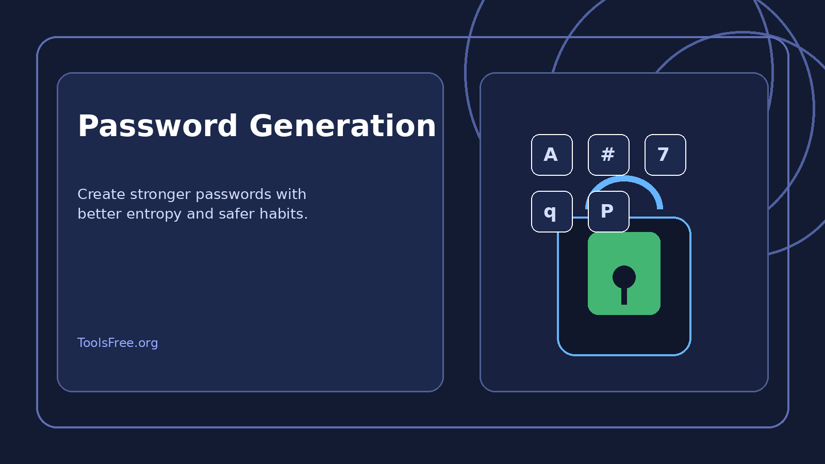
Featured image for the article

Introduction
Passwords remain one of the most common authentication methods on the internet, even though they are also one of the weakest when handled carelessly. Weak passwords cause account takeovers, data leaks, unauthorized admin access, and expensive recovery work. Strong password generation is one of the simplest ways to reduce that risk.
For developers, password generation is not only a user-facing topic. It also affects admin panels, temporary tokens, testing accounts, API credentials, and internal tools. Understanding how good passwords are created and stored helps both security and product quality.

What Makes a Password Strong
A strong password is long, random, and difficult to guess. Length matters more than many people think. A short password with symbols is still weak if it follows a predictable pattern. A longer password with random characters is usually far stronger, even if it looks less complicated.
Good passwords avoid names, birthdays, repeated words, obvious substitutions, and keyboard patterns. They should also be unique across different systems. Reusing a password across sites is one of the fastest ways to turn a single breach into a larger compromise.

Why Generators Are Better Than Humans
Humans are bad at randomness. When people try to create their own passwords, they often choose memorable patterns that are easy to guess or hard for computers to brute-force. Password generators do a better job because they can produce random combinations without bias.
That does not mean every generated password is automatically safe. The output still depends on length, character mix, and how the password is stored or transmitted. If a site exposes credentials in logs or sends them over insecure channels, the generation quality becomes only one part of the problem.

Where Passwords Are Used in Development
Developers deal with passwords in many places: user signups, admin logins, staging environments, database users, deployment credentials, and temporary support accounts. Teams sometimes generate passwords for internal systems or one-time access during troubleshooting.
A generator is useful when creating placeholder credentials for demos or when rotating passwords after a security incident. The important practice is to generate them safely and store them in a password manager or secure vault, not in plain text notes.

Best Security Practices
Never reuse credentials. Encourage or require multi-factor authentication wherever possible. Hash passwords with a strong algorithm such as bcrypt, Argon2, or a framework-supported equivalent. Never store plain text passwords in a database or log file. Never email passwords in clear text if you can avoid it.
For users, the best habit is to combine a password manager with generated passwords. For developers, the best habit is to make password policies practical rather than annoying. A policy that is easy to follow is usually better than a strict policy people ignore.

Common Mistakes
Some systems still force complex passwords but ignore length. Others reject spaces or long passphrases even though those can be very strong. Another common mistake is treating password strength meters as a complete security solution. They are useful, but they do not replace hashing, rate limiting, and MFA.
Another weak practice is revealing whether a password was right or wrong in a way that leaks too much information. Good authentication flows should be careful about both security and user feedback.

Conclusion
Password generation is a simple feature that carries real security value. It protects accounts, reduces brute-force risk, and supports better account hygiene across websites and internal tools. For a developer audience, it also reinforces the broader lesson that security is a design choice, not an afterthought.
A strong password generator article is valuable because it combines practical guidance with everyday usage. Readers want a tool they can trust and a clear explanation of why it matters.

Frequently Asked Questions
- Why is this topic important? Because it appears in daily development work and affects accuracy, usability, and debugging speed.
- Who is this article for? It is written for developers, site owners, and users who need practical explanations and a tool they can trust.
- How can ToolsFree.org help? It can provide quick browser-based tools that save time and reduce manual mistakes.

Conclusion
This article is designed to work as a strong evergreen SEO page. It explains the concept in practical language, gives real-world context, and naturally connects the content to the developer tools that ToolsFree.org offers.

4. HEX, RGB, and HSL Color Conversion Guide for Web Designers and Developers
Slug | hex-rgb-hsl-color-conversion-guide
Excerpt | Explore how HEX, RGB, and HSL color models work, when to use each one, and how color converters help build better web interfaces.
Meta Title | HEX, RGB, and HSL Color Conversion Guide | ToolsFree.org
Meta Description | Learn how color formats work in web design, how to convert HEX, RGB, and HSL values, and how to choose the right format for each task.

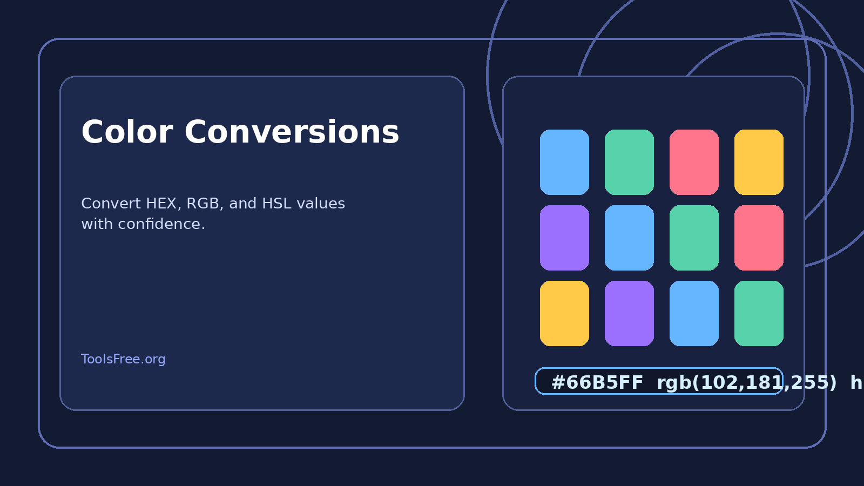
Featured image for the article

Introduction
Color values appear everywhere in frontend work. Buttons, backgrounds, charts, links, alerts, dashboards, and landing pages all depend on color codes. Designers and developers often move between HEX, RGB, and HSL formats depending on the task, which is why a color converter is such a practical tool.
A good understanding of color formats helps teams work faster and communicate more clearly. It also improves accessibility, branding consistency, and design handoff between Figma, CSS, and production code.

HEX Colors
HEX colors are written as six hexadecimal digits, sometimes shortened to three. The code represents red, green, and blue values in base 16. For example, #66B5FF is a light blue. HEX is popular because it is compact, easy to copy, and widely supported across design tools and CSS.
Developers like HEX because it is simple to paste into code and easy to reuse across a project. Designers like it because it is clear and predictable. It is a strong default format for most web projects.

RGB Colors
RGB stands for red, green, and blue. Each channel uses numeric values, typically from 0 to 255. RGB is intuitive for many developers because it mirrors how screens create color from light. It is also useful when scripts need to manipulate color values programmatically.
RGB can be easier than HEX when you want to reason about intensity or compare transparency settings. In CSS, rgb() and rgba() are common, especially when dynamic values are being generated from variables or animations.

HSL Colors
HSL stands for hue, saturation, and lightness. It is often easier for humans to understand because it separates the color family from the strength and brightness of that color. Designers often prefer HSL when they want to create consistent variations of the same palette.
Hue defines the base color. Saturation controls how vivid the color looks. Lightness controls how dark or light it appears. This makes HSL very helpful for generating hover states, lighter backgrounds, and subtle UI variations without manually guessing new HEX values.

When to Use Each Format
Use HEX when you want quick, stable values in code. Use RGB when you need numerical control or alpha transparency. Use HSL when you are building a palette, experimenting with shades, or adjusting colors systematically. Each format has a place in modern frontend work.
The key is not to force one format everywhere. Good teams choose the format that best supports the task at hand and then keep conversions consistent across the design system.

Accessibility and Contrast
Color is not only about appearance. It also affects readability and accessibility. Text must contrast clearly with its background. Buttons need visible states. Charts need distinguishable values. Poor contrast can make a page harder to use for everyone, not only for users with visual impairments.
When choosing colors, designers should test readability early. A color converter helps quickly compare values and tune shades before they are copied into a live interface.

Conclusion
HEX, RGB, and HSL are not competing ideas. They are different views of the same visual information. Developers and designers who understand them can build better interfaces, maintain consistency, and work more efficiently.
For ToolsFree.org, a color conversion article fits naturally with the audience because it gives practical help and encourages daily use of the site’s tools.

Frequently Asked Questions
- Why is this topic important? Because it appears in daily development work and affects accuracy, usability, and debugging speed.
- Who is this article for? It is written for developers, site owners, and users who need practical explanations and a tool they can trust.
- How can ToolsFree.org help? It can provide quick browser-based tools that save time and reduce manual mistakes.

Conclusion
This article is designed to work as a strong evergreen SEO page. It explains the concept in practical language, gives real-world context, and naturally connects the content to the developer tools that ToolsFree.org offers.

5. Unit Conversion Made Simple for Developers, Engineers, and Everyday Users
Slug | unit-conversion-made-simple-guide
Excerpt | Learn the basics of unit conversion, why it matters in development and daily work, and how reliable unit converters reduce mistakes.
Meta Title | Unit Conversion Made Simple | ToolsFree.org
Meta Description | A practical unit conversion guide covering metric and imperial units, common mistakes, and how converters help developers and users.


Featured image for the article

Introduction
Unit conversion is part of everyday life. Developers use it when building calculators, dashboards, logistics tools, fitness apps, and data interfaces. Engineers rely on it for measurements and formulas. Everyday users depend on it to compare distances, weights, temperatures, and speeds.
Even though the math behind conversion is simple, mistakes happen often. A wrong multiplier, a misplaced decimal, or confusion between metric and imperial systems can create serious errors. A reliable unit converter removes that risk and speeds up the task.

Why Unit Conversion Matters
A website may need to convert storage size, file size, speed, distance, mass, time, or temperature. An ecommerce store may show product dimensions in inches for one market and centimeters for another. A logistics app may need to switch between kilometers and miles based on region. These tasks happen constantly in software products.
The reason converters are so useful is that they eliminate manual calculation. That means fewer mistakes, faster workflows, and less time spent checking formulas.

Metric and Imperial Systems
Metric units are based on powers of ten, which makes them easy to scale. Imperial units are still common in some countries and industries. Developers often need to support both because products are used globally.
For example, 1 kilometer equals 1000 meters, 1 meter equals 100 centimeters, and 1 inch equals 2.54 centimeters. These relationships are straightforward, but they still need to be applied accurately in software and documentation.

Common Conversion Scenarios
A developer may convert file sizes from bytes to kilobytes or megabytes. A fitness app may convert pounds to kilograms. A travel platform may switch between miles and kilometers. A temperature tool may convert Celsius to Fahrenheit and back again.
The same is true for time-based calculations, currency-like comparisons in data systems, and storage planning. Any time one unit is represented in another system, conversion logic becomes important.

Best Practices for Conversion Tools
Good converters should be easy to use, accurate, and transparent about the formulas behind the result. They should support common units that users actually need. They should also be fast enough to use on mobile devices and in quick one-off tasks.
When developers build conversion features, they should avoid rounding too early. They should also think about locale, decimal separators, and label clarity so the result is understandable to users across regions.

Common Mistakes
One common mistake is mixing unit systems without labeling them clearly. Another is hard-coding conversion constants in multiple places. That creates inconsistency and maintenance issues. Some apps also round too aggressively, which can produce results that look clean but are not accurate enough for practical use.
Unit conversion should be treated as a small but important part of data accuracy, especially when the application supports multiple countries or technical workflows.

Conclusion
Unit conversion may look simple, but it powers a lot of real-world software. Whether the goal is development, engineering, education, or everyday productivity, a good converter saves time and prevents costly errors.
That makes it a strong topic for ToolsFree.org because it is practical, globally useful, and easy for visitors to understand and apply immediately.

Frequently Asked Questions
- Why is this topic important? Because it appears in daily development work and affects accuracy, usability, and debugging speed.
- Who is this article for? It is written for developers, site owners, and users who need practical explanations and a tool they can trust.
- How can ToolsFree.org help? It can provide quick browser-based tools that save time and reduce manual mistakes.

Conclusion
This article is designed to work as a strong evergreen SEO page. It explains the concept in practical language, gives real-world context, and naturally connects the content to the developer tools that ToolsFree.org offers.

