Subnet Mask Math
Let's use IP address 192.168.10.44 with subnet mask 255.255.255.248 or /29.

STEP 1: Convert to Binary
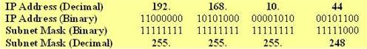

STEP 2: Calculate the Subnet Address
To calculate the IP Address Subnet you need to perform a bit-wise AND operation (1+1=1, 1+0 or 0+1 =0, 0+0=0) on the host IP address and subnet mask. The result is the subnet address in which the host is situated.
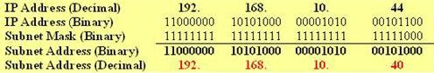

STEP 3: Find Host Range
We know already that for subnetting this Class C address we have borrowed 5 bits from the Host field. These 5 bits are used to identify the subnets. The remaining 3 bits are used for defining hosts within a particular subnet.
The Subnet address is identified by all 0 bits in the Host part of the address. The first host within the subnet is identified by all 0s and a 1. The last host is identified by all 1s and a 0. The broadcast address is the all 1s. Now, we move to the next subnet and the process is repeated the same way.
The following diagram clearly illustrates this process:
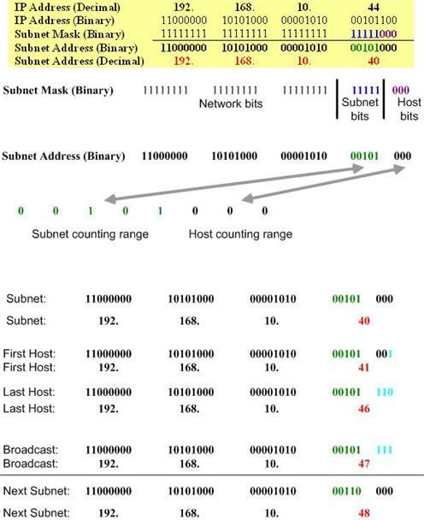

STEP 4: Calculate the Total Number of Subnets and Hosts Per Subnet
Knowing the number of Subnet and Host bits we can now calculate the total number of possible subnets and the total number of hosts per subnet. We assume in our calculations that all-zeros and all-ones subnets can be used. The following diagram illustrates the calculation steps.
