USER-GUIDE



This E-Project is Presented By:

* **Hafiz Uzair Afzal**
* **Muhammad Jazib**

**PAGES:**

1. **HOME**
2. **ABOUT**
3. **COURSES**
4. **NEWS**
5. **CONTACT**

**HOMEPAGE:**

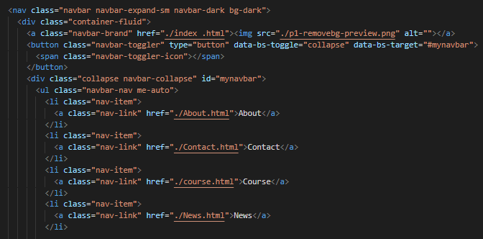

This is Our Homepage and There are 5 Navigation bars like **“** **Home , About , Contact, Course , News”**

In Navbar and after the Navigation Bar. There are some pictures to show the motivation of Daily Exercise.

**ABOUT:**

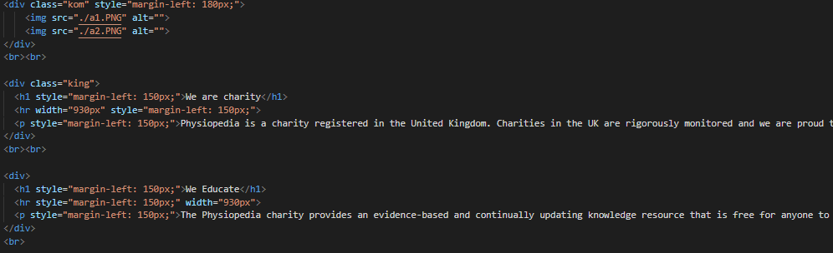

This is Our **“About”** page. It tells you about the key features of our Organization. As it is a charity , Not-for profit Organization. We help those who are in need of Rehabilitation Knowledge.

**COURSES:**

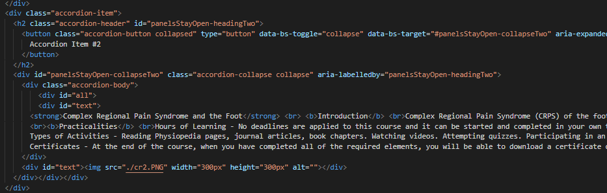

Hours of Learning - No deadlines are applied to this course and it can be started and completed in your own time according to your personal schedule. We expect the required elements to take around 1-1.5 hours depending on your schedule and learning style. Additionally, there are many optional resources provided and if you choose to review these the course could take longer to complete. Types of Activities - Reading pages, journal articles, book chapters. Watching videos. Attempting quizzes. Participating in an international discussion forum.

**NEWS:**

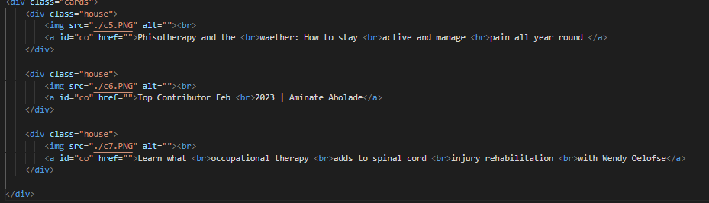

This is Our news page . In this Page it shows news about different healthcare exercises. And the news about the World Encephalitis Day which is celebrated on 22nd February.