Literature Review
Paper 1: An adaptive relationship of thermal comfort for the Gulf Cooperation Council (GCC) Countries: The case of offices in Qatar.
This paper will help us in estimating unfound numbers in PMV,
Main Points:
- In Doha, median air speed was found to be much lower at 0.02 m/s (mean = 0.04 m/s; SD = 0.06, all data. And it very different comparing to ASHRAE number “0.28 m/s”.
Numbers below are based on study of 3742 people.
Variable | Mean | SD
V_{a} (m/s) | 0.04 | 0.06
I_{cl_tot} (clo) | 0.81 | 0.23
Activity (Met) | 2.3 | 1.1

- Note that the CLO is high, because of non-western clothing culture.
- Griffiths comfort temperature: T_{c} = T + (0 − TSV)/a. what next temperature that make this user satisfied.
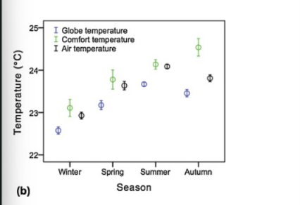
This pic directly says optimization with regulation of having indoor temp between 22 to 26 can preserve great thermal environment.

Location | Adaptive model | Mean comfort temp
Qatar | Tc= 0.049Tr + 22.5 | 24.0
ASHRAE DB 2 | Top = 0.31Tmm + 17.8 | NA

Conclusion:
- in Qatari buildings the PMV was found to overestimate occupants' actual response, which is why authors built an adaptive model instead.

