Week_20_Tableau_Advanced_Tableau_Features_Theory_Assignment
Dataset: Superstore_Dataset

Question 1: What are Dashboard Actions in Tableau? Explain different types.
Answer:
Dashboard actions are interactive features in Tableau that allow users to interact with visualizations. They help in connecting multiple charts and dashboards.
Types of Dashboard Actions:
- Filter Action: Filters data in one chart based on selection in another
- Highlight Action: Highlights related data across charts
- URL Action: Opens a web page when a user clicks on a data point

Question 2: Create a dashboard action that filters a table when clicking on a chart.
Answer:
Created a bar chart using Category and Sales, and a table using Sub-Category and Sales. Added both to a dashboard and applied a filter action so that clicking on the chart filters the table dynamically.
Screenshot:
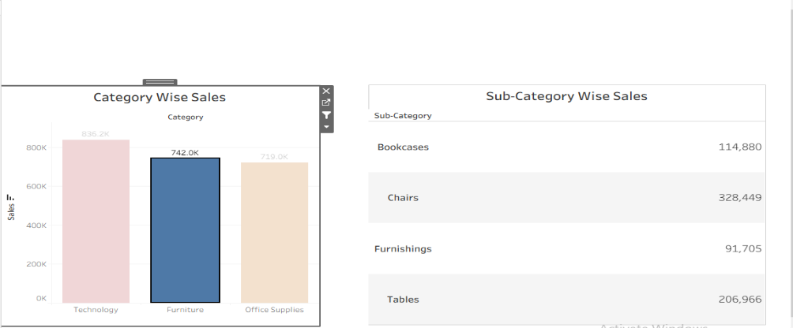
Figure 1: Dashboard filter action

Question 3: Explain the difference between Parameters and Filters.
Answer:
- Filter: Used to restrict the data displayed in a view
- Parameter: A dynamic value that allows user input and can be used in calculations, filters, and reference lines

Question 4: Create a map that filters a bar chart when selecting a region or state.
Answer:
Created a map using State and a bar chart using Region and Sales. Added both to a dashboard and applied a filter action so that selecting a state on the map filters the bar chart accordingly.
Screenshot:
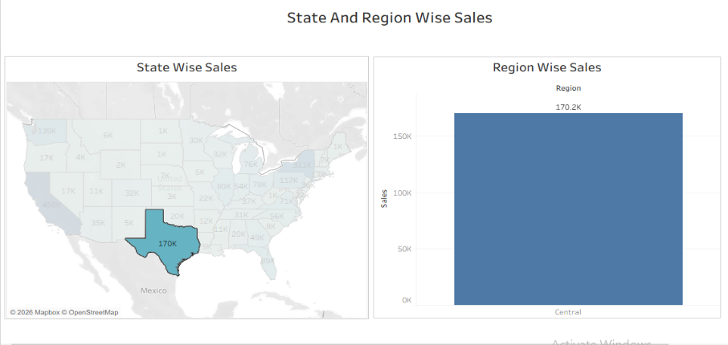
Figure 2: State and Region Wise Sales Dashboard

Question 5: Create a calculated field to classify Profitability.
Answer:
Created a calculated field to classify profit as Profit or Loss.
Calculated Field:
IF [Profit] > 0 THEN "Profit"
ELSE "Loss"
END
Screenshot:
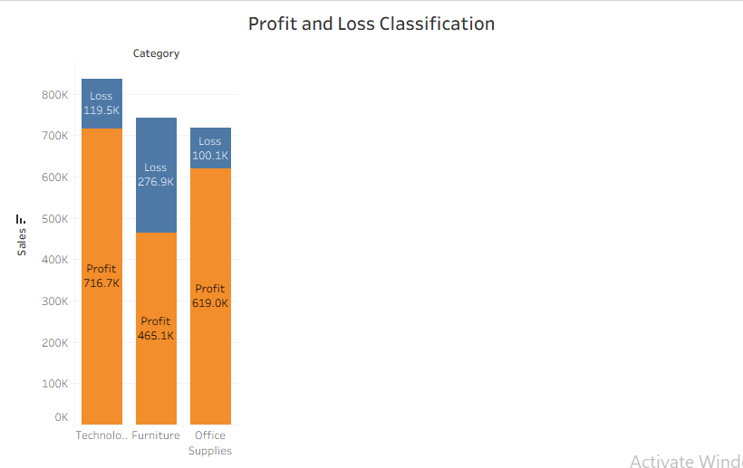
Figure 3: Profit and Loss Classification

Question 6: Build an interactive dashboard showing Sales and Profit by Region.
Answer:
Created multiple visualizations including a map, sales chart, and profit chart. Combined them into a dashboard and applied filter actions to make the dashboard interactive based on region selection.
Screenshot:
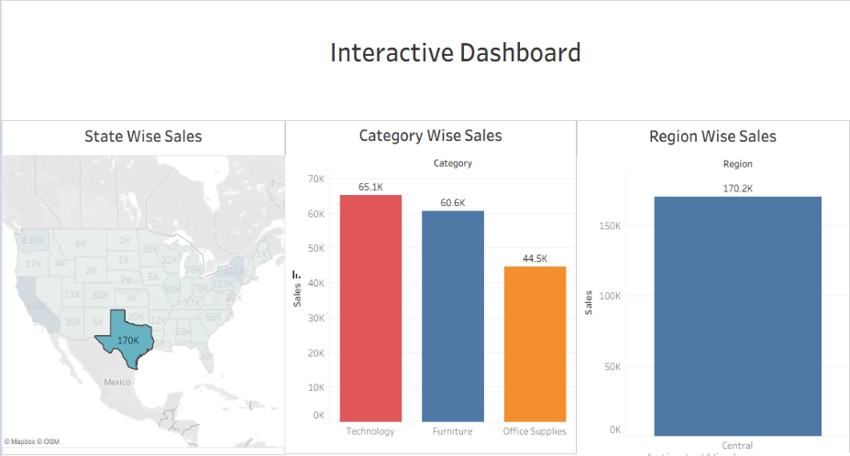
Figure 4: Interactive Dashboard

Question 7: Create a parameter to switch between Day, Month, and Year.
Answer:
Created a parameter with values Day, Month, and Year. Used a calculated field with DATETRUNC function to dynamically change the date level in the visualization.
Calculated Field:
CASE [Date Level]
WHEN "Day" THEN DATETRUNC('day',[Order Date])
WHEN "Month" THEN DATETRUNC('month',[Order Date])
WHEN "Year" THEN DATETRUNC('year',[Order Date])
END
Screenshot:
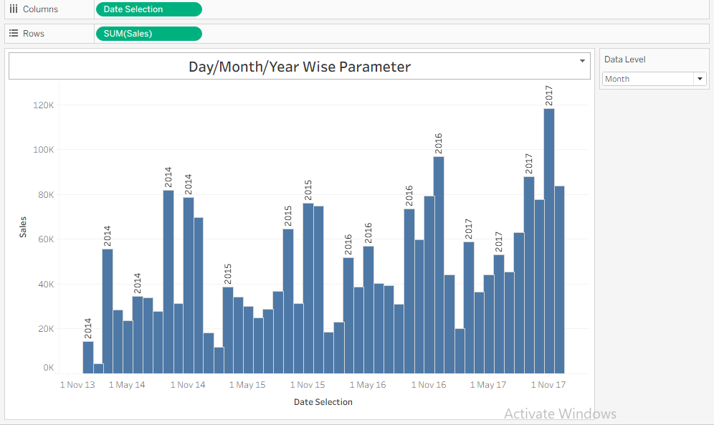
Figure 5: Day/Month/Year Wise Parameter Chart

Question 8: Create a Top N filter using a parameter.
Answer:
Created a parameter to define the number of top items. Applied this parameter in the filter to dynamically show Top N Sub-Categories based on Sales.
Screenshot:
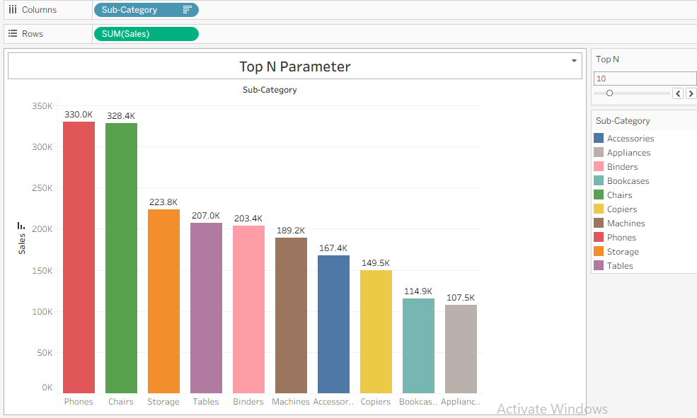
Figure 6: Top N Parameter Chart

Question 9: Create a filter to show last N days using a parameter.
Answer:
Created a parameter for number of days and a calculated field to filter records based on the current date.
Calculated Field:
DATEDIFF ('day', [Order Date], { FIXED : MAX([Order Date]) }) <= [Number of Days]
Screenshot:
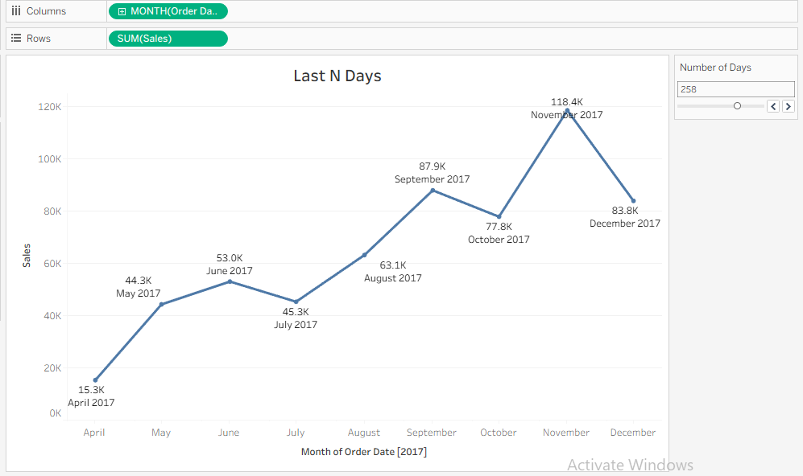
Figure 7: Last N Days Chart

Question 10: Filter data to show only negative profit.
Answer:
Applied a filter on Profit field to show only records where profit is less than zero, highlighting loss-making transactions.
Screenshot:
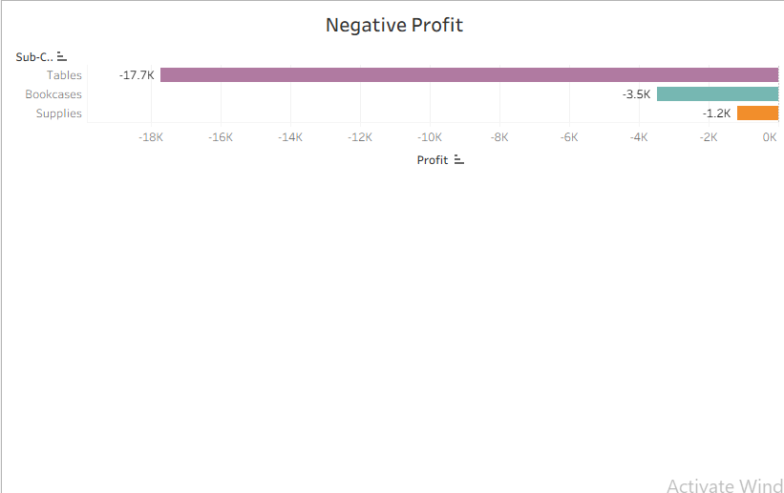
Figure 8: Negative Profit Chart

