Week_20_Tableau_Data_Storytelling_Assignment

1. What is a Story Point in Tableau?
A Story Point in Tableau is a sequence of visualizations used to present data insights step-by-step like a presentation. It helps users understand trends, comparisons, and business insights in a logical flow.
A Dashboard in Tableau is a collection of multiple visualizations displayed together on a single screen for interactive analysis.

Differences Between Story and Dashboard
Story | Dashboard
Used for storytelling and presentations | Used for interactive analysis
Displays insights step-by-step | Displays multiple charts together
Contains Story Points | Contains Worksheets and Charts
Focuses on explaining insights | Focuses on monitoring KPIs
Works like presentation slides | Works like a business control panel

2. Importing Dataset into Tableau

Steps Performed
- Opened Tableau Public/Desktop.
- Clicked on “Text File”.
- Selected the dataset file:
Tableau_Sales_Data_India.csv
- Loaded the dataset successfully into Tableau.
- Opened Sheet 1 for visualization creation.

3. Creating Tableau Story
A new Story was created in Tableau to present different business insights related to sales and profit performance.
The Story contains multiple Story Points showing important analytical insights.

STORY POINT 1 — Total Sales per Region

Visualization Used
Bar Chart

Description
This chart compares total sales across different regions.

Why Bar Chart Was Used
A bar chart makes it easier to compare sales values between regions.
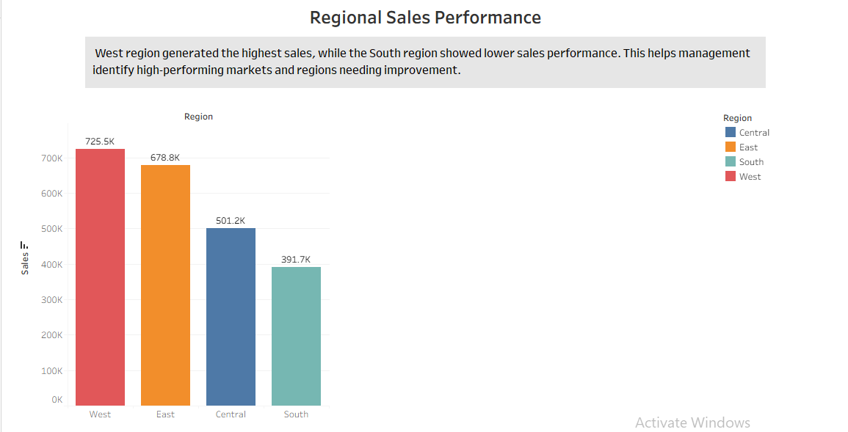

Insight Derived
The West region generated the highest sales, while some regions showed comparatively lower sales performance.

Business Decision-Making Benefit
This insight helps management identify strong-performing regions and regions requiring marketing improvements or sales strategies

STORY POINT 2 — Total Profit by Product Category

Visualization Used
Bar Chart

Description
This visualization shows profit generated by different product categories.

Why Bar Chart Was Used
Bar charts are suitable for comparing profitability among categories.
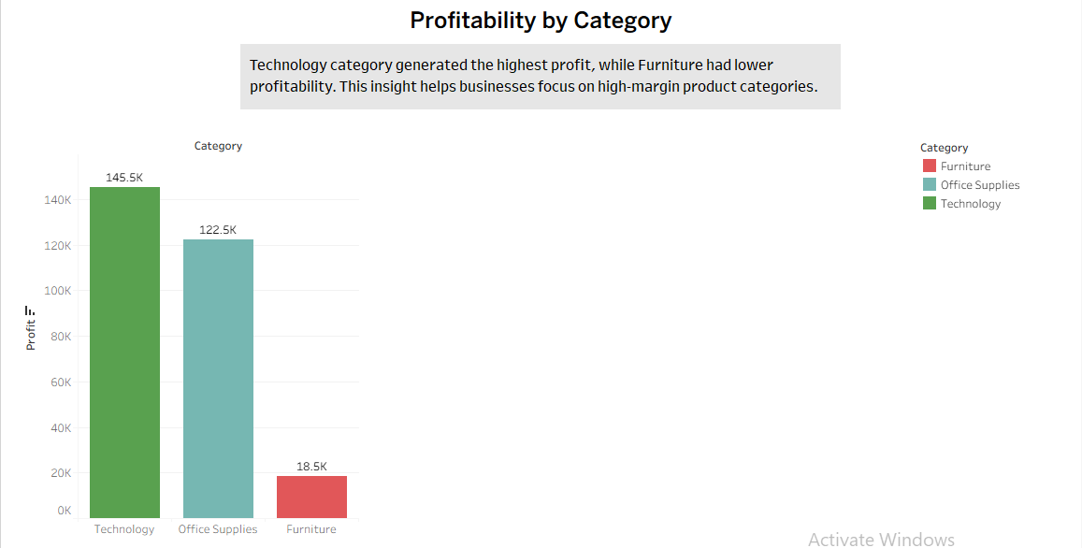

Insight Derived
Technology products generated the highest profit, while Furniture showed relatively lower profitability.

Business Decision-Making Benefit
The company can focus more on high-profit product categories and improve pricing or cost strategies for low-performing categories.

STORY POINT 3 — Top 5 Customers by Sales

Visualization Used
Horizontal Bar Chart

Description
This chart displays the top 5 customers contributing the highest sales.
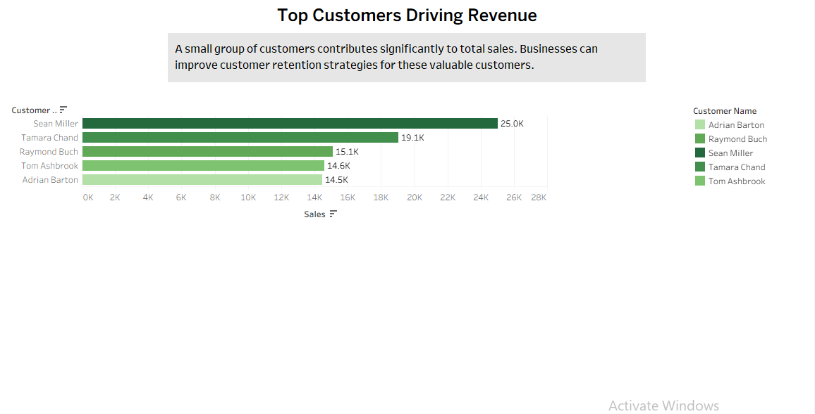

Insight Derived
A small group of customers contributes significantly to overall company revenue.

Business Decision-Making Benefit
The business can improve customer retention strategies and offer loyalty programs to valuable customers.

4. Profit Trends Over Time

Visualization Used
Line Chart

Features Added
- Date Filter
- Region Filter
- Dynamic Interaction
- Colour Coding by Region

Description
The line chart visualizes profit trends across order dates and regions.
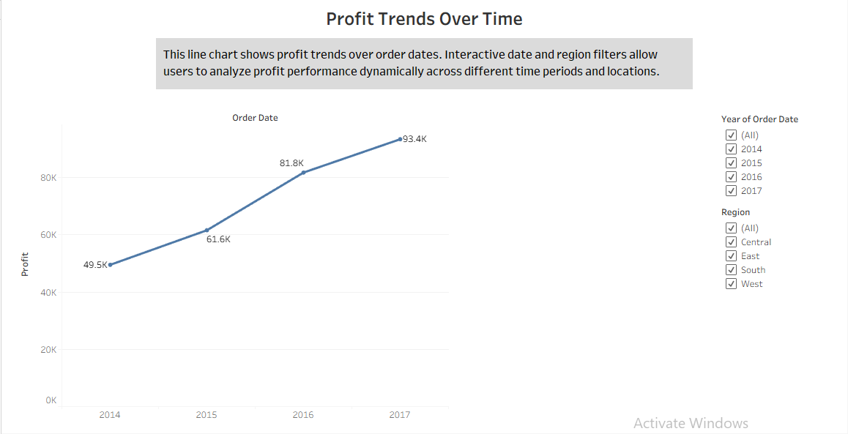

Insight Derived
Profit changes over time depending on seasons and regions. Some periods show higher profitability than others.

Business Decision-Making Benefit
Managers can identify seasonal trends, profitable time periods, and regional performance differences to improve planning and forecasting.

How Interactive Filters Improve Tableau Story Usability
Interactive filters improve usability by allowing users to analyse specific regions and custom date ranges dynamically. Users can quickly explore trends without creating separate reports.
These filters help business teams:
- Analyse regional performance
- Detect seasonal sales trends
- Compare profit changes over time
- Make faster and more accurate business decisions

5. Finding the Most Profitable Product Category

Dashboard Created
A dashboard was created containing:
- Total Profit by Product Category
- Profitability Trend Over Time
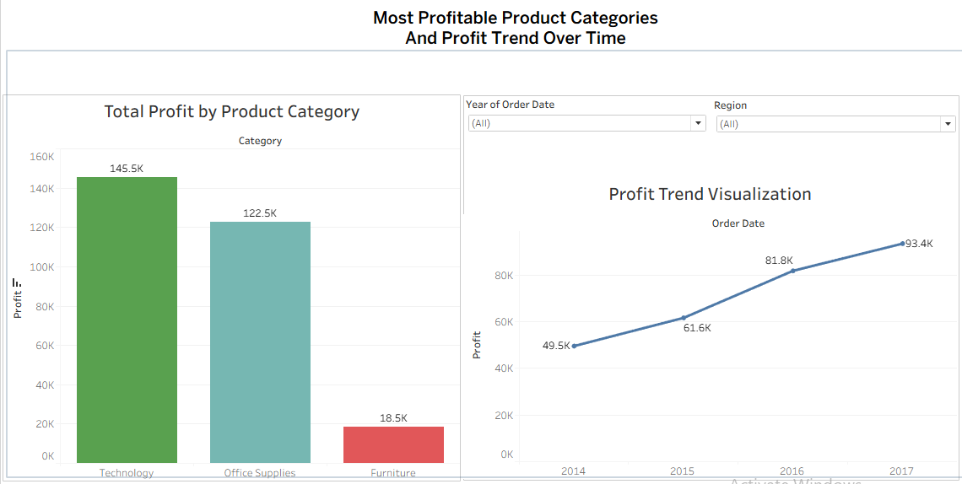

Insight Derived
Technology products consistently generated higher profits over time.

Business Decision-Making Benefit
The company can focus investment and marketing on highly profitable product categories.

6. Top 5 and Bottom 5 Customers Based on Sales

Visualization Used
Ranked Bar Chart

Colour Coding
- Green → Top Customers
- Red → Bottom Customers

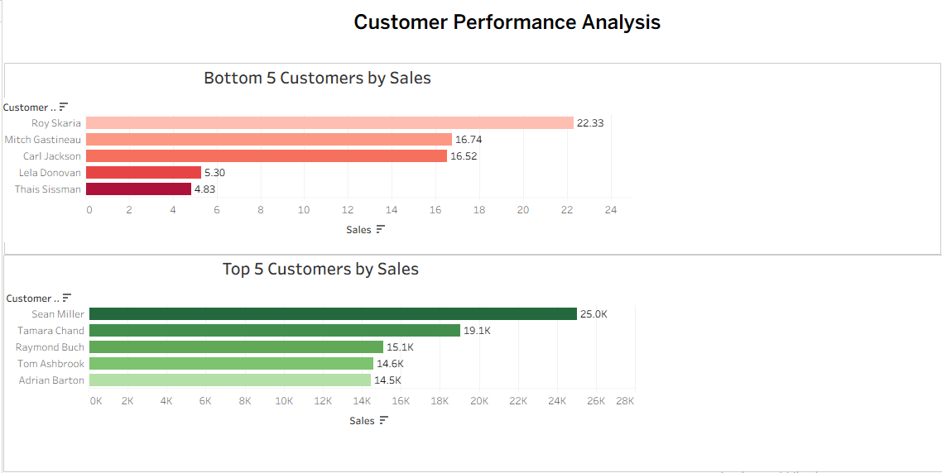

Insight Derived
Top customers generate a major share of revenue, while bottom customers contribute very little sales.

Business Decision-Making Benefit
The company can retain valuable customers and design strategies to improve engagement with low-performing customers.

7. Detecting Sales Patterns Across Regions

Visualization Used
Dual-Axis Chart
- Sales represented using Bars
- Profit represented using Line Chart

Description
This chart compares sales and profit across different regions.

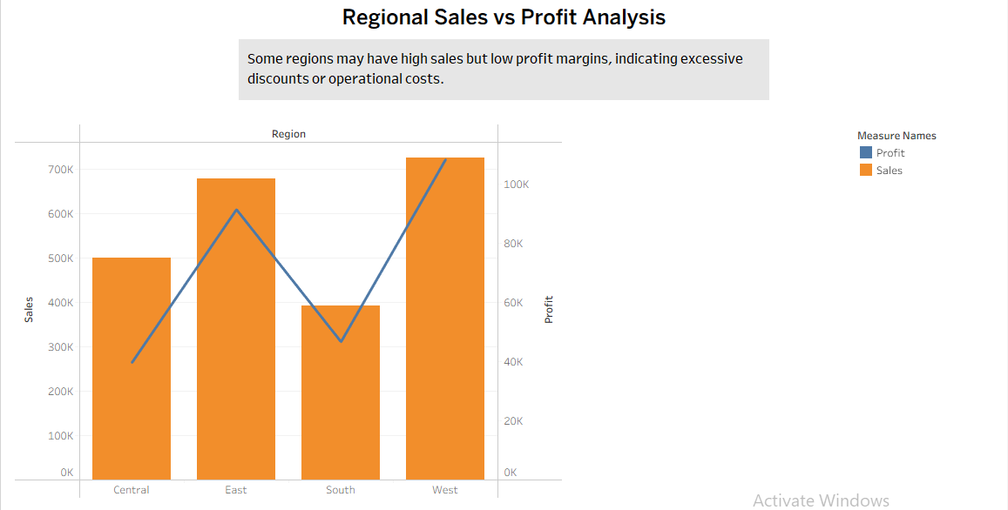

Insight Derived
Some regions have high sales but lower profit margins, which may indicate higher operational costs or discounting.

Business Decision-Making Benefit
The company can improve profitability strategies in regions with lower margins despite strong sales.

8. Identifying the Most Profitable Region for Expansion

Visualization Used
Forecast Chart

Description
Sales forecasting was performed to predict future sales for the next quarter.
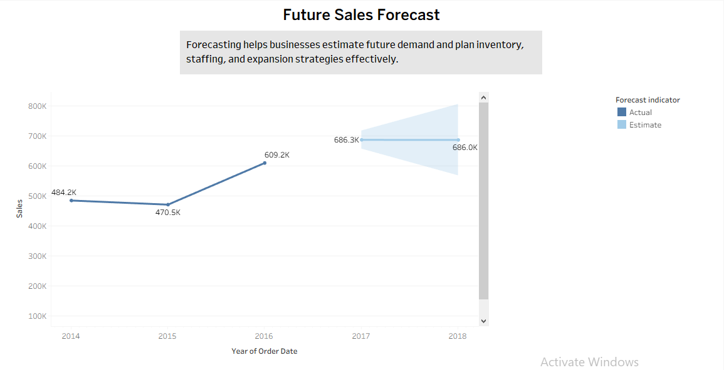

Insight Derived
The most profitable region showed consistent growth and strong forecasted sales performance.

Business Decision-Making Benefit
The business can prioritize expansion in regions with stable growth and strong future sales potential.

Conclusion
This Tableau Story and Dashboard project helped analyse sales, profit, customer performance, and regional trends using different visualizations and interactive filters.
The analysis supports better business decision-making by identifying:
- High-performing regions
- Profitable product categories
- Valuable customers
- Future sales opportunities
Tableau Stories and Dashboards provide an effective way to present business insights visually and interactively.

