**Login & signup (Airbnb)**



**Transition (Airbnb) → nice to have, but not necessary**

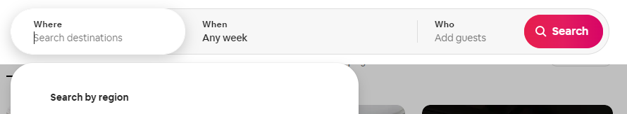

**Search (top of front page) (booking.com)**

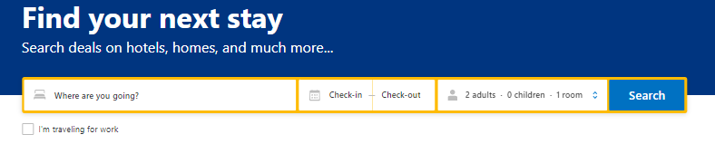

**Banner of categories and suggestions (booking)**

categories

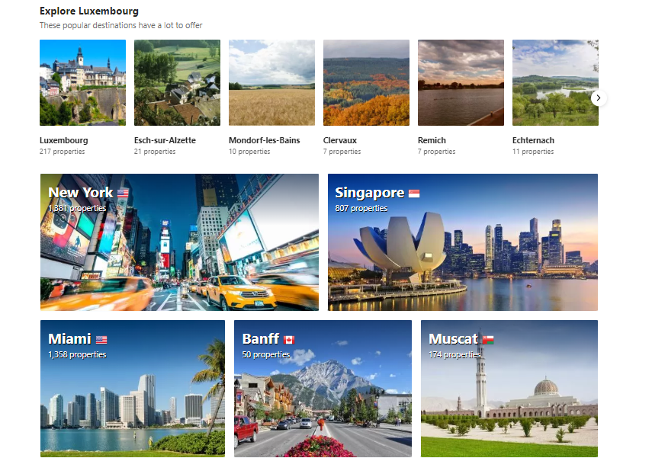

**Maps with pointers**

