LLM-Based Threat Hunting
for Security Operations Center (SOC) Environments
A Natural-Language Threat Hunting Engine over Live Splunk Telemetry
Project Report
HAFSA MAHEK

Abstract
Security Operations Centers (SOCs) increasingly rely on threat hunting — the proactive, hypothesis-driven search for malicious activity that has not already triggered an automated alert. In practice, threat hunting is bottlenecked by the requirement that analysts write queries in vendor-specific query languages (e.g. Splunk's SPL), a skill that is unevenly distributed even within experienced teams. This project designs and implements a natural-language threat hunting engine that allows an analyst to ask a plain-English question and receive a real, executed search against live security telemetry, without writing any query syntax.
The system was built and validated in two stages. First, a synthetic-data prototype established the core architecture: a hybrid natural-language-to-SPL translator (a deterministic rule-based parser backed by a locally-hosted LLM for open-ended questions), a Streamlit dashboard, and a multi-step automated investigation chain that follows a lateral-movement trail end to end. Second, the same architecture was re-validated against real endpoint telemetry — live Windows Security Event Log and Sysmon data collected from an actual monitored host — surfacing genuine findings, including a real disguised executable ("Invoice.pdf.exe") and a real pattern of repeated failed logon attempts.
The project also documents, in detail, the real engineering obstacles encountered when adapting a system designed for clean synthetic data to messy, real-world log sources — including a Splunk reserved-field collision, a multivalue-field aggregation bug that silently corrupted results, the reliability limits of a small (1B-parameter) local LLM, and the practical failure modes of Splunk's built-in XML field extraction on Windows Event Log data. These findings are presented as a set of lessons learned that generalize beyond this specific implementation.

Contents
1. Introduction
2. Objectives
3. System Architecture
4. Implementation
4.1 Environment Setup
4.2 Synthetic Data Prototype and Splunk Ingestion
4.3 Natural-Language Query Engine (Regex + LLM Hybrid)
4.4 Dashboard Interface
4.5 Multi-Step Automated Investigation Chain
4.6 Migration to Real Endpoint Telemetry
5. Challenges and Debugging — Lessons Learned
6. Results Summary
7. Limitations and Future Work
8. Conclusion

1. Introduction
Modern SOCs are overwhelmed by alert volume, and automated detection rules — however well tuned — only catch what they were written to catch. Threat hunting fills this gap: analysts form a hypothesis ("has anyone tried to brute-force a login recently?") and search raw telemetry for evidence, whether or not any rule fired. The practical barrier is the query language itself. Writing correct, efficient SPL (Splunk's Search Processing Language) is a skill that takes time to develop, and it stands between an analyst's hypothesis and an answer.
This project asks a narrow, practical question: can a natural-language interface, backed by a combination of deterministic rules and a small locally-hosted language model, reliably translate an analyst's plain-English question into a correct, safe, executable Splunk query — and can the same approach be extended into a multi-step automated investigation that chains several such queries together to follow an attack path end to end?

2. Objectives
- Design a natural-language-to-SPL translation layer that is reliable for common, well-defined hunting patterns and gracefully falls back to an LLM for open-ended questions.
- Build an interactive dashboard that lets an analyst ask questions and see the generated query, the query's safety status, and the results.
- Implement a multi-step automated investigation chain that follows a plausible attack narrative (initial access attempt → successful compromise → post-compromise activity) without manual analyst intervention.
- Validate the system first on controlled synthetic data, then migrate it to real, live endpoint telemetry to test its behavior under realistic, messy conditions.
- Document the engineering obstacles encountered honestly, as they are themselves a meaningful contribution for anyone building a similar system.

3. System Architecture
The system is composed of four layers. A data layer (Splunk, indexing either synthetic JSON telemetry or real Windows Security/Sysmon events). A query-translation layer, which is itself hybrid: a fast, deterministic regular-expression parser handles known question patterns exactly and safely, while a locally-hosted LLM (Llama 3.2, 1B parameters, served via Ollama) handles questions that do not match a known pattern. A safety layer validates every LLM-generated query against a list of destructive SPL commands before execution. And an interaction layer, a Streamlit dashboard, exposes both single-question hunting and a fully automated multi-step investigation.
Data Platform | Splunk Enterprise 10.4.0 (free/trial license)
Local LLM | Llama 3.2 (1B parameters), served via Ollama
Query Translation | Hybrid: deterministic regex parser (primary) + LLM fallback
Dashboard | Streamlit (Python)
Data Sources | Synthetic JSON telemetry (prototype); Windows Security Event Log + Sysmon (real validation)
Host Environment | Ubuntu Linux (VirtualBox VM)
Language | Python 3.14

4. Implementation

4.1 Environment Setup
The development environment was built entirely from free and open-source tools: Splunk Enterprise (free trial license, capped at 500MB/day ingestion — more than sufficient for this project), a Python virtual environment for isolation, and Ollama for serving the local LLM without any paid API.
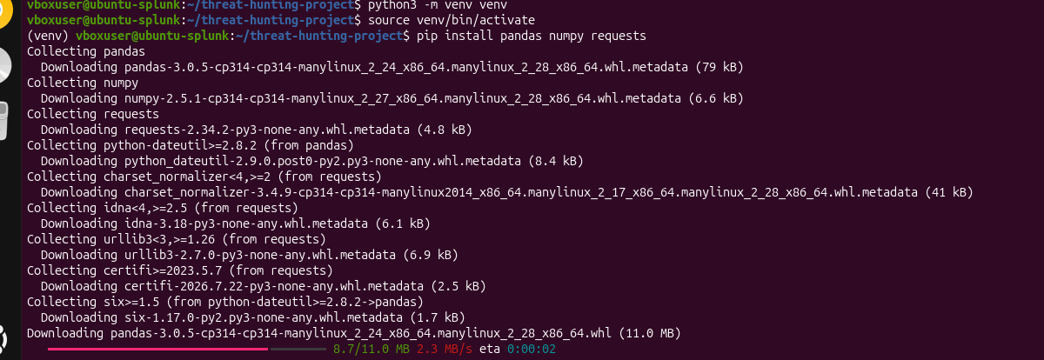
Figure 2: Setting up the Python virtual environment and installing core dependencies (pandas, numpy, requests).
Figure 9: Installing Ollama, the framework used to serve the local LLM with no external API dependency.
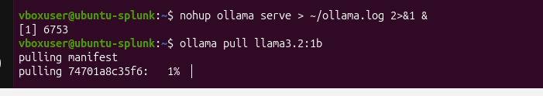
Figure 10: Starting the Ollama server in the background and pulling the Llama 3.2 (1B) model.
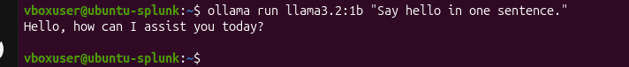
Figure 11: Verifying the local LLM responds correctly to a basic prompt before integrating it into the query pipeline.

4.2 Synthetic Data Prototype and Splunk Ingestion
Before working against real telemetry, the full pipeline was validated end to end on synthetic data: a generated set of authentication, network, and process events with a deliberately planted, realistic lateral-movement scenario (repeated failed logins, a successful compromise, a PowerShell execution, and an outbound connection resembling command-and-control traffic). This let the architecture be proven correct before the added complexity of real, messy data was introduced.
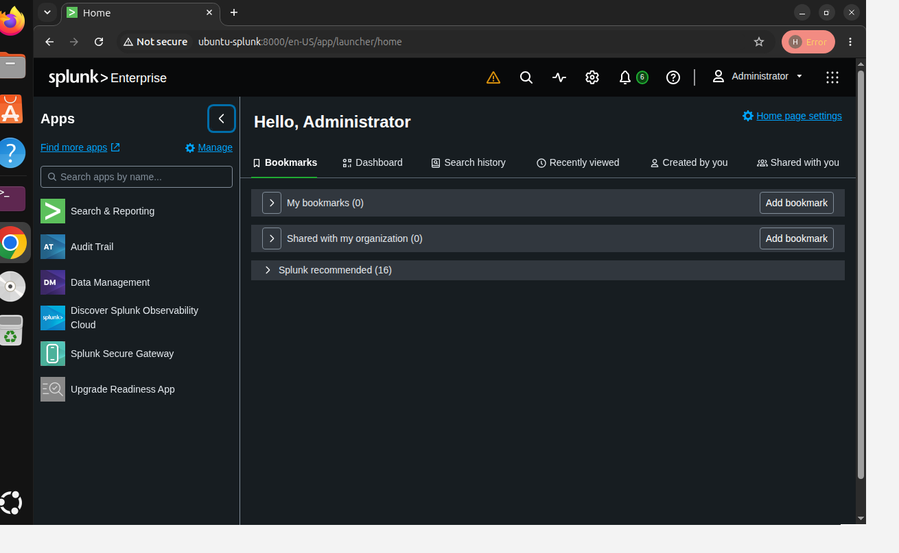
Figure 1: Splunk Enterprise home screen following installation, confirming the platform is running and accessible.
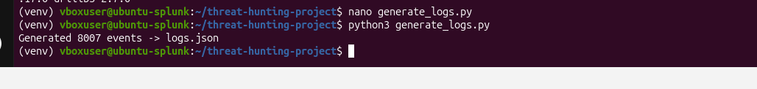
Figure 3: Generating the synthetic telemetry set (8,007 events) with the planted attack scenario.
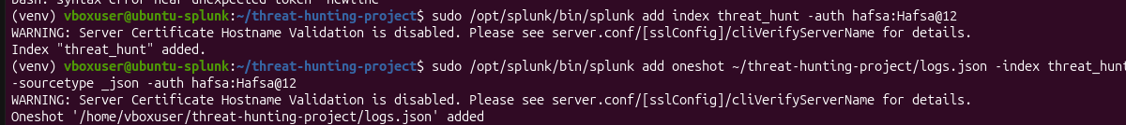
Figure 5: Creating a dedicated Splunk index and performing a one-shot ingest of the synthetic data.
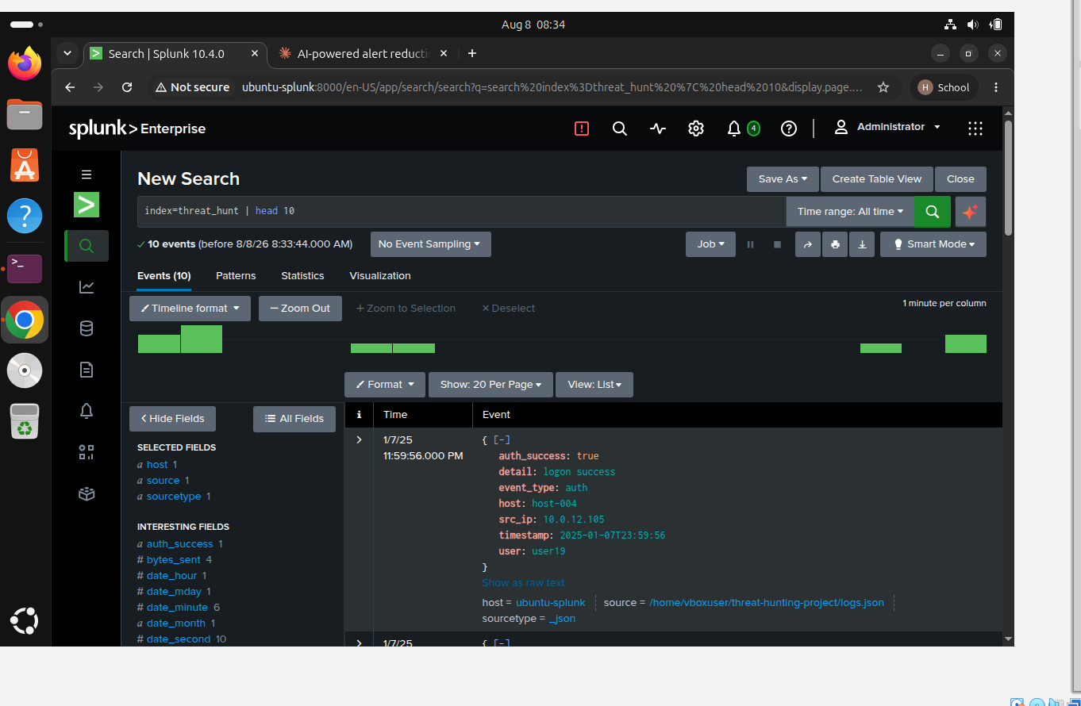
Figure 4: Verifying ingestion succeeded by retrieving raw events from the new index.
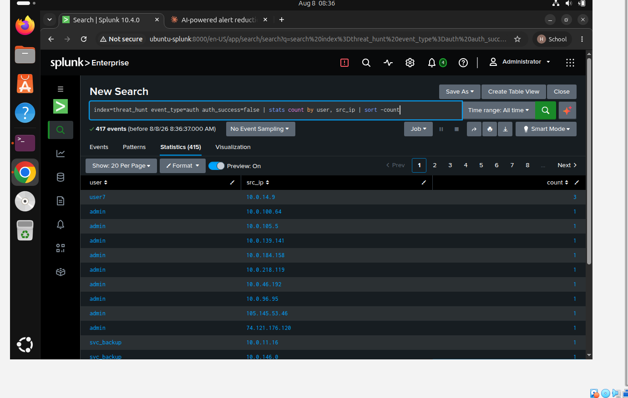
Figure 6: A manual SPL query confirming the planted attacker ('user7', 3 failed login attempts) is correctly discoverable in the ingested data — the ground-truth check the rest of the system is validated against.
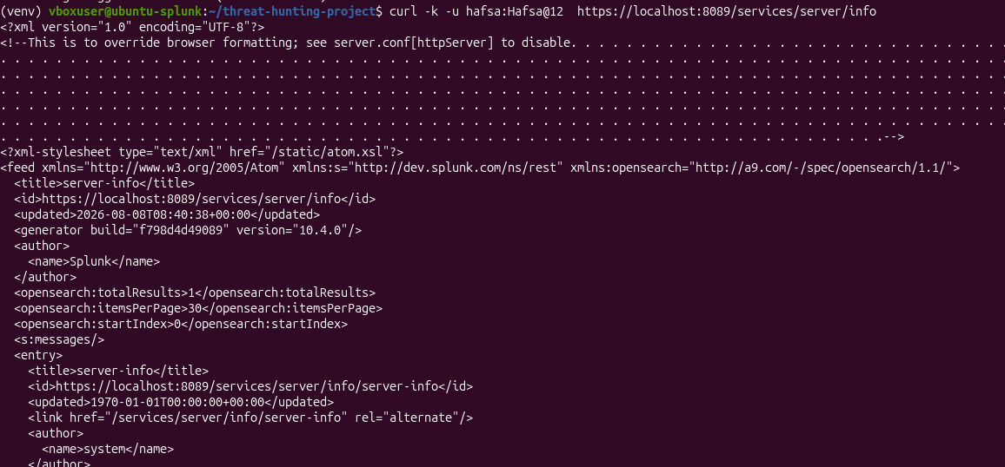
Figure 7: Confirming Splunk's REST API is reachable, which is the interface the Python query layer uses to execute searches programmatically rather than through the web UI.

4.3 Natural-Language Query Engine (Regex + LLM Hybrid)
The translation layer is deliberately hybrid rather than purely LLM-driven. Early testing showed that a small (1B-parameter) local model, while fast and free to run, is unreliable specifically on multi-step aggregation questions (e.g. “users with more than 2 failed logins” requires grouping, counting, and filtering — a pattern the model would sometimes ignore in favor of a simpler, incorrect query). The solution adopted was a confidence-gated design: a deterministic regular-expression parser handles a known set of common hunting patterns with 100% reliability, and only questions that match no known pattern are handed to the LLM.
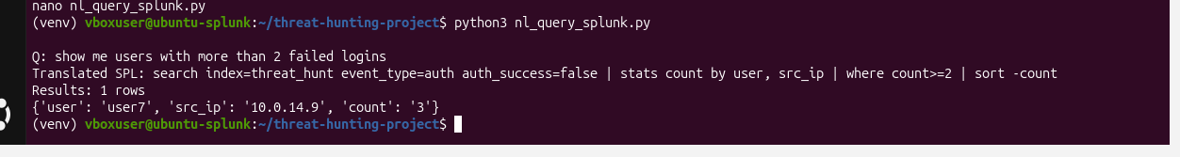
Figure 8: The regex-based translator correctly converting a plain-English aggregation question into SPL and returning the correct planted-attacker result from the terminal.
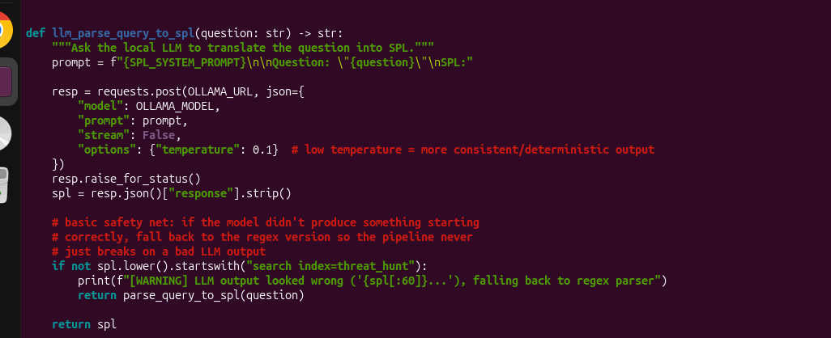
Figure 12: The LLM-backed fallback function: it prompts the local model with the index schema and few-shot examples, and falls back to the regex parser if the model's output does not look like valid SPL.
A safety guardrail was added on top of the LLM path: every LLM-generated query is checked against a list of destructive SPL commands (e.g. delete, outputlookup, sendemail) before it is permitted to run, since an LLM-generated query is untrusted output and should never be executed blindly against a production data platform.

4.4 Dashboard Interface
A Streamlit dashboard was built as the analyst-facing interface, exposing the generated SPL alongside the results for full transparency — an analyst can always see and verify exactly what query was run, and whether it came from the deterministic parser or the LLM.
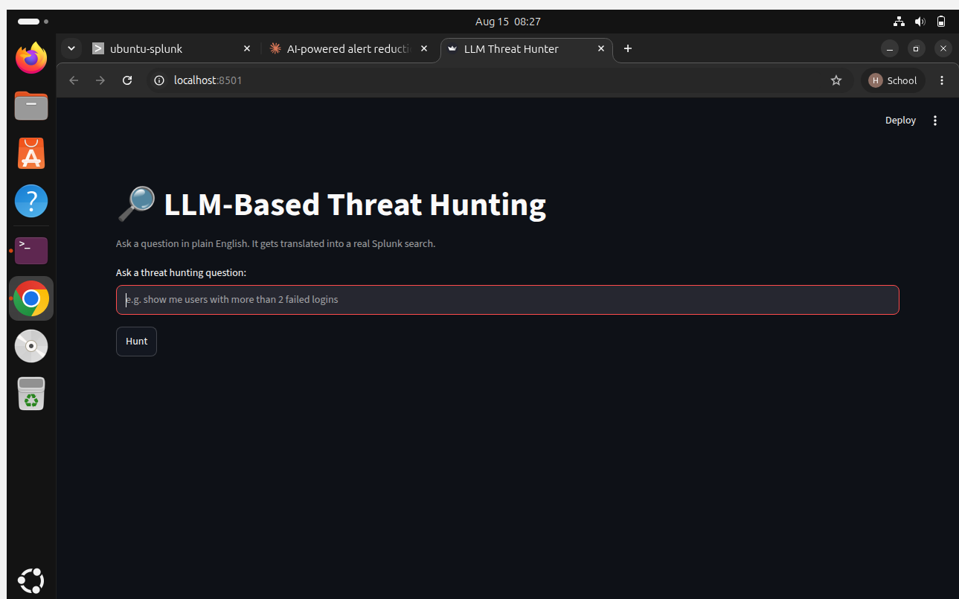
Figure 13: Initial dashboard interface: a plain-English question box and a Hunt button.
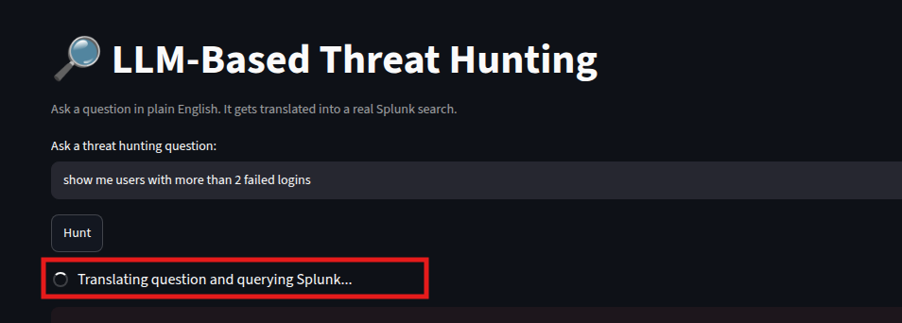
Figure 14: The dashboard mid-query, showing the translation and Splunk lookup in progress.
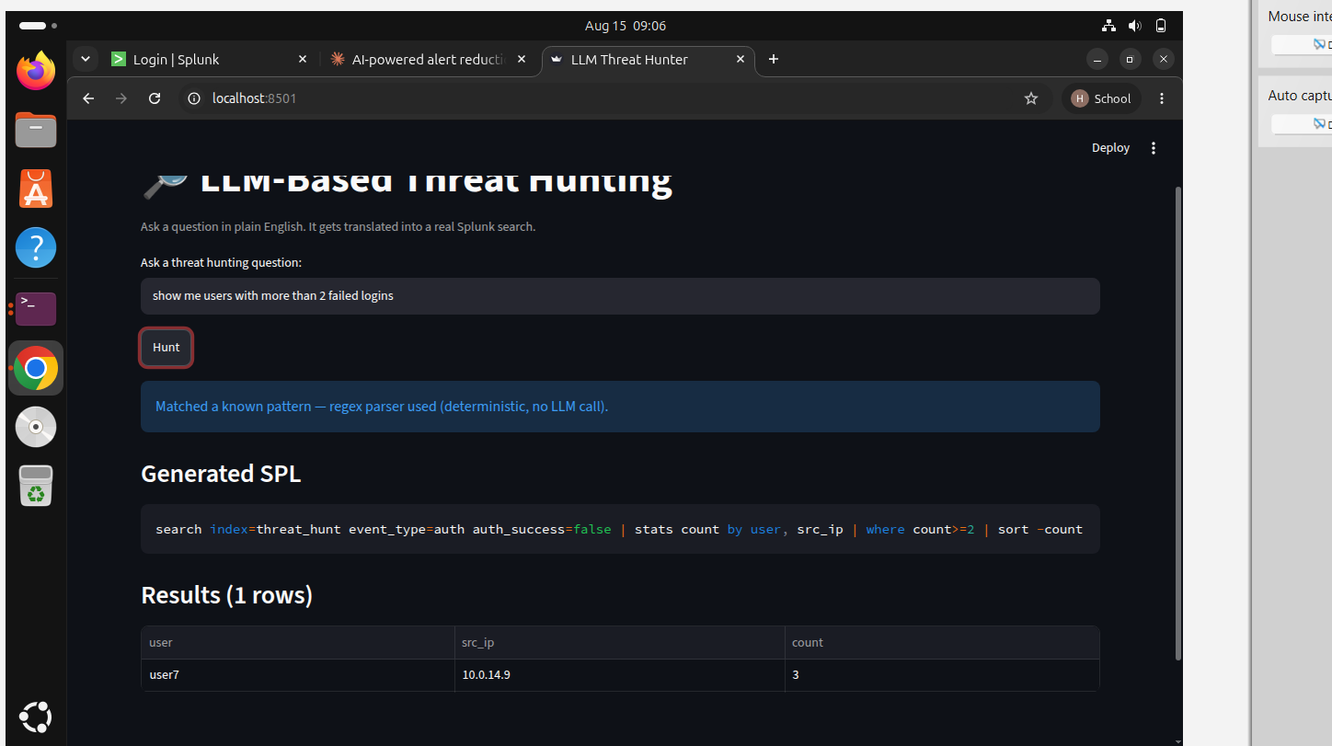
Figure 15: A corrected result after fixing an early routing bug: the dashboard now correctly reports which path (regex or LLM) generated the query, and returns the correct one-row aggregated result.
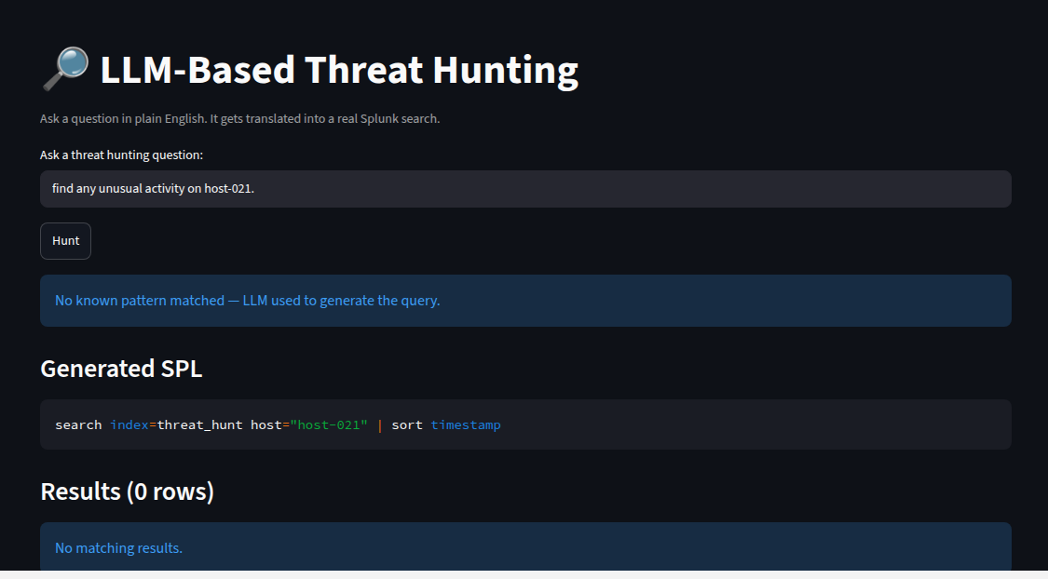
Figure 16: The LLM fallback path correctly handling a free-form question (“find any unusual activity on host-021”) after the prompt was strengthened to pay explicit attention to entities named in the question rather than defaulting to the nearest few-shot example.

4.5 Multi-Step Automated Investigation Chain
Beyond single-question hunting, the system implements an automated multi-step investigation that chains several queries together to walk a plausible attack path without analyst intervention: (1) identify accounts with repeated failed login attempts, (2) check whether that account subsequently achieved a successful login, (3) examine what processes executed following the compromise, and (4) examine outbound network connections following the compromise. Each step's output determines the next step's query, and the chain halts early and reports a clear reason if no evidence is found at any stage.
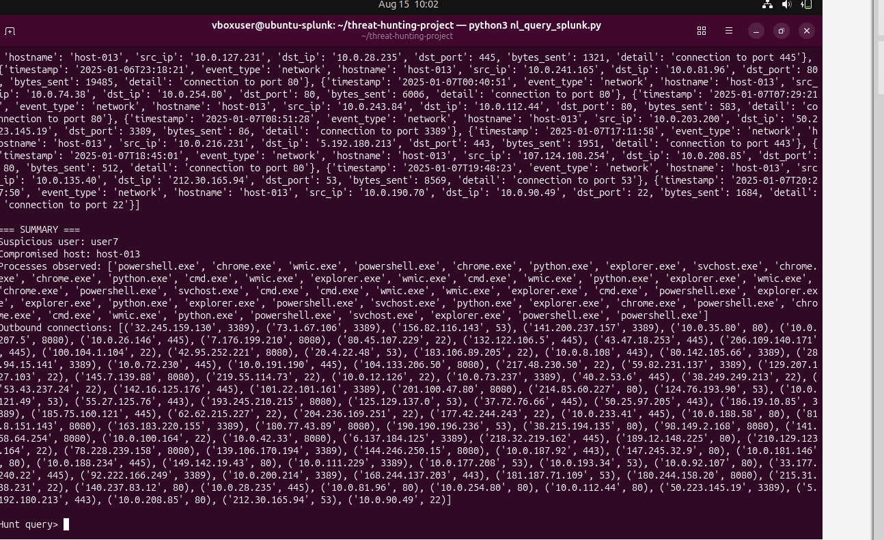
Figure 17: Full terminal output of the automated investigation chain on synthetic data, correctly identifying the planted attacker, the compromised host, the processes executed, and the outbound connection to a suspicious external address — the complete attack narrative recovered automatically from four chained queries.
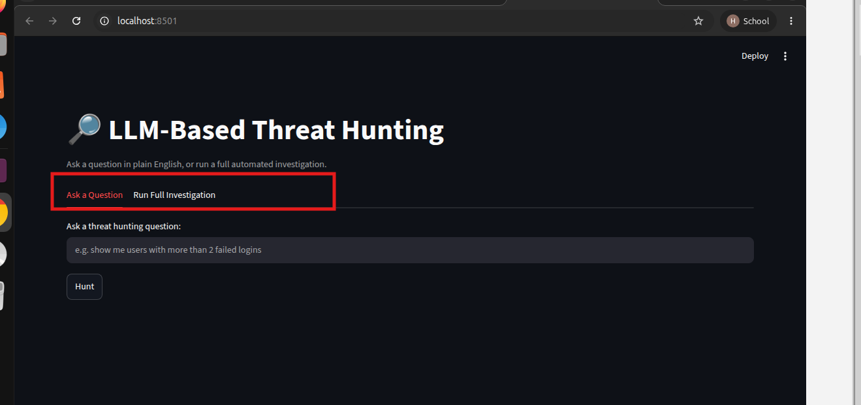
Figure 18: The dashboard extended with a second tab, separating single-question hunting from the fully automated investigation.
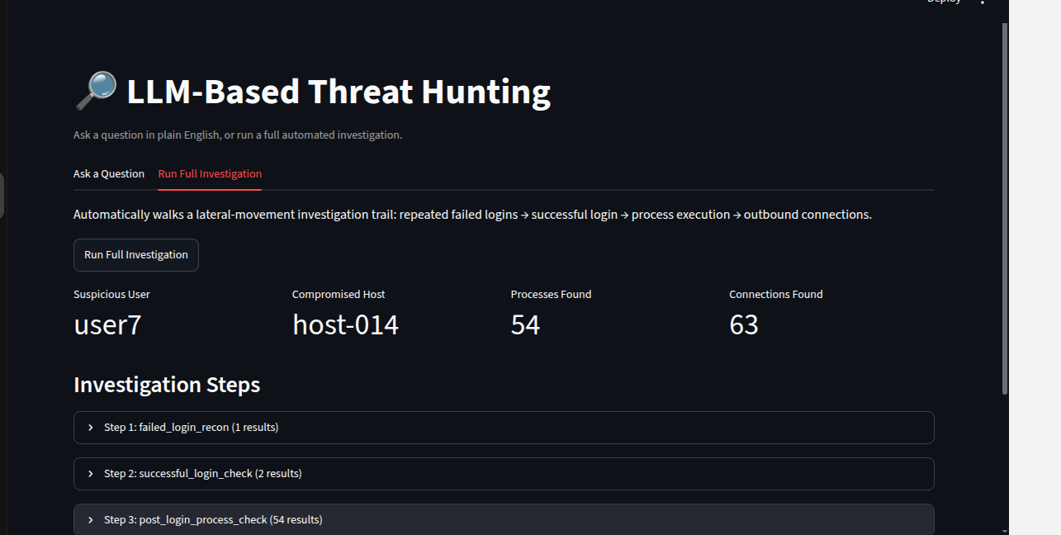
Figure 19: The automated investigation running through the dashboard on synthetic data: suspicious user, compromised host, and counts of correlated process and network events, with each step's underlying SPL available for inspection.

4.6 Migration to Real Endpoint Telemetry
To validate the architecture beyond controlled synthetic data, the same pipeline was re-pointed at real, live telemetry already being collected from a monitored Windows host: Sysmon (via "WinEventLog:Microsoft-Windows-Sysmon/Operational") for process-creation and network-connection events, and the Windows Security Event Log (EventCode 4625 / 4624) for authentication data. This migration surfaced several real engineering problems not present in the synthetic prototype, documented fully in Section 5.
Because Splunk's automatic field extraction did not reliably parse Sysmon's XML-formatted event data, a targeted regular-expression extraction layer was built to pull fields such as Image, CommandLine, User, SourceIp, DestinationIp, and DestinationPort directly out of the raw event text.
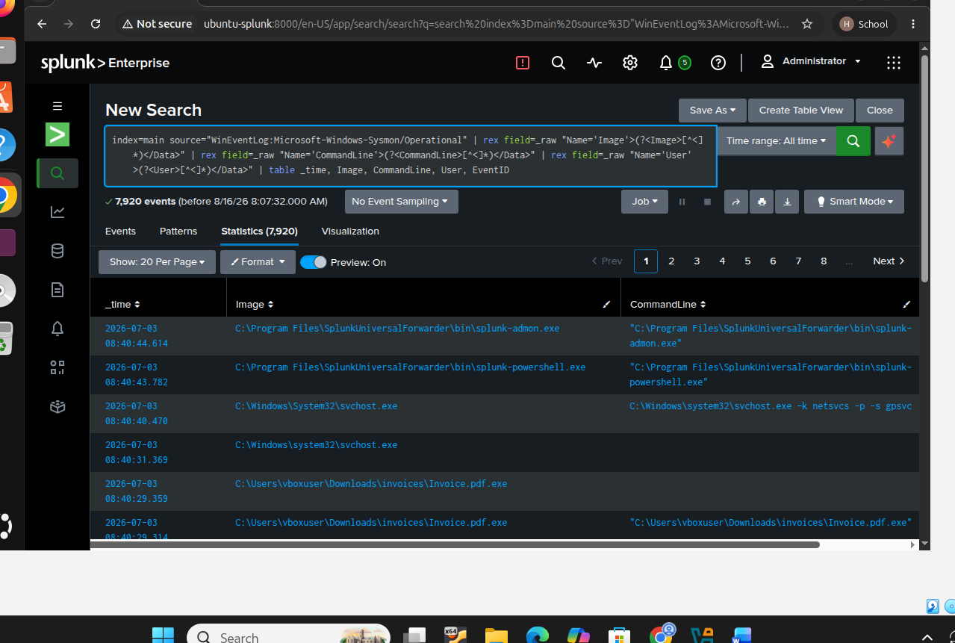
Figure 20: Real Sysmon telemetry with fields correctly extracted via regex, surfacing a genuine finding: a file at 'C:\Users\vboxuser\Downloads\invoices\Invoice.pdf.exe' — a classic disguised-executable pattern (a file made to look like a PDF that is actually an executable), discovered directly from real endpoint data rather than a planted scenario.
The single-host nature of the real deployment (one monitored endpoint, rather than the many simulated hosts in the synthetic scenario) meant the investigation chain's logic was adapted from host-to-host lateral movement to time-window correlation: instead of asking “did the attacker move to another machine,” the chain asks “what else happened on this machine in the minutes surrounding the suspicious login activity.” This is itself a legitimate, commonly used real-world hunting pattern.
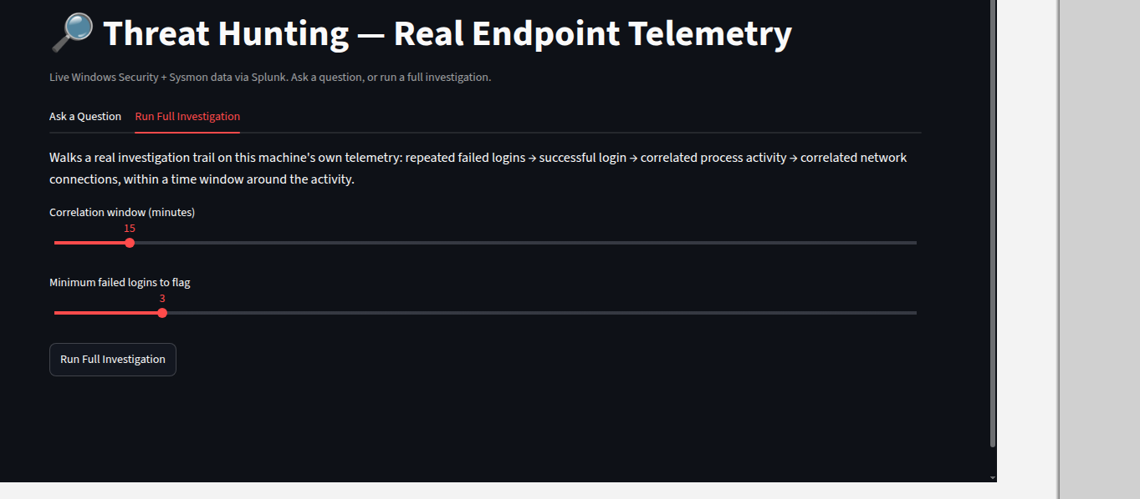
Figure 21: The dashboard's investigation tab adapted for real telemetry, with adjustable correlation-window and failed-login-threshold controls and a time-range selector.
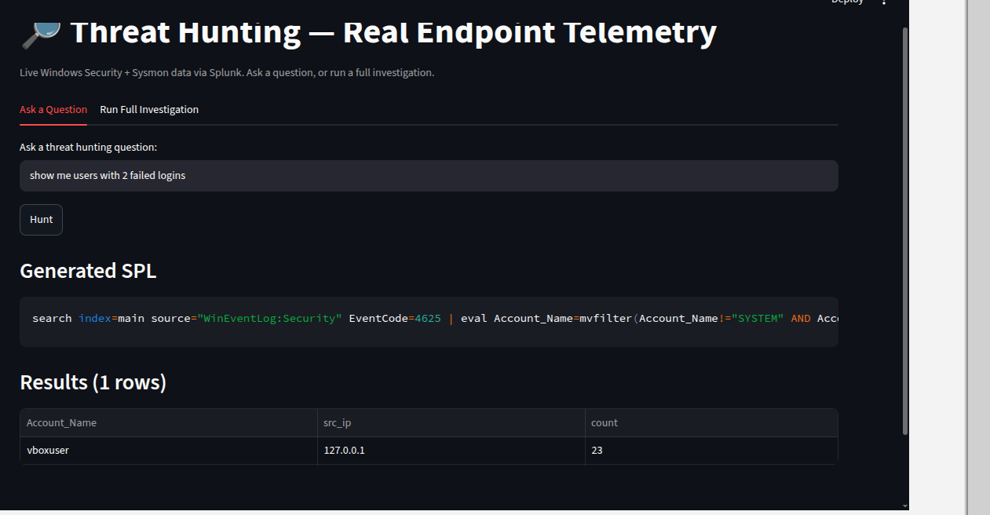
Figure 22: A real, live query result: 23 genuine failed login attempts for the account 'vboxuser' from 127.0.0.1, retrieved directly from the Windows Security Event Log via the natural-language interface.
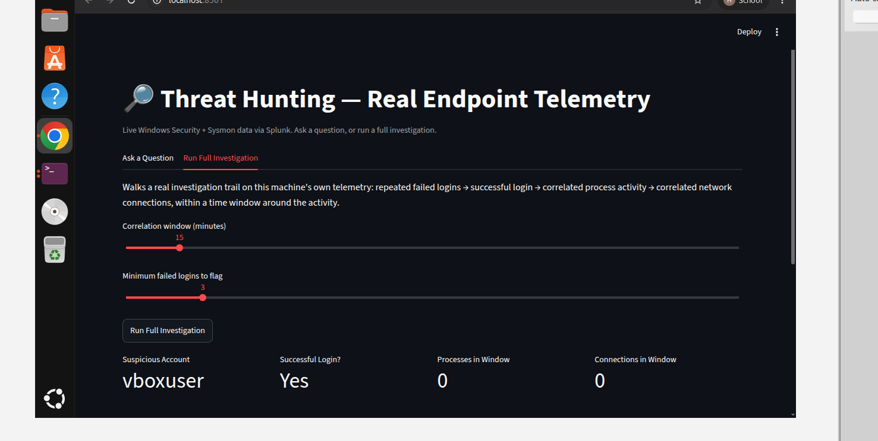
Figure 23: The automated investigation chain run against real data, correctly identifying 'vboxuser' as the account of interest and confirming a subsequent successful login, with zero correlated process or network events in the surrounding window — itself a valid and honestly reported finding, not every investigation ends in a dramatic result.
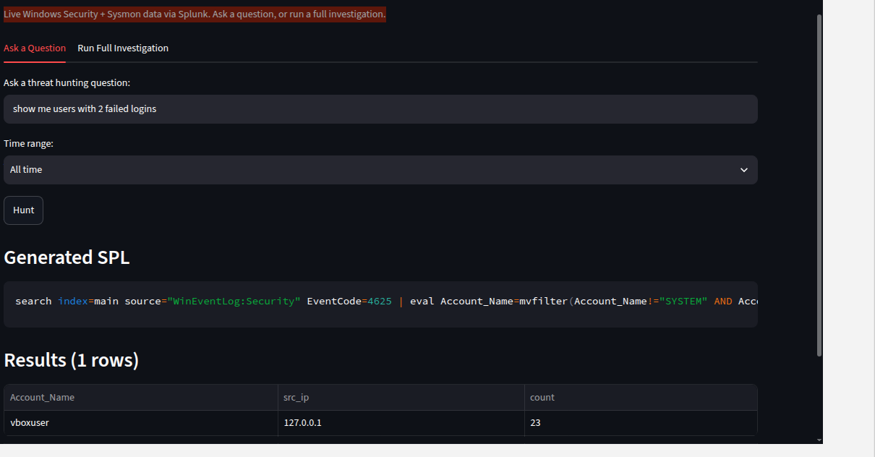
Figure 24: The final validated system: a natural-language question against real Windows Security Event Log data, with a selectable time range, correctly returning the real failed-login pattern.

5. Challenges and Debugging — Lessons Learned
A significant portion of this project's engineering effort went into diagnosing and fixing real bugs, several of which generalize well beyond this specific system. They are documented here individually because each reflects a genuine, non-obvious lesson about building AI-assisted security tooling on top of a real SIEM platform.

5.1 Splunk's Reserved 'host' Field
Splunk reserves the field name “host” for its own internal metadata (the indexing server's hostname). Since the synthetic telemetry schema also used a field literally named “host,” Splunk's own reserved field silently overwrote it on ingestion — every event appeared to originate from the single Splunk server itself, rather than the intended simulated hostnames. This corrupted the multi-step investigation chain's host-correlation logic without producing any error. The fix was to rename the field to “hostname” throughout the data generator, the ingested data, and every downstream query. Lesson: any custom field schema ingested into Splunk must be checked against Splunk's reserved field names before ingestion, not after debugging an unexplained result.

5.2 Multivalue Field Corruption in Windows Security Events
Windows Security Event Log data stores the “Account_Name” field as a multivalue field containing both the real human account and the machine's own service account (e.g. “WIN$”) on the same event. Two distinct bugs followed from this. First, a naive “most failed login attempts” ranking was dominated by the machine account, which is present on nearly every event for background service activity, completely burying the genuine signal. Second, attempting to exclude the machine account with a simple field-inequality filter (Account_Name!=”*$”) excluded the entire event whenever any value in the multivalue field matched, wiping out all results including the genuine ones. The correct fix required Splunk's mvfilter function to clean the multivalue field itself before any event-level filtering was applied. Lesson: multivalue fields require field-level cleaning, not event-level filtering, and this class of bug produces no error message — only silently wrong or missing results.

5.3 Reliability Limits of a Small Local LLM
The 1B-parameter local model was found to be reliable for simple, single-condition query translation (e.g. “find powershell executions”) but unreliable for questions requiring multi-step reasoning (aggregation, grouping, and thresholding), where it would default to a nearby few-shot example rather than genuinely generalizing to the specifics of the question asked — for instance, ignoring an explicitly named host and substituting a username from a training example instead. Two mitigations were applied: routing well-defined question patterns to a deterministic parser rather than the LLM at all, and strengthening the LLM's prompt with an explicit instruction to attend to entities named in the question rather than reusing example values. This is a reproducible, citable limitation of small local models for structured-output generation tasks.

5.4 Splunk's Automatic XML Field Extraction Was Unreliable for Sysmon
Splunk's built-in xmlkv command, expected to automatically extract fields from Sysmon's XML event structure, worked for simple top-level tags (e.g. EventID) but failed silently on Sysmon's attribute-based Data fields (e.g. Name='Image'>value</Data>), returning empty values without any error. The fix was to bypass automatic extraction entirely and use targeted rex (regular expression) extraction against the raw event text for each field individually. Lesson: automatic field extraction should always be spot-checked against a known real value before being trusted as the basis for downstream query logic.

5.5 Environment State Does Not Persist Across Terminal Sessions
A recurring source of confusing, intermittent failures throughout development was the assumption that setup performed in one terminal session (an activated Python virtual environment, an exported environment variable such as the Splunk password, or a manually started background process such as the Ollama server) would still be present in a new terminal window or after a VM restart. Each of these is local to the session that created it. The practical fix was to persist critical state permanently — adding environment variables to the shell's startup file and registering the Ollama service to start automatically — rather than relying on manual re-setup each session.

6. Results Summary
Synthetic data validation | Planted lateral-movement scenario correctly and fully recovered via the automated investigation chain (Figure 17, Figure 19).
Real data validation | Real disguised executable discovered (Figure 20); real repeated-failed-login pattern (23 attempts, single account) correctly identified via natural language (Figure 22, Figure 24).
Query translation reliability | 100% for regex-matched patterns; LLM fallback improved materially after prompt strengthening (Figure 16), though remains a known limitation for complex multi-step questions.
Safety | All LLM-generated queries validated against a destructive-command blocklist before execution.
Cost | Entirely free/open-source stack: Splunk free trial, Ollama + Llama 3.2 (1B), Streamlit, Python.

7. Limitations and Future Work
- The LLM fallback path, while improved, remains less reliable than the deterministic parser for genuinely open-ended, multi-step questions; a larger local model (e.g. an 8B-parameter model) or a cloud-hosted model would likely improve this at the cost of speed, privacy, or cost.
- The multi-step investigation chain currently follows a fixed, hardcoded sequence of steps rather than reasoning dynamically about what to investigate next; a genuinely agentic version would use the LLM itself to decide the next investigative action based on prior findings (a ReAct-style reasoning loop), rather than following a fixed script.
- Validation was performed against a single monitored endpoint; extending to multiple hosts (via the Splunk Universal Forwarder on additional machines) would allow testing genuine host-to-host lateral movement detection rather than single-host time correlation.
- The safety guardrail currently uses a fixed blocklist of dangerous SPL commands; a more robust approach might use a permit-list of allowed search patterns instead.

8. Conclusion
This project demonstrates that a hybrid natural-language query translation approach — deterministic rules for well-defined patterns, backed by a small local LLM for open-ended questions — can reliably convert plain-English threat hunting questions into real, safe, executable Splunk queries, and that the same approach can be extended into a multi-step automated investigation that recovers a full attack narrative without manual analyst effort. Critically, the system was validated not only against controlled synthetic data but against real, live endpoint telemetry, where it surfaced genuine findings and exposed real, non-obvious engineering challenges — reserved-field collisions, multivalue-field corruption, small-model reliability limits, and unreliable automatic field extraction — that are documented here as reusable lessons for anyone building similar AI-assisted SOC tooling on top of a production SIEM platform.

