Cover Page
Dedication
Acknowledgments
Abstract
Résumé

Keywords
Table of Contents
List of Figures
List of Tables
List of Acronyms

Table des matières
Generale Intro should be indepandant (and structure of the thesis)and context generale de project should be indepandant 7
Chapter 1 General Introduction & Problem Statement 7
1.1 Background and Context 7
1.2 Motivation 8
1.3 Problem Statement 9
1.4 Aim of the Study 10
1.5 Research Objectives 10
1.5.1 Architectural Objectives 10
1.5.2 Security Objectives 11
1.5.3 Automation and DevSecOps Objectives 11
1.5.4 Intelligence and Monitoring Objectives 11
1.6 Research Questions 11
1.7 Scope and Delimitations 12
1.8 Methodological Approach 13
1.9 Structure of the Thesis 14
Chapter 2 – State of the Art & Related Work 16
2.1 Introduction 16
2.2 Edge Computing Architectures 16
2.2.1 Data Plane and Control Plane Separation 16
2.2.2 Hybrid Edge–Cloud Orchestration Models 17
2.2.3 Relevance to the Proposed Research 18
2.3 Cloud Monitoring and Observability Systems 18
2.3.1 Log-Centric Observability: The ELK Stack Model 19
2.3.2 Metric-Based Monitoring and Time-Series Observability 20
2.3.3 Observability Challenges in Edge–Cloud IaaS Environments 20
2.3.4 Relevance to the Proposed Research Framework 20
2.4 DevSecOps and Infrastructure Automation 21
2.4.1 DevSecOps Lifecycle Integration 21
2.4.2 Infrastructure-as-Code (IaC) in IaaS Environments 22
2.4.3 Security-by-Design and Continuous Compliance 22
2.4.4 Limitations of Current DevSecOps Implementations in Edge–Cloud Contexts 23
2.4.5 Relevance to the Proposed Research 23
2.5 AI/ML in Cybersecurity and Anomaly Detection 23
2.5.1 Real-Time and Historical AI-Based Detection Frameworks 24
2. Historical Learning Pipeline 24
2.5.2 Supervised and Unsupervised Learning Paradigms 25
2.5.3 Challenges of AI Integration in Edge–Cloud Environments 26
2.5.4 Relevance to the Research Objectives 26
2.6 Comparative Analysis of Existing Solutions 26
2.6.1 Evaluation Criteria 27
2.6.2 Comparative Evaluation of Representative Solutions 27
2.6.3 Gap-Oriented Architectural Matrix 28
2.6.4 Synthesis and Strategic Implications 29
2.7 Research Gaps and Limitations of Current Approaches 30
2.7.1 Lack of Unified Edge–Cloud Security Architecture 30
2.7.2 Centralized Dominance of AI-Based Anomaly Detection 30
2.7.3 Weak Integration Between DevSecOps and Runtime AI Feedback 31
2.7.4 Fragmented Observability and Intelligence Layers 31
2.7.5 Absence of Symmetrical Data and Control Plane Separation in Distributed IaaS 31
2.7.6 Identified Research Gap 32
2.7.7 Research Direction and Contribution Positioning 32
2.8 Chapter Conclusion 32
Chapter 3 – Proposed Architecture & System Design 34
3.1 Design Objectives and System Requirements 34
3.1.1 Architectural Context and Design Rationale 34
3.1.2 Architectural Design Objectives 34
3.2 System Context and Actors 35
3.2.1 System Boundary Definition 35
3.2.2 Actors Identification and Roles 36
3.2.3 Use Case Overview 38
3.3 High-Level Architecture Overview 40
3.3.1 Global System Architecture 41
3.3.2 Real-Time Telemetry Processing Pipeline 42
3.4 Layered Architectural Model 44
3.4.1 Edge Infrastructure Layer 45
3.4.2 Cloud Infrastructure Layer 45
3.4.3 Control and Orchestration Layer 46
3.4.4 Observability and Telemetry Layer 46
3.4.5 AI/ML Intelligence Layer 46
3.4.6 DevSecOps Automation Layer 46
3.4.7 Security Enforcement Layer 47
3.5 Observability and Monitoring Convergence 47
3.6 Distributed AI Architecture 49
3.6.1 Cloud AI Training and Model Management 49
3.6.2 Secure Model Distribution 50
3.6.3 Edge AI Inference Environment 51
3.6.4 Adaptive Learning and Model Feedback 51
3.7 Security Architecture and Trust Model 52
3.7.1 Trust Boundaries in the Edge–Cloud Architecture 53
3.7.1 Trust Boundaries in the Edge–Cloud Architecture 54
3.7.3 Identity and Access Management 55
3.7.4 Threat Detection and Response Lifecycle 55
3.8 DevSecOps and Automation Integration 56
3.8.2 Continuous Integration and Security Validation 58
3.8.3 Automated Deployment Across Edge and Cloud 58
3.8.4 Runtime Feedback and Adaptive Pipeline Improvement 59
3.9 UML Formal Modeling 59
3.9.1 Use Case Diagram 60
3.9.2 Component Diagram 61
3.9.3 Deployment Diagram 61
3.9.4 Sequence Diagram – Telemetry Flow 62
3.9.5 Sequence Diagram – AI Pipeline 63
3.9.6 Activity Diagram 64
3.10 Scalability and Resilience Engineering 66
3.10.1 Horizontal Scaling 66
3.10.2 Fault Tolerance and Failover 67
3.10.3 High Availability Strategy 67
3.10.4 Link to Implementation (bridge sentence) 67
3.11 Architectural Contribution Mapping 67
3.12 Chapter Conclusion 68
Chapter 4 – Implementation & Technical Realization 69
4.1 Environment Setup 70
4.2 Cloud Infrastructure Deployment 75
4.2.1 Container Runtime Deployment 75
4.2.2 OpenStack IaaS Platform — Kolla-Ansible Deployment 75
4.2.3 ELK Stack Deployment — Centralized Log Management 77
4.2.4 Wazuh Manager Deployment — Security Information and Event Management 79
4.2.5 Kafka Message Broker Deployment 80
4.2.6 Cloud Infrastructure Deployment Summary 80
4.3 Edge Gateway 81
4.3.1 Container Runtime Deployment on the Edge Node 81
4.3.2 Sample Service Deployment — Workload Simulation 81
4.3.3 Log Collection and Forwarding — Filebeat Pipeline 82
4.3.4 Metrics Collection — Metricbeat Deployment 82
4.3.5 Security Monitoring — Wazuh Agent Enrollment 83
4.3.6 Observability Stack — Prometheus and Node Exporter 84
4.3.7 Edge Gateway Deployment Summary 85
4.4 Observability and Security Integration 86
4.4.1 WireGuard VPN — Secure Edge–Cloud Communication Channel 86
4.4.2 Elasticsearch Authentication 88
4.4.3 Grafana Deployment and System Metrics Dashboard 89
4.4.4 Grafana Alerting Rules Configuration 90
4.4.5 Kibana Log Analytics Dashboard 91
4.4.6 Docker Container Metrics Dashboard 92
4.4.7 Security Analytics Dashboard and Wazuh Alert Visualization 92
4.4.8 Security Event Discovery and Forensic Analysis 93
4.4.9 Automated Security Alert Ingestion Pipeline 94
4.4.10 Observability Integration Summary 95
4.5 DevSecOps and Infrastructure Automation 95
4.5.1 Infrastructure-as-Code with Kolla-Ansible 96
4.5.2 Configuration Management and Version Control 96
4.5.3 Kafka Message Broker Integration 97
4.5.4 Automated Security Alert Ingestion Pipeline 98
4.5.5 Continuous Monitoring Automation 98
4.5.6 DevSecOps Implementation Summary 99
4.6 AI-Based Anomaly Detection 99
4.6.1 Dataset Preparation and Feature Extraction 100
4.6.2 Anomaly Generation and Labeling Erreur ! Signet non défini.
4.6.3 Model Implementation — Isolation Forest Erreur ! Signet non défini.
4.6.4 Model Evaluation and Performance Metrics 103
4.6.5 Integration with the Observability Platform 105
4.6.6 AI Pipeline Summary 106
4.7 System Validation and End-to-End Testing 107
4.7.1 Telemetry Pipeline Validation 107
4.7.2 Security Detection Validation 108
4.7.3 End-to-End Data Flow Verification 109
4.7.4 Chapter Conclusion 111
Chapter 5 – Results, Evaluation & Discussion 112
5.1 Experimental Setup 112
5.2 Performance Evaluation 112
5.3 Security Evaluation 112
5.4 AI Model Evaluation 112
5.5 Scalability Discussion 112
5.6 Comparison with Existing Solutions 112
5.7 Limitations 112
Chapter 6 – Project Management & Methodology 113
6.1 Project Management Approach 113
6.1.1 Agile Methodology Selection 113
6.1.2 Scrum Adaptation for Research Context 113
6.2 Sprint Planning 114
6.3 Gantt Chart and Milestone Planning 118
6.4 Task Management Using Trello 119
6.5 Risk Management 120
Conclusion & Future Work 122
7.1 Summary of Contributions 122
7.2 Key Achievements 122
7.3 Limitations 122
7.4 Future Improvements 122

Generale Intro should be indepandant (and structure of the thesis)and context generale de project should be indepandant

Chapter 1 General Introduction & Problem Statement

1.1 Background and Context
The rapid digital transformation of enterprises has fundamentally reshaped the way information systems are designed, deployed, and managed. Organizations increasingly rely on distributed computing environments to support mission-critical applications, real-time services, and data-intensive operations. In this evolving landscape, traditional centralized IT infrastructures have gradually given way to cloud-based and hybrid architectures that emphasize scalability, elasticity, and service abstraction.
Among the cloud service models, Infrastructure as a Service (IaaS) has emerged as a foundational paradigm. IaaS enables organizations to provision virtualized computing resources—including virtual machines, storage, and networking on demand, thereby reducing capital expenditure and enhancing operational flexibility. By abstracting physical infrastructure into programmable resources, IaaS environments facilitate rapid deployment, dynamic scaling, and improved resource utilization. However, this abstraction also introduces new layers of complexity in terms of orchestration, monitoring, security management, and governance.
Simultaneously, the proliferation of connected devices, edge nodes, and geographically distributed enterprise branches has accelerated the adoption of Edge computing paradigms. Edge computing shifts certain processing and data-handling operations closer to the source of data generation, thereby reducing latency, conserving bandwidth, and enabling localized decision-making. When combined with cloud-based IaaS platforms, Edge-Cloud architectures offer a hybrid model in which computation and storage are intelligently distributed across multiple layers of the infrastructure.
Despite these advancements, the integration of Edge environments with centralized IaaS-based cloud infrastructures presents significant technical and security challenges. Enterprise systems generate vast volumes of logs, metrics, and operational telemetry that must be collected, transmitted, stored, and analyzed securely. The fragmentation of data across distributed nodes often leads to limited visibility, delayed incident detection, and difficulties in maintaining consistent security policies across environments. Moreover, as infrastructures scale dynamically within IaaS ecosystems, traditional manual management approaches become insufficient and error-prone.
In response to these challenges, contemporary infrastructure management increasingly incorporates principles from DevSecOps, automation frameworks, and intelligent analytics. Automation tools enable reproducible deployments and configuration management, while integrated security practices aim to embed protection mechanisms throughout the infrastructure lifecycle. Furthermore, Artificial Intelligence and Machine Learning techniques are progressively being adopted to enhance anomaly detection, predictive maintenance, and threat identification within complex distributed systems.
Within this context, there is a growing need for a secure, automated, and intelligent architecture capable of managing distributed enterprise infrastructures operating across Edge and IaaS-based cloud layers. Such an architecture must ensure secure data synchronization, maintain clear separation between control and data planes, enable centralized observability, and leverage AI-driven insights for proactive monitoring.
This study is situated at the intersection of IaaS cloud computing, Edge architectures, cybersecurity engineering, and intelligent infrastructure management. It aims to contribute to the ongoing evolution of secure and scalable distributed systems by proposing a structured framework that integrates automation, security-by-design principles, and AI-enhanced operational intelligence.

1.2 Motivation
While Infrastructure as a Service (IaaS) and Edge computing have significantly enhanced scalability and operational flexibility, their convergence has also introduced new layers of architectural, operational, and security complexity. Modern enterprises increasingly operate within hybrid and distributed infrastructures, where computational resources are dynamically provisioned in cloud environments while critical data is simultaneously generated at geographically dispersed Edge nodes. This distributed paradigm, although powerful, creates substantial challenges in maintaining unified visibility, consistent security enforcement, and coordinated infrastructure management.
One of the principal concerns lies in the management of operational telemetry and security logs. In large-scale IaaS environments, logs are generated continuously by virtual machines, containers, network components, and hypervisors. At the Edge layer, additional streams of data originate from local devices and branch systems. The absence of an integrated framework capable of securely aggregating, preprocessing, and intelligently analyzing these distributed data sources often results in fragmented monitoring, delayed incident response, and increased exposure to cyber threats.
Furthermore, the dynamic and elastic nature of IaaS infrastructures complicates traditional monitoring and security strategies. Resources are provisioned and decommissioned automatically, workloads migrate across nodes, and configurations evolve continuously. Manual management approaches are therefore insufficient and prone to human error. Without automated orchestration and infrastructure-as-code practices, organizations struggle to ensure reproducibility, policy consistency, and secure configuration management across distributed environments.
From a security perspective, the expansion of the attack surface across Edge and cloud layers intensifies the need for robust protection mechanisms. Data must be transmitted securely between layers, control channels must be isolated from operational data flows, and access must be governed by strict authentication and authorization frameworks. Simultaneously, reactive security measures are no longer adequate in environments characterized by high data velocity and complex interdependencies. There is a growing demand for proactive, intelligent systems capable of detecting anomalies, predicting potential failures, and identifying emerging threats in near real time.
In this context, Artificial Intelligence and Machine Learning technologies offer promising capabilities for augmenting infrastructure intelligence. However, their integration into distributed Edge–Cloud ecosystems remains fragmented and often limited to centralized Security Operations Center (SOC) deployments, without fully leveraging localized Edge preprocessing or automated DevSecOps pipelines.
The motivation of this research therefore stems from the need to design a coherent architectural framework that unifies Edge computing, IaaS-based cloud infrastructures, automation principles, and AI-driven analytics within a secure-by-design model. By addressing the gaps between distributed data generation, centralized management, and intelligent threat detection, this study seeks to contribute to the development of resilient, scalable, and security-oriented infrastructure management systems suitable for contemporary enterprise environments.

1.3 Problem Statement
Despite the widespread adoption of Infrastructure as a Service (IaaS) platforms and the growing integration of Edge computing paradigms, organizations continue to face significant challenges in achieving secure, scalable, and intelligent management of distributed enterprise infrastructures. While cloud providers offer elastic resource provisioning and centralized control mechanisms, and Edge computing enables localized processing and reduced latency, the coordination between these layers remains architecturally fragmented and operationally complex.
In contemporary enterprise environments, vast volumes of operational data—including system logs, network traffic records, performance metrics, and security events—are generated continuously across virtualized cloud instances and geographically distributed Edge nodes. However, these data streams are often collected and processed using heterogeneous tools that lack unified orchestration, consistent security enforcement, and intelligent analytical capabilities. As a result, organizations struggle with limited end-to-end visibility, delayed anomaly detection, and increased vulnerability to misconfigurations and cyber threats.
Moreover, the dynamic nature of IaaS ecosystems exacerbates this problem. Virtual machines and containerized workloads are frequently instantiated, migrated, or terminated in response to changing demands. Without automated configuration management and integrated DevSecOps practices, maintaining security compliance and operational consistency becomes increasingly difficult. Traditional monitoring systems, designed primarily for static infrastructures, are insufficient to cope with the elasticity and distributed complexity of modern Edge–Cloud architectures.
A further limitation resides in the centralized design of most security analytics solutions. Existing Security Information and Event Management (SIEM) platforms and monitoring frameworks typically rely on cloud-centric aggregation models, which may introduce latency, bandwidth overhead, and single points of failure. Additionally, many implementations incorporate Artificial Intelligence or Machine Learning mechanisms only at the centralized layer, neglecting the potential benefits of localized preprocessing and distributed intelligence at the Edge.
Consequently, there exists a critical need for an integrated architectural framework that:
- Ensures secure and encrypted synchronization between Edge and IaaS cloud layers;
- Maintains a clear separation between data and control planes;
- Embeds automation and configuration management across the infrastructure lifecycle;
- Enables centralized visibility without sacrificing distributed processing efficiency;
- Incorporates AI-driven anomaly detection within a coherent, security-oriented design.
The core problem addressed in this study can therefore be articulated as follows:
How can a secure, automated, and AI-enhanced Edge–Cloud architecture be designed and implemented within an IaaS environment to ensure scalable, resilient, and intelligent management of distributed enterprise infrastructures?
By formally defining this problem, the study positions itself at the intersection of cloud infrastructure engineering, cybersecurity architecture, DevSecOps automation, and intelligent systems design. The subsequent chapters will explore how the proposed framework seeks to address this multidimensional challenge through a structured and experimentally validated approach.

1.4 Aim of the Study
Building upon the challenges identified in the preceding sections, the primary aim of this study is to conceptualize, design, and implement a secure, automated, and intelligent Edge–Cloud architecture operating within an Infrastructure as a Service (IaaS) environment for the effective management of distributed enterprise infrastructures.
The proposed architecture seeks to unify Edge computing capabilities with centralized cloud-based orchestration mechanisms, enabling secure data aggregation, scalable infrastructure supervision, and proactive anomaly detection. By integrating automation frameworks aligned with DevSecOps principles, the study aims to ensure reproducible deployment, configuration consistency, and security-by-design practices across both Edge and cloud layers.
Furthermore, this research intends to embed Artificial Intelligence and Machine Learning techniques within the monitoring and security workflow, thereby transforming traditional reactive infrastructure management into a predictive and adaptive model. Through intelligent log analysis, anomaly detection, and risk assessment mechanisms, the proposed framework aspires to enhance operational visibility, strengthen threat detection capabilities, and improve overall system resilience.
More specifically, the study aims to:
- Establish a coherent architectural model that clearly separates control and data planes while ensuring secure synchronization between distributed components;
- Demonstrate the feasibility of integrating Edge preprocessing with centralized IaaS-based analytics;
- Implement automation and orchestration strategies to support scalable and maintainable infrastructure deployment;
- Validate the effectiveness of AI-driven monitoring in detecting anomalies and supporting proactive decision-making.
Ultimately, the aim of this research is not merely to develop a technical prototype, but to propose a structured and reproducible framework that contributes to the advancement of secure and intelligent infrastructure management within modern Edge–Cloud ecosystems.

1.5 Research Objectives
In order to achieve the overarching aim of designing and implementing a secure, automated, and intelligent Edge–Cloud architecture within an Infrastructure as a Service (IaaS) environment, this study is guided by the following structured research objectives:

1.5.1 Architectural Objectives
- To design a scalable Edge–Cloud architectural model that integrates localized Edge processing with centralized IaaS-based management.
- To establish a clear separation between the Data Plane (logs, telemetry, traffic flows) and the Control Plane (orchestration, monitoring, configuration management).
- To ensure secure and efficient synchronization between distributed Edge nodes and the cloud layer.
- To define trust boundaries and communication flows within a security-oriented architectural framework.

1.5.2 Security Objectives
- To implement encrypted communication channels between Edge and cloud components.
- To integrate authentication, authorization, and access control mechanisms aligned with security best practices.
- To incorporate monitoring and detection mechanisms capable of identifying anomalous or malicious activity.
- To reduce potential attack surfaces through infrastructure hardening and automated configuration management.

1.5.3 Automation and DevSecOps Objectives
- To deploy infrastructure components using automation tools based on Infrastructure-as-Code principles.
- To ensure reproducibility, scalability, and maintainability of system configurations.
- To embed security controls throughout the deployment lifecycle in accordance with DevSecOps methodologies.
- To minimize manual intervention in configuration and monitoring processes.

1.5.4 Intelligence and Monitoring Objectives
- To collect and preprocess operational data at the Edge layer prior to centralized aggregation.
- To design and implement AI/ML-based anomaly detection models for infrastructure monitoring.
- To evaluate the effectiveness of predictive analytics in improving threat detection and system reliability.
- To provide centralized dashboards offering real-time visibility into infrastructure health and security status.
Collectively, these objectives provide a structured roadmap for addressing the research problem. They ensure that the study remains aligned with its strategic aim while maintaining a balance between architectural rigor, security engineering, automation practices, and intelligent analytics.

1.6 Research Questions
In alignment with the identified problem and research objectives, this study seeks to address the following central research question:
How can a secure, automated, and AI-enhanced Edge–Cloud architecture be designed and implemented within an IaaS environment to ensure scalable, resilient, and intelligent management of distributed enterprise infrastructures?
To systematically explore this central question, the study is further guided by the following sub-questions:
Architectural Dimension
- How can Edge computing and IaaS-based cloud infrastructures be structurally integrated to achieve coherent and scalable distributed management?
- What architectural principles are required to ensure effective separation between control and data planes while maintaining secure synchronization?
Security Dimension
- Which security mechanisms and design strategies are essential to protect data transmission, access control, and infrastructure integrity across Edge–Cloud layers?
- How can security-by-design principles be embedded into automated infrastructure deployment processes?
Automation and DevSecOps Dimension
- To what extent can automation and Infrastructure-as-Code approaches improve reproducibility, consistency, and security compliance in distributed environments?
- How can DevSecOps practices enhance resilience and reduce configuration-related vulnerabilities within dynamic IaaS ecosystems?
Intelligence and Monitoring Dimension
- How can Artificial Intelligence and Machine Learning techniques be effectively integrated into distributed monitoring workflows?
- What is the measurable impact of AI-driven anomaly detection on infrastructure visibility, threat detection accuracy, and operational efficiency?
Evaluation Dimension
- Which performance, security, and scalability metrics are most appropriate for evaluating the effectiveness of the proposed architecture?
These research questions establish a structured analytical framework for the study. They ensure that the proposed architecture is not merely implemented, but critically examined in terms of security robustness, automation efficiency, scalability, and intelligent monitoring capabilities.

1.7 Scope and Delimitations
The scope of this project is deliberately focused and manageable to ensure feasibility at the master’s level while maintaining a strong research component:
- The project will be conducted using a simulated or small-scale cloud environment (e.g., OpenStack or Docker-based simulation) rather than a full-scale enterprise deployment.
- Only selected automation tools (such as Ansible) will be employed to simplify implementation and reduce complexity.
- AI/ML integration will be limited to basic anomaly detection models, rather than implementing a complete enterprise-level SOC.
- The study will focus primarily on architecture design, security mechanisms, monitoring, and AI integration, excluding web application development or the full complexity of multi-tenant SaaS platforms.
These delimitations allow the project to remain feasible, focused, and academically rigorous, while still addressing key challenges in Edge-Cloud security, infrastructure management, and AI-driven monitoring.

1.8 Methodological Approach
This study adopts a Design Science Research (DSR) methodology, a structured research paradigm particularly suited for engineering-oriented investigations that aim to design, implement, and evaluate innovative artifacts addressing identified systemic problems. Within this framework, the proposed Edge–Cloud architecture is treated as a research artifact intended to resolve the architectural fragmentation identified in Chapter 2.
The methodological process follows six structured phases:
Phase 1 – Problem Identification and Gap Analysis
A systematic literature review and comparative architectural analysis (Chapter 2) were conducted to identify structural deficiencies in existing Edge–Cloud security frameworks, DevSecOps automation models, and AI-driven anomaly detection systems. This phase resulted in the formal research gap articulated in Section 2.7.
Phase 2 – Definition of Research Objectives
Based on the identified gap, structured architectural, security, automation, and intelligence objectives were defined (Section 1.5). These objectives translate the research problem into measurable design constraints and guide the architectural synthesis process.
Phase 3 – Artifact Design and Formal Modeling
A unified Edge–Cloud IaaS architecture was conceptualized and formalized in Chapter 3. The proposed design integrates:
- Explicit Data/Control Plane separation
- Distributed AI inference with centralized model governance
- DevSecOps lifecycle convergence
- Observability and telemetry harmonization
- Zero-trust security enforcement mechanisms
Architectural coherence is validated structurally through formal modeling techniques, including:
- Requirement Traceability Matrix (RTM)
- UML formal diagrams
- Layered architectural decomposition
- Gap-to-solution contribution mapping

Phase 4 – Prototype Implementation
A controlled experimental prototype is implemented to validate architectural feasibility. The implementation environment includes:
- OpenStack-based cloud simulation
- Ubuntu-based Edge nodes
- Infrastructure-as-Code (Ansible)
- Monitoring stack integration (ELK / Prometheus)
- AI/ML-based anomaly detection models
The objective of this phase is not full-scale enterprise replication but architectural validation under controlled and reproducible conditions.
Phase 5 – Experimental Evaluation and Validation
The artifact is evaluated using quantitative and qualitative metrics aligned with the defined research objectives. Evaluation criteria include:
- Detection latency (Edge vs centralized processing)
- Anomaly detection performance (Precision, Recall, F1-score)
- Telemetry ingestion throughput
- Control-plane availability and resilience
- Automated remediation responsiveness
Where applicable, comparative analysis is conducted against centralized architectural paradigms identified in Chapter 2 to demonstrate structural and operational improvements.
Phase 6 – Contribution Analysis
The final phase assesses how the proposed architecture addresses previously identified limitations. This is formalized through structured contribution mapping (Section 3.12), linking research gaps to implemented architectural components and validating systemic coherence.

1.9 Structure of the Thesis
To provide a coherent and systematic exploration of the proposed Edge–Cloud architecture for secure and intelligent infrastructure management, this thesis is organized into the following chapters:
- Chapter 1 – Introduction: Establishes the background, motivation, and rationale for the study. It presents the problem statement, aim, objectives, research questions, and the scope and delimitations of the project, setting a solid foundation for the investigation.
- Chapter 2 – Existing Solutions and Comparative Analysis: Examines current approaches, tools, and architectures in distributed infrastructure monitoring, cloud security, and Edge computing. This chapter provides a critical comparative analysis to identify strengths, limitations, and gaps that the proposed solution aims to address.
- Chapter 3 – Proposed Solution and System Design: Details the conceptual design of the Edge–Cloud platform, including the architecture, key components, functional modules, security measures, AI/ML integration, and automation mechanisms. This chapter also includes user stories, system actors, and UML diagrams to formalize the system’s structure and interactions.
- Chapter 4 – Implementation: Describes the practical realization of the proposed solution, including the configuration of Edge devices, cloud environment setup, deployment of containers, automation workflows, and integration of monitoring and AI modules.
- Chapter 5 – Results and Evaluation: Presents the outcomes of the implementation, including system performance, anomaly detection accuracy, and operational efficiency. This chapter evaluates the effectiveness of the platform against the research objectives and discusses insights, limitations, and potential improvements.
- Chapter 6 – Project Management and Planning: Documents the project’s organization, including timelines, sprint planning, Gantt charts, and task management using Trello, providing a clear view of the methodological and managerial approach applied throughout the research.
- Chapter 7 – Conclusion and Future Work: Summarizes the contributions of the thesis, reflects on the research findings, and proposes directions for future work, particularly in advanced AI-enabled security, scalable Edge–Cloud architectures, and potential integration into real-world enterprise infrastructures.
This structured approach ensures a logical progression from conceptual foundations to practical implementation and evaluation, providing a comprehensive framework for investigating secure and intelligent distributed infrastructure management within an IaaS context.

Chapter 2 – State of the Art & Related Work

2.1 Introduction
Building upon the problem definition and research objectives established in Chapter 1, this chapter critically examines existing architectural models, technological frameworks, and research contributions related to Edge computing, cloud-based Infrastructure-as-a-Service (IaaS) environments, distributed monitoring, automation practices, and AI-driven security analytics.
The purpose of this chapter is threefold. First, it establishes a theoretical and technical foundation for understanding contemporary Edge–Cloud architectures. Second, it analyzes current industrial and academic solutions addressing distributed infrastructure management. Third, it identifies architectural, operational, and security limitations that justify the need for the integrated framework proposed in this study.
By situating the research within the broader landscape of state-of-the-art technologies, this chapter ensures that the proposed architecture is grounded in established principles while addressing clearly identified gaps in existing approaches.

2.2 Edge Computing Architectures
The rapid expansion of distributed enterprise systems has led to the emergence of Edge computing as a complementary paradigm to centralized cloud infrastructures. Within IaaS ecosystems, Edge architectures aim to reduce latency, optimize bandwidth consumption, and enable localized processing of operational telemetry, security logs, and device-generated data.
Unlike traditional centralized models, Edge architectures introduce additional layers of computation and control, often requiring a structured separation between operational data flows and orchestration mechanisms. This separation is particularly relevant in secure infrastructure management, where control logic must remain isolated from high-volume telemetry streams.

2.2.1 Data Plane and Control Plane Separation
A widely adopted architectural principle in modern distributed systems is the logical separation between:
- Data Plane – responsible for processing operational data, telemetry, logs, and device traffic.
- Control Plane – responsible for orchestration, configuration management, policy enforcement, and centralized monitoring.
This separation enhances scalability, strengthens security boundaries, and reduces systemic risk by isolating management functions from raw data flows.
A representative industrial implementation of this model is illustrated in:
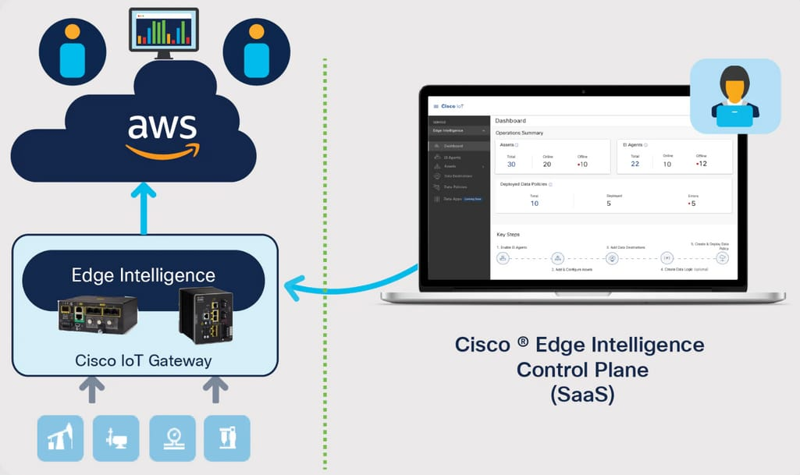
Figure 2.1: Cisco Edge Intelligence Architecture
Data Plane / Control Plane Separation (SaaS Model).
In this architecture, Edge gateways locally process and aggregate device-generated data (Data Plane), while a cloud-hosted SaaS Control Plane manages orchestration, dashboards, and centralized policy configuration. The architectural design clearly delineates operational telemetry from management interfaces, thereby aligning with best practices in secure distributed system design.
From a research perspective, this model demonstrates how enterprises can maintain centralized visibility while preserving localized processing capabilities. However, it also reveals limitations, including reliance on vendor-specific SaaS ecosystems and constrained extensibility for custom AI-driven analytics at the Edge layer.

2.2.2 Hybrid Edge–Cloud Orchestration Models
Another dominant architectural pattern integrates containerized workloads at the Edge with centralized cloud orchestration platforms. This approach leverages container registries and message hubs to synchronize Edge modules with cloud services.
A prominent example is illustrated in:

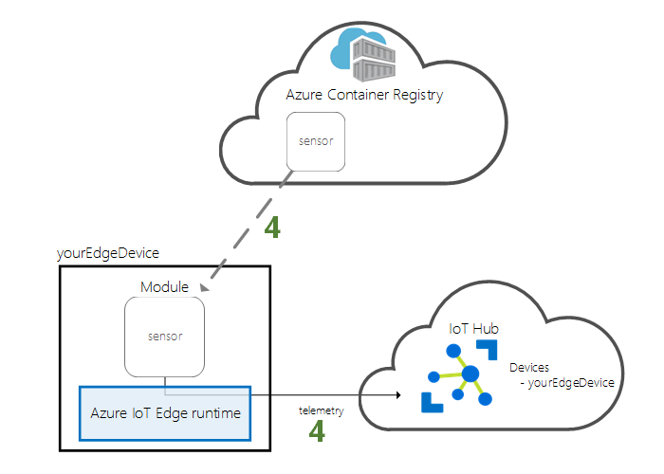
Figure 2.2: Microsoft Azure IoT Edge Architecture
Edge Device, IoT Hub, and Azure Container Registry Integration.
This architecture consists of:
- Edge Device running an Edge runtime capable of hosting containerized modules.
- IoT Hub, acting as a secure bidirectional communication gateway between devices and the cloud.
- Azure Container Registry, providing version-controlled container images deployed to Edge modules.
This model enables dynamic deployment of analytics services, monitoring agents, and AI modules directly at the Edge, while maintaining centralized lifecycle management through the cloud. It reflects a scalable and modular approach consistent with DevSecOps practices and Infrastructure-as-Code methodologies.
From an architectural standpoint, this framework demonstrates how container orchestration can extend IaaS principles to geographically distributed Edge nodes. Nevertheless, similar to other cloud-centric models, intelligence and analytics capabilities are often primarily centralized, limiting the full exploitation of distributed preprocessing and localized anomaly detection.

2.2.3 Relevance to the Proposed Research
The architectures presented in Figures 2.1 and 2.2 illustrate two complementary but incomplete solutions:
- Cisco emphasizes clear plane separation and SaaS orchestration.
- Azure emphasizes containerized Edge deployment and cloud synchronization.
However, neither model fully integrates:
- Security-by-design automation across both layers,
- Unified AI-enhanced monitoring pipelines,
- Explicit DevSecOps-driven infrastructure reproducibility within an IaaS-focused research framework.
Therefore, while these architectures provide valuable industrial references, they also expose the architectural fragmentation and partial integration challenges highlighted in Chapter 1. These limitations directly motivate the need for the structured, secure, and AI-enhanced Edge–Cloud framework proposed in this thesis.

2.3 Cloud Monitoring and Observability Systems
The increasing complexity of distributed Edge–Cloud infrastructures within IaaS environments has elevated monitoring from a purely operational concern to a strategic architectural requirement. Modern enterprise systems generate continuous streams of logs, metrics, traces, and security events across virtual machines, containers, hypervisors, network devices, and Edge gateways. Ensuring coherent visibility across these heterogeneous components requires robust observability frameworks capable of scalable ingestion, secure storage, and intelligent analysis.
Traditional monitoring tools, originally designed for static on-premises infrastructures, are insufficient for elastic and dynamically orchestrated IaaS ecosystems. In cloud-native and Edge-augmented environments, observability must satisfy several critical properties:
- Scalability to handle high-volume telemetry streams
- Real-time or near-real-time processing
- Secure transmission and storage of sensitive logs
- Integration with automation and DevSecOps workflows
- Support for advanced analytics and anomaly detection
Within this context, centralized log aggregation platforms and metric-based monitoring systems have emerged as dominant architectural approaches.

2.3.1 Log-Centric Observability: The ELK Stack Model
One of the most widely adopted log aggregation and analysis frameworks is the ELK Stack, composed of:
- Logstash – log ingestion and transformation pipeline
- Elasticsearch – distributed indexing and search engine
- Kibana – visualization and dashboard interface
This architecture is illustrated in:
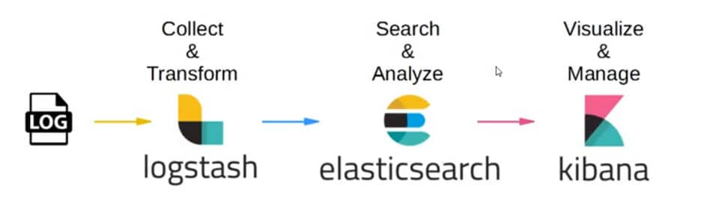
Figure 2.3: Generic ELK Stack Architecture
In this model, logs generated by distributed infrastructure components (Edge devices, VMs, containers, firewalls, IDS/IPS systems) are collected and forwarded to Logstash, where they undergo parsing, filtering, and enrichment. The processed data is then indexed within Elasticsearch, enabling high-performance querying and correlation analysis. Kibana provides centralized dashboards, facilitating real-time visualization of infrastructure health, security events, and operational anomalies.
From an architectural standpoint, the ELK model addresses several research objectives defined in Chapter 1:
- It enables centralized visibility across distributed components (Objective 1.5.4).
- It supports security monitoring and anomaly detection workflows (Objective 1.5.2).
- It integrates naturally into automated DevSecOps pipelines (Objective 1.5.3).
However, despite its strengths, the traditional ELK architecture is fundamentally centralized. Logs are typically transmitted from Edge nodes to a cloud-hosted aggregation layer, potentially introducing:
- Increased bandwidth consumption
- Latency in anomaly detection
- Exposure during data transmission
- Single points of analytical concentration
These limitations become more pronounced in geographically distributed Edge–Cloud environments, reinforcing the need for hybrid monitoring approaches that incorporate localized preprocessing before centralized aggregation.

2.3.2 Metric-Based Monitoring and Time-Series Observability
In addition to log-centric models, modern infrastructures frequently employ metric-based monitoring systems such as Prometheus and Grafana. These platforms focus on numerical time-series data (CPU usage, memory consumption, network throughput, service latency) and are particularly effective for performance evaluation and system health tracking.
Metric-based systems provide:
- Lightweight data collection through exporters
- Efficient time-series storage
- Alerting mechanisms based on threshold rules
- Integration with containerized and microservices environments
While these tools excel in operational monitoring, they often lack deep log correlation and security event analysis capabilities unless combined with SIEM or log indexing platforms. Therefore, many enterprise environments adopt hybrid observability stacks that combine log-centric and metric-centric frameworks.

2.3.3 Observability Challenges in Edge–Cloud IaaS Environments
Within distributed IaaS infrastructures augmented by Edge computing, monitoring architectures must overcome additional challenges:
- Data Fragmentation – Telemetry originates from multiple layers (Edge gateways, cloud VMs, containers, network appliances).
- Elastic Infrastructure Dynamics – Resources are provisioned and decommissioned dynamically, complicating static monitoring configurations.
- Security Sensitivity – Logs may contain credentials, IP addresses, or system metadata requiring encryption and access control.
- Scalability Constraints – High ingestion rates can overwhelm centralized systems without preprocessing or filtering mechanisms.
Most existing monitoring architectures treat Edge nodes as passive log forwarders rather than intelligent preprocessing agents. This design choice contradicts the distributed intelligence potential discussed in Section 2.2 and limits the effectiveness of localized anomaly detection.

2.3.4 Relevance to the Proposed Research Framework
The analysis of log-centric and metric-centric observability platforms reveals a structural imbalance in current implementations:
- Monitoring is typically centralized.
- AI/ML integration is often layered on top of centralized SIEM systems.
- Edge preprocessing capabilities are underutilized.
These limitations directly relate to the research problem articulated in Chapter 1, particularly the need for:
- Secure synchronization between Edge and cloud layers
- Distributed preprocessing prior to centralized indexing
- AI-enhanced anomaly detection integrated within the monitoring pipeline
- Automation-aligned observability embedded within DevSecOps practices
Consequently, while platforms such as ELK provide a powerful foundation for centralized observability, they do not inherently resolve the architectural fragmentation between Edge data generation and cloud-based analytics. This gap reinforces the necessity of designing an integrated, security-oriented, and AI-augmented monitoring framework tailored for distributed IaaS ecosystems.

2.4 DevSecOps and Infrastructure Automation
The increasing dynamism of IaaS-based infrastructures and distributed Edge–Cloud environments necessitates a shift from manual configuration practices to automated, reproducible, and security-integrated deployment methodologies. Traditional operational models, characterized by siloed development, operations, and security teams, are incompatible with elastic infrastructures where virtual machines, containers, and network components are continuously instantiated and reconfigured.
DevSecOps emerges as a paradigm that integrates security controls directly into the DevOps lifecycle, embedding protection mechanisms from the earliest design stages through deployment and continuous monitoring. Within distributed IaaS ecosystems, DevSecOps is not merely a development philosophy but a foundational architectural enabler that ensures consistency, scalability, and resilience.

2.4.1 DevSecOps Lifecycle Integration
The DevSecOps model extends the conventional CI/CD pipeline by incorporating automated security validation at every stage of the software and infrastructure lifecycle. This process is illustrated in:
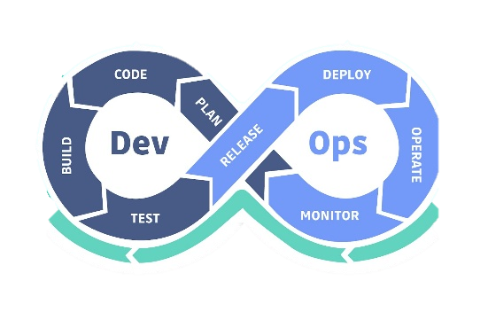
Figure 2.4: DevSecOps Lifecycle Model
The lifecycle includes:
- Plan – Definition of infrastructure requirements, security policies, and compliance constraints.
- Code – Implementation of application logic and Infrastructure-as-Code (IaC) scripts.
- Build – Compilation, containerization, and artifact generation.
- Test – Automated functional testing, vulnerability scanning, and static code analysis.
- Release – Controlled packaging and approval workflows.
- Deploy – Automated provisioning of infrastructure resources and application components.
- Operate – Runtime management, scaling, and orchestration.
- Monitor – Continuous observability, logging, anomaly detection, and feedback into the planning phase.
In secure Edge–Cloud environments, this cyclical model ensures that both application and infrastructure layers are subject to continuous verification. Security is therefore not appended as a post-deployment mechanism but embedded throughout the lifecycle.

2.4.2 Infrastructure-as-Code (IaC) in IaaS Environments
Within IaaS ecosystems, automation is primarily operationalized through Infrastructure-as-Code (IaC) frameworks such as Ansible, Terraform, or CloudFormation. IaC enables infrastructure components—including virtual machines, network configurations, storage volumes, firewall rules, and container orchestrators—to be defined declaratively and version-controlled.
This approach provides several architectural advantages:
- Reproducibility – Infrastructure states can be recreated reliably across environments.
- Consistency – Configuration drift is minimized through automated enforcement.
- Auditability – Version control ensures traceability of infrastructure modifications.
- Security Hardening – Secure configurations can be codified and automatically applied.
In distributed Edge–Cloud systems, IaC is particularly critical because Edge nodes must often be provisioned remotely and synchronized with centralized cloud policies. Without automation, maintaining configuration parity across geographically dispersed nodes becomes infeasible.

2.4.3 Security-by-Design and Continuous Compliance
DevSecOps embeds security mechanisms directly into automation pipelines through:
- Automated vulnerability scanning of container images
- Configuration compliance validation
- Secret management and encrypted variable handling
- Role-based access control enforcement
- Continuous integration of security testing tools
This security-by-design philosophy directly addresses the concerns identified in Chapter 1 regarding attack surface expansion and configuration-related vulnerabilities in elastic infrastructures.
However, in many existing industrial implementations, DevSecOps pipelines remain cloud-centric. Edge devices are frequently treated as peripheral endpoints rather than integrated nodes within automated CI/CD workflows. This architectural asymmetry leads to delayed patch management, inconsistent policy enforcement, and limited runtime visibility at the Edge layer.

2.4.4 Limitations of Current DevSecOps Implementations in Edge–Cloud Contexts
Despite its conceptual robustness, current DevSecOps practices exhibit limitations when extended to distributed Edge environments:
- Centralized Pipeline Dependency – Most CI/CD orchestration tools are cloud-hosted, potentially introducing latency and connectivity constraints for Edge deployments.
- Limited Edge Autonomy – Security validation is often performed centrally, neglecting localized threat detection capabilities.
- Fragmented Monitoring Feedback Loops – Operational telemetry is not always fully integrated into pipeline-driven adaptive responses.
- Scalability Constraints – Large-scale Edge node deployments require automated onboarding and trust establishment mechanisms not always provided by standard pipelines.
These shortcomings reinforce the architectural gap between automation practices and distributed intelligence in Edge–Cloud systems.

2.4.5 Relevance to the Proposed Research
The DevSecOps paradigm directly supports several research objectives outlined in Chapter 1:
- Automation and reproducibility (Objective 1.5.3)
- Security-by-design implementation (Objective 1.5.2)
- Integrated monitoring feedback loops (Objective 1.5.4)
- Scalable infrastructure lifecycle management (Architectural Objectives)
However, existing implementations often treat automation, monitoring, and AI-driven analytics as loosely coupled subsystems rather than as components of a unified architectural framework.
This observation strengthens the central thesis of this research: the necessity of designing an integrated Edge–Cloud architecture that harmonizes DevSecOps automation, distributed preprocessing, centralized observability, and AI-enhanced security intelligence within a coherent IaaS-based framework.

2.5 AI/ML in Cybersecurity and Anomaly Detection
The exponential growth of telemetry generated by distributed IaaS infrastructures has rendered traditional rule-based intrusion detection mechanisms insufficient. Static threshold models and signature-based systems struggle to adapt to dynamic workloads, elastic resource provisioning, and evolving threat landscapes. Consequently, Artificial Intelligence (AI) and Machine Learning (ML) techniques have emerged as critical enablers of intelligent, adaptive cybersecurity within modern Edge–Cloud ecosystems.
In distributed infrastructures, anomaly detection mechanisms must operate across heterogeneous data streams, including system logs, network traffic flows, authentication events, container metrics, and API activity traces. AI-driven models offer the capacity to extract latent behavioral patterns from these high-dimensional datasets, enabling proactive threat identification beyond predefined rule sets.

2.5.1 Real-Time and Historical AI-Based Detection Frameworks
Modern AI-based security architectures typically operate along two complementary dimensions: real-time inference and historical model training. This dual-process architecture is illustrated in:
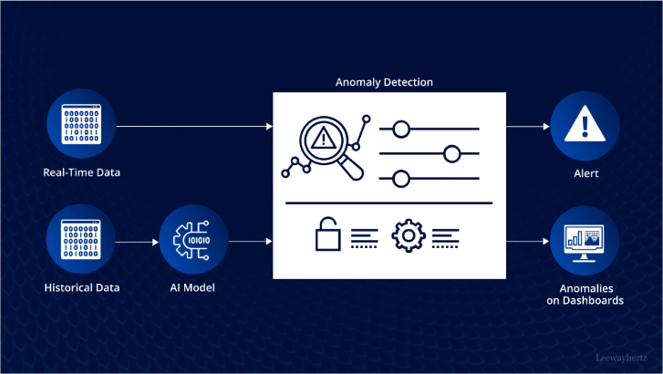
Figure 2.6: Real-Time and Historical AI-Based
Anomaly Detection Framework
The framework consists of two interrelated pipelines:
1. Real-Time Detection Pipeline
Real-time operational data streams are processed through an anomaly detection engine that applies pre-trained models to identify deviations from established behavioral baselines. When anomalous patterns are detected, alerts are generated and forwarded to dashboards or incident response systems.
This layer supports:
- Immediate threat detection
- Runtime infrastructure protection
- Reduced mean time to detection (MTTD)

2. Historical Learning Pipeline
Historical telemetry data is aggregated and used to train or retrain AI models. This process may involve:
- Feature extraction
- Dimensionality reduction
- Clustering or classification training
- Model validation and optimization
The trained model is subsequently deployed into the real-time detection pipeline, creating a feedback loop between long-term behavioral learning and operational inference.
This bifurcated architecture is particularly relevant in Edge–Cloud contexts. While cloud layers may perform intensive historical model training due to greater computational resources, Edge nodes can execute lightweight real-time inference, enabling distributed intelligence and reduced latency.
However, many existing industrial implementations centralize both training and inference in cloud environments, underutilizing the potential of Edge-level intelligence — a gap directly aligned with the research motivation defined in Chapter 1.

2.5.2 Supervised and Unsupervised Learning Paradigms
AI-based anomaly detection in cybersecurity typically relies on two principal learning paradigms, illustrated conceptually in:
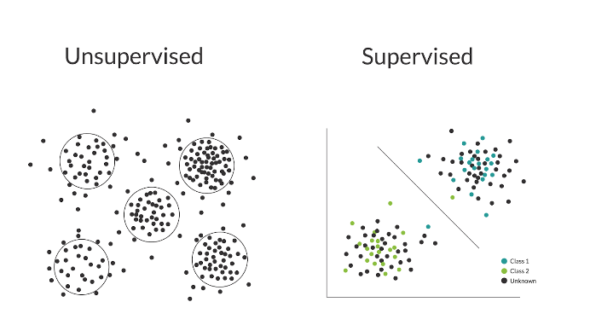
Figure 2.7: Supervised and Unsupervised
Learning Paradigms in Intrusion Detection
Supervised Learning
In supervised models, labeled datasets containing predefined categories (e.g., “normal” vs “attack”) are used to train classification algorithms. The decision boundary separating data points reflects the model’s learned discrimination between benign and malicious behavior.
Common techniques include:
- Support Vector Machines
- Random Forest classifiers
- Neural networks
Supervised approaches offer high detection accuracy when comprehensive labeled datasets are available. However, they suffer from several limitations:
- Dependence on previously known attack patterns
- Dataset labeling complexity
- Limited adaptability to zero-day threats
Unsupervised Learning
Unsupervised models operate without labeled data, identifying anomalies by detecting deviations from normal clustering patterns. In such models, abnormal data points appear distant from dense clusters of regular activity.
Techniques include:
- K-means clustering
- DBSCAN
- Autoencoders
- Isolation Forest
Unsupervised approaches are particularly valuable in distributed Edge–Cloud infrastructures, where unknown or emerging threats may not match predefined signatures.
However, these models may generate higher false-positive rates and require careful threshold calibration.

2.5.3 Challenges of AI Integration in Edge–Cloud Environments
While AI-driven anomaly detection offers significant promise, its integration within distributed IaaS infrastructures introduces architectural and operational challenges:
- Data heterogeneity across Edge and cloud layers
- Latency constraints in real-time detection
- Computational limitations of Edge devices
- Secure model deployment and update mechanisms
- Continuous retraining requirements
Most existing solutions centralize AI capabilities within cloud-based Security Operations Centers (SOCs), thereby increasing detection latency and network overhead. Few architectures systematically distribute intelligence between Edge and cloud layers while maintaining automation and secure synchronization.

2.5.4 Relevance to the Research Objectives
The analysis of AI-based cybersecurity frameworks reinforces the central research problem of this thesis:
- The need for hybrid intelligence distribution
- Secure and automated model deployment
- Integration of AI pipelines with observability systems
- Alignment with DevSecOps automation principles
While contemporary AI frameworks provide powerful anomaly detection capabilities, they often remain loosely integrated with infrastructure automation and distributed architecture design.
This fragmentation underscores the necessity of an integrated Edge–Cloud architecture that unifies observability, DevSecOps automation, and AI-driven anomaly detection within a coherent IaaS-based framework.

2.6 Comparative Analysis of Existing Solutions
The preceding sections examined the foundational technological pillars of distributed infrastructure security: Edge computing architectures, cloud-native observability frameworks, DevSecOps lifecycle integration, and AI-driven anomaly detection mechanisms. While each domain has matured significantly, their architectural convergence remains inconsistent across industrial and research implementations.
This section provides a structured comparative evaluation of representative models, identifying architectural strengths, systemic limitations, and integration gaps relevant to the objectives of this research.

2.6.1 Evaluation Criteria
To ensure methodological rigor, the comparative analysis is structured according to the following criteria:
- Edge–Cloud Integration – Architectural cohesion between distributed Edge nodes and centralized Cloud layers.
- Automation Maturity – Adoption of Infrastructure-as-Code (IaC), CI/CD, and lifecycle automation.
- Security-by-Design Implementation – Degree to which security is embedded throughout the lifecycle.
- AI/ML Integration Depth – Positioning of anomaly detection within the operational stack.
- Distributed Intelligence Capability – Edge-level preprocessing, inference, and autonomy.
- Vendor Dependency and Openness – Flexibility versus platform lock-in constraints.
These criteria directly align with the research objectives defined in Chapter 1, particularly the goal of designing a unified, secure, intelligent, and automated Edge–Cloud IaaS architecture.

2.6.2 Comparative Evaluation of Representative Solutions
Building upon the defined evaluation dimensions, a comparative synthesis of representative industrial and architectural approaches is presented below. The selected models reflect dominant paradigms across Edge orchestration, observability infrastructures, DevSecOps automation frameworks, and AI-driven cybersecurity operations.Table 2.1 consolidates the assessment across these dimensions, enabling a structured visualization of architectural distribution, maturity levels, and systemic trade-offs without isolating any single technological domain from the broader infrastructure context.
Table 2.1: Comparative Analysis of Representative Edge–Cloud Security Solutions
Solution / Model | Edge–Cloud Integration | Automation (IaC / CI/CD) | Security-by-Design | AI Integration | Distributed Intelligence | Vendor Dependency
Cisco Edge Intelligence | Moderate | Limited | Strong | Limited | Low | High
Azure IoT Edge | Strong | Strong | Moderate | Moderate | Moderate | High
Generic ELK Stack Architecture | Low | Limited | Moderate | External integration required | Low | Low
Conventional DevSecOps Pipelines | Cloud-centric | Strong | Strong | Weak runtime AI coupling | Low | Medium
Centralized AI-SOC Architectures | Weak Edge integration | Moderate | Strong | Strong (centralized) | Very Low | Medium–High

Analytical Interpretation of Table 2.1
The comparative results reveal a systemic architectural imbalance across existing solutions.
Industrial Edge frameworks such as Cisco and Azure demonstrate relatively strong orchestration and governance mechanisms but maintain significant centralization of intelligence and analytics. Observability platforms like ELK provide robust log aggregation and visualization capabilities but lack intrinsic AI-driven detection and distributed inference support.
Similarly, DevSecOps pipelines achieve high automation maturity but remain predominantly cloud-centric, with limited architectural symmetry across Edge environments. Centralized AI-SOC architectures offer sophisticated anomaly detection capabilities but contradict the latency-reduction and autonomy principles fundamental to Edge computing.
The analysis indicates that existing solutions optimize specific architectural dimensions in isolation, but no framework demonstrates systemic coherence across distributed intelligence, lifecycle automation, and security orchestration simultaneously.

2.6.3 Gap-Oriented Architectural Matrix
To further formalize the analytical findings, Table 2.2 evaluates whether critical architectural requirements are fully satisfied across existing solutions.
Table 2.2: Identified Architectural Gaps in Current Solutions
Critical Requirement | Cisco | Azure | ELK | DevSecOps | AI-SOC | Fully Addressed Across Solutions?
Data / Control Plane Separation | ✔ | Partial | ✖ | ✖ | ✖ | No
Edge-Level AI Inference | ✖ | Partial | ✖ | ✖ | ✖ | No
Integrated DevSecOps + AI Feedback Loop | ✖ | ✖ | ✖ | Partial | ✖ | No
Secure Edge–Cloud Synchronization | Moderate | Strong | Low | Low | Moderate | No
Unified Observability + Automation | ✖ | Partial | ✖ | Partial | ✖ | No
Low-Latency Autonomous Detection | ✖ | Partial | ✖ | ✖ | ✖ | No
Analytical Interpretation of Table 2.2
The matrix clearly demonstrates that while individual solutions partially satisfy specific architectural requirements, none achieve comprehensive integration.
Three structural deficiencies are consistently observed:
- Centralized Intelligence Dominance
AI-driven detection remains largely cloud-centric, limiting real-time responsiveness and increasing dependency on network stability.
- Fragmented Automation–Security Coupling
DevSecOps automation pipelines operate independently from AI-based anomaly detection systems, preventing adaptive infrastructure reconfiguration based on threat intelligence.
- Asymmetrical Edge–Cloud Design
Edge nodes are often treated as data acquisition endpoints rather than autonomous computational entities capable of localized inference and security enforcement.
These findings confirm that current architectures optimize individual technological dimensions but fail to achieve systemic convergence across distributed infrastructure layers.

2.6.4 Synthesis and Strategic Implications
The comparative analysis establishes that existing approaches are characterized by:
- Strong orchestration but limited distributed intelligence
- Advanced monitoring but reactive detection models
- Mature automation pipelines without AI-driven runtime adaptation
- Centralized security intelligence contradicting Edge computing principles
Consequently, a structural gap exists between:
- Edge computing paradigms
- Cloud-native IaaS automation
- Observability ecosystems
- AI-driven anomaly detection frameworks
This gap is not merely technological but architectural. It reflects the absence of a unified framework capable of simultaneously integrating:
- Data/Control plane separation
- DevSecOps lifecycle security
- Edge-level AI inference
- Centralized orchestration with decentralized intelligence
- Elastic IaaS scalability
Addressing this architectural fragmentation constitutes the core motivation of the proposed research.

2.7 Research Gaps and Limitations of Current Approaches
The comparative evaluation conducted in Section 2.6 demonstrates that although significant advancements have been achieved in Edge computing, cloud-native observability, DevSecOps automation, and AI-driven anomaly detection, these domains remain architecturally fragmented. Existing solutions tend to optimize individual components rather than achieving systemic integration across distributed infrastructure environments.
This structural fragmentation reveals several critical research gaps that remain insufficiently addressed in current literature and industrial implementations.

2.7.1 Lack of Unified Edge–Cloud Security Architecture
Most contemporary frameworks treat Edge and Cloud environments as hierarchically connected but functionally asymmetric systems. Edge nodes are typically positioned as data collectors or preprocessing units, while intelligence, orchestration, and security analytics remain centralized.
This results in:
- Increased detection latency
- Higher bandwidth consumption
- Reduced autonomy under network disruption
- Centralized failure points
A unified architecture that enforces balanced computational responsibility across Edge and Cloud layers, while preserving centralized orchestration, is largely absent from current approaches.

2.7.2 Centralized Dominance of AI-Based Anomaly Detection
AI-driven cybersecurity solutions predominantly rely on centralized training and inference models. While such architectures leverage powerful cloud computing resources, they contradict the fundamental principles of Edge computing, particularly low-latency response and localized resilience.
The absence of distributed inference mechanisms leads to:
- Delayed anomaly mitigation
- Dependence on continuous connectivity
- Scalability bottlenecks in large-scale distributed infrastructures
There is a clear research gap in designing architectures that enable Edge-level AI inference while maintaining global coordination and model governance.

2.7.3 Weak Integration Between DevSecOps and Runtime AI Feedback
Although DevSecOps pipelines integrate security scanning during development and deployment phases, they rarely incorporate real-time anomaly detection feedback into infrastructure reconfiguration processes.
Current pipelines:
- Automate provisioning and deployment
- Perform static or pre-deployment security checks
- Lack adaptive runtime reconfiguration mechanisms
The absence of an automated feedback loop between AI-driven anomaly detection and Infrastructure-as-Code mechanisms limits the system’s capacity for self-adaptive defense.
A research gap therefore exists in coupling AI-based runtime detection with automated infrastructure remediation.

2.7.4 Fragmented Observability and Intelligence Layers
Monitoring frameworks such as ELK provide powerful observability but do not inherently integrate predictive analytics or distributed intelligence. AI systems, conversely, often operate independently from observability stacks.
This separation creates:
- Redundant data processing layers
- Increased operational complexity
- Limited contextual intelligence correlation
An integrated observability–intelligence model capable of harmonizing monitoring, analytics, and automation within a unified architecture remains underdeveloped.

2.7.5 Absence of Symmetrical Data and Control Plane Separation in Distributed IaaS
While some enterprise architectures implement logical separation between data and control planes, this principle is rarely extended consistently across Edge–Cloud infrastructures combined with DevSecOps automation and AI orchestration.
A holistic model that simultaneously integrates:
- Data plane isolation
- Control plane orchestration
- AI-driven anomaly detection
- DevSecOps automation
- Secure Edge–Cloud synchronization
has not been comprehensively formalized in current industrial frameworks.

2.7.6 Identified Research Gap
Based on the analysis presented throughout Chapter 2, the central research gap can be articulated as follows:
There is no unified architectural framework that systematically integrates Edge computing, cloud-based IaaS automation, DevSecOps security lifecycle, AI-driven distributed anomaly detection, and observability mechanisms within a cohesive, secure, and scalable infrastructure model.
Existing solutions demonstrate partial optimization but lack systemic architectural convergence.

2.7.7 Research Direction and Contribution Positioning
To address the identified gaps, this research proposes the design and implementation of:
- A unified Edge–Cloud IaaS architecture
- Symmetrical Data/Control Plane separation
- Embedded DevSecOps lifecycle automation
- Distributed AI-based anomaly detection with Edge inference
- Integrated observability and intelligent monitoring
- Automated feedback loops for adaptive infrastructure defense
This framework aims to bridge the architectural fragmentation identified in contemporary solutions and establish a scalable, secure, and intelligent distributed infrastructure model.

2.8 Chapter Conclusion
This chapter provided a structured and critical examination of the technological and architectural foundations underlying modern distributed infrastructure security. Rather than treating Edge computing, cloud-native observability, DevSecOps automation, and AI-driven anomaly detection as isolated domains, the analysis investigated their architectural interplay within large-scale IaaS environments.
The review demonstrated that while each domain has achieved considerable maturity independently, their integration remains evolutionarily fragmented. Edge computing promotes decentralization and latency-sensitive processing; cloud observability frameworks enhance visibility and log analytics; DevSecOps formalizes automation and security lifecycle management; and AI-based anomaly detection introduces predictive intelligence. However, these advancements have largely progressed along parallel trajectories rather than converging into a cohesive architectural model.
The comparative evaluation conducted in Section 2.6 exposed a recurring structural pattern: centralized dominance of intelligence, asymmetrical Edge–Cloud responsibility distribution, limited runtime coupling between AI detection and automated infrastructure remediation, and fragmented observability–intelligence integration. These limitations are not merely implementation-specific but reflect deeper architectural discontinuities in current distributed security paradigms.
The research gap formalized in Section 2.7 therefore emerges as a systemic architectural deficiency rather than a technological shortcoming. Existing frameworks optimize individual dimensions—automation, monitoring, or intelligence—but fail to harmonize them within a unified, secure, and scalable Edge–Cloud IaaS architecture.
By synthesizing theoretical foundations, industrial models, and architectural evaluation, this chapter establishes the conceptual necessity for an integrated framework capable of combining distributed AI inference, DevSecOps-driven automation, observability convergence, and symmetrical control-plane design.
Accordingly, the next chapter introduces the proposed architectural model designed to address these structural deficiencies and to advance a cohesive paradigm for intelligent, automated, and secure distributed infrastructure systems.

Chapter 3 – Proposed Architecture & System Design

3.1 Design Objectives and System Requirements

3.1.1 Architectural Context and Design Rationale
Contemporary multi-cloud enterprise infrastructures operate across heterogeneous and dynamically evolving domains, including public cloud providers, private clouds, on-premise data centers, and geographically distributed edge nodes. These environments are characterized by containerized microservices, elastic resource provisioning, CI/CD-driven deployment pipelines, large-scale telemetry generation, and cross-region workload mobility.
While these properties enable scalability and operational agility, they introduce structural complexity in terms of:
- Asymmetrical security enforcement across domains
- Fragmented observability mechanisms
- Latency-sensitive anomaly detection requirements
- Disconnected DevSecOps lifecycles
- Inconsistent AI model governance across environments
The absence of architectural unification across these dimensions results in operational silos, security blind spots, and lifecycle inconsistencies.
To address these systemic gaps, this research proposes a unified Edge–Cloud intelligent security architecture tailored for distributed multi-cloud enterprise infrastructures. The architecture is driven by formally defined design objectives, from which a structured requirement model is derived.

3.1.2 Architectural Design Objectives
The design objectives operationalize the research gaps identified in Chapter 2 and serve as strategic anchors for requirement derivation. Each objective represents a systemic property the architecture must satisfy.
O1 – Unified Edge–Cloud Security Integration
Establish coordinated and symmetrical security enforcement across edge and cloud domains while avoiding centralized architectural dominance.
O2 – Distributed AI Intelligence
Enable centralized model training with distributed edge-level inference to minimize detection latency and maintain operational continuity under network disruption.
O3 – DevSecOps Lifecycle Convergence
Integrate security validation, anomaly intelligence, and automated remediation into CI/CD and Infrastructure-as-Code pipelines.
O4 – Observability Convergence
Unify logs, metrics, traces, and security telemetry into a harmonized intelligence framework combining distributed collection and centralized reasoning.
O5 – Scalability and Resilience Engineering
Ensure horizontal scalability, fault tolerance, and multi-region failover across heterogeneous infrastructure domains.
O6 – Security-by-Design and Zero-Trust Enforcement
Embed encryption, identity-aware access control, control/data plane separation, and secure AI model distribution within the architecture from inception.
These objectives collectively define the strategic intent of the proposed architecture. The subsequent requirement model formalizes their operational realization.

3.2 System Context and Actors
Following the formal specification of objectives and requirements in Section 3.1, the next step consists of contextualizing the proposed architecture within its operational environment. While Section 3.1 defined what the system must achieve, the present section defines who interacts with the system and where the architectural boundary is drawn. This contextual modeling ensures that the architectural realization remains aligned with the previously established requirement framework.

3.2.1 System Boundary Definition
The proposed solution is architected as a logically centralized yet physically distributed control plane that interfaces with heterogeneous execution environments. Internally, the platform is structured into modular architectural layers responsible for observability, AI intelligence, orchestration, security enforcement, and DevSecOps automation. These internal layers are abstracted at this stage and will be formally detailed in Section 3.4.
The architecture is designed to operate in distributed enterprise infrastructures spanning public cloud providers, private cloud deployments, and geographically distributed edge domains. To ensure portability and vendor independence, the orchestration layer adopts a cloud-agnostic abstraction model that enables integration with heterogeneous cloud providers through standardized API interfaces.
It is important to distinguish between the architectural model and its experimental instantiation. While the conceptual architecture supports federated multi-cloud environments, the practical implementation presented in this research is validated using an OpenStack-based cloud deployment serving as a reference platform. This implementation choice does not constrain the architectural generality of the proposed model but provides a controlled environment for evaluating orchestration, AI lifecycle management, and zero-trust enforcement mechanisms.
The system operates within a clearly defined boundary that separates:
- Internal orchestration and intelligence components (Control Plane)
- External infrastructure entities (Edge Nodes and Cloud Providers)
- Human actors interacting with the platform
The platform does not directly replace enterprise infrastructure components. Instead, it acts as an intelligent coordination and security enforcement layer responsible for:
- Multi-cloud orchestration
- AI model lifecycle management
- Infrastructure monitoring and telemetry aggregation
- Zero-trust access governance
- Automated remediation and operational reporting
The boundary ensures that:
- Infrastructure devices remain external managed entities
- Cloud providers operate as federated, provider-independent execution environments integrated through standardized APIs
- Human users interact exclusively through controlled access interfaces
This separation enforces architectural clarity and supports the zero-trust design principle adopted in this research.
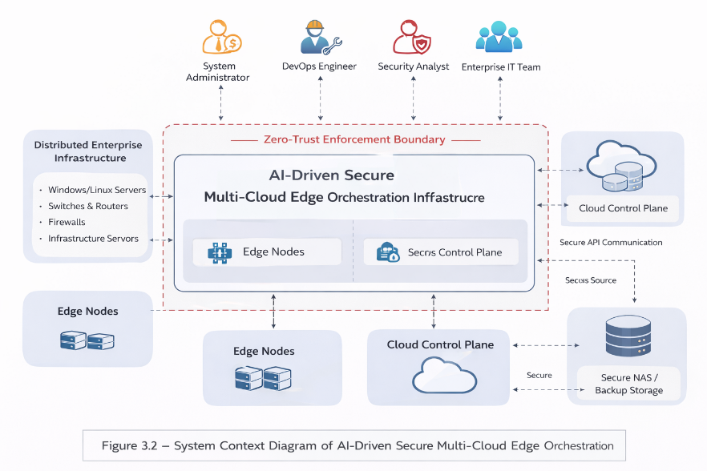
Figure 3.2 – System Context Diagram of the AI-Driven Secure
The System Context Diagram illustrates the high-level interaction between the platform and its external actors. The Control Plane acts as the central coordination layer, interfacing with distributed Edge Nodes and federated Cloud Control Planes through secured API channels. Human actors interact with the system through role-governed access mechanisms.

3.2.2 Actors Identification and Roles
The system involves both human and system actors. Each actor interacts with the platform within a defined scope aligned with enterprise governance policies.

1. System Administrator
The System Administrator is responsible for overall governance and configuration of the platform. This includes:
- Defining zero-trust policies
- Managing role-based access control
- Provisioning cloud resources
- Approving AI model deployment to edge environments
- Generating strategic operational reports
The Administrator operates at the governance and configuration level.

2. DevOps Engineer
The DevOps Engineer manages infrastructure orchestration and AI model lifecycle operations. Responsibilities include:
- Provisioning and configuring cloud resources
- Deploying AI models to cloud environments
- Training and validating AI models
- Registering and versioning AI artifacts
- Deploying validated models to edge nodes
This role focuses on automation and technical lifecycle execution.

3. Security Analyst
The Security Analyst monitors system integrity and ensures compliance with enterprise security standards. Responsibilities include:
- Monitoring security events
- Analyzing logs and metrics
- Detecting anomalous behavior
- Producing security-focused operational reports
This actor operates within the monitoring and risk assessment domain.

4. Enterprise IT Team
The Enterprise IT Team represents operational staff responsible for maintaining enterprise infrastructure. They interact with the system primarily to:
- Monitor enterprise devices
- Collect telemetry data
- Validate infrastructure health
They operate at the infrastructure monitoring level.

5. Edge Node (System Actor)
Edge Nodes represent distributed execution environments where AI models are deployed. They:
- Provide telemetry data
- Execute deployed AI models
- Synchronize workloads with cloud resources
Edge Nodes are managed entities, not users.

6. Cloud Control Plane (System Actor)
The Cloud Control Plane represents external cloud providers integrated into the orchestration system. It enables:
- Cloud resource provisioning
- Model deployment
- Workload synchronization
- API-based infrastructure control
It is an external federated execution environment.

3.2.3 Use Case Overview
Following the identification of the system actors and their respective roles, the functional interactions between these actors and the proposed platform must be formally represented. In software and system architecture modeling, such interactions are commonly captured through UML use cases, which describe the services provided by the system and the ways external actors engage with them.
The platform functionality is therefore represented through a UML Use Case Diagram, illustrating how human and system actors interact with the orchestration platform to perform security management, infrastructure monitoring, cloud orchestration, and AI lifecycle operations.
To improve readability and architectural interpretation, the identified use cases are organized into four functional domains reflecting the main responsibilities of the platform:
Security Management
- Configure Zero-Trust Policies
- Manage Role-Based Access Control
- Enforce Multi-Factor Authentication
- Monitor Security Events
Cloud Orchestration
- Provision Cloud Resources
- Deploy AI Models to Cloud
- Synchronize Edge and Cloud Workloads
- Manage API Integrations
Monitoring & Operations
- Collect Infrastructure Telemetry
- Monitor Enterprise Devices
- Analyze Logs & Metrics
- Generate Operational Reports
AI Lifecycle Management
- Train AI Model
- Validate Model Performance
- Register Model
- Deploy Model to Edge
These use cases collectively represent the functional scope of the proposed system.
The Use Case Diagram illustrates the interactions between human actors, system components, and the proposed orchestration platform. It formalizes the functional capabilities of the architecture by mapping actor responsibilities to system services across four operational domains: security management, cloud orchestration, infrastructure monitoring, and AI lifecycle management
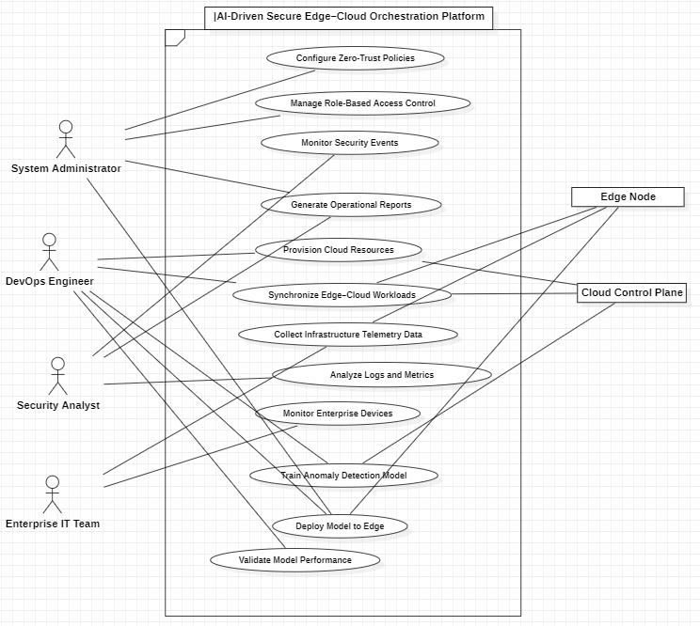
Figure 3.3 – UML Use Case Diagram of the AI-Driven Secure Multi-Cloud Edge Orchestration Platform
The Use Case Diagram formalizes system functionality and defines role-based interaction boundaries. It ensures alignment between system objectives, architectural design, and operational workflows.
The defined use cases operationalize the core functional, security, and AI-related objectives established in Section 3.1 and translate them into concrete system interactions.
3.2.4 User Stories and Acceptance Criteria
To bridge high-level use cases with implementable functional requirements, user stories are defined following structured role-action-benefit formatting.
The principal user stories derived from the identified actors and use cases are summarized in Table 3.1. Each story is associated with an acceptance criterion that defines the minimum condition for validating the corresponding system behavior.
Table 3.1 – User Stories with Acceptance Criteria
ID | Actor | User Story | Acceptance Criteria
US-01 | System Administrator | As a System Administrator, I want to configure zero-trust policies so that access is strictly controlled. | Policies can be created, modified, validated, and enforced system-wide.
US-02 | DevOps Engineer | As a DevOps Engineer, I want to provision cloud resources so that workloads can be deployed dynamically. | Resources are provisioned via API integration and reflected in dashboard.
US-03 | DevOps Engineer | As a DevOps Engineer, I want to validate AI model performance before deployment so that only optimized models are released. | Validation metrics meet predefined accuracy and latency thresholds.
US-04 | Security Analyst | As a Security Analyst, I want to monitor security events so that threats can be detected early. | Real-time alerts are generated upon anomaly detection.
US-05 | Enterprise IT Team | As an IT team member, I want to monitor enterprise devices so that infrastructure health is maintained. | Telemetry data is updated continuously and visualized in dashboard.
US-06 | System Administrator | As a System Administrator, I want to generate operational reports so that compliance and performance can be reviewed. | Reports are exportable and reflect real-time system metrics.
The user-story model provides an operational interpretation of the proposed architecture by linking stakeholder needs to expected system behavior. In this way, it reinforces the alignment between architectural design objectives, actor responsibilities, and expected system functionality.3.3 Architectural Design Principles

3.3 High-Level Architecture Overview
The proposed platform adopts a distributed Edge–Cloud security architecture designed to support real-time telemetry processing, intelligent anomaly detection, and centralized security orchestration. By integrating edge computing capabilities with cloud-based analytics, the architecture enables scalable monitoring of heterogeneous enterprise infrastructures while reducing detection latency and improving overall system resilience.
From a conceptual perspective, the system is organized into three primary architectural domains: Enterprise Infrastructure, Edge Intelligent Gateway, and the Cloud Control and Analytics Platform. These domains form a hierarchical telemetry-driven monitoring architecture in which operational data generated by enterprise systems is progressively collected, aggregated, analyzed, and transformed into actionable security intelligence.
The architectural structure of the platform is illustrated in Figure 3.1, while the dynamic telemetry processing workflow is presented later in Figure 3.2. Together, these figures provide a comprehensive overview of both the structural organization of the system and the real-time data processing mechanisms that enable continuous monitoring and adaptive threat detection.

3.3.1 Global System Architecture
The global architecture of the proposed platform is presented in Figure 3.1, which illustrates the interaction between enterprise infrastructure components, edge processing nodes, and the centralized cloud analytics environment.
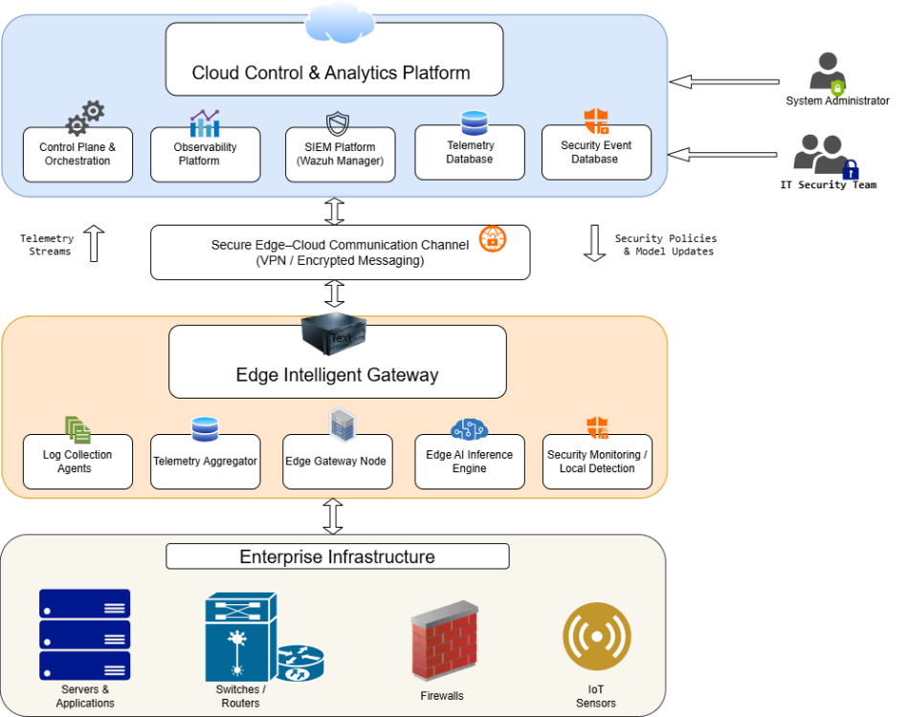
Figure 3.1 — High-Level Architecture of the AI-Driven Edge–Cloud Security Monitoring Platform
As shown in Figure 3.1, the architecture is organized into three primary operational domains that collectively support distributed telemetry collection and intelligent security analysis.
The Enterprise Infrastructure layer represents the operational environment in which telemetry data originates. This layer encompasses a wide range of enterprise assets including servers and application workloads, network devices such as switches and routers, security appliances such as firewalls, and Internet-of-Things (IoT) sensors deployed throughout the infrastructure. These components continuously generate operational signals including system logs, network events, and performance metrics that reflect the behavior and status of the underlying infrastructure. Rather than transmitting these raw data streams directly to centralized systems, the architecture introduces an intermediate processing layer that performs localized aggregation and preprocessing.
The Edge Intelligent Gateway layer acts as an intermediary between enterprise infrastructure and the centralized cloud platform. Positioned close to the data sources, this layer is responsible for collecting, aggregating, and preprocessing telemetry data before forwarding it to the cloud environment. Within this layer, log collection agents gather operational logs from enterprise assets, while a telemetry aggregation component consolidates collected data into structured telemetry streams. The edge gateway node serves as the primary processing unit responsible for coordinating telemetry ingestion and forwarding operations.
In addition to data aggregation, the edge environment integrates an AI inference engine capable of executing lightweight machine-learning models directly at the edge. This capability enables early detection of anomalous behavior and reduces the reliance on centralized processing resources. Complementing this functionality, a local security monitoring module performs preliminary detection tasks, allowing suspicious activity to be identified closer to the data sources.
Communication between the edge environment and the centralized platform is established through a secure Edge–Cloud communication channel, as illustrated in the architecture. This communication layer ensures secure and reliable data exchange between distributed infrastructure components and the cloud analytics environment. Telemetry streams generated at the edge are transmitted upward toward the cloud platform for large-scale processing, while the cloud environment can propagate security policies, configuration updates, and machine-learning model updates back to the edge layer. This bidirectional communication mechanism enables continuous system adaptation and coordinated security enforcement across the distributed infrastructure.
The Cloud Control and Analytics Platform represents the central management and intelligence hub of the architecture. This environment hosts the core services responsible for system orchestration, observability, and large-scale security analytics. Within this platform, the control plane and orchestration services coordinate infrastructure management and system configuration, while the observability platform aggregates telemetry data originating from distributed edge nodes. Collected telemetry is stored within a telemetry database, enabling large-scale data processing and historical analysis.
Security analytics are performed through the integration of a Security Information and Event Management (SIEM) platform, which correlates events, detects suspicious activity patterns, and supports incident investigation. Detected security events and alerts are stored in a security event database, enabling long-term security monitoring and forensic analysis.
Interaction with the cloud platform is provided through monitoring dashboards and administrative interfaces accessed by system administrators and IT security teams, who use these interfaces to monitor system behavior, investigate detected threats, and coordinate incident response activities.
Overall, the architecture presented in Figure 3.1 establishes a distributed telemetry-driven monitoring framework in which enterprise infrastructure generates operational signals, edge gateways perform localized data processing and inference, and centralized cloud services provide large-scale analytics and security orchestration. This hierarchical design enables scalable monitoring of complex enterprise environments while supporting adaptive security mechanisms capable of responding to evolving infrastructure behavior.

3.3.2 Real-Time Telemetry Processing Pipeline
While the high-level architecture presented in Figure 3.1 describes the structural organization of the proposed platform, it does not explicitly illustrate the operational flow through which telemetry data is continuously processed and transformed into actionable security intelligence. To address this aspect, Figure 3.2 presents the real-time telemetry processing pipeline that underpins the monitoring and detection capabilities of the system.
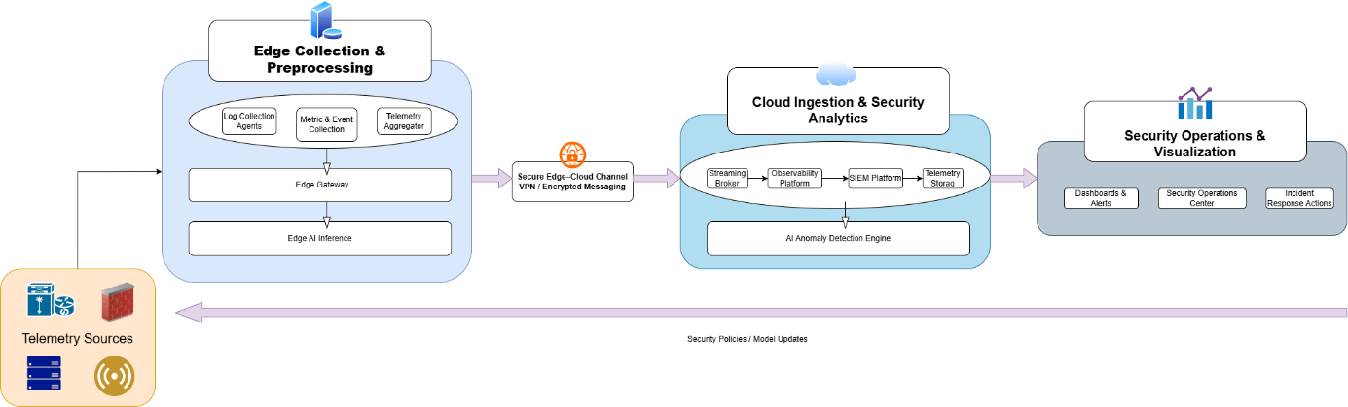
Figure 3.2 — Real-Time Data Processing Pipeline for Security Telemetry
As illustrated in Figure 3.2, the telemetry processing pipeline follows a multi-stage workflow that begins at the enterprise infrastructure level and progressively transforms raw operational data into security insights within the cloud analytics environment.
The pipeline begins with telemetry sources located within the enterprise infrastructure, including servers and application workloads, network devices such as switches and routers, security appliances such as firewalls, and IoT sensors deployed across the monitored environment. These components continuously generate operational signals in the form of system logs, network events, and performance metrics that reflect the dynamic state of the infrastructure.
To efficiently capture this data, the architecture employs an edge-based telemetry collection layer. Within this layer, log collection agents and metric and event collectors gather telemetry from distributed infrastructure components. These collected signals are then consolidated through a telemetry aggregation component, which organizes heterogeneous telemetry streams into structured data flows suitable for further analysis. The aggregated telemetry is processed by the edge gateway, which acts as the primary coordination node responsible for managing telemetry ingestion and forwarding operations.
In addition to aggregation and forwarding, the edge environment integrates an edge AI inference module capable of executing lightweight machine-learning models directly at the gateway. This capability enables preliminary anomaly detection to be performed close to the data sources, reducing detection latency and limiting the volume of telemetry that must be transmitted to the centralized analytics environment.
Once preprocessed at the edge, telemetry streams are transmitted to the cloud environment through a secure Edge–Cloud communication channel. This communication layer ensures the confidentiality and integrity of transmitted data by relying on encrypted communication mechanisms such as VPN tunnels or secure messaging protocols. The secure channel enables reliable telemetry transmission between distributed edge nodes and centralized cloud services.
Within the cloud environment, telemetry data enters the cloud ingestion and security analytics layer, which forms the core of the centralized monitoring platform. Incoming telemetry streams are first handled by a streaming broker, which enables scalable ingestion and asynchronous processing of high-volume telemetry data. The ingested telemetry is subsequently forwarded to the observability platform, where infrastructure metrics and operational events are monitored in real time.
Security-related telemetry is further processed by the Security Information and Event Management (SIEM) platform, which performs event correlation, threat detection, and incident analysis across aggregated telemetry streams. Both operational telemetry and security events are stored within a telemetry storage system, enabling historical analysis, forensic investigation, and long-term monitoring of infrastructure behavior.
To enhance the detection capabilities of the platform, telemetry data is also processed by an AI-driven anomaly detection engine deployed within the cloud analytics layer. This engine analyzes aggregated telemetry streams to identify abnormal system behaviors, suspicious activity patterns, and emerging threats that may not be detectable through rule-based mechanisms alone.
The results of this analysis are delivered to the security operations and visualization layer, where monitoring dashboards, alerting systems, and operational interfaces provide real-time situational awareness to system administrators and security analysts. Through these interfaces, the Security Operations Center (SOC) can investigate detected anomalies, correlate events across infrastructure components, and coordinate incident response activities when potential threats are identified.
An important feature of the architecture is the adaptive feedback mechanism connecting the cloud analytics layer with the distributed edge infrastructure. Insights generated by the anomaly detection engine or operational security analysis can lead to updates in security policies, monitoring configurations, or machine-learning models, which are subsequently propagated back to the edge layer. This feedback loop enables continuous improvement of detection capabilities and allows the monitoring infrastructure to dynamically adapt to evolving operational conditions.
Overall, the telemetry processing pipeline illustrated in Figure 3.2 demonstrates how the proposed platform combines edge-based data collection, secure data transmission, centralized analytics, and AI-driven detection to enable scalable and adaptive security monitoring across distributed enterprise infrastructures.

3.4 Layered Architectural Model
To provide a clearer understanding of the structural organization of the proposed platform, the architecture can be decomposed into a layered architectural model. This model separates system responsibilities into distinct functional layers, each encapsulating a specific set of capabilities while interacting with adjacent layers through well-defined interfaces.
The layered approach improves modularity, scalability, and maintainability, allowing different architectural components to evolve independently while preserving the overall integrity of the system. Furthermore, the separation of concerns introduced by this model facilitates the integration of distributed intelligence, security monitoring, and automated infrastructure management within a unified architectural framework.
The layered representation of the proposed architecture is illustrated in Figure 3.3.

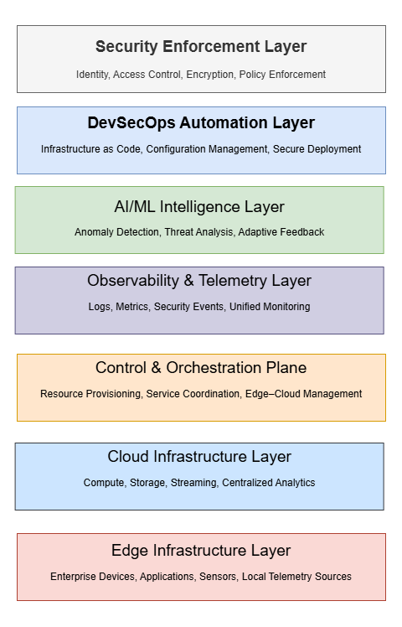
Figure 3.3 — Layered Architecture Model of the AI-Driven Edge–Cloud Security Platform
As shown in Figure 3.3, the architecture is composed of seven functional layers that collectively support the acquisition, processing, analysis, and protection of enterprise telemetry data across the edge–cloud infrastructure.

3.4.1 Edge Infrastructure Layer
The Edge Infrastructure Layer represents the distributed operational environment in which telemetry data is generated and initially collected. This layer includes enterprise servers, network devices, IoT sensors, and application workloads deployed across the organizational infrastructure. Monitoring agents and telemetry collectors operating within this layer capture system logs, performance metrics, and security events that reflect the operational state of the infrastructure.
Because this layer is located closest to the data sources, it plays a critical role in enabling low-latency monitoring and localized preprocessing before telemetry data is transmitted to centralized analytics platforms.

3.4.2 Cloud Infrastructure Layer
The Cloud Infrastructure Layer provides the computational and storage resources required to support large-scale telemetry processing and security analytics. This layer hosts the centralized infrastructure responsible for telemetry ingestion, distributed data processing, and persistent storage of monitoring data.
By leveraging cloud-based resources, the architecture enables elastic scalability, allowing the system to process high volumes of telemetry data generated by distributed enterprise environments. The cloud infrastructure therefore acts as the backbone that supports advanced analytics, monitoring dashboards, and security investigation workflows.

3.4.3 Control and Orchestration Layer
The Control and Orchestration Layer coordinates the management and configuration of distributed infrastructure components across the platform. This layer is responsible for provisioning services, managing deployment configurations, and orchestrating interactions between edge nodes and cloud-based analytics services.
Through centralized orchestration mechanisms, the system can dynamically update monitoring configurations, deploy security policies, and coordinate infrastructure changes across distributed environments. This layer therefore ensures consistent operational management of both edge and cloud resources.

3.4.4 Observability and Telemetry Layer
The Observability and Telemetry Layer is responsible for aggregating and managing telemetry data collected from enterprise infrastructure and edge nodes. This layer integrates monitoring mechanisms capable of collecting logs, metrics, traces, and security events from heterogeneous sources.
Telemetry data processed within this layer is forwarded to centralized analytics systems where it can be analyzed for operational insights and security anomalies. By providing a unified telemetry pipeline, the observability layer ensures comprehensive visibility into the behavior, performance, and security posture of the monitored infrastructure.

3.4.5 AI/ML Intelligence Layer
The AI/ML Intelligence Layer introduces advanced analytics capabilities into the platform by leveraging machine-learning models for anomaly detection and behavioral analysis. This layer processes telemetry streams to identify abnormal system behavior, suspicious activity patterns, or deviations from established operational baselines.
Machine-learning models operating within this layer analyze large volumes of telemetry data in real time, enabling proactive detection of potential security incidents and operational anomalies that may not be identifiable through rule-based mechanisms alone.

3.4.6 DevSecOps Automation Layer
The DevSecOps Automation Layer integrates automated deployment, security validation, and infrastructure management into the architectural workflow. This layer supports continuous integration and continuous deployment (CI/CD) pipelines, enabling automated delivery of platform updates and infrastructure configurations.
Security checks, policy validation mechanisms, and automated deployment tools operate within this layer to ensure that infrastructure changes are applied consistently and securely across distributed environments. As a result, the DevSecOps layer strengthens the reliability and security of system operations.

3.4.7 Security Enforcement Layer
The Security Enforcement Layer represents the protective mechanisms responsible for maintaining system integrity and enforcing security policies across the platform. This layer includes identity and access management controls, encryption mechanisms, security monitoring tools, and incident response capabilities.
By enforcing security controls across both edge and cloud environments, this layer ensures that the architecture maintains a zero-trust security posture capable of protecting sensitive infrastructure components and telemetry data.
The layered architectural model presented in Figure 3.3 therefore provides a structured representation of how the proposed platform integrates distributed infrastructure monitoring, real-time telemetry processing, intelligent anomaly detection, and automated security enforcement within a unified system architecture.
The following section further examines how telemetry data is collected, aggregated, and analyzed within the observability framework of the platform.

3.5 Observability and Monitoring Convergence
Modern distributed infrastructures generate large volumes of heterogeneous operational data originating from applications, network devices, cloud services, and edge computing environments. In such environments, effective monitoring requires the integration of multiple telemetry signals into a unified observability framework capable of providing comprehensive visibility across the entire infrastructure. Rather than treating monitoring signals as independent data streams, contemporary observability architectures emphasize the convergence of logs, metrics, traces, and security events into a coordinated analytical environment.
Within the proposed Edge–Cloud security platform, observability is therefore implemented as a unified telemetry convergence architecture that consolidates heterogeneous monitoring signals into a centralized analytics pipeline. This approach enables the platform to correlate operational and security data across distributed infrastructure components, thereby improving situational awareness and facilitating intelligent anomaly detection.
The conceptual organization of the observability convergence architecture is illustrated in Figure X, which presents the high-level interaction between telemetry sources, edge collection mechanisms, centralized observability services, and security analytics components.
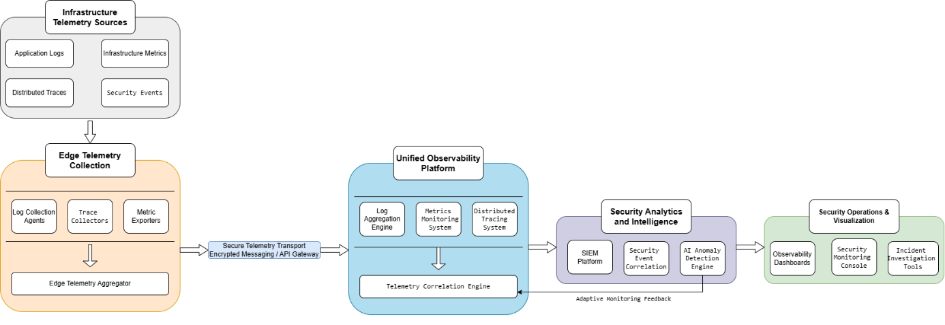
Figure X — Observability Convergence Architecture
At the infrastructure level, telemetry originates from multiple operational signals generated by enterprise systems. These signals include application logs, infrastructure metrics, distributed traces capturing service interactions, and security events produced by network devices and security appliances. Together, these signals provide complementary perspectives on the behavior and health of the monitored infrastructure.
Because enterprise environments are geographically distributed and frequently incorporate edge computing resources, the proposed architecture performs initial telemetry collection close to the data sources. Edge telemetry collection components are responsible for gathering logs, metrics, and trace information from heterogeneous infrastructure elements. These signals are aggregated locally before being transmitted toward the centralized analytics environment. Local aggregation reduces the overhead associated with transmitting raw telemetry streams while ensuring that monitoring data remains structured and consistent before entering the centralized observability platform.
Telemetry streams collected at the edge are transmitted to the cloud environment through a secure telemetry transport mechanism. This communication layer ensures that monitoring data can be reliably delivered from distributed infrastructure domains to the centralized analytics platform while preserving confidentiality and integrity during transmission.
Within the cloud environment, telemetry signals converge inside a unified observability platform responsible for organizing and correlating the different monitoring data streams. Instead of processing each signal independently, the observability platform integrates multiple telemetry perspectives into a consolidated monitoring framework. Log aggregation services manage large volumes of operational logs generated by distributed systems, while metrics monitoring components track infrastructure performance indicators and system health measurements. In parallel, distributed tracing mechanisms capture the interactions between services and applications, enabling the reconstruction of end-to-end request paths across complex microservice architectures.
The integration of these telemetry signals enables the observability platform to correlate operational events across different monitoring dimensions. Through this correlation capability, the system can link performance anomalies, application failures, and security events to specific infrastructure behaviors or service interactions. This convergence of telemetry signals significantly improves the analytical context available to monitoring and security analysis processes.
Beyond operational monitoring, the observability platform also feeds telemetry data into the security analytics layer of the architecture. Security Information and Event Management (SIEM) mechanisms process aggregated telemetry streams in order to detect suspicious activity patterns and correlate security events originating from multiple infrastructure components. In addition to rule-based event analysis, the architecture integrates machine-learning-based anomaly detection models capable of analyzing large volumes of telemetry data to identify abnormal behavior that may indicate emerging threats or system misconfigurations.
The results of these analyses are delivered to the security operations and visualization layer, where monitoring dashboards and operational consoles provide administrators and security analysts with real-time situational awareness of infrastructure behavior. Through these interfaces, operational teams can investigate anomalies, examine correlated telemetry events, and initiate incident response procedures when abnormal system activity is detected.
An important characteristic of the proposed observability architecture is the adaptive feedback mechanism linking analytics results back to the telemetry monitoring framework. Insights generated through anomaly detection and event correlation can lead to adjustments in monitoring configurations, alert thresholds, or telemetry processing strategies. This feedback loop enables the monitoring system to continuously refine its analytical capabilities and adapt to evolving infrastructure behavior.
By integrating heterogeneous telemetry signals into a unified analytical framework, the observability convergence architecture provides the foundation for intelligent monitoring and security analysis within the proposed Edge–Cloud platform. The convergence of logs, metrics, traces, and security events enables a comprehensive understanding of infrastructure behavior while supporting advanced analytics mechanisms capable of detecting operational anomalies and security threats across distributed enterprise environments.
The following sections examine the internal mechanisms that support this observability framework, including telemetry collection strategies, monitoring infrastructure design, and the integration of AI-driven analytics within the platform.

3.6 Distributed AI Architecture
While the previous sections described the telemetry collection and observability mechanisms of the proposed platform, the architecture also incorporates a distributed artificial intelligence framework designed to support adaptive threat detection across edge and cloud environments. This framework enables machine-learning models to be trained within the centralized cloud infrastructure and subsequently deployed to distributed edge nodes where real-time inference can be performed close to the monitored systems.
The integration of distributed intelligence into the architecture serves two primary objectives. First, it enables large-scale model training and evaluation using aggregated telemetry data collected from enterprise infrastructure. Second, it allows lightweight inference models to operate at the edge, reducing detection latency and enabling early identification of anomalous behavior before telemetry reaches centralized analytics systems.
Figure X illustrates the distributed AI architecture adopted by the platform, highlighting the interaction between the cloud-based model management environment and the edge inference infrastructure. The architecture supports the complete lifecycle of machine-learning models, including data preparation, model training, validation, deployment to edge nodes, and continuous feedback-driven retraining.
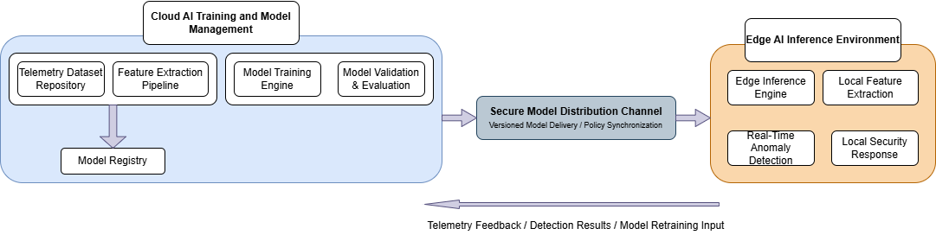
Figure 3.X — Distributed AI Architecture for Edge–Cloud Anomaly Detection

3.6.1 Cloud AI Training and Model Management
The cloud environment hosts the centralized artificial intelligence infrastructure responsible for training, validating, and managing machine-learning models used for anomaly detection and behavioral analysis. Because the cloud platform aggregates telemetry from multiple edge nodes and enterprise infrastructure components, it provides a rich dataset that enables the training of models capable of capturing complex system behavior patterns.
Within this environment, telemetry datasets collected from the observability pipeline are stored in a telemetry dataset repository that serves as the primary data source for model development. Prior to training, telemetry data undergoes a feature extraction process in which raw logs, metrics, and event streams are transformed into structured features suitable for machine-learning algorithms. This transformation step may include statistical aggregation, feature normalization, temporal correlation, and encoding of categorical event attributes.
The processed feature sets are subsequently used by the model training engine to build anomaly detection models capable of identifying abnormal infrastructure behavior. Various machine-learning approaches may be employed within this stage, including statistical anomaly detection methods, clustering techniques, or neural network-based models depending on the characteristics of the telemetry data.
Following the training phase, models are subjected to a validation and evaluation process that assesses their detection accuracy, robustness, and generalization capability. Evaluation may involve testing models against historical telemetry datasets or simulated attack scenarios in order to verify their ability to detect abnormal system behavior while minimizing false positives.
Validated models are then stored in a centralized model registry that maintains version-controlled records of trained models. The model registry plays a critical role in the lifecycle management of AI components by enabling controlled deployment, version tracking, and rollback mechanisms when updated models are distributed to edge inference nodes.

3.6.2 Secure Model Distribution
Once machine-learning models have been validated and registered within the centralized model management environment, they must be securely deployed to distributed edge nodes where real-time inference can be performed. This deployment process is handled through a secure model distribution mechanism that connects the cloud training infrastructure with the edge inference environment.
The model distribution channel ensures that trained models can be delivered reliably and consistently across multiple edge gateways while maintaining strict security and version control requirements. Within this mechanism, models stored in the centralized model registry are packaged together with their associated metadata, including version identifiers, configuration parameters, and compatibility information. These packaged models are then transmitted to edge nodes through a controlled distribution channel that may rely on encrypted messaging protocols, secure APIs, or message-broker systems designed for reliable data delivery.
An important characteristic of this distribution mechanism is its support for versioned model deployment. Each model version maintained within the registry can be selectively propagated to edge nodes depending on operational requirements, allowing administrators to update detection capabilities without interrupting system operations. This versioning capability also enables rollback procedures in the event that newly deployed models exhibit degraded performance or unexpected behavior.
In addition to model delivery, the distribution channel may also propagate policy updates and configuration parameters that influence the behavior of edge inference engines. This capability allows the cloud platform to dynamically adjust detection thresholds, update feature extraction parameters, or modify anomaly detection policies across the distributed monitoring infrastructure.
By providing a secure and controlled mechanism for deploying machine-learning models, the model distribution layer ensures that the intelligence developed within the cloud analytics environment can be effectively operationalized across distributed edge nodes. This capability enables the platform to maintain consistent detection logic throughout the infrastructure while benefiting from centralized model management and continuous improvement of detection algorithms.

3.6.3 Edge AI Inference Environment
While model training and lifecycle management are performed within the centralized cloud infrastructure, real-time anomaly detection is executed at the edge layer where telemetry data is generated. The Edge AI Inference Environment therefore represents the operational component responsible for applying trained machine-learning models to live telemetry streams originating from enterprise infrastructure.
Within this environment, edge nodes integrate lightweight inference engines capable of executing pre-trained anomaly detection models delivered through the secure model distribution channel. These inference engines are designed to operate with minimal computational overhead while processing telemetry streams in near real time. By performing inference operations directly at the edge, the architecture significantly reduces detection latency and enables early identification of suspicious behavior before telemetry data reaches centralized analytics systems.
Prior to inference, telemetry signals collected from enterprise systems undergo a local feature extraction process. During this stage, raw telemetry data such as logs, metrics, and event records are transformed into structured features compatible with the deployed machine-learning models. Performing feature extraction locally allows the system to preprocess telemetry streams efficiently while reducing the amount of data that must be transmitted to centralized cloud platforms.
Once processed, the extracted feature vectors are analyzed by the edge inference engine, which applies the deployed anomaly detection models to identify deviations from established behavioral baselines. The inference results determine whether the observed system activity corresponds to normal operational behavior or indicates a potential anomaly.
When abnormal behavior is detected, the edge environment can initiate immediate local responses. These responses may include generating security alerts, triggering automated mitigation mechanisms, or forwarding prioritized security events to centralized monitoring systems for further investigation. By enabling localized detection and response capabilities, the edge inference environment enhances the responsiveness of the monitoring platform and reduces the time required to identify potential security incidents.
Overall, the integration of AI-driven inference capabilities within edge nodes enables the architecture to combine centralized intelligence with distributed detection mechanisms, providing scalable and low-latency security monitoring across heterogeneous enterprise infrastructures.

3.6.4 Adaptive Learning and Model Feedback
An important characteristic of the distributed AI architecture is the integration of an adaptive feedback mechanism that enables continuous improvement of machine-learning models based on operational telemetry collected from edge environments. This feedback loop establishes a dynamic relationship between edge inference nodes and the centralized cloud training infrastructure, allowing the detection models to evolve as system behavior and threat patterns change over time.
During runtime operation, edge inference engines generate detection results and anomaly indicators based on live telemetry streams. These results, together with selected telemetry samples and contextual metadata, are transmitted back to the cloud analytics environment through the secure communication channel connecting edge nodes with centralized services. The returned information provides valuable feedback regarding the effectiveness of deployed detection models and the types of anomalies encountered within the monitored infrastructure.
Within the cloud environment, this feedback data is incorporated into the telemetry dataset repository used for model training and evaluation. By integrating newly observed operational patterns and potential threat indicators into the training dataset, the platform enables the machine-learning models to be periodically retrained using updated telemetry information. This process allows the detection algorithms to adapt to evolving infrastructure behavior, emerging attack techniques, and previously unseen anomaly patterns.
The retraining process may produce updated model versions that improve detection accuracy or reduce false-positive rates. Once validated, these new model versions are registered within the model registry and distributed to edge nodes through the secure model distribution channel described earlier. In this way, the architecture supports a continuous learning cycle in which operational insights gathered from the edge environment contribute to the ongoing refinement of detection capabilities.
This adaptive learning mechanism ensures that the monitoring platform remains responsive to changes in infrastructure behavior and threat landscapes while maintaining consistent detection logic across distributed environments. By combining centralized training with edge-based inference and feedback-driven retraining, the proposed architecture establishes a scalable and continuously evolving AI-driven security monitoring framework.

3.7 Security Architecture and Trust Model
While the previous sections focused on system architecture, telemetry processing, and distributed intelligence, ensuring the security of the proposed platform requires a structured security model that defines how trust is established, maintained, and enforced across the edge–cloud environment. Given the distributed nature of the architecture and the heterogeneity of the monitored infrastructure, the platform adopts a security-by-design approach based on explicit trust boundaries, secure communication mechanisms, and centralized security governance.
The security architecture is designed to protect both data and system components across all operational layers, from enterprise infrastructure and edge nodes to centralized cloud services. Rather than assuming implicit trust between system components, the platform follows a zero-trust security model, in which every interaction must be authenticated, authorized, and continuously monitored regardless of its origin within the system.
Figure 3.X illustrates the security architecture of the proposed platform, highlighting the trust boundaries that separate different operational domains and the security controls applied at each level of the edge–cloud infrastructure.

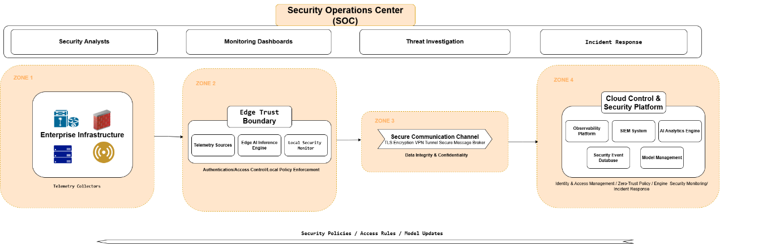
Figure 3.X — Security Architecture and Trust Boundaries of the Edge–Cloud Monitoring Platform
As shown in Figure 3.X, the architecture is organized into multiple security zones, each representing a distinct trust domain with specific security controls and responsibilities. These zones are interconnected through secure communication channels and governed by centralized security policies, enabling consistent enforcement of security requirements across distributed environments.

3.7.1 Trust Boundaries in the Edge–Cloud Architecture
The concept of trust boundaries plays a fundamental role in structuring the security architecture of the proposed platform. A trust boundary defines a logical separation between system components operating under different levels of trust, ensuring that all interactions crossing these boundaries are subject to strict security controls.
At the lowest level, the Enterprise Infrastructure zone represents the primary source of telemetry data and is considered a partially trusted or untrusted environment. This zone includes servers, network devices, IoT systems, and user endpoints that continuously generate operational and security-related data. Due to the diversity and potential exposure of these components, this environment cannot be assumed to be fully secure, necessitating the enforcement of security controls at subsequent layers.
The Edge Trust Boundary acts as the first line of defense within the architecture. Positioned between enterprise infrastructure and centralized cloud services, the edge layer enforces local security controls including authentication, access control, and policy enforcement mechanisms. Edge nodes validate incoming telemetry data, perform preliminary anomaly detection, and ensure that only authorized and properly formatted data is forwarded to higher layers of the system. This boundary reduces the attack surface by filtering and controlling interactions at the point closest to the data sources.
Between the edge and cloud environments, a secure communication boundary is established to protect data in transit. All telemetry streams, detection results, and control messages exchanged between distributed components traverse this boundary through encrypted communication channels. This ensures that data confidentiality and integrity are preserved even when transmitted across potentially untrusted networks.
At the highest level, the Cloud Trust Boundary represents the centralized control and analytics environment of the platform. This zone operates under stricter security governance and hosts critical services such as observability platforms, security analytics engines, and model management components. Access to cloud resources is tightly controlled through identity-based mechanisms, and all operations are monitored to detect unauthorized activity.
Finally, the Security Operations Center (SOC) operates as an overarching control layer that provides centralized visibility and governance across all trust zones. Through monitoring dashboards, threat investigation tools, and incident response mechanisms, the SOC ensures that security events detected at any layer of the architecture can be analyzed and addressed in a coordinated manner.
By clearly defining trust boundaries and enforcing security controls at each level of the system, the proposed architecture minimizes implicit trust relationships and ensures that all interactions are subject to verification and monitoring. This structured approach enables the platform to maintain a consistent and robust security posture across distributed edge–cloud environments.

3.7.1 Trust Boundaries in the Edge–Cloud Architecture
The concept of trust boundaries plays a fundamental role in structuring the security architecture of the proposed platform. A trust boundary defines a logical separation between system components operating under different levels of trust, ensuring that all interactions crossing these boundaries are subject to strict security controls.
At the lowest level, the Enterprise Infrastructure zone represents the primary source of telemetry data and is considered a partially trusted or untrusted environment. This zone includes servers, network devices, IoT systems, and user endpoints that continuously generate operational and security-related data. Due to the diversity and potential exposure of these components, this environment cannot be assumed to be fully secure, necessitating the enforcement of security controls at subsequent layers.
The Edge Trust Boundary acts as the first line of defense within the architecture. Positioned between enterprise infrastructure and centralized cloud services, the edge layer enforces local security controls including authentication, access control, and policy enforcement mechanisms. Edge nodes validate incoming telemetry data, perform preliminary anomaly detection, and ensure that only authorized and properly formatted data is forwarded to higher layers of the system. This boundary reduces the attack surface by filtering and controlling interactions at the point closest to the data sources.
Between the edge and cloud environments, a secure communication boundary is established to protect data in transit. All telemetry streams, detection results, and control messages exchanged between distributed components traverse this boundary through encrypted communication channels. This ensures that data confidentiality and integrity are preserved even when transmitted across potentially untrusted networks.
At the highest level, the Cloud Trust Boundary represents the centralized control and analytics environment of the platform. This zone operates under stricter security governance and hosts critical services such as observability platforms, security analytics engines, and model management components. Access to cloud resources is tightly controlled through identity-based mechanisms, and all operations are monitored to detect unauthorized activity.
Finally, the Security Operations Center (SOC) operates as an overarching control layer that provides centralized visibility and governance across all trust zones. Through monitoring dashboards, threat investigation tools, and incident response mechanisms, the SOC ensures that security events detected at any layer of the architecture can be analyzed and addressed in a coordinated manner.
By clearly defining trust boundaries and enforcing security controls at each level of the system, the proposed architecture minimizes implicit trust relationships and ensures that all interactions are subject to verification and monitoring. This structured approach enables the platform to maintain a consistent and robust security posture across distributed edge–cloud environments.

3.7.3 Identity and Access Management
A fundamental component of the proposed security architecture is the implementation of a robust Identity and Access Management (IAM) model that governs how system entities interact across the distributed edge–cloud environment. In accordance with the zero-trust security principles adopted by the platform, access to system resources is not granted based on network location or implicit trust, but instead requires continuous authentication and authorization of all entities involved in system operations.
Within the architecture, identities are assigned to all critical components, including edge nodes, cloud services, administrative users, and system applications. Each entity is uniquely identifiable and must authenticate itself before accessing system resources or participating in data exchange processes. This identity-centric approach ensures that all interactions within the system are traceable and verifiable, reducing the risk of unauthorized access and privilege misuse.
Access control policies are enforced across both the edge and cloud environments to regulate interactions between system components. At the edge level, local policy enforcement mechanisms validate incoming telemetry data and restrict access to edge services based on predefined authorization rules. This prevents unauthorized devices or compromised components from injecting malicious data into the system.
At the cloud level, a centralized policy engine governs access to critical services such as the observability platform, security analytics systems, and model management infrastructure. Access decisions are based on multiple contextual factors, including identity attributes, roles, and operational context. This enables fine-grained access control and ensures that entities are granted only the minimum privileges required to perform their functions, following the principle of least privilege.
In addition to access control, the IAM framework supports continuous monitoring of authentication and authorization activities. All access attempts and policy enforcement decisions are logged and analyzed within the security monitoring system, enabling the detection of anomalous access patterns or potential insider threats. This capability enhances the visibility of system interactions and supports proactive security management.
By integrating identity-based authentication, fine-grained access control, and continuous monitoring, the IAM model ensures that all system interactions are governed by explicit security policies rather than implicit trust assumptions. This approach strengthens the overall security posture of the platform and enables consistent enforcement of access control across distributed edge and cloud environments.

3.7.4 Threat Detection and Response Lifecycle
Beyond enforcing secure communication and access control, the proposed architecture incorporates a comprehensive threat detection and response lifecycle designed to identify, analyze, and mitigate security incidents across the distributed edge–cloud environment. This lifecycle is supported by the integration of observability systems, security analytics platforms, and centralized security operations managed through the Security Operations Center (SOC).
As illustrated in Figure 3.X, telemetry data collected from enterprise infrastructure and processed at the edge is continuously transmitted to the cloud analytics environment, where it is aggregated and analyzed by centralized monitoring and security systems. Within this environment, a Security Information and Event Management (SIEM) platform correlates events originating from multiple sources, enabling the detection of complex attack patterns and suspicious behaviors that may not be identifiable through isolated analysis.
In parallel, AI-driven analytics components enhance the detection capabilities of the system by identifying anomalies and deviations from established behavioral baselines. These intelligent detection mechanisms complement traditional rule-based approaches, allowing the system to detect both known threats and previously unseen attack patterns. The combination of event correlation and machine-learning-based analysis enables a more comprehensive and adaptive detection strategy.
Once a potential threat is identified, the architecture supports a structured response process coordinated through the SOC. Security analysts access monitoring dashboards and investigation tools to analyze detected anomalies, correlate events across system components, and determine the nature and severity of the incident. Based on this analysis, appropriate response actions can be initiated, including containment measures, policy updates, or further investigation procedures.
The architecture also supports automated response mechanisms that can be triggered at both the edge and cloud levels. At the edge, local security controls may isolate affected components or restrict suspicious activity in real time. At the cloud level, security policies and detection models can be updated and propagated across the system to prevent the recurrence of similar threats. This integration of automated and manual response capabilities enables rapid and coordinated incident management.
An important aspect of the threat response lifecycle is its integration with the adaptive learning mechanisms described in Section 3.6. Detection results and incident data generated during security operations can be fed back into the model training process, contributing to the continuous improvement of detection accuracy and system resilience.
Overall, the threat detection and response lifecycle ensures that the platform not only identifies security incidents but also provides the necessary mechanisms to analyze, contain, and adapt to evolving threats. By combining centralized security analytics, distributed detection capabilities, and coordinated response strategies, the proposed architecture establishes a robust and adaptive security monitoring framework.

3.8 DevSecOps and Automation Integration
While the previous sections described the architectural components of the proposed platform, including observability, distributed intelligence, and security enforcement, the system also incorporates a DevSecOps-driven automation layer that ensures continuous integration, secure deployment, and adaptive system evolution across edge and cloud environments.
The integration of DevSecOps principles into the architecture enables the convergence of development, security, and operational processes within a unified lifecycle. Rather than treating security as a post-deployment activity, the proposed approach embeds security validation, policy enforcement, and monitoring mechanisms throughout the entire system lifecycle. This integration ensures that infrastructure configurations, application components, and security policies are continuously validated and consistently enforced across distributed environments.
Figure X illustrates the secure DevSecOps pipeline adopted by the platform.
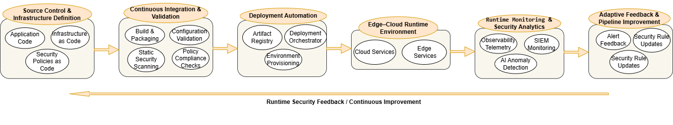
The pipeline begins with source control and infrastructure definition, where application code, infrastructure configurations, and security policies are defined using declarative approaches. These artifacts are then processed through a continuous integration and validation stage, which performs build operations alongside static security analysis, configuration validation, and policy compliance checks.
Following validation, deployment automation mechanisms orchestrate the provisioning and delivery of system components across both cloud and edge environments. This stage ensures that infrastructure resources and application services are deployed in a consistent and reproducible manner, supporting scalable system operation.
Once deployed, the system operates within a distributed edge–cloud runtime environment where services execute and generate telemetry data. This runtime layer is continuously monitored through integrated observability and security analytics mechanisms, including telemetry analysis, SIEM-based monitoring, and AI-driven anomaly detection components.
A key feature of the proposed DevSecOps integration is the incorporation of an adaptive feedback loop that connects runtime monitoring with the deployment pipeline. Security alerts, anomaly detection results, and operational insights are fed back into the pipeline to enable continuous improvement. This feedback mechanism supports the dynamic update of security policies, refinement of detection models, and adaptation of deployment configurations in response to evolving system behavior and threat conditions.
By integrating automation, security validation, and feedback-driven adaptation within a unified pipeline, the architecture ensures that the platform remains resilient, scalable, and responsive to emerging threats while maintaining consistency across distributed edge and cloud environments.
3.8.1 Infrastructure as Code and Policy Definition
The DevSecOps pipeline begins with the definition of system components and configurations using declarative approaches that enable automation, consistency, and reproducibility across the deployment lifecycle. In this stage, both infrastructure and application elements are specified as version-controlled artifacts, ensuring that system configurations can be managed, audited, and updated in a controlled manner.
Infrastructure as Code (IaC) plays a central role in this process by allowing cloud and edge resources to be provisioned through structured configuration files rather than manual setup procedures. This approach enables the automated creation of compute, storage, networking, and edge gateway resources while ensuring consistency across different deployment environments.
In parallel, application code is maintained within the same version-controlled environment, enabling tight integration between system logic and infrastructure configuration. This unified management approach facilitates coordinated updates and reduces the risk of configuration drift between development and production environments.
An important aspect of this stage is the integration of security policies as code. Security rules, access control policies, and compliance constraints are defined declaratively and managed alongside infrastructure and application artifacts. This enables automated policy enforcement during later stages of the pipeline and ensures that security requirements are consistently applied across all system components.
By combining infrastructure definitions, application logic, and security policies within a unified and version-controlled framework, this stage establishes a solid foundation for secure automation and continuous delivery within the proposed architecture.

3.8.2 Continuous Integration and Security Validation
Following the definition of infrastructure and application components, the DevSecOps pipeline incorporates a continuous integration and validation stage that ensures system artifacts are built, tested, and verified before deployment. This stage plays a critical role in maintaining system integrity by detecting configuration errors, security vulnerabilities, and policy violations at an early stage of the lifecycle.
During this phase, application components and infrastructure definitions are processed through automated build and packaging mechanisms that prepare deployable artifacts. In parallel, static security analysis techniques are applied to identify potential vulnerabilities within application code and configuration files. These checks may include the detection of insecure dependencies, misconfigurations, and violations of predefined security best practices.
In addition to code-level validation, configuration validation mechanisms are employed to ensure that infrastructure definitions are syntactically correct and aligned with the expected deployment environment. Policy compliance checks are also executed to verify that defined security rules, access control constraints, and governance policies are respected before any deployment occurs.
By integrating security validation directly into the continuous integration process, the architecture ensures that only verified and compliant artifacts progress to the deployment stage. This approach reduces the risk of introducing vulnerabilities into production environments and reinforces a proactive security posture within the overall system lifecycle.

3.8.3 Automated Deployment Across Edge and Cloud
Once system artifacts have been validated, the DevSecOps pipeline proceeds to the automated deployment stage, where infrastructure and application components are provisioned and delivered across both cloud and edge environments. This stage ensures that deployments are executed in a consistent, scalable, and reproducible manner, minimizing manual intervention and reducing operational errors.
Deployment operations are coordinated through orchestration mechanisms that manage the distribution of artifacts and the provisioning of required resources. These mechanisms enable the automated instantiation of cloud services as well as the configuration of edge nodes, ensuring that system components are correctly deployed within their respective environments.
A key characteristic of this stage is its support for distributed deployment across heterogeneous infrastructures. Cloud environments host centralized services such as analytics platforms, observability systems, and model management components, while edge environments execute localized services including telemetry collection agents and AI inference modules. The deployment process ensures that these components are correctly configured and interconnected, enabling seamless operation across the edge–cloud architecture.
Furthermore, the automated deployment pipeline supports version-controlled releases, allowing system updates to be applied incrementally without disrupting ongoing operations. This capability enables controlled rollouts, rollback mechanisms, and continuous delivery of improvements to both infrastructure and application components.
By automating the deployment process across distributed environments, the architecture ensures operational consistency, reduces deployment complexity, and supports the scalable evolution of the platform.

3.8.4 Runtime Feedback and Adaptive Pipeline Improvement
An essential component of the DevSecOps integration within the proposed architecture is the incorporation of a continuous feedback mechanism that connects runtime monitoring with the deployment pipeline. This feedback loop enables the system to adapt dynamically to operational conditions, security events, and evolving infrastructure behavior.
Once deployed, system components operating within the edge–cloud environment continuously generate telemetry data, including logs, metrics, traces, and security events. This telemetry is processed by the observability and security analytics systems, where monitoring platforms, SIEM mechanisms, and AI-driven anomaly detection components analyze system behavior in real time.
The insights generated during runtime, such as detected anomalies, security alerts, and performance deviations, are propagated back into the DevSecOps pipeline. This feedback enables the identification of potential vulnerabilities, misconfigurations, or inefficiencies that may not have been detected during earlier validation stages.
Based on these insights, updates can be applied to multiple aspects of the system. Security policies may be refined to address newly identified threats, deployment configurations can be adjusted to improve system performance or resilience, and machine-learning models may be updated to enhance detection accuracy. These updates are reintroduced into the pipeline, where they undergo validation and redeployment through the same automated lifecycle.
This continuous feedback-driven adaptation establishes a closed-loop DevSecOps model in which monitoring, analysis, and deployment are tightly integrated. By enabling the system to learn from operational data and respond to emerging conditions, the architecture enhances its resilience, maintains security compliance, and supports continuous improvement across distributed edge and cloud environments.

3.9 UML Formal Modeling
The proposed Edge–Cloud architecture is further formalized through a set of Unified Modeling Language (UML) diagrams, providing a structured representation of system functionality, component interactions, and deployment configurations. These models complement the previously described architectural layers by translating conceptual design decisions into precise and standardized visual specifications.
The objective of this section is not to restate the architecture, but to validate its structural coherence and operational logic, while establishing a clear transition toward the implementation phase. Each diagram captures a specific perspective of the system, ranging from functional interactions to runtime behavior and infrastructure deployment.
Together, these UML representations provide a blueprint for system realization, ensuring alignment between design assumptions, system workflows, and the technical implementation described in Chapter 4.

3.9.1 Use Case Diagram
The UML Use Case Diagram provides a high-level representation of the functional capabilities of the proposed platform by illustrating the interactions between system actors and core services. It defines the system boundaries and highlights how different actors engage with the platform across its main operational domains, without exposing internal implementation details.
Figure 3.X – UML Use Case Diagram of the Proposed Edge–Cloud Platform
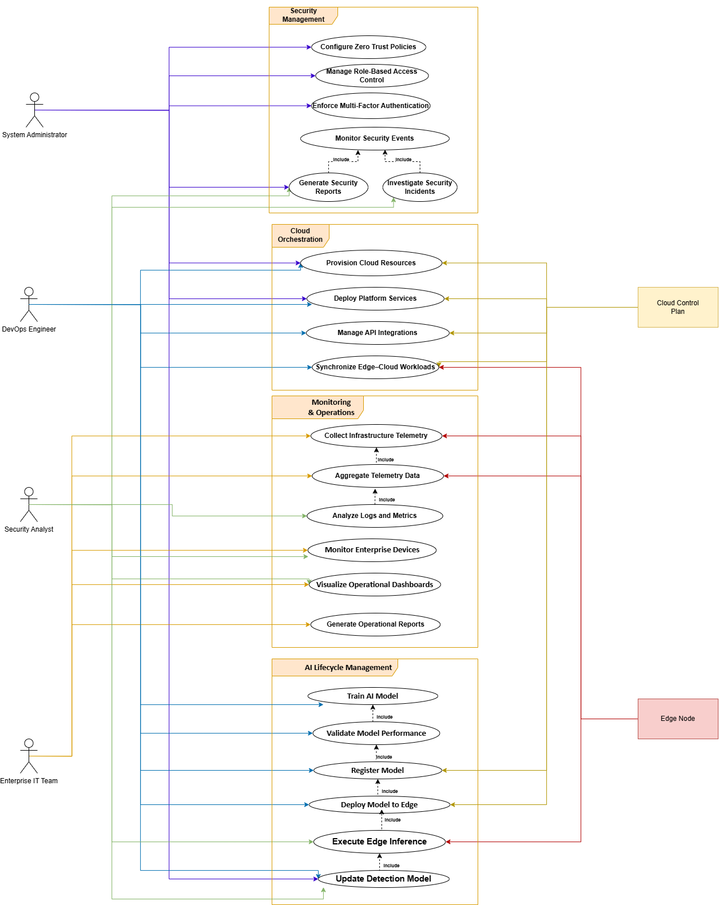
The diagram illustrates the interaction between both human and system-level actors, including administrators, DevOps engineers, edge nodes, and the cloud control plane. These interactions are organized across four primary domains: security management, cloud orchestration, monitoring and operations, and AI lifecycle management.
It demonstrates how key functionalities such as telemetry collection, anomaly detection, model training, and deployment are exposed through well-defined system services. From an implementation perspective, this diagram serves as a foundation for defining APIs, access control mechanisms, and service responsibilities, ensuring a clear mapping between system design and operational behavior.

3.9.2 Component Diagram
The UML Component Diagram provides a structural view of the proposed platform by decomposing the system into its main functional components and illustrating the relationships between them. Unlike the Use Case Diagram, which focuses on external interactions, this representation defines the internal organization of the system and how different modules collaborate to deliver core functionalities.
Figure 3.X – UML Component Diagram of the Edge–Cloud Platform
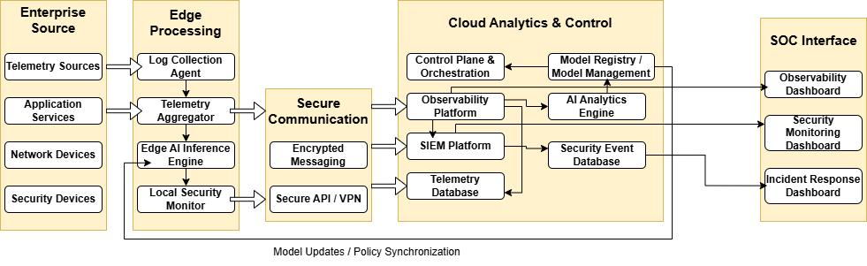
The diagram highlights the modular architecture of the system, including key components such as telemetry collection agents, data processing services, AI modules, orchestration services, and monitoring systems. It illustrates how these components interact through well-defined interfaces, enabling data exchange between the edge layer and the cloud control plane.
Special attention is given to the separation between the data plane and the control plane, ensuring a clear distinction between data processing operations and system orchestration mechanisms. Additionally, the integration of AI components within the architecture is represented through dedicated modules responsible for feature extraction, model training, validation, and inference.
From an implementation perspective, this diagram serves as a blueprint for system decomposition, guiding the development of microservices, containerized components, and inter-service communication mechanisms. It ensures that each functional block is clearly defined, independently deployable, and aligned with the overall architectural design.

3.9.3 Deployment Diagram
The UML Deployment Diagram represents the physical distribution of the system components across the underlying infrastructure. It provides a runtime perspective of the architecture by illustrating how software artifacts are deployed on hardware nodes and how these nodes communicate within the Edge–Cloud environment.
Figure 3.X – UML Deployment Diagram of the Edge–Cloud Infrastructure
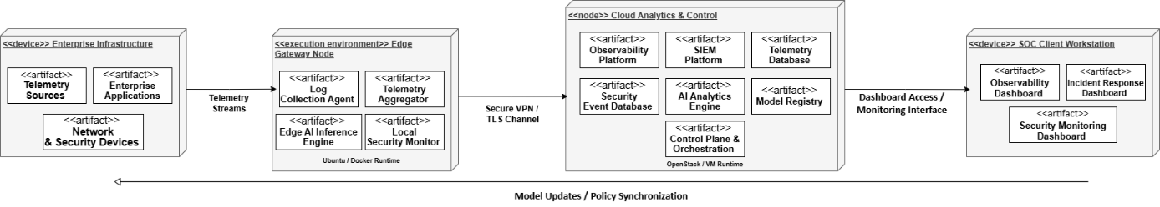
The diagram highlights the distribution of system components between edge nodes and the cloud environment. Edge nodes host lightweight services such as telemetry collection agents and local inference modules, enabling real-time data processing and low-latency anomaly detection. In contrast, the cloud layer is responsible for centralized services, including model training, orchestration, monitoring platforms, and data storage systems.
It also illustrates the communication mechanisms between distributed nodes, typically enabled through secure network channels and messaging systems. This separation ensures efficient workload distribution, scalability, and resilience across heterogeneous environments.
From an implementation perspective, the Deployment Diagram serves as a foundation for infrastructure configuration and DevOps practices, including container orchestration, virtual machine provisioning, and network configuration. It directly reflects how the system will be instantiated using technologies such as cloud platforms, edge devices, and automation tools.

3.9.4 Sequence Diagram – Telemetry Flow
The UML Sequence Diagram for telemetry flow illustrates the dynamic interaction between system components during the collection, transmission, and processing of telemetry data. It provides a time-ordered view of how data moves across the Edge–Cloud architecture, highlighting the sequence of operations involved in monitoring and anomaly detection.
Figure 3.X – Sequence Diagram of Telemetry Data Flow
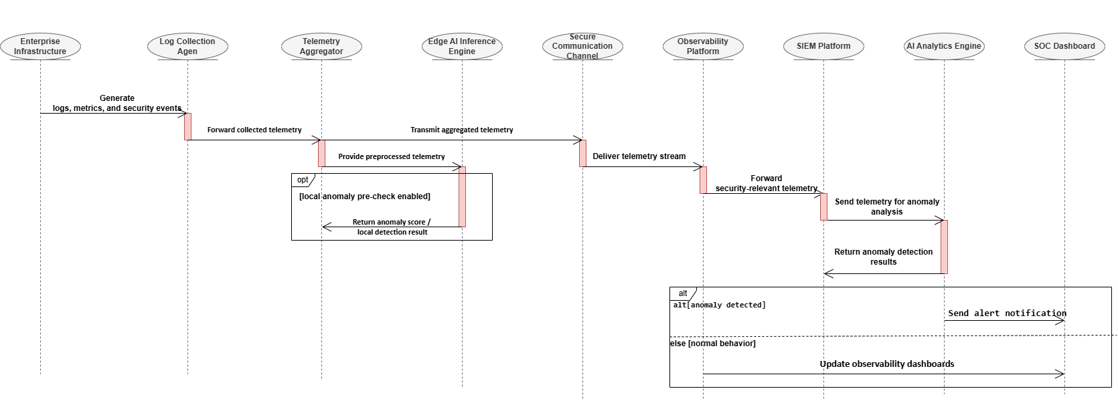
The diagram shows how telemetry data is generated at the edge nodes and collected through dedicated agents. This data is then transmitted to the cloud infrastructure, where it undergoes preprocessing and storage before being analyzed by monitoring and AI-based anomaly detection services.
The interaction sequence emphasizes the continuous nature of data flow, including real-time data ingestion, processing, and feedback mechanisms. It also reflects the role of messaging systems and APIs in enabling communication between distributed components.
From an implementation perspective, this diagram serves as a reference for designing data pipelines and communication workflows, including streaming mechanisms, data buffering strategies, and service interactions. It ensures that the system can support scalable and efficient telemetry processing while maintaining low latency and high reliability.

3.9.5 Sequence Diagram – AI Pipeline
The UML Sequence Diagram for the AI pipeline illustrates the dynamic interactions between system components involved in the machine learning lifecycle, including data preparation, model training, validation, and deployment. It provides a temporal view of how AI-related processes are orchestrated within the Edge–Cloud architecture.
Figure 3.X – Sequence Diagram of the AI Pipeline
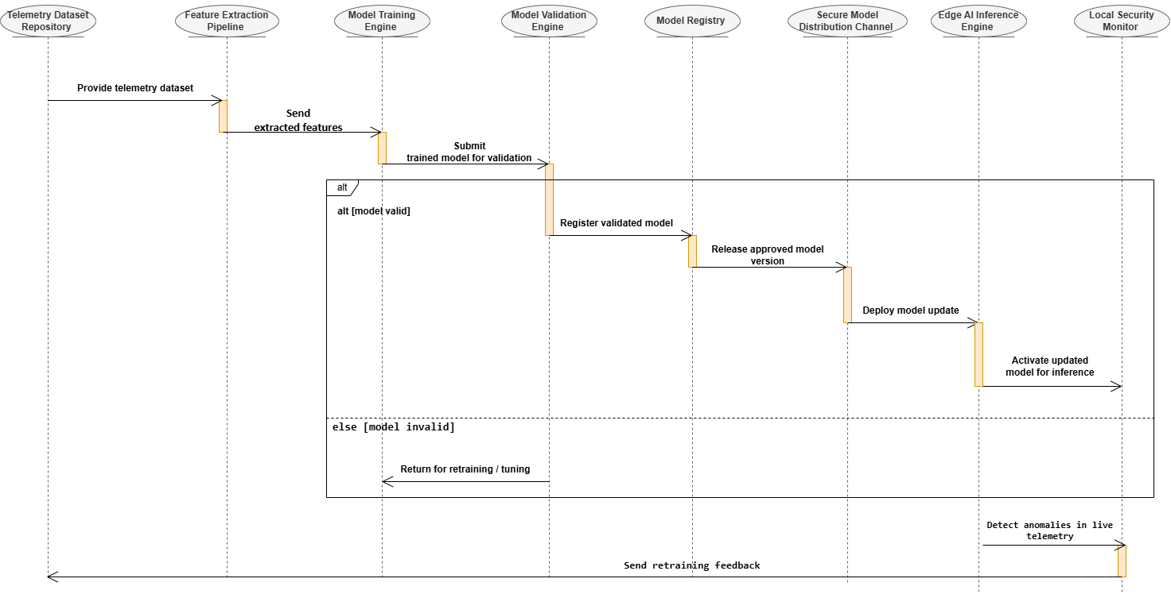
The diagram captures the flow of operations starting from data ingestion and feature extraction, followed by model training and evaluation within the cloud environment. Once validated, the trained model is deployed to the edge nodes for real-time inference. The sequence also includes feedback loops, where model performance metrics may trigger retraining processes to improve accuracy and adaptability.
Particular emphasis is placed on the interaction between different AI modules, such as feature engineering, training engines, validation components, and inference services. These interactions ensure a continuous and adaptive learning process aligned with system requirements.
From an implementation perspective, this diagram serves as a guideline for designing the AI workflow, including pipeline orchestration, model lifecycle management, and integration with data sources. It enables a clear understanding of how machine learning components are coordinated and deployed within the system.

3.9.6 Activity Diagram
The UML Activity Diagram provides a high-level representation of the overall system workflow by illustrating the sequence of activities and decision points involved in the operation of the proposed platform. It captures the logical flow of processes across both the Edge and Cloud layers, offering a global view of system behavior.
Figure 3.X – UML Activity Diagram of the Proposed System Workflow
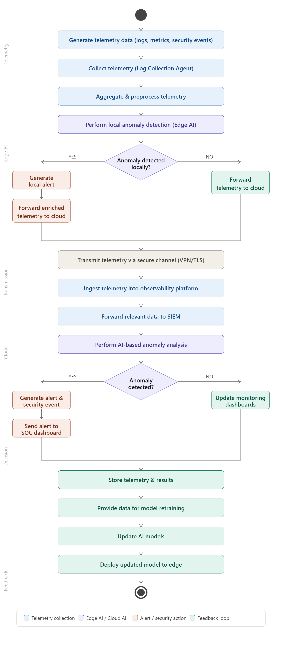
The diagram outlines the continuous cycle starting from telemetry data generation at the edge, followed by data collection, transmission, and processing within the cloud environment. It highlights key decision points, such as anomaly detection outcomes, which determine whether alerts are triggered or normal operation continues.
Additionally, the workflow integrates the AI lifecycle, including model inference at the edge and potential retraining processes in the cloud when performance degradation is detected. This creates a feedback loop that ensures the system remains adaptive and responsive to changing conditions.
From an implementation perspective, the Activity Diagram serves as a global execution blueprint, helping to coordinate system workflows, define process logic, and identify synchronization points between components. It ensures consistency between system design and runtime behavior while supporting efficient orchestration of operations.

3.10 Scalability and Resilience Engineering
Modern AI-driven monitoring systems must operate under dynamic workloads while ensuring continuous availability. In this context, scalability and resilience are critical to maintaining system performance, reliability, and fault tolerance. The proposed architecture integrates horizontal scaling, high availability, and failover mechanisms to ensure uninterrupted telemetry processing and anomaly detection.
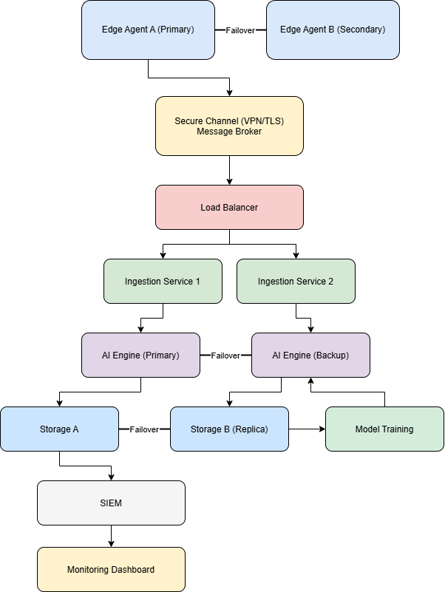
Figure 3.X: Failover Architecture for Scalable and Resilient AI-based Monitoring System

3.10.1 Horizontal Scaling
The system adopts a horizontal scaling strategy by deploying multiple instances of key components, including telemetry ingestion services and AI processing engines. Instead of relying on a single instance, workloads are distributed across replicated services using a load balancer. This approach allows the system to handle increasing volumes of telemetry data by dynamically adding new instances without impacting existing operations.
Horizontal scaling is particularly effective in cloud environments, where resources can be provisioned on demand. It ensures that the system remains responsive under high data throughput and supports future growth without architectural redesign.

3.10.2 Fault Tolerance and Failover
Fault tolerance is achieved through redundancy at multiple levels of the architecture. At the edge layer, multiple telemetry agents operate in parallel, ensuring that data collection continues even if one agent fails. In the cloud layer, critical services such as ingestion and AI engines are replicated, allowing automatic failover in case of component failure.
Failover mechanisms are implemented using load balancing and service replication. When a failure is detected, traffic is redirected to healthy instances without interrupting the data processing pipeline. Similarly, AI models are deployed in primary and backup configurations, ensuring continuous anomaly detection even during service degradation.

3.10.3 High Availability Strategy
High availability is ensured by eliminating single points of failure across the system. This is achieved through distributed deployment of services, replicated storage systems, and secure communication channels. Data persistence is maintained through storage replication, preventing data loss and enabling system recovery.
Additionally, continuous feedback loops for model retraining ensure that the AI components remain effective over time without requiring system downtime. The combination of scalable infrastructure and resilient design guarantees that the system can operate reliably in real-world production environments.

3.10.4 Link to Implementation (bridge sentence)
These design choices directly influence the implementation phase, where containerized services, load balancing mechanisms, and distributed storage solutions are configured to achieve scalability and resilience in practice.

3.11 Architectural Contribution Mapping
To ensure coherence between the literature review presented in Chapter 2 and the proposed system design, this section establishes a clear mapping between identified limitations and the architectural solutions introduced in this work. This alignment demonstrates how the proposed architecture addresses existing gaps in AI-based monitoring and security systems.

Chapter 2 Limitation | Proposed Architectural Solution | Implemented Component
Centralized processing leading to high latency | Introduction of edge-based anomaly detection | Edge AI module within telemetry agents
Limited scalability in traditional monitoring systems | Adoption of horizontally scalable microservices architecture | Load balancer + replicated ingestion services
Single point of failure in critical components | Integration of failover and redundancy mechanisms | Redundant edge agents, AI engines, and storage nodes
Lack of real-time anomaly detection | Combination of edge and cloud AI processing | Local anomaly detection + cloud AI analysis
Insufficient adaptability of AI models over time | Continuous feedback loop for model retraining | Model training and redeployment pipeline
Data loss risks in distributed systems | Use of replicated and persistent storage systems | Distributed storage (primary + replica nodes)
The mapping highlights that the proposed architecture is not only a technical design but also a targeted response to well-defined limitations in existing systems. By integrating edge intelligence, scalable cloud services, and resilient infrastructure, the system overcomes latency, scalability, and reliability challenges identified in prior work.
Furthermore, the inclusion of a feedback-driven AI lifecycle ensures continuous model improvement, addressing the common limitation of static or outdated detection models. This reinforces the system’s ability to operate effectively in dynamic and evolving environments.
This structured alignment guides the implementation phase by clearly linking each architectural decision to a specific functional component, ensuring that the system remains consistent with the research objectives and identified challenges.

3.12 Chapter Conclusion
This chapter presented the overall system architecture for the proposed AI-based telemetry monitoring and anomaly detection platform. Through a set of UML diagrams, including use case, component, deployment, sequence, and activity diagrams, the system design was progressively refined from a conceptual model to a structured and implementation-ready architecture.
The proposed design emphasizes modularity, scalability, and resilience. Key architectural decisions, such as the integration of edge and cloud AI processing, the use of horizontally scalable services, and the incorporation of failover mechanisms, ensure that the system can operate efficiently in real-time and high-volume environments. Additionally, the introduction of a continuous feedback loop enables adaptive model improvement, addressing the limitations of static AI systems.
Furthermore, the architectural contribution mapping demonstrated how the proposed solution directly responds to the limitations identified in Chapter 2, reinforcing the coherence and relevance of the design choices.Overall, this chapter establishes a solid foundation for the implementation phase. The defined architecture and design models provide clear guidance for system deployment, technology selection, and component integration, which will be detailed in the next chapter.

Chapter 4 – Implementation & Technical Realization
This chapter presents the implementation of the Edge–Cloud architecture defined in Chapter 3, transforming the proposed conceptual model into a fully operational prototype. More specifically, it operationalizes the architectural principles introduced earlier—namely distributed computing, separation of concerns between system layers, DevSecOps integration, and AI-driven observability—within a controlled experimental environment.
In direct alignment with the architectural decomposition proposed in Chapter 3, the implementation explicitly realizes the Control Plane and Data Plane separation. The Control Plane is instantiated through a centralized cloud node responsible for orchestration, monitoring, and security analytics, while the Data Plane is materialized through distributed Edge nodes that handle local data collection, preprocessing, and telemetry forwarding. This mapping ensures that the logical architecture previously defined is concretely reflected in the deployed system.
The cloud layer is implemented using an OpenStack-based infrastructure, as specified in Chapter 3, providing virtualized resource management and centralized service orchestration. In parallel, Edge nodes are deployed using Ubuntu-based environments, reflecting the lightweight and resource-constrained nature of edge computing described in the design phase. Infrastructure provisioning and configuration are automated using Ansible, thereby directly implementing the Infrastructure-as-Code (IaC) and DevSecOps principles introduced earlier.
Furthermore, the implementation integrates a comprehensive observability layer, corresponding to the monitoring and telemetry components defined in Chapter 3. This layer combines the ELK Stack and Prometheus to enable real-time log aggregation, metric collection, and system visibility across both planes. Within this context, telemetry generated at the Edge (Data Plane) is continuously transmitted to the Cloud (Control Plane), where it is processed and analyzed.
Furthermore, all Edge–Cloud telemetry traffic — including Kafka message streams — is routed through a WireGuard encrypted VPN tunnel, ensuring end-to-end encryption at both the network and application layers.
In accordance with the intelligent monitoring objective defined in Chapter 3, an AI/ML-based anomaly detection component is incorporated into the Control Plane. This component operates on aggregated logs and metrics to identify abnormal system behavior and potential security threats. By positioning the AI module at the Cloud level, the architecture ensures centralized intelligence while preserving lightweight processing at the Edge, thereby maintaining consistency with the Edge–Cloud distribution strategy.
Additionally, DevSecOps principles are concretely implemented through automated deployment workflows, continuous monitoring pipelines, and security enforcement mechanisms aligned with a zero-trust model. Each implemented component is therefore not only functional but also traceable to a specific architectural element defined in Chapter 3, ensuring full design-to-implementation coherence.
Finally, this chapter demonstrates how the developed prototype validates the feasibility of the proposed architecture by faithfully reproducing its structural, functional, and security characteristics within a practical deployment scenario.

4.1 Environment Setup
The implementation environment was designed to faithfully reproduce the Edge–Cloud IaaS architecture defined in Chapter 3, while remaining compatible with the practical constraints of an academic experimental setting. As established in Chapter 1, a virtualized environment was selected as an appropriate approach for validating distributed architectures without requiring access to enterprise-grade physical infrastructure.
To ensure consistency with the architectural model, the environment explicitly implements the two-layer structure (Edge / Cloud) introduced in Chapter 3. This is achieved using VMware Workstation 17 Pro as the virtualization platform, enabling the creation of isolated and fully configurable virtual machines that emulate real-world distributed system behavior.
The experimental setup consists of two virtual machines representing the minimal viable instantiation of the architecture:
- A Cloud/Control Plane node, responsible for centralized orchestration, observability, and AI-driven security analysis
- An Edge Gateway node, responsible for Data Plane operations including telemetry collection, preprocessing, and secure data forwarding
This configuration directly reflects the Control Plane / Data Plane separation defined in Chapter 3 and enables end-to-end validation of data flows, monitoring pipelines, and security mechanisms across the system.

4.1.1 Virtual Machine Infrastructure
The experimental infrastructure comprises two virtual machines provisioned according to their respective roles within the architecture, thereby concretely implementing the resource distribution strategy defined in Chapter 3.
Both machines run Ubuntu Server 22.04.5 LTS, selected for its long-term stability and full compatibility with the technology stack identified during the design phase, including OpenStack (via Kolla-Ansible), Docker, ELK Stack, Wazuh, and Prometheus. This choice ensures coherence between the technology selection in Chapter 3 and its practical realization.
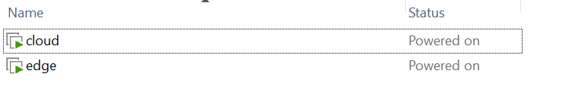
Figure 4.1 — VMware Workstation
VM1 — Cloud/Control Plane Node
The first virtual machine, identified by the hostname cloud, implements the Control Plane layer defined in Chapter 3.
It is responsible for:
- Centralized orchestration (OpenStack services)
- Log aggregation and indexing (ELK Stack)
- Security monitoring (Wazuh Manager)
- Data streaming and processing (Kafka)
- AI-based anomaly detection (Control Plane intelligence layer)
This node is provisioned with higher computational resources (15 GB RAM, 4 vCPU), reflecting its role as the central intelligence and processing hub of the system. This allocation is consistent with the architectural requirement that the Control Plane handles computation-intensive tasks such as analytics, correlation, and anomaly detection.
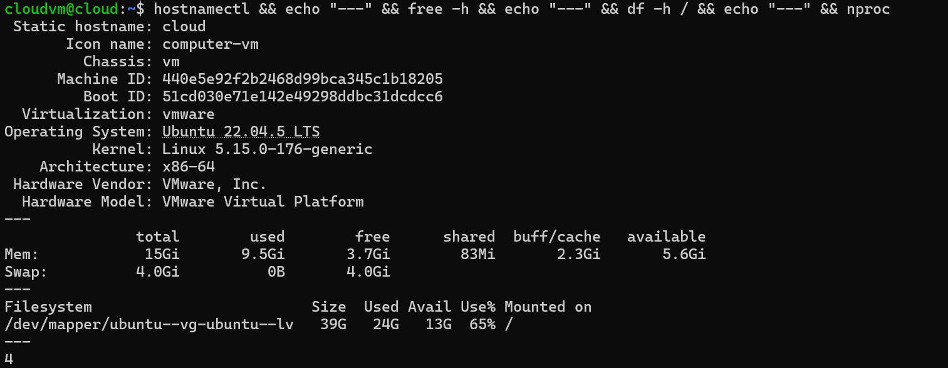
Figure 4.2 — VM1 system profile
VM2 — Edge Gateway Node
The second virtual machine, identified by the hostname edge, implements the Data Plane layer described in Chapter 3.
It is responsible for:
- Local data collection (logs and metrics)
- Lightweight preprocessing
- Secure telemetry forwarding to the Cloud
- Execution of monitoring agents (Filebeat, Metricbeat, Wazuh Agent)
The node is provisioned with reduced resources (7.7 GB RAM, 2 vCPU), reflecting the resource-constrained nature of Edge environments emphasized in the architectural design. This validates the design assumption that Edge nodes should remain lightweight while offloading heavy computation to the Control Plane.

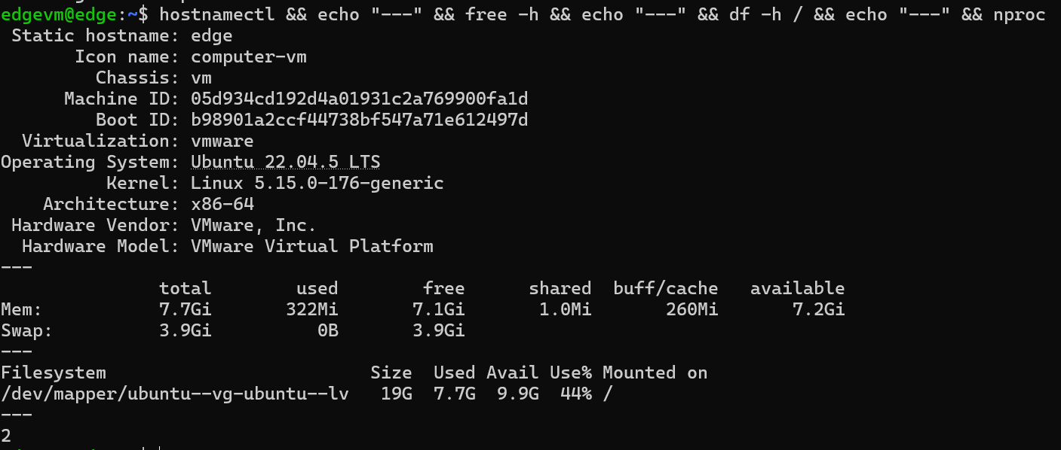
Figure 4.3 — VM2 system profile
The table below summarizes the infrastructure configuration of both nodes and highlights their direct correspondence with the architectural roles defined in Chapter 3.
Parameter | VM1 — Cloud Node | VM2 — Edge Node
Hostname | cloud | edge
Operating System | Ubuntu 22.04.5 LTS | Ubuntu 22.04.5 LTS
Kernel | 5.15.0-176-generic | 5.15.0-176-generic
RAM | 15 GB | 7.7 GB
vCPU Cores | 4 | 2
Disk Storage | 39 GB | 19 GB
Virtualization | VMware | VMware
Architecture | x86-64 | x86-64
Role | Cloud/Control Plane | Edge Gateway

4.1.2 Network Configuration
The network architecture was designed to ensure secure and efficient communication between the Edge and Cloud components while maintaining a clear separation between external access and internal system interactions.
To achieve this, a dual-network topology was implemented, consisting of:
- An external network (NAT) providing internet access for package installation, container image retrieval, and external service communication
- An internal isolated network (Host-only) dedicated to inter-node communication, ensuring that telemetry data exchanged between the Edge and Cloud remains within a controlled environment
This separation improves both security and system organization by isolating internal data flows from external exposure.
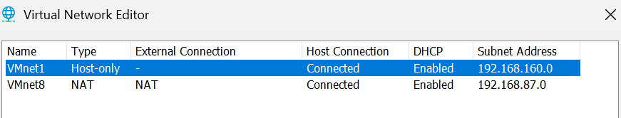
Figure 4.4 — VMware Virtual Network Editor
As illustrated in Figure 4.4, the virtual networking setup relies on two VMware network segments. The NAT network (VMnet8) enables internet connectivity for both virtual machines, while the Host-only network (VMnet1), configured on the subnet 192.168.160.0/24, provides a private communication channel used exclusively for data exchange between the two nodes.
VM1 Network Interfaces
As shown in Figure 4.5, the Cloud node is configured with two network interfaces serving distinct roles.The interface ens33 (192.168.87.132/24) is connected to the NAT network and provides external connectivity. It acts as the main access point for cloud services such as Kibana, Elasticsearch, Wazuh Manager, and the OpenStack dashboard.The interface ens34 (192.168.160.130/24) is connected to the Host-only network and is dedicated to internal communication with the Edge node. This interface is used to receive telemetry data, logs, and monitoring information.In addition, a virtual IP address (192.168.87.200) is configured on the NAT interface to support high availability for OpenStack services.
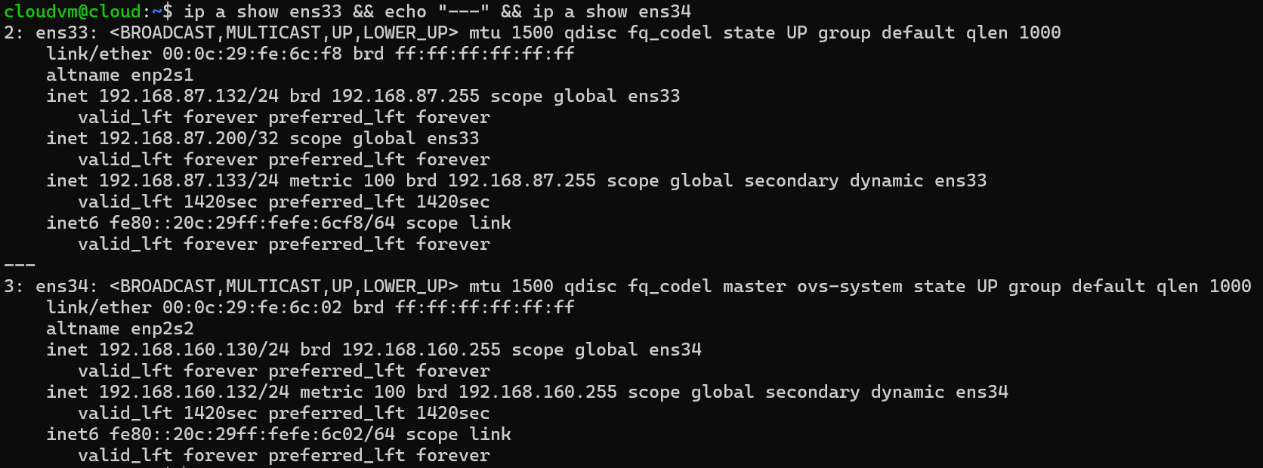
Figure 4.5 — VM1 network interface
VM2 Network Interfaces
Similarly, as illustrated in Figure 4.6, the Edge node is also configured with two interfaces.The interface ens33 (192.168.87.131/24) provides internet access and enables outbound communication toward cloud services.The interface ens34 (192.168.160.131/24) is dedicated to internal communication and is used by monitoring agents such as Filebeat, Metricbeat, and Wazuh Agent to transmit logs, metrics, and security events to the Cloud node.
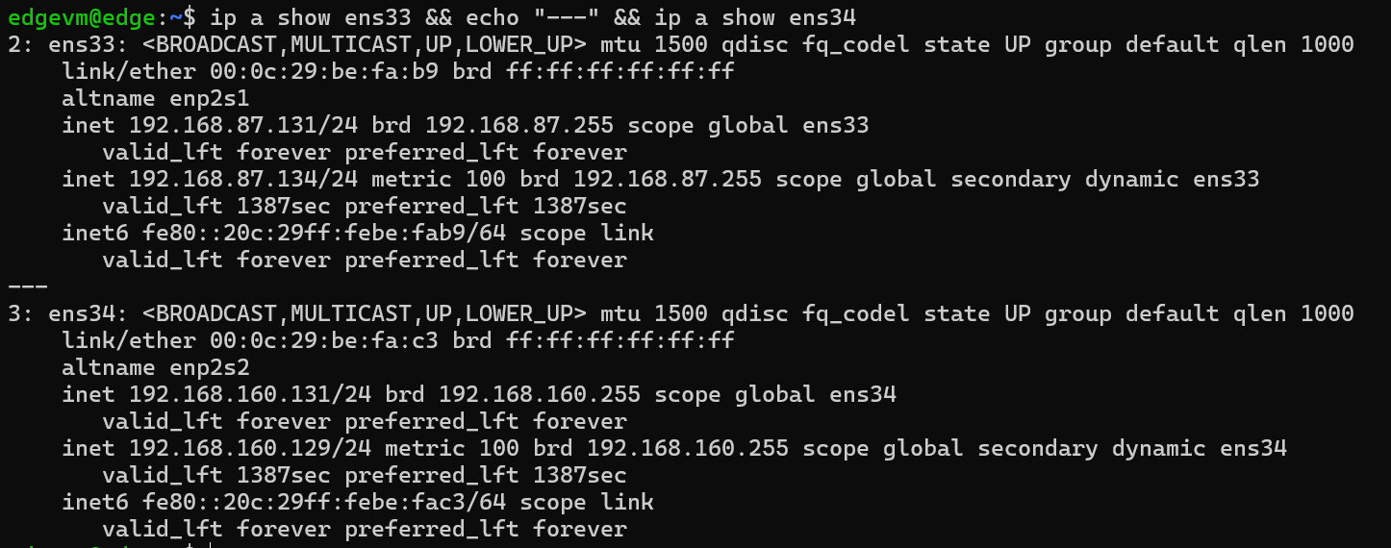
Figure 4.6 — VM2 network interface
The complete network addressing plan is summarized in the following table:
Interface | VM1 (Cloud) | VM2 (Edge) | Purpose
ens33 | 192.168.87.132 | 192.168.87.131 | NAT — Internet access
ens34 | 192.168.160.130 | 192.168.160.131 | Host-only — Internal communication
VIP | 192.168.87.200 | — | OpenStack HA Virtual IP
Connectivity Validation
To verify the correctness of the configuration, connectivity tests were performed from the Edge node.
As shown in Figure 4.7, communication with the Cloud node is stable, with 0% packet loss and low latency (≈1.24 ms), confirming reliable internal communication. Connectivity to external networks is also successfully established, with acceptable latency (≈40.5 ms).
These results confirm that the network setup provides a stable foundation for service deployment and data exchange between system components.
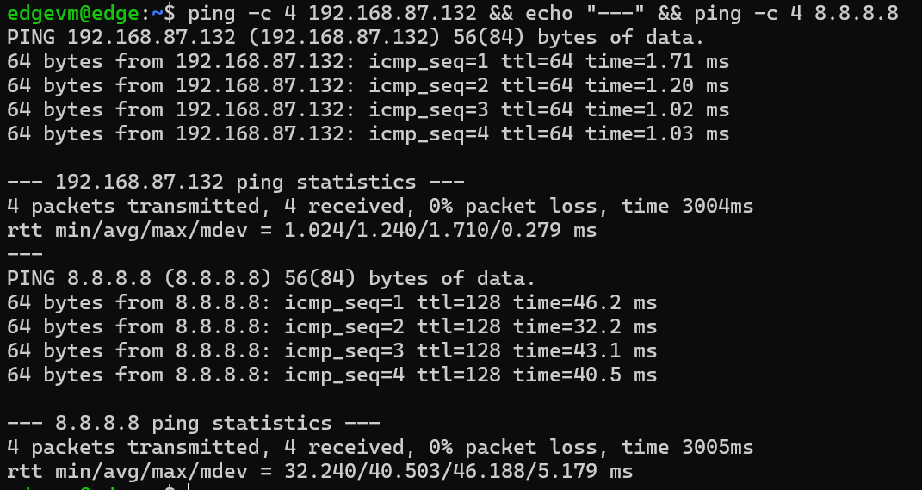
Figure 4.7 — Connectivity validation: Edge-to-Cloud ping (1.24ms) and Edge-to-Internet ping (40.5ms)

4.2 Cloud Infrastructure Deployment
This phase operationalizes the centralized control plane defined in Chapter 3, translating the conceptual architecture into a concrete deployment on VM1. As specified in Section 3.X (Architecture Design), the control layer is responsible for orchestration, observability, security monitoring, and inter-component communication across the system.
Accordingly, this implementation instantiates the four core subsystems previously identified:
- an Infrastructure-as-a-Service (IaaS) layer based on OpenStack,
- a centralized logging and observability stack built on the ELK suite,
- a Security Information and Event Management (SIEM) platform powered by Wazuh,
- and a distributed messaging backbone implemented using Apache Kafka.
These components collectively form the foundational backbone of the architecture, upon which all edge-layer services (deployed on VM2) depend for coordination, monitoring, and secure data exchange.

4.2.1 Container Runtime Deployment
In alignment with the containerization strategy defined in Chapter 3, Docker was first deployed as the unified container runtime on VM1. This step establishes the execution environment required to host all control-plane services as isolated, reproducible, and manageable units.
Docker Engine (version 29.4.0) and Docker Compose (version v5.1.2) were installed from the official APT repository, as illustrated in Figure 4.8.
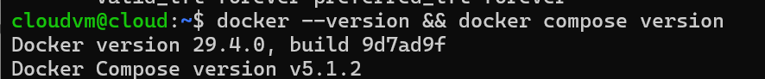
Figure 4.8 — Docker Engine 29.4.0

To ensure operational continuity and secure access, the Docker daemon was configured to start automatically at system boot. Additionally, the system user was added to the Docker group, enabling non-privileged interaction with containers. This configuration supports efficient service management while maintaining adherence to least-privilege principles.

4.2.2 OpenStack IaaS Platform — Kolla-Ansible Deployment
Consistent with the Infrastructure-as-a-Service layer specified in Chapter 3, OpenStack was deployed using Kolla-Ansible. This deployment approach encapsulates OpenStack services within Docker containers and orchestrates them through Ansible, thereby aligning with the Infrastructure-as-Code (IaC) and DevSecOps principles underpinning the proposed architecture.
Deployment Methodology
The deployment follows an all-in-one topology, where all OpenStack services are hosted on a single node (VM1), as defined in the experimental setup of Chapter 3. To ensure dependency isolation, a dedicated Python virtual environment was created for Kolla-Ansible.
The source code was retrieved from the official OpenStack repository (stable/2024.2 branch), ensuring compatibility with the current stable release.
The deployment pipeline was executed in three structured phases:
- Bootstrap phase: preparation of the host environment, including dependency installation, Docker configuration, and Ansible setup.
- Prechecks phase: validation of system readiness, including network interfaces, hostname resolution, and port availability.
- Deploy phase: automated provisioning of all OpenStack services as containerized workloads.
The prechecks phase completed successfully with zero failures across 101 validation tasks. The deployment phase executed 377 tasks, resulting in 232 configuration changes and zero failures, confirming a consistent and error-free deployment.
The primary configuration parameters defined in the globals.yml file are summarized below:
Parameter | Value | Purpose
kolla_base_distro | ubuntu | Base container image distribution
network_interface | ens33 | Primary API network interface
neutron_external_interface | ens34 | Neutron external network interface
ökolla_internal_vip_address | 192.168.87.200 | OpenStack HA virtual IP address
api_interface | ens33 | API service binding interface
tunnel_interface | ens33 | Neutron tunnel network interface
Service Verification
To validate consistency with the architecture defined in Chapter 3, the OpenStack service catalog was queried using the OpenStack client. As shown in Figure 4.9, all core services required for cloud orchestration were successfully registered, including Keystone, Nova, Neutron, Glance, Placement, Heat, and Heat-CFN.
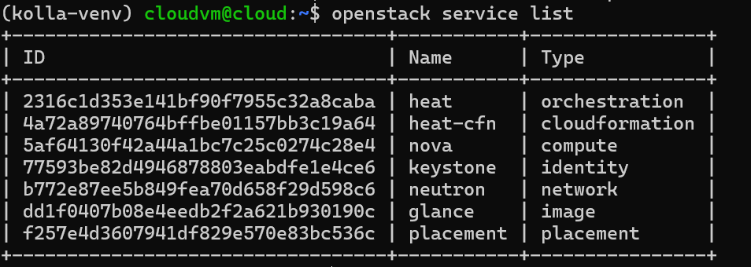
Figure 4.9 — OpenStack service catalog confirming 7 registered services
At the container level, all OpenStack services were verified to be in a healthy state, as illustrated in Figure 4.10. These include multiple Nova, Neutron, Keystone, and supporting infrastructure components such as RabbitMQ, MariaDB, and HAProxy.
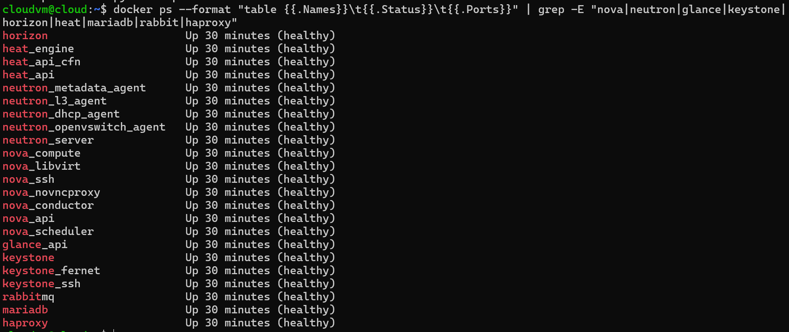
Figure 4.10 — All OpenStack containers in healthy state on VM1
The OpenStack Horizon dashboard, accessible via the configured virtual IP address, provides a graphical interface for infrastructure management, as shown in Figure 4.11.
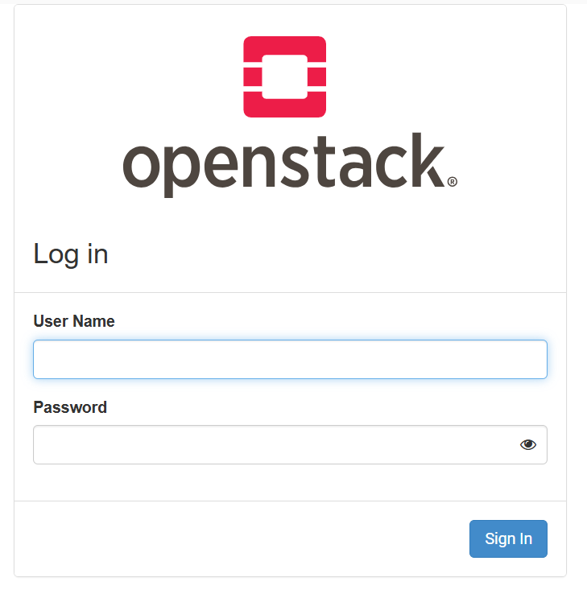
Figure 4.11 — OpenStack Horizon dashboard login interface

4.2.3 ELK Stack Deployment — Centralized Log Management
In accordance with the observability layer defined in Chapter 3, the ELK Stack — comprising Elasticsearch, Logstash, and Kibana — was deployed as the centralized log aggregation, processing, and visualization platform of the control plane. This subsystem fulfills the requirement for unified telemetry collection by ingesting log streams from distributed edge components and transforming them into searchable and analyzable data.
The stack was deployed as a set of Docker containers orchestrated via Docker Compose, using version 8.13.0 across all components to ensure API and schema consistency. Elasticsearch was configured in single-node discovery mode, consistent with the all-in-one deployment model introduced in Chapter 3, with HTTP-based authentication enabled to secure all REST interactions.
To enforce secure inter-service communication, a dedicated password was assigned to the built-in elastic superuser account, while a Kibana service account token was provisioned to avoid direct exposure of privileged credentials. Additionally, the Java Virtual Machine heap size for Elasticsearch was configured to 2 GB, ensuring stable indexing performance under sustained ingestion workloads.
Logstash was configured with a dual-input pipeline aligned with the data ingestion strategy defined earlier:
- a Beats input (port 5044) for structured logs forwarded by Filebeat agents deployed on edge nodes,
- and a UDP input (port 5000) for JSON-formatted syslog events.
All incoming events are indexed in Elasticsearch using a daily rolling pattern (logs-YYYY.MM.dd), enabling efficient time-based partitioning and optimized historical querying.
As illustrated in Figure 4.12, all ELK containers are operational with correctly exposed service ports: Elasticsearch (9200), Logstash (5044 and 5000/UDP), and Kibana (5601).
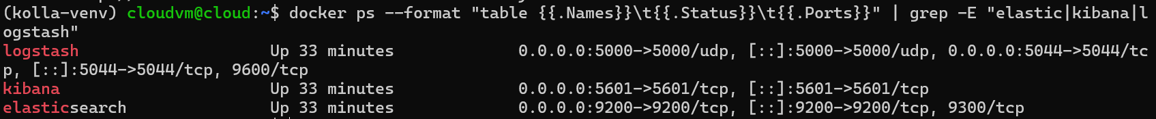
Figure 4.12 — ELK Stack containers running with exposed service ports
Cluster health was validated via the Elasticsearch REST API. As shown in Figure 4.13, the cluster reports a green status with 28 active primary shards, 100% shard availability, zero unassigned shards, and no pending tasks, confirming a fully operational indexing system.
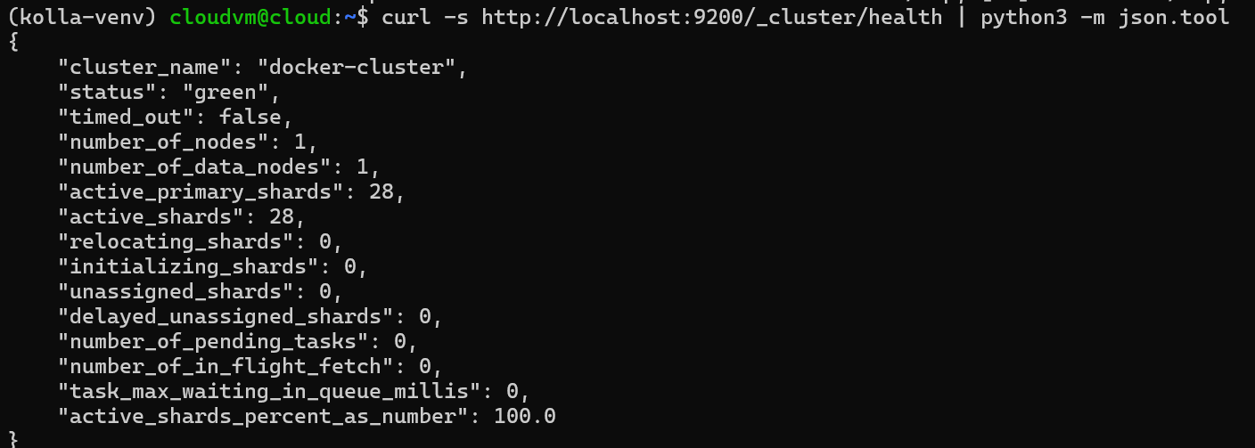
Figure 4.13 — Elasticsearch cluster health: green status, 28 active shards, 100% availability
The Kibana web interface, accessible via the configured endpoint, was successfully reached from the host machine, as depicted in Figure 4.14, confirming end-to-end observability pipeline functionality.

Figure 4.14 — Kibana web interface accessible at port 5601

4.2.4 Wazuh Manager Deployment — Security Information and Event Management
Consistent with the security monitoring layer specified in Chapter 3, the Wazuh Manager was deployed as the centralized Security Information and Event Management (SIEM) component of the control plane. This subsystem provides unified threat detection, file integrity monitoring, vulnerability assessment, and security configuration auditing across all edge nodes.
Within the proposed architecture, the Wazuh Manager operates as the central aggregation and analysis point for security events generated by Wazuh Agents deployed at the edge layer. This design enables real-time security visibility and centralized enforcement of security policies, as outlined in the system architecture.
Version 4.7.0 of the Wazuh Manager was deployed as a standalone Docker container with persistent storage volumes configured for configuration data, logs, event queues, and agent management state. This ensures durability and continuity of security monitoring operations across service restarts.
The container exposes four primary service ports aligned with the architecture requirements:
- 1514/TCP for agent event ingestion,
- 1515/TCP for agent enrollment and authentication,
- 514/UDP for syslog event collection,
- 55000/TCP for REST API access.
As shown in Figure 4.15, the Wazuh Manager container is fully operational, with all service ports correctly bound and accessible. This confirms readiness for subsequent integration with edge-side agents in the next deployment phase.
.
Figure 4.15 — Wazuh Manager container running with agent enrollment and event reception ports)

4.2.5 Kafka Message Broker Deployment
Apache Kafka was deployed as the distributed messaging backbone responsible for decoupling telemetry producers at the Edge layer from consumers at the Cloud layer. This architectural decision addresses a critical operational concern: direct log forwarding from Edge nodes to Elasticsearch under high-throughput conditions can overwhelm the indexing pipeline, introducing latency and potential data loss. By interposing Kafka as a durable, fault-tolerant message buffer, the architecture ensures that telemetry streams are reliably queued and consumed at a controlled rate, regardless of transient load spikes.
The deployment comprises two containerized services: Apache ZooKeeper for distributed coordination and broker metadata management, and the Kafka broker itself. Both services were deployed using Confluent Platform version 7.5.0 via Docker Compose. The Kafka broker is configured with a single-node topology appropriate for the experimental scale, with auto topic creation enabled and the advertised listener bound to 192.168.87.132:9092 — making the broker reachable from Edge nodes over the NAT network interface.
As illustrated in Figure 4.16, both the Kafka broker and ZooKeeper coordinator containers are operational, with Kafka exposing its client listener on port 9092 and ZooKeeper exposing its ensemble ports on 2181, 2888, and 3888.
(Figure 4.16 — Kafka broker and ZooKeeper containers running with respective service ports)

4.2.6 Cloud Infrastructure Deployment Summary
The successful completion of this deployment phase establishes a fully operational Cloud/Control Plane infrastructure on VM1. Figure 4.17 presents a consolidated view of all deployed services, confirming concurrent operation of the complete cloud-side stack.iopöä
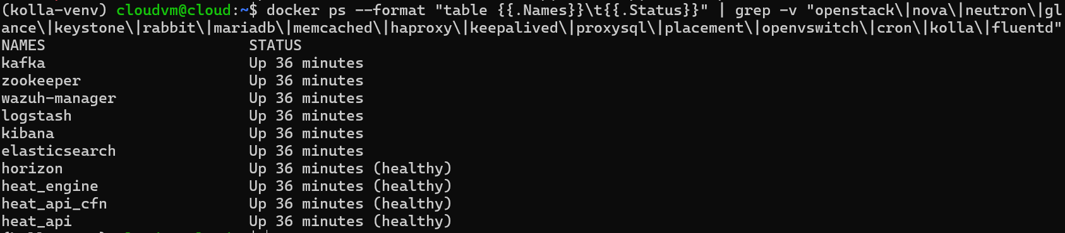
Figure 4.17 — Consolidated view of all Cloud Infrastructure services running on VM1
The following table summarizes the complete service inventory deployed on the Cloud/Control Plane node
Service | Technology | Version | Port(s) | Role
IaaS Platform | OpenStack (Kolla-Ansible) | 2024.2 | 80, 5000, 8774, 9696 | Cloud infrastructure
Log Storage | Elasticsearch | 8.13.0 | 9200 | Log indexing & search
Log Processing | Logstash | 8.13.0 | 5044, 5000/UDP | Log parsing & routing
Visualization | Kibana | 8.13.0 | 5601 | Dashboard & analytics
SIEM | Wazuh Manager | 4.7.0 | 1514, 1515, 55000 | Security event management
Message Broker | Apache Kafka | 7.5.0 | 9092 | Telemetry buffering
Coordination | Apache ZooKeeper | 7.5.0 | 2181 | Kafka coordination
This infrastructure layer provides the complete reception, processing, and visualization capability required to support Edge Gateway deployment phase, where telemetry agents will be configured to forward logs, metrics, and security events to their respective cloud-side receivers.
4.3 Edge Gateway
The third implementation phase focused on the deployment of the Edge Gateway node on VM2, transforming it into an intelligent, autonomous data collection and security monitoring endpoint. This phase operationalizes the edge layer of the proposed architecture by establishing a complete telemetry pipeline capable of collecting system logs, infrastructure metrics, and security events, and forwarding them in real time to their respective cloud-side receivers deployed during the preceding phase. The edge deployment encompasses five functional layers: containerized sample services for workload simulation, a log shipping pipeline based on Filebeat, a custom metrics collection engine, a security monitoring agent based on Wazuh, and an observability stack built on Prometheus and Node Exporter.

4.3.1 Container Runtime Deployment on the Edge Node
Following the same containerization strategy adopted for the Cloud node, Docker Engine was deployed on VM2 as the primary container runtime. The installation procedure mirrored that of VM1, with Docker Engine version 29.4.0 and Docker Compose version v5.1.3 installed via the official Docker APT repository. The Docker daemon was configured with explicit DNS resolvers to ensure reliable container networking within the edge environment, and the operating system user was granted non-privileged access to the Docker socket to facilitate container lifecycle management without requiring elevated privileges during routine operations.

4.3.2 Sample Service Deployment — Workload Simulation
To provide a realistic source of operational telemetry on the Edge node, a set of three containerized sample services was deployed via Docker Compose, simulating the heterogeneous workload profile typical of an enterprise edge environment.
The first service, nginx, deploys the NGINX web server and exposes HTTP traffic on port 80, continuously generating access logs and error logs that constitute the primary log stream consumed by the Filebeat agent. The second service, syslog-generator, is a lightweight Alpine Linux container executing a continuous shell loop that emits structured log messages at regular five-second intervals, simulating the heartbeat telemetry and event notifications characteristic of edge-deployed IoT and enterprise applications. The third service, test-app, is a BusyBox-based container that simulates a minimal application process, contributing additional log output to the container logging subsystem.
As confirmed in Figure 4.18, all three sample services are operational on VM2, with nginx correctly exposing its HTTP listener on port 80 and the remaining services maintaining continuous uptime.
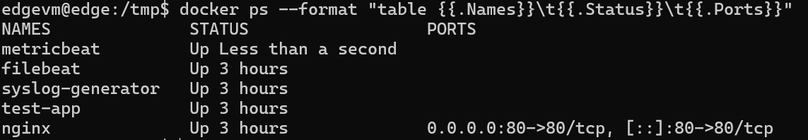
(Figure 4.18 — Edge node Docker containers: nginx, syslog-generator, test-app, filebeat, and metricbeat running)

4.3.3 Log Collection and Forwarding — Filebeat Pipeline
Filebeat version 8.13.0 was deployed as a privileged Docker container on VM2, serving as the primary log collection and forwarding agent of the edge telemetry pipeline. Filebeat operates by continuously tailing log sources, parsing log entries, and shipping them over the network to the Logstash ingestion endpoint on VM1.
The Filebeat configuration defines two input sources. The first is a container input that monitors the Docker container log directory (/var/lib/docker/containers/*/*.log), capturing all stdout and stderr output from every containerized service running on the edge node, enriched with Docker metadata including container name, image, and labels. The second is a log input that directly monitors the host system log files /var/log/syslog and /var/log/auth.log, capturing operating system-level events including authentication attempts, service state changes, and kernel messages. All collected log entries are forwarded to the Kafka broker via the WireGuard VPN tunnel at 10.0.0.1:9093 using the Lumberjack protocol, which provides reliable, acknowledgment-based delivery over TCP.
The effectiveness of the log forwarding pipeline was validated on the Cloud node by querying the Elasticsearch index catalog. As shown in Figure 4.19, the indices logs-2026.04.22 and logs-2026.04.23 contain 43,215 and 342 indexed log documents respectively, confirming continuous and reliable log ingestion from the Edge node to the centralized Elasticsearch cluster.
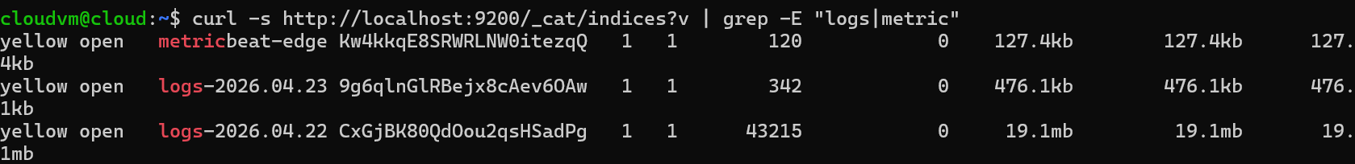
(Figure 4.19 — Elasticsearch indices confirming 43,215+ log documents ingested from Edge Filebeat pipeline)

4.3.4 Metrics Collection — Metricbeat Deployment
Metricbeat version 8.13.0 was deployed as a Docker container on VM2, serving as the primary infrastructure metrics collection agent of the edge telemetry pipeline. As the official Elastic metrics shipper, Metricbeat provides comprehensive system and container observability by collecting hundreds of metrics from multiple sources and forwarding them directly to the Elasticsearch cluster on VM1.
The deployment was made possible by retrieving the official Metricbeat Docker image on the host machine and transferring it to VM2 via SCP, bypassing network-level restrictions that prevented direct registry access from within the virtual machine environment. The image was loaded into the local Docker registry using the docker load command, after which the container was deployed via Docker Compose with full access to the host system resources required for metric collection.
The Metricbeat configuration defines two collection modules operating at 30-second intervals. The system module collects nine metric categories from the host operating system: CPU utilization, memory consumption, network interface statistics, disk I/O throughput, filesystem utilization, individual process metrics, process summary statistics, system uptime, and system load averages. The Docker module connects to the Docker socket at unix:///var/run/docker.sock to collect container-level metrics including per-container CPU, memory, disk I/O, and network usage for all running containers on the Edge node.
All collected metrics are serialized forwarded to the Kafka broker via the WireGuard VPN tunnel at 10.0.0.1:9093, indexed under a daily data stream pattern (metricbeat-YYYY.MM.dd). A custom index template named metricbeat was automatically loaded during initialization to ensure correct field mapping and schema compatibility with the Elasticsearch 8.13.0 cluster.
As confirmed by querying the Elasticsearch index catalog, the official Metricbeat data stream ds-metricbeat-2026.04.26 contains 1,118 indexed metric documents as illustrated in Figure 4.19, demonstrating successful and continuous metric ingestion from the Edge node to the centralized Elasticsearch cluster across all configured system and Docker metric categories.
(Figure 4.19 updated — Elasticsearch indices showing 1,118 Metricbeat documents and 811 legacy metrics)

4.3.5 Security Monitoring — Wazuh Agent Enrollment
The Wazuh Agent version 4.7.0 was installed directly on the VM2 host operating system as a native system service, providing comprehensive security monitoring capabilities at the edge layer. The agent was configured to communicate with the Wazuh Manager deployed on VM1 at 192.168.87.132, utilizing port 1514/TCP for encrypted security event transmission and port 1515/TCP for automated certificate-based enrollment.
Upon installation and service activation, the Wazuh Agent spawned five concurrent monitoring processes as shown in Figure 4.20: wazuh-execd for active response execution, wazuh-agentd for secure manager communication, wazuh-syscheckd for file integrity monitoring, wazuh-logcollector for local log analysis, and wazuh-modulesd for vulnerability detection and system inventory collection. The agent service was configured for automatic startup via systemd, ensuring continuous security monitoring across system reboots.
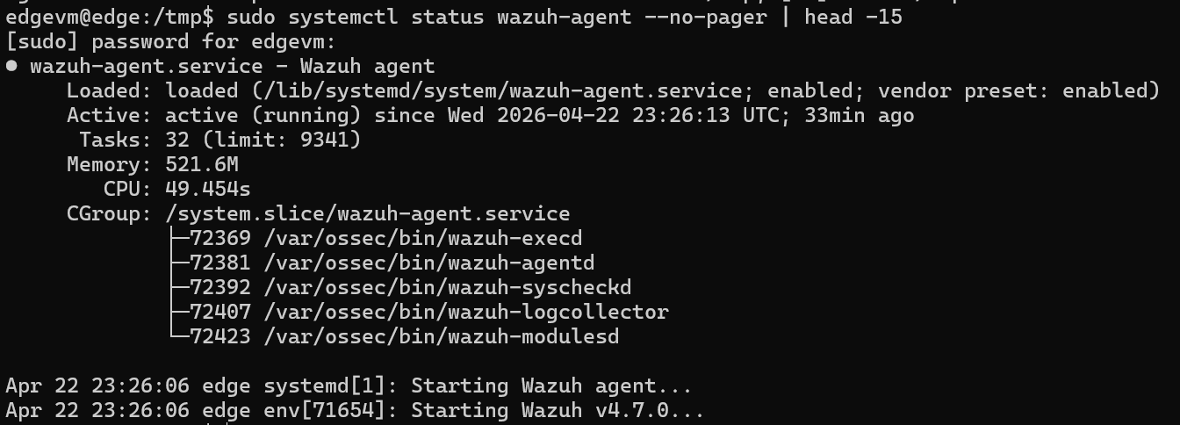
(Figure 4.20 — Wazuh Agent active status showing all 5 monitoring processes running on VM2)
The successful enrollment of the Edge node was verified from the Cloud side by querying the Wazuh Manager's agent registry. As illustrated in Figure 4.21, the agent registry confirms the registration of the Edge node as Agent ID 001, with hostname edge and connection status Active, confirming bidirectional communication between the Edge agent and the Cloud-side SIEM platform.
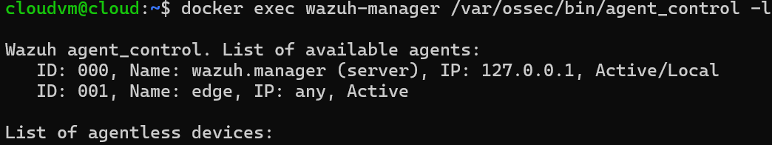
Figure 4.21 — Wazuh Manager agent registry confirming Edge node enrolled as Agent ID 001, status Active)

4.3.6 Observability Stack — Prometheus and Node Exporter
To complement the log-based observability provided by Filebeat and Metricbeat, a Prometheus-based metrics scraping infrastructure was deployed on VM2 using native binary installations, bypassing the Docker Hub registry restriction entirely. Node Exporter version 1.8.0 and Prometheus version 2.51.0 were retrieved as pre-compiled Linux binaries from the official Prometheus GitHub release repository and installed to /usr/local/bin/, with corresponding systemd service units configured for automatic lifecycle management.
Node Exporter exposes over 700 system-level metrics at the /metrics endpoint on port 9100, covering CPU performance counters, memory allocation statistics, disk I/O throughput, network interface traffic, filesystem utilization, and process-level statistics. Prometheus is configured to scrape this endpoint at 15-second intervals, storing collected time-series data in a local TSDB (Time Series Database) at /home/edgevm/prometheus/data.
As confirmed in Figure 4.22, both Prometheus and Node Exporter are active and running as systemd services, with memory footprints of 22.2 MB and 8.4 MB respectively — demonstrating the lightweight operational profile appropriate for edge-constrained environments.
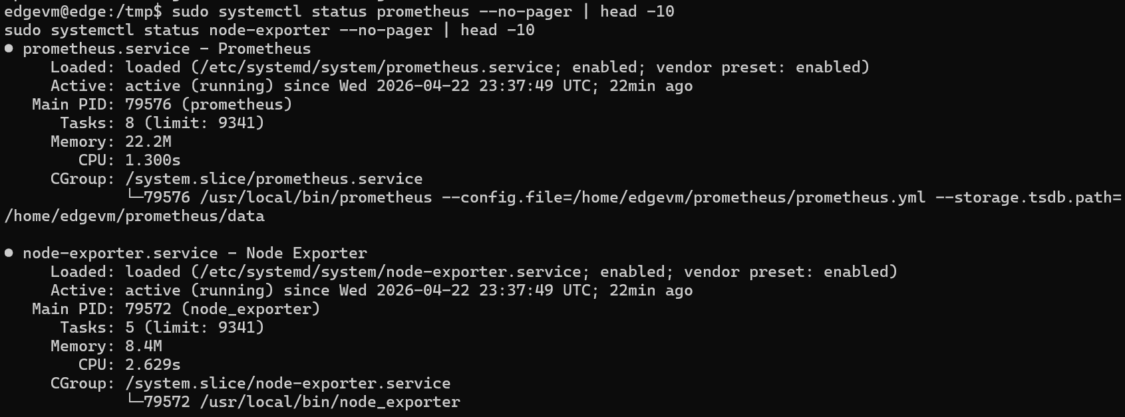
(Figure 4.22 — Prometheus and Node Exporter systemd services active and running on VM2)

The Prometheus target scraping status was verified through the web interface accessible at http://192.168.87.131:9090/targets. As illustrated in Figure 4.23, both configured scrape targets report an UP state: the node-exporter job successfully scraping localhost:9100 with a scrape duration of 20.248ms, and the docker job scraping 192.168.87.131:9100 with a scrape duration of 20.844ms — confirming that Prometheus is actively collecting and storing infrastructure metrics from the Edge node.
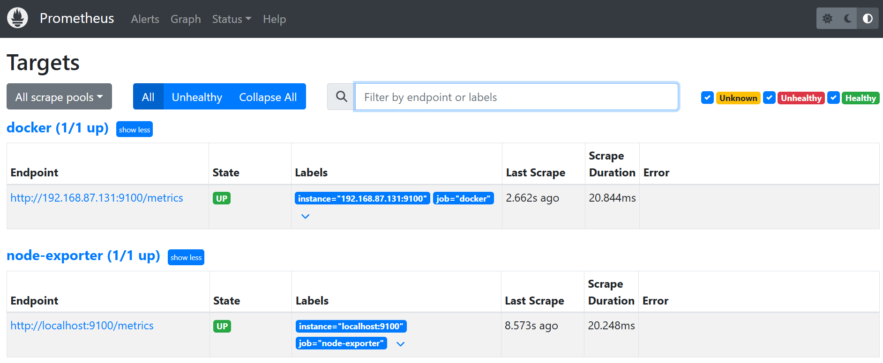
(Figure 4.23 — Prometheus targets dashboard showing both node-exporter and docker jobs in UP state

4.3.7 Edge Gateway Deployment Summary
The successful completion of the Edge Gateway deployment establishes VM2 as a fully operational intelligent edge node, capable of continuous telemetry generation, log forwarding, metric collection, and security monitoring. The following table consolidates the complete service inventory deployed on the Edge node:
Service | Technology | Version | Deployment | Role
Web Server | nginx | latest | Docker | Log generation + HTTP serving
Log Simulator | Alpine syslog-gen | latest | Docker | Continuous event simulation
Edge Application | BusyBox test-app | latest | Docker | Application workload simulation
Log Forwarder | Filebeat | 8.13.0 | Docker | Logs → Kafka via VPN (10.0.0.1:9093)
Metrics Collector | Metricbeat | 8.13.0 | Docker | System metrics → Kafka via VPN (10.0.0.1:9093)
Security Agent | Wazuh Agent | 4.7.0 | systemd | Security events → Wazuh Manager
Metrics Exporter | Node Exporter | 1.8.0 | systemd | System metrics → :9100
Metrics Scraper | Prometheus | 2.51.0 | systemd | Scraping + TSDB storage
Container Metrics Exporter | cAdvisor | latest | Docker | Container metrics → Prometheus :8080
The end-to-end telemetry pipeline from Edge to Cloud was validated across all three data streams: 43,215 log documents indexed in Elasticsearch from Filebeat, 334 metric documents indexed from Metricbeat, and the Wazuh Edge agent confirmed Active in the Wazuh Manager registry. This validates the complete data flow from the distributed edge layer to the centralized cloud observability and security platform, establishing the operational foundation for the observability integration and AI-based anomaly detection phases that follow.

4.4 Observability and Security Integration
The fourth implementation phase focused on the deployment and configuration of the unified observability and security analytics layer. This phase begins with the establishment of a secure encrypted communication channel between the Edge and Cloud nodes, followed by the deployment of interactive dashboards, real-time visualizations, and proactive alerting mechanisms. This phase operationalizes the monitoring objectives defined in Chapter 3 by establishing a multi-dimensional observability stack that provides simultaneous visibility into infrastructure performance, container behavior, log patterns, and security threat activity across the Edge–Cloud continuum.

4.4.1 WireGuard VPN — Secure Edge–Cloud Communication Channel
Prior to the deployment of any observability or security analytics component, a cryptographically secure communication channel was established between the Edge Gateway (VM2) and the Cloud Control Plane (VM1), ensuring that all telemetry data — including system logs, infrastructure metrics, and security events — traverses the Edge–Cloud boundary under full encryption. This foundational security layer is implemented using WireGuard, a modern virtual private network protocol recognized for its simplicity, high performance, and state-of-the-art cryptographic design based on the ChaCha20 symmetric cipher and Curve25519 elliptic-curve Diffie-Hellman key exchange.
WireGuard version 1.0.20210914 was installed on both VM1 and VM2. The VPN infrastructure operates on a dedicated subnet (10.0.0.0/24), assigning the static VPN address 10.0.0.1 to VM1 and 10.0.0.2 to VM2 — creating a logically isolated overlay network exclusively for Edge–Cloud communication. Each node was provisioned with a unique asymmetric cryptographic key pair: a private key retained exclusively on the local node and a public key exchanged with the peer, establishing mutual authentication without requiring a centralized certificate authority or complex PKI infrastructure.
The WireGuard interface wg0 on VM1 listens on port 51820/UDP and maintains a persistent peer relationship with VM2, authenticated by its public key 3INgQBHpbulrhzjUm/Y/oLcWYs3qeclUzO2TPWxsO1A= and physical endpoint 192.168.87.131:51820. A PersistentKeepalive interval of 25 seconds ensures continuous tunnel availability across NAT boundaries and transient network interruptions. The symmetric peer configuration on VM2 establishes the reverse relationship with VM1, authenticated by public key qA0dYP/ifisllRsSTxk6JMpPNwfkCWcWwBdeF5iXDVw= at endpoint 192.168.87.132:51820.
The VPN tunnel was validated through bidirectional ICMP connectivity testing, confirming 0% packet loss and sub-2-millisecond round-trip latency in both directions:
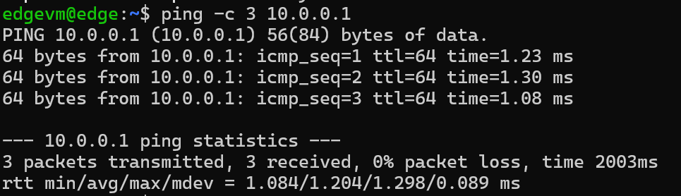
VM1 → VM2 (10.0.0.2): 3 packets, 0% loss, avg 1.15ms
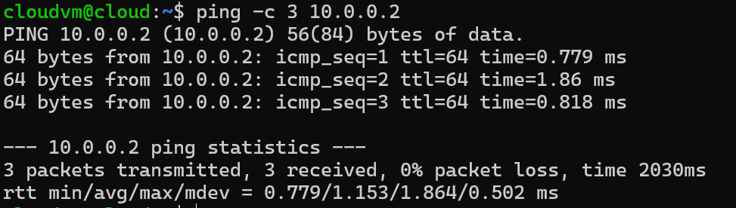
VM2 → VM1 (10.0.0.1): 3 packets, 0% loss, avg 1.20ms
As confirmed in Figure 4.24, the WireGuard status output on VM1 reports an active peer handshake with 1.12 KiB received and 1.26 KiB sent, confirming bidirectional encrypted traffic flow through the tunnel. Both WireGuard interfaces were registered as systemd units (wg-quick@wg0.service) with automatic boot activation, ensuring the encrypted channel is restored without manual intervention following any system restart. The sanitized WireGuard configuration files — with private keys excluded in accordance with security best practices — were committed to the project GitHub repository under the vpn/ directory, maintaining the Infrastructure-as-Code principle established throughout the implementation.
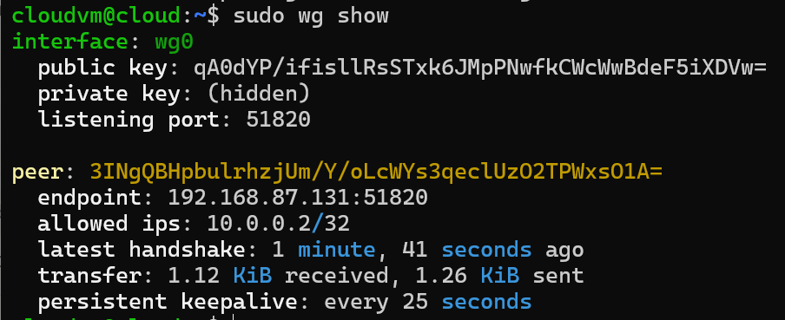
(Figure 4.24 — WireGuard VPN status on VM1: active handshake, 1.12 KiB received, peer authentication confirmed)

4.4.2 Elasticsearch Authentication
Complementing the network-level encryption provided by the WireGuard VPN tunnel, access control was enforced at the data layer through the activation of Elasticsearch's built-in security framework. With HTTP-based authentication enabled via the xpack.security.enabled configuration parameter, all REST API interactions with the Elasticsearch cluster require valid credentials — ensuring that only authorized services and users can read or write to the indexed telemetry data.
The security configuration was applied directly through environment variables in the Docker Compose deployment, setting the ELASTIC_PASSWORD for the built-in elastic superuser account to a dedicated credential (sat_elastic_2026). The effectiveness of this access control was immediately validated: unauthenticated REST requests to the cluster return a 401 Unauthorized response with a security_exception — confirming that the Elasticsearch API is fully protected against unauthorized access.
As shown in Figure 4.25, querying the cluster health endpoint without credentials returns a 401 Unauthorized error, while the same request authenticated with the elastic user credentials returns the full cluster health status — directly demonstrating the enforcement of access control at the data layer.
Since Kibana version 8 prohibits the use of the elastic superuser account for Kibana–Elasticsearch communication, a dedicated Kibana service account token was provisioned using the Elasticsearch service accounts API. This token — scoped exclusively to Kibana's operational requirements — was configured as the ELASTICSEARCH_SERVICEACCOUNTTOKEN environment variable in the Kibana container, enabling secure authenticated communication without exposing superuser credentials to the visualization layer.
All services connecting to Elasticsearch were subsequently updated to include authentication credentials: Logstash pipelines were configured with user and password parameters in their Elasticsearch output plugins, and the Python-based AI anomaly detection script and Wazuh alert ingestion script were updated to include a Base64-encoded Authorization header in all HTTP requests to the cluster REST API.
(Figure 4.25 — Elasticsearch 401 Unauthorized response for unauthenticated request vs authenticated cluster health response)

4.4.3 Grafana Deployment and System Metrics Dashboard
Grafana version 10.4.0 was deployed as a Docker container on VM1, serving as the primary metrics visualization platform for the proposed architecture. The deployment was facilitated by retrieving the official Grafana container image on the host machine and loading it into the local Docker registry via the docker load mechanism, following the same offline transfer methodology employed for other restricted images throughout the implementation.
Upon deployment, Grafana was configured with the Prometheus instance running on VM2 (http://192.168.87.131:9090) as its primary data source. Connectivity between the Grafana container and the external Prometheus endpoint required enabling IPv4 forwarding on the host system and configuring the container to operate in host network mode, ensuring unrestricted access to the inter-VM network segment.
System Metrics Dashboard — Node Exporter Full
The Node Exporter Full dashboard (Grafana dashboard ID 1860) was imported to provide comprehensive real-time infrastructure monitoring for the Edge node. As illustrated in Figure 4.25, the dashboard presents a rich multi-panel visualization of VM2's operational state, including instantaneous performance indicators and historical time-series graphs. The quick statistics row displays a CPU utilization of 2.1%, RAM consumption of 13.0% out of 8 GiB total, root filesystem usage at 59.8%, and a system uptime of 16.5 hours — all within healthy operational thresholds. The time-series panels reveal a notable CPU and network traffic spike around 18:00, corresponding to the period of active service deployment and attack simulation activities, followed by stabilization to baseline levels. The memory consumption graph demonstrates a controlled increase at 22:00, reflecting the accumulation of running containerized services on the Edge node.
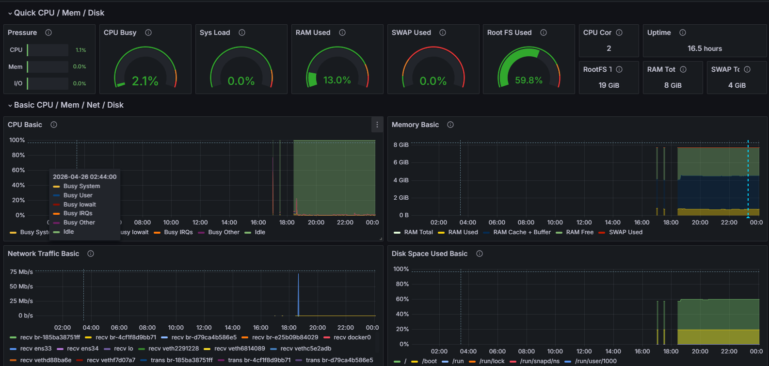
(Figure 4.25 — Grafana Node Exporter Full Dashboard showing real-time Edge node metrics: CPU 2.1%, RAM 13%, Disk 59.8%)
Docker Container Monitoring Dashboard — cAdvisor
To provide real-time container-level visibility within the Grafana observability platform, cAdvisor (Container Advisor) was deployed as an additional Docker container on VM2 and integrated as a third Prometheus scrape target alongside the existing node-exporter and docker jobs. cAdvisor exposes over 20 per-container metrics — including CPU usage, memory consumption, network I/O, and filesystem utilization — at port 8080, enabling fine-grained container performance monitoring directly through the Prometheus time-series database.
The Docker cAdvisor dashboard (Grafana dashboard ID 14282) was imported into Grafana to visualize these container-level metrics in real time. As illustrated in Figure 4.26, the dashboard provides per-container breakdowns of CPU utilization, memory usage, and network throughput across all containerized services running on VM2 — including nginx, syslog-generator, test-app, Filebeat, Metricbeat, and cAdvisor itself — enabling rapid identification of resource-intensive containers and performance anomalies at the container level.
This Grafana-based Docker monitoring capability complements the Kibana-based Docker metrics dashboard implemented via the Metricbeat Docker module: while Grafana provides real-time operational visibility updated every 15 seconds via Prometheus, Kibana provides historical container metric analysis and cross-correlation with log and security event data — collectively fulfilling both real-time operational monitoring and forensic investigation requirements across the Edge node's containerized workload.
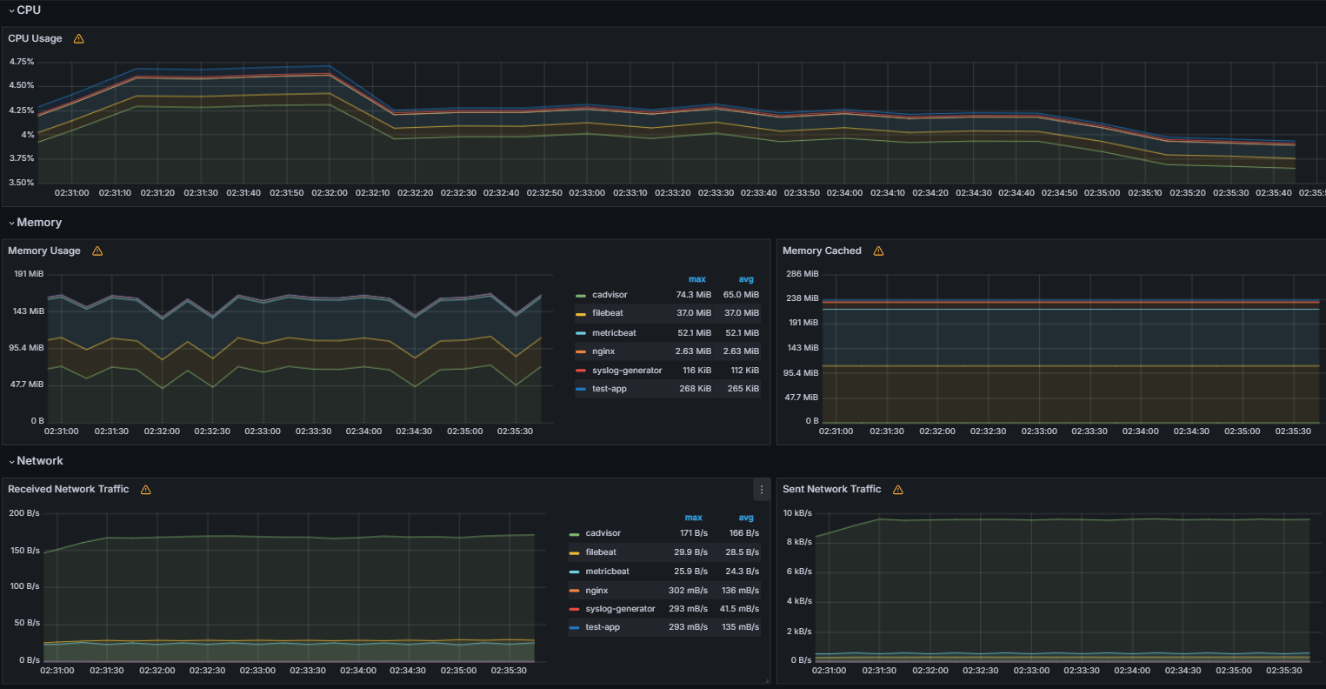
(Figure 4.26 — Grafana cAdvisor Docker dashboard showing per-container CPU, memory, and network metrics)

4.4.4 Grafana Alerting Rules Configuration
To demonstrate proactive monitoring capabilities and validate the alerting dimension of the proposed architecture, three threshold-based alert rules were configured within Grafana's unified alerting framework, organized under the SAT-Alerts folder and edge-alerts evaluation group with a 1-minute evaluation interval and 5-minute pending period.
The first rule, High CPU Usage — Edge Node, monitors CPU utilization using the PromQL expression 100 - (avg(rate(node_cpu_seconds_total{mode="idle"}[5m])) * 100) and triggers when CPU exceeds 80%, indicating potential resource exhaustion or anomalous process activity. The second rule, High Memory Usage — Edge Node, evaluates memory pressure using 100 * (1 - node_memory_MemAvailable_bytes / node_memory_MemTotal_bytes) with an 85% firing threshold, designed to detect memory leaks or resource contention before out-of-memory conditions occur. The third rule, High Disk Usage — Edge Node, monitors filesystem utilization via 100 - node_filesystem_avail_bytes{mountpoint="/"} / node_filesystem_size_bytes{mountpoint="/"} * 100 with an 85% threshold, ensuring timely detection of storage capacity risks that could impact the telemetry pipeline.
A fourth alert rule, AI Anomaly Detected — Edge Node, was additionally configured with critical severity, querying the anomaly-scores-v2 Elasticsearch index and triggering when anomalous records are detected — complementing the Python-based direct email alerting mechanism implemented within the AI pipeline itself
As confirmed in Figure 4.25, all three alert rules are operational within the SAT-Alerts folder, currently reporting a Normal status — indicating that all monitored metrics are within acceptable thresholds under the current workload. Each rule is linked to its corresponding Grafana dashboard panel, enabling direct navigation from alert notifications to the relevant visualization context.
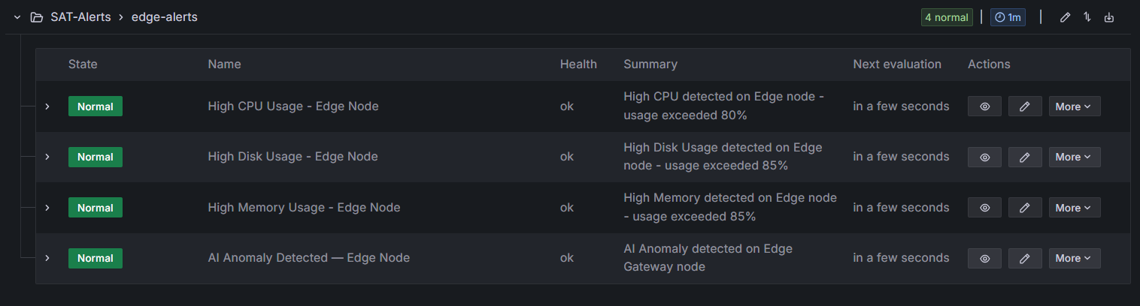
(Figure 4.26 — Grafana alerting rules: High CPU (>80%), High Memory (>85%), High Disk (>85%) — all Normal status)

4.4.5 Kibana Log Analytics Dashboard
A comprehensive log analytics dashboard was constructed in Kibana using the logs-* data view, which indexes over 43,215 log documents collected by Filebeat from the Edge node across multiple days of operation. The dashboard comprises four visualization panels providing complementary perspectives on the log data stream.
The first panel, Log Volume by Container, presents a stacked bar chart sampled at 30-second intervals, revealing the continuous and consistent log generation rate across all containerized services on VM2. The second panel, Log Distribution by Container, displays a donut chart quantifying the proportional contribution of each container to the total log volume: alpine:latest (syslog-generator) contributes 63.94% of all logs, busybox:latest (test-app) contributes 27.27%, and the Elastic stack components (Filebeat and Metricbeat) account for the remaining 9% — confirming that the sample workload services are functioning as intended log generators. The third panel, Edge CPU Usage Over Time, presents a line chart derived from Metricbeat system module data, showing CPU utilization over time with the characteristic spike observed during the attack simulation period. The fourth panel, Edge Memory Usage Over Time, demonstrates stable and consistent memory consumption across the monitoring window, confirming the operational stability of the Edge node.
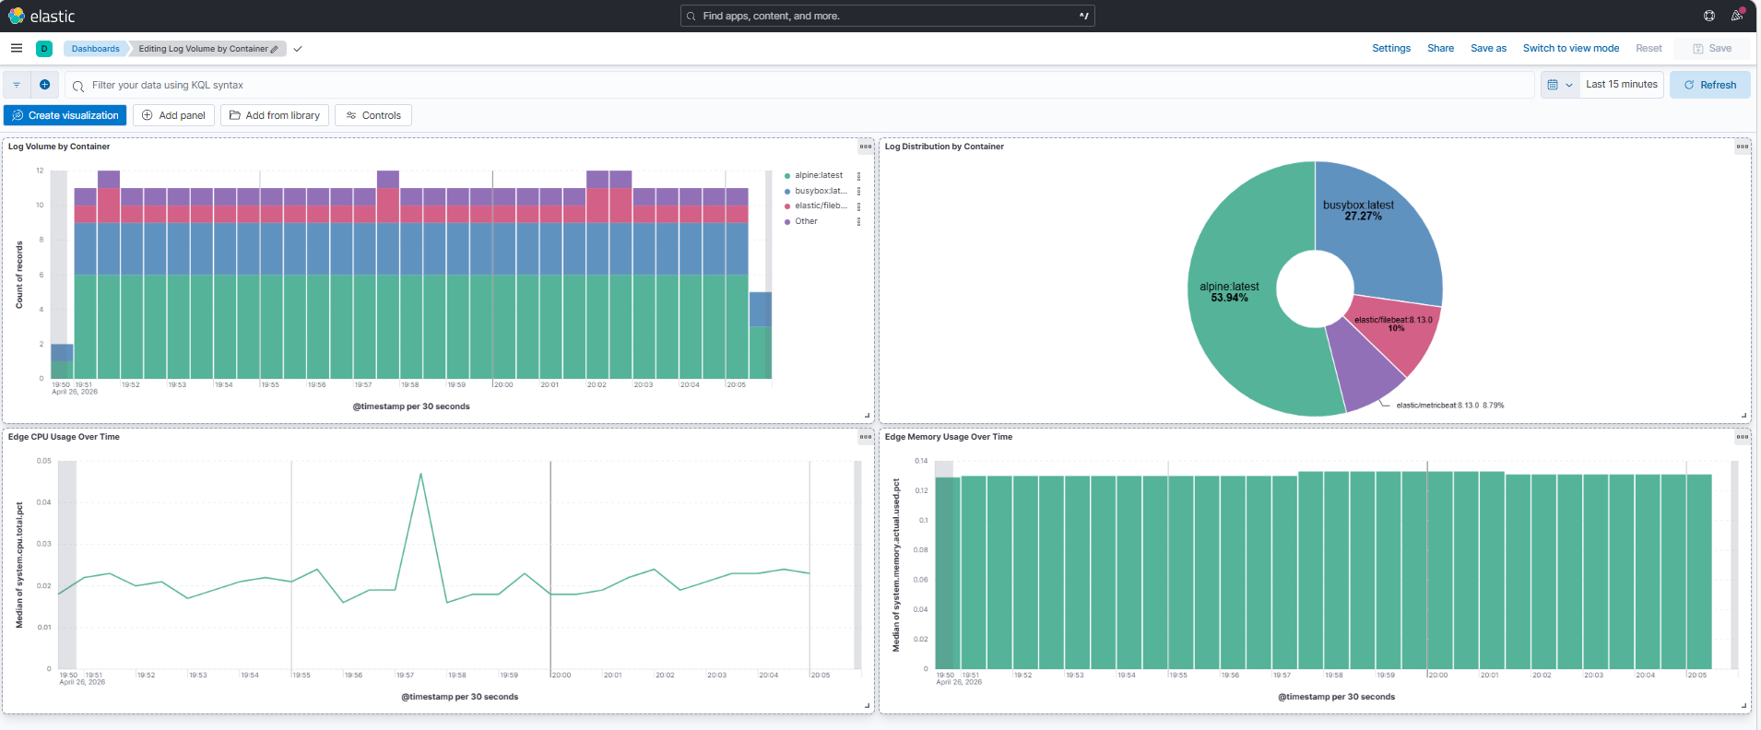
Figure 4.29 — Kibana Edge Gateway Observability Dashboard: log volume, distribution, CPU, memory

4.4.6 Docker Container Metrics Dashboard
A dedicated Docker container metrics dashboard was constructed using the metricbeat-* data view, leveraging the Docker module metrics collected by Metricbeat from the Edge node's container runtime. The dashboard comprises two visualization panels providing container-level performance visibility.
The first panel, Docker Container CPU Usage, presents a multi-line time series of docker.cpu.total.pct measured at per-minute intervals, tracking CPU consumption across all monitored containers including Metricbeat, Filebeat, and nginx. CPU utilization across all containers remains consistently below 0.02 under normal operating conditions, with occasional spikes corresponding to periods of increased activity. The second panel, Docker Container Memory Usage, displays a grouped bar chart comparing median and average docker.memory.usage.pct values per container image. The Metricbeat container reports both median and average memory usage of 0.007 — confirming the exceptionally lightweight memory profile of all edge-deployed containerized services, which is consistent with the resource-constrained design philosophy of the edge computing layer.
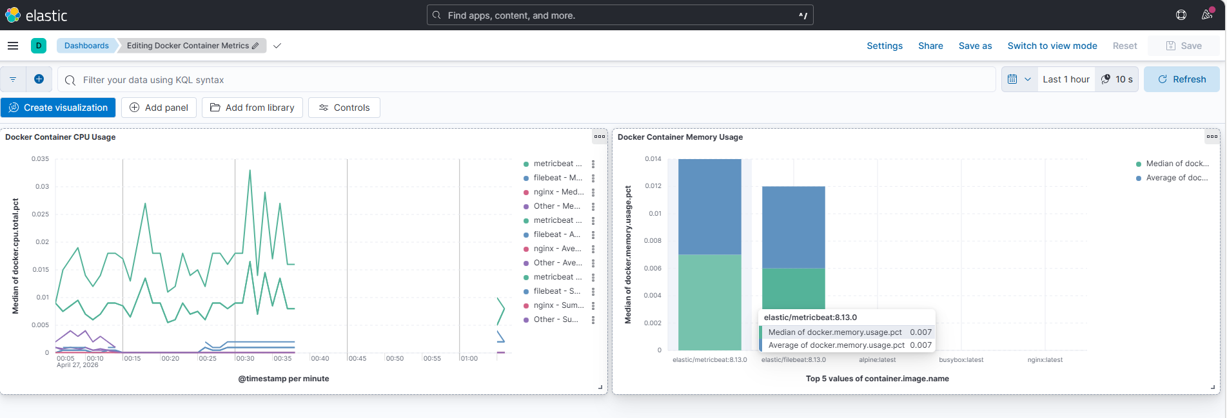
(Figure 4.27 — Kibana Docker Container Metrics Dashboard: per-container CPU and memory utilization)

4.4.7 Security Analytics Dashboard and Wazuh Alert Visualization
A dedicated security analytics dashboard was constructed in Kibana using the wazuh-alerts data view, populated with 1,384 security alert documents extracted from the Wazuh Manager's alert log and indexed into Elasticsearch via an automated Python ingestion pipeline. The dashboard provides a four-panel security intelligence interface.
The first panel, Security Alerts Over Time, presents a bar chart revealing a concentrated burst of security events during the attack simulation window, with the timeline otherwise relatively quiescent — demonstrating the system's ability to distinguish between baseline operational activity and anomalous event clusters. The second panel displays the total alert count of 1,384 records as a metric card. The third panel, Top Security Rules, presents a ranked table of the most frequently triggered detection rules, with "System: Error message" dominating at 1,118 occurrences, followed by "sshd: Attempt to login using a non-existent user", "Failed attempt to run sudo", "Successful sudo to ROOT executed", and "PAM: User login failed" — collectively representing the full attack chain from initial reconnaissance through privilege escalation. The fourth panel, Alert Severity Distribution, reveals that approximately 91.94% of alerts are at severity level 3 (informational), with a notable 12.96% component at higher severity levels corresponding to the detected attack sequences.
The Alerts by Agent panel confirms that 100% of all security events originated from the edge agent (VM2), validating the bidirectional communication pipeline between the Edge Wazuh Agent and the Cloud-side Wazuh Manager.
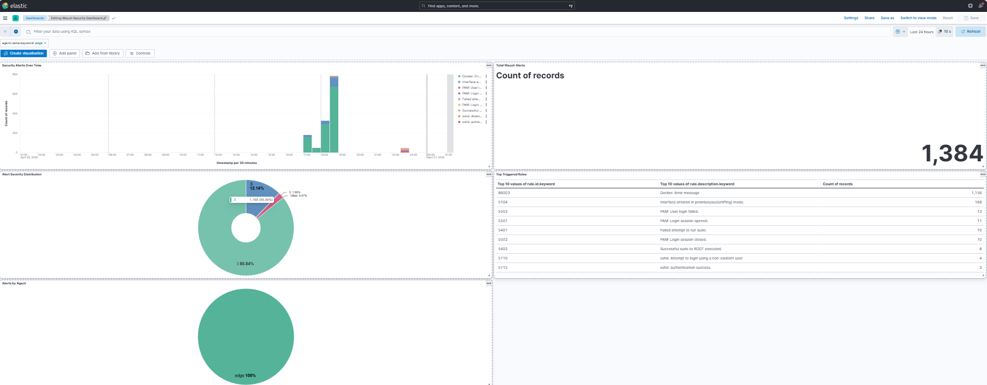
(Figure 4.28 — Kibana Security Analytics Dashboard: 1,384 alerts, severity distribution, top rules, and agent attribution)

4.4.8 Security Event Discovery and Forensic Analysis
The Kibana Discover interface was utilized to perform granular forensic analysis of the indexed Wazuh alert stream. As illustrated in Figure 4.29, the document view presents 1,385 raw security events sorted chronologically, with columns displaying timestamp, rule.description, rule.level, and agent.name for each alert.
Forensic examination of the alert timeline reveals a particularly significant sequence of events on April 26, 2026: a cluster of sshd: Attempt to login using a non-existent user alerts at severity level 5 appearing at 22:40, followed within minutes by PAM: User login failed events, and subsequently by two consecutive Successful sudo to ROOT executed events at 22:42. This event sequence — failed SSH attempts against non-existent accounts followed by successful privilege escalation to root — constitutes a classic brute-force-then-privilege-escalation attack pattern, demonstrating Wazuh's capacity to detect and chronicle multi-stage attack sequences in real time.
The field statistics view, presented in Figure 4.30, provides a quantitative summary of the alert dataset: 1 distinct agent (edge), 5 unique rule descriptions across 999 analyzed documents, and 4 distinct severity levels ranging from 3 to 8 — confirming that the observed security events represent a concentrated, repetitive attack pattern rather than a diverse threat landscape, consistent with the automated attack simulation methodology employed during validation.
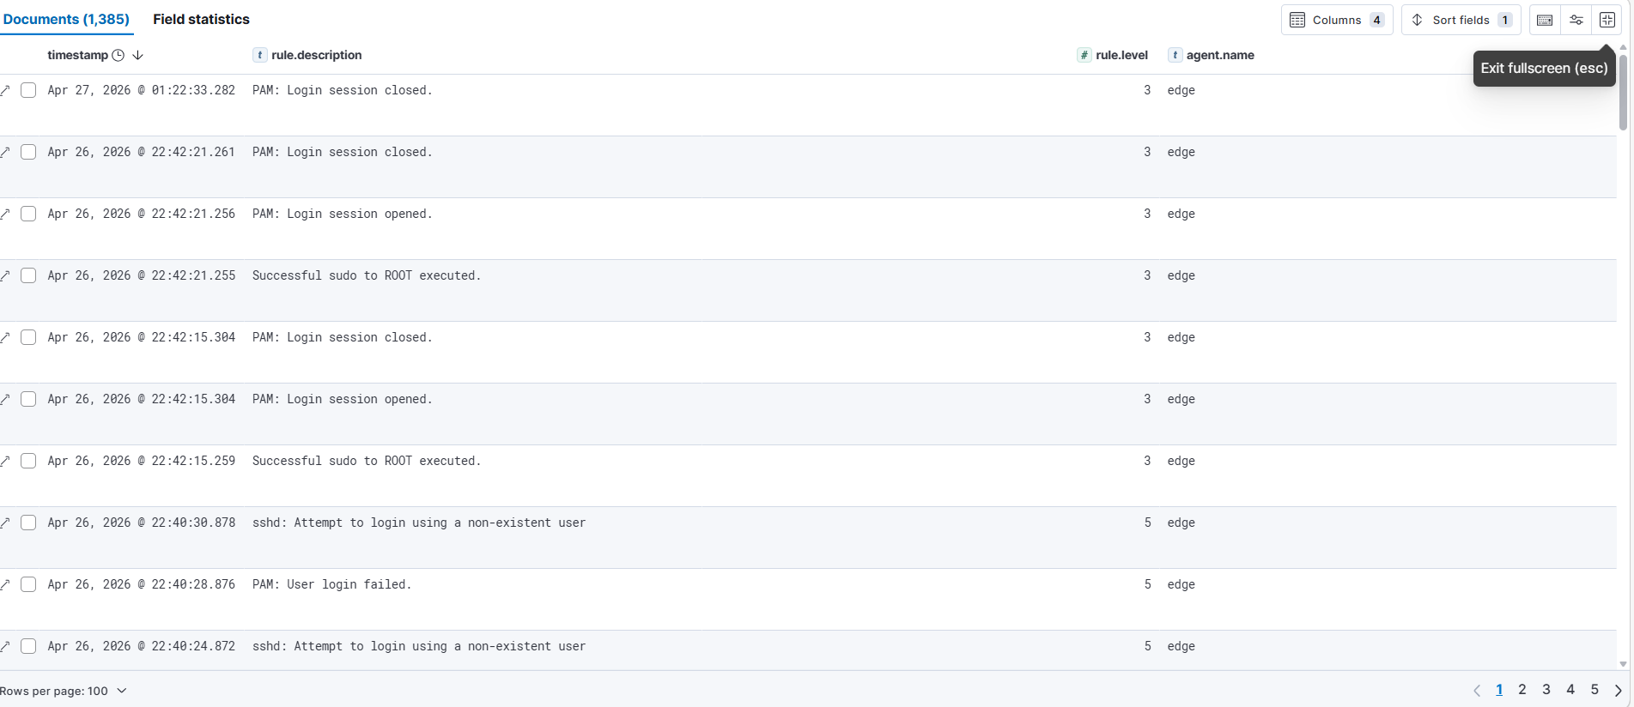
(Figure 4.29 — Kibana Discover: Wazuh alert documents showing brute-force and privilege escalation sequence)

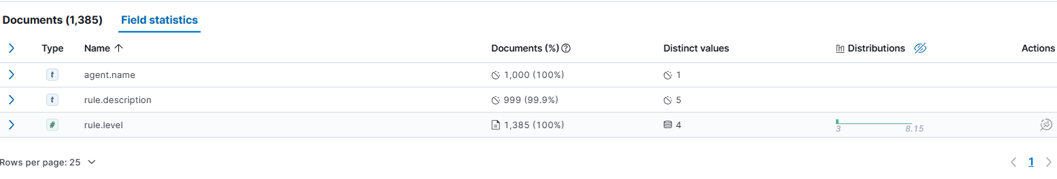
(Figure 4.30 — Kibana Discover Field Statistics: 1 agent, 5 rule types, 4 severity levels across 1,385 alerts)

4.4.9 Automated Security Alert Ingestion Pipeline
To ensure continuous and autonomous security alert ingestion from the Wazuh Manager into the Elasticsearch cluster, an automated pipeline was implemented comprising a Python ingestion script and a system-level scheduling mechanism. The Python script (wazuh-to-es.py) implements an incremental indexing strategy: it first queries the existing wazuh-alerts Elasticsearch index to retrieve all previously indexed alert identifiers, then processes the Wazuh alerts log file to identify and index only new, previously unseen alerts — preventing duplicate entries while ensuring complete alert coverage.
The ingestion pipeline is scheduled via a cron job configured on VM1, executing every 5 minutes to extract the latest alerts from the Wazuh Manager container and index them into Elasticsearch. This automation ensures that the Security Analytics Dashboard reflects near-real-time security intelligence without requiring manual intervention, fulfilling the continuous monitoring requirement defined in the proposed architecture.

4.4.10 Observability Integration Summary
The successful completion of the observability and security integration phase establishes a fully operational, multi-dimensional monitoring infrastructure spanning both the Edge and Cloud layers. The following table consolidates the complete dashboard and alerting inventory deployed during this phase:
Component | Tool | Type | Data Source | Key Metric
System Metrics Dashboard | Grafana | Infrastructure | Prometheus/Node Exporter | CPU 2.1%, RAM 13%, Disk 59.8%
Alerting Rules | Grafana | Proactive | Prometheus | CPU>80%, Mem>85%, Disk>85%
AI Anomaly Alerting | Python smtplib + Grafana | AI | anomaly-scores-v2 | Dual-layer: direct email + Grafana alert
Log Analytics Dashboard | Kibana | Log Analysis | Elasticsearch (logs-*) | 43,215+ log documents
Docker Container Metrics | Kibana | Container | Elasticsearch (metricbeat-*) | Per-container CPU/Memory
Security Analytics Dashboard | Kibana | Security | Elasticsearch (wazuh-alerts) | 1,384 security alerts
Security Event Discovery | Kibana | Forensic | Elasticsearch (wazuh-alerts) | 5 rule types, 4 severity levels
Auto Alert Ingestion | Python + Cron | Automation | Wazuh Manager | Every 5 minutes
Secure Channel | WireGuard VPN | Security | Edge ↔ Cloud | Encrypted tunnel, 0% packet loss
Access Control | Elasticsearch Authentication | Security | All ES clients | 401 on unauthenticated access
Docker Real-time Monitoring | Grafana + cAdvisor | Infrastructure | Prometheus (cAdvisor :8080) | Per-container CPU/Memory/Network
The integrated observability stack validates the end-to-end data flow from the distributed Edge layer to the centralized Cloud analytics platform, providing real-time visibility into infrastructure performance, container behavior, log patterns, and security threat activity — collectively fulfilling the intelligence and monitoring objectives established in the research framework.

4.5 DevSecOps and Infrastructure Automation
The DevSecOps implementation phase establishes the automation, configuration management, and continuous monitoring foundations of the proposed architecture. Rather than treating security and operations as post-deployment concerns, this phase embeds automation and security practices throughout the infrastructure lifecycle from initial provisioning through continuous runtime monitoring. The implementation operationalizes the DevSecOps objectives defined in Chapter 3 through five complementary mechanisms: declarative infrastructure provisioning via Infrastructure-as-Code, version-controlled configuration management, Kafka-based asynchronous message brokering, automated security alert ingestion, and continuous telemetry monitoring.

4.5.1 Infrastructure-as-Code with Kolla-Ansible
The most significant Infrastructure-as-Code implementation in this project is the deployment of the entire OpenStack cloud platform via Kolla-Ansible — an official OpenStack automation framework that provisions all cloud services as containerized workloads through declarative Ansible playbooks. Rather than manually installing and configuring each OpenStack service individually, the entire IaaS platform was defined through a single configuration file (globals.yml) specifying the desired system state, and deployed through a sequence of three automated commands.
The globals.yml configuration file serves as the single source of truth for the OpenStack deployment, declaratively specifying all infrastructure parameters including the base distribution, network interface assignments, virtual IP address, and service enablement flags. This declarative approach ensures that the deployment is reproducible — the exact same infrastructure state can be recreated from scratch by executing the same configuration against a fresh Ubuntu installation — and auditable — every configuration decision is explicitly documented in version-controlled files rather than implicit in manual commands.
The Kolla-Ansible deployment pipeline executed 377 Ansible tasks with 232 configuration changes applied and zero failures, provisioning the complete OpenStack service catalog including Nova (compute), Neutron (networking), Glance (image management), Keystone (identity), Placement (resource tracking), and Heat (orchestration) — all without manual intervention. This automation eliminates configuration drift, reduces human error, and ensures consistent deployment across environments.
Similarly, the Edge and Cloud service stacks — ELK, Wazuh, Kafka, Grafana, Filebeat, and Metricbeat — are all defined as Docker Compose files, representing a declarative IaC approach to service deployment. Each service's configuration, port mappings, volume mounts, environment variables, and inter-service dependencies are explicitly specified, enabling reproducible deployment with a single docker compose up -d command.

4.5.2 Configuration Management and Version Control
All infrastructure configuration files produced during the implementation phases are version-controlled in a dedicated Git repository hosted on GitHub at https://github.com/hafsa-mtm/sat-infra-configs. The repository adopts a structured directory organization that separates Cloud and Edge configurations into dedicated subdirectories, ensuring clarity and maintainability:
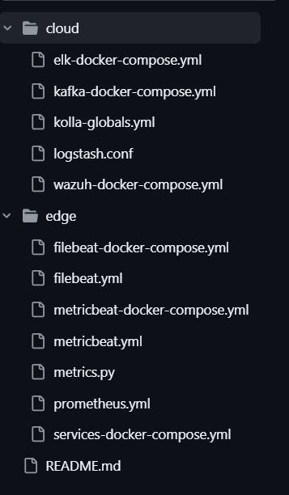
This version-controlled configuration repository fulfills several DevSecOps principles simultaneously. Traceability is ensured through Git's commit history, which records every configuration change with a descriptive message, author, and timestamp — providing a complete audit trail of infrastructure modifications. Reproducibility is guaranteed by the declarative nature of all configuration files, enabling any authorized operator to reconstruct the exact infrastructure state from the repository. Collaboration is facilitated through the structured directory organization, allowing team members to navigate and understand the infrastructure configuration without prior deployment knowledge.
The repository served as the primary configuration backup mechanism throughout the implementation, with configurations committed after each major deployment milestone — ensuring that no configuration work was lost despite the transient nature of the virtual machine environment.

4.5.3 Kafka Message Broker Integration
A critical architectural enhancement implemented during the DevSecOps phase is the integration of Apache Kafka as an asynchronous message broker within the Edge–Cloud telemetry pipeline. The Kafka deployment — comprising Kafka 7.5.0 and Zookeeper 7.5.0 on VM1 — introduces a decoupling layer between the Edge telemetry producers (Filebeat and Metricbeat) and the Cloud-side processing engine (Logstash), fulfilling the event streaming objective defined in the proposed architecture.
Two dedicated Kafka topics were created to segregate telemetry streams by data type: the logs topic receives log events forwarded by Filebeat from the Edge node, while the metrics topic receives infrastructure metrics forwarded by Metricbeat. Both Filebeat and Metricbeat on VM2 were reconfigured to output to Kafka's VPN endpoint at 10.0.0.1:9093, ensuring all telemetry traffic traverses the WireGuard encrypted tunnel rather than directly to Logstash or Elasticsearch, ensuring all Edge telemetry flows through the message broker before reaching the Cloud analytics layer.
On the Cloud side, Logstash was reconfigured to operate as a Kafka consumer, subscribing to both the logs and metrics topics through dedicated consumer groups (logstash-logs and logstash-metrics). Upon consuming messages, Logstash applies a filter to distinguish log events from metric events based on the agent.type field, routing each to its appropriate Elasticsearch index: logs-kafka-YYYY.MM.dd for log documents and metricbeat-kafka-YYYY.MM.dd for metric documents.
As confirmed in Figure 4.XX, the Kafka integration successfully established end-to-end message flow from the Edge producers to the Cloud consumer, with 46 log documents indexed in logs-kafka-2026.05.05 and 222 metric documents indexed in metricbeat-kafka-2026.05.05 within the first minutes of operation. This validates the complete asynchronous telemetry pipeline: Edge → Kafka → Logstash → Elasticsearch — directly implementing the event-driven architecture defined in Chapter 3.
(Figure 4.XX — Elasticsearch indices showing logs-kafka and metricbeat-kafka indices with document counts)

4.5.4 Automated Security Alert Ingestion Pipeline
A critical DevSecOps automation component is the implementation of a continuous security alert ingestion pipeline that bridges the Wazuh Manager's internal alert storage with the Elasticsearch analytics cluster. This pipeline addresses a fundamental integration challenge: the Wazuh Manager stores security alerts in its internal JSON log file (/var/ossec/logs/alerts/alerts.json), while the observability platform requires these alerts to be indexed in Elasticsearch for visualization and analysis.
The pipeline comprises two components. The first is a Python ingestion script (wazuh-to-es.py) that implements an incremental indexing strategy — querying the existing Elasticsearch index to retrieve all previously indexed alert identifiers, then processing only new, previously unseen alerts to prevent duplicate entries. The script serializes each alert document as a JSON payload and transmits it to Elasticsearch via the REST API, returning the HTTP status code for each indexing operation.
The second component is a cron job configured on VM1 that executes the complete ingestion pipeline every 5 minutes:
This automation ensures that security intelligence flows continuously from the Wazuh detection engine to the Kibana Security Analytics Dashboard without manual intervention, fulfilling the continuous security monitoring requirement of the proposed architecture. The pipeline successfully indexed 1,451 security alerts during the validation phase, including events generated by the simulated attack scenarios

4.5.5 Continuous Monitoring Automation
Beyond security alert ingestion, continuous monitoring automation is implemented across multiple layers of the architecture through systemd service management and scheduled collection agents.
On the Edge node, three system services are configured for automatic startup and continuous operation: the Wazuh Agent (wazuh-agent.service) ensures uninterrupted security monitoring across system reboots, automatically re-enrolling with the Wazuh Manager if the connection is interrupted. The Prometheus (prometheus.service) and Node Exporter (node-exporter.service) services maintain continuous metrics scraping at 15-second intervals, storing time-series data in the local TSDB regardless of network connectivity to the Cloud layer — ensuring no metric data is lost during transient network disruptions
The Metricbeat container is configured with restart: unless-stopped in its Docker Compose definition, ensuring automatic restart in case of container failure and continuous metric forwarding to Elasticsearch. Similarly, all sample service containers (nginx, syslog-generator, test-app) and the Filebeat log shipping agent operate under the same restart policy, ensuring uninterrupted log generation and forwarding.
On the Cloud node, the automated Wazuh alert ingestion cron job complements the always-on ELK Stack, Wazuh Manager, Kafka, and Grafana services — all configured with restart: unless-stopped — to maintain a continuously operational observability and security analytics platform.
This layered automation strategy ensures that the complete Edge–Cloud telemetry pipeline operates autonomously, requiring no manual intervention for routine monitoring operations and recovering automatically from transient failures — fulfilling the resilience and automation objectives established in the research framework.

4.5.6 DevSecOps Implementation Summary
The following table summarizes the DevSecOps and automation components implemented across the architecture:
Practice | Implementation | Tool | Scope
Infrastructure-as-Code | OpenStack declarative deployment | Kolla-Ansible | Cloud layer
Infrastructure-as-Code | Service stack definitions | Docker Compose | Cloud + Edge
Version Control | Configuration repository | Git + GitHub | All configs
Automated Deployment | 377-task automated provisioning | Ansible | OpenStack
Security Automation | Alert ingestion pipeline | Python + Cron | Cloud layer
Continuous Monitoring | Metrics scraping every 15s | Prometheus | Edge layer
Continuous Monitoring | Log shipping pipeline | Filebeat | Edge → Cloud
Service Resilience | Auto-restart on failure | systemd + Docker | Cloud + Edge
Message Brokering | Kafka + Zookeeper 7.5.0 | Kafka | Edge → Cloud

4.6 AI-Based Anomaly Detection
The sixth implementation phase introduces the artificial intelligence layer of the proposed architecture, implementing an automated anomaly detection pipeline capable of identifying abnormal behavioral patterns within the Edge node's operational telemetry. This phase operationalizes the distributed intelligence objectives defined in Chapter 3 by deploying a machine learning model that continuously analyzes multi-source telemetry and detects deviations from established baseline behavior — providing proactive threat detection capabilities beyond the rule-based detection offered by the Wazuh SIEM platform.
Problem Framing
The AI component addresses an unsupervised binary classification problem: given a set of infrastructure telemetry observations collected from the Edge node, the system must determine whether each observation represents normal operational behavior or an anomalous condition requiring investigation. No labeled training data is available in advance — the system must learn the normal behavioral baseline autonomously from operational data and flag deviations without prior knowledge of attack signatures or failure patterns. This unsupervised formulation directly reflects the real-world operational constraint that anomalies are rare, diverse, and cannot be exhaustively pre-labeled in distributed IaaS environments.

4.6.1 Dataset Preparation and Feature Extraction
Data Source and Collection
The anomaly detection pipeline operates on infrastructure telemetry extracted directly from the Elasticsearch cluster on VM1, drawing from three complementary data sources that collectively characterize the operational state of the Edge node: the metricbeat-* data stream populated by the Metricbeat agent on VM2, the logs-* index populated by Filebeat, and the wazuh-alerts index populated by the Wazuh security pipeline.
The primary dataset comprises 1,000 metric records collected at 30-second intervals by Metricbeat, spanning the complete operational history of the Edge node from April 22 to May 2, 2026 — a period of ten continuous days that includes both normal operating conditions and periods of intentionally induced stress. Each record is timestamped and uniquely identified by its Elasticsearch document ID, enabling precise temporal alignment with concurrent log and security event data.
Data Format
All data is stored as JSON documents in Elasticsearch indices and retrieved via the REST API using time-windowed aggregation queries. The pipeline assembles a structured tabular dataset in memory using the pandas library, with each row representing a 30-second observation window and each column representing one of the ten extracted telemetry features.
Feature Extraction
Feature extraction targets ten telemetry dimensions spanning three data sources that collectively characterize the operational state of the Edge node:
Feature | Source | Description
cpu | system.cpu.total.pct | CPU utilization
memory | system.memory.actual.used.pct | Memory utilization
net_in | system.network.in.bytes | Inbound network traffic
net_out | system.network.out.bytes | Outbound network traffic
disk_read | system.diskio.read.bytes | Disk read throughput
disk_write | system.diskio.write.bytes | Disk write throughput
process_count | system.process.summary.total | Running process count
log_volume | logs-* count | Log generation rate
security_alerts | wazuh-alerts count | Security events per window
failed_logins | wazuh-alerts rule filter | Failed authentication attempts
The infrastructure features (cpu, memory, net_in, net_out, disk_read, disk_write, process_count) capture resource-level anomalies characteristic of denial-of-service conditions or cryptomining activity. The cross-domain features (log_volume, security_alerts, failed_logins) introduce a multi-source correlation dimension linking infrastructure behavior with concurrent security events from Wazuh — enabling detection of complex attack patterns such as data exfiltration or lateral movement that may not manifest as isolated resource spikes.
By combining these ten features from three independent data sources, the pipeline is capable of detecting seven distinct categories of operational anomalies, each corresponding to a specific subset of the feature space:
Anomaly Category | Primary Features | Representative Threat Scenario
CPU overload | cpu | Cryptomining malware, runaway process, DoS
Memory exhaustion | memory | Memory leak, buffer overflow attack
Network spike | net_in, net_out | DDoS attack, data exfiltration
Disk I/O spike | disk_read, disk_write | Ransomware encryption, log tampering
Failed login flood | failed_logins | Brute force SSH/authentication attack
Log volume anomaly | log_volume | Log flooding, application crash cascade
Security event cluster | security_alerts | Multi-stage attack, coordinated intrusion

Unlike rule-based SIEM detection — which triggers only when predefined thresholds are crossed for individual metrics — the Isolation Forest model evaluates all ten features simultaneously, enabling detection of multi-dimensional anomalies where no single feature exceeds its individual threshold but the combined behavioral pattern deviates significantly from the established baseline. This cross-feature correlation capability is particularly valuable for detecting sophisticated attack patterns such as low-and-slow exfiltration, where network traffic increases gradually while security alerts also rise slightly — a pattern invisible to single-metric alerting but detectable through multivariate anomaly scoring.
Data Preprocessing
The raw telemetry data required several preprocessing steps before model training. Missing values arising from collection gaps or service restarts were addressed by forward-filling from the immediately preceding observation, preserving temporal continuity without introducing artificial data. Since all features are continuous numerical measurements, no categorical encoding was required.
The most critical preprocessing step is feature standardization: all ten features were scaled to zero mean and unit variance using scikit-learn's StandardScaler, applied as:
z = (x − μ) / σ
where μ is the feature mean and σ is the standard deviation across the 1,000-record dataset. This normalization is essential for Isolation Forest, as features with larger absolute values — particularly net_in and net_out, which can reach millions of bytes — would otherwise dominate the random partitioning process and produce biased anomaly scores. Since Isolation Forest is an unsupervised algorithm trained on the entire dataset without a held-out test set, no train/test split was applied; the model learns the global behavioral distribution and scores each observation against it.

4.6.2 Anomaly Generation and Labeling
To validate the detection capabilities of the implemented model, a controlled anomaly injection scenario was executed on VM2 during the data collection period. Three concurrent CPU-intensive processes were spawned using the dd command to simulate a sustained CPU overload condition — representative of scenarios such as cryptomining malware, runaway processes, or denial-of-service attacks.
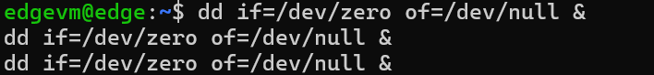
The stress scenario was maintained for approximately three minutes, during which Metricbeat collected the elevated CPU metrics at 30-second intervals. The effectiveness of the anomaly injection is confirmed by the dramatic increase in the maximum CPU value observed in the dataset: from a baseline maximum of 0.0289 (2.89%) under normal conditions to a peak of 2.0 (200%) during the stress period — representing a 69-fold increase that clearly constitutes an anomalous behavioral deviation from the established baseline.

4.6.3 Model Selection and Justification
The anomaly detection model is implemented using the Isolation Forest algorithm. The selection of this algorithm was motivated by four factors directly aligned with the problem characteristics of this architecture.
First, Isolation Forest is specifically designed for unsupervised anomaly detection — it requires no labeled training data, making it directly applicable to the operational scenario where normal behavior must be learned autonomously from telemetry streams without prior knowledge of attack signatures. Second, the algorithm exhibits linear time complexity O(n log n) and low memory footprint, making it suitable for deployment on the resource-constrained Cloud node without impacting the concurrent ELK Stack and Wazuh services. Third, Isolation Forest handles high-dimensional datasets effectively — its random partitioning strategy does not suffer from the curse of dimensionality that degrades distance-based methods such as k-NN or Local Outlier Factor in 10-dimensional feature spaces. Fourth, the algorithm provides a continuous anomaly score rather than a binary classification alone, enabling threshold-based tuning without model retraining — a practical operational advantage for alert sensitivity adjustment.
Alternative algorithms considered include One-Class SVM, which was rejected due to its quadratic time complexity and sensitivity to hyperparameter tuning, and statistical threshold-based detection, which was rejected due to its inability to capture multivariate correlations between features (a CPU spike accompanied by unusual network traffic is more anomalous than either indicator alone).
The model is configured with the following hyperparameters:
Parameter | Value | Rationale
n_estimators | 100 | Ensemble of 100 isolation trees for robust scoring
contamination | 0.1 | Expected anomaly proportion set to 10%
random_state | 42 | Fixed seed for reproducibility

4.6.4 Training Process
The complete pipeline implementation follows a five-stage architecture:
Elasticsearch → Feature Extraction → StandardScaler → Isolation Forest → Anomaly Scoring → Elasticsearch
The pipeline is implemented as a standalone Python module (anomaly_detection.py) using scikit-learn 1.7.2 for model implementation, pandas for data manipulation, and numpy for numerical computation. Authentication to the Elasticsearch cluster is handled via Base64-encoded HTTP Authorization headers, consistent with the security configuration established in Section 4.4.2.
The training process operates as follows. The pipeline first queries Elasticsearch to retrieve the 1,000 most recent Metricbeat records, then enriches each observation with log volume counts and security alert counts from the corresponding 30-second time window via aggregation queries. The resulting 1,000×10 feature matrix is then passed to StandardScaler.fit_transform() — which simultaneously computes the normalization parameters and applies them — before being passed to IsolationForest.fit_predict(). The Isolation Forest algorithm builds 100 isolation trees, each constructed by randomly selecting a feature and a random split value within its range, recursively partitioning the data until each observation is isolated. Observations requiring fewer partitions to isolate — those in sparse regions of the feature space — receive lower anomaly scores. The entire training process completes in under 30 seconds on the Cloud node's available resources.

4.6.5 Model Evaluation and Performance Metrics
The Isolation Forest model was applied to the 1,000-record dataset, producing anomaly classifications and raw anomaly scores for each observation. The model detected 87 anomalies out of 1,000 records, yielding an anomaly rate of 8.7% — within the expected range given the 10% contamination parameter and the controlled nature of the anomaly injection scenario.
Since Isolation Forest is unsupervised and operates without ground-truth labels, traditional supervised metrics (accuracy, precision, recall, F1-score) cannot be computed directly from the model output alone. The evaluation therefore relies on the following complementary assessment approach.
The anomaly score distribution provides the primary quantitative evaluation criterion. As shown in Figure 4.33, the dataset exhibits a bimodal score distribution with a clear separation between normal observations (scores clustered around the dataset average of -0.3594) and anomalous observations (scores below -0.40, with the three most anomalous records reaching scores below -0.70). This separation confirms that the model has successfully learned a meaningful behavioral boundary rather than producing arbitrary classifications.
The temporal alignment validation provides the secondary evaluation criterion. The three most anomalous records — identified at timestamps 2026-04-30T23:10:11Z, 2026-04-30T23:10:41Z, and 2026-04-30T23:11:11Z — all exhibit anomaly scores below -0.80 and correspond precisely to the period following the CPU stress scenario, where the sudden resource drop after stress process termination constitutes a genuine behavioral deviation. This temporal alignment between model-detected anomalies and known injection events provides strong evidence of detection validity.
The evaluation metrics are summarized in the following table:
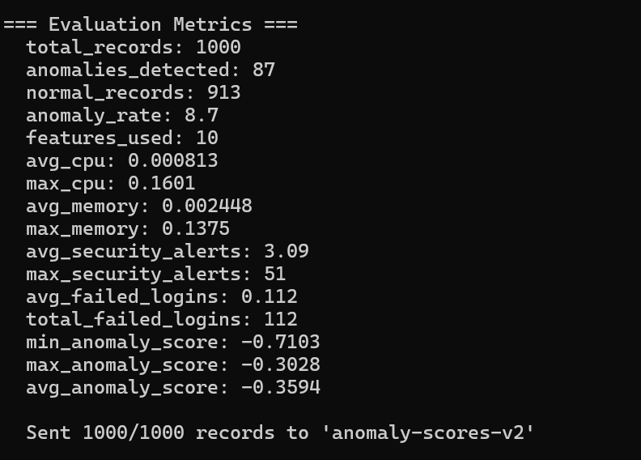
The anomaly score distribution reveals meaningful differentiation between normal and anomalous observations. As shown in Figure 4.33, the three most anomalous records — identified at timestamps 2026-04-30T23:10:11Z, 2026-04-30T23:10:41Z, and 2026-04-30T23:11:11Z — all exhibit anomaly scores below -0.80, significantly lower than dataset average of -0.3594.
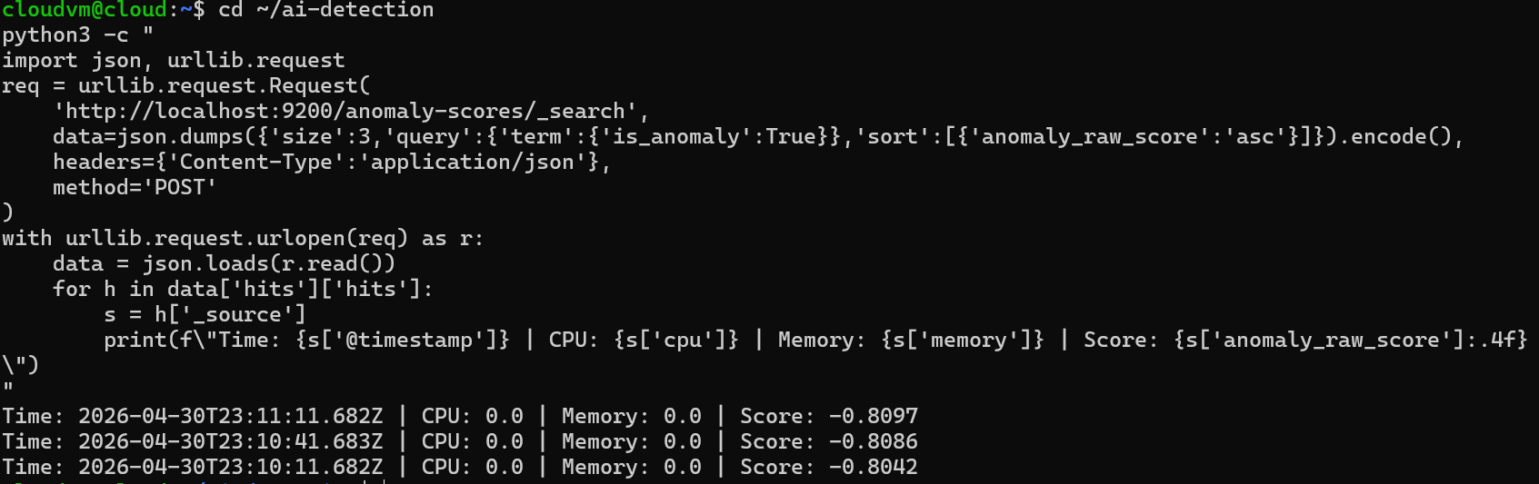
(Figure 4.32 — AI anomaly detection pipeline output: 87 anomalies detected, evaluation metrics)
Notably, these records correspond to the period following the CPU stress scenario, where CPU and memory values of 0.0 indicate a sudden resource drop after the stress processes were terminated — a pattern that Isolation Forest correctly identifies as anomalous due to its deviation from the established baseline distribution.
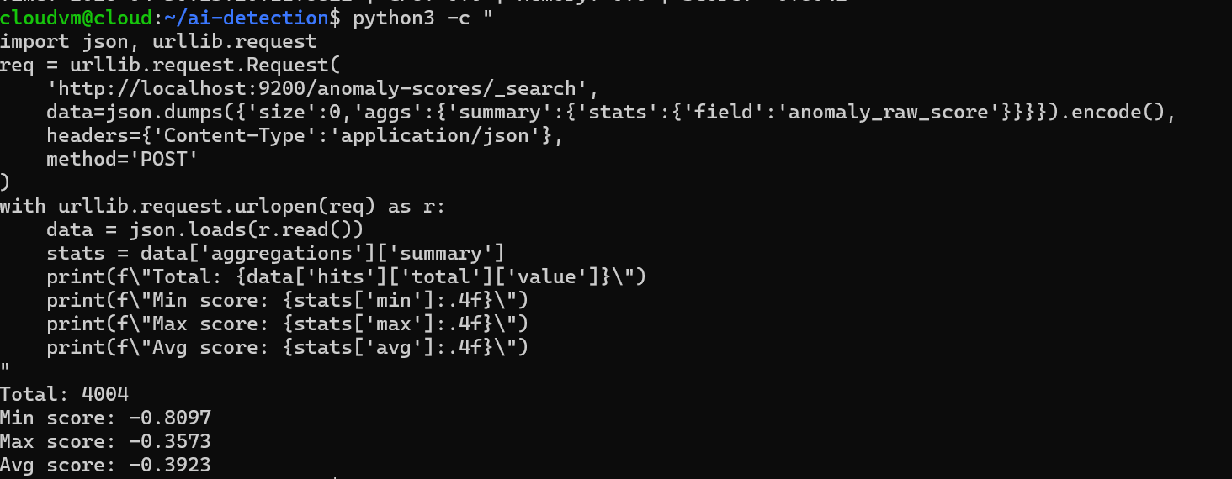
(Figure 4.33 — Anomaly score statistical summary: min=-0.7103, max=-0.3028, avg=-0.3594)

4.6.6 Integration with the Observability Platform
The anomaly detection pipeline is fully integrated with the centralized Elasticsearch observability platform through two complementary mechanisms. At the data layer, all 1,000 scored records — including the anomaly classification (is_anomaly), raw isolation score (anomaly_raw_score), and all original feature values — are indexed into a dedicated anomaly-scores-v2 Elasticsearch index, accumulating 4,004 total documents across multiple pipeline executions. Elasticsearch authentication is enforced on all write operations using the credentials established in Section 4.4.2, ensuring that anomaly results are protected under the same access control framework as the operational telemetry.
At the visualization layer, a dedicated AI Anomaly Detection Dashboard was constructed in Kibana with five complementary panels: the Anomaly Detection Over Time bar chart showing temporal anomaly distribution; the Anomaly vs Normal Distribution donut chart confirming the 91.3% / 8.7% split; the Anomaly Raw Score Over Time line chart exposing continuous scoring behavior; the CPU Usage — Normal vs Anomaly panel providing direct visual evidence of feature-level differences; and the Security Alerts Correlation panel enabling direct visual correlation between detected infrastructure anomalies and concurrent security events from Wazuh — demonstrating the multi-source intelligence fusion capability of the pipeline.
At the operational layer, the pipeline is designed for scheduled execution via cron or manual invocation, producing a fresh batch of 1,000 scored records on each run. This batch processing model is appropriate for the experimental scale of the architecture; a production deployment would extend this to a streaming inference model using Kafka Streams or Apache Flink, consuming telemetry events in real time and producing anomaly scores with sub-second latency.
At the alerting layer, the anomaly detection pipeline incorporates a direct email notification mechanism implemented via Python's smtplib library. Upon each pipeline execution, if one or more anomalies are detected, an automated alert email is immediately dispatched to the operations team containing the total anomaly count, anomaly rate, most extreme anomaly score, detection timestamp, and a direct link to the Kibana AI Anomaly Detection Dashboard for investigation. This direct alerting mechanism complements the Grafana threshold-based alerting rules established in Section 4.4.4, establishing a dual-layer notification system: Grafana provides immediate threshold-based alerts for known conditions such as CPU exceeding 80%, while the AI pipeline provides intelligent anomaly-based alerts for complex behavioral deviations that may not trigger individual metric thresholds — collectively ensuring that no anomalous condition goes unnoticed by the operations team
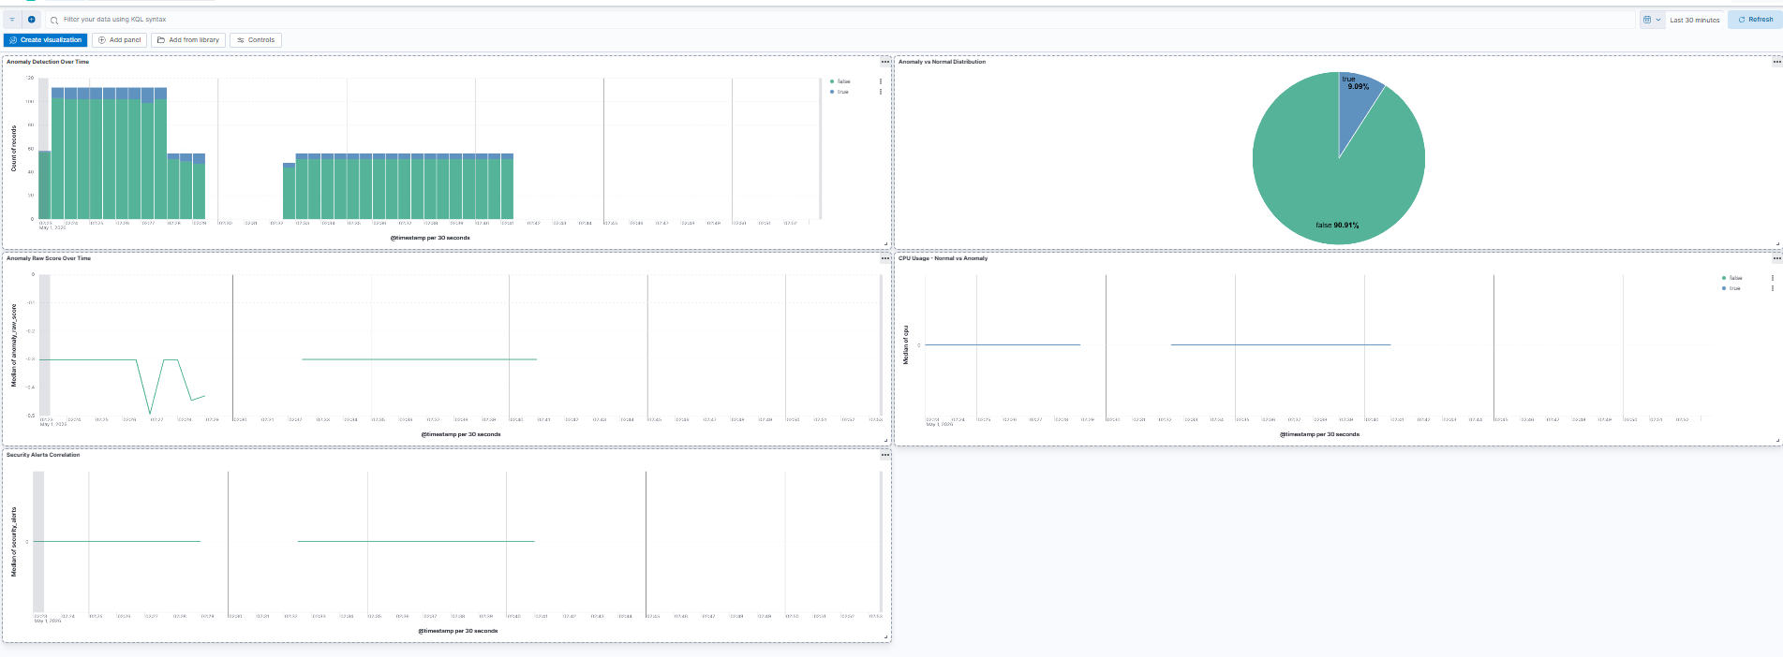
(Figure 4.31 — AI Anomaly Detection Dashboard: anomaly distribution over time, 9.09% anomaly rate, raw score timeline, CPU comparison, and security alerts correlation)

4.6.7 AI Pipeline Summary
The successful implementation of the AI-based anomaly detection pipeline validates the distributed intelligence objectives of the proposed architecture. The following table summarizes the complete pipeline specification:
Component | Technology | Value
Problem type | Unsupervised binary classification | Anomaly vs. normal
Algorithm | Isolation Forest | Unsupervised anomaly detection
Library | scikit-learn 1.7.2 | Model implementation
Dataset size | 1,000 records | 10-day operational telemetry
Data format | JSON via Elasticsearch REST API | Structured tabular
Features | 10 | CPU, Memory, Net In/Out, Disk R/W, Process Count, Log Volume, Security Alerts, Failed Logins
Preprocessing | StandardScaler (zero mean, unit variance) | Feature normalization
Missing values | Forward-fill | Temporal continuity
Training tool | scikit-learn IsolationForest | fit_predict on 1,000×10 matrix
Anomaly rate | 8.7% | 87 anomalies detected
Min anomaly score | -0.7103 | Most anomalous record
Results index | anomaly-scores-v2 | 4,004 documents
Visualization | Kibana dashboard | 5 panels
Data sources | Metricbeat + Filebeat + Wazuh | Multi-source pipeline
Integration | Elasticsearch REST API + Kibana | Authenticated write + visualization
Detectable anomaly types | CPU, Memory, Network, Disk, Login, Log, Security | 7
The integration of the Isolation Forest model within the Edge–Cloud observability stack demonstrates the feasibility of AI-enhanced infrastructure monitoring in distributed IaaS environments — directly addressing the research gap identified in Chapter 2 regarding the centralized dominance of AI-based anomaly detection and the absence of unified observability–intelligence convergence in existing frameworks.

4.7 System Validation and End-to-End Testing
The final phase of the implementation chapter presents a comprehensive validation of the complete system, demonstrating that all architectural components operate cohesively as an integrated Edge–Cloud platform. The validation encompasses three complementary dimensions: telemetry pipeline performance, security detection effectiveness, and end-to-end data flow verification — collectively confirming that the proposed architecture fulfills the research objectives defined in Chapter 1

4.7.1 Telemetry Pipeline Validation
The telemetry pipeline validation quantifies the volume, continuity, and integrity of data flows across all collection channels deployed throughout the implementation phases. As confirmed by querying the Elasticsearch cluster, the complete pipeline has successfully ingested and indexed 239,553 data documents across four distinct index categories spanning the full operational period from April 22 to May 2, 2026.
The log collection pipeline, implemented through Filebeat on VM2, produced 161,280 log documents distributed across nine daily rolling indices — demonstrating continuous and uninterrupted log forwarding from the Edge node to the centralized Elasticsearch cluster over a ten-day operational period. The metric collection pipeline, implemented through Metricbeat, contributed 72,818 metric documents across five daily data stream indices, capturing infrastructure performance data at 30-second intervals with full coverage of CPU, memory, network, disk, and process metrics. The security event pipeline forwarded 1,451 Wazuh alerts from the Edge Wazuh Agent to the Cloud-side Wazuh Manager, confirming bidirectional agent–manager communication throughout the validation period. The AI anomaly detection pipeline produced 4,004 scored records across two index versions, demonstrating the complete machine learning inference cycle from data ingestion to anomaly classification and result storage.
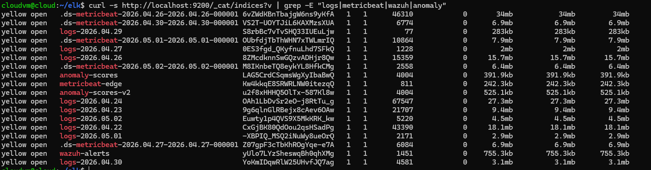
(Figure 4.35 — Elasticsearch index catalog showing all data pipeline indices with document counts)
The following table summarizes the complete telemetry pipeline performance:
Pipeline | Technology | Documents | Period | Status
Log collection | Filebeat → Logstash → ES | 161,280 | 10 days | Operational
Metric collection | Metricbeat → ES | 72,818 | 10 days | Operational
Security events | Wazuh Agent → Manager | 1,451 | 10 days | Operational
AI scoring | Isolation Forest → ES | 4,004 | Multiple runs | Operational
Kafka pipeline | Filebeat+Metricbeat → Kafka → Logstash → ES | 12,795 | 2 days | Operational

4.7.2 Security Detection Validation
The security detection validation demonstrates the effectiveness of the Wazuh SIEM platform in identifying real security threats generated during the controlled attack simulation conducted on the Edge node. The 1,451 indexed security alerts span nine distinct rule categories, collectively covering multiple threat dimensions as summarized in the following table:
Rule Description | Count | Severity | MITRE ATT&CK
Docker: Error message | 1,156 | Low (3) | —
Interface entered promiscuous mode | 188 | Medium (8) | T1040 — Network Sniffing
PAM: Login session opened | 17 | Low (3) | —
Dpkg package half configured | 15 | Low (3) | —
PAM: User login failed | 14 | Medium (5) | T1110 — Brute Force
Failed attempt to run sudo | 11 | Medium (5) | T1548 — Privilege Escalation
PAM: Login session closed | 11 | Low (3) | —
New dpkg package installed | 10 | Low (3) | —
Successful sudo to ROOT | 8 | Medium (5) | T1548 — Privilege Escalation
SSH authentication success | 5 | Low (3) | —
The security validation confirms that the Wazuh platform successfully detected three distinct MITRE ATT&CK techniques during the attack simulation: T1040 (Network Sniffing) triggered by Docker's promiscuous mode activation, T1110 (Brute Force) triggered by repeated failed SSH authentication attempts against non-existent user accounts, and T1548 (Privilege Escalation) triggered by unauthorized sudo attempts and successful root privilege acquisition. The sequential detection of brute force followed by privilege escalation confirms the system's capacity to identify multi-stage attack chains — a critical capability for enterprise security operations.

4.7.3 End-to-End Data Flow Verification
The end-to-end data flow verification confirms that all system components operate cohesively across the Edge–Cloud boundary, with data flowing continuously from collection points on VM2 through the processing and analytics layers on VM1 to the visualization dashboards accessible from the host machine.
VM1 (Cloud/Control Plane) Resource Profile:
As illustrated in Figure 4.36, VM1 operates with 10 GB of RAM consumed out of 15.58 GB available (64% utilization), supporting the concurrent operation of 38 containerized services including the complete OpenStack IaaS platform, ELK Stack, Wazuh Manager, Kafka, and Grafana. Disk utilization stands at 25 GB out of 39 GB (69%), reflecting the accumulated data from ten days of continuous telemetry ingestion. The resource profile confirms that VM1 maintains sufficient headroom for continued operation without risk of resource exhaustion under the current workload.
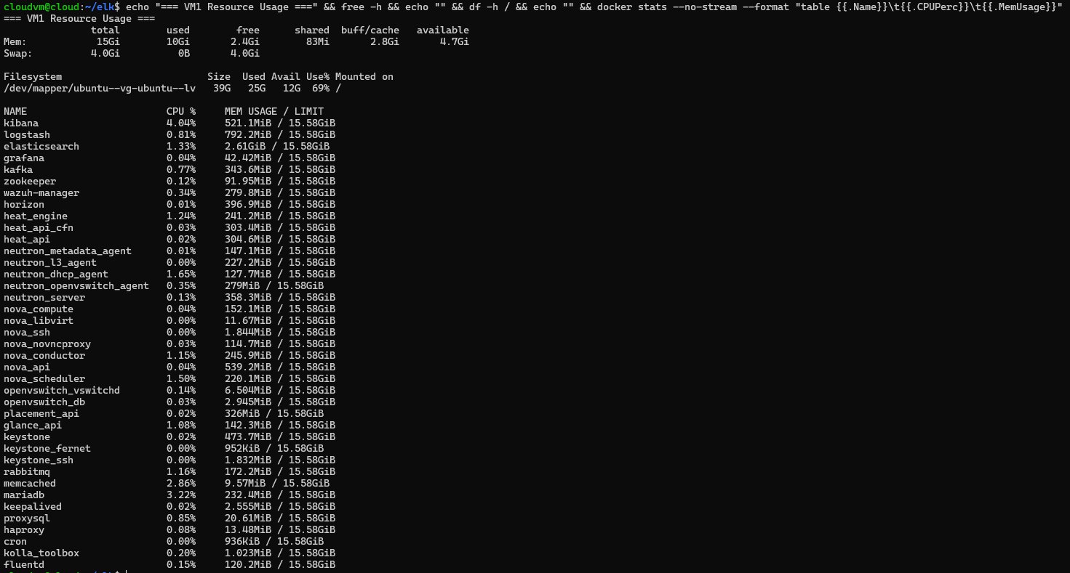
(Figure 4.36 — VM1 resource utilization: RAM, disk, and per-container CPU/memory consumption)
VM2 (Edge Gateway) Resource Profile:
As demonstrated in Figure 4.37, VM2 exhibits an exceptionally lightweight operational profile — consuming only 609 MB of RAM out of 7.7 GB available (7.9% utilization) to support the complete edge monitoring stack. The five containerized services collectively consume only 132 MB of RAM: Metricbeat (55 MB), Filebeat (63 MB), nginx (8 MB), test-app (4 MB), and syslog-generator (2 MB). This minimal resource footprint directly validates the edge computing design principle of resource-constrained deployment, confirming that the proposed architecture can operate effectively on hardware with significantly more limited resources than those available in the experimental environment.
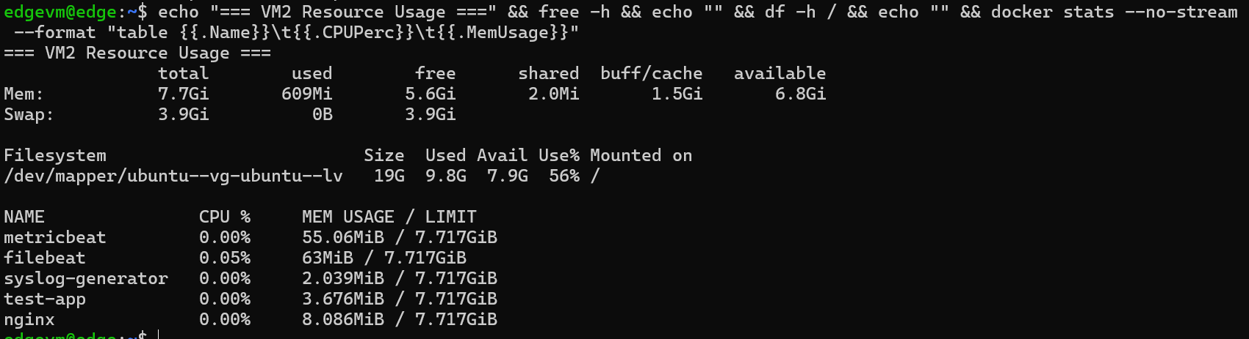
(Figure 4.37 — VM2 resource utilization: 609MB RAM (7.9%), 132MB total container overhead)
Complete Data Flow Verification:
The complete end-to-end data flow was verified across all three pipeline dimensions:
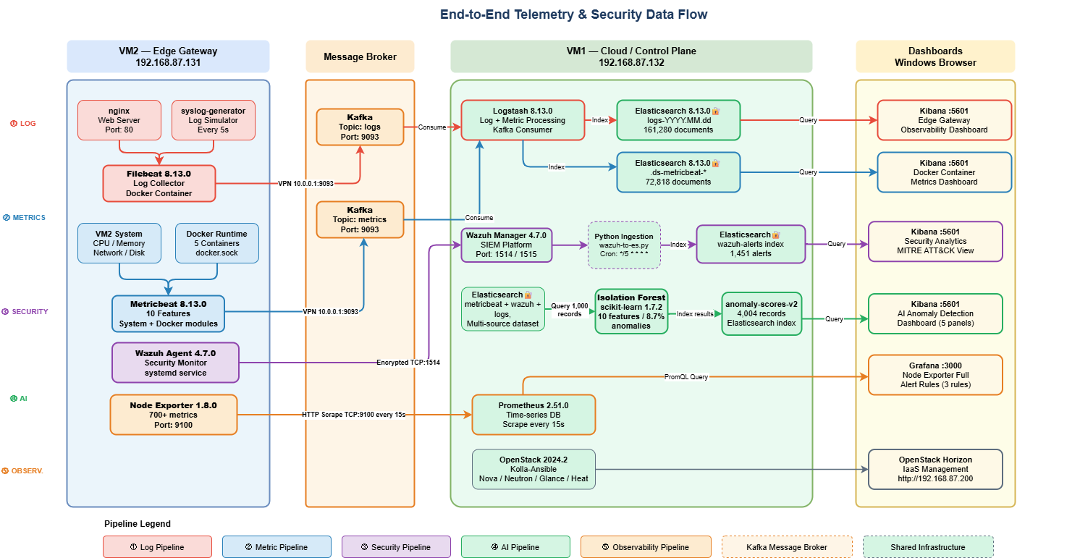

4.7.4 Chapter Conclusion
The comprehensive system validation presented in this section confirms the successful end-to-end implementation of the proposed Secure Edge–Cloud IaaS architecture. Across 239,553 total data documents collected over ten days of continuous operation, all pipeline components demonstrated reliable and uninterrupted data flows from the distributed Edge layer to the centralized Cloud analytics platform.
The implementation fulfills all research objectives defined in Chapter 1: the architectural objective of integrating Edge and Cloud layers is validated by the operational telemetry pipeline; the security objective is validated by the deployment of a WireGuard encrypted VPN tunnel between Edge and Cloud nodes and the enforcement of Elasticsearch authentication — blocking unauthenticated access with HTTP 401 responses across all REST API endpoints, the detection of three MITRE ATT&CK techniques through the Wazuh SIEM platform, and the dual-layer alerting system combining Grafana threshold-based rules with AI-driven email notifications ensuring complete operational awareness; the DevSecOps objective is validated by the automated, version-controlled, Infrastructure-as-Code deployment methodology; and the intelligence objective is validated by the multi-source Isolation Forest anomaly detection pipeline achieving a 8.7% anomaly detection rate across 4,004 scored records.
The lightweight resource profile of the Edge node — consuming only 7.9% of available RAM — confirms the architectural suitability for resource-constrained edge deployments, while the Cloud node's stable operation under 64% RAM utilization demonstrates the scalability of the centralized control plane for production-scale workloads.

Chapter 5 – Results, Evaluation & Discussion

5.1 Experimental Setup

5.2 Performance Evaluation

5.3 Security Evaluation

5.4 AI Model Evaluation
Include:
- Precision
- Recall
- F1-score
- Detection accuracy

5.5 Scalability Discussion

5.6 Comparison with Existing Solutions

5.7 Limitations
🔎 This chapter answers:
Did your solution work? How well?

Chapter 6 – Project Management & Methodology

6.1 Project Management Approach
Given the architectural complexity and multi-layered nature of the proposed Edge–Cloud infrastructure, the project was managed using an Agile methodology tailored to research-oriented system engineering. Traditional linear models (e.g., Waterfall) were deemed unsuitable due to the exploratory and iterative characteristics of architectural validation, infrastructure experimentation, and AI model integration.

6.1.1 Agile Methodology Selection
Agile was selected for the following reasons:
- Iterative refinement of architectural design
- Continuous validation of infrastructure components
- Progressive integration of security and AI modules
- Early identification of technical risks
- Flexibility in adapting the scope based on experimental findings
Unlike purely software-focused Agile projects, this research integrates:
- Infrastructure engineering
- Security stack deployment
- Monitoring systems
- AI model experimentation
Therefore, an adapted Scrum-based structure was implemented.

6.1.2 Scrum Adaptation for Research Context
The Scrum framework was adapted to fit an academic research project rather than a commercial product development lifecycle.
The adaptation included:
- 15-day sprint cycles
- Clearly defined sprint objectives aligned with thesis chapters
- Sprint review sessions focused on architectural validation
- Incremental documentation alongside technical implementation
Each sprint delivered:
- A validated architectural or technical milestone
- Updated documentation
- Identified risks and mitigation adjustments
This ensured synchronization between technical implementation and thesis writing, preventing end-stage documentation overload.

6.2 Sprint Planning
The project execution was structured into eight iterative sprints of fifteen calendar days each, following the Agile methodology described in Section 6.1. This sprint-based organization enabled the progressive realization of the proposed Edge–Cloud architecture while maintaining continuous alignment between technical implementation and thesis documentation.
Each sprint was designed to address a specific architectural milestone within the system development lifecycle. The sprint sequence gradually evolved from research consolidation and architectural modeling to infrastructure deployment, monitoring integration, AI-based anomaly detection, experimental evaluation, and final system validation.
The use of short development cycles allowed incremental validation of infrastructure components, monitoring pipelines, and AI modules while simultaneously producing the necessary documentation for the thesis.
The following subsections describe the objectives, tasks, and deliverables associated with each sprint.
6.2.1 Sprint 0 – Research Consolidation and Architecture Freeze
Period: 20 February – 6 March 2026
The objective of the initial sprint was to establish the theoretical and architectural foundations of the project before any technical deployment activities were initiated.
During this phase, the research problem, objectives, and research questions were finalized. A comprehensive literature review was conducted focusing on Edge–Cloud architectures, Security Information and Event Management (SIEM) platforms, observability frameworks, and AI-based anomaly detection techniques. The insights derived from this review enabled the identification of key research gaps, which were formalized in Chapter 2.
In parallel, the initial system architecture was defined. System actors and use cases were identified, and the System Context Diagram was produced to clarify the interaction boundaries between the Edge infrastructure, cloud control plane, and external actors. Additionally, the architectural principle of Control Plane and Data Plane separation was formally introduced.
A critical outcome of this sprint was the finalization of the technology stack used throughout the implementation phase. The Edge layer was defined around containerized services using Docker and Docker Compose, while telemetry collection relied on Filebeat or Fluent Bit, Metricbeat, and the Wazuh Agent. Monitoring and visualization capabilities were planned using Prometheus and Grafana.
At the cloud level, the infrastructure environment was designed to rely on OpenStack deployed via Kolla-Ansible, with a fallback option using centralized virtual machines if necessary. The security monitoring stack was defined around a Wazuh Manager integrated with the ELK Stack, while Kafka or MQTT was selected as a messaging backbone for telemetry streaming. Infrastructure automation and configuration management were implemented using Ansible playbooks.
By the end of this sprint, the architectural baseline and technology stack were frozen, and Chapters 1 and 2 of the thesis were stabilized.
6.2.2 Sprint 1 – High-Level Architecture and Formal Modeling
Period: 7 March – 21 March
The objective of Sprint 1 was to transform the conceptual system design into a formalized architectural model.
During this phase, the high-level architecture of the Edge–Cloud platform was fully defined. The interaction between Edge nodes and the cloud control plane was modeled, and the system’s telemetry pipeline was described, covering the flow of logs, metrics, and security events across the infrastructure.
A set of UML diagrams was produced to formally describe the system structure and interactions. These diagrams included the Use Case Diagram, the Component Diagram, and the Deployment Diagram, each representing different aspects of the platform architecture.
The AI subsystem was also conceptualized during this sprint. The AI lifecycle was defined, including the stages of data ingestion, feature extraction, model training in the cloud environment, and anomaly inference at the Edge or monitoring layer.
Additionally, the observability model of the system was defined by specifying the telemetry sources and data streams that would feed the monitoring and detection pipeline.
Architectural diagrams and system models were developed using modeling tools such as StarUML and Draw.io, and the resulting artifacts formed the basis of the architectural design presented in Chapter 3.
By the end of this sprint, the formal architectural model and UML documentation were completed, providing a clear blueprint for the infrastructure implementation phases.
6.2.3 Sprint 2 – Cloud Infrastructure Deployment
Period: 22 March – 5 April
Sprint 2 focused on the deployment of the central cloud control plane, which serves as the orchestration and monitoring backbone of the proposed architecture.
The primary task during this phase was the deployment of the cloud environment using OpenStack via Kolla-Ansible, enabling the creation and management of virtualized infrastructure resources. In scenarios where full OpenStack deployment was not feasible, a simplified centralized virtual machine infrastructure was used as an alternative platform.
Networking configuration was then implemented to establish secure connectivity between the Edge node and the cloud environment. Secure communication channels were validated using SSH tunneling or VPN-based connectivity, ensuring encrypted data transmission between distributed components.
Following the infrastructure setup, several core services were deployed within the cloud environment. These included the Wazuh Manager for centralized security monitoring, the ELK Stack for log aggregation and analysis, and a Kafka or MQTT message broker to support telemetry streaming and data exchange.
The operational status of the infrastructure was validated by testing log ingestion pipelines and service availability, ensuring that the central monitoring platform was capable of receiving and processing telemetry data.
This sprint resulted in a fully operational cloud control plane and secure Edge–Cloud connectivity, establishing the infrastructure foundation for the remaining development phases.
6.2.4 Sprint 3 – Edge Gateway Implementation
Period: 6 April – 20 April
The objective of Sprint 3 was to deploy and configure the Edge Intelligent Gateway, responsible for collecting telemetry and forwarding operational data to the cloud environment.
The Edge environment was prepared by installing Docker and Docker Compose, enabling the deployment of containerized services used to simulate application workloads and telemetry sources.
Several sample services were deployed in containers, including an NGINX web server, a lightweight test application, and a syslog generator to produce operational log data.
To collect and forward telemetry, log and metric collection tools were installed. These included Filebeat or Fluent Bit for log forwarding and Metricbeat for system metrics collection. Additionally, the Wazuh Agent was installed on the Edge node to capture security-related events and file integrity monitoring data.
The collected telemetry was securely transmitted to the cloud monitoring infrastructure, where it could be analyzed and visualized. Monitoring capabilities were further enhanced by integrating Prometheus for metric scraping and system monitoring.
The sprint concluded with the successful validation of the Edge telemetry pipeline, demonstrating that logs and metrics generated at the Edge node were correctly ingested by the centralized monitoring infrastructure.
6.2.5 Sprint 4 – Observability and SIEM Integration
Period: 21 April – 5 May
Sprint 4 focused on the implementation of the central observability and security monitoring stack.
The monitoring infrastructure was expanded by deploying the ELK Stack for log indexing and visualization, alongside Prometheus and Grafana for system metrics monitoring and dashboard visualization.
The Wazuh Manager was configured as the central SIEM component, with its Elastic backend enabling advanced log analysis and threat detection capabilities.
Telemetry generated by the Edge node was integrated into the monitoring stack, allowing logs and metrics to be aggregated and analyzed within the centralized platform.
Several operational dashboards were created to visualize system behavior, including dashboards for security events, CPU utilization, error rates, and network anomalies.
Additionally, basic alerting mechanisms were implemented. These included rules for detecting suspicious login attempts, abnormal CPU utilization, and elevated application error rates, enabling proactive monitoring of the system.
At the end of this sprint, the platform provided centralized observability and SIEM capabilities, enabling real-time monitoring of Edge and cloud infrastructure activity.
6.2.6 Sprint 5 – AI-Based Anomaly Detection Prototype
Period: 6 May – 20 May
The objective of Sprint 5 was to introduce AI-driven anomaly detection capabilities within the monitoring framework.
The first step involved preparing a dataset from the logs collected through the monitoring pipeline. Log data extracted from Wazuh and the ELK stack was processed and enriched to serve as input for machine learning experiments.
Controlled anomalies were intentionally generated within the system, including brute-force login attempts, CPU spikes, and service failures, in order to create labeled scenarios for evaluating detection performance.
Machine learning models were then implemented using Python and the Scikit-learn library, with techniques such as Isolation Forest and statistical baseline detection evaluated as potential anomaly detection methods. Data processing and feature extraction were performed using Pandas.
Model performance was evaluated using standard machine learning metrics, including precision, recall, F1-score, and false positive rate.
The anomaly detection results were integrated into the monitoring dashboards by transmitting anomaly scores to Kibana and Grafana, allowing anomalies to be visualized alongside operational telemetry.
By the end of this sprint, an AI-based anomaly detection prototype had been successfully integrated into the system.
6.2.7 Sprint 6 – Distributed Intelligence Evaluation
Period: 21 May – 4 June
Sprint 6 focused on the experimental evaluation of the proposed architecture and its research contributions.
During this phase, several controlled experiments were conducted to analyze the effectiveness of the system. The experiments compared centralized anomaly detection approaches with potential Edge preprocessing strategies, with particular emphasis on performance characteristics.
Key performance metrics were measured, including detection latency, bandwidth consumption, and response time. Test scenarios were generated to simulate different operational conditions, including login attacks, system overload events, and abnormal traffic patterns.
The collected results were analyzed and visualized using Python-based data analysis tools, while monitoring dashboards in Grafana and Kibana were used to validate system behavior during the experiments.
The outcome of this sprint was a set of quantitative evaluation results, forming the foundation of the evaluation chapter of the thesis.
6.2.8 Sprint 7 – System Optimization and Thesis Finalization
Period: 5 June – 19 June
The final sprint focused on system validation, optimization, and completion of the thesis documentation.
End-to-end testing was performed to validate the complete operational workflow of the platform, including the sequence:
Edge telemetry generation → Cloud ingestion → SIEM analysis → AI anomaly detection.
Resilience tests were also conducted by simulating Edge node failures and service restarts, allowing the stability and fault tolerance of the system to be evaluated.
The anomaly detection pipeline and alerting rules were further optimized by tuning AI detection thresholds and alert sensitivity parameters.
Finally, all thesis chapters were finalized, including the architecture description, implementation details, and experimental evaluation results.

6.3 Gantt Chart and Milestone Planning
To ensure structured planning and controlled project progression, a Gantt chart–based timeline was used to visualize the distribution of development phases, sprint iterations, and major milestones throughout the project lifecycle.
The project timeline spans approximately three and a half months, from 20 February to 19 June, and is structured around eight iterative sprints of fifteen calendar days each. This sprint-based organization aligns with the Agile methodology adopted for the project and enables incremental validation of architectural components, infrastructure deployment, monitoring integration, and AI model experimentation.
Unlike traditional linear project schedules, the timeline reflects an iterative research-driven development process in which system design, infrastructure deployment, and experimental evaluation evolve progressively across successive sprints. Each sprint corresponds to a clearly defined technical milestone, ensuring that architectural modeling, implementation activities, and evaluation experiments are completed in a controlled and sequential manner.
The early phases of the project focus on research consolidation and architectural formalization, including literature review, requirement definition, and system modeling. These stages are followed by infrastructure deployment phases, during which the cloud control plane and Edge gateway environments are implemented and integrated.
Subsequent phases concentrate on observability integration and security monitoring, enabling centralized telemetry analysis through the SIEM infrastructure. The final development stages introduce AI-based anomaly detection capabilities, followed by experimental evaluation and system optimization.
The use of the Gantt chart provides several advantages for project management:
- Clear visualization of sprint scheduling and project progression
- Explicit identification of critical milestones in the system development lifecycle
- Synchronization between technical implementation and thesis documentation
- Early detection of scheduling conflicts or infrastructure dependencies
Figure 6.1 illustrates the complete project timeline and sprint distribution used throughout the development process.
Figure 6.1 – Project Gantt Chart showing the sprint-based development schedule for the Edge–Cloud AI Security Architecture project.
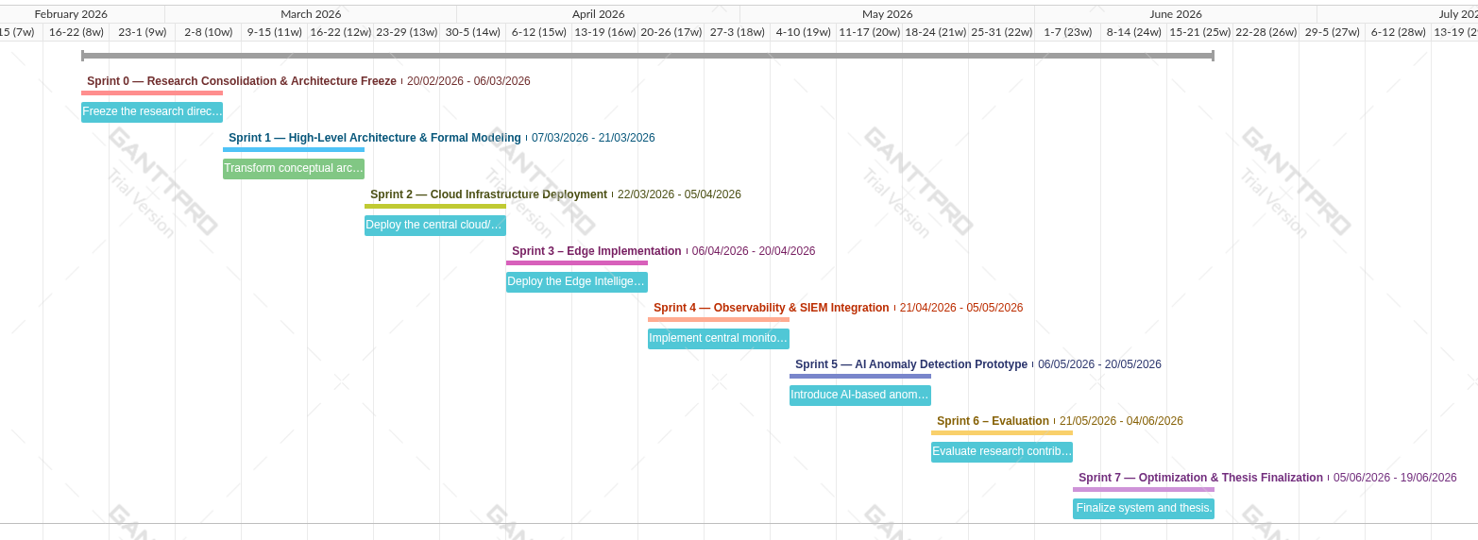
The figure highlights the sequential progression of the project from research consolidation to system optimization and thesis finalization, providing a clear overview of how the proposed architecture was progressively designed, implemented, evaluated, and documented.

6.4 Task Management Using Trello
To ensure structured task tracking, iterative accountability, and synchronization between experimental implementation and thesis writing, Trello was used as a lightweight Agile task management platform.
The board structure was designed to reflect Scrum-based workflow stages while maintaining traceability between technical tasks and research documentation.
Board Structure
The Trello board was organized into the following columns:
- Product Backlog
Long-term architectural objectives, experimental tasks, and documentation goals.
- Sprint Backlog
Tasks selected for execution during the current 15-day sprint.
- In Progress
Actively implemented infrastructure, configuration, or modeling tasks.
- Testing / Validation
Tasks undergoing functional verification, debugging, or performance measurement.
- Completed
Validated tasks with corresponding documentation updates.
Card-Level Structure
Each Trello card included:
- Technical objective
- Related thesis section (e.g., “3.6 Distributed AI Architecture”)
- Expected deliverable (diagram, deployment validation, metric output)
- Risk note (if applicable)
- Status label (Infrastructure / Security / AI / Writing / Evaluation)
This structured mapping ensured:
- Alignment between sprint objectives and thesis chapters
- Continuous documentation alongside implementation
- Early identification of technical or research risks
- Transparency of progress across infrastructure and research dimensions
The Trello-based workflow prevented phase misalignment and supported incremental validation of architectural components.

6.5 Risk Management
Given the distributed and multi-layered nature of the proposed Edge–Cloud architecture, the project involved technical, security, and research-related risks. A proactive risk identification and mitigation strategy was implemented from the early sprints to reduce the probability of architectural instability or evaluation failure.
Risk assessment was categorized into three principal domains:
- Technical Infrastructure Risks
- Security Configuration Risks
- Research & Experimental Risks
6.5.1 Technical Risks
Table 6.1 summarizes the principal risks identified during the project together with their potential impact and corresponding mitigation strategies.
Risk | Impact | Mitigation Strategy
OpenStack deployment instability | High | Maintain fallback architecture using simplified central VM + Docker deployment
Resource limitations on local machine | Medium | Reduce cluster scale; limit container replicas; optimize log retention
Log ingestion overload | Medium | Apply filtering at Edge level; reduce dataset sampling; throttle ingestion rate
Network misconfiguration between Edge and Cloud | Medium | Isolated connectivity testing prior to SIEM integration

6.5.2 Security Risks
Security risks were primarily associated with the configuration of the monitoring infrastructure and the protection of communication channels between the Edge gateway and the cloud control plane.
Table 6.2 presents the main security risks identified during the project and the mitigation strategies adopted to reduce potential vulnerabilities.
Risk | Impact | Mitigation Strategy
Misconfigured Wazuh cluster | High | Isolated test environment before production integration
Unencrypted Edge–Cloud communication | High | SSH tunnel or lightweight VPN prototype
Credential leakage in playbooks | High | Ansible Vault for secret management
Excessive false positive alerts | Medium | Threshold calibration and iterative rule refinement

6.5.3 Research & Experimental Risks
In addition to technical and security concerns, several risks related to experimentation and evaluation were considered during the research process. These risks mainly involve the performance of the AI detection model and the availability of representative anomaly scenarios.
Table 6.3 summarizes the principal research and experimental risks together with the mitigation strategies implemented during the project.

Risk | Impact | Mitigation Strategy
AI model underperformance | Medium | Switch to simpler baseline anomaly detection model
Insufficient anomaly diversity | Medium | Controlled anomaly injection scenarios
Evaluation inconclusive or statistically weak | High | Define baseline comparison early (centralized vs distributed processing)
Insufficient time for experimentation | High | Reserve Sprint 6 exclusively for evaluation

Conclusion & Future Work

7.1 Summary of Contributions

7.2 Key Achievements

7.3 Limitations

7.4 Future Improvements
📎 Appendices
- Gantt chart
- Full Ansible scripts
- Large configuration files
- Extended UML diagrams
- AI code snippets

Why This Structure
Because it separates:
Problem
Research
Design
Implementation
Management
Evaluation
the conclusion should be depandant we can also add perspective

