

**Department of Software Engineering**

**Mehran University of Engineering & Technology, Jamshoro**

**Course: Mobile Application Development (SW-327)**

**Instructor: Ms. Mariam Memon**

**Assignment Type: Complex Engineering Problem (CEP)**

**Submitted By: Hafsa Noor (22SW020), Heer Memon (22SW131), Nashrah Jahejo (22SW135)**

**Title of Project: SilverCare — Elderly Assistance Mobile Application**

**GitHub Repo Link:** [**https://github.com/hafsa-noor2/smart_elderly_care.git**](https://github.com/hafsa-noor2/smart_elderly_care.git)

### ****1. REAL WORLD PROBLEM IDENTIFICATION:****

With the rise in the elderly population, many senior citizens face challenges in managing their daily health routines and safety. Most of them live alone or rely on others for medication reminders, health tracking, and emergency support.  
In critical situations such as sudden illness, accidental falls, or forgetting to take medicines, the absence of immediate help can lead to severe health complications or even life-threatening outcomes.  
There is a strong need for a **simple, reliable, and user-friendly system** that can help elderly individuals stay safe, healthy, and connected with their caregivers or family members at all times.

### ****2. PROPOSED SOLUTION:****

To address these challenges, we propose **SilverCare**, a smart elderly care mobile application that focuses on health management, safety, and independence.  
The app integrates essential features in one platform to assist elderly users and caregivers effectively.

Key features include:

* **Medicine Reminder System:** Sends timely notifications for medication intake to prevent missed doses.
* **Emergency SOS Feature:** Instantly alerts family members or emergency contacts in case of emergencies.
* **Profile Information:** **Add and update personal details** such as name, age, gender, and contact information.
* **Health Tips:** Provides useful daily health tips and wellness advice to promote a healthy lifestyle and preventive care for elder users

By combining these features, **SilverCare** ensures **timely support, enhanced safety,** and **better communication** between elderly individuals and caregivers, promoting independent and healthy living through technology.

* 1. **RESPONSIVE USER INTERFACES**
* **Chrome**

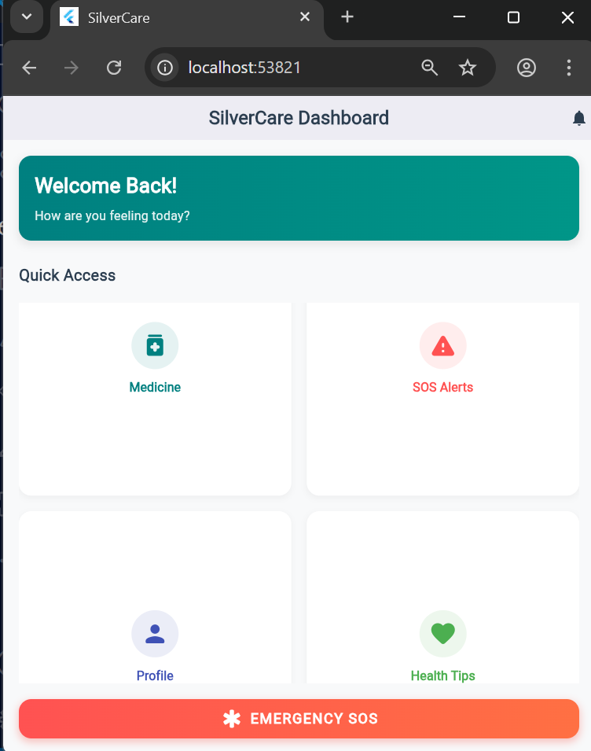

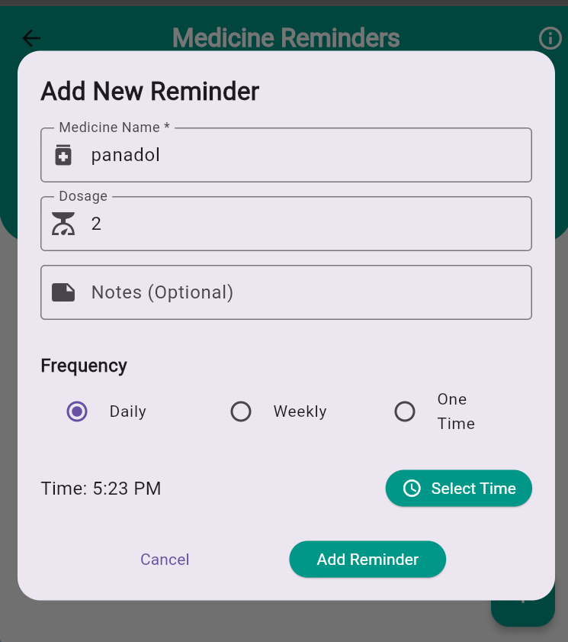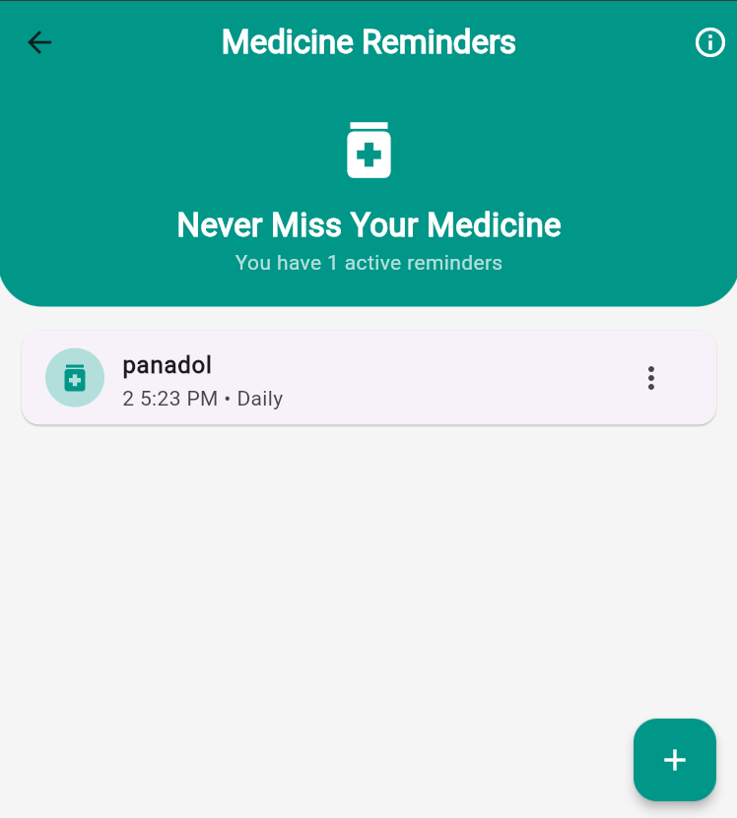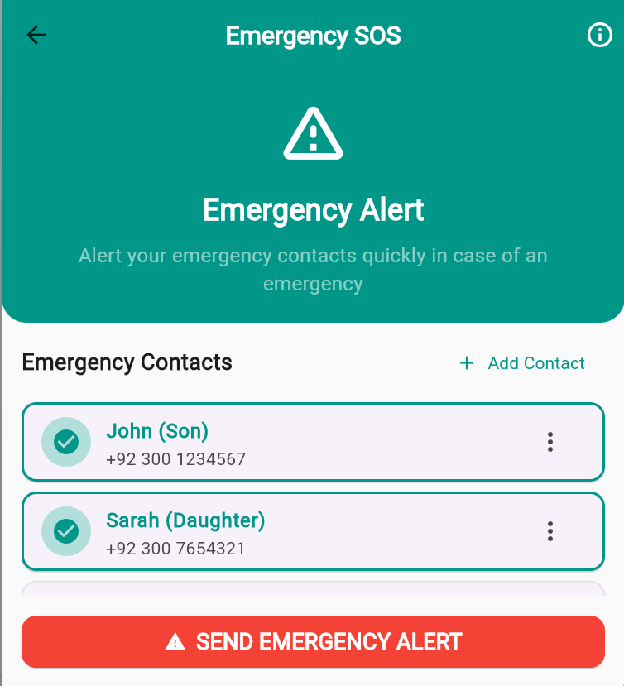

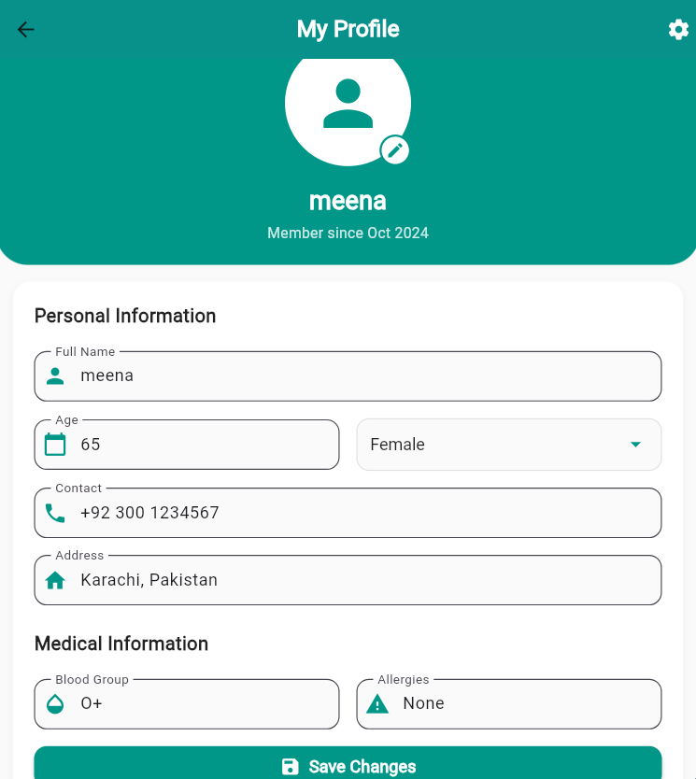

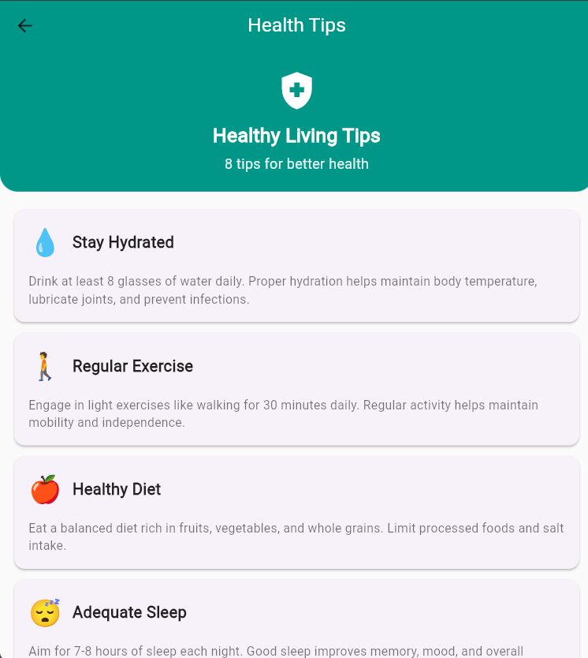

* **Mobile**

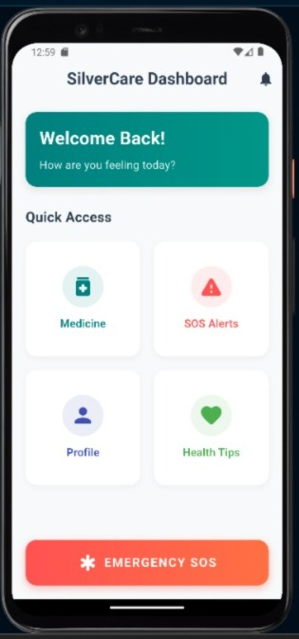 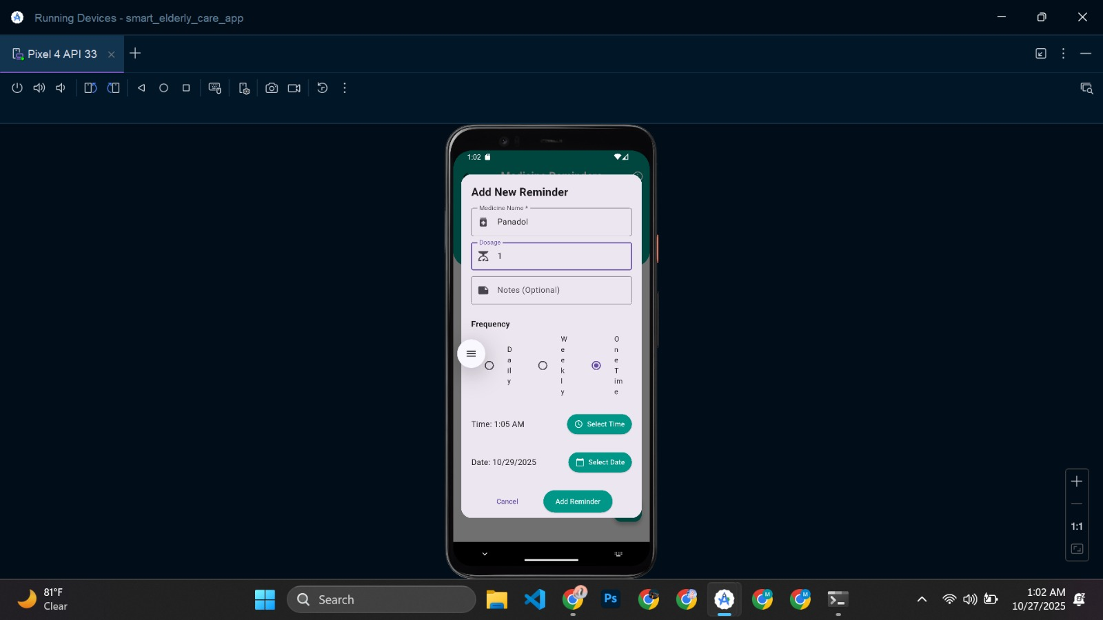

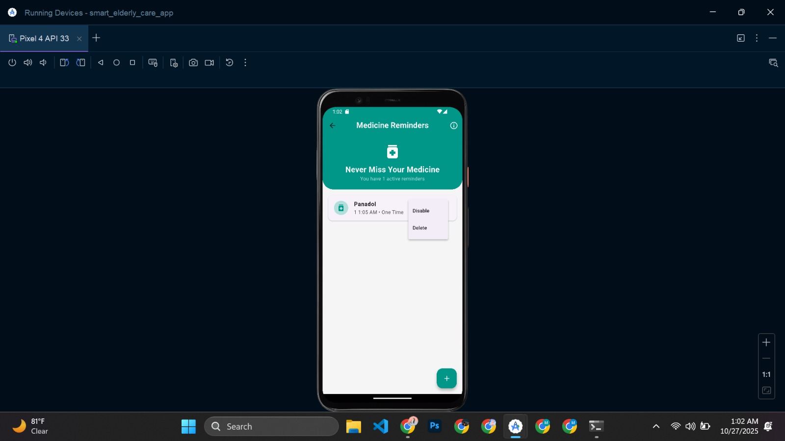 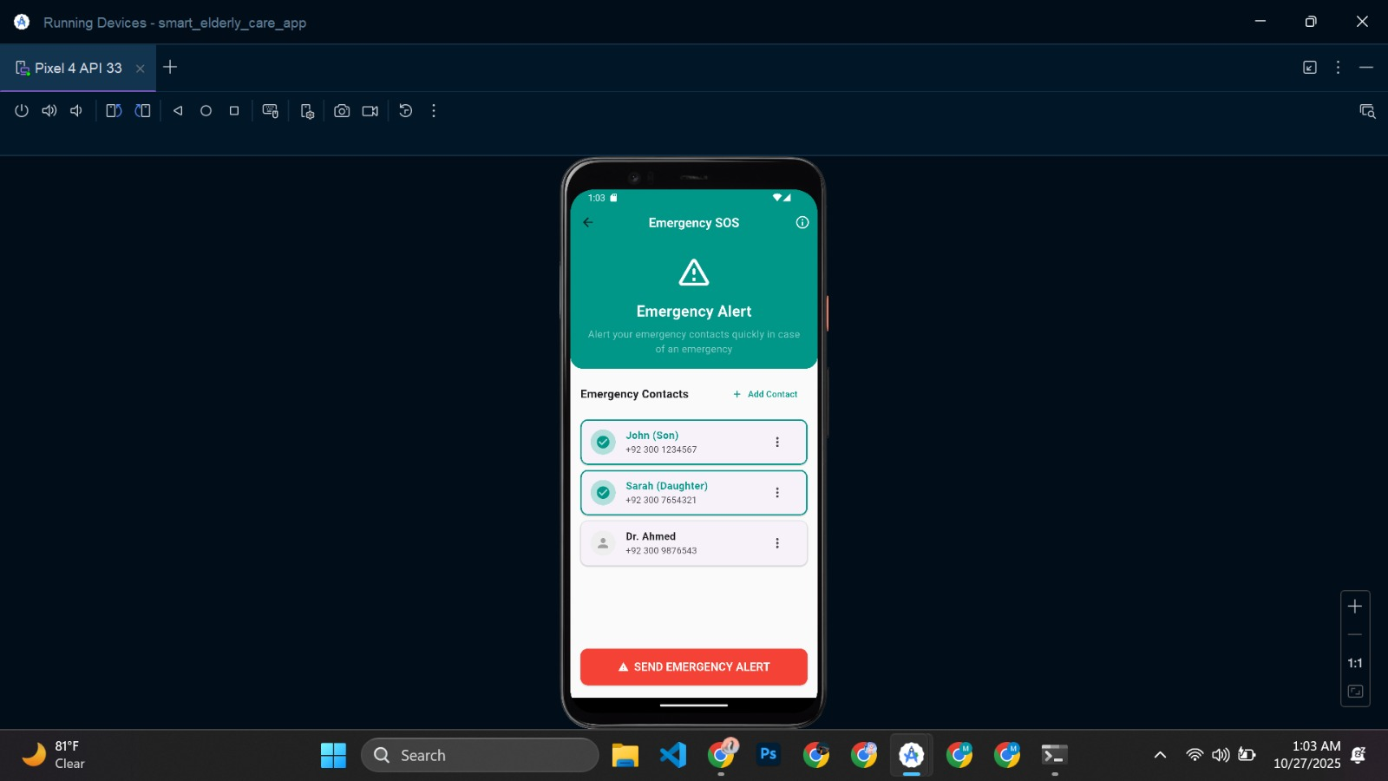

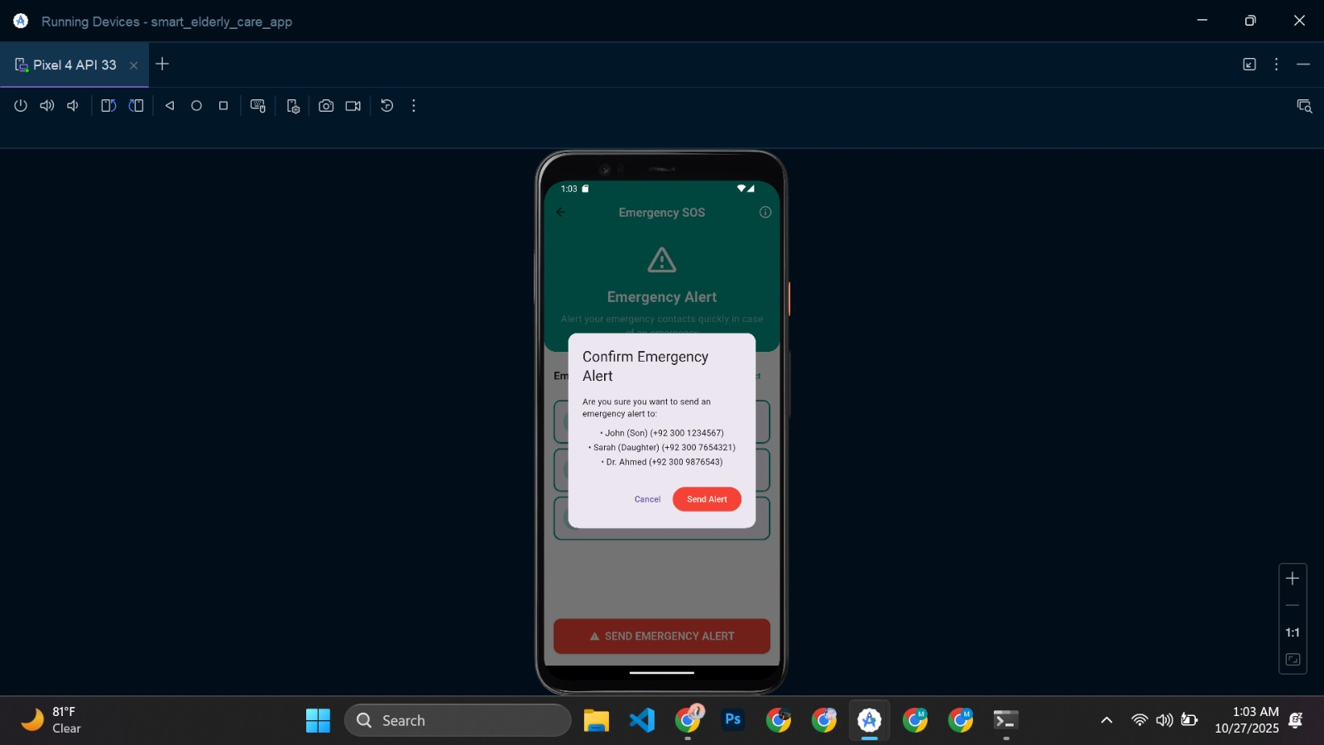 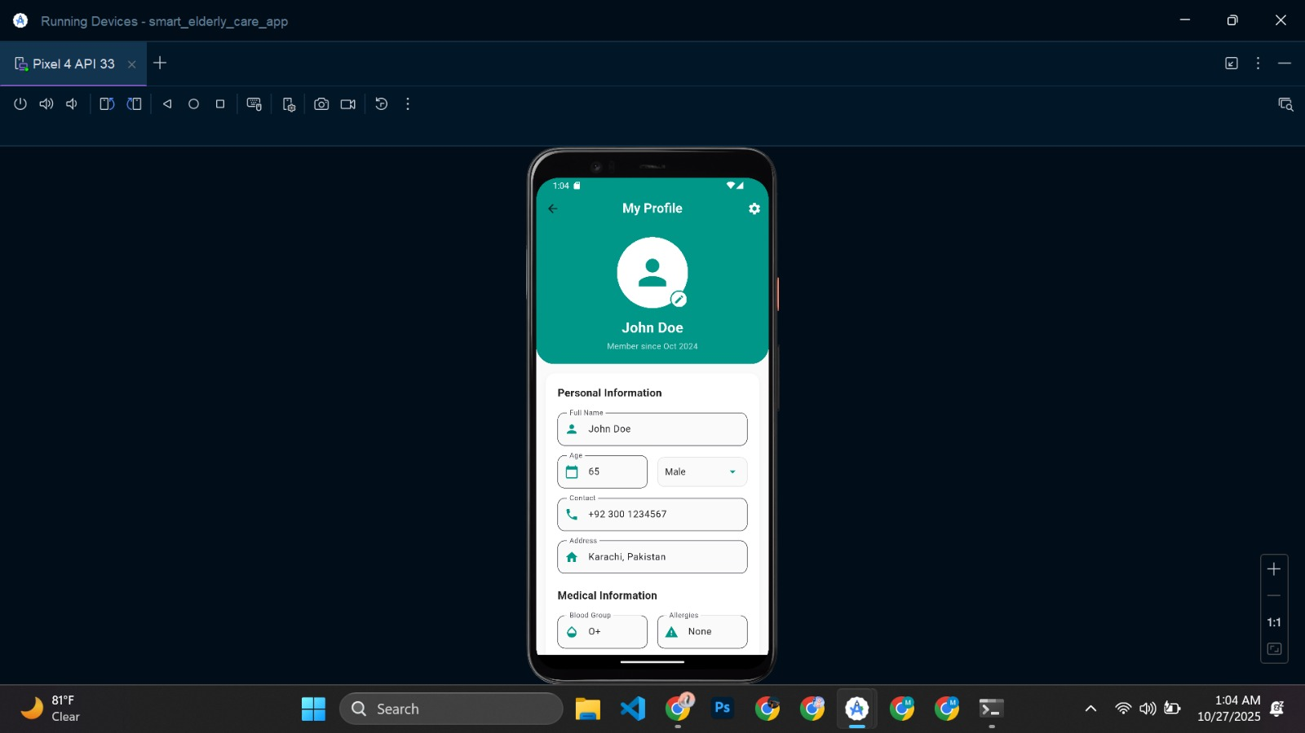

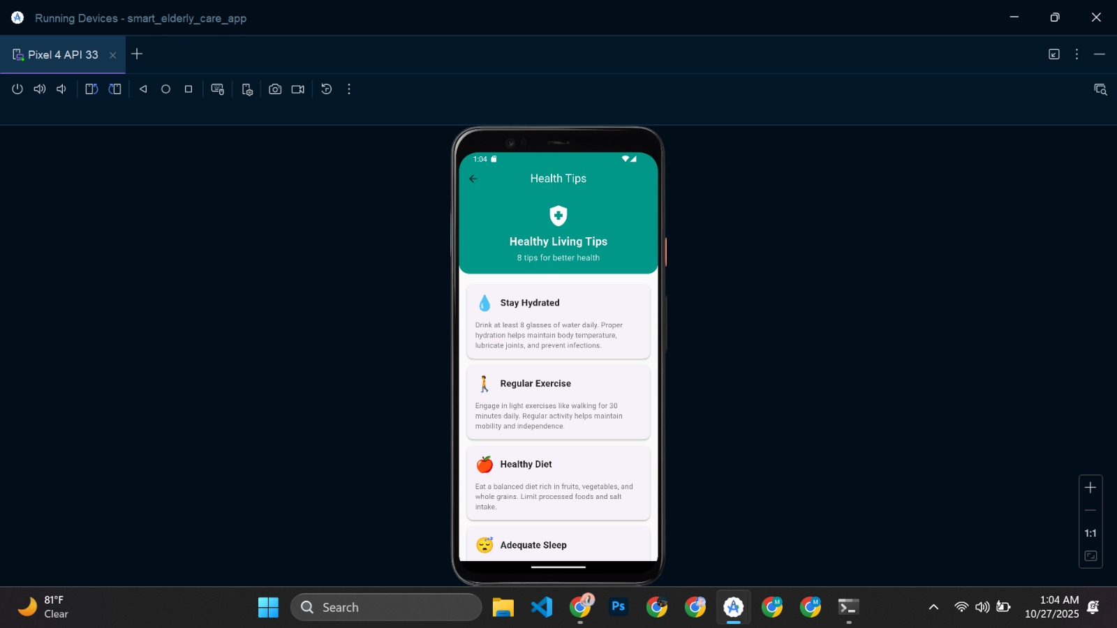

* 1. **DATA STORAGE**

## **Hive**

### ****Justification:****

Our Silver Care App requires fast, reliable, and offline-first data management for features such as medicine reminders, health tips, and SOS records. To achieve this efficiently, we used **Hive**, a lightweight and high-performance **NoSQL local database** for Flutter**.**

Hive allows our app to **store and retrieve data directly on the device**, ensuring that essential features like medicine reminders and health logs continue to function **even without internet connectivity**. This is especially beneficial for elderly users who may not always have stable network access.

We selected Hive because it provides:

* **High speed and low latency** for local read/write operations.
* **Offline persistence** — data remains available without internet.
* **Secure local storage**, supporting encryption for sensitive data.
* **Easy integration with Flutter**, requiring no external server setup.

Using Hive also reduces dependency on external cloud services, improving **app performance, privacy, and simplicity** while maintaining reliable data storage.

Hence, Hive ensures **efficiency, accessibility, and privacy**, which are critical for a health-focused elderly care application.

### ****How It’s Used in the App:****

| **Feature** | **Hive Usage** |
| --- | --- |
| **Medicine Reminders** | Each medicine reminder (name, dosage, time, frequency) is stored in a Hive box (remindersBox). Users can add, update, or delete reminders, which remain accessible offline. |
| **Health Tips** | Health tips and wellness suggestions are stored in a Hive box (tipsBox), allowing users to view them instantly without internet access. |
| **User Preferences / Profile** | Basic profile info and user preferences can be cached locally using Hive for quick loading and offline use. |
| **Offline Functionality** | All locally stored data is preserved even after app restarts, ensuring continuous access without needing to re-fetch data. |

* 1. **ISSUES AND BUGS ENCOUNTERED**

During the development of the **SilverCare App**, we faced a few technical issues related to the **SOS feature, notifications**, and **Firestore integration.**

* **SOS Call Management:**  
  The SOS button initially failed to make direct phone calls due to missing permissions and Android security restrictions. This was fixed by adding proper runtime permission handling and using the url_launcher package safely.
* **Notification Difficulty:**  
  Implementing local notifications for reminders was challenging, especially when the app was closed. We resolved this using the flutter_local_notifications package, though background alerts still required fine-tuning.

### ****Hive Initialization Error:****

### While implementing local data storage using Hive, an initialization error occurred because the Hive boxes were accessed before proper initialization. This happened due to missing or incorrect placement of Hive.initFlutter() and Hive.openBox() in the main() function. The issue was resolved by initializing Hive before running the app and ensuring all boxes were opened with the correct names.

* **UI Adjustments:**  
  Minor layout issues occurred on different screen sizes, which were fixed using responsive design widgets.

Despite these challenges, most bugs were resolved, improving the app’s performance and reliability.