QuickEats – Online Food Delivery System
MongoDB Edition
Advanced Database Management System (ADBMS) Project
By: Muhammad Suleman, Alina Ali, Hafsa Sheikh
Submitted To: Ma'am Muniza Memon

Project Overview
System Purpose:
Streamline food ordering with real-time restaurant browsing, secure payments, and complete order tracking.
Core Functionality:
User authentication, restaurant search, cart management, payment processing, and order history.
Technology Stack:
MongoDB (NoSQL), Flask (Backend), Python, HTML/CSS/JavaScript (Frontend).
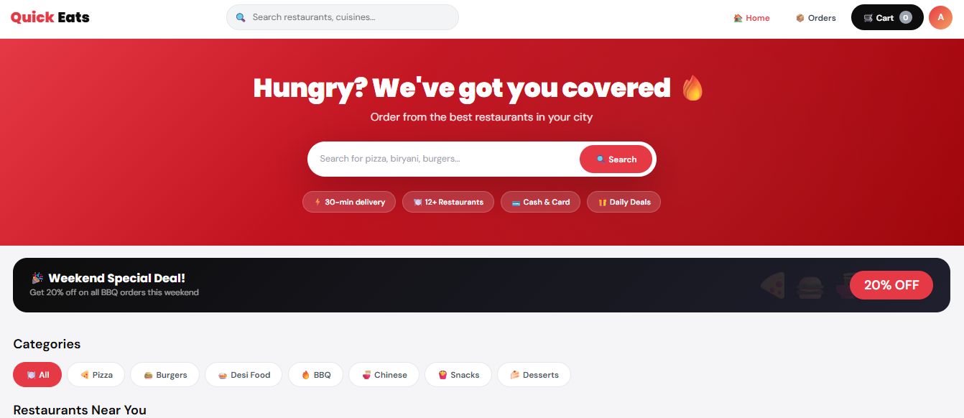

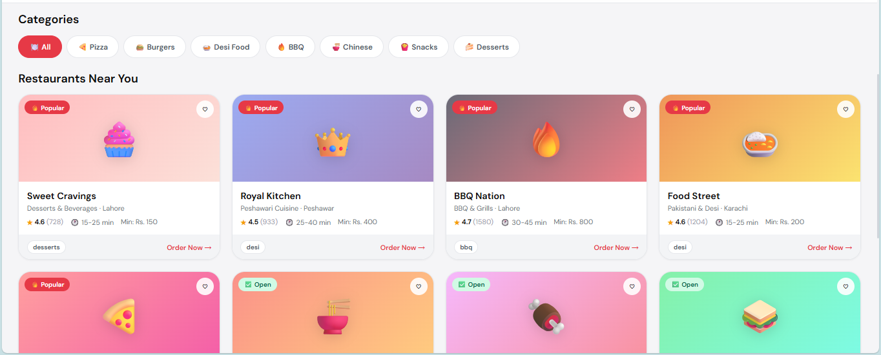

Problem Statement
Traditional System Challenges:
- Manual order processing errors
- Limited restaurant discovery
- Payment security concerns
- No real-time order tracking
- Data inconsistency issues
Proposed Solution:
- Automated order management
- Advanced search capabilities
- Secure payment gateway
- Live order status updates
- Robust database architecture

Technology Stack
MongoDB:
Flexible NoSQL document-based storage.
Python & Flask:
Backend framework providing RESTful APIs.
Frontend:
HTML, CSS, JavaScript for responsive UI.

Database Architecture
Collections:
- Users
- Restaurants
- Menu
- Orders
- Order Items
- Payment

ER Diagram & Relationships
- Users → Orders
- Restaurants → Menu
- Orders → Order Items
- Orders → Payment (1:1)

Schema Design Details
Users: user_id, username, email, password_hash, created_at
Restaurant: restaurant_id, name, cuisine, city, address
Menu: menu_id, restaurant_id, item_name, price, description
Orders: order_id, user_id, total_amount, status, order_date
Order_items: order_id, menu_id, quantity, price
Payment: payment_id, order_id, amount, method, status

CRUD Operations & Workflow
Create: User registration, orders, payments
Read: Search menus, view history
Update: Modify cart, update profile
Delete: Cancel orders, delete account
Workflow:
Place Order → Confirm Order → Process Payment → Store Order

Advantages & Future Enhancements
Advantages:
- Flexible document structure
- Scalable
- Fast performance
Future Improvements:
- Real-time chat
- Geolocation tracking
- AI recommendations
- Rating system
- Admin dashboard

Conclusion
Successful Implementation of a complete food delivery system using MongoDB.
Learning Outcome:
Practical understanding of NoSQL database design and Flask integration.

