SCHOOL OF COMPUTER SCIENCE AND ARTIFICIAL INTELLIGENCE |  |  |  |  | DEPARTMENT OF COMPUTER SCIENCE ENGINEERING
ProgramName:B. Tech |  |  |  | Assignment Type: Lab |  |  | AcademicYear:2025-2026
CourseCoordinatorName |  |  |  | Venkataramana Veeramsetty
Instructor(s)Name |  |  |  | Dr. V. Venkataramana (Co-ordinator)  Dr. T. Sampath Kumar  Dr. Pramoda Patro  Dr. Brij Kishor Tiwari  Dr.J.Ravichander  Dr. Mohammand Ali Shaik  Dr. Anirodh Kumar  Mr. S.Naresh Kumar  Dr. RAJESH VELPULA  Mr. Kundhan Kumar  Ms. Ch.Rajitha  Mr. M Prakash  Mr. B.Raju  Intern 1 (Dharma teja)  Intern 2 (Sai Prasad)  Intern 3 (Sowmya)  NS_2 ( Mounika)
CourseCode |  |  | 24CS002PC215 | CourseTitle |  | AI Assisted Coding
Year/Sem |  |  | II/I | Regulation |  | R24
Date and Day  of Assignment |  |  | Week4 - Wednesday | Time(s)
Duration |  |  | 2 Hours | Applicableto  Batches
AssignmentNumber:7.3(Present assignment number)/24(Total number of assignments)
NAME : Hafsa Anwar
ROLLNO : 2503B02110
BATCH : M.Tech(EEE)
 | Q.No. | Question |  |  |  |  |  | ExpectedTime  to complete
 | 1 | Lab 7: AI-Error Debugging with AI: Systematic approaches to finding and fixing bugs  Task Description#1  - Paste a function with a missing colon (add(a, b)), and let AI fix the syntax error.  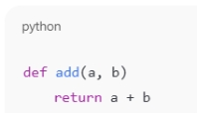  Expected Output#1  - Corrected function with syntax fix  Prompt:  Find syntax error in following function def add(a, b)  return a + b  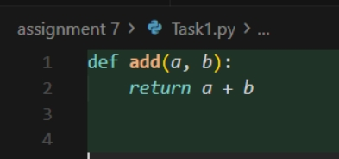  Task Description#2 (Loops)  - Identify and fix a logic error in a loop that causes infinite iteration.  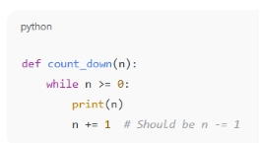  Expected Output#2  - AI fixes increment/decrement error  Prompt:  Fix the logic error in a loop that causes infinite iteration.  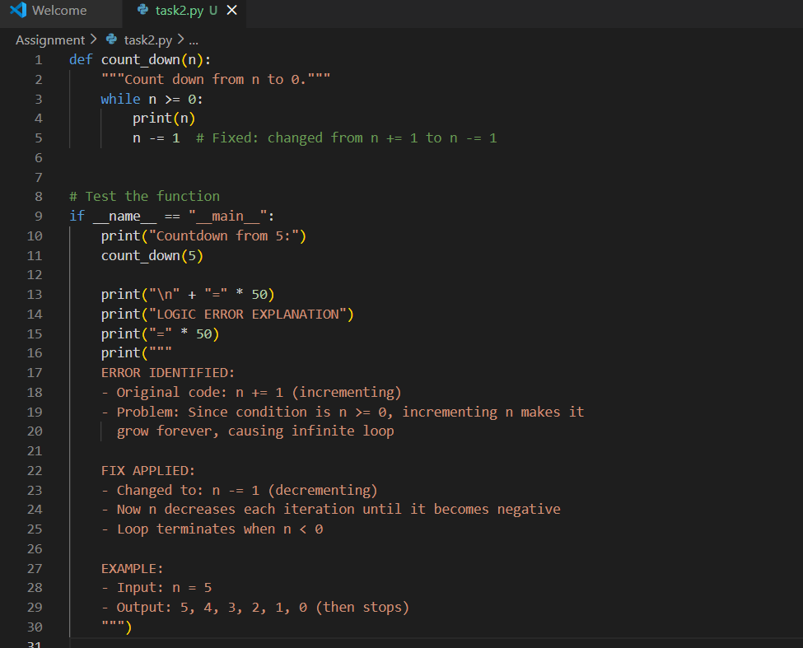  Output:  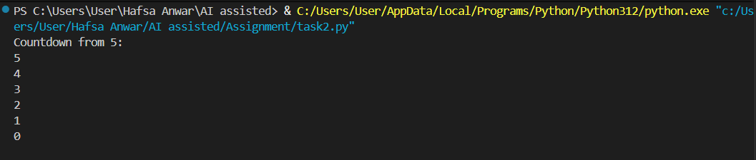  Task Description#3  - Debug a runtime error caused by division by zero. Let AI insert try-except.  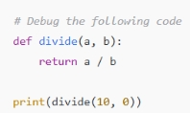  Expected Output#3  - Corrected function with safe error handling  Prompt:  Debug the following Python code that causes a runtime error due to division by zero and insert try except  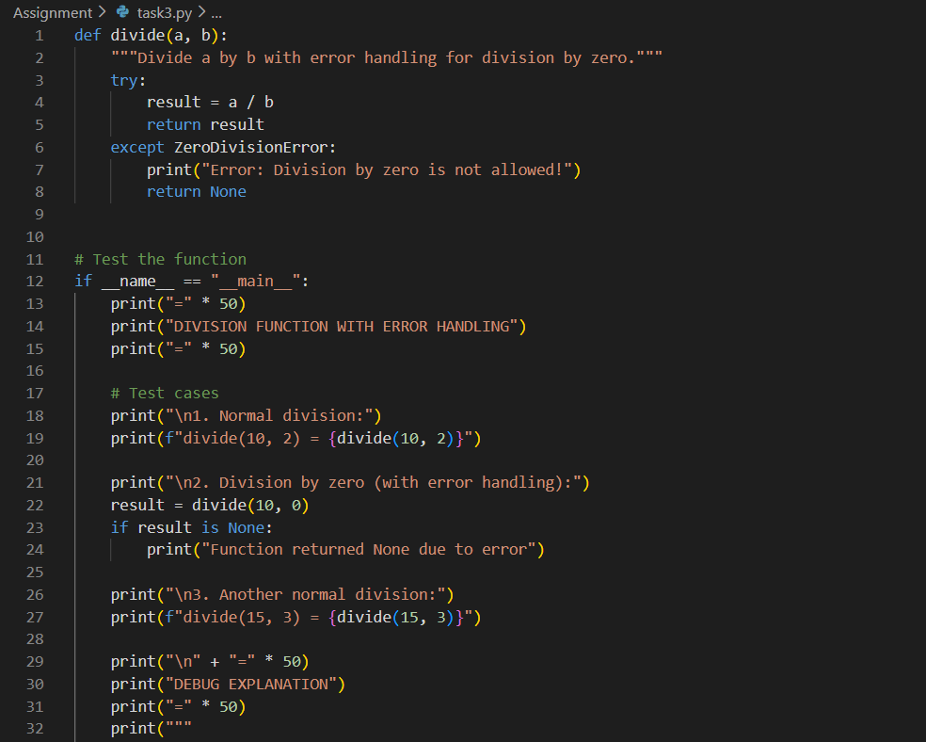  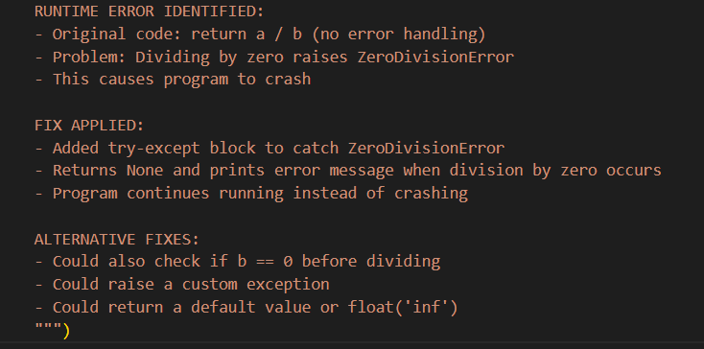  Output:  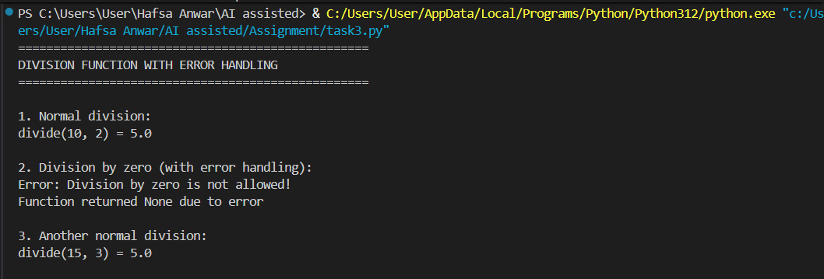  Task Description#4  - Provide a faulty class definition (missing self in parameters). Let AI fix it  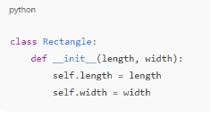  Expected Output#4  - Correct __init__() method and explanation  Prompt:  Provide the following faulty Python class definition identify and fix the error (missing self parameter in the constructor).  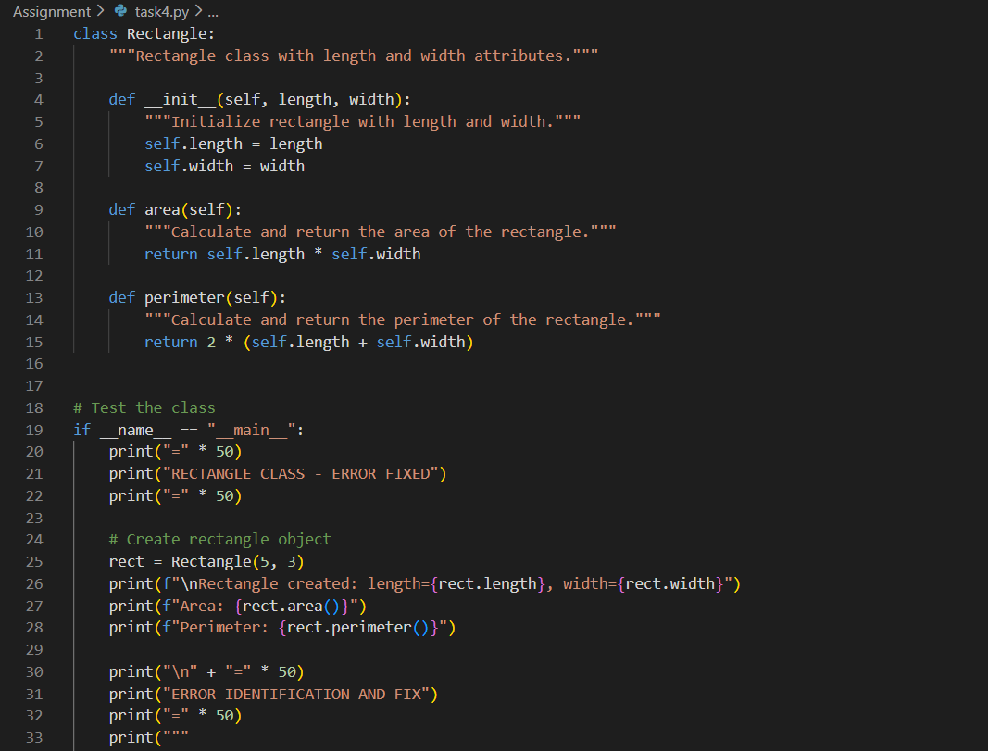  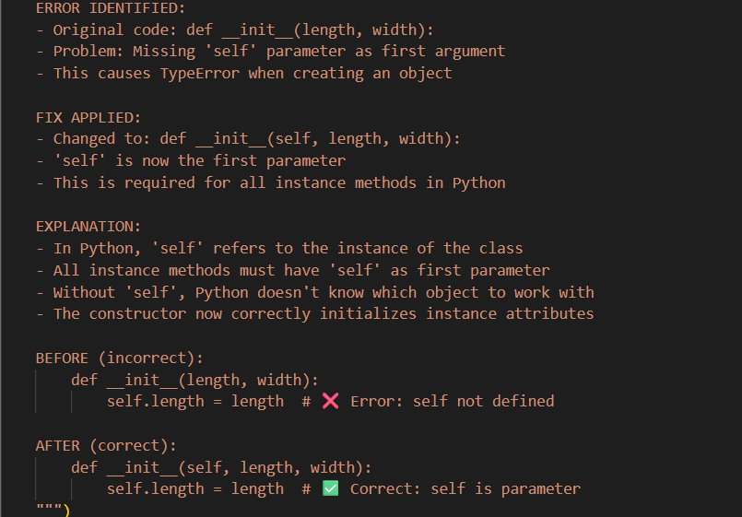  Output:  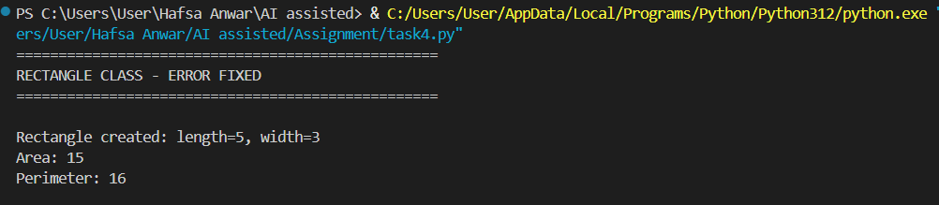  Task Description#5  - Access an invalid list index and use AI to resolve the Index Error.  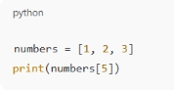  Expected Output#5  - AI suggests checking length or using safe access logic  Prompt:  Resolve the index error and access an invalid list index.  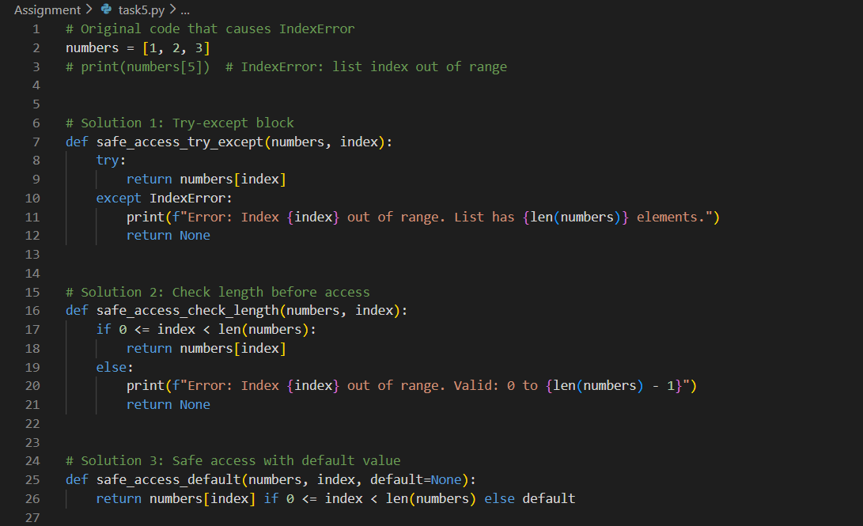  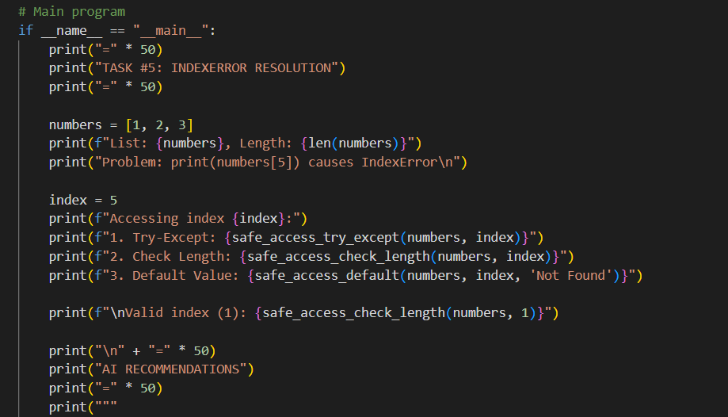  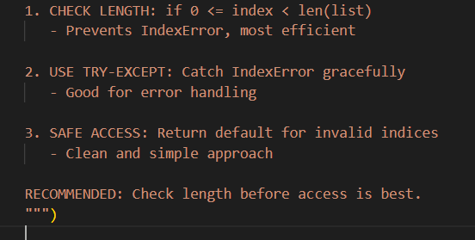  Output:  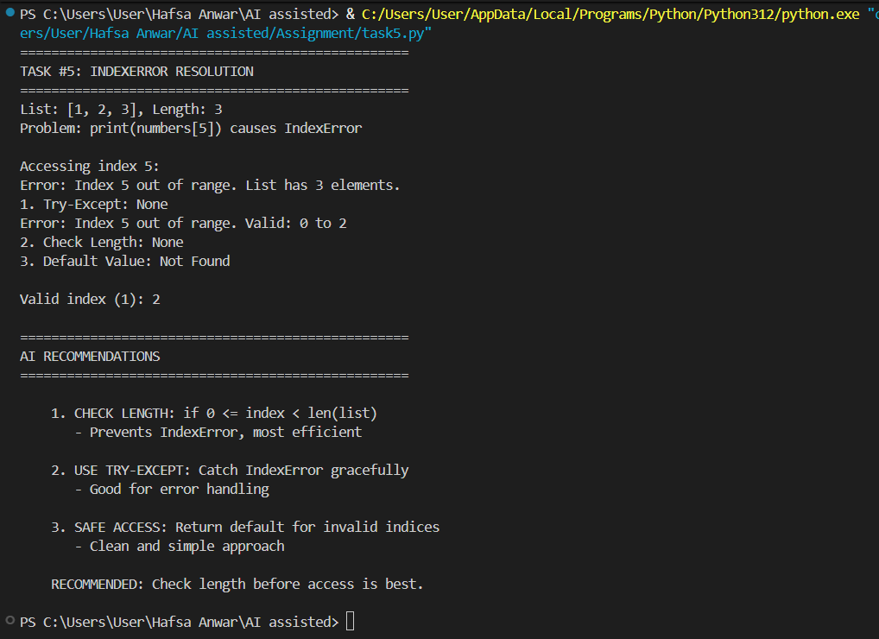 |  |  |  |  |  | Week4 - Wednesday

