SCHOOL OF COMPUTER SCIENCE AND ARTIFICIAL INTELLIGENCE |  |  |  |  | DEPARTMENT OF COMPUTER SCIENCE ENGINEERING
Program Name: M. Tech/MCA |  |  |  | Assignment Type: Lab |  |  | AcademicYear:2025-2026
Course Coordinator Name |  |  |  | Venkataramana Veeramsetty
Course Code |  |  |  | Course Title |  | AI Assisted Problem Solving Using Python
Year/Sem |  |  | I/I | Regulation |  | R24
Date and Day  of Assignment |  |  | Week1 - TUESDAY | Time(s)
Duration |  |  | 2 Hours | Applicable to  Batches |  | M. Tech/MCA
AssignmentNumber:2.3(Present assignment number)/24(Total number of assignments)
Name: Hafsa Anwar Roll no:2505B02110 Batch :M.Tech (EEE)
 | Q.No. | Question |  |  |  |  |  | Expected Time  to complete
 | 1 | Lab 2: Exploring Additional AI Coding Tools – Gemini (Colab) and Cursor AI  Task Description#1  Use Google Gemini in Colab to write a function that reads a CSV file and calculates mean, min, max.  Expected Output#1  Functional code with output and screenshot  Prompt  Create a CSV file and write a function that reads a CSV file and calculates mean, min, max and print output.  CSV file  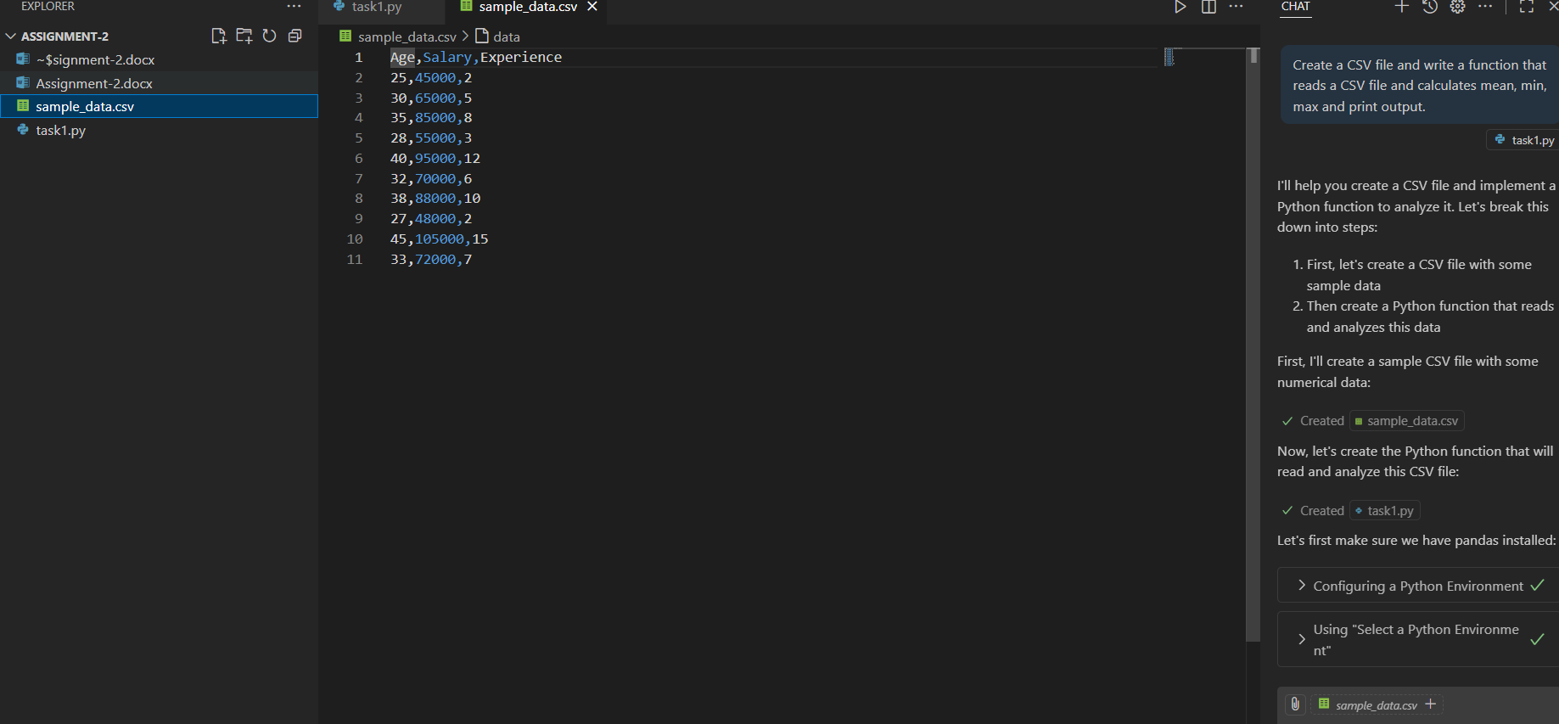  Code:  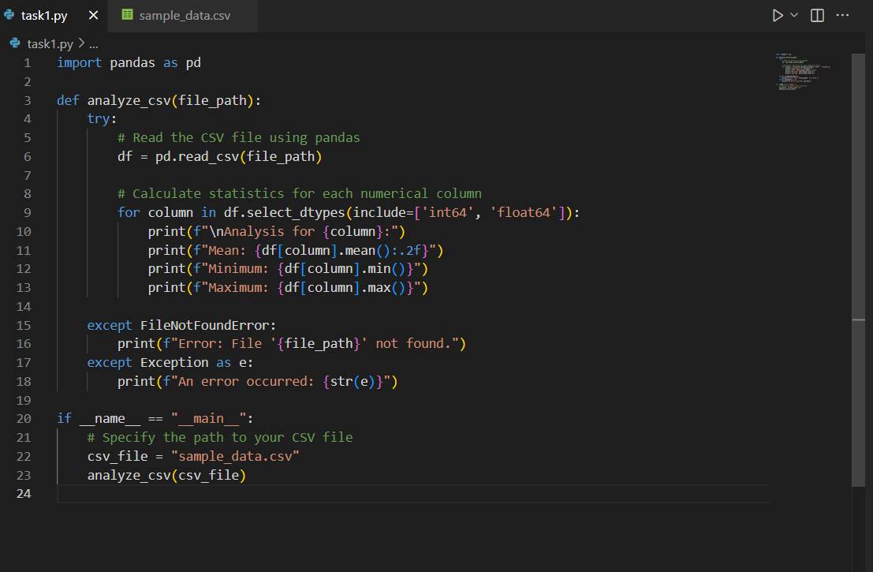  Output:  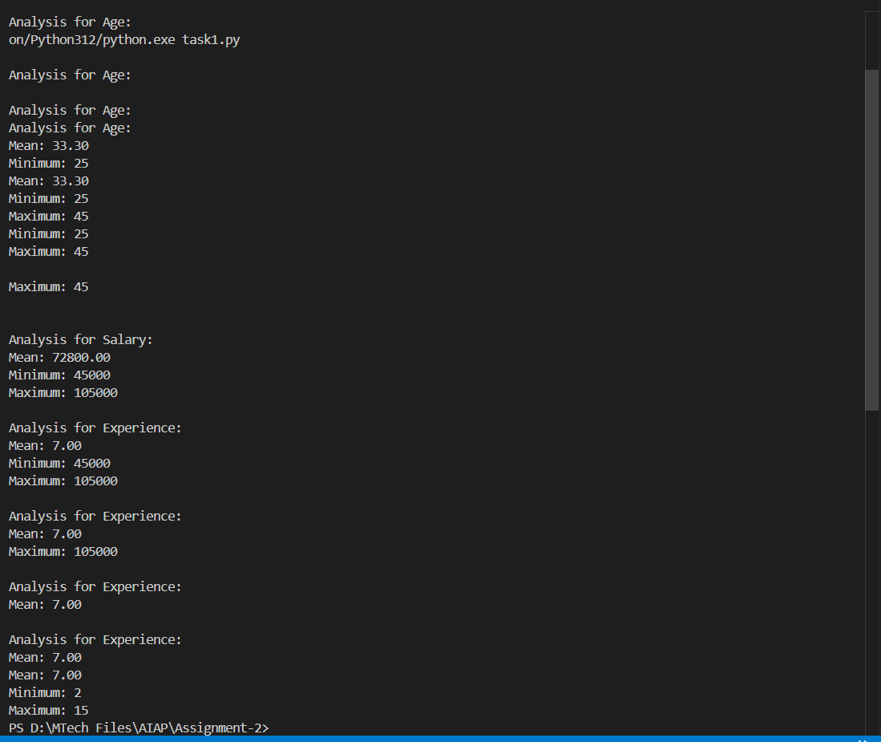  Task Description#2  - Compare Gemini and Copilot outputs for a palindrome check function.  Expected Output#2  - Side-by-side comparison and observations  Prompt  Generate a python function to check palindrome function by taking user input manually.  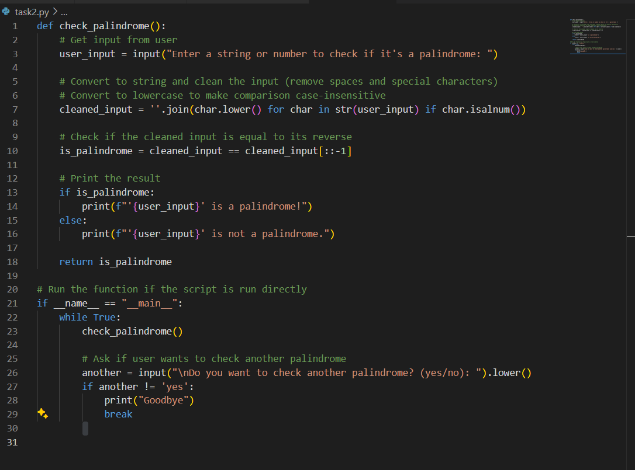  Output:  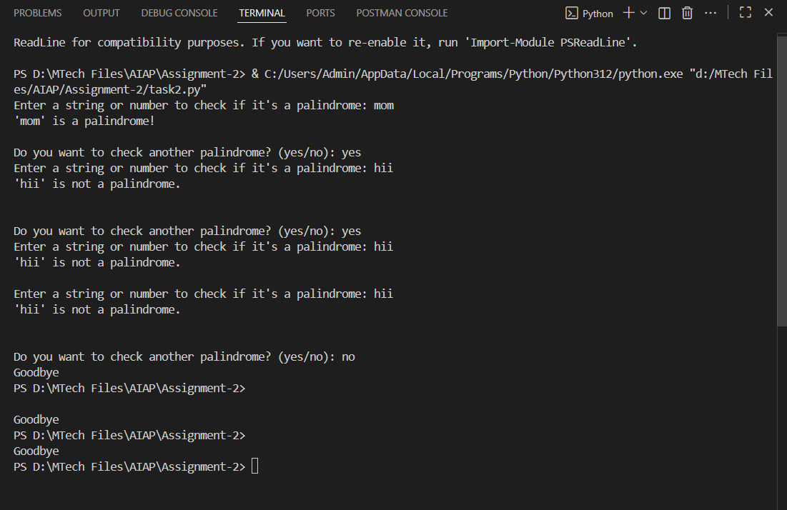  Task Description#3  - Ask Gemini to explain a Python function (to calculate area of various shapes) line by line..  Expected Output#3  - Detailed explanation with code snippet  Prompt  Write a Python function to calculate area of various shapes and explain line by line.  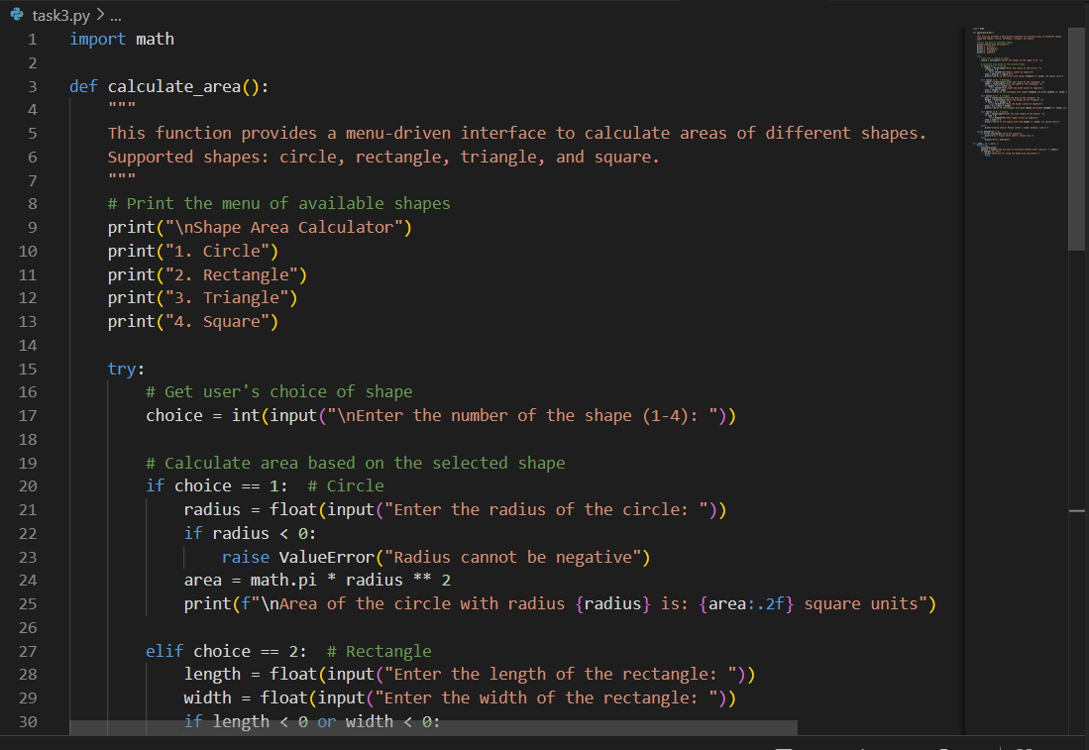  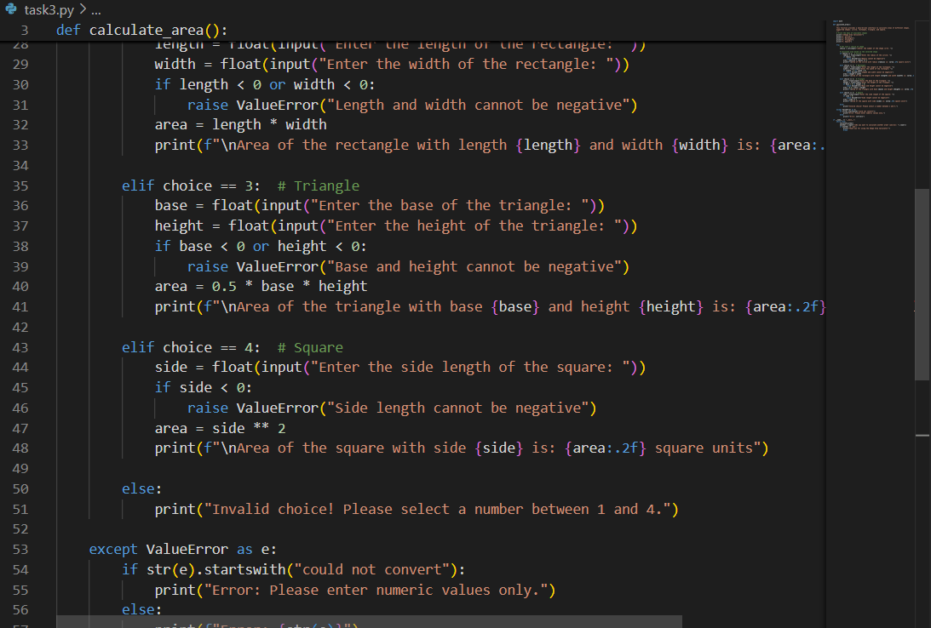  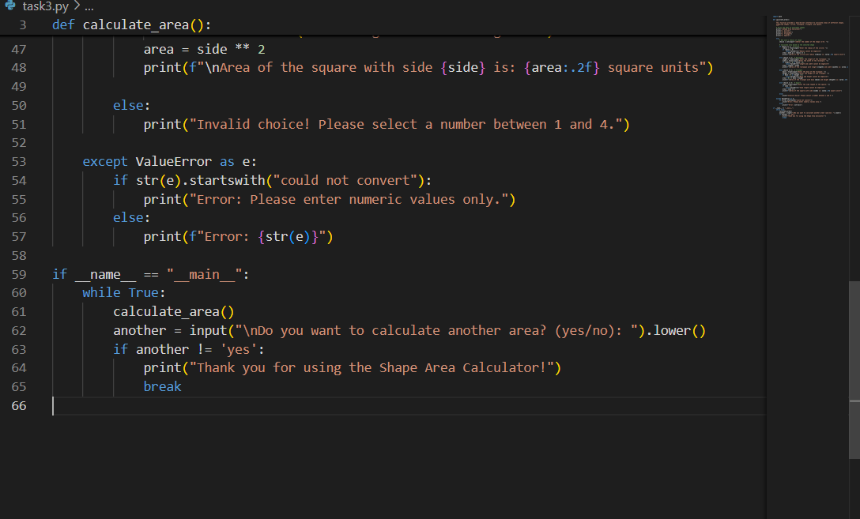  Output:  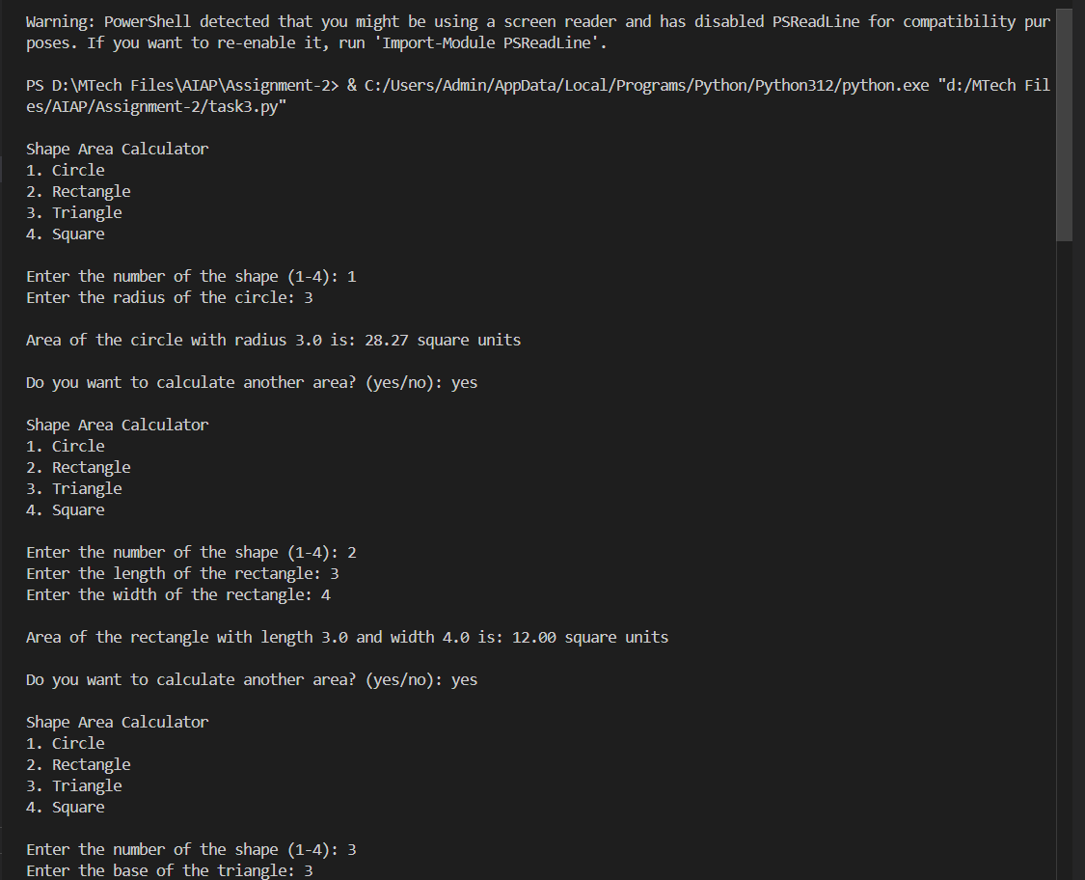  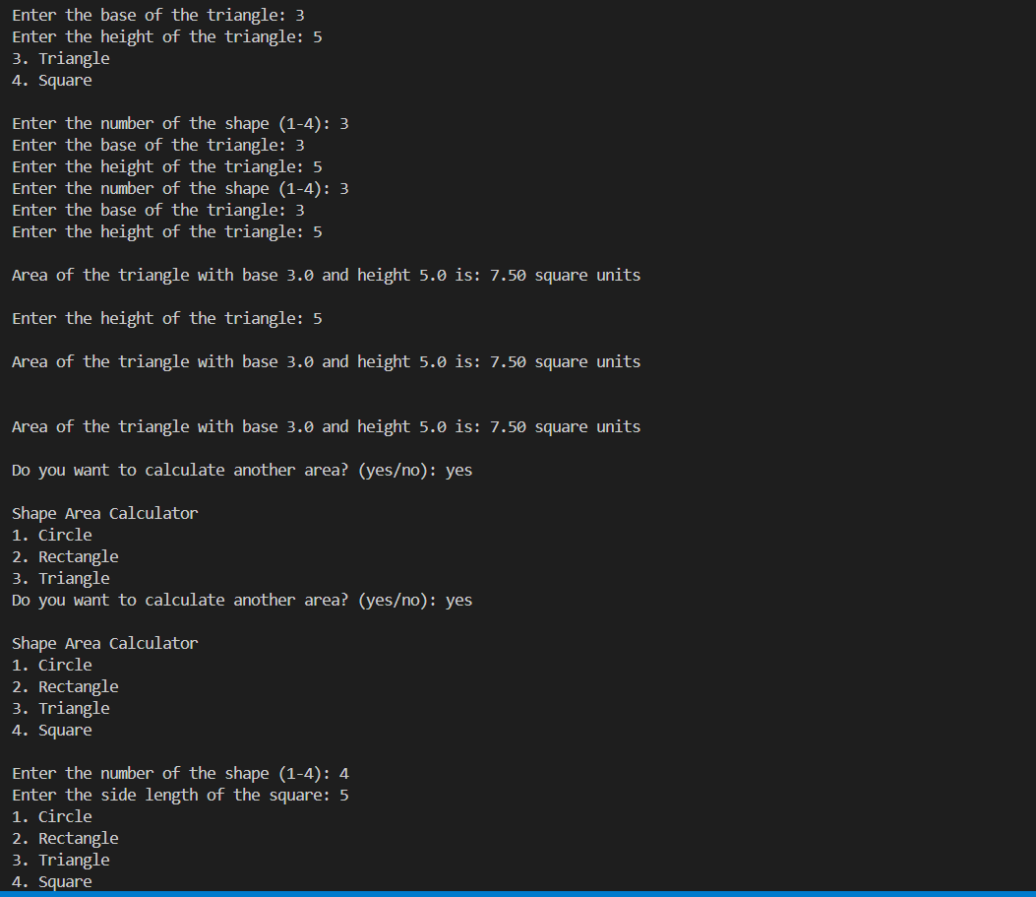  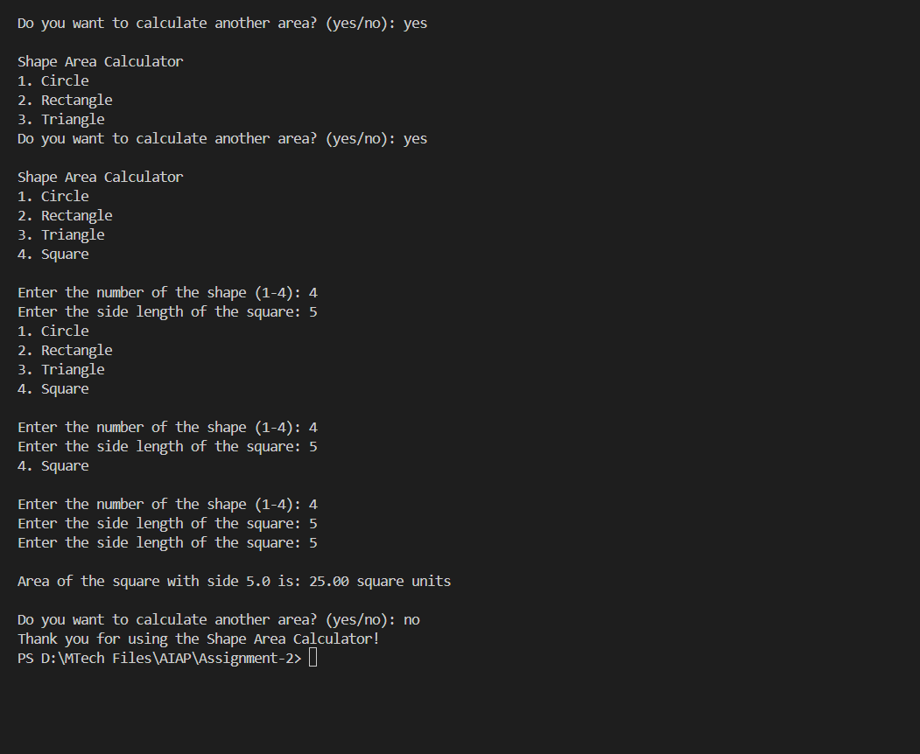  Task Description#4  - Install and configure Cursor AI. Use it to generate a Python function (e.g., sum of squares).  Expected Output#4  - Screenshots of working environments with few prompts to generate python code  Prompt  Generate a Python function sum of squares by taking user input manually  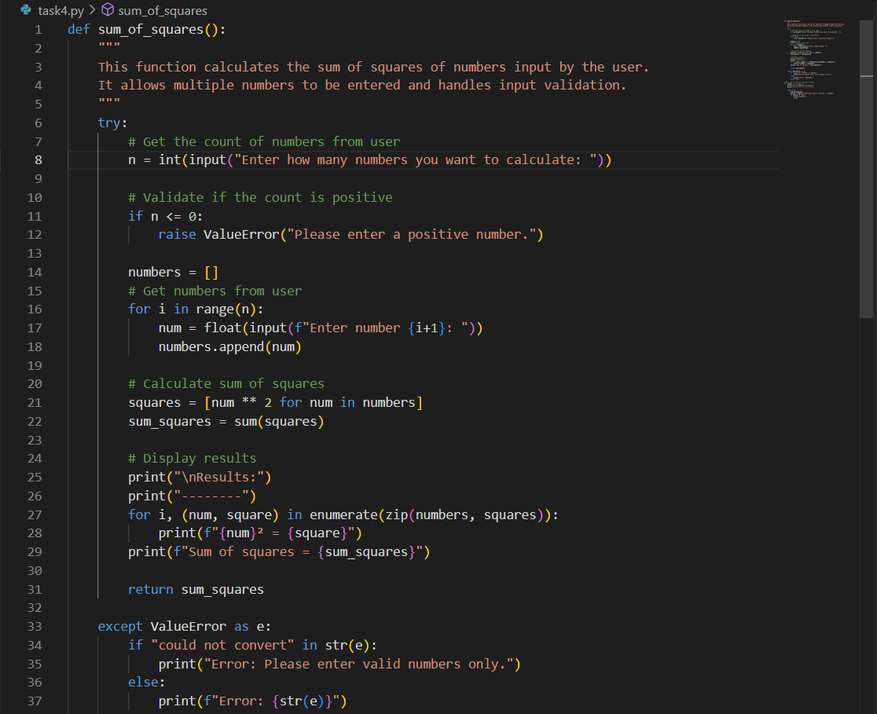  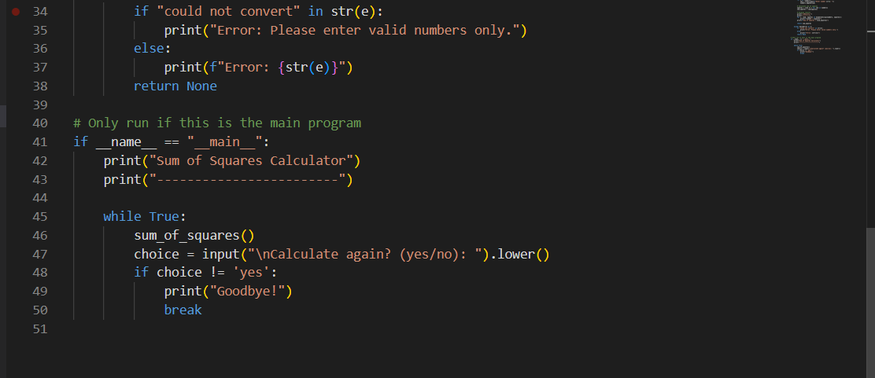  Output:  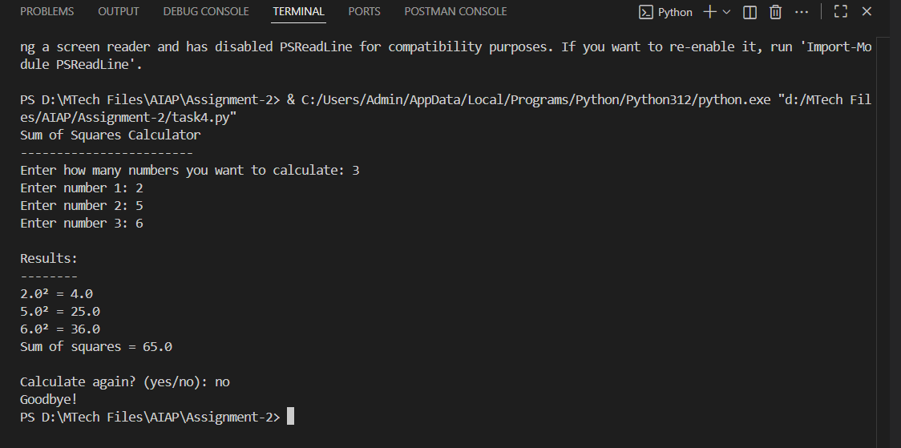  Task Description#5  - Student need to write code to calculate sum of add number and even numbers in the list  Expected Output#5  - Refactored code written by student with improved logic  Prompt  write code to calculate sum of odd numbers and even numbers in the list by taking user input manually.  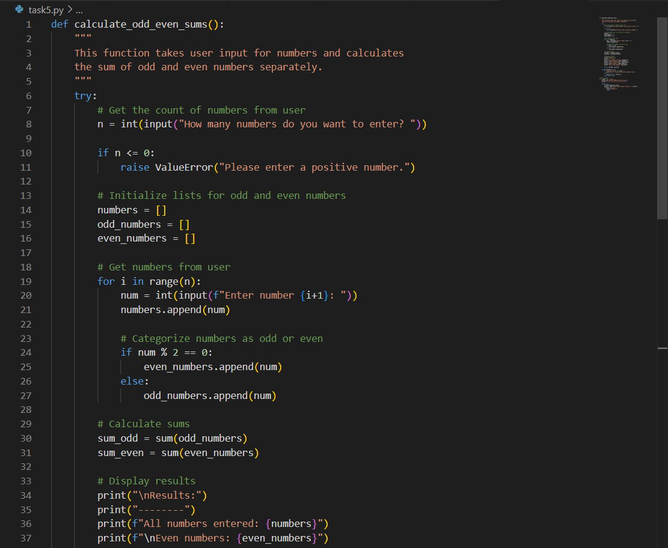  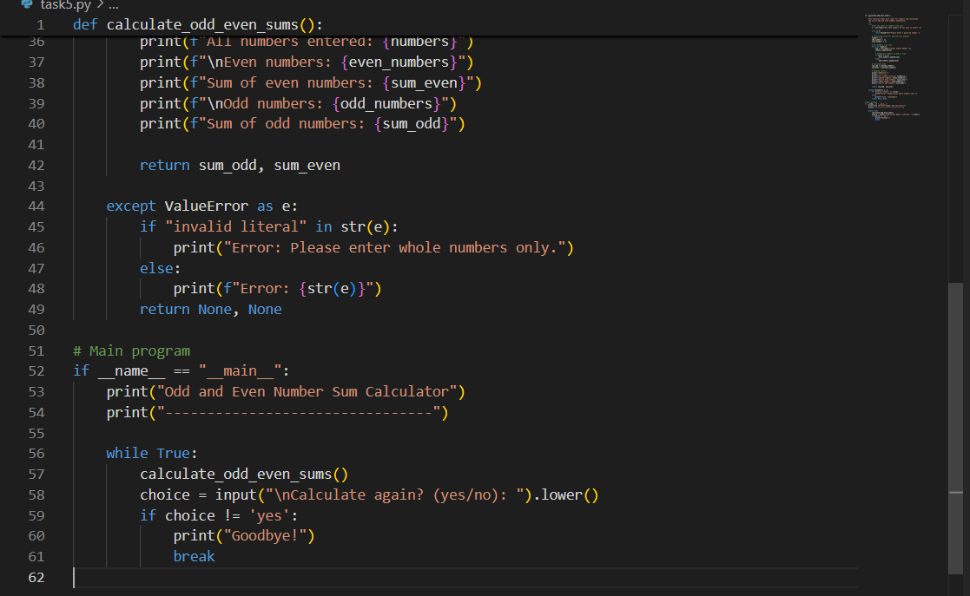  Output  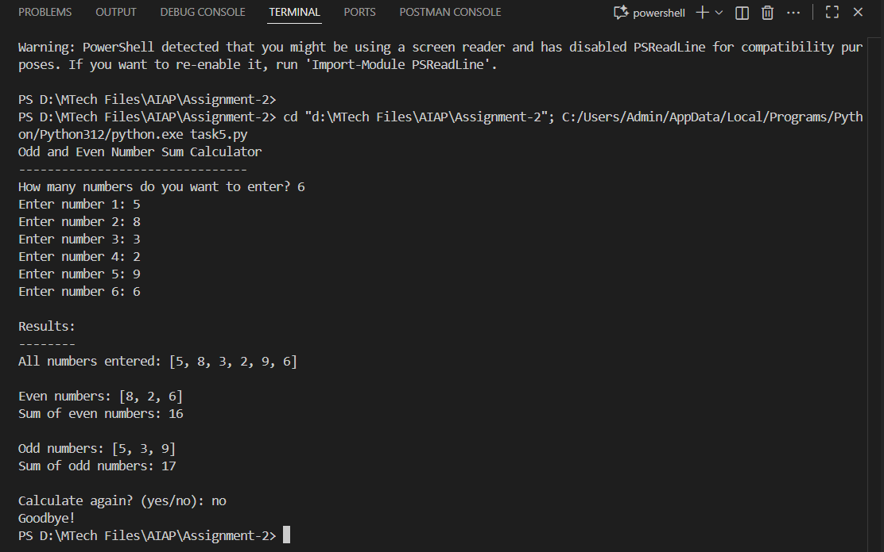 |  |  |  |  |  | Week1 - TuesDay

