SCHOOL OF COMPUTER SCIENCE AND ARTIFICIAL INTELLIGENCE |  |  |  |  | DEPARTMENT OF COMPUTER SCIENCE ENGINEERING
Program Name: M. Tech/MCA |  |  |  | Assignment Type: Lab |  |  | AcademicYear:2025-2026
Course Coordinator Name |  |  |  | Venkataramana Veeramsetty
Course Code |  |  |  | Course Title |  | AI Assisted Problem Solving Using Python
Year/Sem |  |  | I/I | Regulation |  | R24
Date and Day  of Assignment |  |  | Week1 - Monday | Time(s)
Duration |  |  | 2 Hours | Applicable to  Batches |  | M. Tech/MCA
AssignmentNumber:1.3(Present assignment number)/24(Total number of assignments)
Name: Hafsa Anwar Roll no:2505B02110 Branch:M.tech(EEE)
 | Q.No. | Question  Lab 1: Environment Setup – GitHub Copilot and VS Code Integration  Lab Objectives:  - To install and configure GitHub Copilot in Visual Studio Code.  Task Description#1  - Install and configure GitHub Copilot in VS Code. Take screenshots of each step.  Expected Output#1  - Install and configure GitHub Copilot in VS Code. Take screenshots of each step.  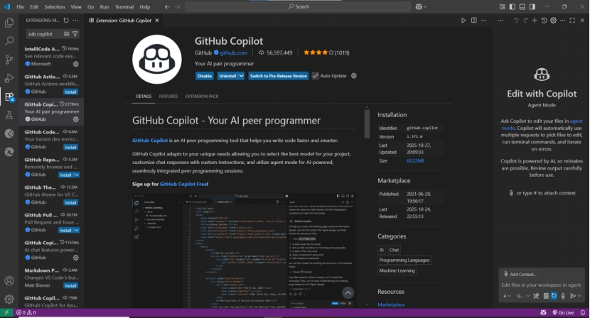 |  |  |  |  |  | Expected Time  to complete  Week1 - Wednesday
 | 2 | Task Description#2  - Use Copilot to generate a is_prime() Python function.  Expected Output#2  - Function to check primality with correct logic.  Prompt -1  Generate a Python function to find whether a number is prime or not.  Prompt-2  Update the function to take user input for a number.  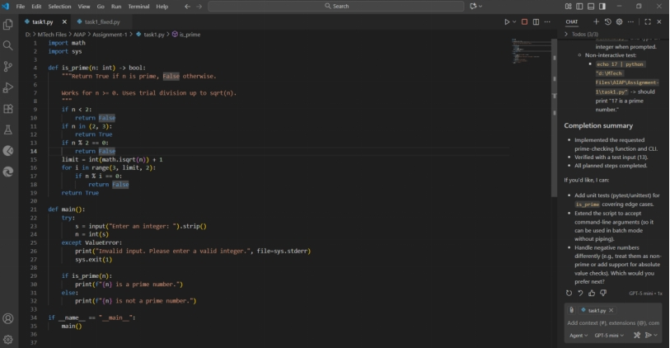  Output  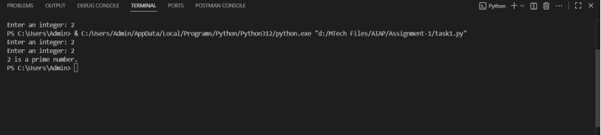  Task Description#3  - Write a comment like # Function to reverse a string and use Copilot to generate the function.  Expected Output#3  - Auto-completed reverse function  Prompt-1  Function to reverse a string where the expected output is to autocomplete the reverse function.  Prompt-2  Update the code to take user input manually  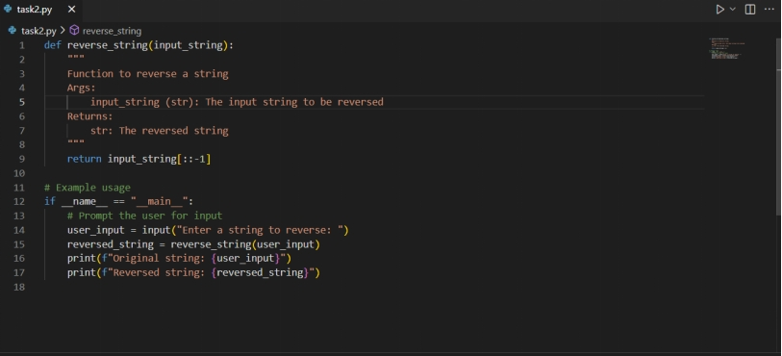  Output  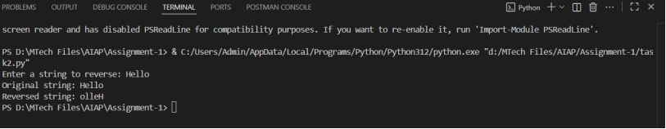  Task Description#4  - Generate both recursive and iterative versions of a factorial function using comments..  Expected Output#4  - Two working factorial implementations  Prompt-1  Generate both recursive and iterative versions of a factorial function in python.  Prompt-2  Update the code to take user input manually.  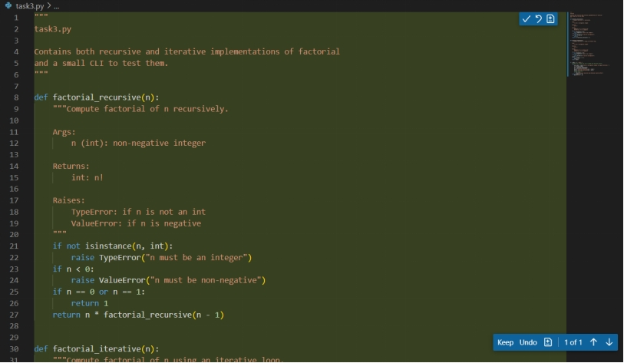  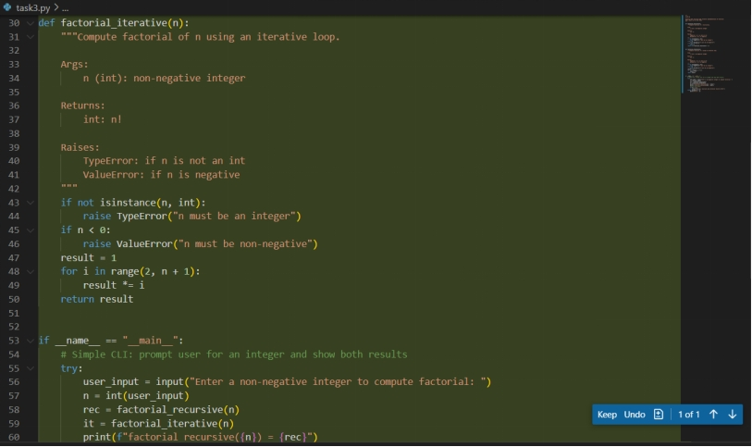  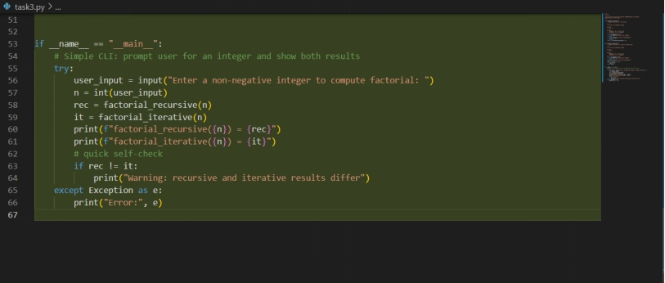  Output  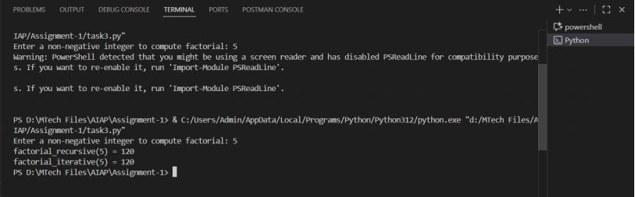  Task Description#5  - Use Copilot to find the largest number in a list. Assess code quality and efficiency.  Expected Output#5  - A valid function with your review  Prompt  Generate python code to find the largest number in a list by taking user input manually.  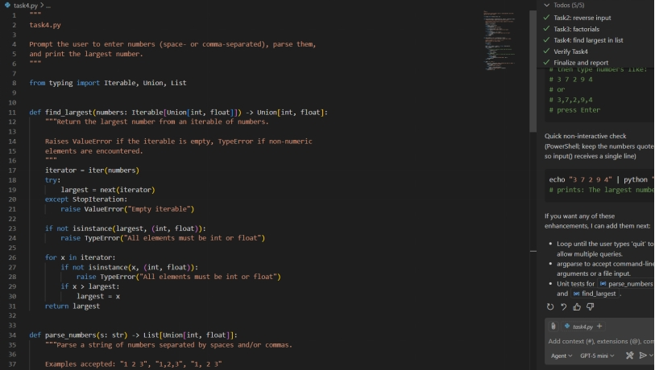  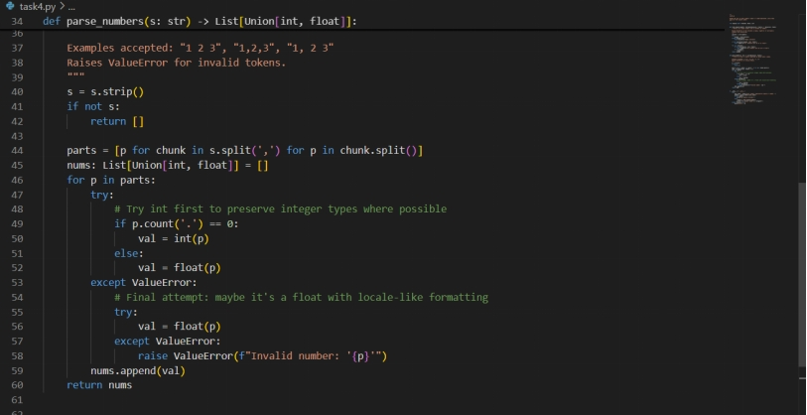  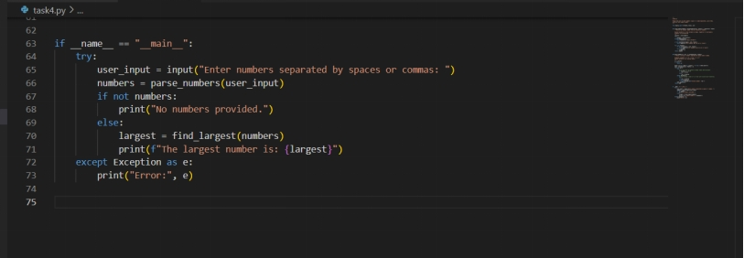  Output  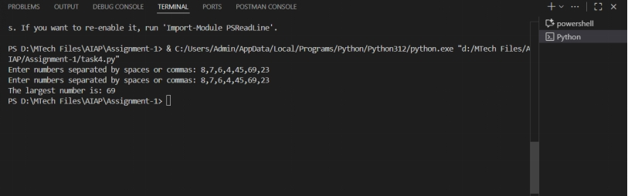 |  |  |  |  |  | Week1 - Wednesday

