SCHOOL OF COMPUTER SCIENCE AND ARTIFICIAL INTELLIGENCE |  |  |  |  | DEPARTMENT OF COMPUTER SCIENCE ENGINEERING
Program Name: M.Tech. and MCA |  |  |  | Assignment Type: Lab |  |  | AcademicYear:2025-2026
Course Coordinator Name |  |  |  | Venkataramana Veeramsetty
Course Code |  |  |  | Course Title |  | AI Assisted Problem Solving Using Python
Year/Sem |  |  | I/I | Regulation |  | R24
Date and Day  of Assignment |  |  | Week3 - Monday | Time(s)
Duration |  |  | 2 Hours | Applicable to  Batches |  | M.Tech. and MCA
AssignmentNumber:4.3(Present assignment number)/24(Total number of assignments)
Name: HafsaAnwar Roll no:2505B02110 Batch:M.tech(EEE)
 | Q.No. | Question |  |  |  |  |  | Expected Time  to complete
 |  | Lab 4: Advanced Prompt Engineering – Zero-shot, One-shot, and Few-shot Techniques  Task Description#1  - Zero-shot: Prompt AI to write a function that checks whether a given year is a leap year.  Expected Output#1  - AI-generated function with no examples provided  Prompt  Write a function in python that checks whether a given year is a leap year by taking user input manually.  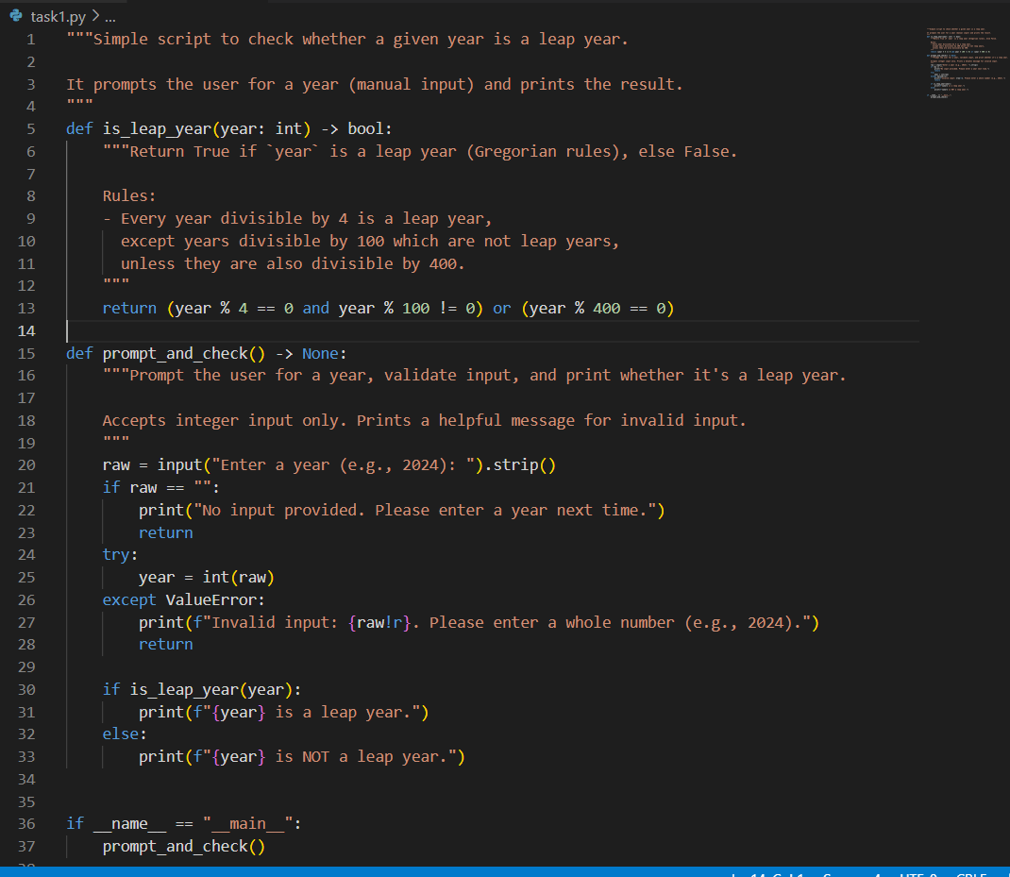  Output:  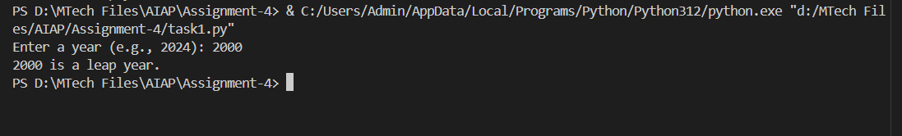  Task Description#2  - One-shot: Give one input-output example to guide AI in writing a function that converts centimeters to inches.  Expected Output#2  - Function with correct conversion logic  Prompt  Write a python function by taking user input manually to convert centimetres to inches like 1 cm = 0.393701 inches  CODE:  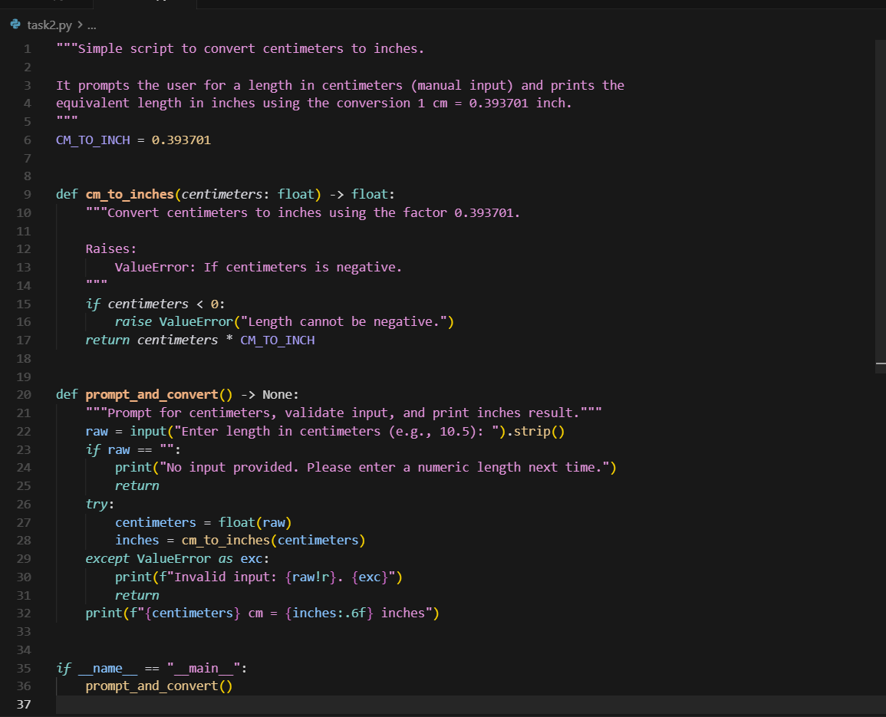  OUTPUT:  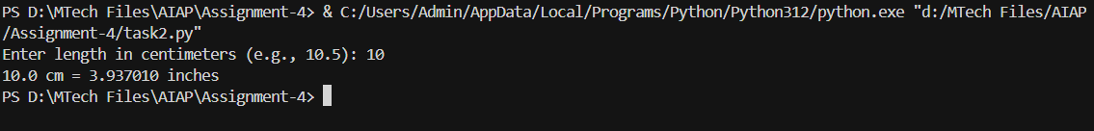  Task Description#3  - Few-shot: Provide 2–3 examples to generate a function that formats full names as “Last, First”.  Expected Output#3  - Well-structured function respecting the examples  Prompt  Generate a function that formats full names as "Last, First" like  Example:  "Chittimalla, Pujitha" as First name: Chittimalla Last name: Pujitha  "Chittimalla, Rajasree " as First name: Chittimalla Last name: Rajasree  CODE:  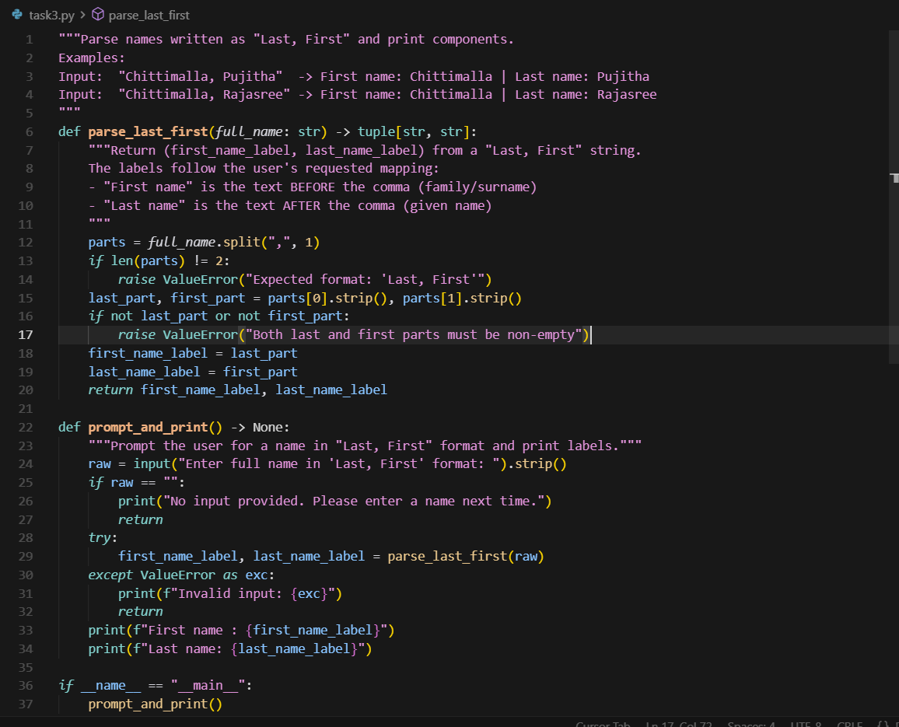  OUTPUT:  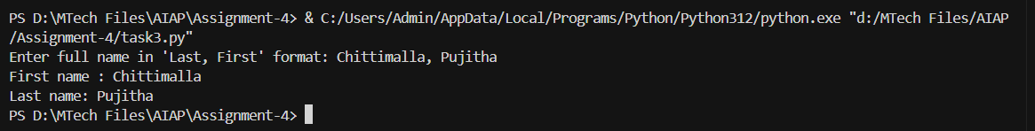  Task Description#4  - Compare zero-shot and few-shot prompts for writing a function that counts the number of vowels in a string.  Expected Output#4  - Functional output and comparative reflection  Prompt  Zero-Shot Prompt :  Generate a python function that counts the number of vowels in a string.  Few-Shot Prompt :  Generate a function that counts the number of vowels in a string. Like in Numbers = 2 vowels, Perfume = vowels, Calender = 3 vowels, Vinayaka = 4 vowels  Zero-Shot Code:  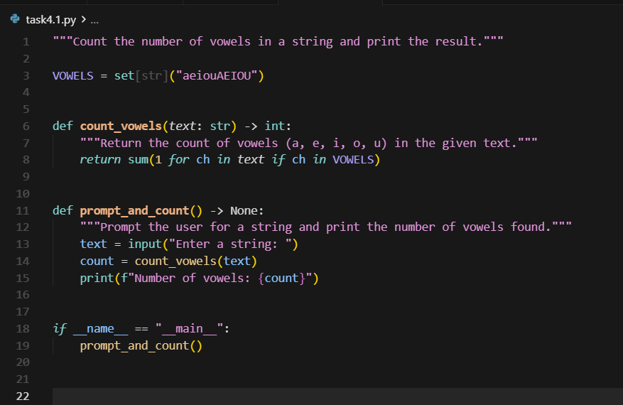  Output:  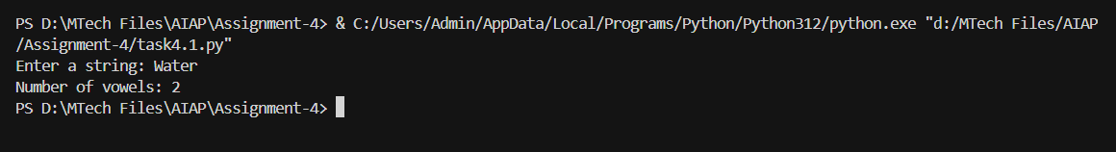  Few-Shot Code:  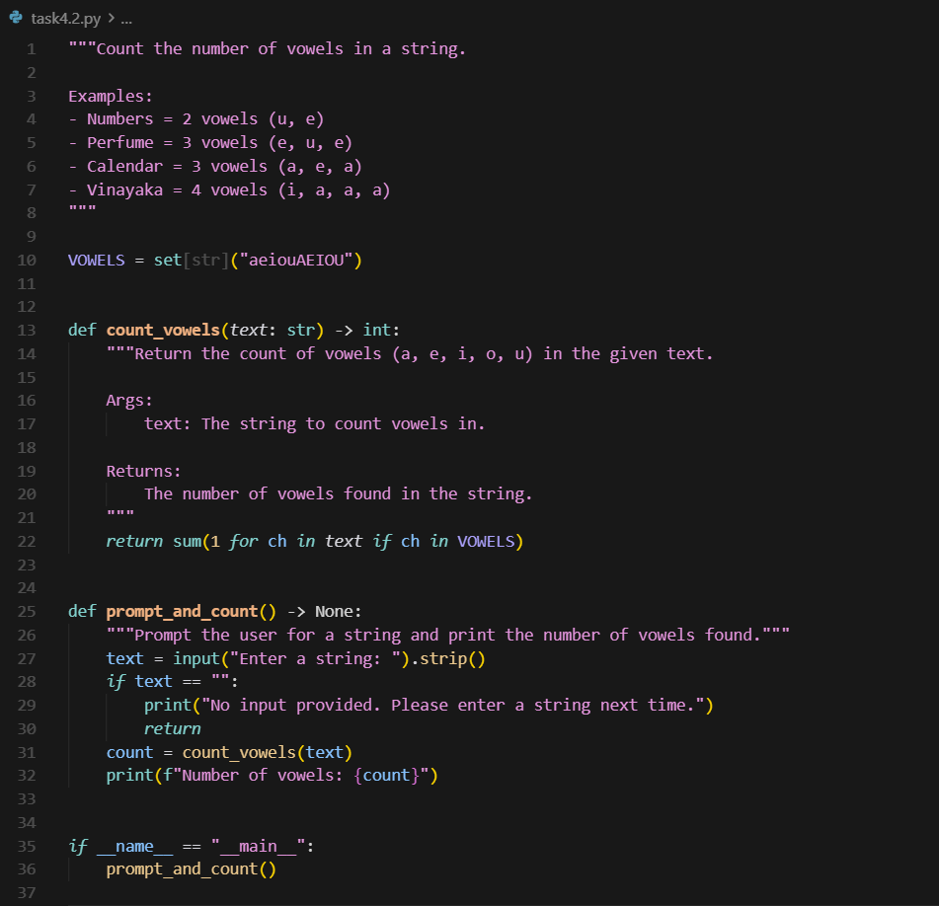  OUTPUT:  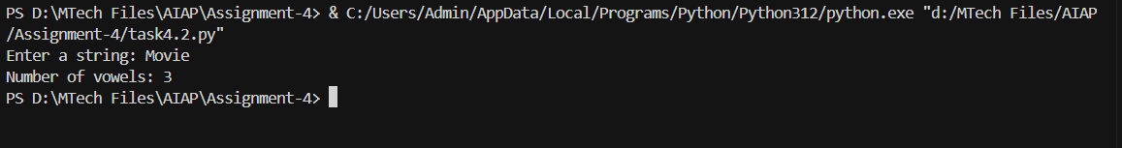  Comparision:  When the task is simple and clear—like writing a function to count the number of vowels in a string—a zero-shot prompt works best. The model can handle it easily without any examples, making the process quicker and simpler.  On the other hand, few-shot prompting is more useful for complex or creative tasks, or when you want the model to follow a specific style or stay consistent with previous examples.  Task Description#5  - Use few-shot prompting to generate a function that reads a .txt file and returns the number of lines.  Expected Output#5  - Working file-processing function with AI-guided logic  Prompt  Write a Python function that takes the file path as input and returns the number of lines in a text file.  Examples:  1) File path : .\xxxx.docx  File Content:  Line 1  Line 2  Line 3  -> function should return: 3  2) Empty file (no bytes)  -> function should return: 0  3) File Path : C:\\Downloads.\xxxxx.pdf  File content:  a  b  c  d  -> function should return: 4  4) Path is missing:  -> function should raise FileNotFoundError  CODE:  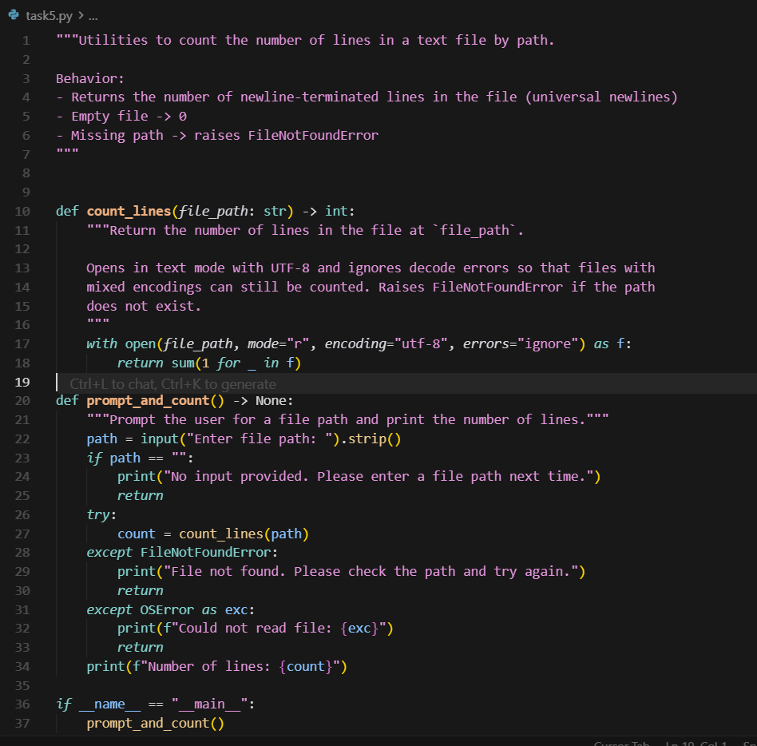  OUTPUT:  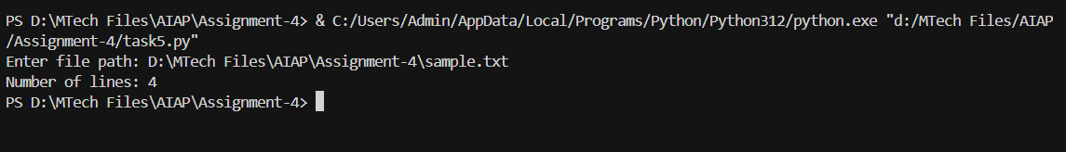 |  |  |  |  |  | Week3 - Monday

