Set 1
- Q1. Write a Python function to calculate the factorial of a number. Use a coding assistant and document how you refine your prompt to ensure the function handles negative input and zeros.
(Each question carries 5 marks)
Prompt: "Write a Python function to calculate the factorial of a number.
Ensure the function handles negative input and zeros properly.
Raise a ValueError for negative numbers since factorial is not defined for negative integers."
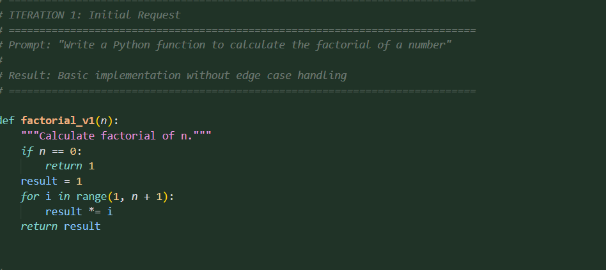
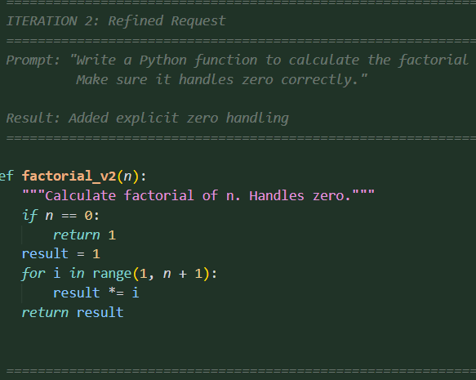
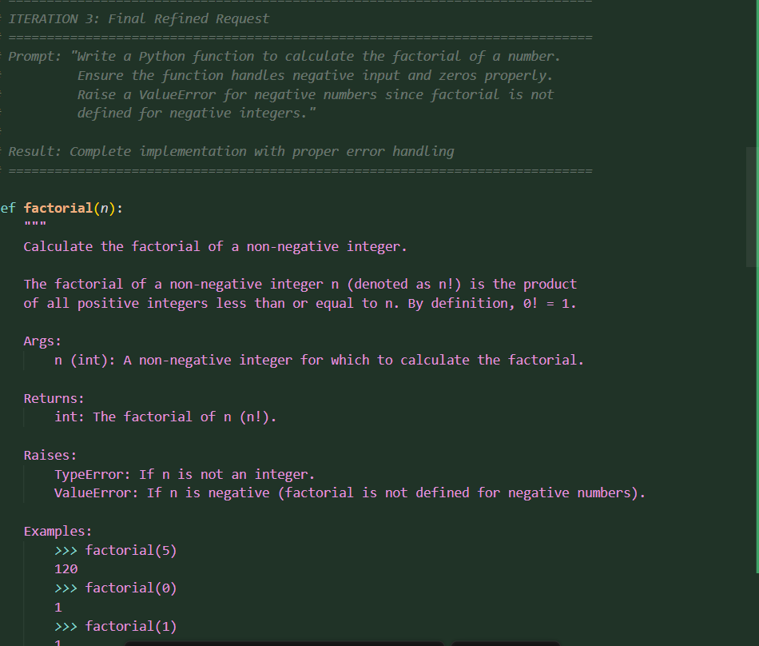
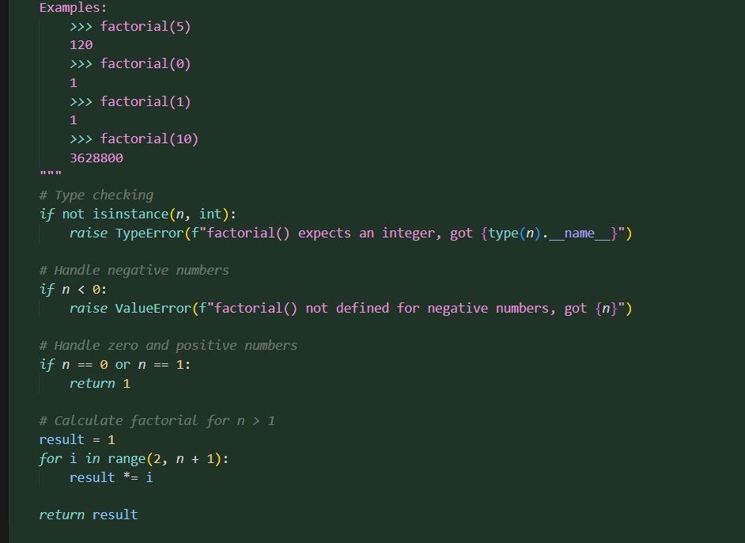
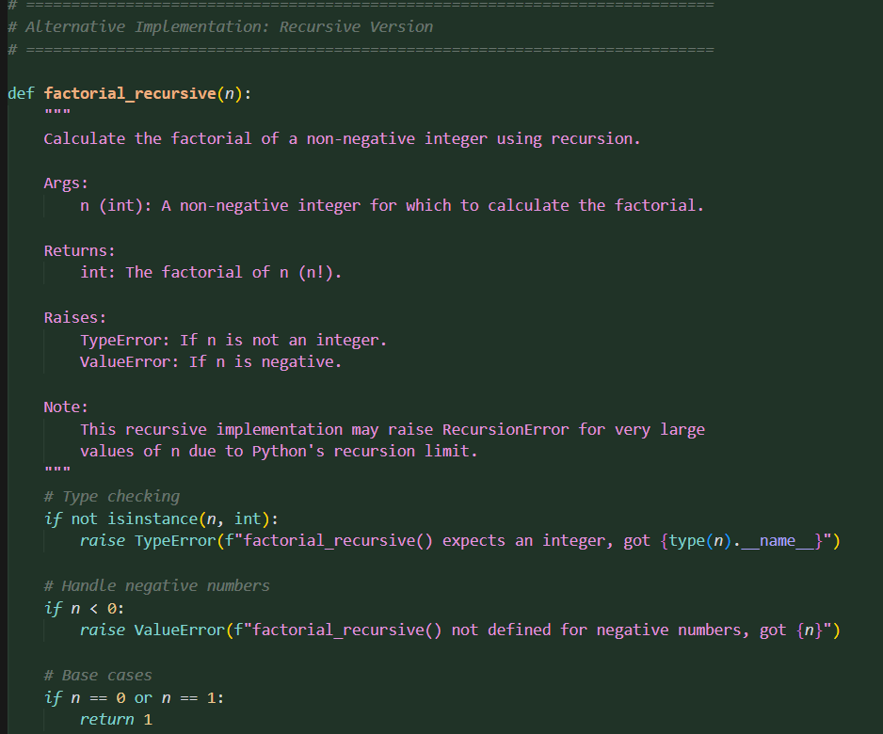
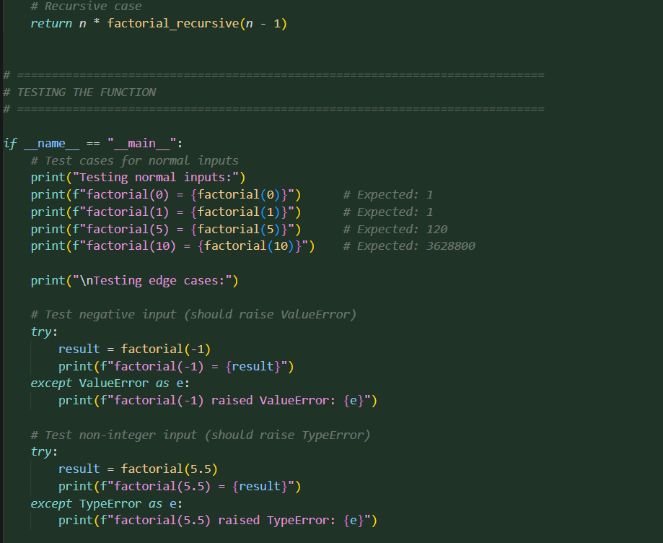
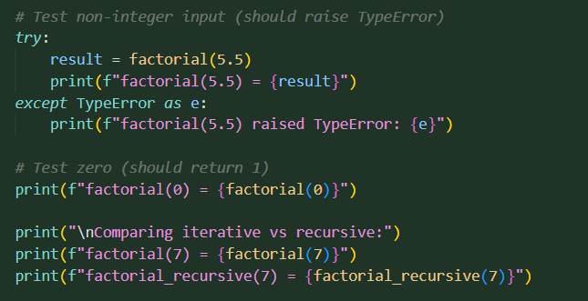
OUTPUT:
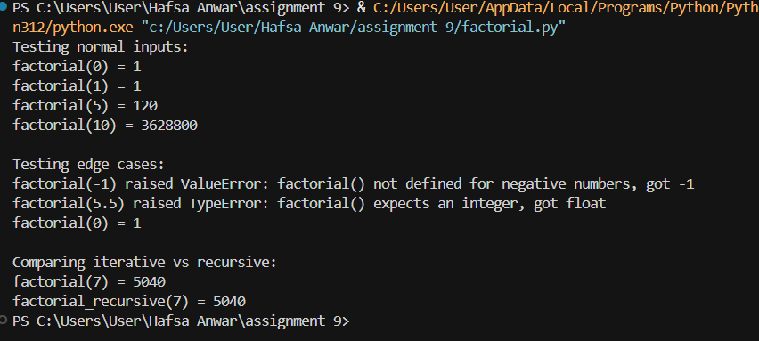

- Q2. Given a list of student marks, compute the mean and list all students above the mean. Demonstrate zero-shot, one-shot, and few-shot prompts to guide an AI tool to solve this. Summarize the differences in approach.
(Each question carries 5 marks)
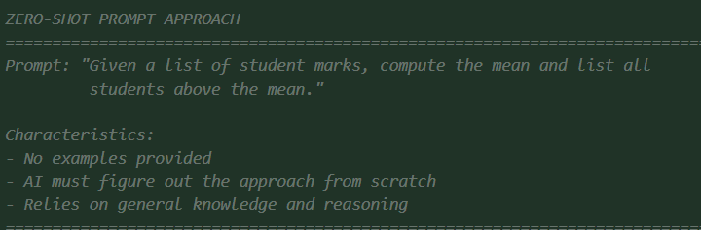
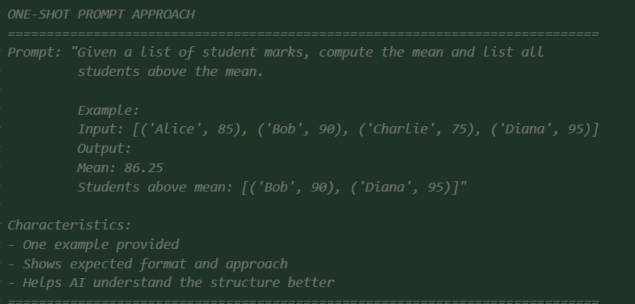
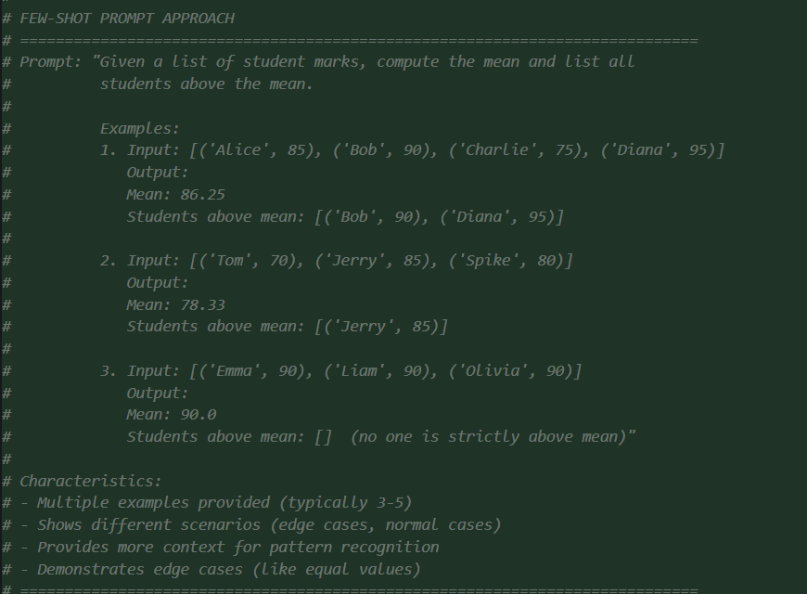
CODE:
ZERO SHOT
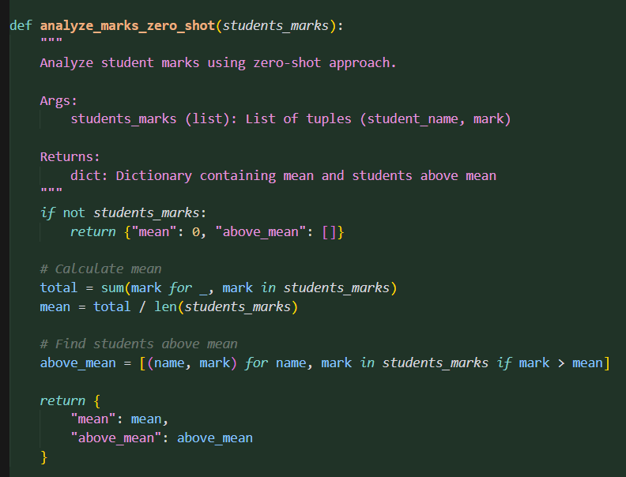
ONE SHOT:
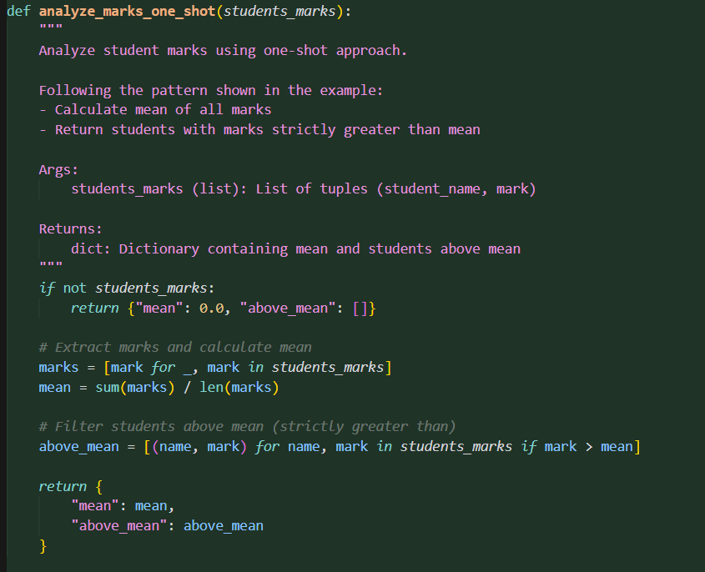
FEW SHOT:
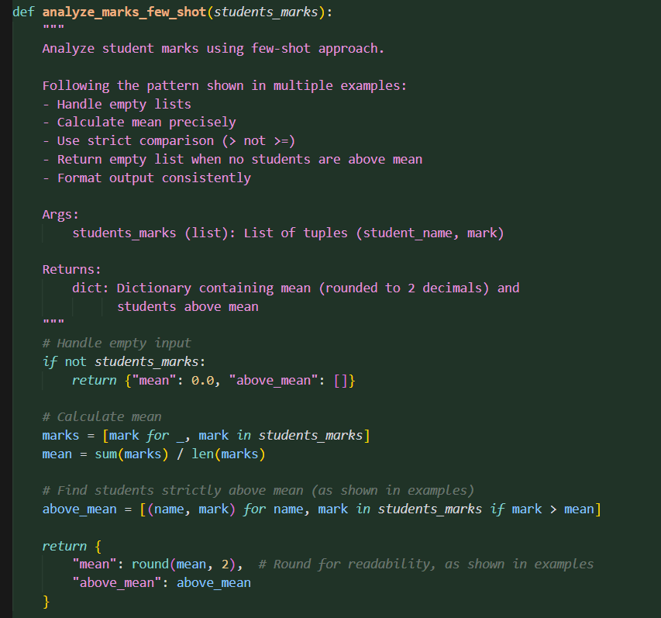
OUTPUT:
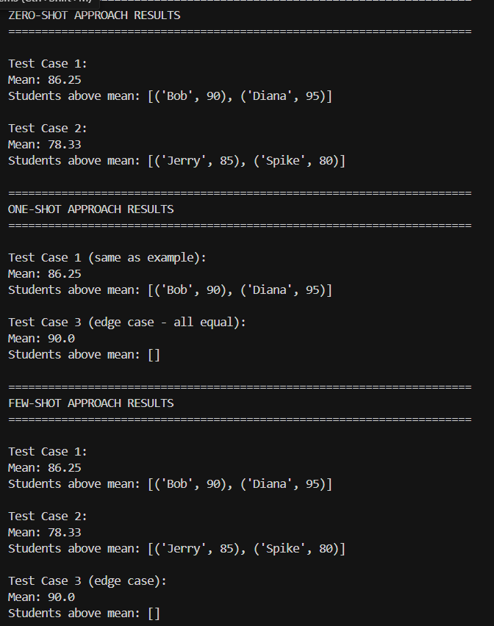
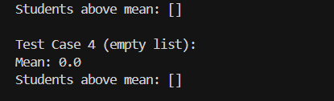
SUMMARY:
Files Created:
- student_marks_analysis.py — Implementation showing:
- Zero-shot approach (no examples)
- One-shot approach (1 example)
- Few-shot approach (3+ examples)
- Enhanced version with additional features
- Test cases with various scenarios
- PROMPTING_TECHNIQUES.md — Documentation covering:
- Detailed explanation of each technique
- Characteristics and use cases
- Comparison table
- Best practices
- Example prompt evolution
- PROMPTING_SUMMARY.md — Summary of differences:
- Quick reference guide
- Side-by-side comparisons
- Decision guide for choosing techniques
- Visual comparison
Summary of differences:
Zero-shot
- No examples
- Fastest to write
- Relies on pre-trained knowledge
- Most ambiguity; may miss edge cases
One-shot
- One example provided
- Shows expected format
- Better format control
- Limited edge case coverage
Few-shot
- Multiple examples (3-5)
- Covers edge cases and patterns
- Most reliable and consistent
- Requires more preparation
Test results:
All three approaches produce the same correct results for the same inputs:
- Mean calculation: working
- Students above mean: filtered correctly
- Edge cases: handled (empty lists, equal values)
- Output format: consistent
The code demonstrates how each prompting technique influences the AI's approach and output reliability. All files are ready for review and use.

