SCHOOL OF COMPUTER SCIENCE AND ARTIFICIAL INTELLIGENCE |  |  |  |  | DEPARTMENT OF COMPUTER SCIENCE ENGINEERING
ProgramName:B. Tech |  |  |  | Assignment Type: Lab |  |  | AcademicYear:2025-2026
CourseCoordinatorName |  |  |  | Venkataramana Veeramsetty
Instructor(s)Name |  |  |  | Dr. V. Venkataramana (Co-ordinator)  Dr. T. Sampath Kumar  Dr. Pramoda Patro  Dr. Brij Kishor Tiwari  Dr.J.Ravichander  Dr. Mohammand Ali Shaik  Dr. Anirodh Kumar  Mr. S.Naresh Kumar  Dr. RAJESH VELPULA  Mr. Kundhan Kumar  Ms. Ch.Rajitha  Mr. M Prakash  Mr. B.Raju  Intern 1 (Dharma teja)  Intern 2 (Sai Prasad)  Intern 3 (Sowmya)  NS_2 ( Mounika)
CourseCode |  |  | 24CS002PC215 | CourseTitle |  | AI Assisted Coding
Year/Sem |  |  | II/I | Regulation |  | R24
Date and Day  of Assignment |  |  | Week3 - Wednesday | Time(s)
Duration |  |  | 2 Hours | Applicableto  Batches
AssignmentNumber:6.3(Present assignment number)/24(Total number of assignments)
Name:Hafsa Anwar Roll no:2505B02110 Batch:M.tech(EEE)
 | Q.No. | Question |  |  |  |  |  | ExpectedTime  to complete
 | 1 | Lab 6: AI-Based Code Completion – Classes, Loops, and Conditionals  Task Description#1 (Classes)  - Use AI to complete a Student class with attributes and a method.  - Check output  - Analyze the code generated by AI tool  Expected Output#1  - Class with constructor and display_details() method  Prompt  Complete a Student class with attributes and a method  Code:  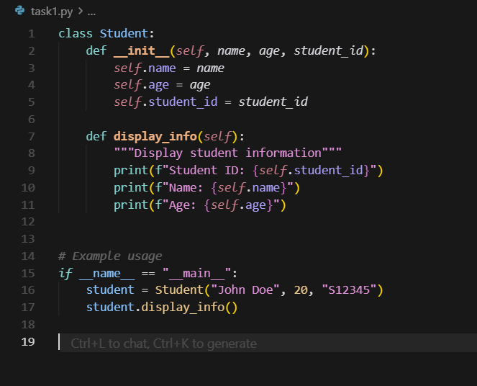  Output  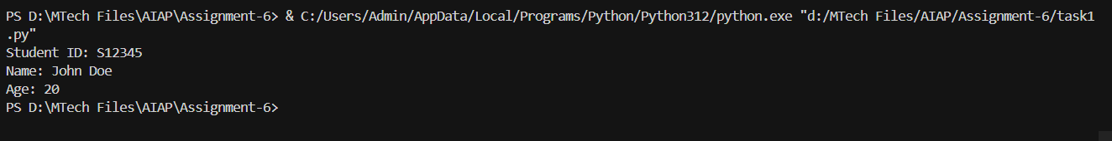  Task Description#2 (Loops)  - Prompt AI to complete a function that prints the first 10 multiples of a number using a loop.  - Analyze the generated code  - Ask AI to generate code using other controlled looping  Expected Output#2  - Correct loop-based implementation  Prompt-1  Complete a function that prints the first 10 multiples of a number using a loop.  Prompt-2  Generate the code using other controlled looping  Code-1:  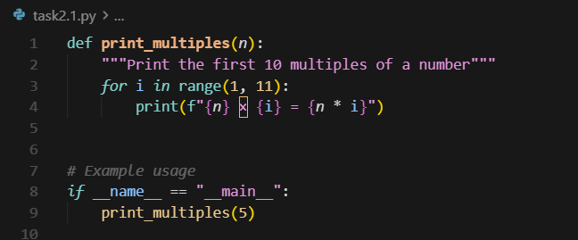  Output-1  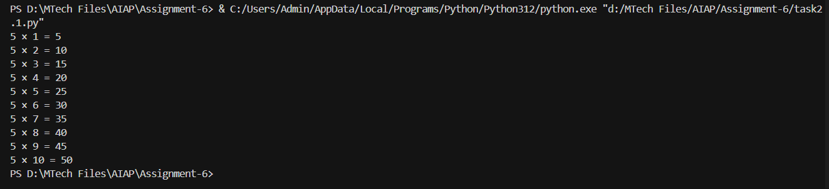  Code-2  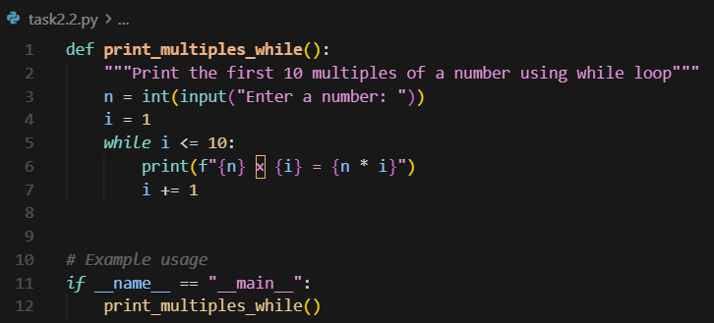  Output-2  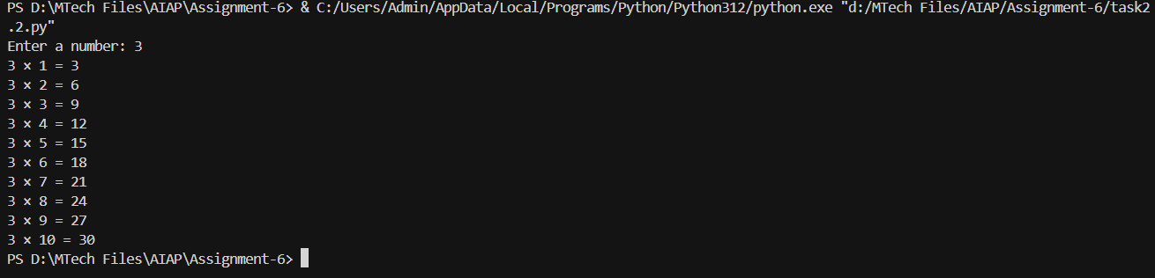  Task Description#3 (Conditional Statements)  - Ask AI to write nested if-elif-else conditionals to classify age groups.  - Analyze the generated code  - Ask AI to generate code using other conditional statements  Expected Output#3  - Age classification function with appropriate conditions and with explanation  Prompt  Write nested if-elif-else conditionals to classify age groups.  Code-1:  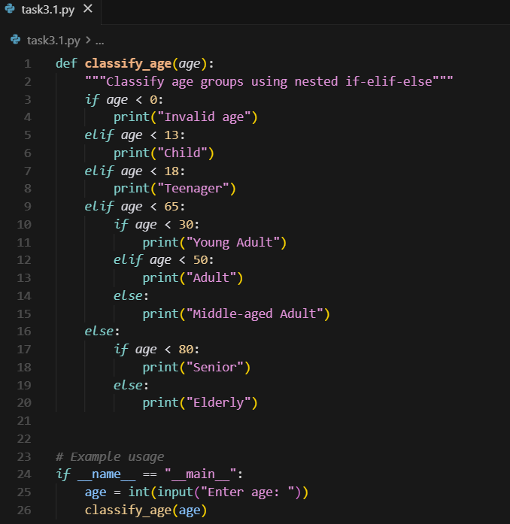  Output-1  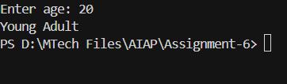  Code-2  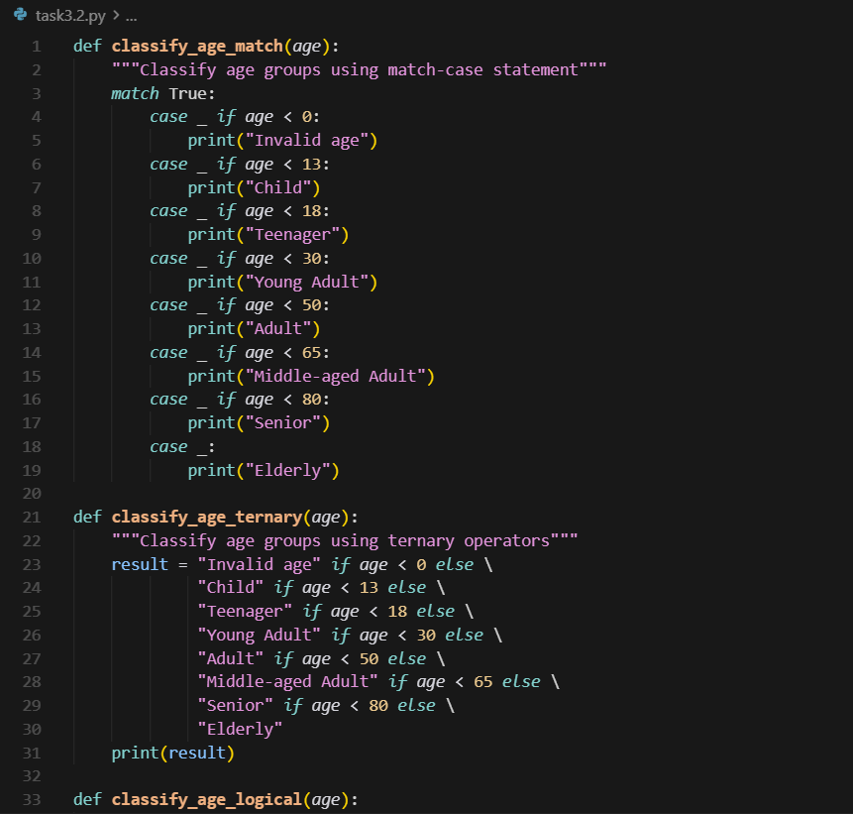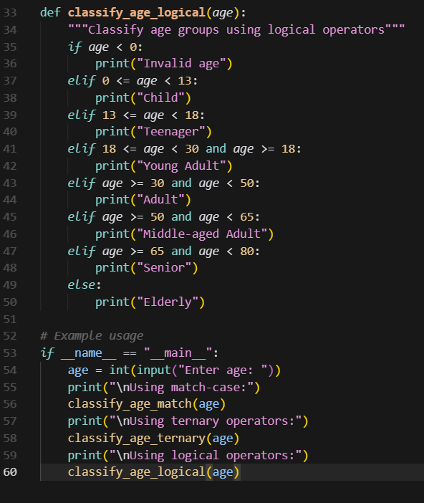  Output-2  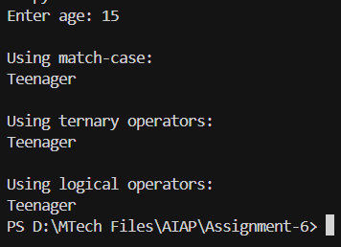  Task Description#4 (For and While loops)  - Generate a sum_to_n() function to calculate sum of first n numbers  - Analyze the generated code  - Get suggestions from AI with other controlled looping  Expected Output#4  - Python code with explanation  Prompt  Generate a sum_to_n() function to calculate sum of first n numbers  Code:  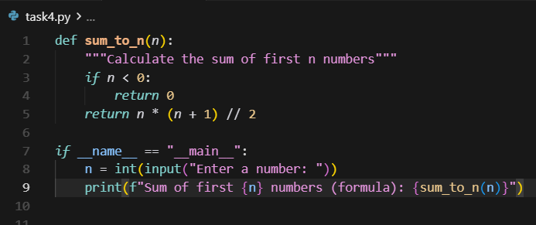  Output  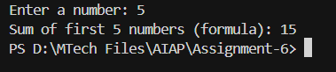  Explaination:  AI has suggested with for loop and while loop in order to calculate sum of first n numbers to achieve the same result.  Task Description#5 (Class)  - Use AI to build a BankAccount class with deposit, withdraw, and balance methods.  - Analyze the generated code  - Add comments and explain code  Expected Output#5  - Python code with explanation  Prompt  Build a BankAccount class with deposit, withdraw, and balance methods and add comments and explain the code.  Code:  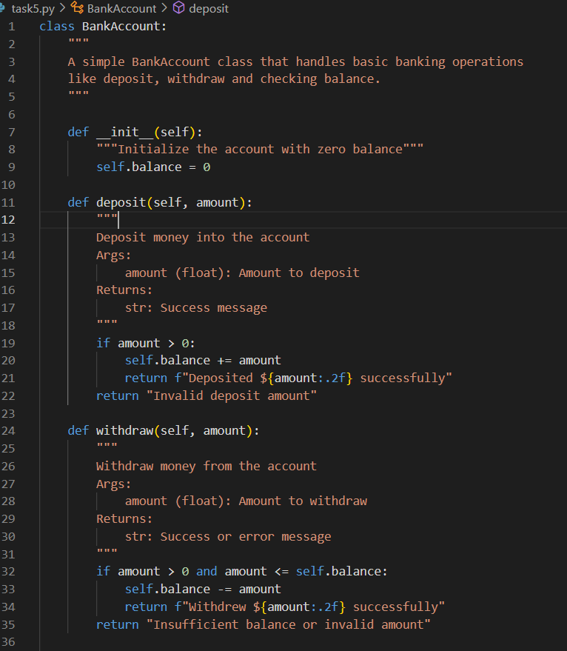  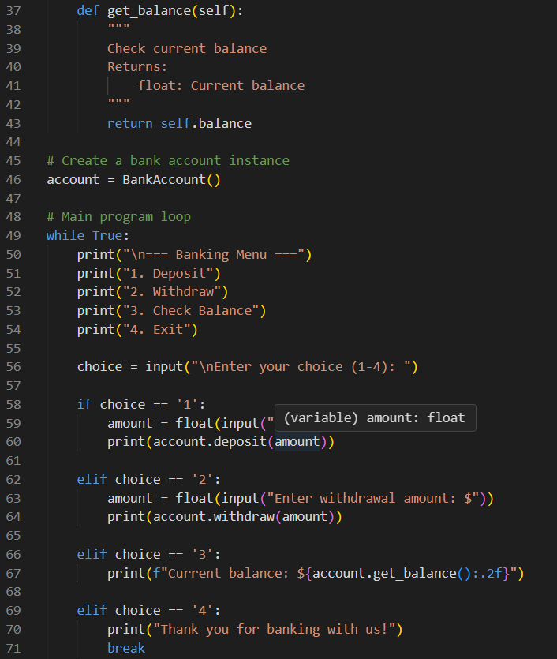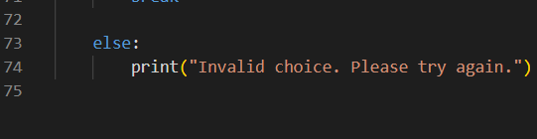  Output  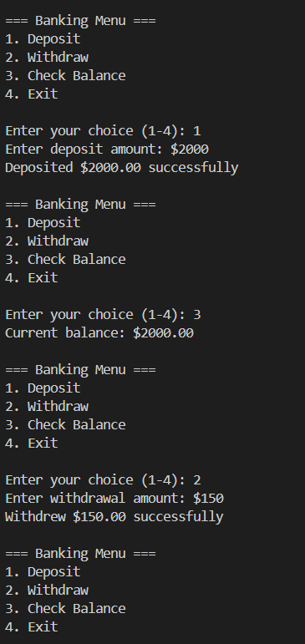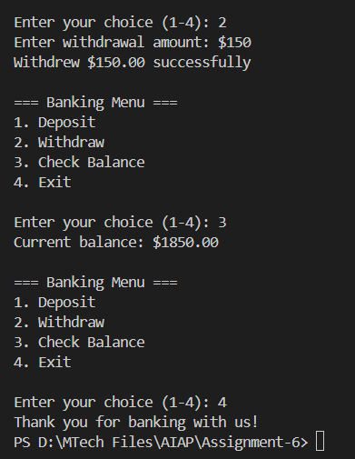 |  |  |  |  |  | Week3 - Wednesday

