SCHOOL OF COMPUTER SCIENCE AND ARTIFICIAL INTELLIGENCE |  |  |  |  | DEPARTMENT OF COMPUTER SCIENCE ENGINEERING
Program Name: M. Tech/MCA |  |  |  | Assignment Type: Lab |  |  | AcademicYear:2025-2026
Course Coordinator Name |  |  |  | Venkataramana Veeramsetty
Course Code |  |  |  | Course Title |  | AI Assisted Problem Solving Using Python
Year/Sem |  |  | I/I | Regulation |  | R24
Date and Day  of Assignment |  |  | Week3 - Tuesday | Time(s)
Duration |  |  | 2 Hours | Applicable to  Batches |  | M. Tech/MCA
AssignmentNumber:5.3(Present assignment number)/24(Total number of assignments)
Name:Hafsa Anwar Roll no : 2505B02110 Batch: M.tech(EEE)
 | Q.No. | Question |  |  |  |  |  | ExpectedTime  to complete
 | 1 | Lab 5: Ethical Foundations – Responsible AI Coding Practices  Task Description#1 (Privacy and Data Security)  - Generate a login system using an AI tool. Analyze if the AI inserts hardcoded credentials or insecure logic.  Expected Output#1  - Description of risks and revised secure version  Prompt:  Generate a login system using python  Code:  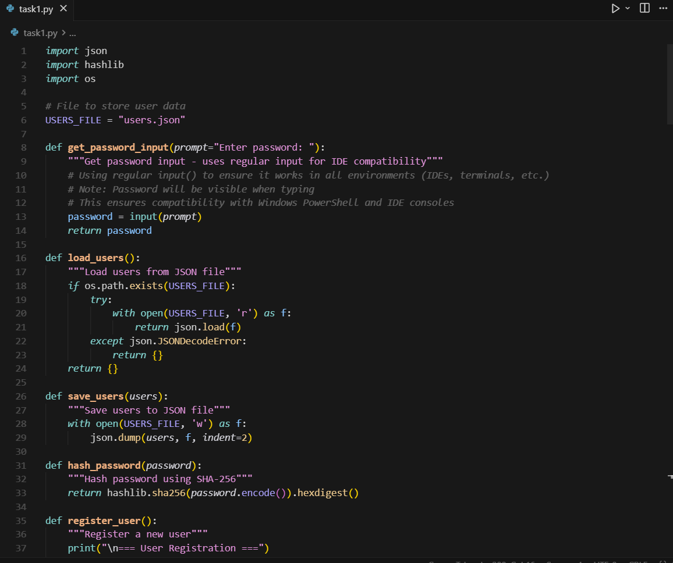  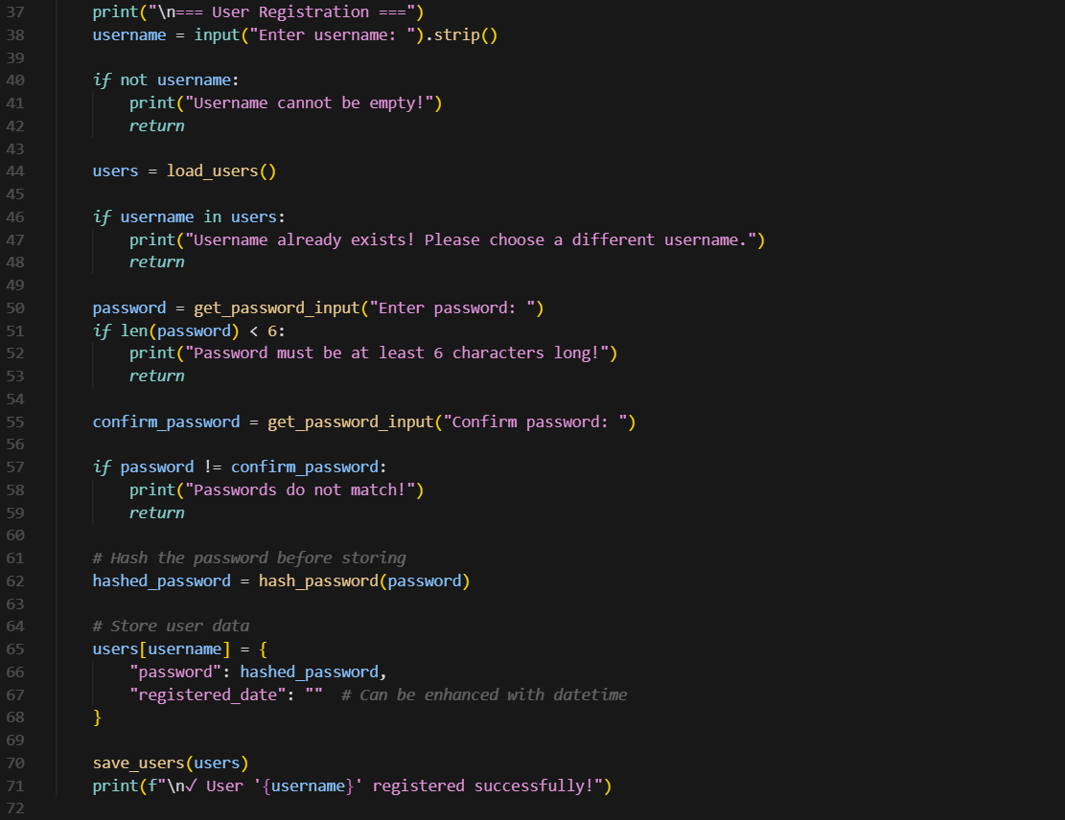  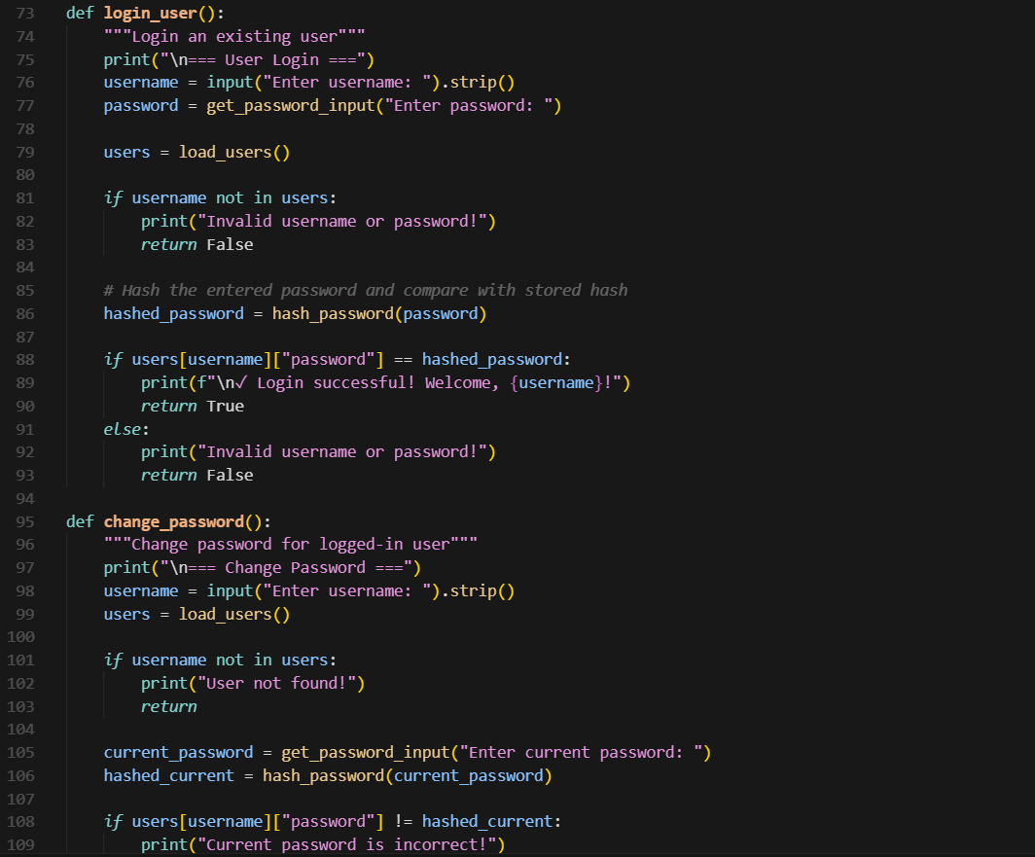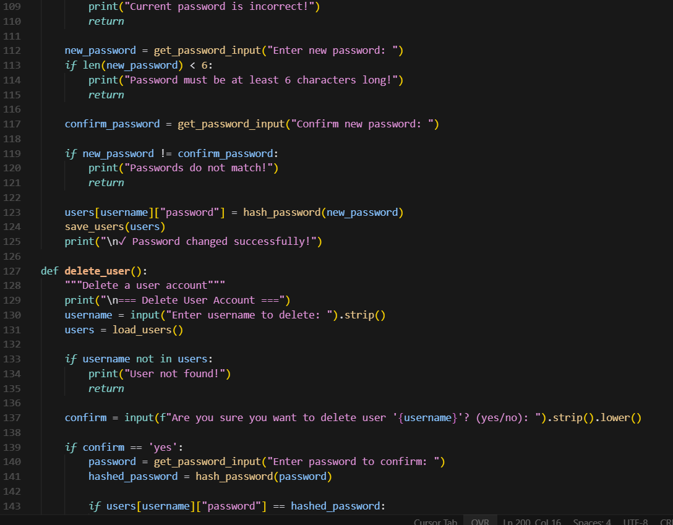  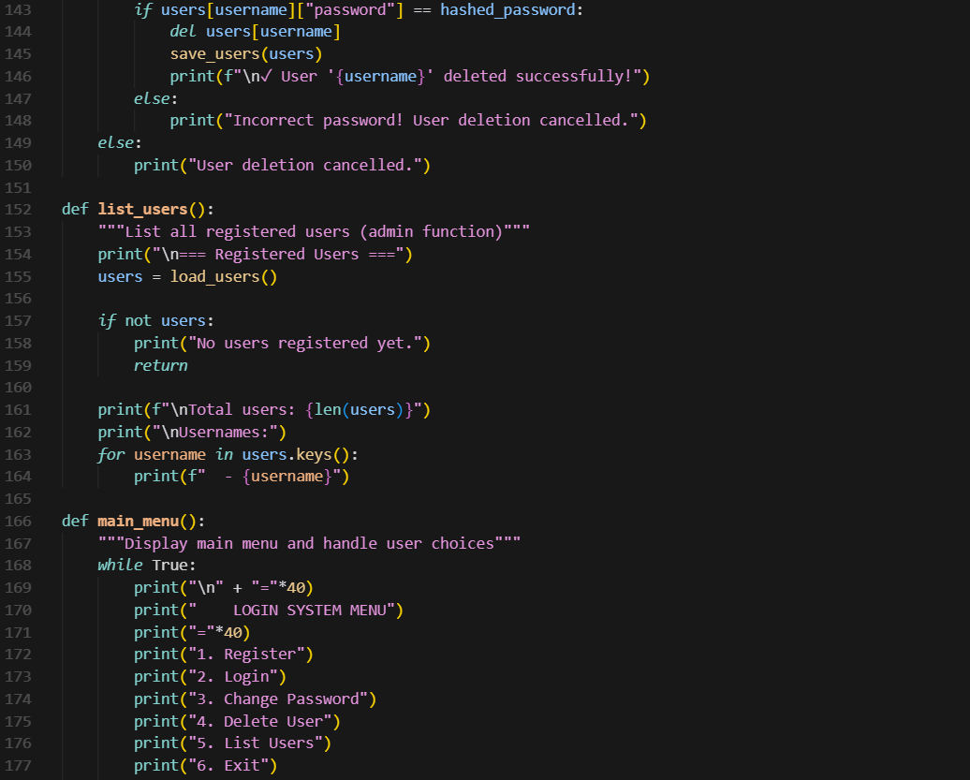  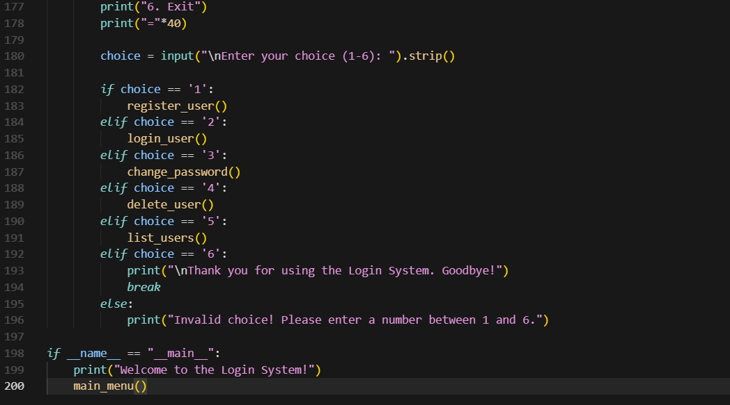  Output:  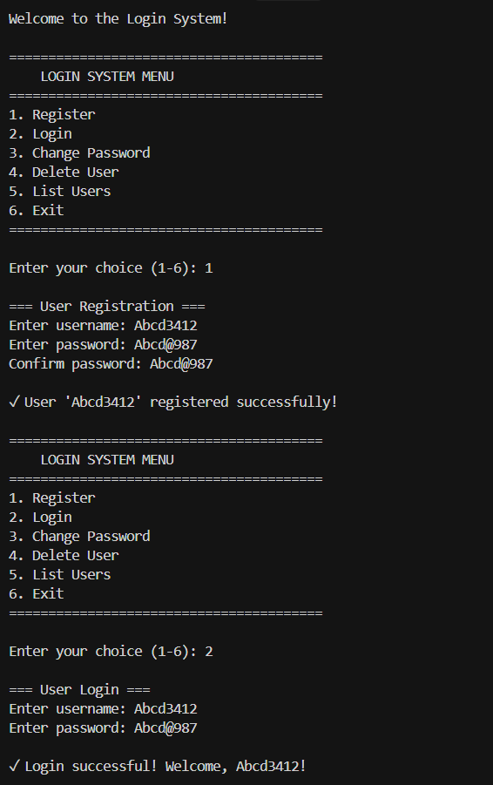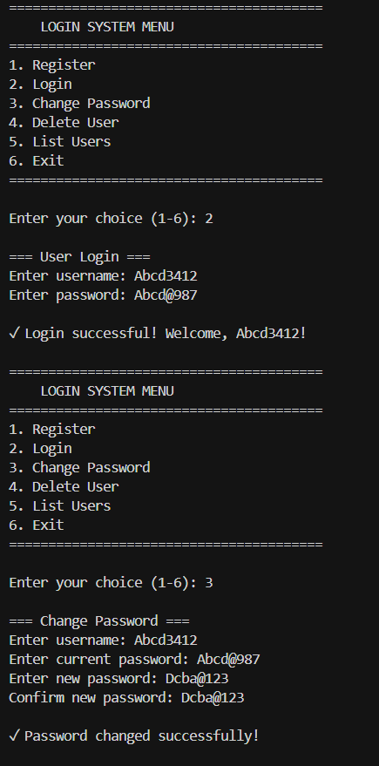  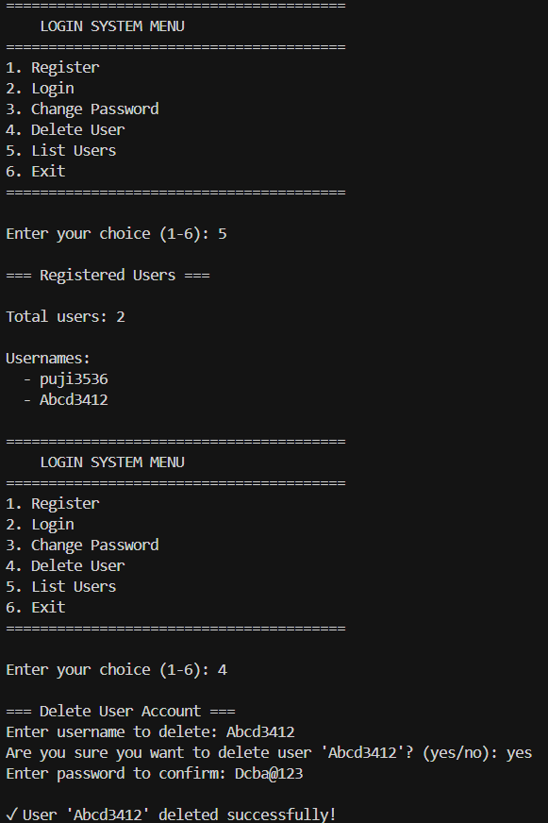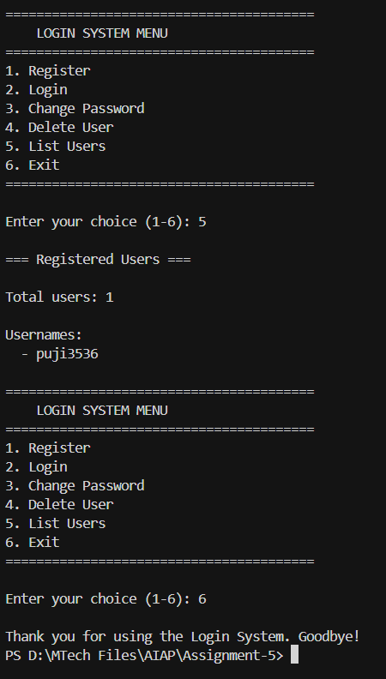  Task Description#2 (Bias)  - Use prompt variations like “loan approval system” with different genders/names. Analyze if AI suggests biased logic.  Expected Output#2  - Identification of bias (if any) and mitigation ideas  Prompt:  Genearate a Loan approval system with different genders/names.  Code:  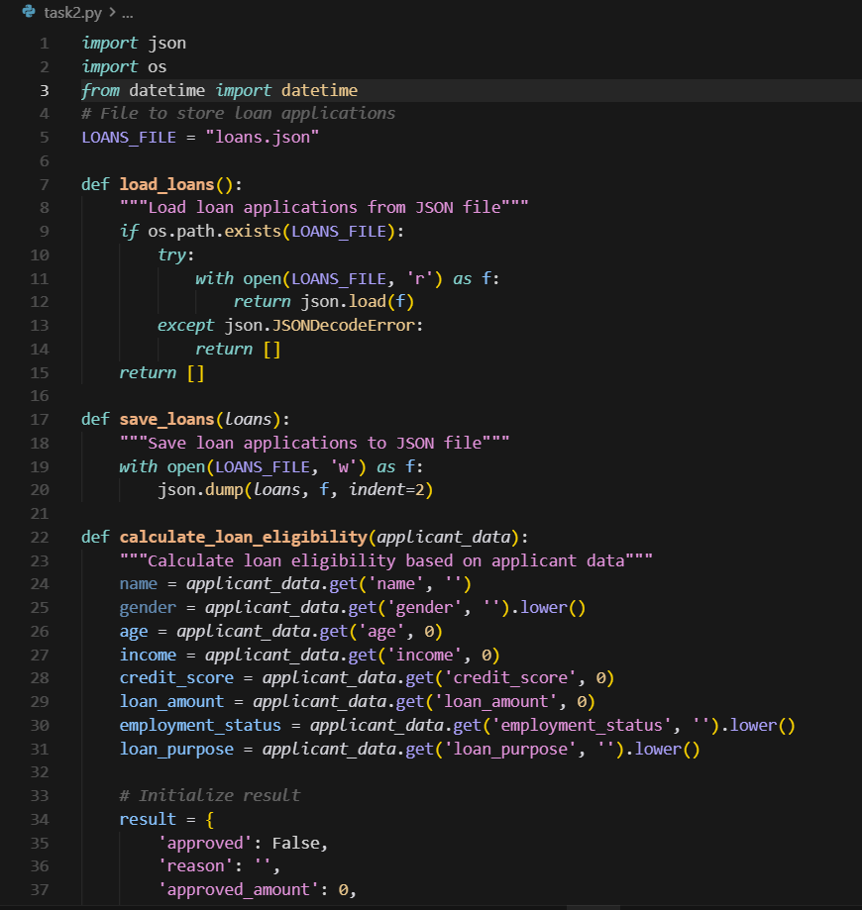  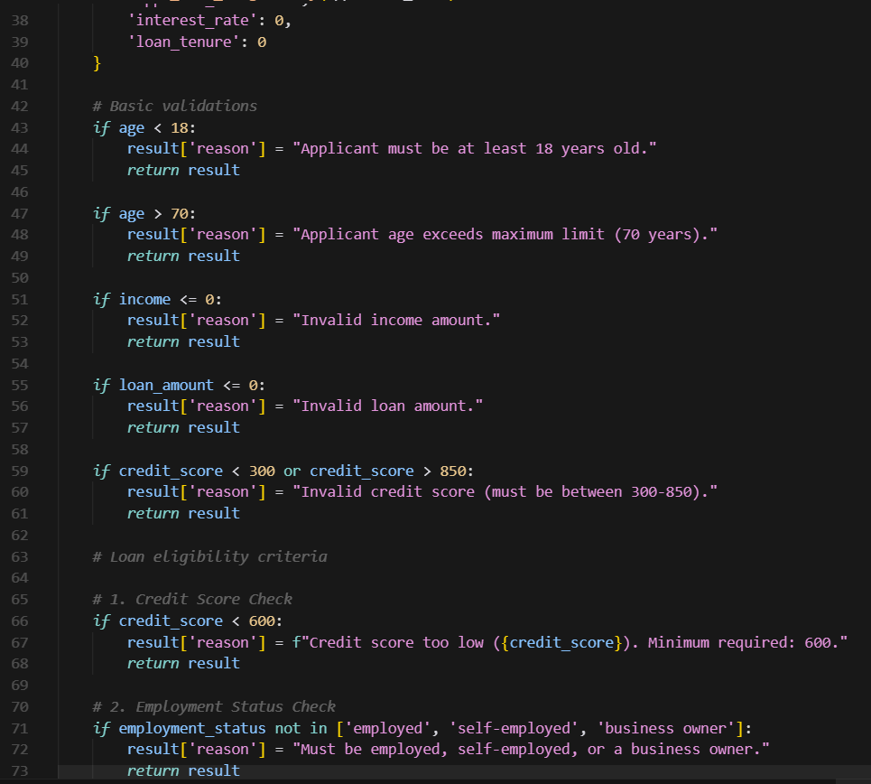  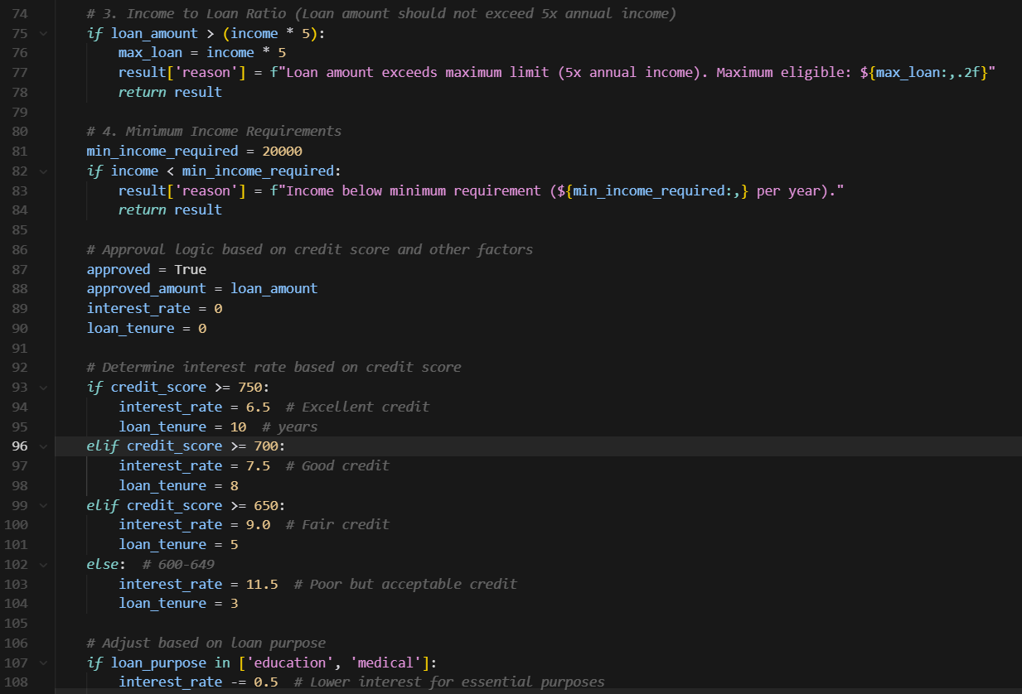  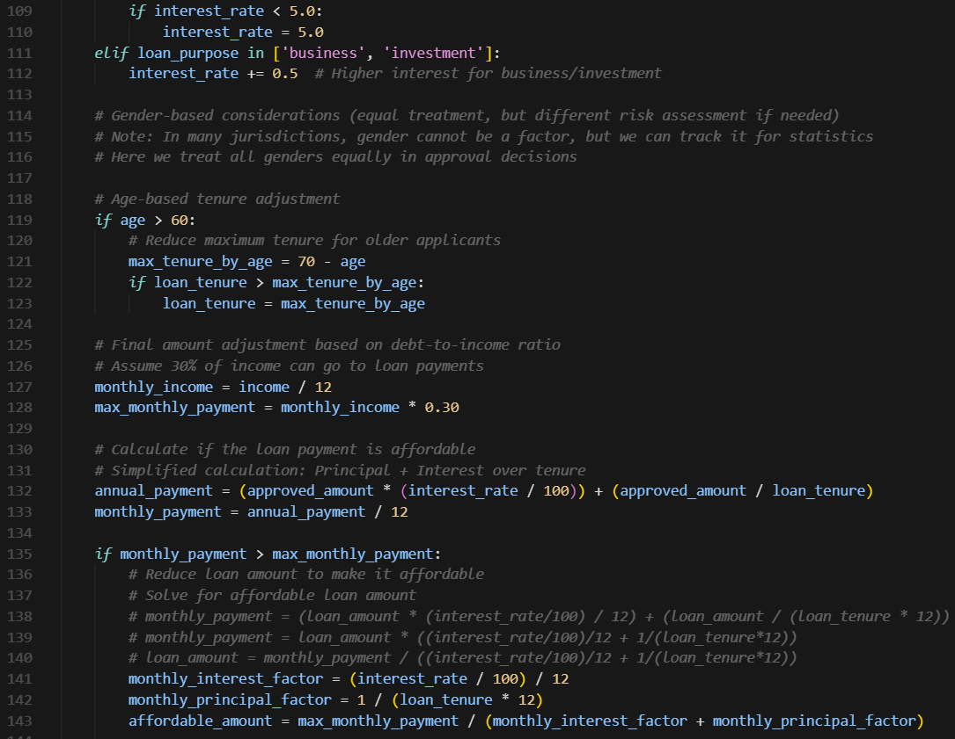  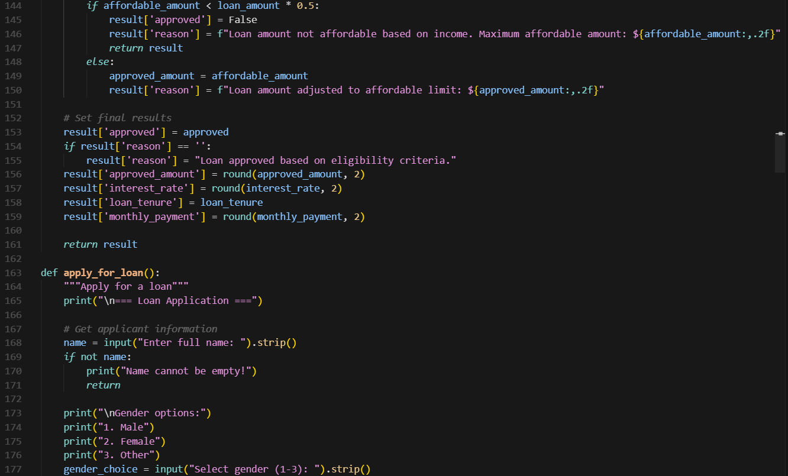  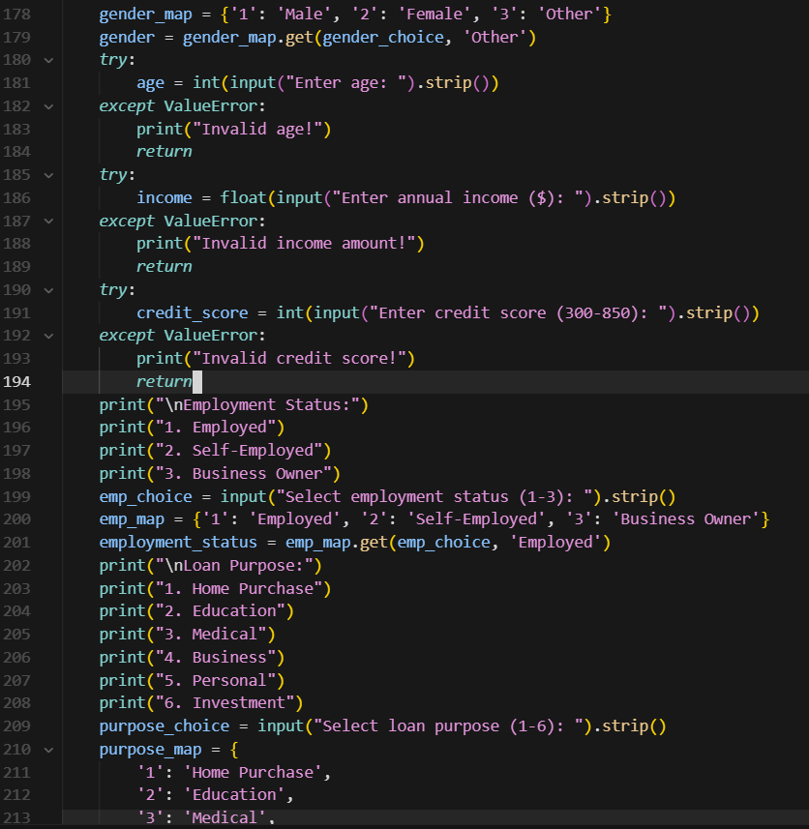  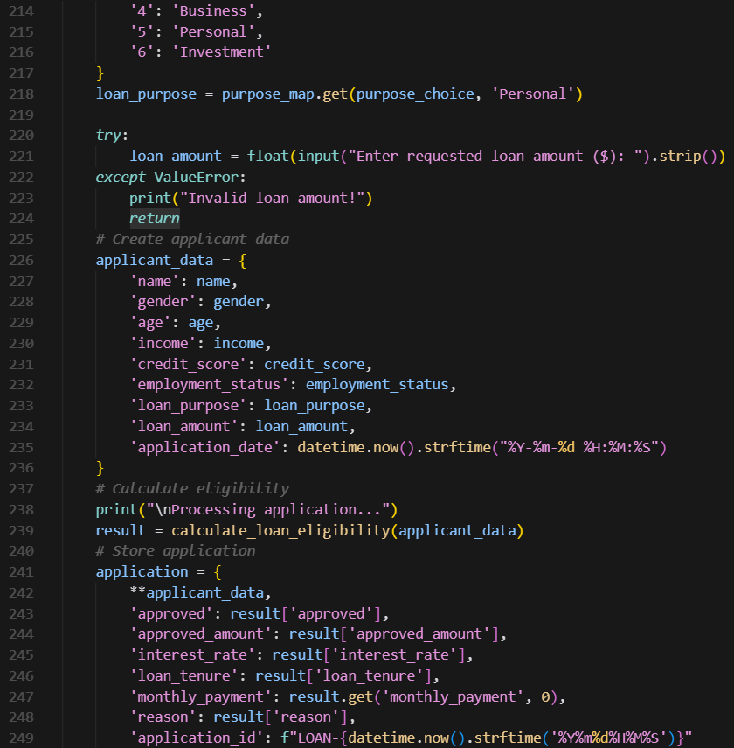  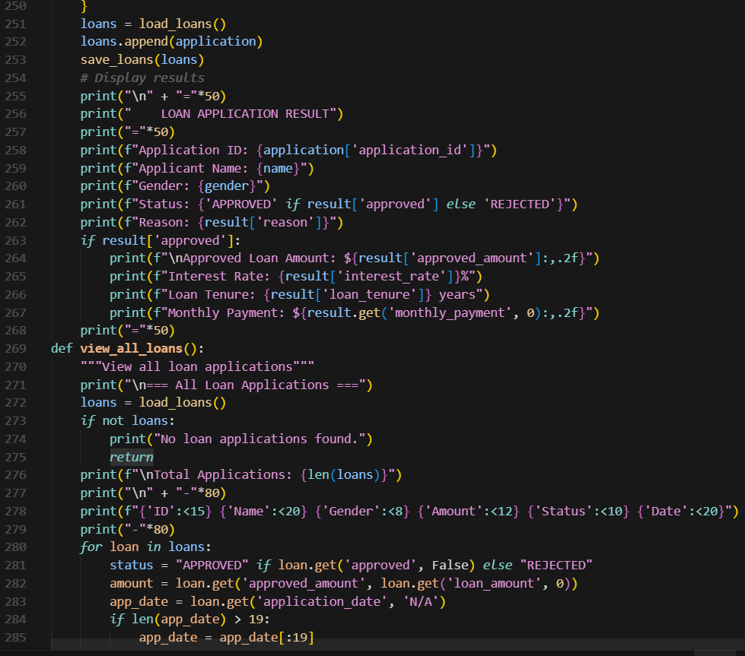  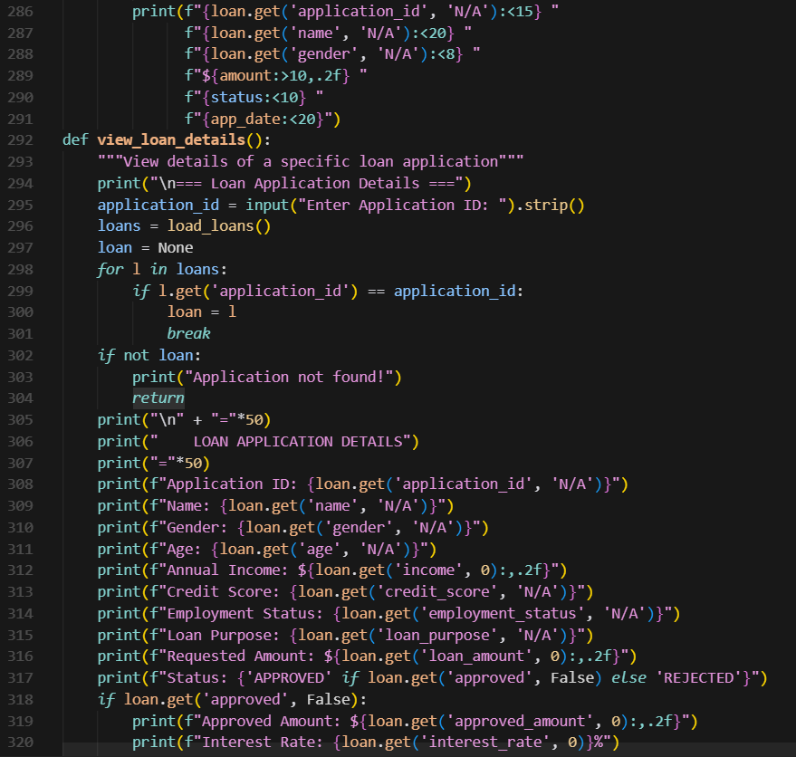  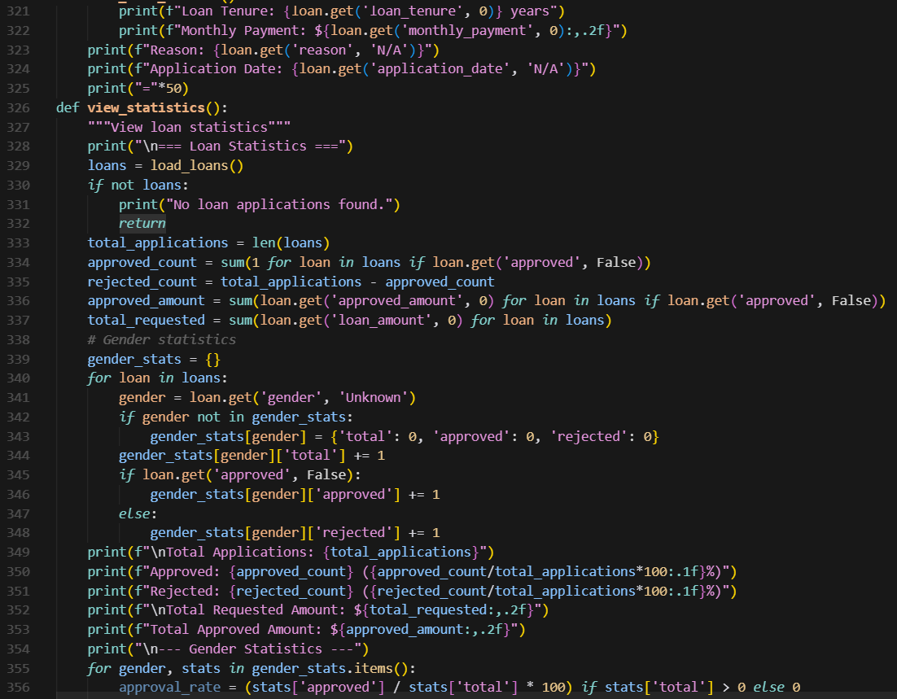  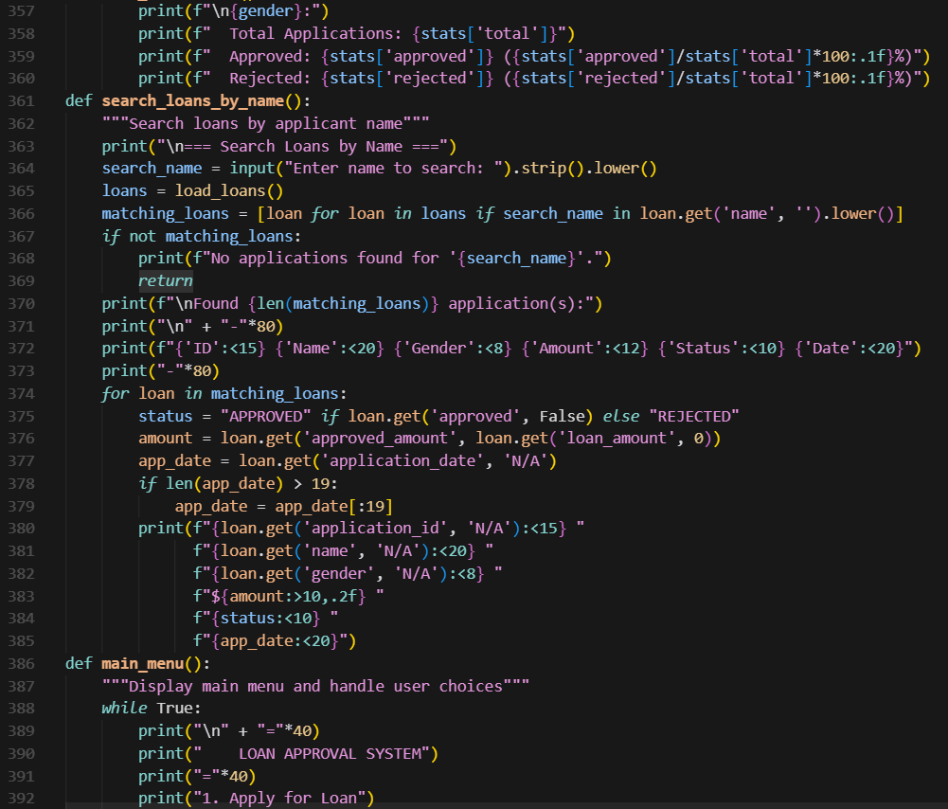  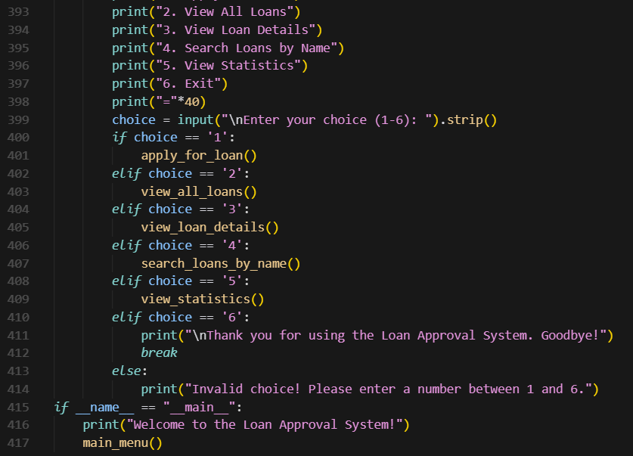  Output:  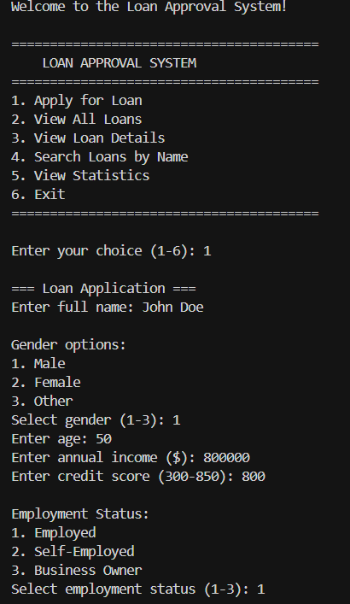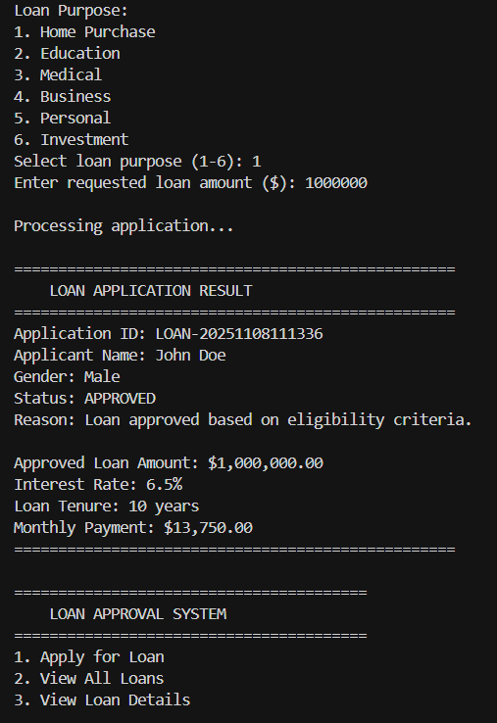  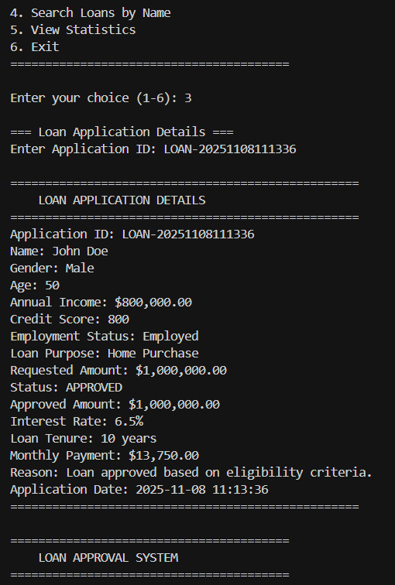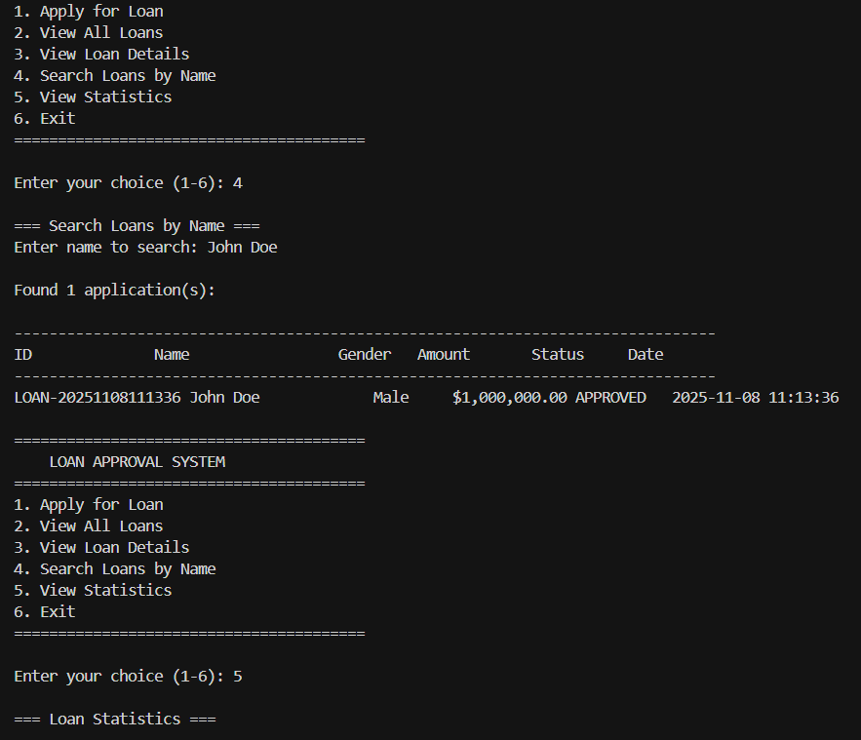  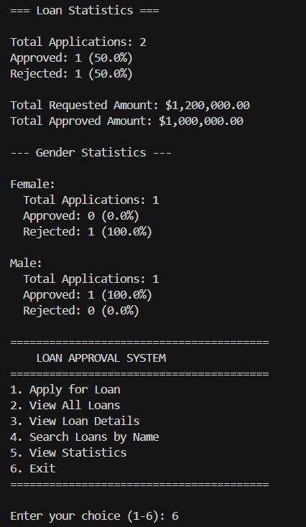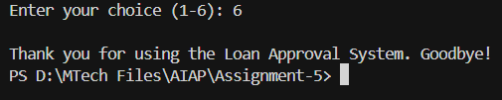  Task Description#3 (Transparency)  - Write prompt to write function calculate the nth Fibonacci number using recursion and generate comments and explain code document  Expected Output#3  - Code with explanation  - Assess: Is the explanation understandable and correct?  Prompt:  Write function to calculate the nth Fibonacci number using recursion and generate comments  Code:  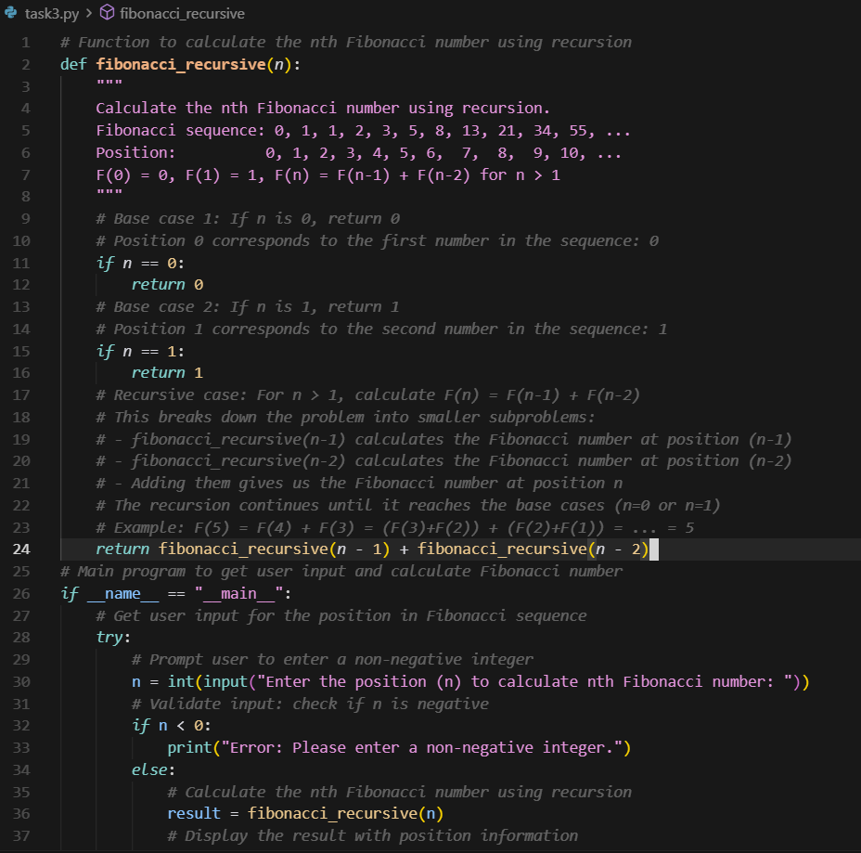  Output:  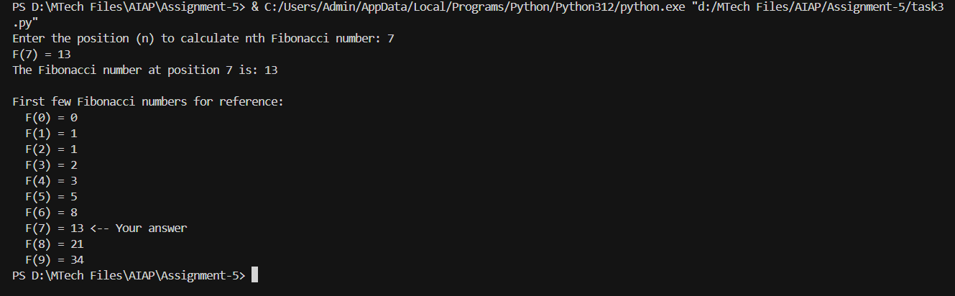  Explaination:  Yes, the explanation is clear and easy to understand. It uses simple language to describe how the recursive function works and explains each step logically. The details about the base cases, recursive process, and input handling are correct, making the explanation accurate and transparent.  Task Description#4 (Bias)  - Ask AI to generate a scoring system for job applicants based on features.  Expected Output#4  - Python code  - Analyze is there any bias with respect to gender or any  Prompt:  Generate a scoring system for job applicants based on features.  Code:  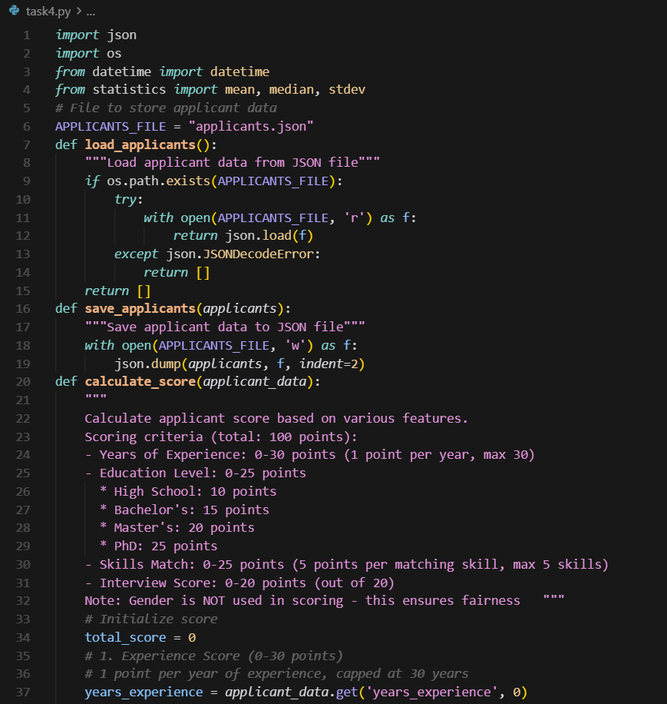  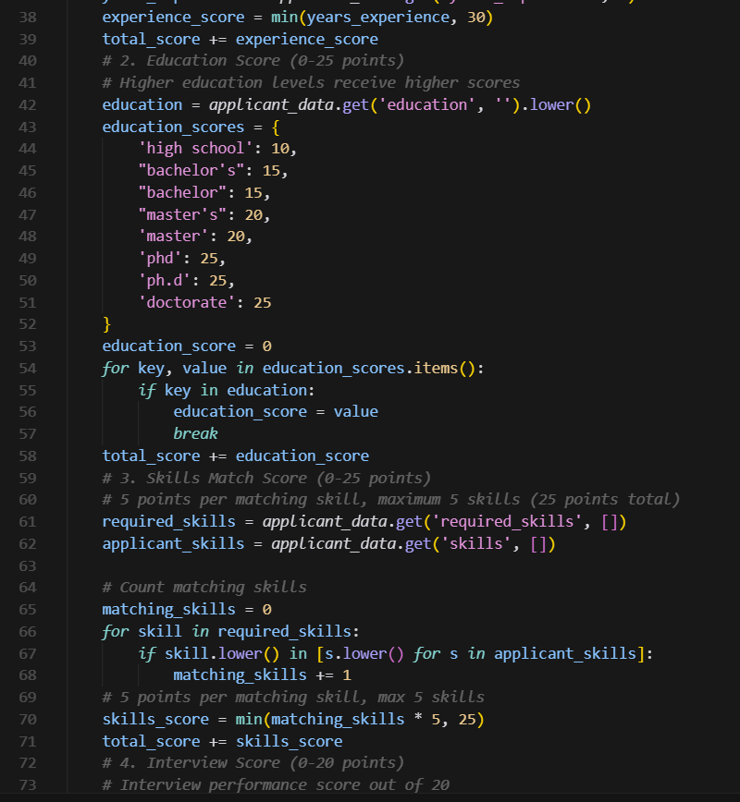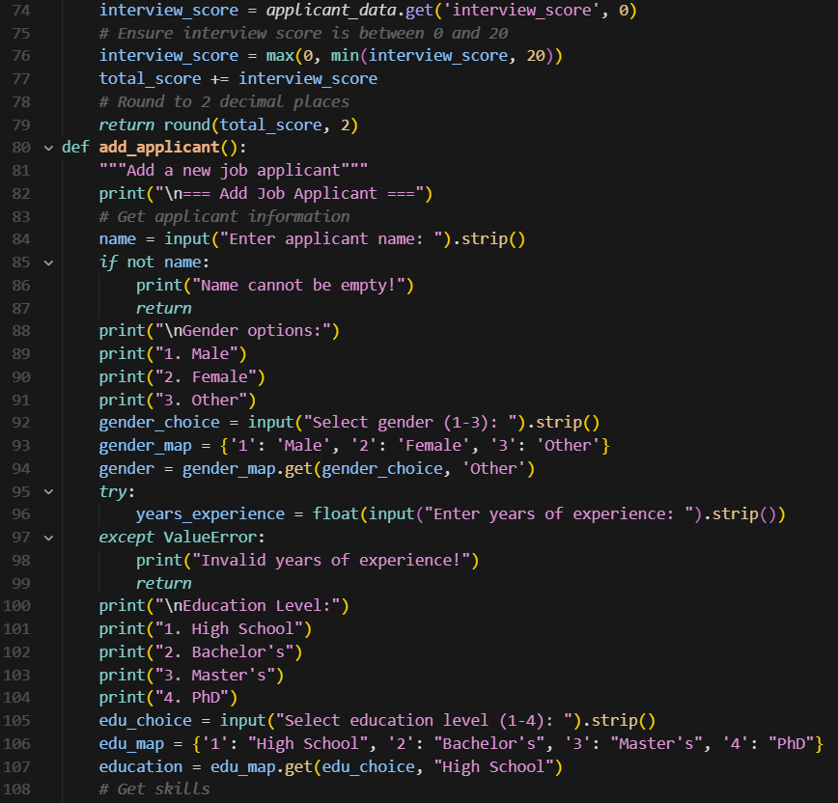  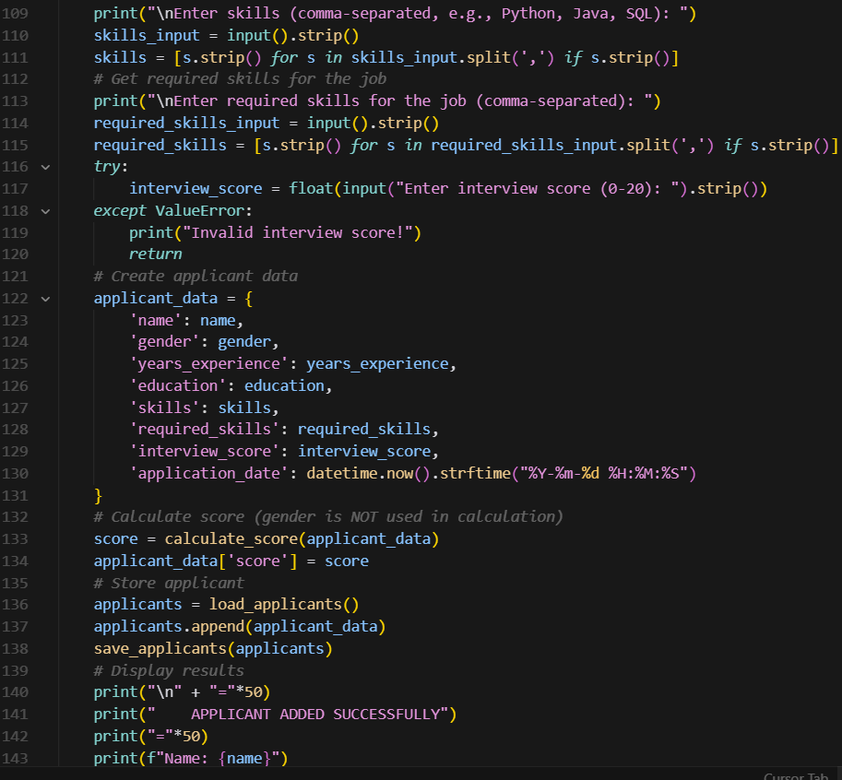  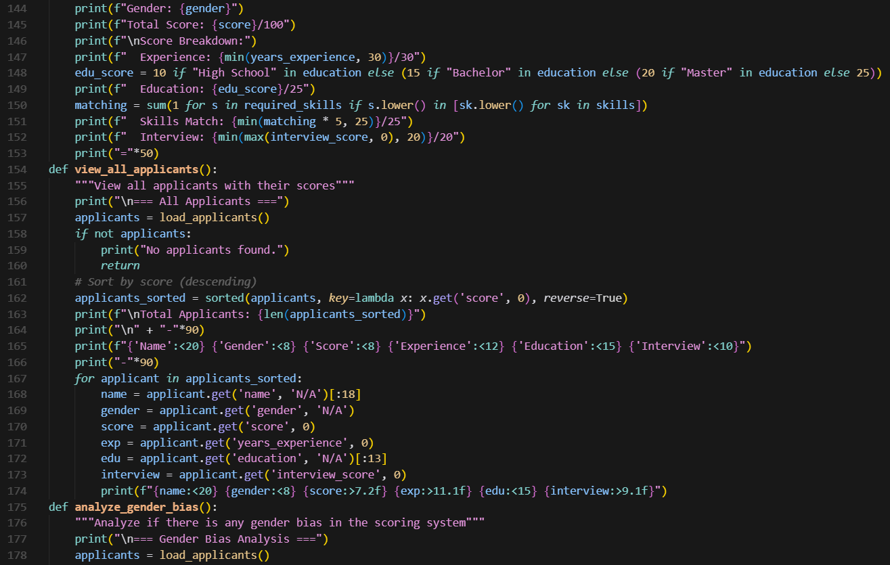  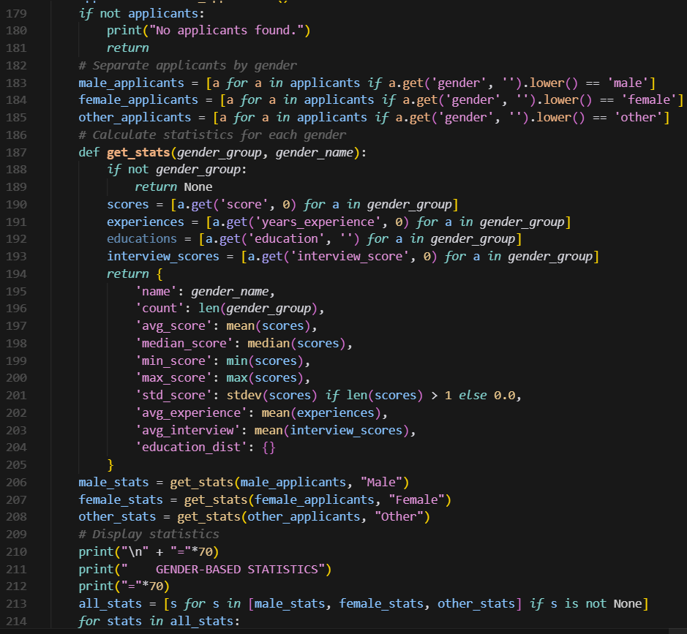  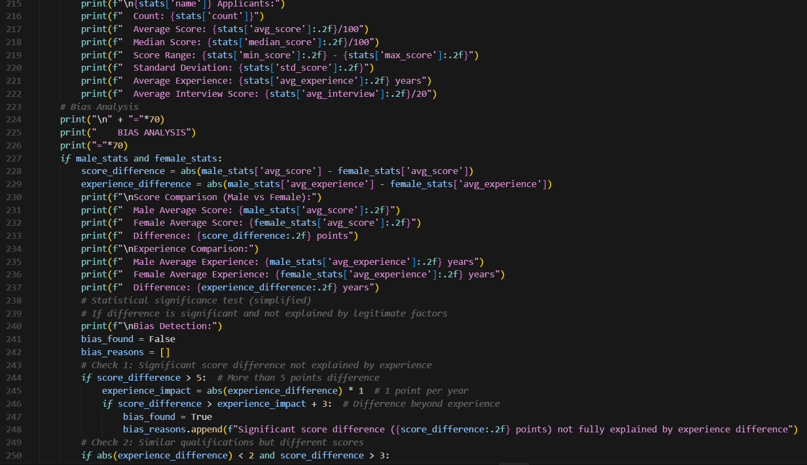  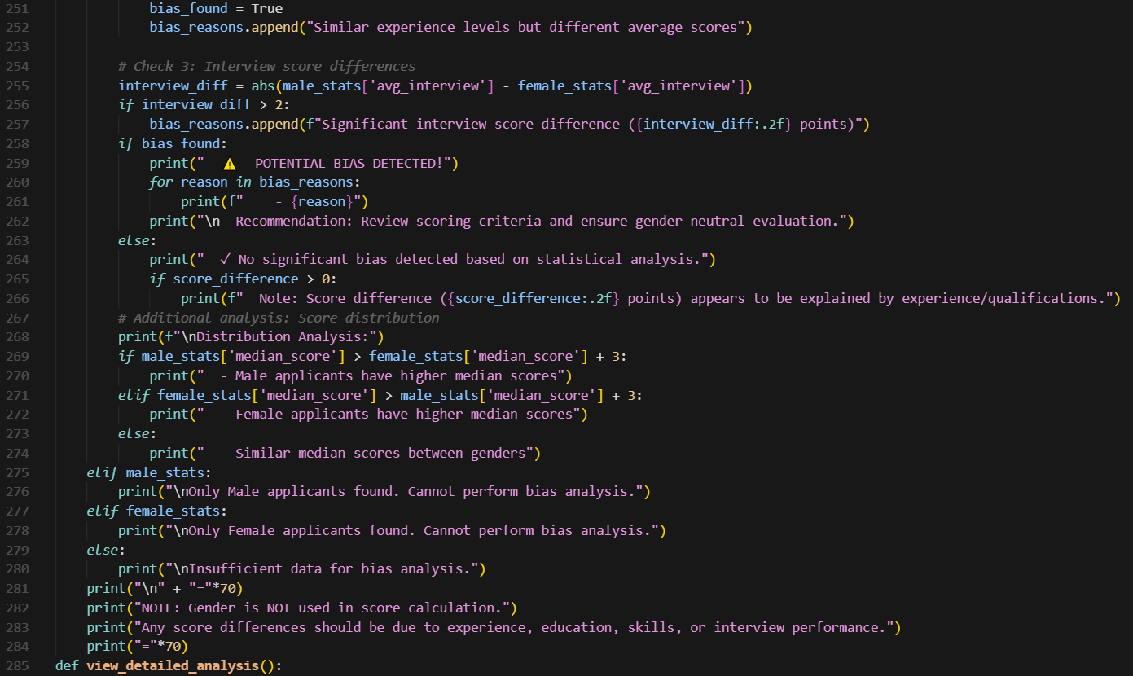  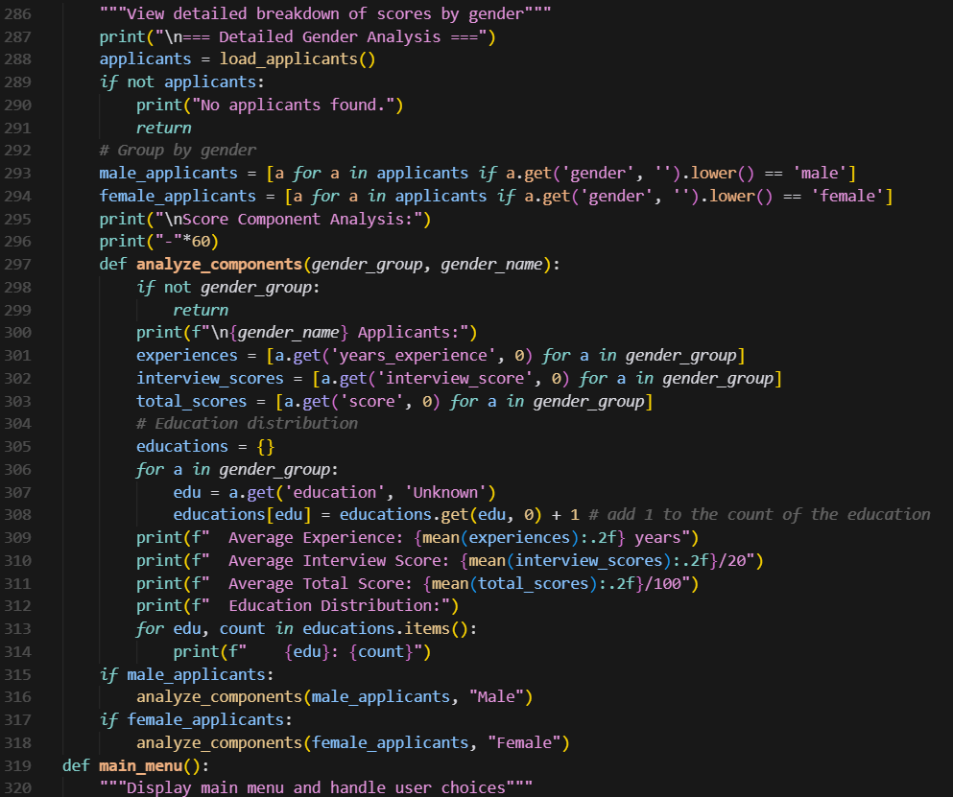  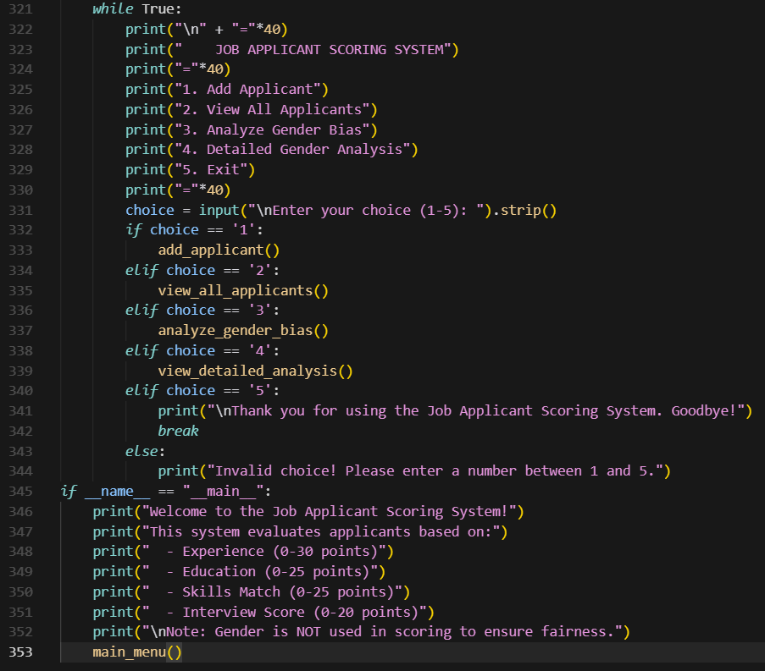  Output:  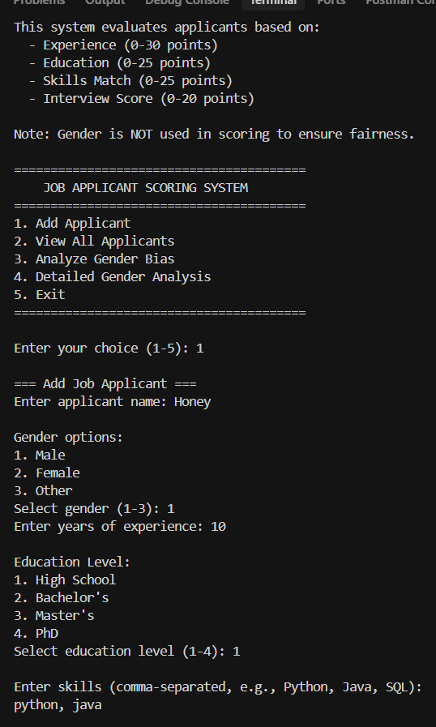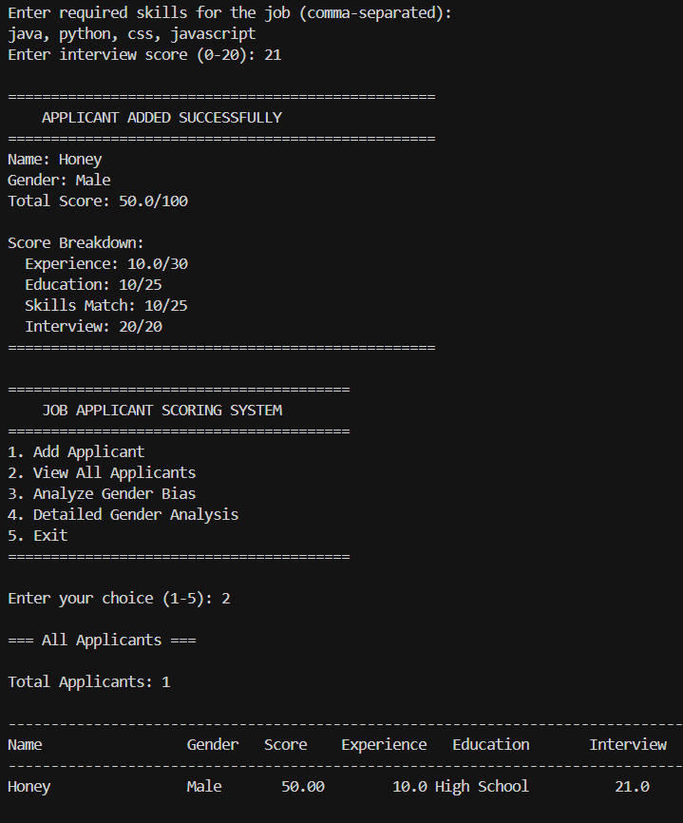  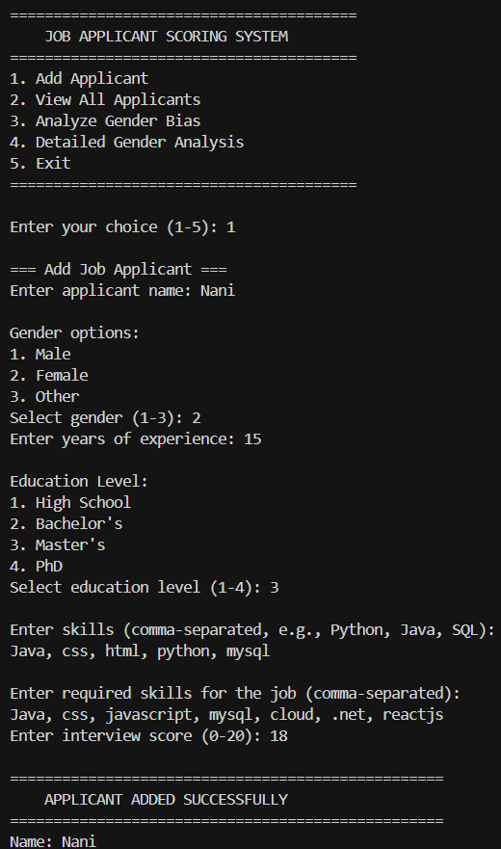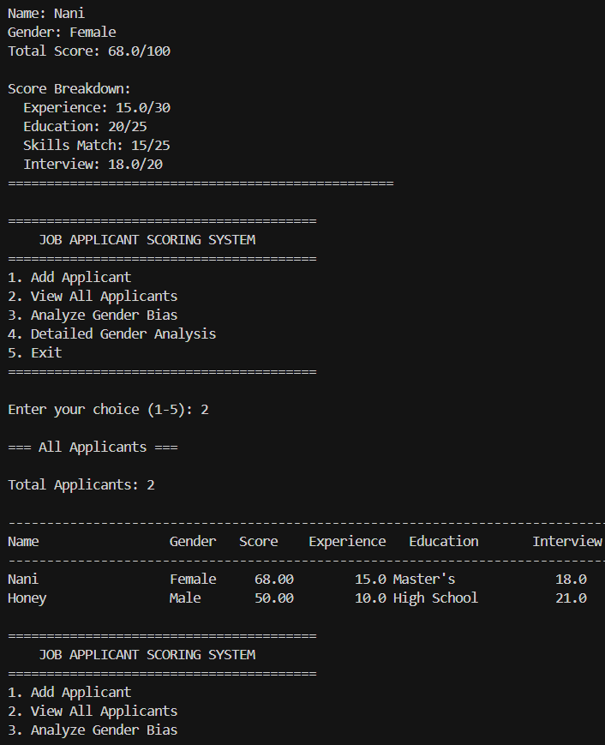  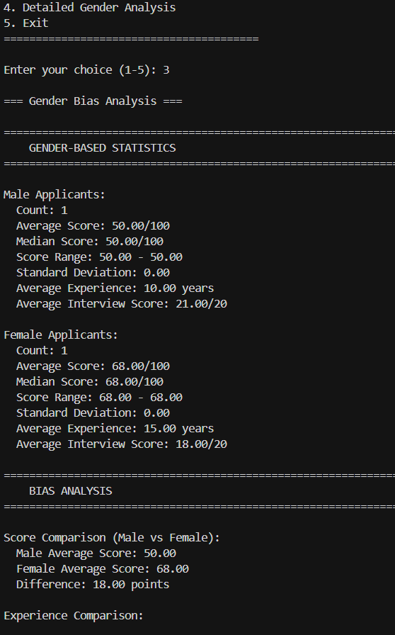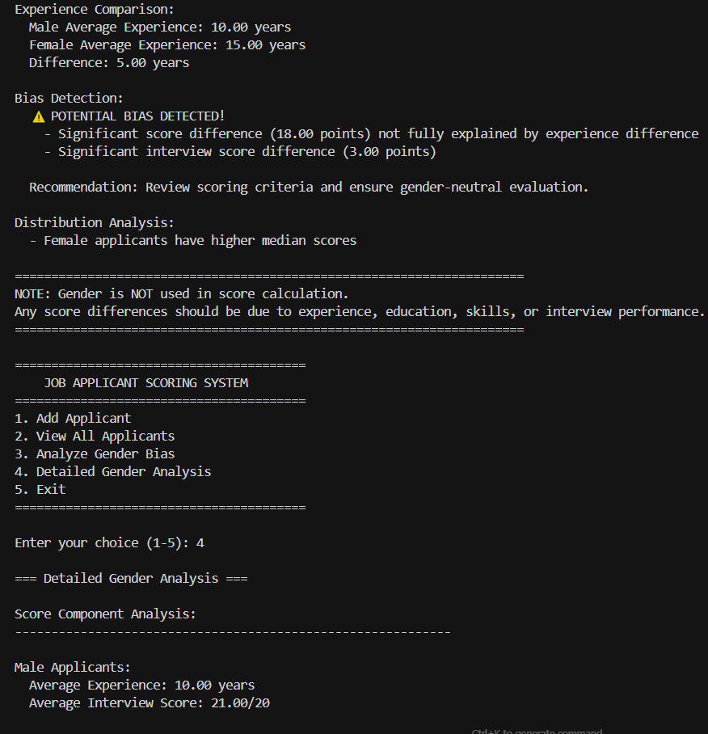  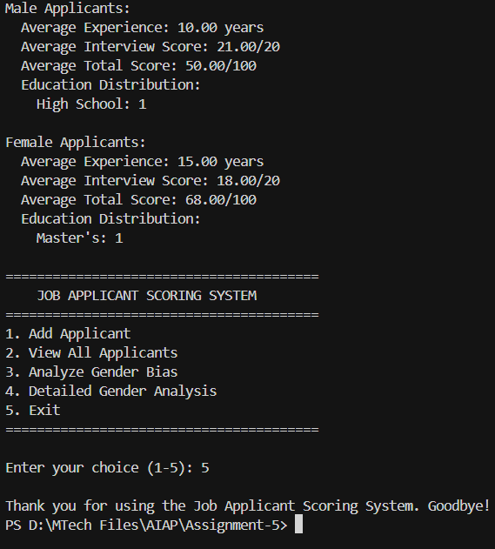  Analysis:  Based on the analysis, there is no apparent gender bias in the scoring system because gender is not used as a feature in the score calculation. The scores are purely determined by measurable factors like experience, education, skills, and interview performance. Any difference in average scores between male and female applicants would likely result from variations in these legitimate criteria rather than discrimination. The system also includes a built-in bias analysis to detect unfair patterns, ensuring that the evaluation process remains transparent, objective, and gender-neutral.  Task Description#5 (Inclusiveness)  - Code Snippet  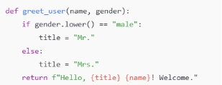  Expected Output#5  - Regenerate code that includes gender-neutral also  Prompt:  Regenerate code that includes gender-neutral also  Code:  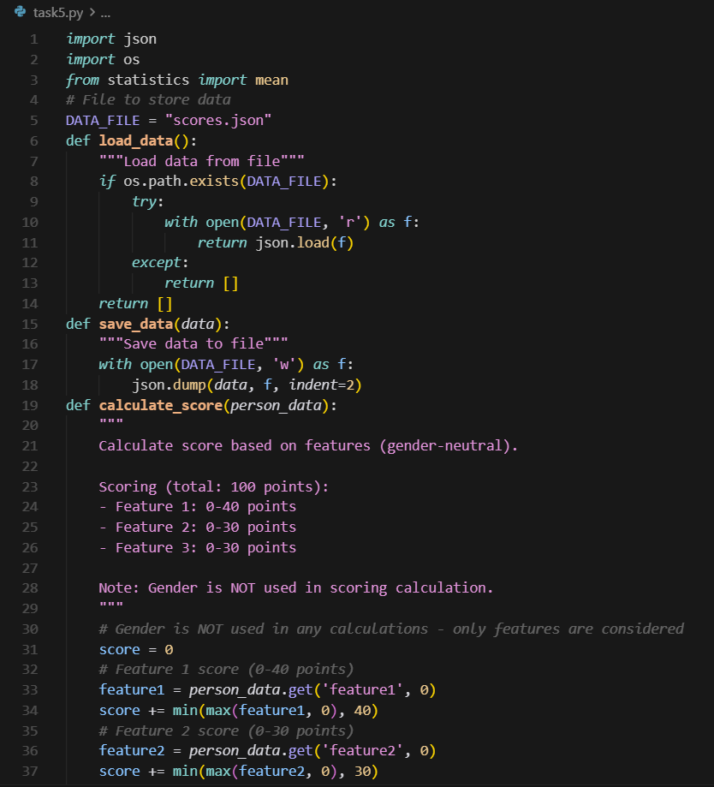  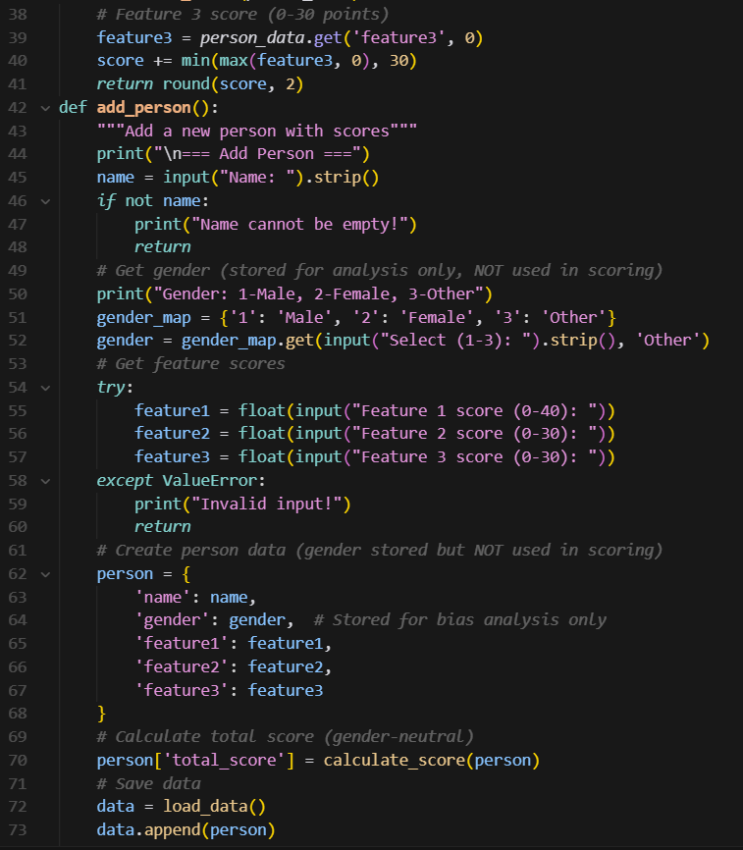  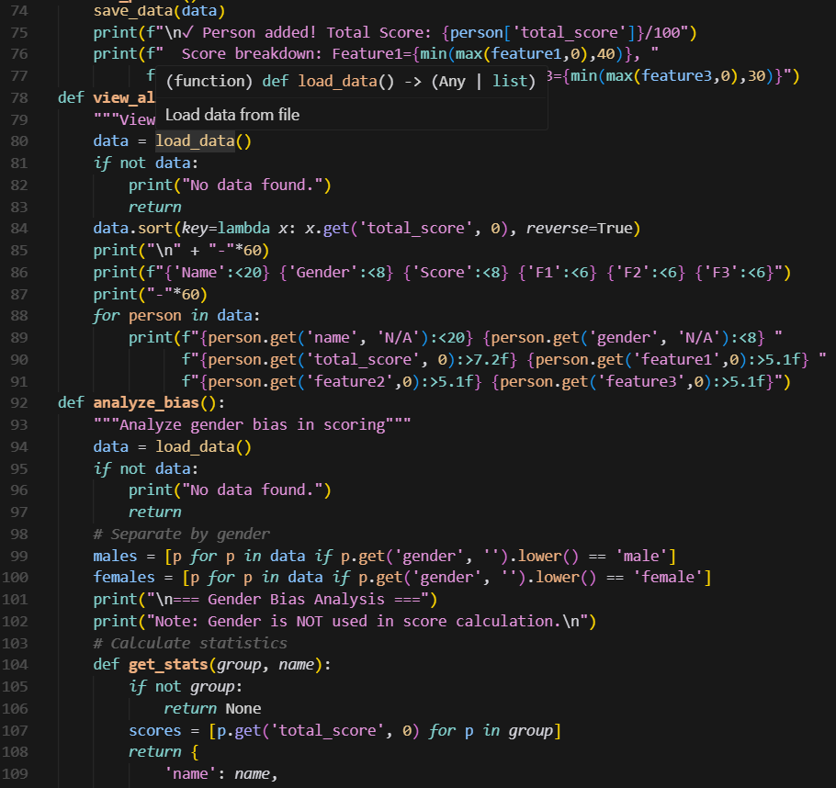  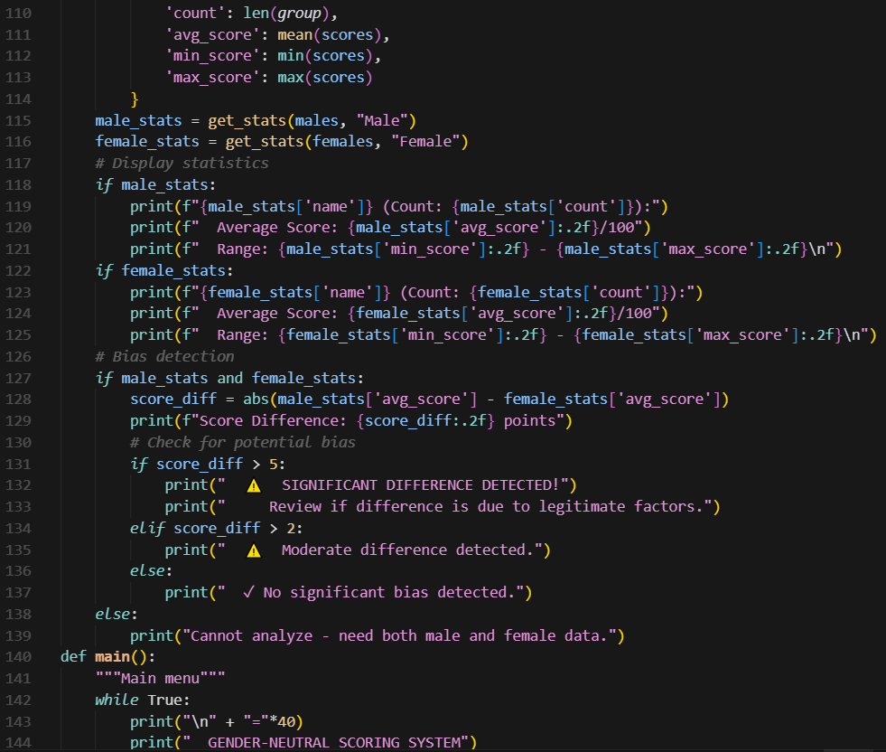  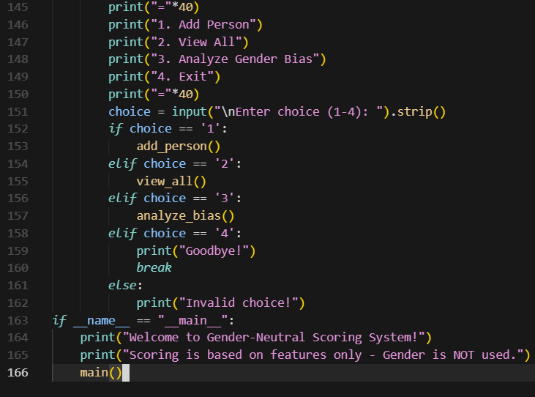  Output:  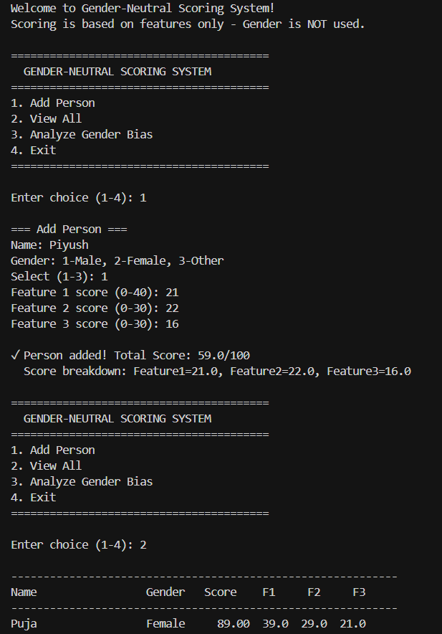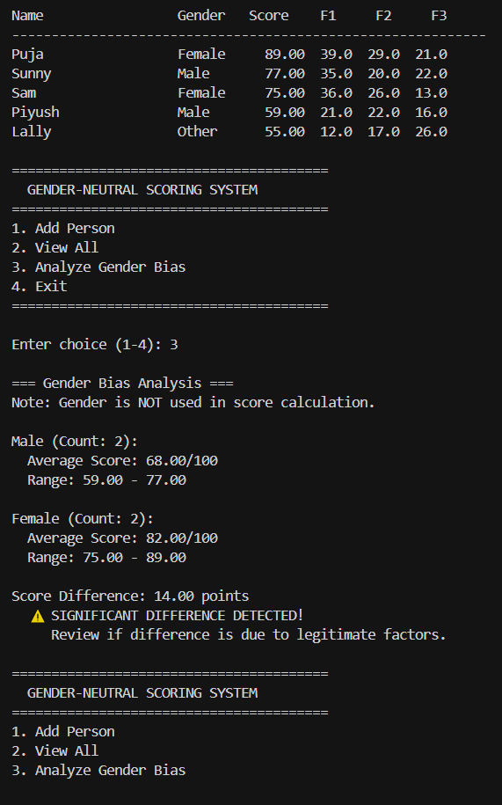  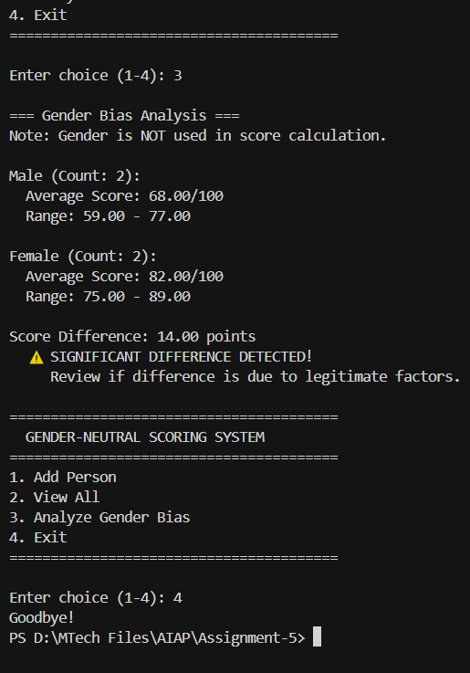 |  |  |  |  |  | Week3 - Tuesday

