

**E-PROJECT-DEVELOPMENT**

* PROJECT TITLE

**Glow & Heaven**

* PROFESSOR NAME
* Hassan Ali
* BATCH CODE
* PR2-2024-02F
* SEMESTER
* DISM



CERTIFICATE OF COMPLETION

This is certify that Hafsa shahid have successfully completed their

ACCP 2nd semester (DISM) E-Project.

Submitted to: Aptech Computer Education

On

February-25-2025



**Problem Statement**

Jenny is a doing business of cosmetics and imitation jewelry. She operates from

home. Initially she started the entire activity by contacting the nearby friends and

relatives, inform them about the various products available with her and their

prices. Maria used to maintain the catalogue of products to display and diary for

contacting the clients wherein she used to record their contact details and also to

record their orders.

With the growing demands of the business and as the number of clients is

increasing day by day, she wishes to have a web site with the complete product

list for the user, also user should be able to place the order using the website.

Web site should also record the complete information regarding the client.

Customer Specifications:

The user should be able to do the following:

1. Browse through the categories and products available and should be able

to add products to the shopping basket.

2. User should be able to specify the quantity of the products required.

3. Complete / Finalize the order.

4. While ordering the product the user should input the following information:



• Name

• Address

• E-mail

• Work Phone No.

• Cell No.

• Date Of Birth

• Category

• Remarks(other additional informational)

5. The user should be able to search a product by name.

Administrator should be able to do the following:

1. Add/Delete categories and products into the website.

2. Update the information for the existing products.

3. Maintenance of the web site

4. Add / Delete records in database.

5. Backup the database.

6. Generate/View the report upon top 10 best selling products.

7. Generate/View the report upon top 10 clients/users (doing maximum

shopping).



**Hardware/ Software Requirements**

**Hardware**

• A minimum computer system that will help you access all the tools in the

courses is a Pentium 166 or better

• 128 Megabytes of RAM or better

Operating System

• LINUX / Windows 7 (or higher if possible)

**Software**

• PHP

• MySQL

• PERL

• Apache



USER INTERACTION PAGES

**NAVIGATION BAR**

The **Navigation Bar (Navbar)** is designed for easy access to essential features, including product browsing, searching, and user interactions. On the left, the logo links to the homepage, while navigation links provide access to sections like Home, Categories (Cosmetics & Jewelry), Offers, and Contact Us. A search bar with a magnifying glass icon allows users to find products by name. The wishlist, represented by a heart icon, lets users save favorite items for future purchases. The shopping cart icon displays added items with a badge, allowing users to review and proceed to checkout. Additionally, a user profile section enables login and registration, enhancing the personalized shopping experience.

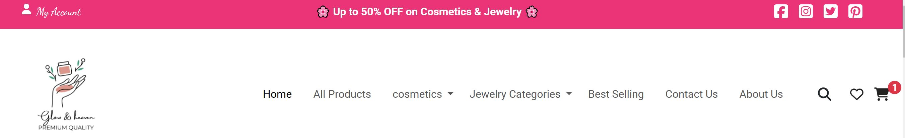



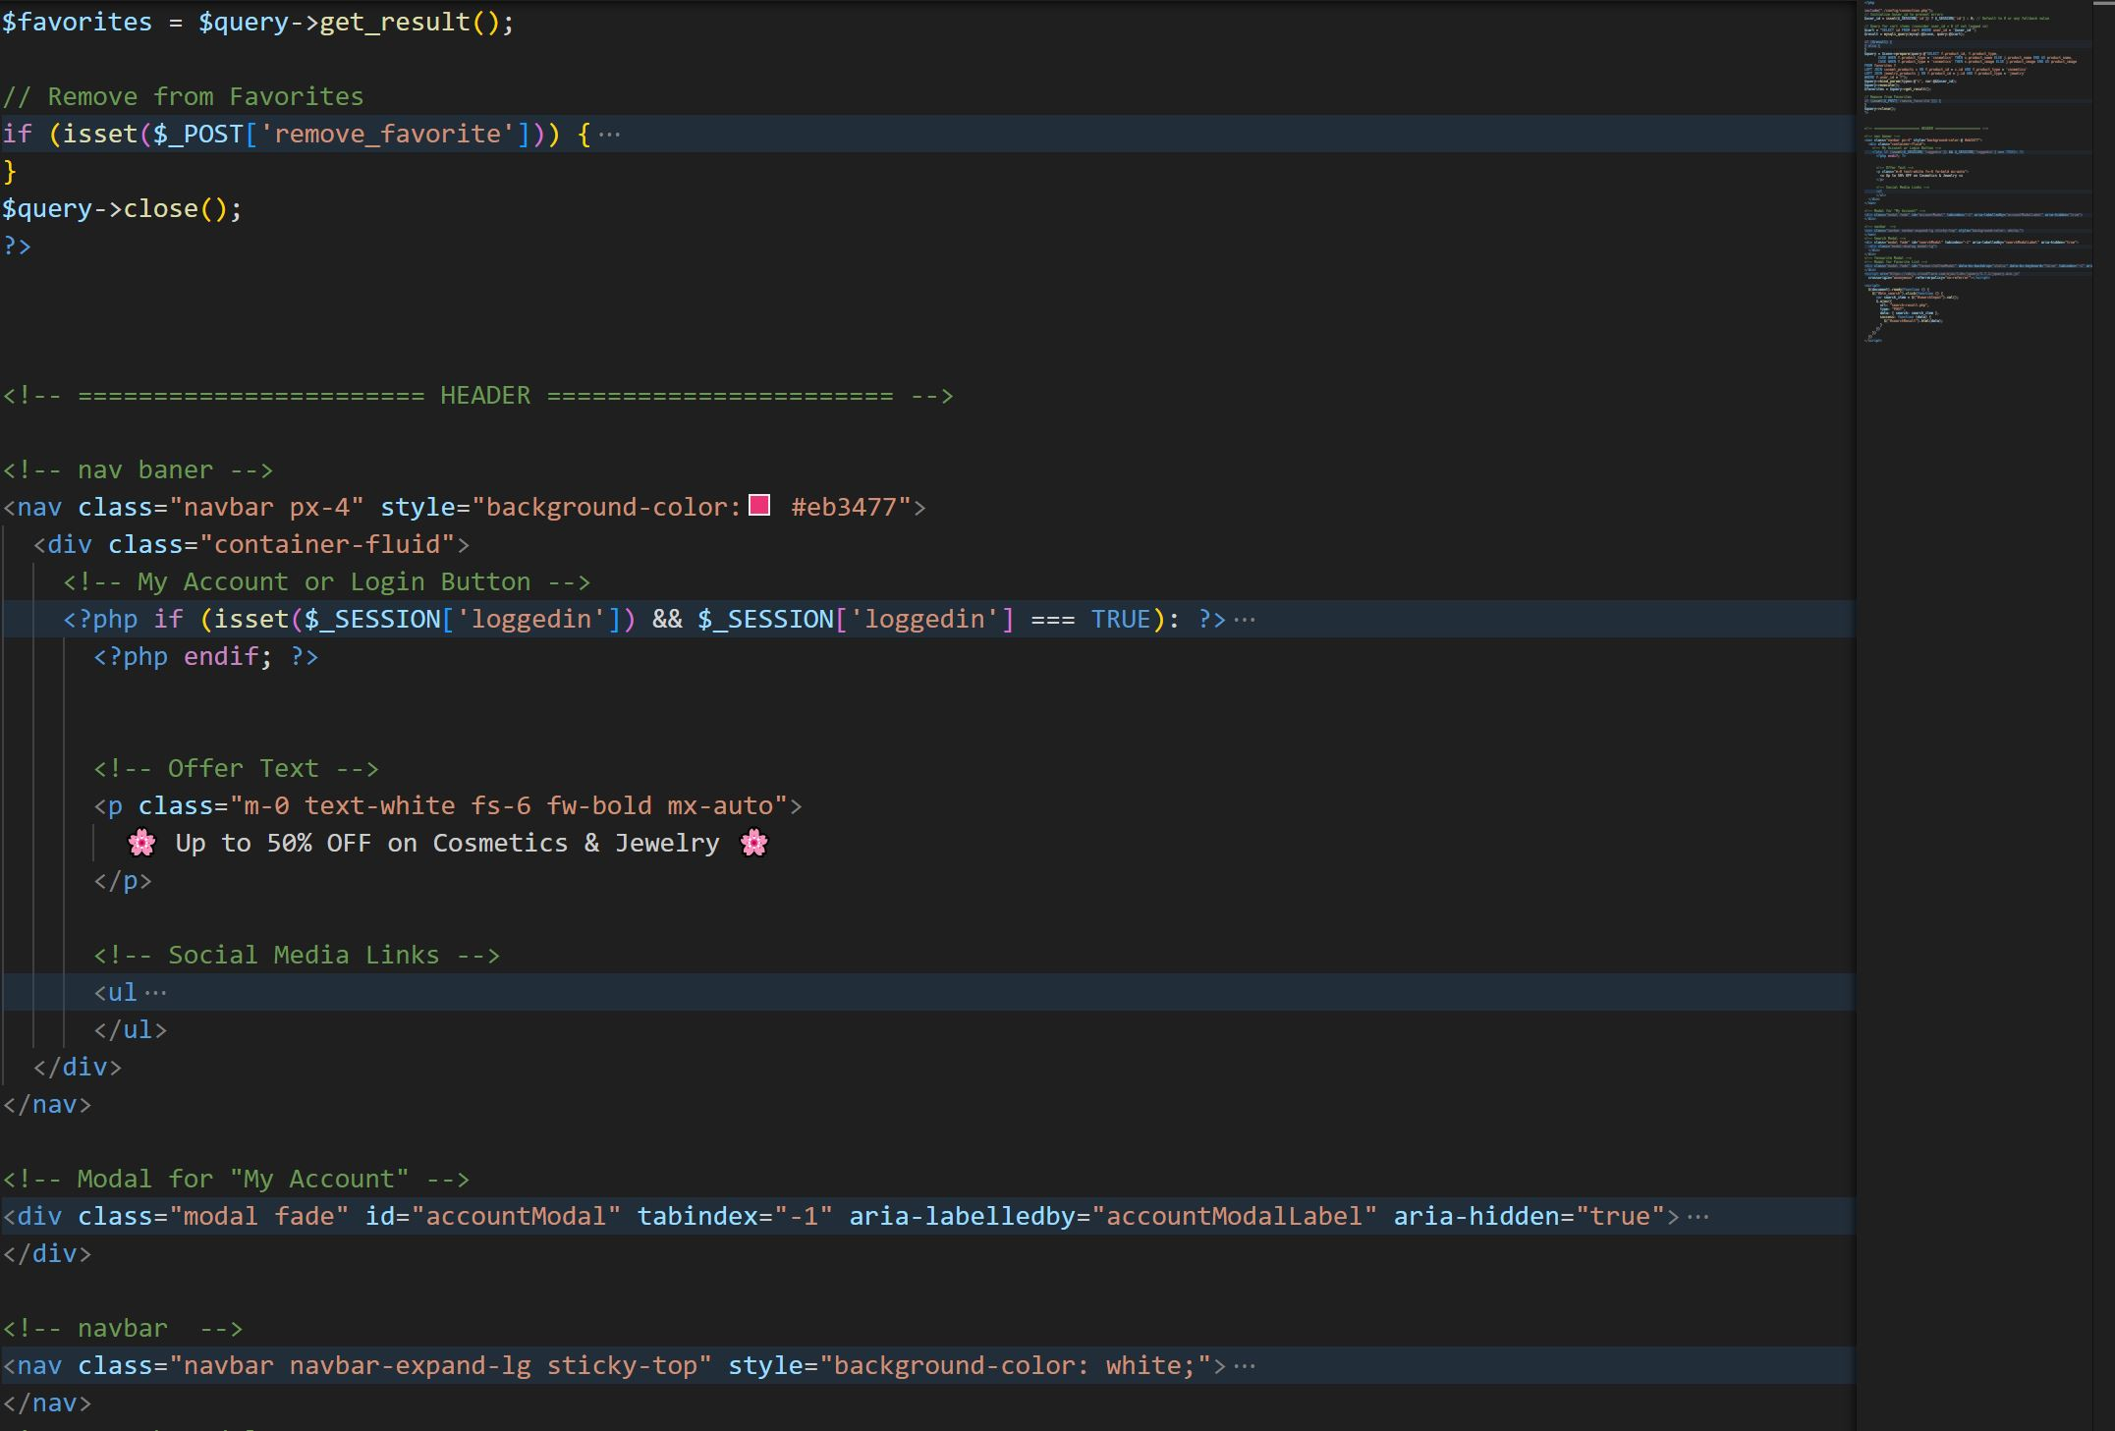

**MAIN PAGE**

The **Index (Main) Page** serves as the homepage of the website, providing users with an engaging and seamless shopping experience. It features a visually appealing **banner section** showcasing promotional offers and featured products. Below, categorized product sections highlight **cosmetics and imitation jewelry**, allowing users to explore the latest arrivals and bestsellers. A **search bar** enables quick product searches, while featured **discounts and deals** attract customer interest. The page also includes a **testimonial section** to build trust and a **footer with contact details, social media links, and policies**. Overall, the main page is designed for easy navigation, product discovery, and user engagement.



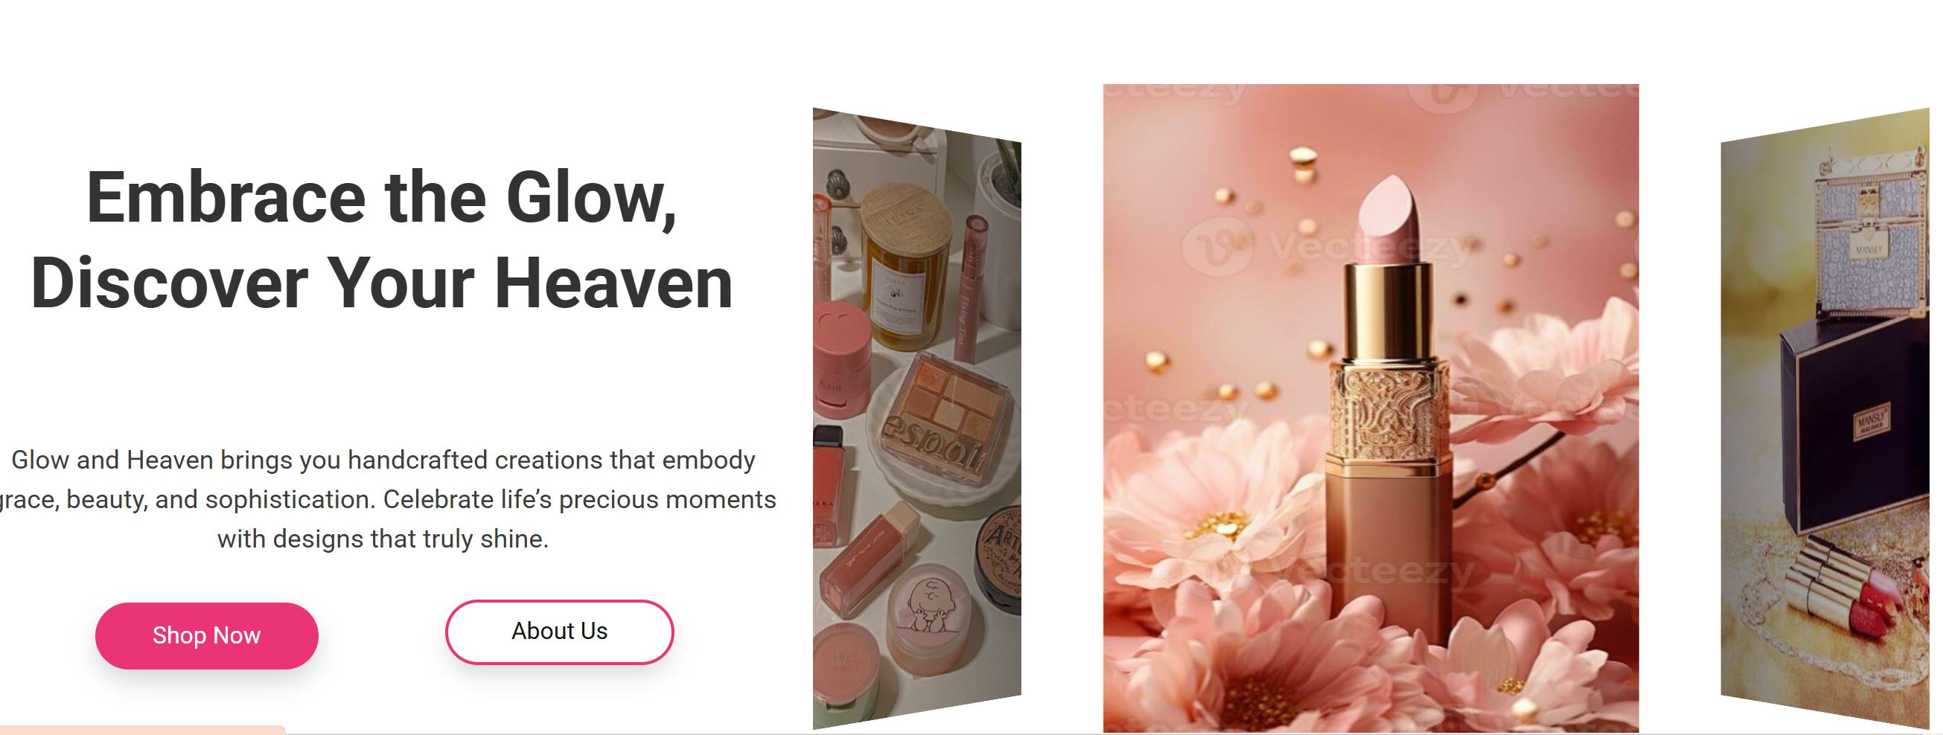

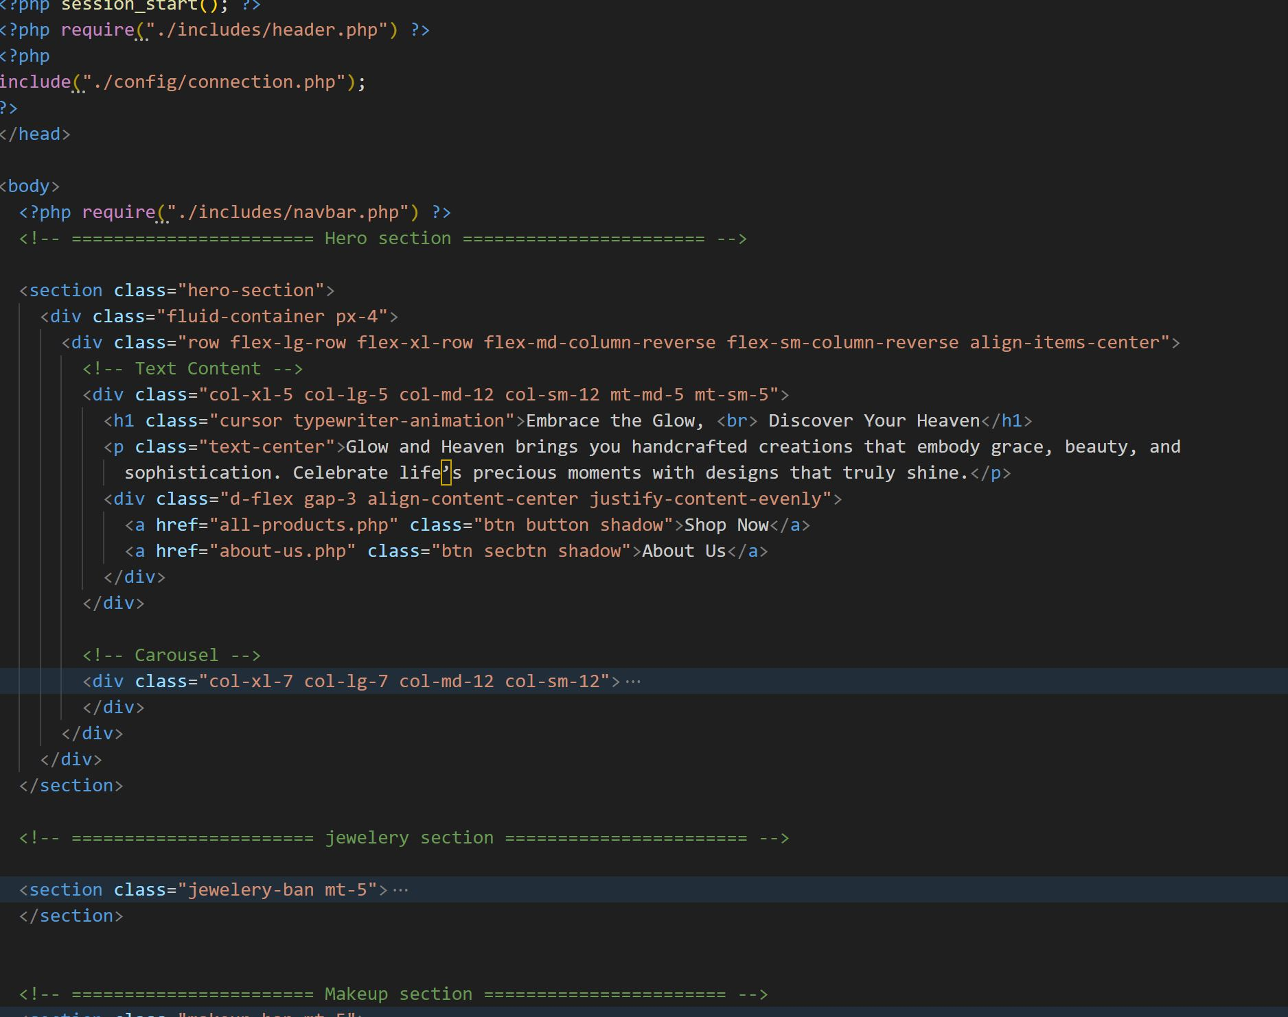



**ALL PRODUCTS**

The **All Products Page** displays a comprehensive collection of **cosmetics and imitation jewelry**, allowing users to browse the entire product catalog. Products are organized into categories with a **sidebar filtration system**, enabling users to refine their search by category, price range, and other relevant filters. Each product is showcased with a **high-quality image, name, price, and an "Add to Cart" button**, making it easy for users to shop. A **search bar** allows direct product searches, while a **wishlist option** lets users save favorite items for later. The page ensures a smooth shopping experience by providing clear product details and easy navigation.

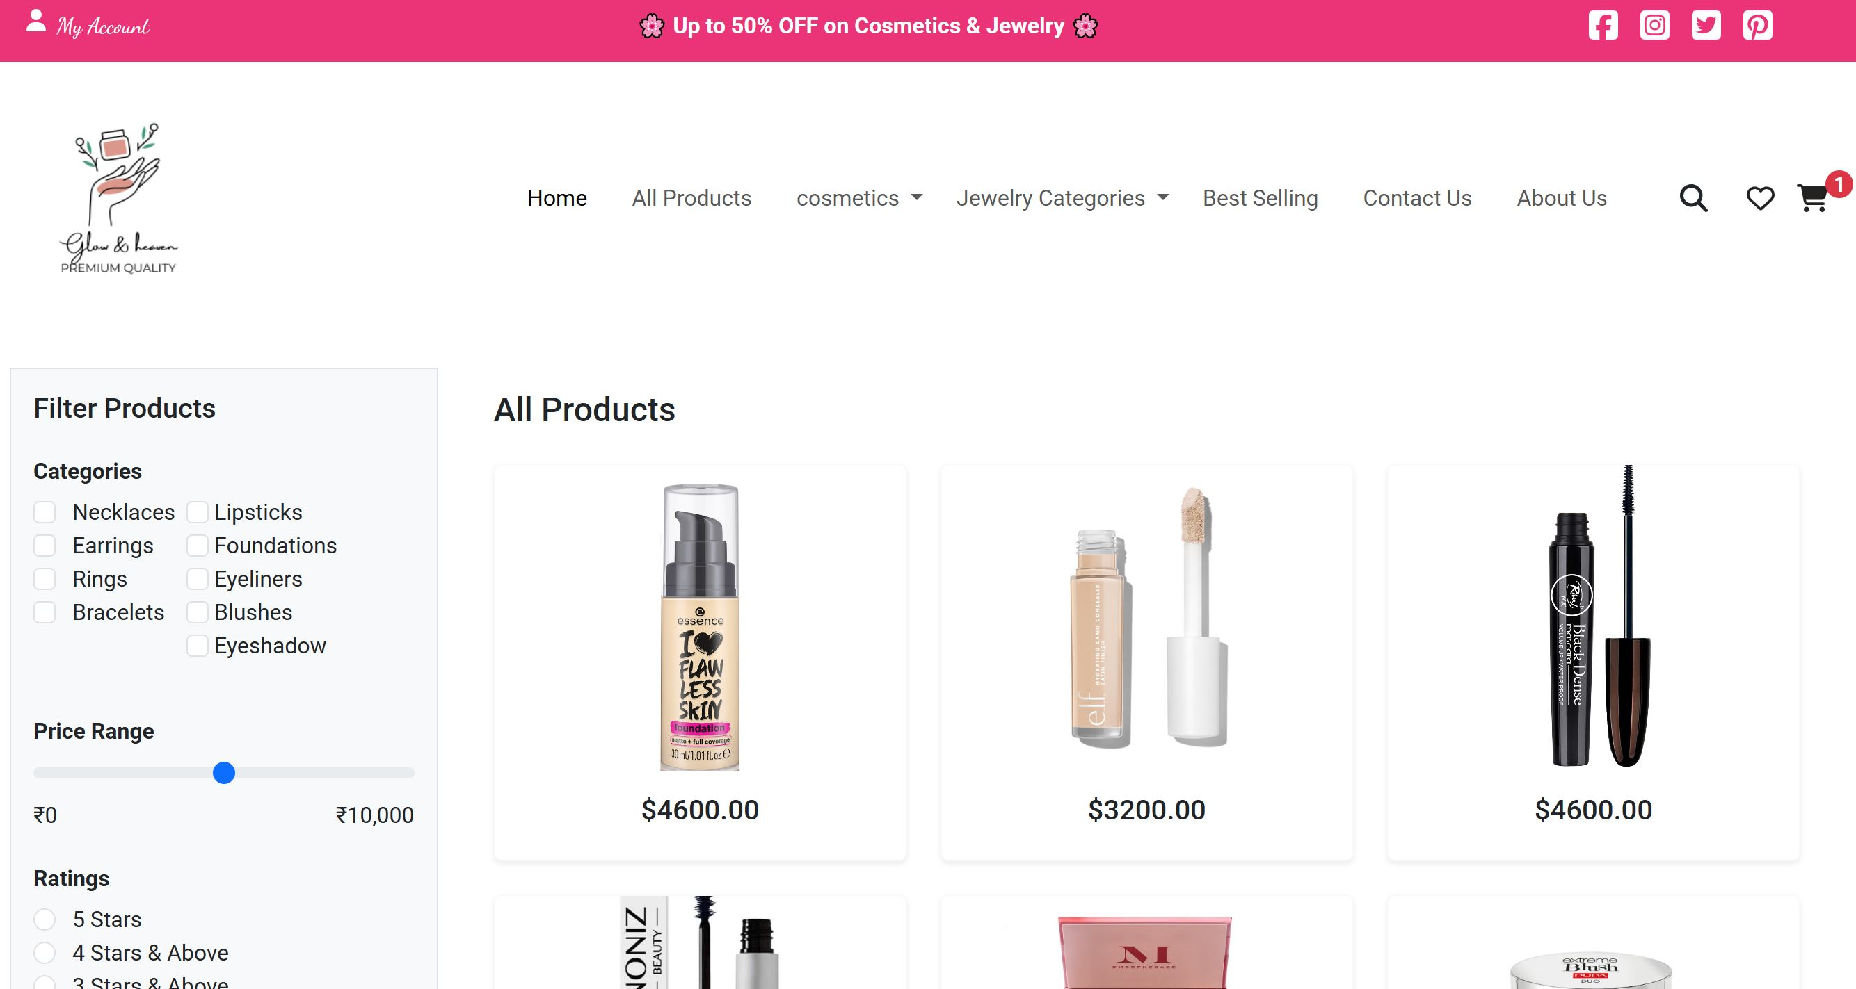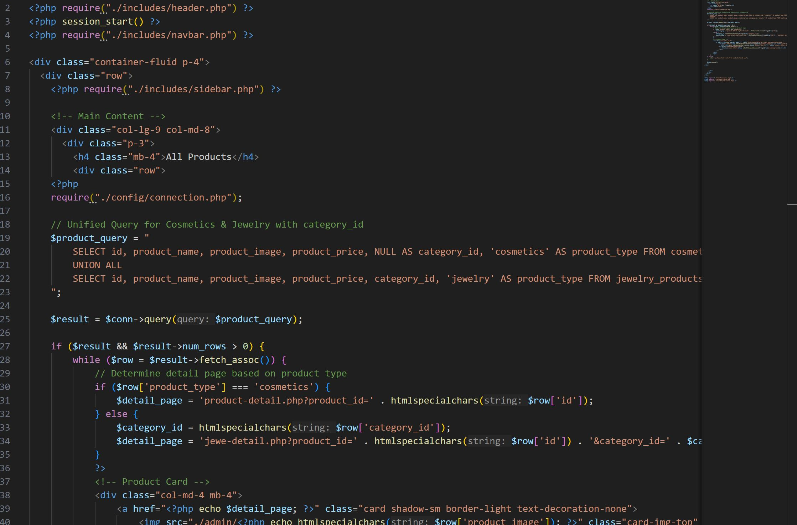



**BEST PRODUCTS**

The **Best Products Page** highlights the **top-rated and most popular** cosmetics and imitation jewelry based on customer purchases and reviews. This section showcases the **best-selling and highly-rated** items to help users discover trending products. Each product is displayed with a **high-quality image, name, price, rating, and an "Add to Cart" button** for quick shopping. Users can also view customer reviews to make informed purchasing decisions. A **wishlist feature** allows users to save their favorite bestsellers, while a **filtering system** helps them sort products by category, price, and ratings. This page enhances the shopping experience by featuring the most in-demand items.

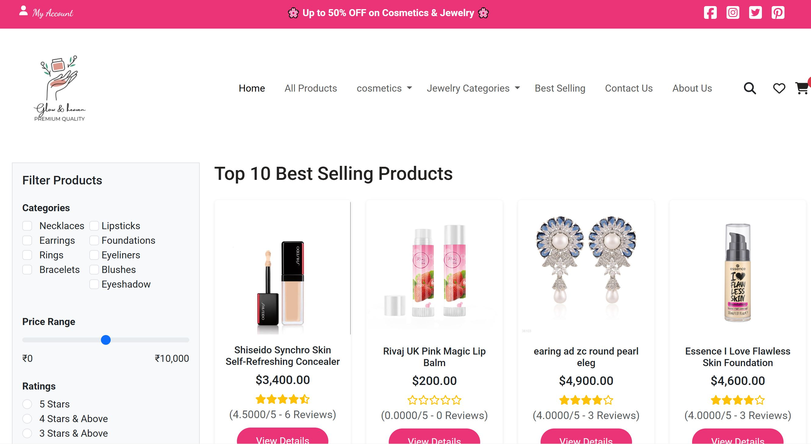

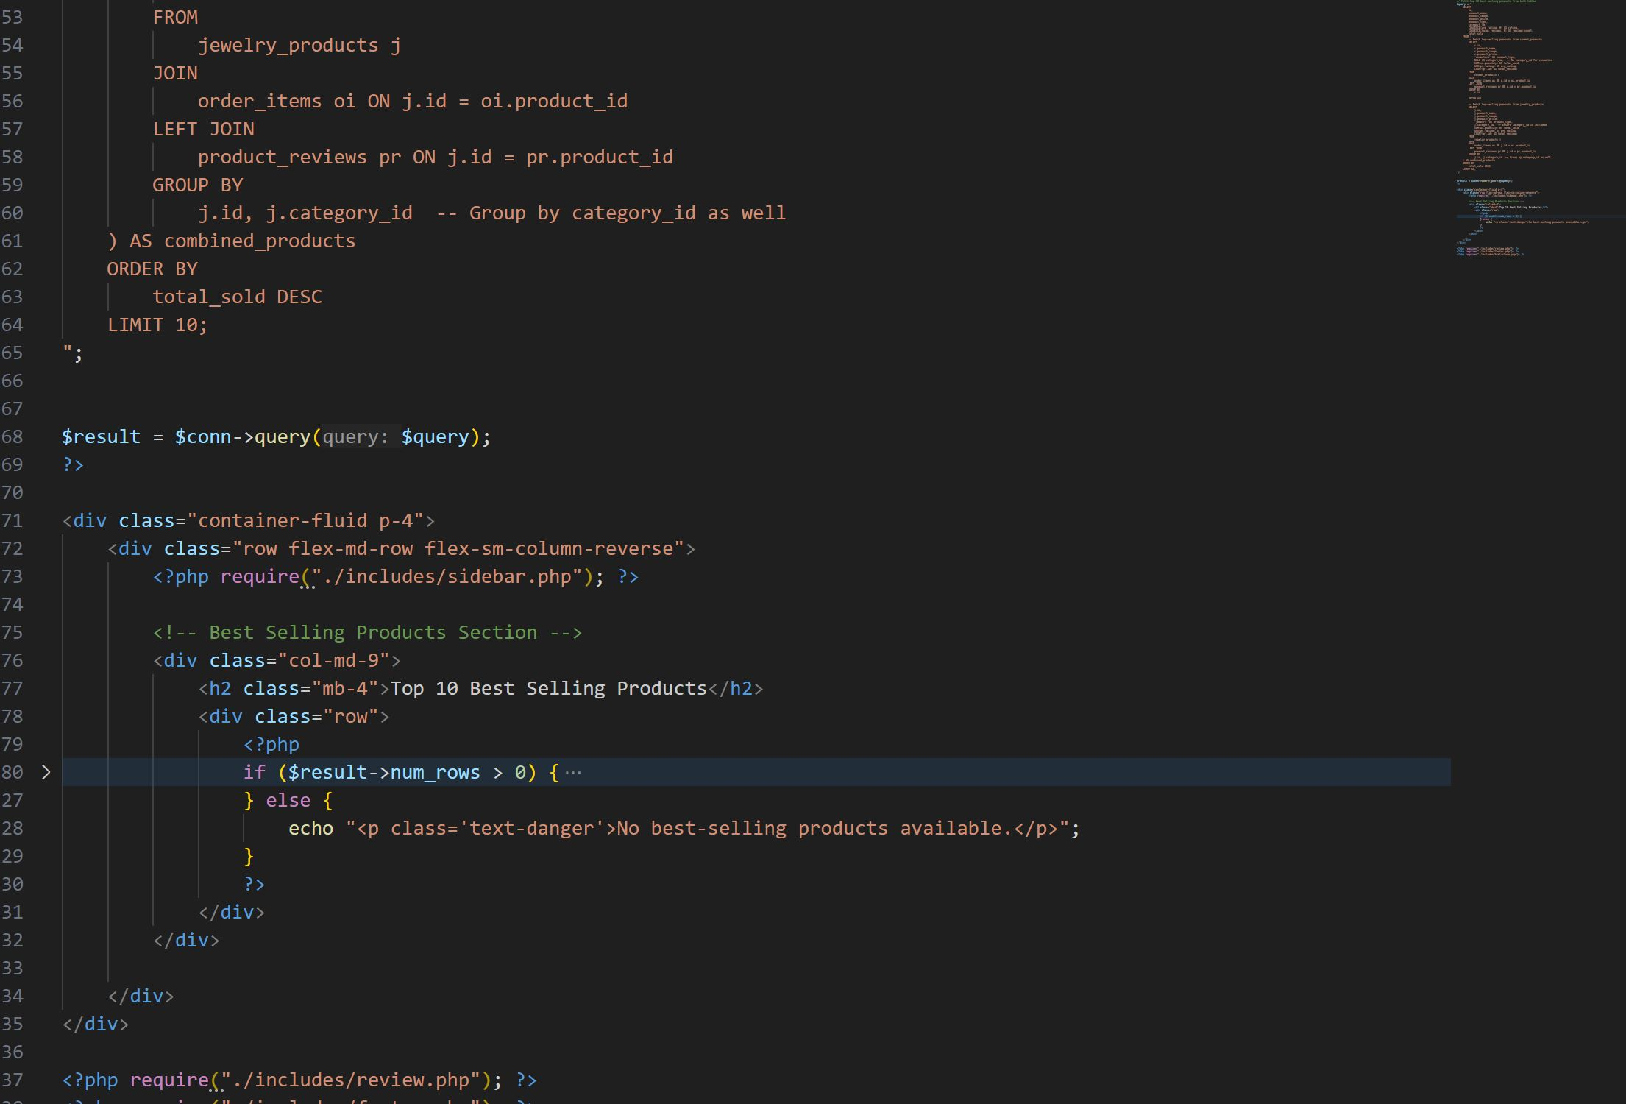



**CART**

The **Cart Page** provides users with a clear overview of the products they have added for purchase. Each item in the cart is displayed with a **product image, name, price, quantity selector, and a remove option**. Users can update the quantity of each product, and the cart dynamically updates the total price. A **checkout button** allows users to proceed with their purchase. Additionally, a **"Continue Shopping" link** redirects users back to browse more products. The cart ensures a smooth purchasing process by providing easy modifications and a clear breakdown of the order summary.

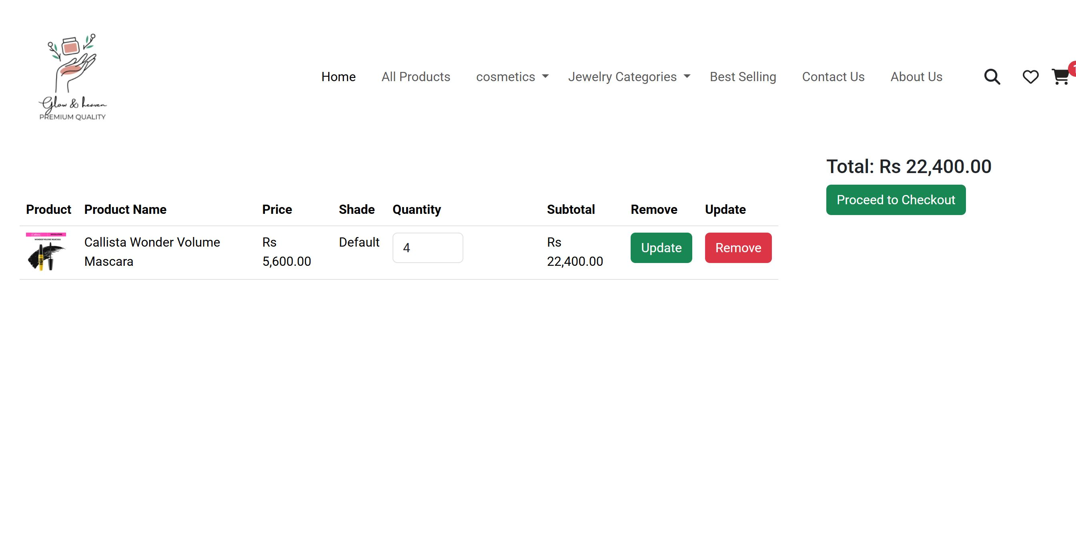

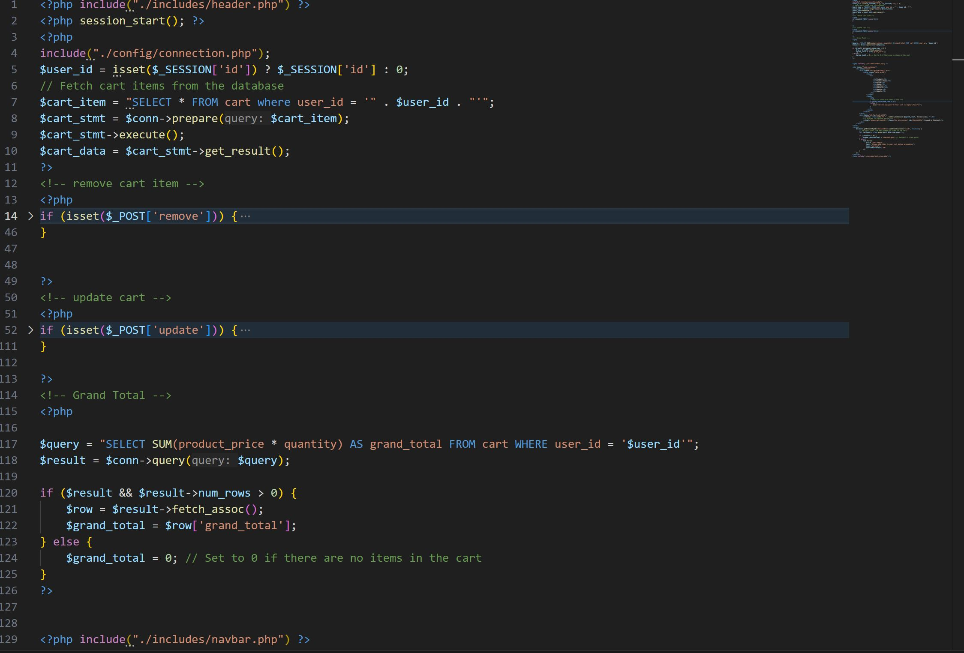



**SEARCH**

The **Search Page** allows users to quickly find products by entering keywords into the search bar. It displays **relevant results** based on the product name, category, or description. Each matching product is shown with a **thumbnail image, name, price, and an "Add to Cart" button** for quick purchase. If no results are found, a **"No products found" message** is displayed with suggestions to refine the search. The page ensures a seamless shopping experience by helping users efficiently locate their desired cosmetics or imitation jewelry products.

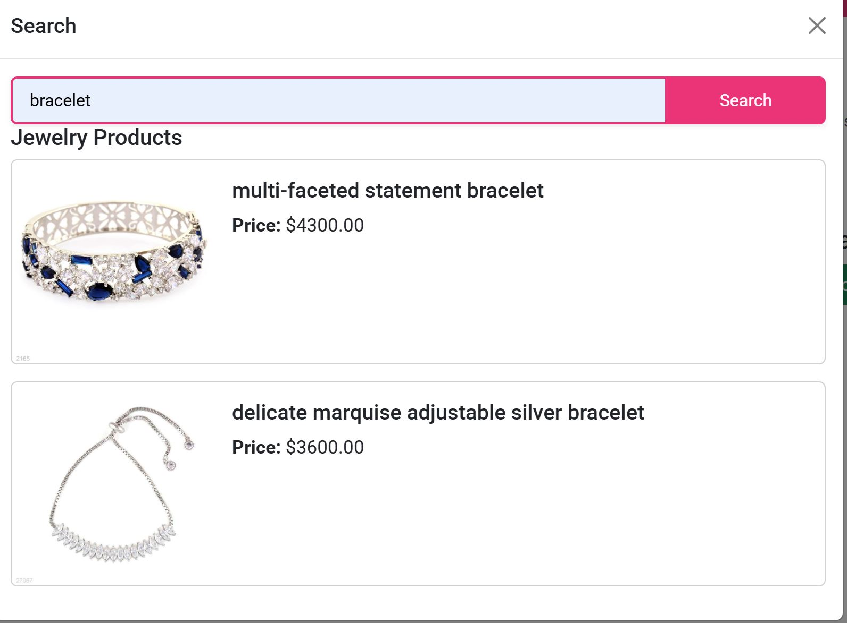

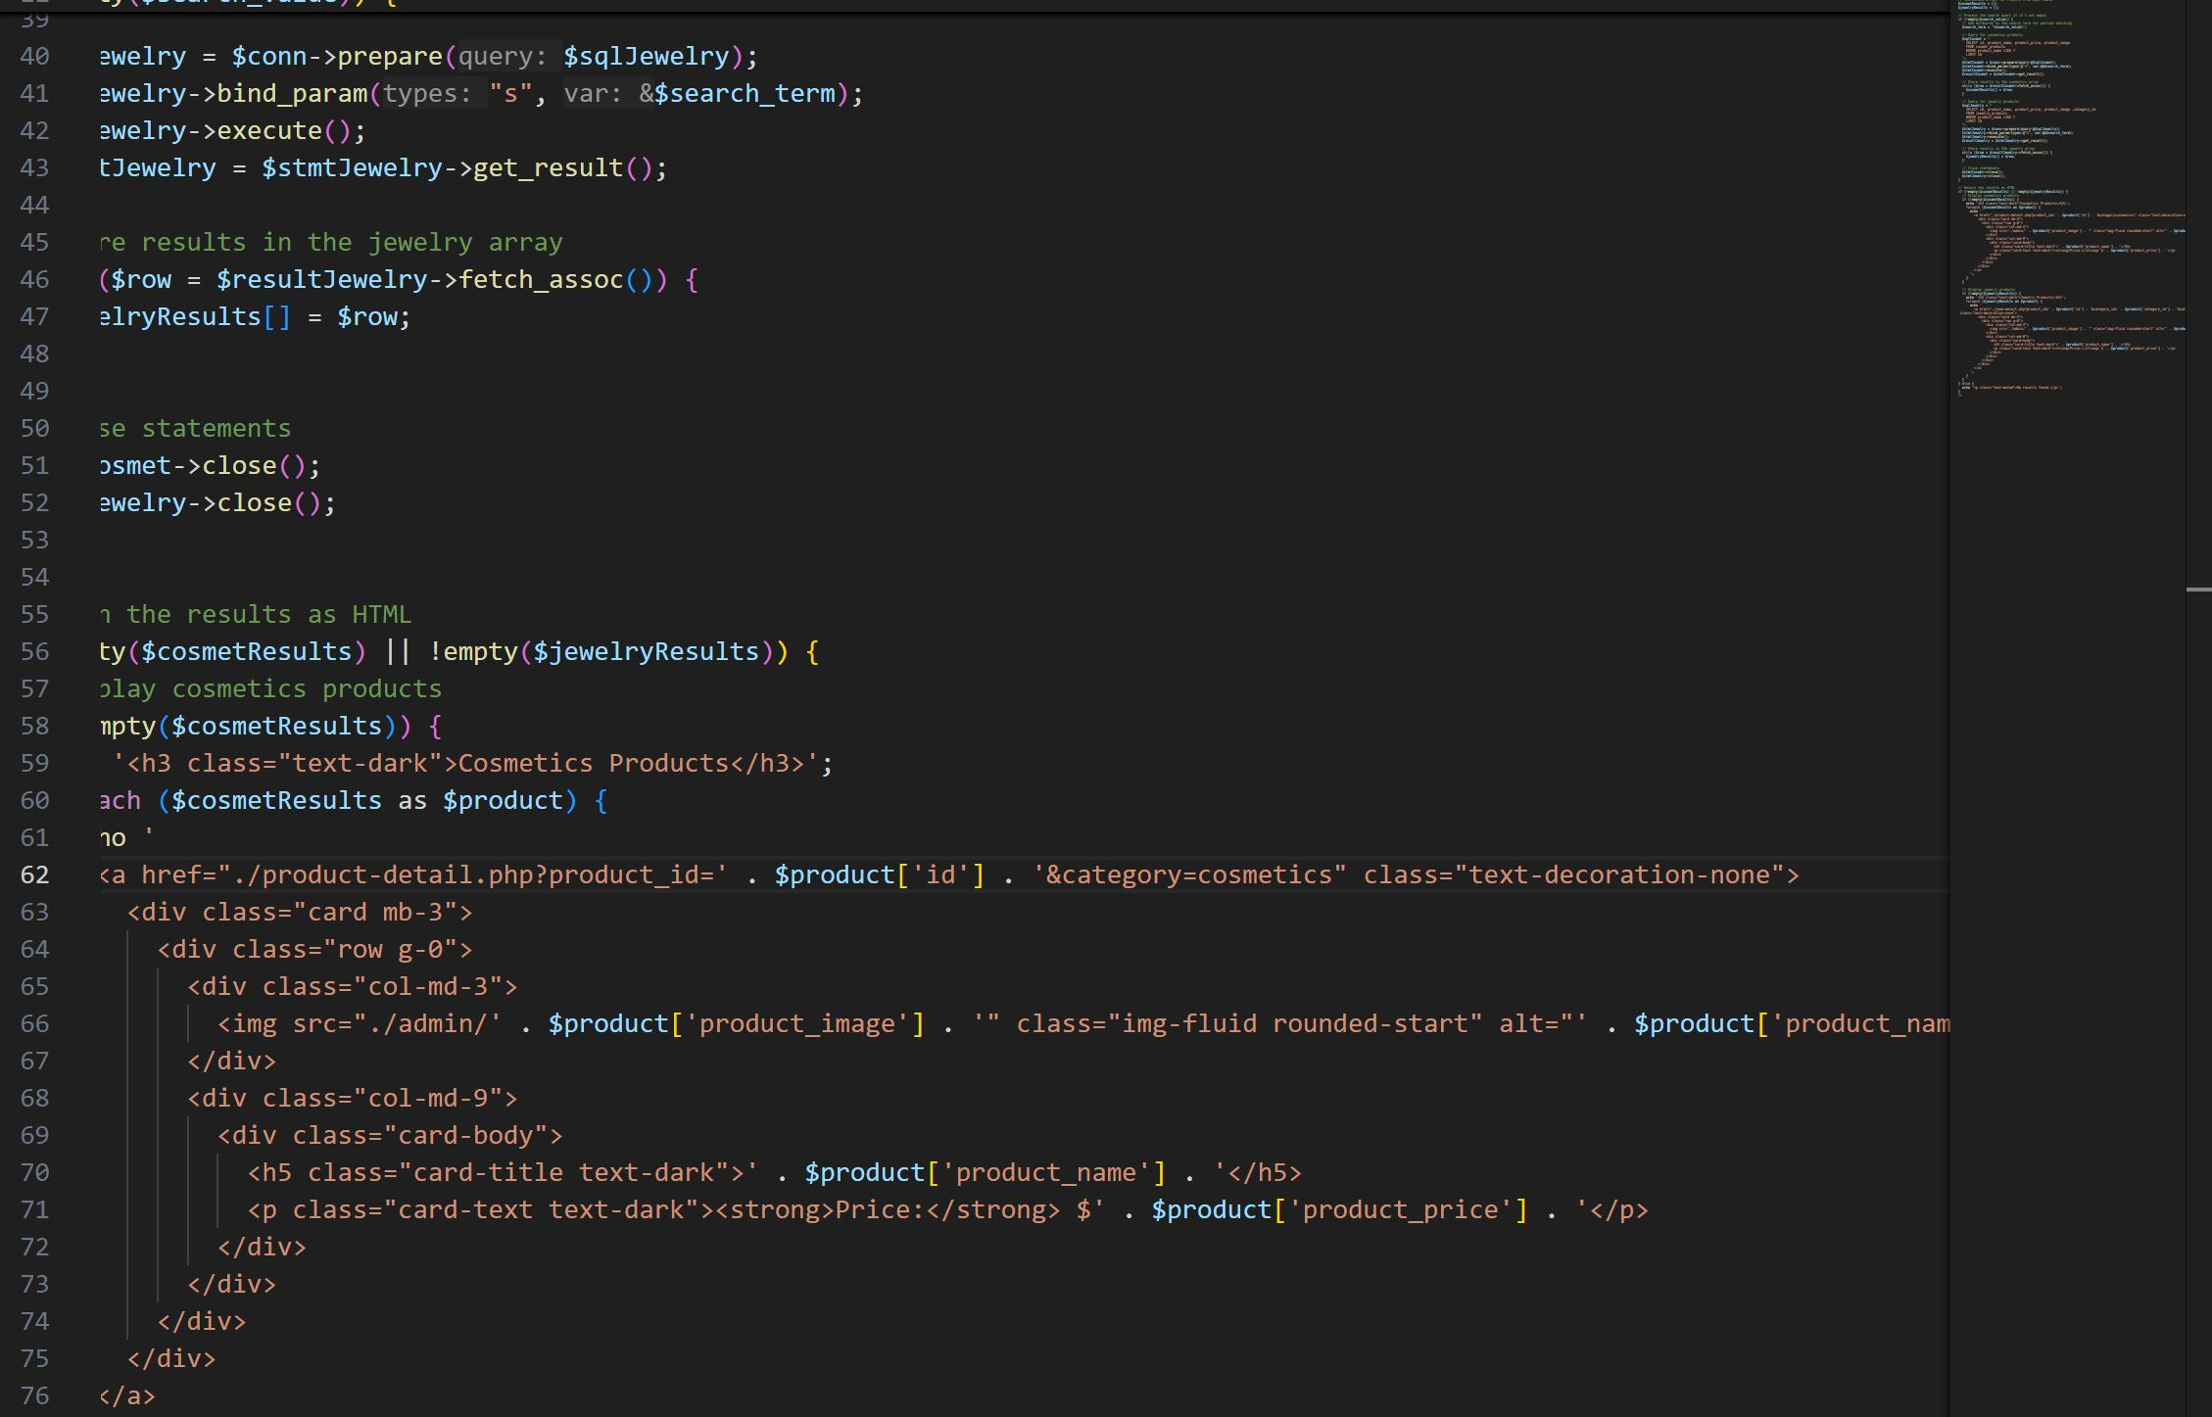



**Detail Products**

The **Product Detail Page** provides a comprehensive view of a selected product, helping users make informed purchase decisions. It displays a **high-quality product image, name, price, description, and available stock**. Users can select the desired **quantity** and add the item to their **cart or wishlist**. A **reviews section** shows customer ratings and feedback, enhancing trust in the product. Additionally, related or similar products are suggested to encourage further browsing. The page ensures a smooth shopping experience by offering all necessary details in a well-structured and visually appealing layout.

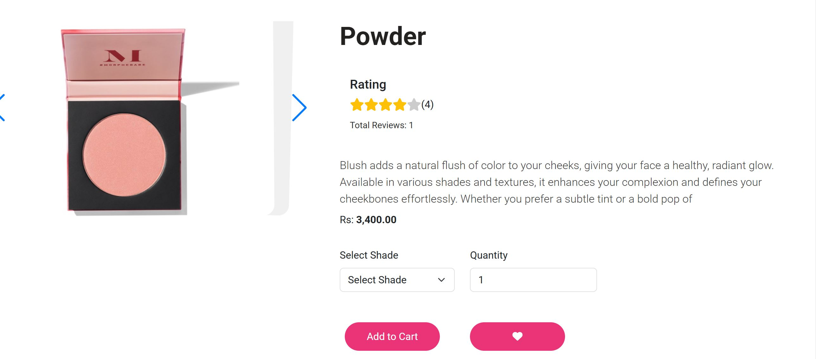

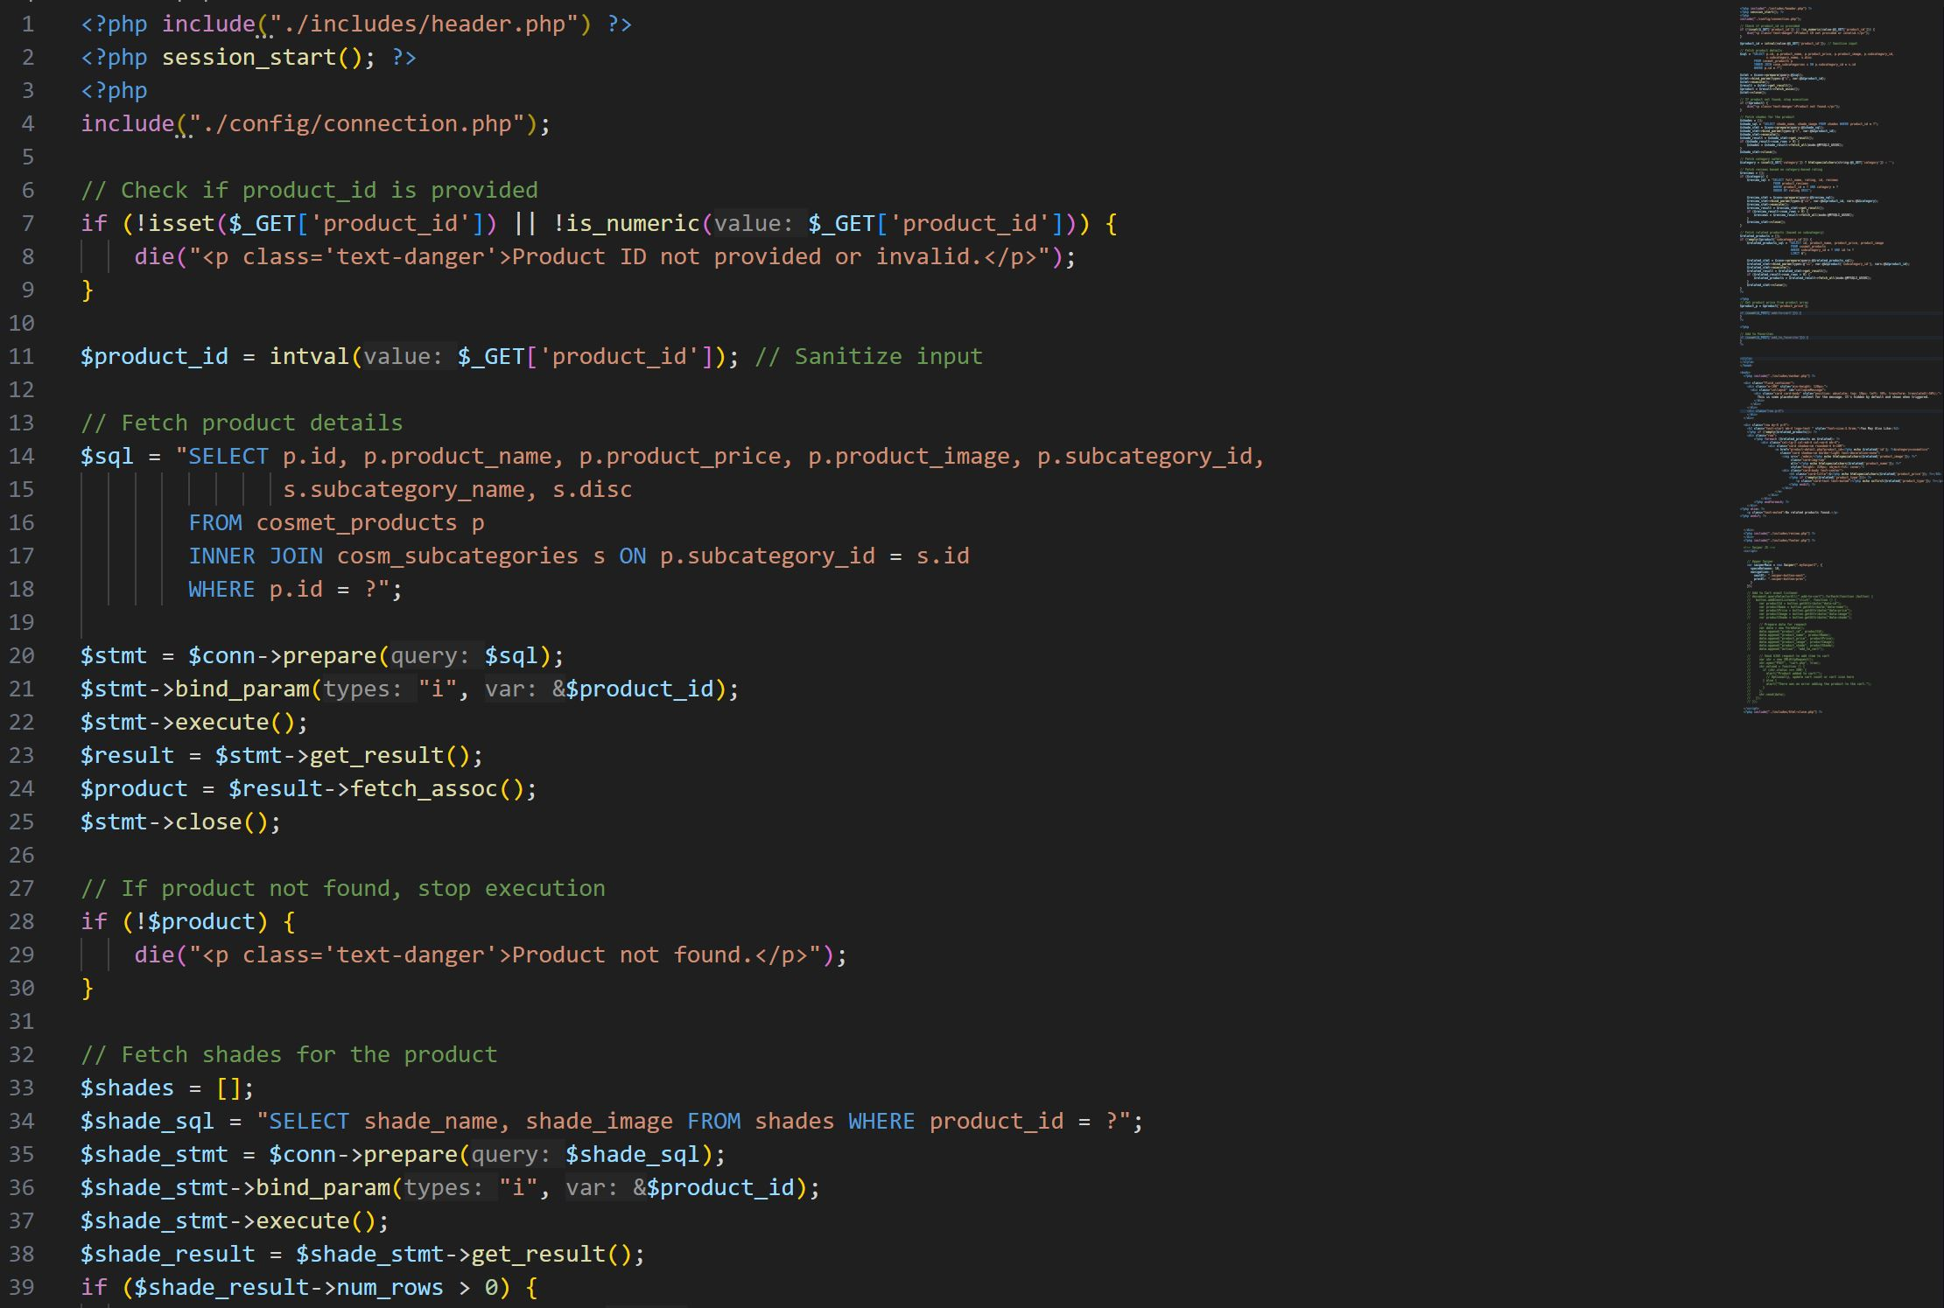



USER INTERACTION PAGES

**ADMIN PANEL**

The **Admin Page** serves as the control panel for managing the website’s products, categories, and customer orders. Administrators can **add, update, or delete products and categories**, ensuring the catalog stays up to date. The page also provides features to **view and manage customer orders, update order statuses, and generate reports** on the **top 10 best-selling products and top 10 most active customers**. Additionally, the admin can perform **database maintenance and backups** to ensure data security. With a user-friendly interface, the Admin Page enables efficient website management and smooth business operations.

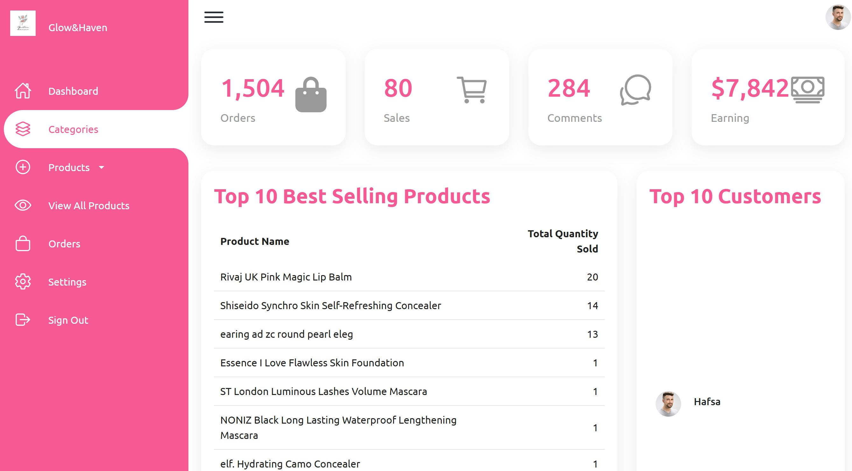



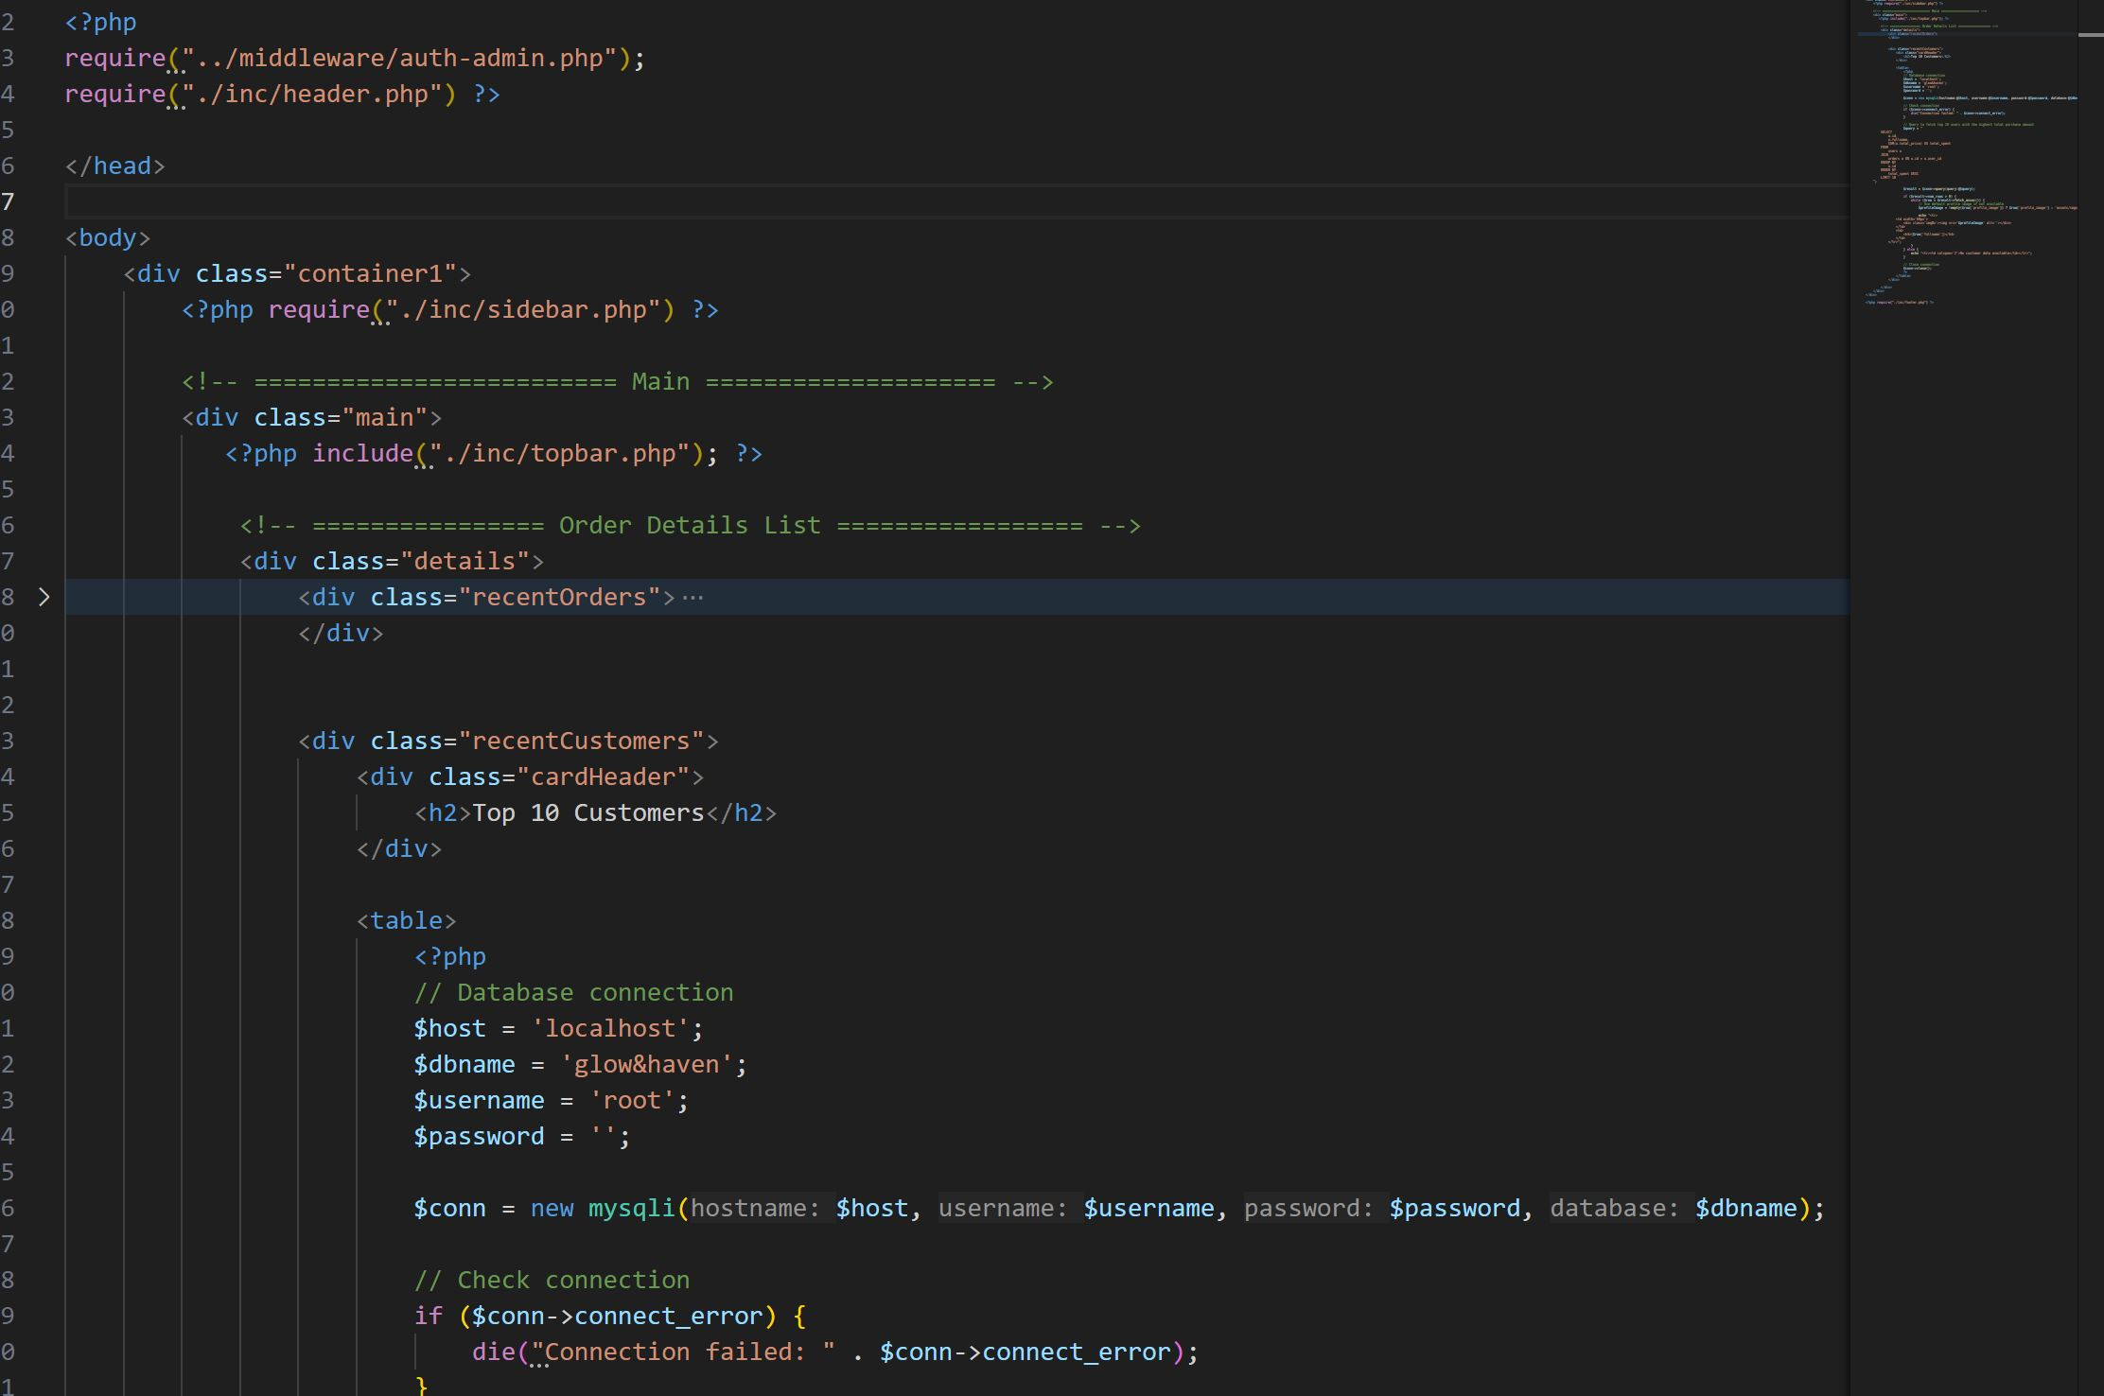

**ADD ITEM TO WEB**

The **Add Item Page** allows the admin to easily add new products to the website. It includes a **form with fields** for entering the **product name, category, price, quantity, description, and uploading a product image**. The admin can select the appropriate **category (Cosmetics or Imitation Jewelry)** to ensure proper organization. Once the details are filled in, clicking the **"Add Product" button** saves the item to the database, making it instantly available on the website. This page ensures seamless product management, allowing the business to keep the catalog updated with new arrivals.



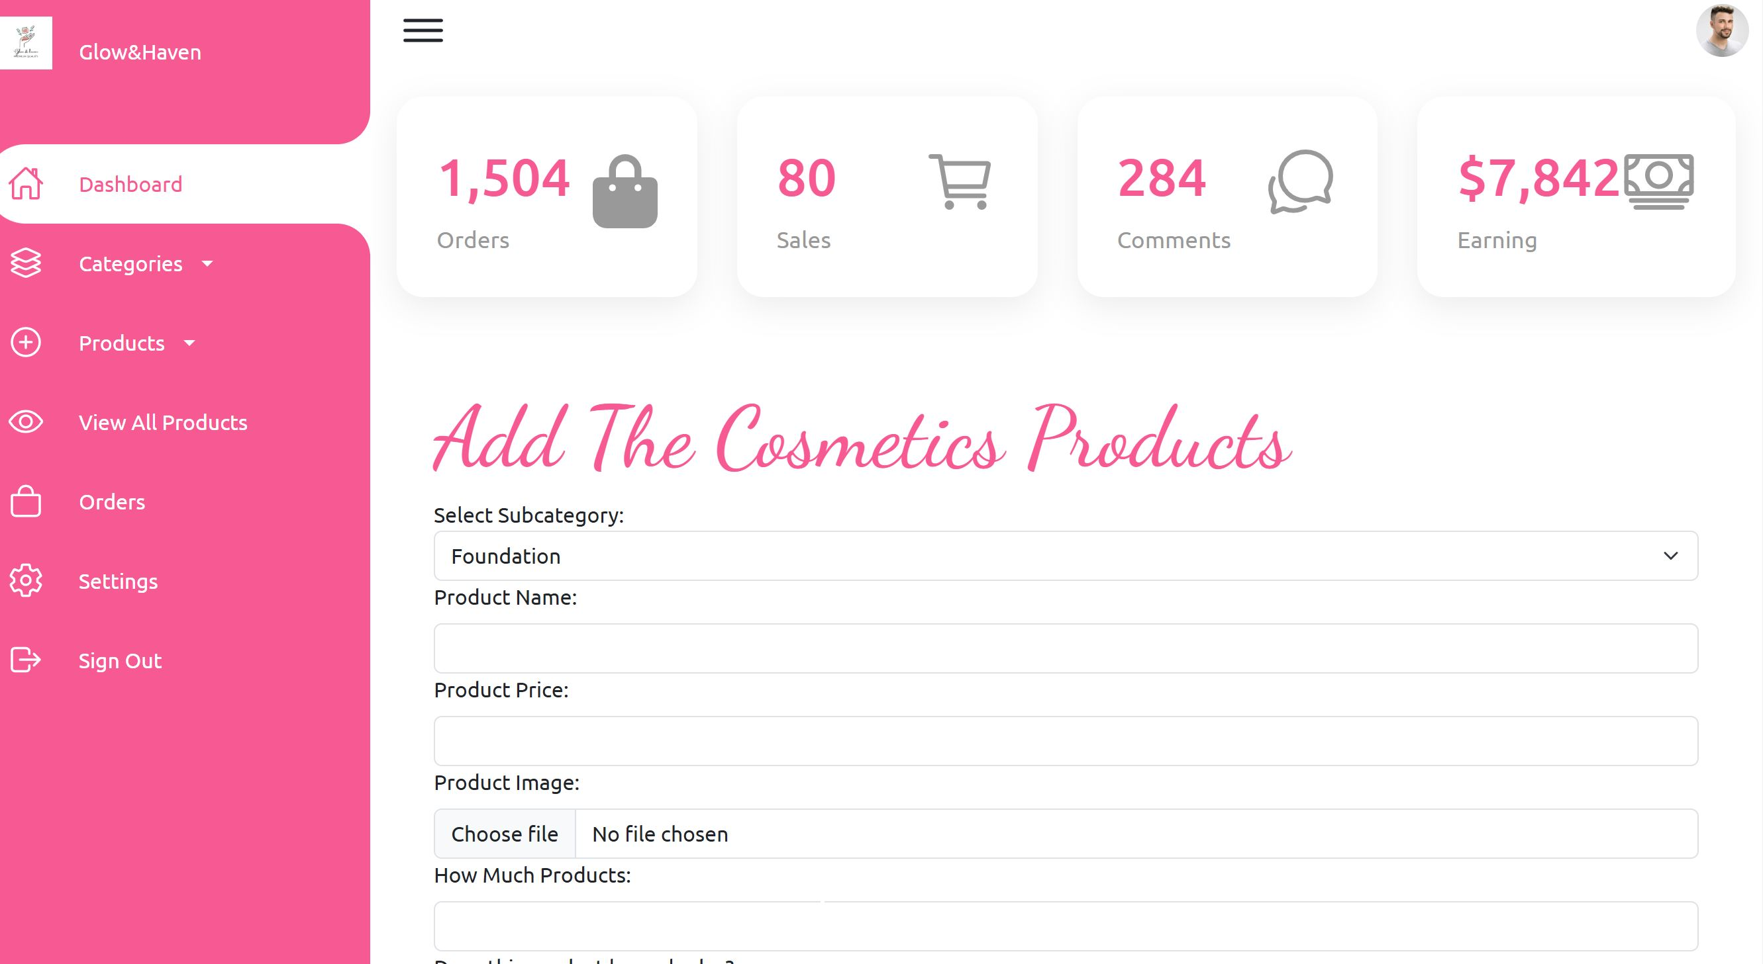





**FOOTER**

The **Footer** is a crucial section at the bottom of the website, providing quick access to important information and links. It is divided into multiple sections, including **Company Information**, **Customer Support**, **Quick Links**, and **Social Media**. The **Company Information** section displays the business name, a short description, and contact details. The **Customer Support** section includes links to FAQs, Return & Refund Policies, and Terms & Conditions. **Quick Links** provide navigation to important pages like Home, Categories, Offers, and Contact Us. Additionally, social media icons link to platforms like **Facebook, Instagram, and WhatsApp**, allowing customers to stay connected. The footer ensures a professional look and enhances user experience by offering essential information in an organized layout.

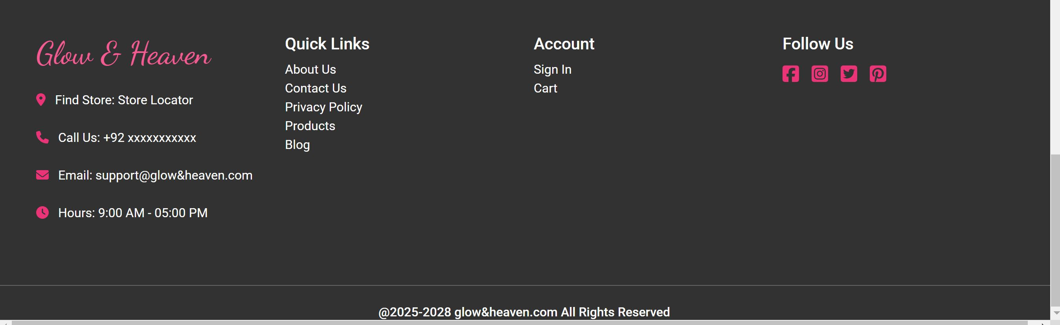

<====THE END====>