Assignment Beta, Question 1
Hafsa Rashid
23K-0064

My parameters
Roll number 23K-0064, so R = 64 and D = (2 + 3 + 0 + 0 + 6 + 4) mod 10 = 15 mod 10 = 5.
Parameter | Formula | Working | Value
Normal daily queries, Q | 1,500 + 25 x R | 1,500 + 25 x 64 | 3,100
LLM calls per query, N | 5 + (R mod 4) | 5 + 0 | 5
Tool failure probability, p | 0.04 + 0.01 x D | 0.04 + 0.05 | 0.09
Heatwave days per month, H | 4 + (R mod 4) | 4 + 0 | 4
Monthly budget, B | 1,200 + 10 x R | 1,200 + 640 | $1,840
Latency target, T | 10 - (R mod 3) | 10 - 1 | 9 s

Short answer for the technical lead
With our traffic (142,600 queries a month, 2.73 billion input tokens) the budget of $1,840 rules out every frontier model I priced: GPT-6.1 Terra, Gemini 3.8 Flash, Claude Sonnet 5.5 and Grok 4.7 all land between $3,160 and $8,676 a month even with caching. The cheap tier fits easily, and the main constraint is latency rather than cost. No model meets 9 s with the five step sequential loop, because five sequential model calls plus four tool calls add too much waiting time.
The recommended option is to pay per token for DeepSeek V4.1 Flash (about $846.37 a month with caching) and change the agent so one planning call fires all independent tools in parallel. That brings it to about 6.7 s. Self hosting gpt-oss-120b on one H100 costs $1,936.80 a month and only becomes cheaper above about 7,100 normal queries a day, which is 2.3 times our current volume.

Section 1: Model comparison
I picked 7 closed models from 4 providers (OpenAI, Anthropic, Google, xAI) and 6 open weight models from 6 providers (DeepSeek, Alibaba, Z.ai, Mistral, OpenAI, Google). I focused on the cheaper and faster tier of each family, because a WhatsApp bot with 3,100 queries a day and a $1,840 budget cannot support flagship models on cost alone, and I included Sonnet 5.5, Terra and Grok 4.7 as higher cost reference points. All figures were accessed on 8 November 2026.
How to read the table: prices are USD per 1M tokens as input / output / cached input. TTFT is in seconds and speed in output tokens per second, both from Artificial Analysis (AA) on the model's own API. A star (*) means the value is time to first answer token, so it includes thinking at the lowest setting. Benchmark 1 is the AA Intelligence Index for the exact setting I run. Benchmark 2 is the tool use benchmark. Rate limits are for a new paid account.

Table 1: Closed and open weight models (accessed 8 November 2026)
Model  setting used | Parameters | Context / max output | Price in / out / cached  provider | Rate limit (new paid tier) | TTFT / speed | AA Intelligence Index | Tool use benchmark | Native tools / JSON  reasoning settings | Licence / commercial self host | Sources
GPT-6 Luna  none | Not disclosed | 1.05M / 128K | $0.10 / $0.50 / $0.01  OpenAI | 5,000 RPM, 2M TPM (see note) | 1.03 s / 86 | 9 | AutomationBench-AA 48% (high) | Yes / Yes  none, low...max | Proprietary / No | S1, S2, S3, S4
GPT-6.1 Terra  none | Not disclosed | 1.1M / 128K | $1.00 / $5.00 / $0.05  OpenAI | 5,000 RPM, 2M TPM (see note) | 1.75 s / 90.7 | 31 | Terminal-Bench 4.0 50.3% (vendor) | Yes / Yes  none, low...max | Proprietary / No | S1, S3, S5, S6
Claude Haiku 5.5  effort low | Not disclosed | 1M / 128K | $0.10 / $0.50 / $0.01  Anthropic | 1,000 RPM, 500K ITPM | 7.98 s* / 137.8 | 19 | AutomationBench-AA 29% (medium); Terminal-Bench 4.0 39.2% | Yes / Yes  low...max (adaptive thinking) | Proprietary / No | S7, S3, S8, S9, S10
Claude Sonnet 5.5  effort low | Not disclosed | 1M / not verified | $2.00 / $10.00 / $0.10  Anthropic | 1,000 RPM, 500K ITPM | 3.28 s* / 109.6 | 26 | Terminal-Bench 4.0 70.6% (vendor) | Yes / Yes  low...max (adaptive thinking) | Proprietary / No | S7, S3, S11, S6, S10
Gemini 3.8 Flash  thinking low | Not disclosed | 1M / not found | $0.75 / $3.75 / $0.075  Google (price until 31 Dec 2026) | 1,000 RPM, 2M TPM (Tier 1) | 2.60 s* / 265.3 | 23 | AutomationBench-AA 50.7%; Terminal-Bench 2.1 90.8% (vendor) | Yes / Yes  low, medium, high | Proprietary / No | S12, S3, S13, S14, S15
Gemini 3.5 Flash-Lite  lowest thinking | Not disclosed | 1M / not found | $0.30 / $2.50 / $0.03  Google | 4,000 RPM, 4M TPM (Tier 1) | 4.46 s* / 161 | 12 | AutomationBench-AA 32.7%; Terminal-Bench 2.1 54.0% (vendor) | Yes / Yes  thinking levels | Proprietary / No | S16, S3, S17, S18, S15
Grok 4.7  reasoning low | Not disclosed | 500K / not published | $2.00 / $6.00 / $0.50  xAI | 150 RPS, 50M TPM (Tier 0) | 9.65 s* / 78 | 31 | AutomationBench-AA 57% (low) | Yes / Yes  low...xhigh | Proprietary / No | S19, S3, S20, S21
DeepSeek V4.1 Flash  non thinking | 552B total / 16B active | 1M / 384K | $0.30 / $1.20 / $0.006  DeepSeek API | Not published (dynamic) | 1.33 s / 269.4 | 19 | AutomationBench-AA 68.9% (max effort) | Yes / Yes  non thinking, thinking up to max | MIT / Yes | S22, S3, S23, S24
Qwen3.8 27B  non thinking | 27B dense | 256K / not found | $0.50 / $3.00 / $0.10  Alibaba Cloud | Not published | 5.30 s / 41 | 10 | AutomationBench-AA 12% (non reasoning) | Yes / Yes  non thinking, low...xhigh | Apache 2.0 / Yes | S25, S26
GLM-5.3-Flash  thinking off | 320B total / 18B active | 1M / not found | $0.15 / $0.50 / $0.03  Z.ai API | Not published | 3.53 s / 56 | 28 | AutomationBench-AA 60%; Terminal-Bench 4.0 33% | Yes / Yes  thinking on or off | MIT / Yes | S27, S28
Mistral Small 4  reasoning off | 119B total / 6.5B active | 256K / 256K | $0.15 / $0.60 / $0.015  Mistral API | Not published | 1.77 s / 127 | 4 | AutomationBench-AA 1.0% | Yes / Yes  reasoning_effort none or high | Apache 2.0 / Yes | S29, S30
gpt-oss-120b  reasoning low | 117B total / 5.1B active | 131K / 131K | $0.03 / $0.17 / none  CoreWeave | Not published | 1.32 s (2.42 s*) / 158 | 12 (high, older index) | AutomationBench-AA 0.2% (high) | Yes / Yes  low, medium, high | Apache 2.0 / Yes | S29, S31, S32
Gemma 4 31B  thinking off | 30.7B dense | 256K / not found | $0.13 / $0.38 / none  DeepInfra (FP8) | Not published | 4.04 s / 52 | 22 (older index) | tau2-bench avg 76.9% (vendor, thinking on) | Yes / Yes  thinking on or off | Apache 2.0 / Yes | S33, S34, S35
Note on rate limits for GPT-6 Luna and GPT-6.1 Terra: value taken from the GPT-5.6 Luna page as a stand in, see the paragraph below the table.

Two values I could not verify. First, the rate limits for the GPT-6 family. OpenAI's GPT-6 Luna page lists the limits but the text I could read did not show the numbers, so I used the GPT-5.6 Luna Build tier (5,000 RPM, 2M TPM) as a stand in. If the real new account limit is lower, the 242 RPM and roughly 0.96M TPM we need at the heatwave peak might not fit, which would push us to a higher tier or a second provider. Second, the tool use score of DeepSeek V4.1 Flash in non thinking mode. AA only publishes AutomationBench-AA for its max effort setting (68.9%), and I run it with thinking off for speed. This matters because DeepSeek is the model recommended in this report. I treat 68.9% as an upper bound, and the real test before launch has to be our own small eval set of Urdu, Roman Urdu and English questions.
Other things to be careful about. AA was moving from Intelligence Index v4.3 to v5 while I collected data, so some models show different index numbers on different AA pages (for example Qwen3.8 27B non reasoning shows 20 on a comparison page and 10 on its own page). I always used the value on the model's current page or the live leaderboard, and marked the two that only had an older value. Reasoning token counts for the models that still think at their lowest setting are my own estimate from AA timing data, explained in Section 2. For DeepSeek, one source counts 552B parameters and another 763B because it includes the speculative decoding and vision parts, so I used AA's 552B.

Section 2: Calculations
Every number below comes from my notebook Q1_calculations_23K-0064.ipynb, where each step is printed.

1. Token volume
Input for call k is 2,000 + 800(k - 1). Calls 1 to 4 give 350 output tokens each and call 5 gives 600.
call 1: input 2,000 output 350
call 2: input 2,800 output 350
call 3: input 3,600 output 350
call 4: input 4,400 output 350
call 5: input 5,200 output 600

First attempt: input = 2,000 + 2,800 + 3,600 + 4,400 + 5,200 = 18,000 and output = 4 x 350 + 600 = 2,000.
Retries: each of calls 1 to 4 fails with p = 0.09 and is repeated once with the same input. Expected extra input = 0.09 x (2,000 + 2,800 + 3,600 + 4,400) = 0.09 x 12,800 = 1,152. Expected extra output = 0.09 x 4 x 350 = 126. Expected calls = 5 + 0.09 x 4 = 5.36.
Per query: 19,152 input tokens and 2,126 output tokens (plus reasoning tokens for models that still think, see part 2).
Monthly queries = (30 - 4) x 3,100 + 4 x 5 x 3,100 = 80,600 + 62,000 = 142,600.
Monthly: 2,731,075,200 input tokens (2.731 B) and 303,167,600 output tokens (303.2 M).

2. API cost per month
Reasoning tokens. Some models cannot fully switch thinking off (Haiku 5.5, Sonnet 5.5, Gemini 3.8 Flash, Gemini 3.5 Flash-Lite, Grok 4.7, gpt-oss-120b). For these I estimate thinking tokens per call as (time to first answer token minus plain TTFT) x output speed, using AA's own measurements. When AA does not give a plain TTFT for the model I assume 1.0 s. Example: Haiku 5.5 low = (7.98 - 1.0) x 137.8 = 962 tokens per call. These are added to output for both cost and latency.
Without caching: cost = (input tokens x input price + (output + reasoning tokens) x output price) / 1,000,000.
With caching: the first 1,500 tokens of every call are the same system prompt and tool schemas, so 764,336 calls x 1,500 = 1,146,504,000 tokens can be cached. At about 2 queries per minute on a normal day the cache stays warm, but to be safe I charge one cache write per TTL window for the whole month, day and night, at the provider's write premium.
Worked example, GPT-6 Luna with caching: uncached input 1,584,571,200 x $0.10 + cache reads 1,144,344,000 x $0.01 + cache writes 2,160,000 x $0.125 + output 303,167,600 x $0.50 = $321.75 per month.
Provider | Min cacheable prefix | Cache lifetime | Write premium | Used for
OpenAI | 1,024 tokens | 30 min default (12 h option) | 1.25x input (12 h: 2.5x) | GPT-6 Luna, GPT-6.1 Terra
Anthropic | 512 tokens | 5 min (1 h option) | 1.25x input (1 h: 2x) | Haiku 5.5, Sonnet 5.5
Google (implicit) | 1,024 tokens (assumed for Flash) | about 3 to 5 min | None | Gemini 3.8 Flash, 3.5 Flash-Lite
xAI | Not published | Not published | None | Grok 4.7
DeepSeek | 64 token units | Hours | None | DeepSeek V4.1 Flash
Z.ai, Mistral, Alibaba | Not published | Not published | None | GLM, Mistral, Qwen
CoreWeave, DeepInfra | No cache discount | - | - | gpt-oss-120b, Gemma 4 31B
1,500 tokens is above every minimum I found, so caching applies wherever a discount exists.
Model | Type | Reasoning tokens / call | No cache | Within B? | With cache | Saving | Within B?
gpt-oss-120b | open | 174 | $156.08 | Yes | $156.08 | 0% | Yes
GPT-6 Luna | closed | 0 | $424.69 | Yes | $321.75 | 24.2% | Yes
GLM-5.3-Flash | open | 0 | $561.25 | Yes | $425.22 | 24.2% | Yes
Mistral Small 4 | open | 0 | $591.56 | Yes | $438.53 | 25.9% | Yes
Gemma 4 31B | open | 0 | $470.24 | Yes | $470.24 | 0% | Yes
Claude Haiku 5.5 | closed | 962 | $792.34 | Yes | $690.64 | 12.8% | Yes
DeepSeek V4.1 Flash | open | 0 | $1,183.12 | Yes | $846.37 | 28.5% | Yes
Qwen3.8 27B | open | 0 | $2,275.04 | No | $1,821.62 | 19.9% | Yes
Gemini 3.5 Flash-Lite | closed | 557 | $2,641.58 | No | $2,335.52 | 11.6% | No
GPT-6.1 Terra | closed | 0 | $4,246.91 | No | $3,160.33 | 25.6% | No
Gemini 3.8 Flash | closed | 483 | $4,569.59 | No | $3,804.45 | 16.7% | No
Claude Sonnet 5.5 | closed | 250 | $10,404.67 | No | $8,257.41 | 20.6% | No
Grok 4.7 | closed | 675 | $10,376.72 | No | $8,676.40 | 16.4% | No

Seven models stay within $1,840 even without caching, and Qwen3.8 27B only fits with caching. All the frontier closed models are far over. Two things the table hides: Gemini 3.8 Flash's price doubles to $1.50 / $7.50 on 1 January 2027, and DeepSeek's $0.30 / $1.20 is its peak rate. DeepSeek's peak window is 06:00 to 10:00 UTC, which is 11:00 to 15:00 in Karachi, so our heatwave rush always pays full price.

3. Peak load and rate limits
Heatwave day = 5 x 3,100 = 15,500 queries. 35% of them, 5,425, arrive in the 120 minutes from 12:00 to 14:00.
- Peak queries per minute = 5,425 / 120 = 45.21
- Peak LLM requests per minute = 45.21 x 5.36 = 242.3
- Peak input tokens per minute = 45.21 x 19,152 = 865,830
- Peak output tokens per minute = 45.21 x 2,126 = 96,113 (more for thinking models)
- Anthropic only counts uncached input: 45.21 x 11,112 = 502,355 per minute
Model | Need RPM | Limit RPM | Need TPM | Limit TPM | Fits?
GPT-6 Luna | 242 | 5,000 | 961,943 | 2,000,000 | Yes
GPT-6.1 Terra | 242 | 5,000 | 961,943 | 2,000,000 | Yes
Claude Haiku 5.5 | 242 | 1,000 | 502,355 | 500,000 | No
Claude Sonnet 5.5 | 242 | 1,000 | 502,355 | 500,000 | No
Gemini 3.8 Flash | 242 | 1,000 | 1,078,982 | 2,000,000 | Yes
Gemini 3.5 Flash-Lite | 242 | 4,000 | 1,096,913 | 4,000,000 | Yes
Grok 4.7 | 242 | 7,200 | 1,125,507 | 50,000,000 | Yes
DeepSeek V4.1 Flash | 242 | not published | - | not published | Unknown
Qwen3.8 27B | 242 | not published | - | not published | Unknown
GLM-5.3-Flash | 242 | not published | - | not published | Unknown
Mistral Small 4 | 242 | not published | - | not published | Unknown
gpt-oss-120b | 242 | not published | - | not published | Unknown
Gemma 4 31B | 242 | not published | - | not published | Unknown

An unexpected result is Anthropic: the new account tier allows 500,000 uncached input tokens per minute and we need about 502,000, so Claude would throttle right at the worst moment unless we move up a tier. The open weight APIs mostly do not publish per minute limits, which is a risk in itself for a public health service.

4. Self hosting memory: gpt-oss-120b (items 4.1 to 4.4)
I chose gpt-oss-120b because it is in my table, has an Apache 2.0 licence and is built to fit one 80 GB GPU. It is not plain full attention, so I adapted the KV formula.
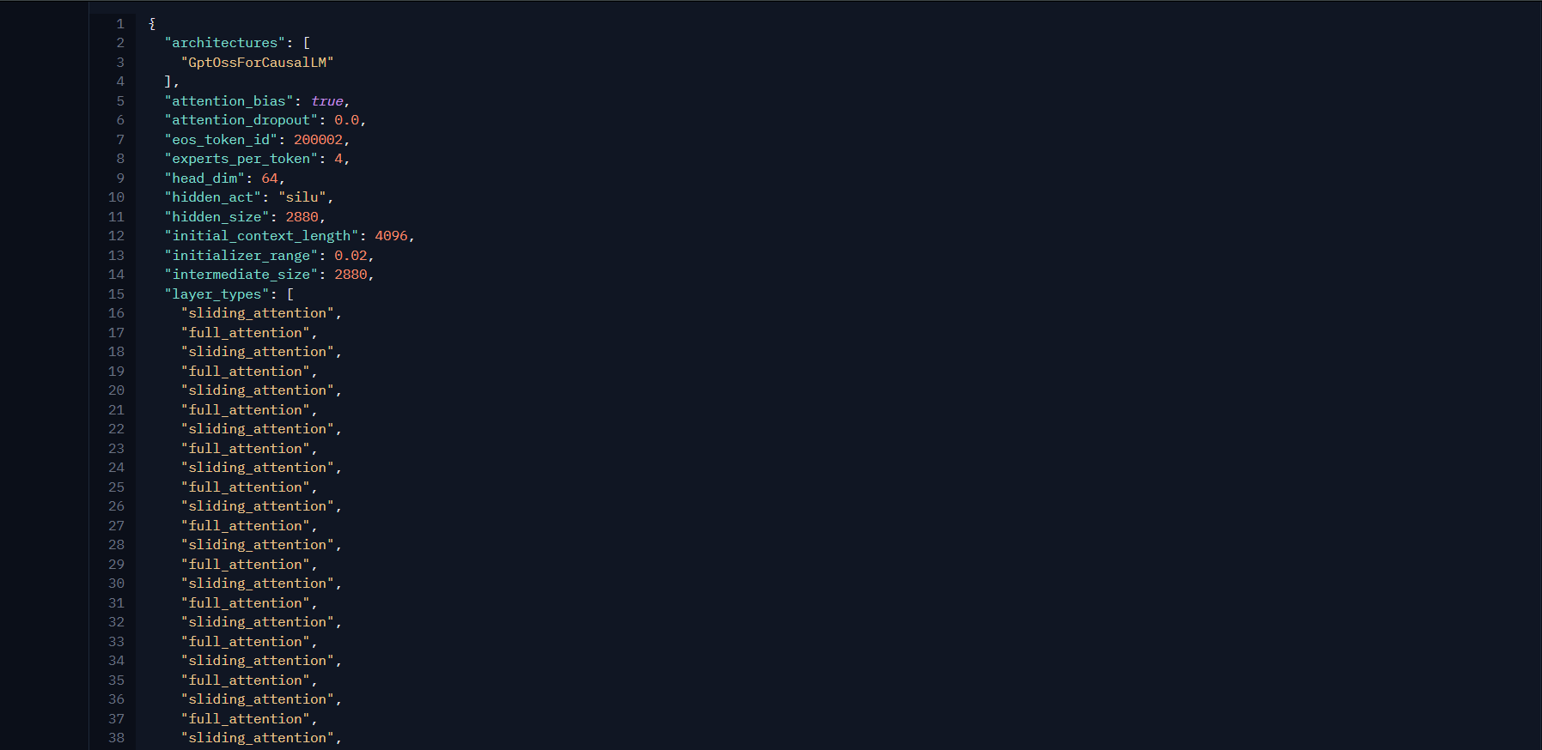
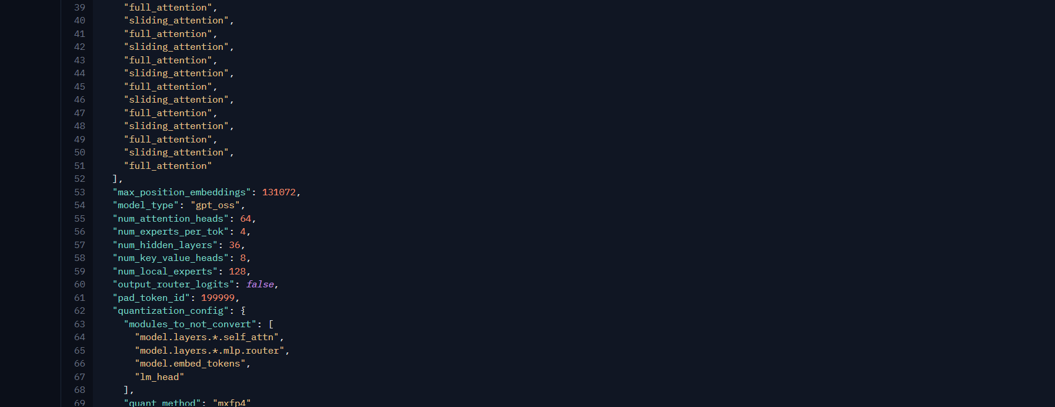
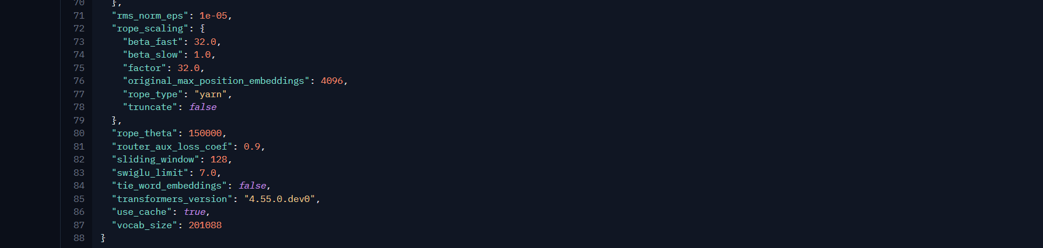
Figure: config.json of openai/gpt-oss-120b on Hugging Face.
Values from config.json: num_hidden_layers = 36, num_key_value_heads = 8, head_dim = 64 (listed, so no need for hidden_size / heads), sliding_window = 128, and layer_types alternates sliding_attention and full_attention. Total parameters 117B, 5.1B active.
4.1 Weight memory: FP16 = 117B x 2 bytes = 234.0 GB; 8-bit = 117B x 1 byte = 117.0 GB; 4-bit = 117B x 0.5 byte = 58.5 GB.
4.2 KV cache per sequence: the longest sequence in my loop is the last call: 5,200 input + 600 output + 174 reasoning tokens = 5,974 tokens. With the formula exactly as given (every layer full): 2 x 36 x 8 x 64 x 5,974 x 2 = 0.440 GB. Adapted for the architecture: only the 18 full layers keep the whole sequence and the 18 sliding layers keep at most 128 tokens, so KV = 2 x 8 x 64 x 2 x (18 x 5,974 + 18 x 128) = 0.225 GB. Using the plain formula would double count half the layers.
4.3 Concurrent sequences on one GPU: NVIDIA H100 SXM 80 GB. Usable = 0.9 x 80 = 72 GB. After 4-bit weights: 72 - 58.5 = 13.5 GB for KV. Max sequences = floor(13.5 / 0.2249) = 60 (it would be 30 if every layer were full attention).
4.4 GPUs needed: by Little's law, sequences in flight at peak = peak queries per second x time per query = (45.21 / 60) x 11.57 s = 8.7. That is far below 60, so 1 GPU is enough on memory. One GPU covers up to about 21,327 normal daily queries. Memory is only one limit: one GPU must also keep up with roughly 14,400 prefill tokens per second at peak, which an H100 can do for a 5.1B active model, but a second GPU for failover would still be advisable in production.

5. Latency budget (item 6, done before the break even because the break even needs it)
Per call I use time to first answer token + answer tokens / speed. Calls run one after another, each tool call adds the median tool delay, and the expected retry delay is p x (time of calls 1 to 4), because a failed call is just run again.
I called the OpenAQ and Open-Meteo APIs from my laptop on 2026-11-09 and 2026-11-10 and timed the heat index and knowledge base code locally. The raw log is in tool_latency_log.csv. The median of all measurements is 0.305 s, and I use that for every tool call as the brief asks. The median of only the two network APIs is 1.174 s, so I repeated the check with that larger value: DeepSeek V4.1 Flash then takes 19.72 s with the original loop and 7.60 s after the change, so the conclusion does not change.
DeepSeek V4.1 Flash: calls 1 to 4 = 1.33 + 350 / 269.4 = 2.63 s each, call 5 = 1.33 + 600 / 269.4 = 3.56 s, tools 4 x 0.305 s, retries 0.09 x 10.52 = 0.95 s. Total = 16.24 s, which misses T = 9 s.
GLM-5.3-Flash: calls 1 to 4 = 3.53 + 350 / 56 = 9.78 s each, call 5 = 14.24 s. Total = 58.10 s. Its low output speed (56 tokens/s) is the main problem.
Architectural change: plan once, run tools in parallel. The four tools do not really depend on the model: air quality, weather and the knowledge base only need the area, time and risk group, which call 1 already extracts, and the heat index is a formula that can run in code right after the weather tool returns. So call 1 plans and fires all tools at once, they run in parallel (one tool delay instead of four), and call 2 writes the answer. That is 2 LLM calls instead of 5.
New latency for DeepSeek V4.1 Flash = 2.63 + 3.56 + 0.305 + 0.09 x 2.63 = 6.73 s, which meets T. For GLM-5.3-Flash it becomes 25.21 s, still too slow. Streaming the final answer would help the user feel it sooner, but it cannot save GLM because its first answer token alone takes 3.53 s per call.
Model | LLM time | Tools | Retries | Total (5 calls) | Meets T? | After change | Meets T?
GPT-6 Luna | 28.41 | 1.22 | 1.84 | 31.46 | No | 13.87 | No
GPT-6.1 Terra | 30.80 | 1.22 | 2.02 | 34.04 | No | 14.78 | No
Claude Haiku 5.5 | 54.41 | 1.22 | 3.79 | 59.42 | No | 24.11 | No
Claude Sonnet 5.5 | 34.65 | 1.22 | 2.33 | 38.20 | No | 16.12 | No
Gemini 3.8 Flash | 20.54 | 1.22 | 1.41 | 23.17 | No | 9.44 | No
Gemini 3.5 Flash-Lite | 34.72 | 1.22 | 2.39 | 38.33 | No | 15.72 | No
Grok 4.7 | 73.89 | 1.22 | 5.09 | 80.20 | No | 33.06 | No
DeepSeek V4.1 Flash | 14.07 | 1.22 | 0.95 | 16.24 | No | 6.73 | Yes
Qwen3.8 27B | 75.28 | 1.22 | 4.98 | 81.48 | No | 35.32 | No
GLM-5.3-Flash | 53.36 | 1.22 | 3.52 | 58.10 | No | 25.21 | No
Mistral Small 4 | 24.60 | 1.22 | 1.63 | 27.45 | No | 11.73 | No
gpt-oss-120b | 24.76 | 1.22 | 1.67 | 27.65 | No | 11.57 | No
Gemma 4 31B | 58.66 | 1.22 | 3.88 | 63.76 | No | 27.62 | No

Only DeepSeek V4.1 Flash meets 9 s after the change. Gemini 3.8 Flash comes close (9.6 s) but costs more than double the budget.

6. Break even analysis (item 4.5)
GPU price: H100 SXM on RunPod Secure Cloud at $2.69 per hour, so one GPU for a 30 day month = 2.69 x 720 = $1,936.80, paid whether busy or idle. Self hosting cost is a step function: GPUs = max(1, ceil(peak concurrency / 60)), and peak concurrency grows in a straight line with Q.
The comparison API is DeepSeek V4.1 Flash, the cheaper of my two candidates that meets T after the change. Its cost per query is $846.37 / 142,600 = $0.00594, so API cost = $0.00594 x 46Q (26 normal days plus 4 heatwave days at 5 times the traffic).
Q* = 7,100 normal queries per day, where 1,938 dollars of API spend passes the one GPU cost of $1,936.80.
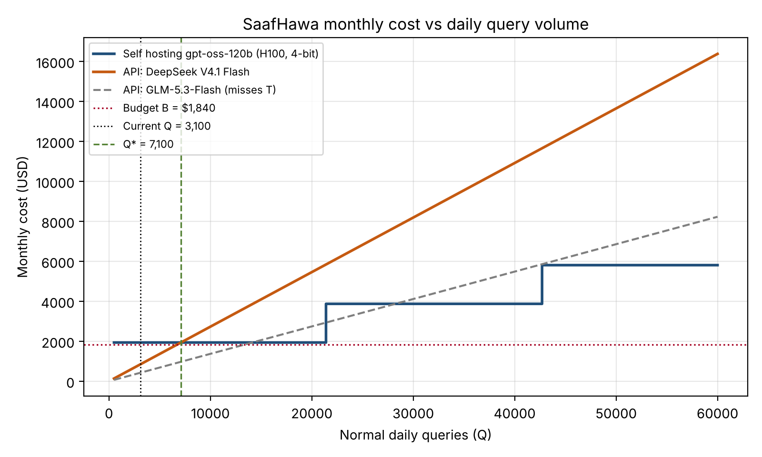
Is Q* realistic? Today's Q is 3,100, so we would need 2.3 times more normal day traffic. This growth is possible for a Karachi service after a severe summer, but the plot still favours self hosting. It ignores a second GPU for failover (which moves Q* to about 14,188), the engineer time to run vLLM, monitoring and on call, and the fact that gpt-oss-120b scored almost zero on AutomationBench-AA, which means self hosting would trade tool use quality for lower cost. GLM-5.3-Flash would even stay cheaper than one GPU up to about 14,120 queries a day if we could fix its speed. At the current scale, self hosting is not recommended; it should be reviewed once daily traffic stays above 10,000 queries.

My recommendation
- Use DeepSeek V4.1 Flash through its API with prompt caching (about $846.37 a month, well under $1,840).
- Rebuild the loop as plan, parallel tools, answer. This change is what brings latency under 9 s, and it also reduces token usage.
- Keep GPT-6 Luna as a fallback provider. It is the cheapest closed model, has published limits and a strong discount for cached input, so the bot keeps working if DeepSeek is down or throttled at peak.
- For the daily summary to municipal officers, the model should not generate numeric values itself. Put PM2.5, PM10, temperature and heat index into the summary from the tool outputs in code, and limit the model to writing the surrounding text. An outage costs one late message; a wrong number reaches people who decide for thousands.
- Before launch, build a 100 question test set in Urdu script, Roman Urdu and English, because none of the public benchmarks test our languages or our tool schema.

Declaration of AI tools used
I used ChatGPT and Claude as AI assistants for this question. I used ChatGPT to search for and collect current model prices, usage limits, and benchmark figures, while Claude assisted me in writing the Python scripts. I checked the formulas against the assignment requirements, ran the notebook and timing script myself, and the choices and final recommendation presented in this report are my own.

References
ID | Source | Link
S1 | OpenAI API pricing | developers.openai.com/api/docs/pricing
S2 | OpenAI, GPT-6 Luna model page | developers.openai.com/api/docs/models/gpt-6-luna
S3 | Artificial Analysis, LLM leaderboard (Intelligence Index, TTFT) | artificialanalysis.ai/leaderboards/models
S4 | AA, GPT-6 Luna (Non-reasoning) and GPT-6 Luna High vs Max comparison | artificialanalysis.ai/models/gpt-6-luna-non-reasoning
S5 | AA, GPT-6.1 Terra (Non-reasoning); ComputePrices citing AA speed | artificialanalysis.ai/models/gpt-6-1-terra-non-reasoning ; computeprices.com/models/gpt-6-1-terra
S6 | Respan, Claude Sonnet 5.5 vs GPT-6.1 Terra (Terminal-Bench 4.0) | respan.ai/models/compare/claude-sonnet-5-5-vs-gpt-6-1-terra
S7 | Anthropic, Claude pricing | platform.claude.com/docs/en/about-claude/pricing
S8 | ComputePrices, Claude Haiku 5.5 (AA speed) | computeprices.com/models/claude-haiku-5-5
S9 | AA, Claude Haiku 5.5 High vs Medium comparison | artificialanalysis.ai/models/comparisons/claude-haiku-5-5-high-vs-claude-haiku-5-5-medium
S10 | Anthropic rate limits (Developers Digest summary; MindStudio Tier 1 ITPM) | developersdigest.tech/rate-limits/anthropic ; mindstudio.ai/blog/claude-api-token-limits-increase-tier-breakdown
S11 | AA, Claude Sonnet 5.5 (low) | artificialanalysis.ai/models/claude-sonnet-5-5-low
S12 | Gemini API pricing summary (from ai.google.dev) | morphllm.com/gemini-api-pricing ; costbench.com/software/llm-api-providers/google-gemini-api
S13 | Tabbit, Gemini 3.8 Flash on Artificial Analysis | go.tabbit.ai/model/gemini-3-8-flash/reviews/artificialanalysis-intelligence-speed-pricing-latency
S14 | BenchLM Gemini 3.8 Flash; DataCamp Gemini 3.8 Flash | benchlm.ai/md/models/gemini-3-8-flash.md ; datacamp.com/blog/gemini-3-8-flash-cyber
S15 | Gemini API rate limits by tier | scriptbyai.com/gemini-api-rate-limits
S16 | Gemini 3.5 Flash-Lite price | costbench.com/software/llm-api-providers/google-gemini-api
S17 | OrcaRouter, Gemini 3.5 Flash-Lite vs 3.8 Flash (speed) | orcarouter.ai/compare/gemini-3.5-flash-lite-vs-gemini-3.8-flash
S18 | BenchLM Gemini 3.5 Flash-Lite; Google DeepMind Flash-Lite page | benchlm.ai/md/models/gemini-3-5-flash-lite.md ; deepmind.google/models/gemini/flash-lite
S19 | xAI Grok 4.7 pricing | layer3labs.io/guides/grok-api-pricing
S20 | AA, GPT-6 Luna vs Grok 4.7 (low) | artificialanalysis.ai/models/comparisons/gpt-6-luna-vs-grok-4-7-low
S21 | xAI rate limits summary | developersdigest.tech/rate-limits/xai
S22 | AA, DeepSeek V4.1 Flash (Non-Reasoning) | artificialanalysis.ai/models/deepseek-v4-1-flash-non-reasoning
S23 | Requesty, DeepSeek V4.1 Flash (max output, peak and off peak pricing) | requesty.ai/models-new/deepseek/deepseek-v4.1-flash
S24 | AA, AutomationBench-AA evaluation page | artificialanalysis.ai/evaluations/automationbench-aa
S25 | AA, Qwen3.8 27B (Non-reasoning) | artificialanalysis.ai/models/qwen3-8-27b-non-reasoning
S26 | AA, Qwen3.8 27B (Non-reasoning) vs Kimi K3 | artificialanalysis.ai/models/comparisons/qwen3-8-27b-non-reasoning-vs-kimi-k3
S27 | AA, GLM-5.3-Flash vs MiniMax-M3 | artificialanalysis.ai/models/comparisons/glm-5-3-flash-vs-minimax-m3
S28 | CometAPI, GLM-5.3-Flash specification (MIT, hybrid attention) | cometapi.com/models/zhipuai/glm-5-3-flash
S29 | AA, Mistral Small 4 vs gpt-oss-120b release comparison | artificialanalysis.ai/models/releases/comparisons/mistral-small-4-vs-gpt-oss-120b
S30 | LLM Stats, Mistral Small 4 | llm-stats.com/models/mistral-small-latest
S31 | AA, gpt-oss-120b providers | artificialanalysis.ai/models/gpt-oss-120b/providers
S32 | SemiAnalysis InferenceX, gpt-oss-120b architecture; Hugging Face config.json | inferencex.semianalysis.com/model/gptoss-120b ; huggingface.co/openai/gpt-oss-120b
S33 | AA, Gemma 4 31B (Non-reasoning) | artificialanalysis.ai/models/gemma-4-31b-non-reasoning
S34 | AA, Gemma 4 31B providers | artificialanalysis.ai/ja/models/gemma-4-31b-non-reasoning/providers
S35 | Gemma 4 benchmarks (tau2-bench, from the model card) | gemma4all.com/blog/gemma-4-benchmarks-performance
S36 | Spheron, RunPod H100 pricing | spheron.network/blog/runpod-h100-pricing-2026
S37 | OpenAI prompt caching 30 min / 12 h and 1,024 token minimum | aicatchup.com/news/openai-12-hour-prompt-caching-api ; alphasignal.ai/news/openai-extends-prompt-caching-to-12-hours-for-long-running-agents
S38 | Claude caching minimum 512 tokens | getmaxim.ai/articles/claude-api-pricing
S39 | Gemini implicit caching minimum and TTL | docs.cortecs.ai/usage/prompt-caching

