Assignment Beta, Question 2
Hafsa Rashid
23K-0064

Setup
Qwen2.5-1.5B-Instruct was fine-tuned on a Google Colab GPU runtime with fp16 mixed precision. Of the 112,960 rows in glaive-function-calling-v2, 37,765 start with a function call; 10 were dropped because their arguments string could not be parsed. A 2,000 example slice (seed 42) was split into 1,800 training and 200 test examples, and none needed truncation at 1,024 tokens.
The input is the system prompt with the function definitions plus the first user message, with one added line asking for a JSON object only. The target is just {"name": ..., "arguments": {...}}, and the loss is masked to the answer tokens. All runs share the same settings: 2 epochs (226 optimizer steps), learning rate 2e-4 with cosine decay and 5% warmup, effective batch size 16, alpha 16, dropout 0.05 and all seven projection matrices as targets. QLoRA used paged_adamw_8bit, since paged optimizers are part of that method.
Run | Trainable params | Peak mem (GB) | Train (min) | Valid JSON | Tool acc. | Full match | Speed (tok/s)
Base | 0 | n/a | n/a | 200/200 | 100% | 94.5% | 225.7
LoRA r=8 | 9.23M (0.595%) | 7.32 | 7.3 | 200/200 | 100% | 94.5% | 109.2
QLoRA r=8 | 9.23M (0.595%) | 6.53 | 9.7 | 200/200 | 100% | 94.5% | 81.0
DoRA r=8 | 9.88M (0.636%) | 8.20 | 13.0 | 200/200 | 100% | 94.5% | 58.8
AdaLoRA 12→8 | 13.85M (0.889%) | 8.46 | 12.7 | 200/200 | 100% | 94.5% | 104.7

No run produced a hallucinated function name, extra text around the JSON or a missing call. Speeds use greedy, batched decoding with the adapter unmerged.
Rank sweep (LoRA, alpha = 2r): r = 4, 8, 16 and 32 all reached 100% tool accuracy and 94.5% full match, even though trainable parameters grew from 4.6M to 36.9M. Training time stayed at 7.3 to 7.4 minutes. Doubling the rank therefore buys nothing on this task; it only adds parameters and memory.
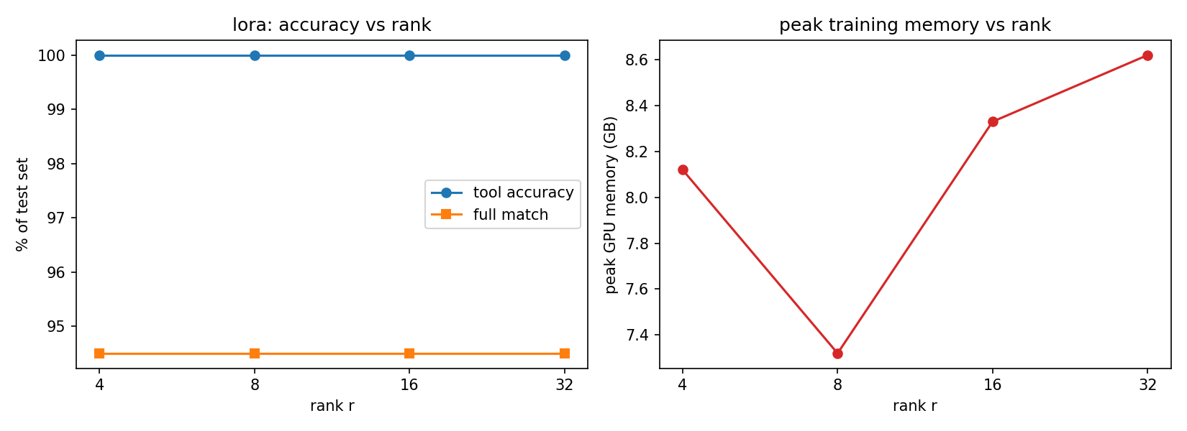

1. Method to ship
LoRA r=8, merged into the fp16 base model. Since all four methods tied at 189/200 full match, the choice comes down to cost and serving behaviour.
- Training time: LoRA was the fastest at 7.3 minutes, against 9.7 for QLoRA, 12.7 for AdaLoRA and 13.0 for DoRA. With one GPU, quick retraining when the tool list changes matters.
- Memory: LoRA peaked at 7.32 GB, so memory is not a constraint at this model size. QLoRA saved only 0.8 GB, because the fp16 weights of a 1.5B model are only about 3.1 GB and activations take most of the rest.
- AdaLoRA: its 200 outputs were identical to the base model's, so on this run it had no measurable effect.
The real difference between QLoRA and DoRA appears when the adapter is merged (merge test on 50 examples):
Adapter | Unmerged | Merged | Full match unmerged / merged
LoRA | 92.2 tok/s | 187.2 tok/s | 96% / 96%
DoRA | 49.3 tok/s | 187.3 tok/s | 96% / 96%
QLoRA, merged into 4-bit | 66.9 tok/s | 114.2 tok/s | 96% / 90%
QLoRA, merged into fp16 base | 66.9 tok/s | 184.3 tok/s | 96% / 96%

DoRA is the slowest unmerged because it recomputes the weight norm on every forward pass, but once merged it becomes plain weights and is as fast as LoRA with no loss. QLoRA behaves the other way: merging into 4-bit rounds the merged weights back to NF4, which cost 3 of 50 examples, and the result is still slow because 4-bit layers dequantize on every pass. Serving QLoRA well therefore means merging into an fp16 base, which removes its only advantage. r=8 is preferred over r=4 because it scored the same and is the version checked end to end in the merge test.
A caveat: these results do not show any adapter beating the base model with a strict prompt on this test set. Before deployment, the base model and the adapter should both be tested on the startup's own tools and real customer messages. The e-commerce demo was run only on the fine-tuned model.

2. Where it still breaks
The best model (LoRA r=8) got 11 of 200 examples wrong. Five of them, with labels checked against each function schema:
# | Customer message (short) | Correct call | Model output | Label
1 | News about the Mars Rover from the last week | search_news, 2022-02-01 to 2022-02-08 | search_news, 2022-03-15 to 2022-03-21 | Other: no reference date
2 | Dystopian book by George Orwell | search_books {author, genre, max_results} | Same plus "query": "" | Made-up argument
3 | Hotel in New York, 1st to 7th May | check_in_date "1st May" | check_in_date "2022-05-01" | Other: invented year
4 | Cheeseburger with fries, 800 calories | meal "Lunch - Cheeseburger with fries" | meal "lunch" | Other: free-text wording
5 | Good Italian restaurant in New York | {query: "Italian restaurant in New York"} | {query, cuisine, location} | Made-up argument

Pattern: all 11 failures use the right tool and valid JSON, so none is a wrong tool, broken JSON or refusal. Every error is in argument values: relative dates with no reference date (3), empty or invented fields (5) and value conventions such as rate 5 instead of 0.05 (3). Some gold answers are themselves arbitrary; for example, one test item expects "2022-05-01" while example 3 expects "1st May" for the same kind of request. For a real backend this is less dangerous than a wrong tool, but invented values still matter: in the demo the model placed an order number in a tracking_number field.

3. Multiple agents with LoRA adapters
A router, refund and shipping agent can share one frozen Qwen2.5-1.5B and differ only in their adapters. One fp16 copy of the base is about 3.1 GB, while one r=8 adapter is about 18.5 MB, so three adapters add roughly 55 MB compared with about 9.3 GB for three separate fine-tuned models. Each adapter trains in about 7 minutes, and retraining one agent does not affect the others. Multi-adapter servers such as vLLM can also batch requests for different adapters together. The trade-off is that swappable adapters must stay unmerged, which halves decoding speed in the merge test (92.2 vs 187.2 tok/s).
A real risk of swapping adapters live is serving a request with the wrong adapter. In PEFT, the active adapter is global state on the model object, so with concurrent requests one request can switch to the shipping adapter while another is still generating as the refund agent. Nothing crashes and the JSON stays valid, so the error is silent. A related risk is loading an adapter onto a different base version; the QLoRA result shows how sensitive outputs are even to small weight changes. Passing the adapter ID with each request and storing the base model hash in each adapter's metadata would guard against both.

4. What was surprising
- The problem described in the brief did not appear. With a one-line JSON instruction, the base model already produced 200/200 valid JSON, 100% tool accuracy and no extra text. The LoRA loss was already 0.0073 at step 10, so there was little left to learn.
- Fine-tuning changed outputs but not the score. LoRA, QLoRA and DoRA each changed 11 to 12 answers, fixing the same 3 examples and breaking 3 others, at every rank. The adapters picked up the dataset's habits (ISO dates with the year 2022, dropping empty fields), which the dataset itself applies inconsistently.
- AdaLoRA showed the largest loss drop (6.33 to 0.50) and the most trainable parameters, yet its outputs matched the base model exactly. A likely reason is that much of that loss is the orthogonality penalty and its E values start at zero, so the actual update stayed very small; this was not verified because the adapter weights were not kept. It still reallocated rank as intended, ending near 10.5 for attention q and o projections and about 6.5 for MLP layers.
- QLoRA saved much less memory than expected (0.8 GB) and took 2.4 minutes longer to train. At this model size, 4-bit quantization offers little.
- Peak memory for r=8 (7.32 GB) was lower than for r=4 (8.12 GB), which rank cannot explain. The r=8 run was the first in the session, so GPU memory state likely differed. Single-run memory differences under about 1 GB should not be over-interpreted.

