1.run_tests.bat all
output:
2. run_tests.bat parallel
output:
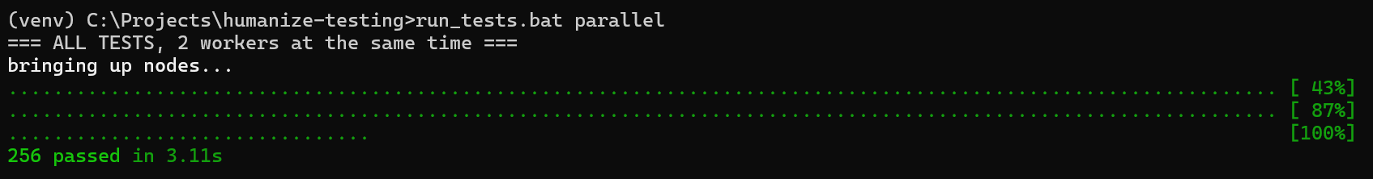
3. run_tests.bat groups
output:
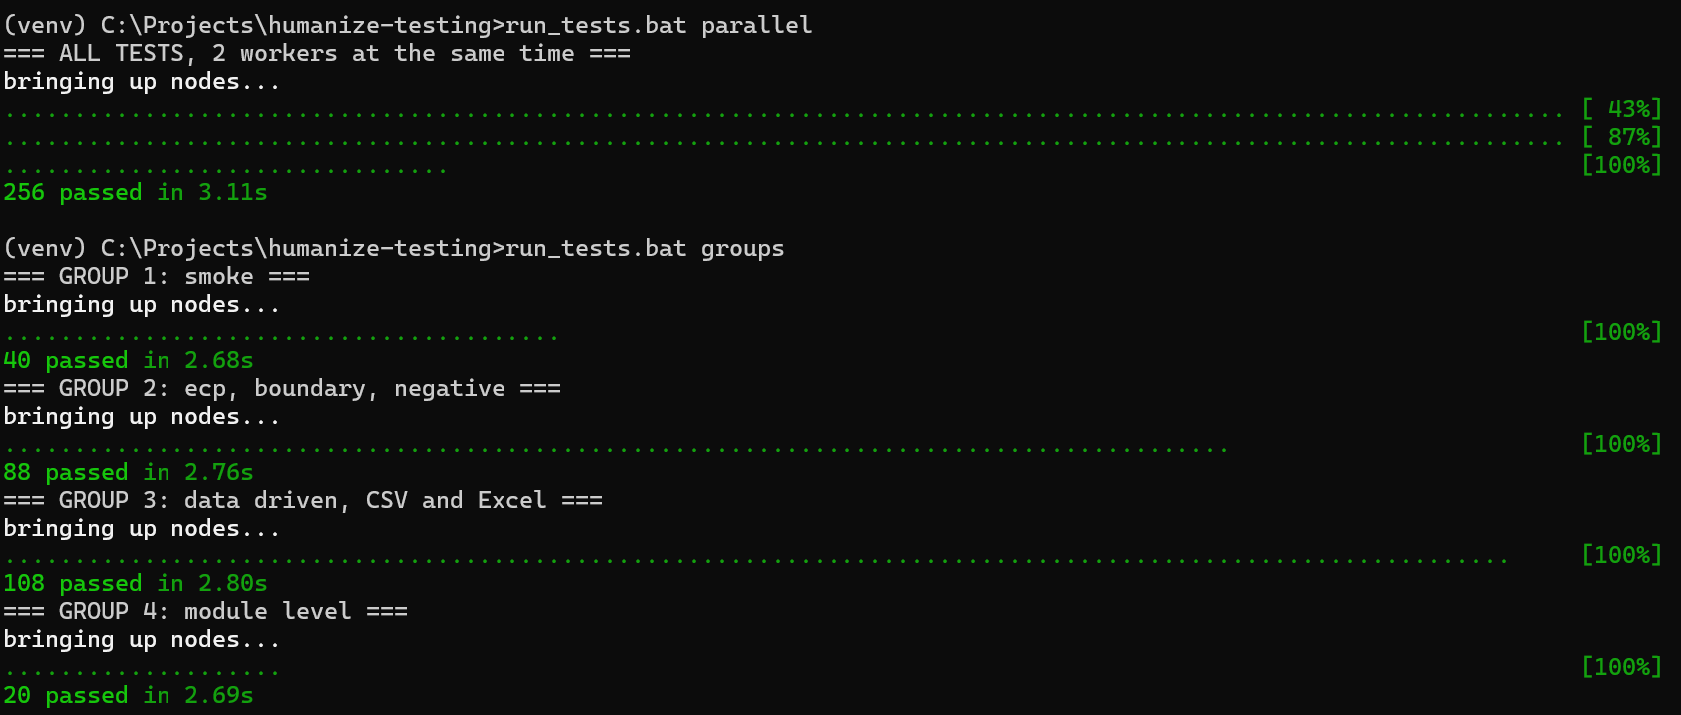
4. run_tests.bat suites
output:
