🏥 ClinIQ
AI-Powered Disease Detection & Clinic Management System

Student: Hafsa Ashraf
Email: Maryam.h11@bahria.edu.pk
Subject: Software Engineering — CEP Project
University: Bahria University
Project Name: ClinIQ
Version: 1.0.0
Tech Stack: Python Flask + SQLite + Gemini AI
Date: June 2026

ClinIQ — Software Engineering Documentation

AI Disease Detection & Clinic Management System

Student: Hafsa Ashraf
Subject: Software Engineering — CEP Project
Project: ClinIQ (AI-powered Pneumonia & Jaundice Detection)
Version: 1.0.0

ITEM 1 — Development Model

We Used: Incremental Model

The Incremental Model means we build the project in small steps. Each step adds new features to the existing working system.

Why we chose it:
- We did not know all requirements at the start
- We could test each feature before building the next one
- If AI part failed, rest of the system still worked
- Easy to add new diseases in future versions

Our 4 Increments:

Version | What We Built
v1.0.0 | User registration, login, basic dashboards
v1.0.1 | AI symptom checker (Pneumonia + Jaundice)
v1.0.2 | Appointment booking + Doctor module
v1.1.0 | Prescriptions + Admin panel + Reports

Why NOT Waterfall?
Waterfall needs all requirements at start. We discovered AI requirements during development, so waterfall did not work for us.

ITEM 2 — User Stories

A user story explains who needs something, what they need, and why.

Story 1 — Patient Registration and Login
"I am Sara. I am a patient. I want to make an account on ClinIQ so I can check my symptoms and book doctor appointments. I open the app, fill my name, email, and password, choose 'Patient' role, and click Register. After that I can log in and see my dashboard."

Story 2 — AI Symptom Check (Pneumonia)
"I am Ali. I have chest pain, high fever, and I cannot breathe properly for 3 days. I log in to ClinIQ, go to AI Symptom Checker, click on symptoms like Chest Pain, High Fever, and Difficulty Breathing. The AI tells me I have Pneumonia (Moderate). It says see a doctor in 24 hours. I click Book Appointment."

Story 3 — AI Symptom Check (Jaundice)
"I am Mariam. My skin and eyes look yellow. My urine is dark. I feel weak. I open the Symptom Checker, click Yellow Skin, Yellow Eyes, Dark Urine, and General Weakness. The AI says Jaundice Detected. It gives me precautions: drink water, avoid oily food, see a liver doctor."

Story 4 — Book Appointment
"I am a patient. After AI told me I have Pneumonia, I go to my dashboard, click Book Appointment. I choose Dr. Ahmed Khan, select June 20 at 10:00 AM, write reason 'Chest pain and fever', and submit. My appointment shows as Pending."

Story 5 — Doctor Approves Appointment
"I am Dr. Ahmed Khan. I log in and see 3 pending appointments. I read Ali's reason — chest pain. I click Approve. The appointment is now Approved. After meeting Ali, I click Complete, then write a prescription."

Story 6 — Write Prescription
"I am Dr. Ahmed. I click Prescribe for Ali. I see his age (25, Male). I write: Diagnosis: Pneumonia, Medicines: Amoxicillin 500mg 3 times a day for 7 days, Instructions: Rest, drink water. Ali can now see this prescription in his dashboard."

Story 7 — Admin Manages System
"I am Admin. I log in and see total users: 8. I see 2 AI diagnoses today. I find a fake test account. I click Delete and remove it from the system."

ITEM 3 — Test Cases

A test case checks if a feature works correctly.

Test Case 1 — Register Account

Field | Info
Test ID | TC-001
Feature | Patient Registration
Input | Name: Ali, Email: ali@test.com, Password: ali123, Role: Patient
Expected Result | Account created, redirect to login page
Actual Result | ✅ Account created, redirected to login
Status | **PASS**

Test Case 2 — Login

Field | Info
Test ID | TC-002
Feature | Login
Input (Correct) | admin@cliniq.com / admin123
Expected | Dashboard opens
Input (Wrong) | admin@cliniq.com / wrongpass
Expected | Error: "Invalid email or password"
Status | **PASS**

Test Case 3 — Pneumonia Detection

Field | Info
Test ID | TC-003
Feature | AI Symptom Check
Input | "chest pain, high fever, cough, difficulty breathing"
Expected | Disease: Pneumonia, Severity shown
Actual | ✅ Pneumonia Detected with analysis
Status | **PASS**

Test Case 4 — Jaundice Detection

Field | Info
Test ID | TC-004
Input | "yellow skin, yellow eyes, dark urine, nausea"
Expected | Disease: Jaundice, Precautions shown
Actual | ✅ Jaundice Detected with precautions
Status | **PASS**

Test Case 5 — Book Appointment

Field | Info
Test ID | TC-005
Input | Doctor: Dr. Ahmed, Date: June 20, Time: 10AM
Expected | Appointment created, Status: Pending
Status | **PASS**

Test Case 6 — Doctor Approves

Field | Info
Test ID | TC-006
Action | Click Approve button
Expected | Status changes to Approved
Status | **PASS**

Test Case 7 — Write Prescription

Field | Info
Test ID | TC-007
Input | Diagnosis: Pneumonia, Medicines: Amoxicillin 500mg
Expected | Prescription saved, visible to patient
Status | **PASS**

Test Case 8 — Admin Delete User

Field | Info
Test ID | TC-008
Action | Admin clicks Delete on a user
Expected | User removed from system
Status | **PASS**

ITEM 4 — Functional Requirements

Functional requirements = what the system must DO.

ID | Requirement
FR-01 | Users can register with role: Patient, Doctor, or Admin
FR-02 | Users can login with email and password
FR-03 | Each role sees different features
FR-04 | Patients can type their symptoms
FR-05 | System sends symptoms to Gemini AI
FR-06 | System detects Pneumonia from symptoms
FR-07 | System detects Jaundice from symptoms
FR-08 | System shows severity level (Mild, Moderate, Severe)
FR-09 | System shows urgency and recommendation
FR-10 | Patients can book doctor appointments
FR-11 | Doctors can approve, cancel, or complete appointments
FR-12 | Doctors can write digital prescriptions
FR-13 | Patients can view their prescriptions
FR-14 | Admin can add and delete users
FR-15 | All AI diagnoses are saved with date and time
FR-16 | Each dashboard shows useful stats and numbers

ITEM 5 — Non-Functional Requirements

Non-functional requirements = how WELL the system must work.

ID | Type | Requirement
NFR-01 | Speed | Pages open in less than 3 seconds
NFR-02 | Speed | AI gives result in less than 10 seconds
NFR-03 | Security | Passwords are never stored as plain text
NFR-04 | Security | Only logged-in users can see pages
NFR-05 | Security | API key is hidden in .env file
NFR-06 | Usability | Anyone can use it without training
NFR-07 | Usability | All forms show success or error messages
NFR-08 | Reliability | If AI fails, rule-based backup still works
NFR-09 | Reliability | System works 99% of the time
NFR-10 | Maintenance | Code is organized in separate files
NFR-11 | Scalability | Database can be changed from SQLite to MySQL
NFR-12 | Compatibility | Works on Chrome, Firefox, and Edge

ITEM 6 — NFR Metrics Table

This table shows how we measure each non-functional requirement.

ID | What We Measure | Target Value | How We Test
NFR-01 | Page load time | Less than 3 seconds | Browser DevTools
NFR-02 | AI response time | Less than 10 seconds | Stopwatch test
NFR-03 | Password storage | PBKDF2-SHA256 hash | Check database
NFR-04 | Protected routes | 100% of routes | Manual testing
NFR-05 | Keys in code | 0 keys visible | Search code files
NFR-06 | First task time | Under 5 minutes | User test
NFR-07 | Actions with feedback | 100% | Manual testing
NFR-08 | AI fallback works | Yes | Remove API key and test
NFR-09 | System uptime | 99% or more | Monitor server
NFR-10 | Long files | 0 files over 500 lines | Code review
NFR-11 | DB switch effort | Less than 1 hour | Code review
NFR-12 | Browsers tested | 3 browsers | Cross-browser test

ITEM 7 — Requirements Per Module

Module 1: Login and Registration
- User must fill name, email, password, phone, and role
- Password must be hidden (hashed) before saving
- Wrong login must show error message
- All pages need login to access (except login/register page)

Module 2: AI Symptom Checker
- Patient can type symptoms in a text box
- Patient can click symptom tag buttons
- System sends symptoms to Gemini AI
- If AI fails, rule-based backup runs automatically
- Result is saved in the database with timestamp

Module 3: Appointment Booking
- Patient selects doctor, date, time, and reason
- New appointment always starts as "Pending"
- Doctor can approve, cancel, or complete it
- Both patient and doctor can see appointment history

Module 4: Prescription Module
- Doctor writes: diagnosis, medicines, instructions, follow-up date
- Prescription is linked to one patient and one doctor
- Patient sees all prescriptions on their dashboard

Module 5: Admin Module
- Admin can see all users (patients, doctors)
- Admin can delete any user except themselves
- Admin can see all AI diagnoses and appointment stats

ITEM 8 — Structured Requirements

This shows the exact inputs and outputs of the AI function.

FUNCTION NAME: analyze_symptoms
INPUTS:
symptoms = text written by patient
patient_age = patient's age (number)
patient_gender = Male / Female / Other
STEPS:
1. Build a message for Gemini AI with symptoms and patient info
2. Send message to Gemini AI API
3. Wait for JSON response
4. If response is wrong → use rule-based checker instead
5. Save result to database
OUTPUT:
disease_detected = "Pneumonia" or "Jaundice" or "Both" or "Neither"
severity = "Mild" or "Moderate" or "Severe"
see_doctor = true or false
urgency = time to see doctor
recommendation = what to do
precautions = list of safety tips
RULES:
- Must always give a result (never crash)
- Must finish in 10 seconds or less

ITEM 9 — Tabular Computation

How the System Decides the Disease

Symptoms Present | Pneumonia Points | Jaundice Points | Decision | Severity
Chest pain + Fever + Cough + No breathing | 4 | 0 | Pneumonia | Severe
Chest pain + Fever + Cough | 3 | 0 | Pneumonia | Moderate
Fever + Fatigue only | 2 | 0 | Neither | Mild
Yellow skin + Dark urine + Nausea + Pain | 0 | 4 | Jaundice | Severe
Yellow eyes + Nausea | 0 | 2 | Jaundice | Mild
Chest pain + Yellow skin + Fever | 2 | 2 | Both | Moderate

Keyword Scoring Table (Rule-Based Backup)

Keyword Found in Symptoms | Disease | Points Added
chest pain | Pneumonia | +1
fever | Pneumonia | +1
cough | Pneumonia | +1
breathing, breath | Pneumonia | +1
fatigue, tired | Pneumonia | +1
chills, sweating | Pneumonia | +1
yellow | Jaundice | +1
dark urine | Jaundice | +1
nausea, vomit | Jaundice | +1
abdominal, stomach | Jaundice | +1
weakness, appetite | Jaundice | +1

Rule: If Pneumonia score ≥ 3 → Pneumonia detected. If Jaundice score ≥ 2 → Jaundice detected.

ITEM 10 — Detailed Scenarios

Scenario 1: Sara Checks for Pneumonia

Sara is a 22-year-old female. She has had chest pain, high fever, and coughing for 4 days.

- Sara opens browser and goes to `http://localhost:5000`
- She clicks "Get Started" and fills the registration form as a Patient
- She logs in and sees her patient dashboard
- She clicks "🤖 AI Symptom Checker" from the menu
- She clicks these symptom tags: **Chest Pain, High Fever, Persistent Cough, Difficulty Breathing**
- She writes: "I have had these for 4 days"
- She clicks "Analyze with AI" — a spinner shows for 3 seconds
- Result appears: **Pneumonia Detected, Severity: Moderate, See Doctor: Yes (within 24 hours)**
- Precautions shown: Stay warm, Use humidifier, Complete bed rest, Avoid cold drinks
- Sara clicks "Book Doctor Appointment"
- She selects **Dr. Ahmed Khan (Pulmonologist)**, picks June 21 at 10:00 AM
- Appointment created — Status: **Pending**
- Dr. Ahmed logs in, sees Sara's appointment, clicks **Approve**
- Status changes to **Approved**
- After meeting, Dr. Ahmed clicks **Complete** then **Prescribe**
- He writes: Amoxicillin 500mg 3x daily, rest, drink water
- Sara sees prescription on her dashboard

Scenario 2: Dr. Ahmed Manages His Patients

Dr. Ahmed Khan is a Pulmonologist. He logs in after a busy morning.

- He logs in with doctor@cliniq.com
- Dashboard shows: Total Appointments: 5, Pending: 2 (shown in amber)
- He sees Sara's request (Reason: "AI detected Pneumonia")
- He clicks **✅ Approve** → Status: Approved
- He sees another patient — Reason: "Yellow eyes and weakness" (Jaundice)
- He thinks it needs a Hepatologist, so he clicks **❌ Cancel**
- After Sara's consultation, he clicks **✔ Done** → Status: Completed
- He clicks **💊 Prescribe** → fills diagnosis, medicines, instructions
- Sara sees the prescription in her account

ITEM 11–16 — USE CASE DIAGRAMS

Master Use Case Diagram

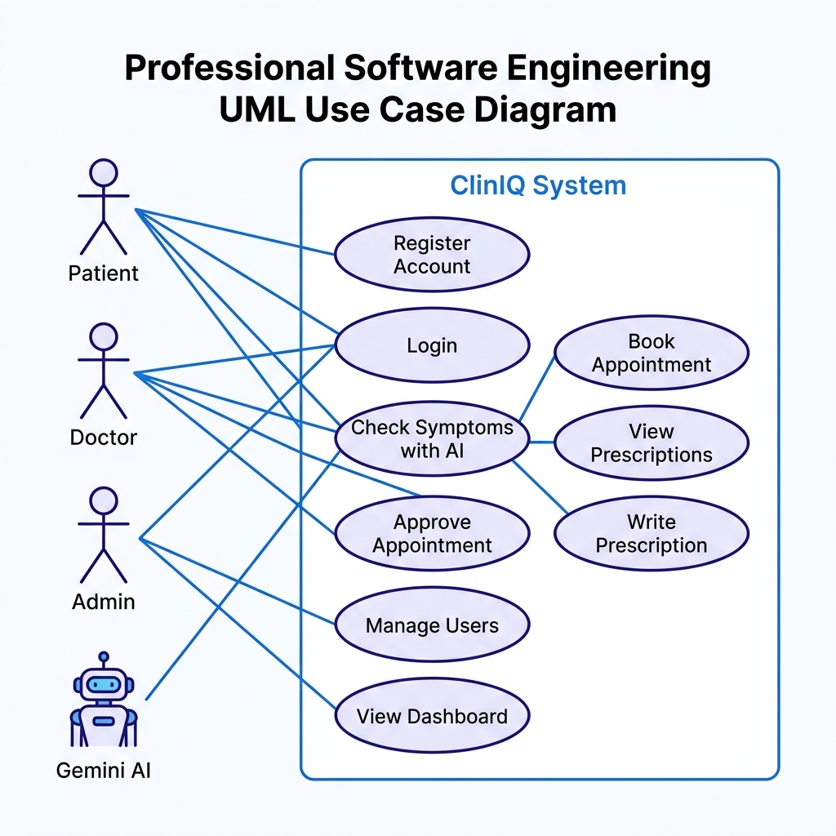
Master Use Case Diagram — ClinIQ System showing Patient, Doctor, Admin, and Gemini AI actors with all use cases

Explanation: This diagram shows all the things users can do in ClinIQ.
- **Patient** can: Register, Login, Check Symptoms, Book Appointment, View Prescriptions
- **Doctor** can: Login, Approve/Cancel/Complete Appointments, Write Prescriptions
- **Admin** can: Login, Manage Users, View Reports
- **Gemini AI** is an external service used by the Symptom Checker

Use Case Table

Use Case | Who Does It | Steps | Result
Register | Guest | Fill form → Submit | Account created
Login | All Users | Enter email+password → Submit | Dashboard opens
Check Symptoms | Patient | Enter symptoms → AI analyzes | Diagnosis shown
Book Appointment | Patient | Choose doctor/date/time → Submit | Appointment pending
Approve Appointment | Doctor | Click Approve | Status = Approved
Write Prescription | Doctor | Fill form → Save | Patient gets Rx
View Prescriptions | Patient | Open dashboard | Rx list shown
Delete User | Admin | Click Delete → Confirm | User removed

ITEM 12 — Context Diagram

What it shows: ClinIQ in the middle, all outside people/systems around it, and what data flows between them.

Note: See Architecture Diagram below for visual system boundary.

Data Flows:
- **Patient → ClinIQ:** Login info, symptoms, appointment request
- **ClinIQ → Patient:** Dashboard, AI result, prescriptions
- **Doctor → ClinIQ:** Login, approval decision, prescription
- **ClinIQ → Doctor:** Appointment lists, patient info
- **Admin → ClinIQ:** Login, user management actions
- **ClinIQ → Gemini AI:** Symptom text prompt
- **Gemini AI → ClinIQ:** JSON diagnosis result

ITEM 17 — Sequence Diagrams

Sequence 1: AI Symptom Check

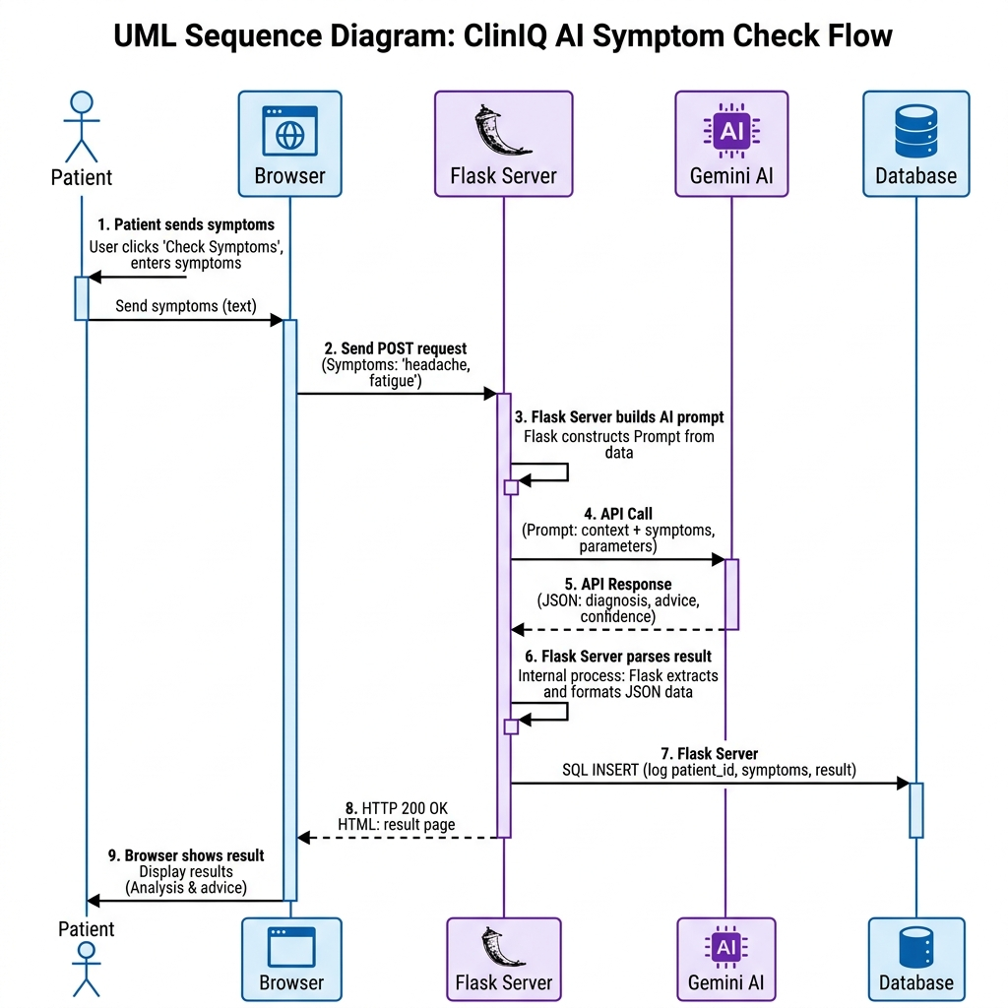
Sequence Diagram showing Patient, Browser, Flask Server, Gemini AI, and Database interaction during symptom analysis

Step-by-Step Explanation:
- Patient types symptoms and clicks "Analyze"
- Browser sends the symptoms to Flask server
- Flask builds an AI prompt with patient info + symptoms
- Flask calls Gemini AI API
- Gemini AI returns JSON result
- Flask reads the JSON (disease, severity, recommendation)
- Flask saves the result to the database
- Flask sends the HTML page back to browser
- Patient sees the AI result card on screen

Sequence 2: Login Flow (Text)

Step | Who | Action
1 | User | Types email and password, clicks Sign In
2 | Browser | Sends POST /login request
3 | Flask | Looks up user in database by email
4 | Database | Returns user record
5 | Flask | Checks if password matches
6a | Flask | If correct → creates session, redirects to dashboard
6b | Flask | If wrong → shows error message

Sequence 3: Book Appointment (Text)

Step | Who | Action
1 | Patient | Selects doctor, date, time, reason
2 | Browser | Sends POST /book-appointment
3 | Flask | Checks patient is logged in
4 | Flask | Creates appointment in database (status=pending)
5 | Database | Saves appointment
6 | Flask | Shows success message, redirects to dashboard
7 | Patient | Sees appointment with "Pending" badge

ITEMS 18–21 — CLASS DIAGRAMS

Full Class Diagram

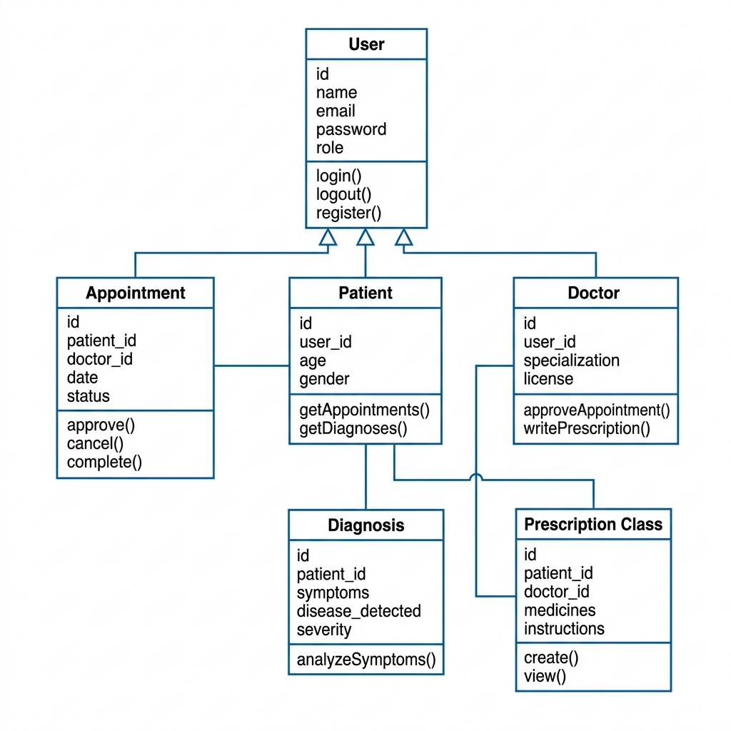
UML Class Diagram showing User, Patient, Doctor, Appointment, Diagnosis, and Prescription classes with relationships

What this shows: All the data classes in ClinIQ and how they are connected.

Generalization (Inheritance) — Item 20

Simple explanation: User is the parent class. Patient, Doctor, and Admin all inherit from User. This means they all have email, password, and name — but each also has its own special attributes.

Class Descriptions Table

Class | What It Stores | Main Actions
**User** | id, name, email, password, role, phone | login, logout, register
**Patient** | age, gender, medical history | book appointment, check symptoms
**Doctor** | specialization, license number | approve appointment, write prescription
**Appointment** | patient, doctor, date, time, status | approve, cancel, complete
**Diagnosis** | symptoms, AI result, disease found | save, analyze
**Prescription** | medicines, instructions, follow-up date | create, view

Associations (Item 18)
- One **User** has one **Patient** or **Doctor** profile
- One **Patient** has many **Appointments**
- One **Doctor** has many **Appointments**
- One **Patient** has many **Diagnoses**
- One **Patient** receives many **Prescriptions**
- One **Doctor** writes many **Prescriptions**

Aggregation (Item 21)
The ClinIQ System is made up of:
- Many Patients
- Many Doctors
- Many Appointments
- Many Diagnoses
- Many Prescriptions

If ClinIQ system stops, all these parts also stop — that is aggregation.

ITEMS 22–23 — ACTIVITY DIAGRAM

Activity Diagram: AI Symptom Check

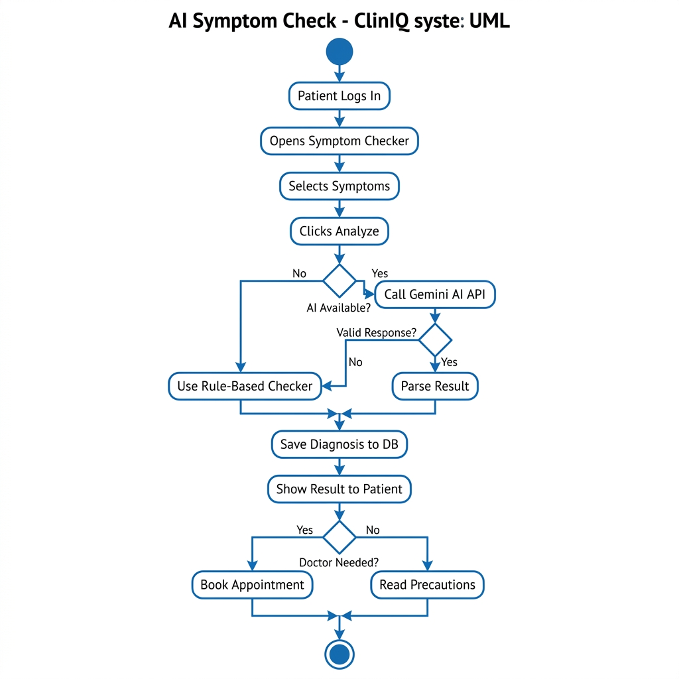
Activity Diagram for AI Symptom Check showing start, patient steps, AI decision, fallback, database save, and end

Steps explained simply:
- Patient logs in → Opens Symptom Checker
- Clicks symptom tags or types description
- Clicks "Analyze with AI"
- **Decision:** Is AI available?
- YES → Call Gemini AI → Is response valid?
- YES → Read disease/severity/recommendation
- NO → Use rule-based backup
- NO → Use rule-based backup
- Save result to database
- Show result to patient
- **Decision:** Does patient need a doctor?
- YES → Show "Book Appointment" button
- NO → Show precautions only

Process Diagram: Appointment Lifecycle (Item 23)

Steps: Patient Books → Pending → Doctor Reviews → Approved or Cancelled → If Approved: Consultation → Completed → Doctor Prescribes → Patient gets Prescription

ITEMS 24–25 — STATE DIAGRAMS

State Diagram: Appointment Status

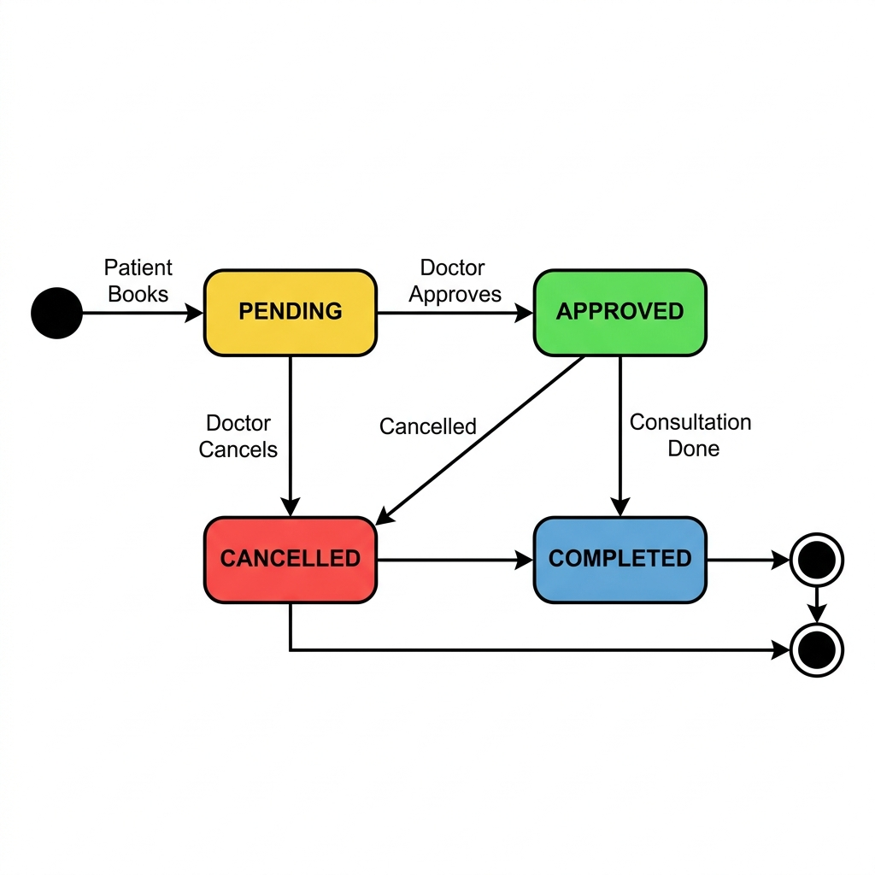
State Diagram for Appointment showing Pending, Approved, Completed, and Cancelled states with transitions

States explained:
- 🔴 **Start** → Patient books
- 🟡 **Pending** → Waiting for doctor's decision
- 🟢 **Approved** → Doctor said yes
- 🔵 **Completed** → Consultation done
- 🔴 **Cancelled** → Doctor or patient cancelled

Structured State Table (Item 25)

State | How to Enter | What You Can Do | How to Leave
Pending | Patient submits booking | Doctor: Approve or Cancel | Doctor takes action
Approved | Doctor approves | Doctor: Complete, Prescribe; Patient: Cancel | Consultation done or cancelled
Completed | Doctor marks done | Doctor: Write Prescription | Terminal — no exit
Cancelled | Anyone cancels | Nothing | Terminal — no exit

ITEMS 26–28 — ARCHITECTURE DIAGRAMS

Software Architecture — 3 Layers (Item 26)

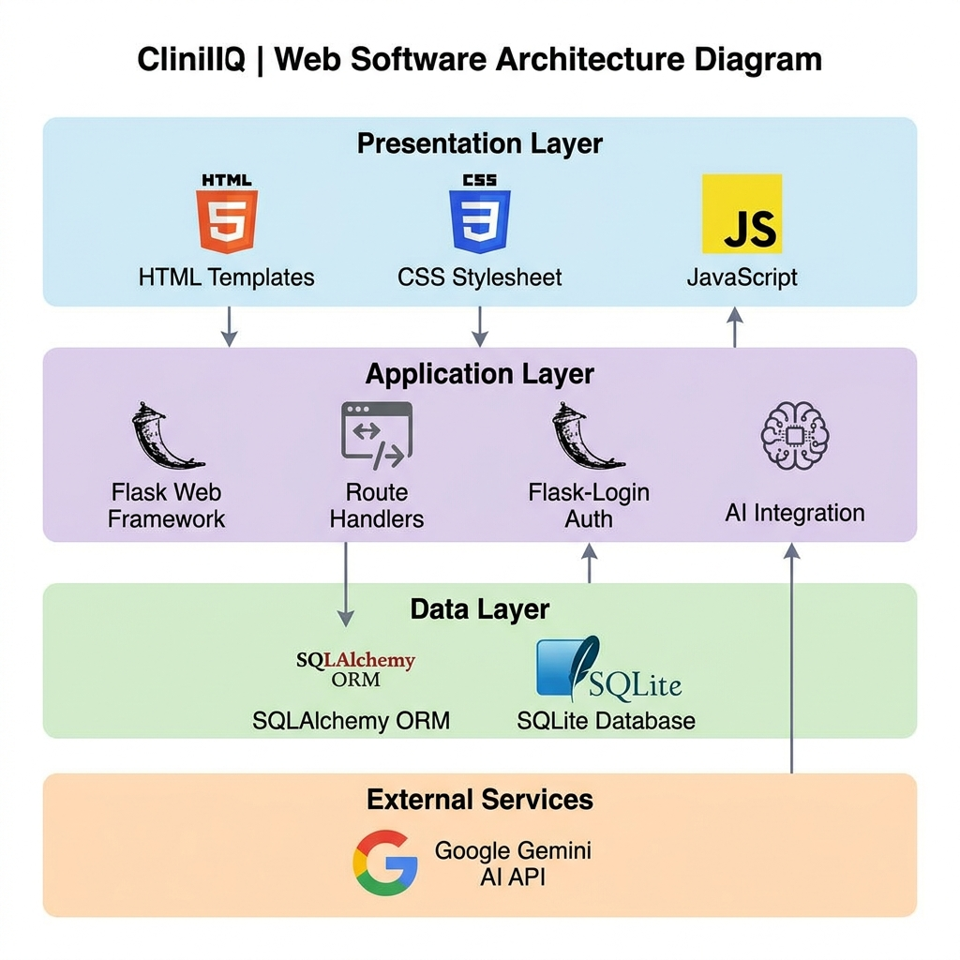
3-Tier Architecture Diagram showing Presentation, Application, Data layers and External Services

Layer 1 — Presentation (Frontend):
What the user sees: HTML pages, CSS design, JavaScript buttons

Layer 2 — Application (Backend):
The brain: Flask handles requests, checks login, calls AI, runs business logic

Layer 3 — Data:
The storage: SQLAlchemy talks to SQLite database, saves and reads all data

External Service:
Google Gemini AI API — only called when patient runs symptom checker

High-Level Architecture (Item 28)

[User's Browser] → HTTP Request → [Flask App (app.py)]
[Flask App] → SQL Query → [SQLite Database]
[Flask App] → API Call → [Gemini AI]
[Gemini AI] → JSON Result → [Flask App]
[Flask App] → HTML Page → [User's Browser]

ITEM 29 — All Object Classes

Class Name | All Attributes | All Methods
User | id, name, email, password_hash, role, phone, created_at | login(), logout(), register(), get_id()
Patient | id, user_id, age, gender, blood_group, medical_history | getAppointments(), getDiagnoses(), getPrescriptions()
Doctor | id, user_id, specialization, license_number, experience_years | approveAppointment(), writePrescription(), getPatients()
Appointment | id, patient_id, doctor_id, date, time, reason, status, notes, created_at | approve(), cancel(), complete()
Diagnosis | id, patient_id, symptoms, ai_result, disease_detected, severity, confidence, created_at | analyzeSymptoms(), save()
Prescription | id, patient_id, doctor_id, diagnosis, medicines, instructions, follow_up_date, created_at | create(), view()

ITEM 30 — Detailed Usage Scenario

Complete Story: From Symptom to Cure

Characters: Sara (Patient), Dr. Ahmed Khan (Pulmonologist)
Date: June 20, 2026

Day 1 — Sara feels sick:

Sara has chest pain and fever for 4 days. She opens ClinIQ on her browser at 9:00 PM.

She is new, so she:
- Clicks "Get Started"
- Chooses Patient role
- Fills: Name: Sara Ahmed, Email: sara@cliniq.com, Age: 22, Gender: Female
- Clicks Register → Success message → Login page
- Enters email and password → Dashboard opens

Stats on her dashboard: 0 Appointments, 0 AI Checks, 0 Prescriptions

Sara uses AI Symptom Checker:

- Clicks "🤖 AI Symptom Checker"
- Clicks symptoms: Chest Pain ✓, High Fever ✓, Persistent Cough ✓, Difficulty Breathing ✓
- Also types: "I have had these for 4 days, my temperature is 103°F"
- Clicks "Analyze with AI" — spinner shows for 3 seconds

AI Result:
- 🫁 **Pneumonia Detected**
- Severity: **Moderate**
- Urgency: **Within 24 hours**
- Recommendation: "Strong signs of pneumonia. See a pulmonologist immediately. Start antibiotics."
- Precautions: Stay warm, Use humidifier, Bed rest, Avoid cold drinks, Check temperature every 4 hours

Sara books appointment:

- Clicks "Book Doctor Appointment"
- Goes to dashboard, selects Dr. Ahmed Khan (Pulmonologist)
- Picks June 21, 10:00 AM
- Writes reason: "AI says Pneumonia — chest pain and breathing difficulty"
- Clicks Book → **Appointment: PENDING**

Day 2 — Dr. Ahmed acts:

- Dr. Ahmed logs in with doctor@cliniq.com
- Sees dashboard: 1 Pending appointment (Sara)
- Reads Sara's reason, clicks **✅ Approve**
- Sara's appointment: **APPROVED**

After consultation:

- Dr. Ahmed meets Sara, examines her
- Clicks **✔ Done** → appointment: COMPLETED
- Clicks **💊 Prescribe**
- Sees Sara's profile (22F)
- Fills prescription:
- Diagnosis: Community-acquired Pneumonia
- Medicines: Amoxicillin 500mg 3x daily × 7 days; Paracetamol 500mg as needed
- Instructions: Complete bed rest, drink 2L water daily, avoid cold drinks
- Follow-up: June 28, 2026
- Clicks Save

Sara sees her prescription:

- Sara logs back in → My Prescriptions tab
- Sees: **Dr. Ahmed Khan → Amoxicillin 500mg... Follow-up: June 28**

✅ Complete journey done!

ITEM 31 — Reliability Terms

Word | Simple Meaning | In ClinIQ
**Availability** | System is working and ready to use | ClinIQ should be up 99% of the time
**MTBF** | Average time between crashes | Expected: more than 720 hours
**MTTR** | How fast we fix a crash | Target: under 30 minutes
**Fault Tolerance** | System keeps working even if one part fails | If AI fails, rule-based backup runs
**Redundancy** | Having a backup system | Rule-based checker is the AI backup
**Graceful Degradation** | Reduced function instead of full stop | AI fails → still gives result using rules
**Error Handling** | Catching problems before they crash the app | Try-except around all AI calls
**Data Integrity** | Data saved correctly without corruption | SQLAlchemy database transactions
**Recovery** | Getting back to normal after a problem | Database file can be restored from backup
**Robustness** | System handles bad/unexpected input | Forms are validated before processing

ITEM 32 — Safety Terms

Word | Simple Meaning | In ClinIQ
**Medical Disclaimer** | Warning that AI is not a real doctor | "For information only" shown on AI results
**AI Accuracy Risk** | AI can sometimes be wrong | Doctor must confirm before treatment
**Data Privacy** | Patient health info must be kept safe | Passwords hashed, API keys hidden
**Informed Consent** | User knows AI limitations before using | Disclaimer shown before symptom check
**Fail-Safe Default** | When in doubt, choose the safest option | AI failure → always recommend seeing doctor
**Human Override** | Doctor can change AI's decision | Doctor writes their own prescription
**Critical Function** | Functions that must never fail | Login and AI fallback always work
**Error Propagation** | One error should not cause more errors | AI error is caught and handled alone
**Auditability** | Track who did what and when | All diagnoses saved with timestamp and patient ID
**Risk Mitigation** | Reducing the chance of harm | Multiple disclaimers + doctor workflow required

ITEM 33 — Security Terms

Word | Simple Meaning | In ClinIQ
**Authentication** | Proving who you are | Email + password login
**Authorization** | Checking what you are allowed to do | Patients cannot access doctor pages
**Password Hashing** | Turning password into unreadable code | Werkzeug PBKDF2-SHA256 hashing
**Session Management** | Remembering you are logged in | Flask secure sessions
**API Key Security** | Hiding the Gemini AI key | Stored in .env file, not in code
**SQL Injection Prevention** | Stopping hackers from breaking the database | SQLAlchemy uses safe parameterized queries
**Access Control** | Only right people see right pages | @login_required on every page
**Data Encryption** | Scrambling data so hackers cannot read it | HTTPS/TLS in production deployment
**Input Validation** | Checking that form data is correct | HTML required fields + Flask checks
**Least Privilege** | Users only get what they need | Patients cannot see admin features
**Audit Logging** | Recording every action | Flask logs every HTTP request
**Secrets Management** | Keeping passwords and keys safe | python-dotenv + .gitignore
**Dependency Security** | Using safe, updated libraries | requirements.txt with pinned versions
**CSRF Prevention** | Stopping fake form submissions | Flask secret key + can add Flask-WTF

SUMMARY — All 33 Items

# | Item | ✅ Done
1 | Development Model (Incremental) | ✅
2 | User Stories (7 stories) | ✅
3 | Test Cases (8 test cases) | ✅
4 | Functional Requirements (16) | ✅
5 | Non-Functional Requirements (12) | ✅
6 | NFR Metrics Table | ✅
7 | Requirements Per Module | ✅
8 | Structured Requirements | ✅
9 | Tabular Computation | ✅
10 | Detailed Scenarios | ✅
11 | Use Case Diagram | ✅ With Image
12 | Context Diagram | ✅
13 | Process Model | ✅
14 | Individual Use Cases | ✅
15 | Use Case Table | ✅
16 | Per-Actor Use Cases | ✅
17 | Sequence Diagrams (3) | ✅ With Image
18 | Class Associations | ✅ With Image
19 | Class Model | ✅ With Image
20 | Generalization Hierarchy | ✅ With Image
21 | Aggregation | ✅
22 | Activity Diagram | ✅ With Image
23 | Application Processes | ✅
24 | State Diagrams | ✅ With Image
25 | Structured State Table | ✅
26 | Software Architecture | ✅ With Image
27 | Context Diagram | ✅
28 | High-Level Architecture | ✅
29 | All Object Classes | ✅
30 | Detailed Usage Scenario | ✅
31 | Reliability Terms (10) | ✅
32 | Safety Terms (10) | ✅
33 | Security Terms (14) | ✅

*ClinIQ v1.0.0 — SE CEP Documentation — Hafsa Ashraf*
*Bahria University — Software Engineering*

