

Project Report
Software Engineering
For Implementing SDLC while developing
Inventory Management System

(Module Login is a default module for all members and is not considered as an individual module for any one student)
Student Name : Hafsa Student ID: 10420 Module 2 Name : Vendors
Student Name : Alina Student ID: 10611 Module 3 Name : Customer
Student Name : Aqsa Student ID: 10609 Module4 Name : Product
Student Name : Fiza Student ID: 10481 Module 5 Name : Categories of items

December, 2021
Submitted to: Dr. Umema Hani

CoCIS, PAF Kiet University, Karachi, Pakistan.
Executive Summary

This report covers major "Software Development" activities on our selected Software. This project activity lasts for duration of 3.5 month time period.

Index

Executive Summary ___________________________________________ II
Index __________________________________________________________ III

- Project Initiation: Proposal Form ___________________________ IV
- Requirement Engineering and Configuration Management ______ V
- Project Management and Risk Management _________________ VI
- Monitoring (Analysis and Design) already covered in SRS 2. _______VII
- Testing _______________________________________________VIII

Conclusion of whole Project ____________________________________ IX
- PROJECT INITIATION: PROPOSAL FORM
Page IV


PAF-Karachi Institute of Economics & Technology
(The Center of Excellence)
College of Computing and Information Sciences
Software Engineering Course Project Proposal Form

Sno. | Stud. ID | Names | Course Name/CID
1 | 10611 | Alina Fahim | Software Engineering  (109120)
2 | 10420 | Hafsa Kanwal | Software Engineering  (109120)
3 | 10609 | Aqsa Hussain | Software Engineering  (109120)
4 | 10481 | Fizza Ishaq | Software Engineering  (109120)

Project Title: Inventory Management System
- Motivation:
With changing market conditions, our goal was to create a more efficient
replenishment method that would maximize profits for everyone.
- Functional Features
Specify the features of your project which would make it significant for the evaluators.
- If you are designing a project, which is in common use then you should specify those features which are making your project distinctive/unique in comparison with the existing ones “Totally a professional concept of implementing a CRUD based Product”.
- Indicate the utilization/benefits of your project “Will demonstrate implemention of all engineering activities expected under different pahses of SDLC on Product Development”.
- List down 5 unique but relevant Modules/Features for 5 members
  - Module 1: Login Authentication (Common for all members)
  - Module 2:Customers
  - Module 3: Vendors
  - Module 4: Products
  - Module 5: Categories of items

- Expected Detail of all Modules to be covered by each Member
Alina Fahim: Login + Customers
- Demonstration of Create actitivty on Customers
- Demonstration of Review actitivty on Customers
- Demonstration of Update actitivty on Customers
- Demonstration of Delete actitivty on Customers
- Demonstration of Search actitivty on Customers

Hafsa Kanwal: Login + Vendors
- Demonstration of Create actitivty on Vendors
- Demonstration of Review actitivty on Vendors
- Demonstration of Update actitivty on Vendors
- Demonstration of Delete actitivty on Vendors
- Demonstration of Search actitivty on Vendors

Aqsa Hussain: Login + Products
- Demonstration of Create actitivty on Products
- Demonstration of Review actitivty on Products
- Demonstration of Update actitivty on Products
- Demonstration of Delete actitivty on Products
- Demonstration of Search actitivty on Products

Fizza Ishaq: Login + Categories of items
- Demonstration of Create actitivty on Categories of items
- Demonstration of Review actitivty on Categories of items
- Demonstration of Update actitivty on Categories of items
- Demonstration of Delete actitivty on Categories of items
- Demonstration of Search actitivty on Categories of items

- Project Planning
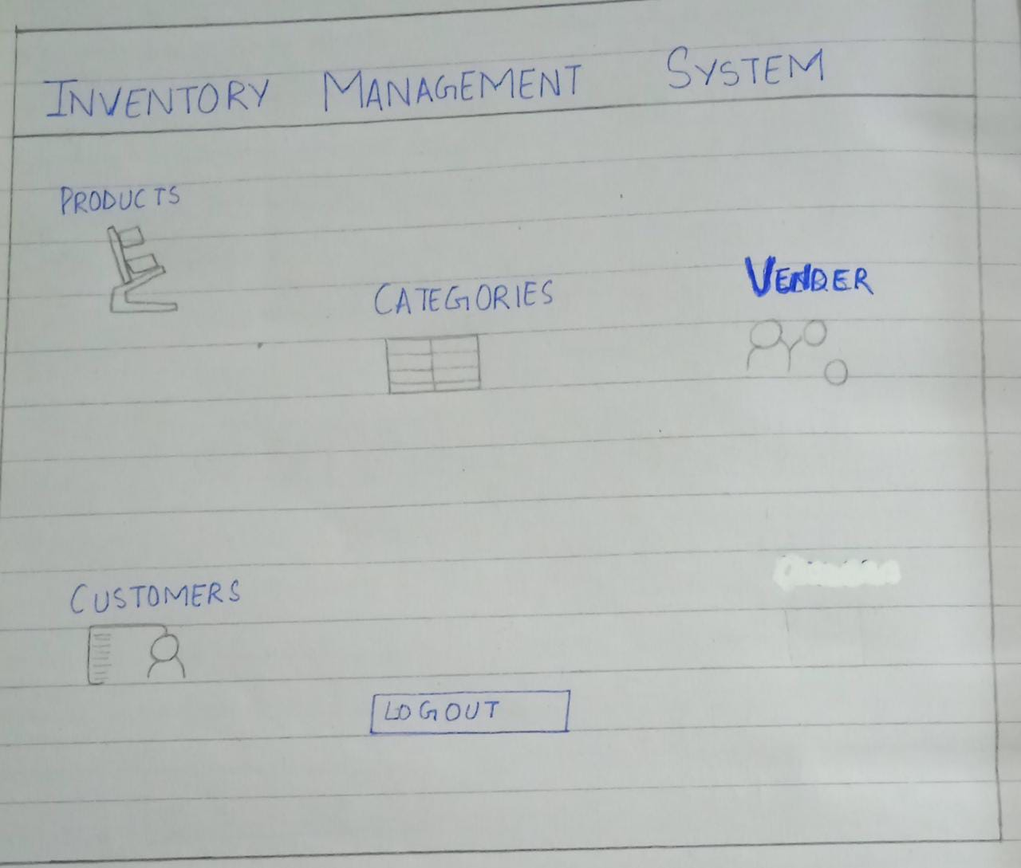

- Diagrammatic Representation of the Overall System
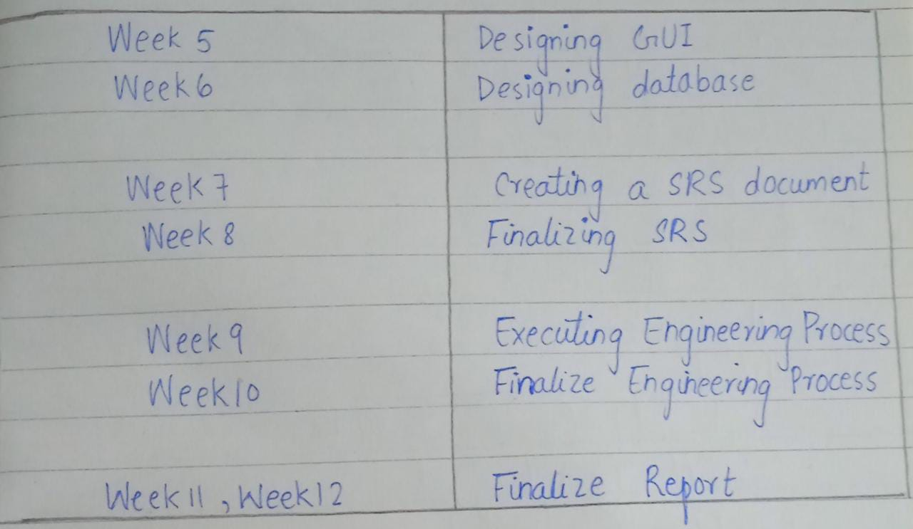

Student’s Signature: ______________ Date: _1_/ March/2022_

- REQUIREMENT ENGINEERING AND CONFIGURATION MANAGEMENT
Page V
Project Log Book

Entry Date | Work Done
March 7th, 2022 | Discussed the basic plan to build the prototype for PAF-Kiet in class, noting down all constraints to be taken care of. Furthermore, we decided our next group meeting would be on March 11th, 2022 (Friday) at 5:30, meeting place:Hafsa Kanwal’s House.
March13th, 2022 | Meeting at Alina’s Place: We discussed about the project objective. Using the Software Management Plan template printed from the web site, we stepped through each section and discussed what was required and what resources were available to us. We also discussed how this prototype should be flexible for other countries. There was constant reference to the "Inventory Management System" and other related articles.
March 16th, 2022 | Finished a rough draft prototype and set it up on the online account.
March19th, 2022 | Hafsa Kanwal checked the document of the Software Project Management Plan, and she made some correction marking the corrections in red.
March 20th, 2022 | The mistakes were corrected on the web site, and email was sent to Hafsa Kanwal to check the document for any more mistakes
March20th, 2022 | The document was checked by Hafsa Kanwal and few more mistakes were found. These mistakes were corrected and put on the web.
March 22th, 2022 | Meeting at Alina’s Place: We discussed the Inventory System in more detail and added more information to the SPMP document.
March 25th, 2022 | Hafsa Kanwal checked the document of the Software Project Management Plan, and she made some corrections.
March27th, 2022 | The mistakes were corrected on the web site, and email was sent to Hafsa Kanwal to check the document for any more mistakes.
March 30th, 2022 | Meeting at Alina’s Place: We discussed parts 4 and 5 of the Software Project Management Plan in more detail and decided to update some information in the SPMP document. The different parts of the document were divided between the team for updates.
April 3th, 2022 | Finished updating the rough draft prototype and set it up on the online account. Sent all team members email with link to latest copy of the document.
April 6th, 2022 | Hafsa Kanwal checked the document of the Software Project Management Plan. The mistakes were corrected on the web site. The latest version of the document is available online.

Last Updated on March 14th, 2022
Software Requirements Specification
for
Inventory Management System
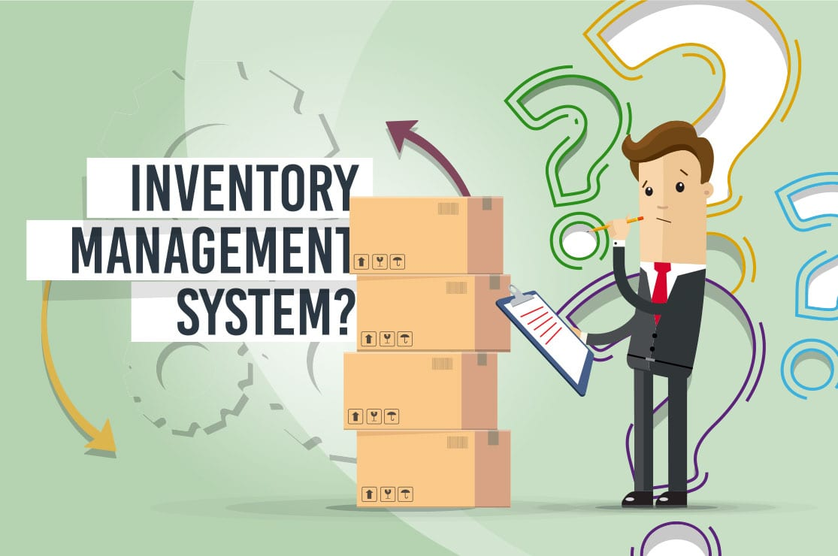
Hafsa Kanwal
Aqsa Hussain
Alina Fahim
Fizza Ishaq
March 14, 2022

Version | Changes Made | Date
1.0 | First Pass for Review | 31/March/2022
1.2 | Second Pass for Review | 15/April/2022
1.3 | Third Pass for Review | 1/may/2022
1.4 | Inventory Review Version | 15/may/2022

Table of Contents
1. Introduction
2. The General Description
3. Specific Requirements
4. Supporting Information
1. Introduction

1.1 Purpose

This document describes the software requirements for the Inventory Management System built for PAF-KIET.

1.2 Scope In

The PAF-KIET is requesting proposals to build a prototype of an Inventory Management System for their current system. This new ARRS needs to be scalable enough so that it can accommodate the increase in reservations caused by new railroad building in China.
The system will be designed to provide Inventory Management system. The system will have a user-friendly graphical interface and will be more cost effective compared to the current non-electronic version of the inventory.
The objectives of this development effort are:
- To provide existing clerks with a new environment in which to make inventory.
- To provide an avenue for customers in a more convenient way.
- To regain control of the Inventory sales to avoid scalping and overselling.
- To implement a prototype of a scaled down version of the final system to test the solution and further develop requirements.
- To collect statistics in a more efficient manner for future inventory development and construction.
- To increase efficiency of inventory. .
1.3 Scope Out

The following features will not be the part of this Project:

1.3 Definitions, Acronyms, and Abbreviations.

APPM – AsiaPac Marketing Manager
CASE – Computer Aided Software Engineering
PP - Project Plan
SDD - Software Design Description
SRS - Software Requirement Specification
SDS – Software Design Specification
SPMP - Software Project Management Plan
GUI – Graphical User Interface
QAM – Quality Assurance Manager
PDM – Project Development Manager
PMP – Project Management Professional
TBD – To be determined
UML – Unified Modeling Language

1.4 References

• Pressman, Roger S., Software Engineering: A Practitioner’s Approach, McGraw-Hill Companies, Inc., 1997.

1.5 Overview

Chapter 2 of the SRS is a brief description of the characteristics of the software to be built, its functions, its users, its constraints and its dependencies.

Chapter 3 is about specific requirements, such as functional requirements, external interface requirements, performance requirements, and also design constraints and quality characteristics.

Finally, chapter 4 includes all the supporting information, such as the Table of Contents, the Appendices, and the Index.

2. The General Description

This section describes the general factors that affect the product and its requirements. This section consists of five subsections that follow. This section does not state specific requirements. Each of the subsections makes those requirements easier to understand, it does not specify design or express specific requirements. Such detail is provided in section 3.

2.1 Product Perspective
The inventory diagram showing the overview of the system’s modules and the relationship of the system to external interfaces is presented in Figure 2.1.

Figure 2.1 Overview/Architecture Diagram of the ARRS
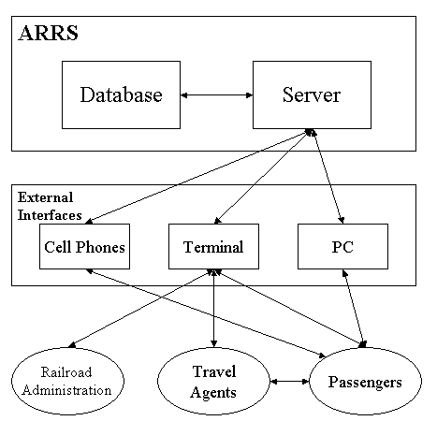
Inventory administration
vendors
Customers

Functions of System Components:

Database:
• Stores data
• Creates reports
• Provides access to data
• Updates information

Server:
• Provides access to the database
• Authenticates users
• Processes reservations
• Performs backups
• Produces reports

External Interfaces:

Terminal
• Users use terminals to access the server
• Passengers and travel agents use terminals to reserve the tickets and to get information about the available seats on particular trains.
• Railroad administration may use terminals to see the reports generated by the database software.

Personal Computers
• Users (passengers, travel agents, and railroad administration) may use personal computers to obtain a remote access to the server and the reservation database via the Internet.

Cell Phones
• Serve as a medium of accessing the server and the reservation database.
• Passengers may use cell phones and the latest telecommunication technologies to access the server and the reservation database via Internet, or they may use cell phones to call travel agents to inquire about railroad and ticket information.

Computer Hardware and Peripheral Equipment to be used:
• 30 workstations, which include CPUs, monitors, keyboards, and mice
• Printers
• Network
• Terminals
• Cell phones to test connection to the server via remote access

2.2 Product Functions
This section provides a summary of the functions that the software will perform.
2.2.1 Function Relationships
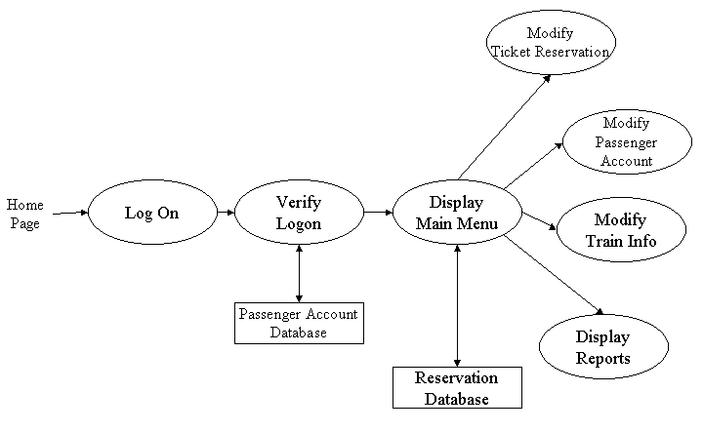
Figure 2.2 to 2.6 depict the relationships among the functions to be implemented by the system.
Figure 2.2 ARRS General Function Relationship/Higher Level Usecase Diagram
Customers

Vendors

Products

Categories of items

2.2.2 Function Descriptions (Functional Requirement Listings)

2.2.2.1 Log In Function

Description: This function ensures that only authorized users gain access to the inventory databases. An authorized user is a user who has an account on the system. Users include vendors, customers, and admins. The user must type a valid username and password to gain access.

2.2.3 Module 1: Customers

Description: This function allows the user to [Make | Drop | View | Update] a customer on a particular date.

2.2.4 Module 2: vendors

Description: This function allows the user to [Make | Drop | View | Update] a customer on a particular date.

2.2.5 Module 3: products

Description: This function allows the user to [Make | Drop | View | Update] a customer on a particular date.

2.2.6 Module 4: categories of items

Description: This function allows the user to [Make | Drop | View | Update] a customer on a particular date.

2.3 User Characteristics
The main users of the system will be the customers buying products, the vendors that process supply of products, and the inventory administration that access the reports generated by the system. The users are not required to have knowledge in the computer field. The graphical interface provides an easy way of using the inventory system with minimum of training.

2.4 General Constraints
The constraints for the project are:
- The functional prototype should be available after 30 days upon the arrival of the management team this may prove to be a serious time constraint on the development of a successful prototype.
- Communication with the team members may prove to be difficult since some developers do not speak Urdu and the management team does not speak English Even with the presence of a translator, communication may be difficult. Absence of the translator may severely affect project development.
- Team members are restricted from bringing their own equipment, and insufficient equipment supply may hinder project development.
- Team members are restricted to bringing only the analysts of the team to China. This might affect the project development if more people are needed or the required skills are not available.
- The majority of the population does not have or have a limited access to the Internet.
2.5 Assumptions and Dependencies or Business Logic
The assumptions for the project are:
- Ten trains transport the passengers between three cities known as Guangzhou, Shanghai and Nanjing. These trains originate only in cities Guangzhou and Shanghai, and they make a stop at Nanjing before arriving to their destination.
• There are five classes of tickets as listed below
  - Sleeping (soft) - compartment style coaches - 4 passenger per compartment
  - Sleeping (hard) - compartment style coaches - 6 passenger per compartment
- Reservation can be made up to one month before a particular trip.
- Seats are assigned during reservation.
- Phone reservation involves tickets being purchased within 24 hours after making the reservation. Otherwise, the reservation will be cancelled.
- No reservations can be made 48 hours prior to the trip. Rather, it will be done on a first come first serve basis from that point on.
- Passenger lists will be provided for conductors at each stop.
- The expected reservations during test period may amount to approximately 25,000 per day. This volume varies by hour, day, and season.
- Chinese Ministry will provide us with information about identification process used in China, so that it can be applied to the reservation system and scalping of tickets is avoided.
- Network connection will always remain established.

<ADD OOAD REPORT DIAGRAMS HERE>

3. Specific Requirements

This section of the SRS contains design requirements for the Inventory Management System.

3.1 Functional Requirements

3.1.1 Log in Function

- Description: This function ensures that only authorized users gain access to the Reservation databases. An authorized user is a user who has an account on the system. Users include customers, vendors. The user must type a valid username and password to gain access.

- Usage Scenario/ Use case Description/ Specification:

Description | Allows access to online inventory
Inputs | Username, password
Source | - User inputs username and password  - Press Login Button

Alternate case
Outputs | Successful login; unsuccessful login
Destination | None
Precondition | Authorized User
Post Condition | No change to Passenger Accounts Database
Side Effects | Failures and successful logins are sent to Reservation Database

- Use case Realization:

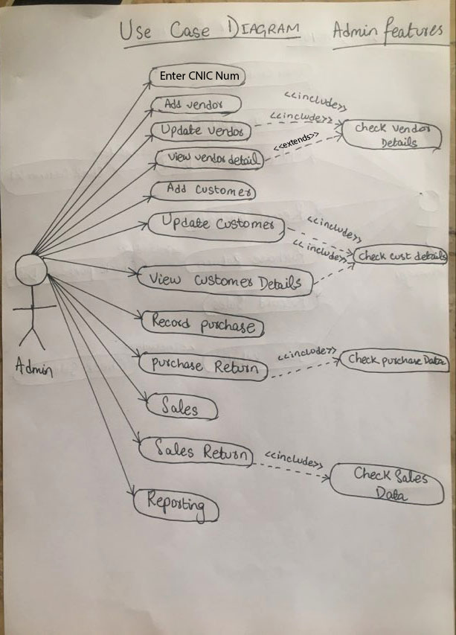

- Flow of Event or Data Flow Diagram for Login:

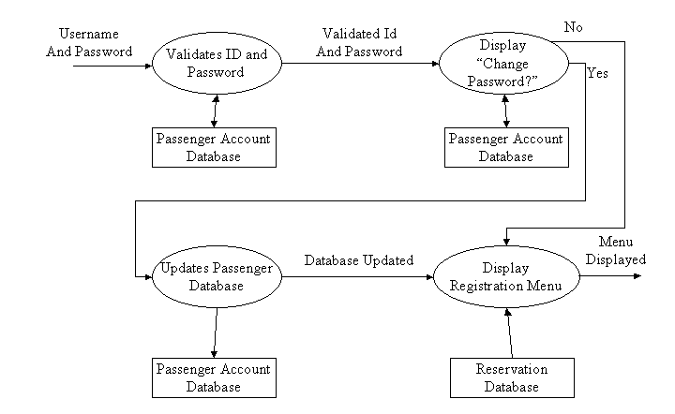

- Sequence Diagram :

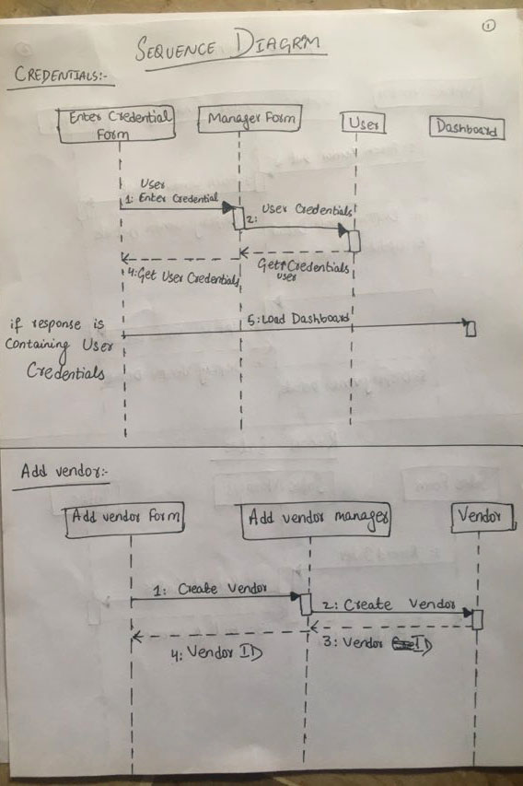

- Activity Diagram :

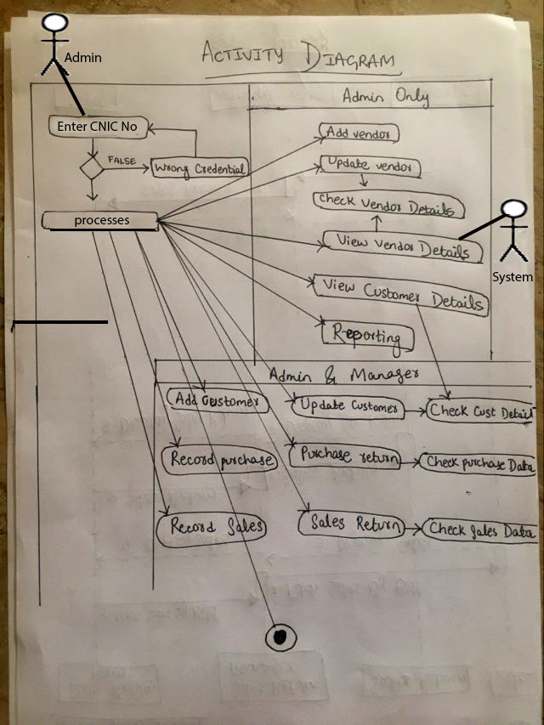

- Class Diagram:

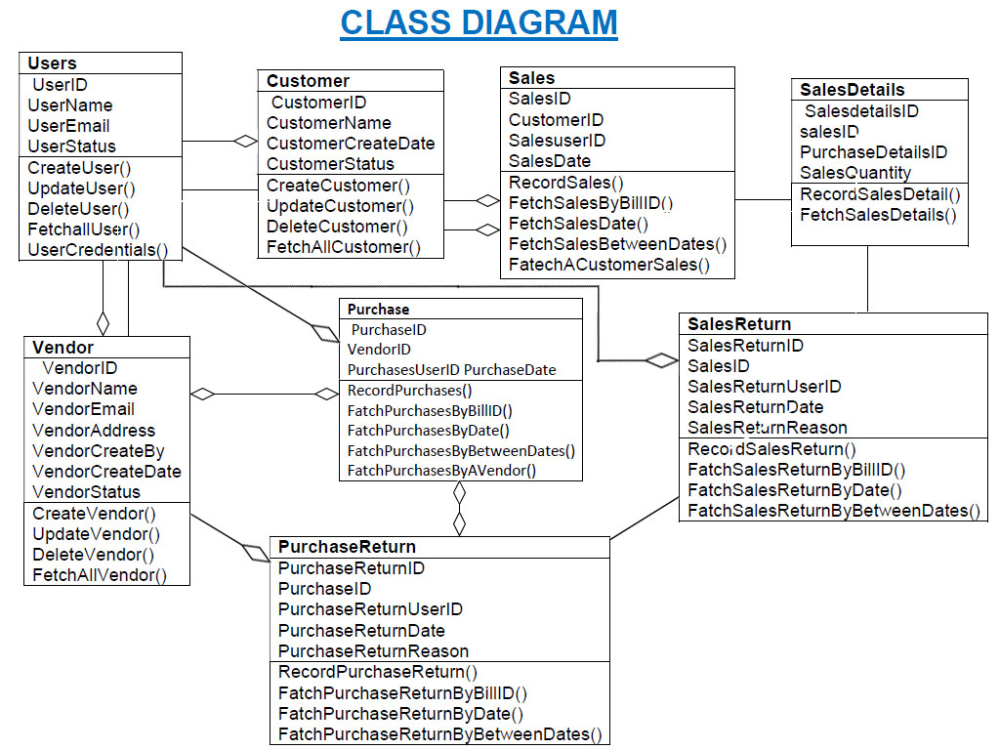

    - Module 1: CUSTOMER complete CRUD

- Description: This function allows the user to [make | drop | view | update] a CUSTOMER for a particular ITEM on a particular date. If the user does not already have a registration, then a new registration is created. If the user already has a previous item added, a new item is added to the list, and the customer account balance gets updated.

- Usage Scenario/ Use case Description/ Specification:

Description | [ make | drop | view | update] to the customer’s account
Inputs | Name of product, quantity of product
Source | - User inputs product, quantity, date and time  - Press Button …

Alternate Case
Outputs | Added | Deleted | Viewed | Modified customers
Destination | Computer screen  Reservation database  customer Account database
Precondition | Valid information; products and quantities available user does not have another registration at the same time
Post Condition | order added to customer account
Side Effects | User’s current order adjusted  Balance due adjusted

- Use case Diagram: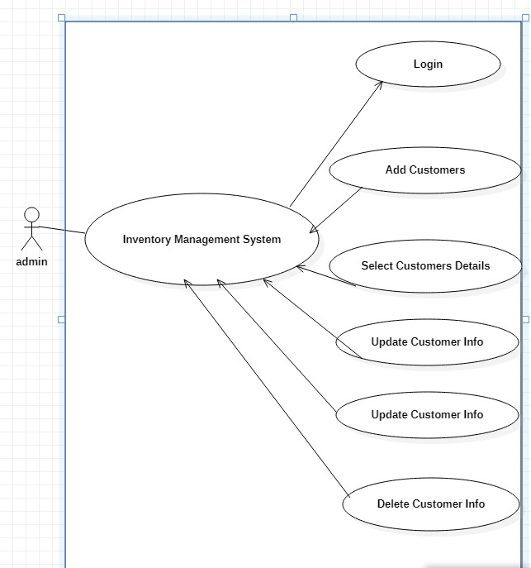

- Activity Diagram: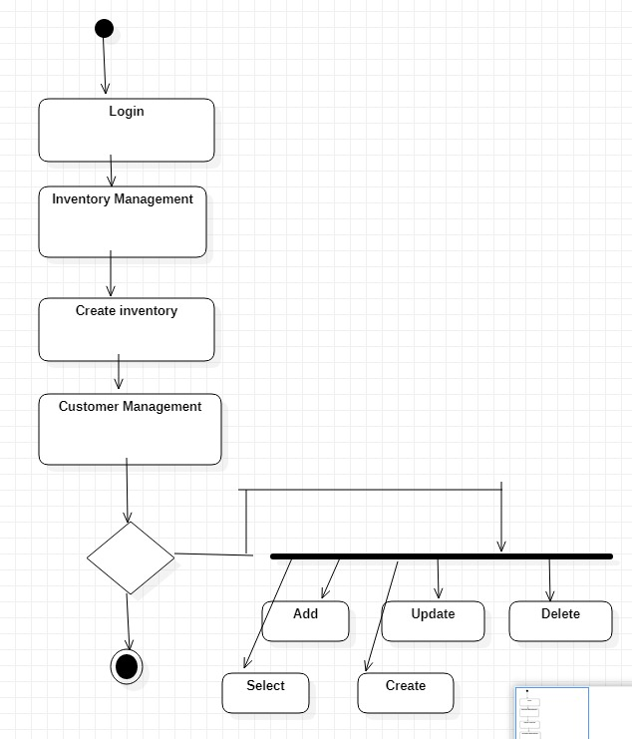

    - Module 2 complete CRUD VENDOR
- Description: This function allows the user to [make | drop | view | update] a vendor for a particular ITEM on a particular date. If the vendor does not already have a registration, then a new registration is created. If the user already has a previous item added, a new item is added to the list, and the vendor account balance gets updated.

- Usage Scenario/ Use case Description/ Specification:

Description | [ make | drop | view | update] a vendor to the user’s account
Inputs | Name of product, quantity of product
Source | - User inputs product, quantity, date and time  - Press Button …

Alternate Case
Outputs | Added | Deleted | Viewed | Modified vendors
Destination | Computer screen  Reservation database  customer Account database
Precondition | Valid information; products and quantities available user does not have another registration at the same time
Post Condition | items added to vendor account
Side Effects | User’s current items adjusted  Balance due adjusted

- Use case Diagram: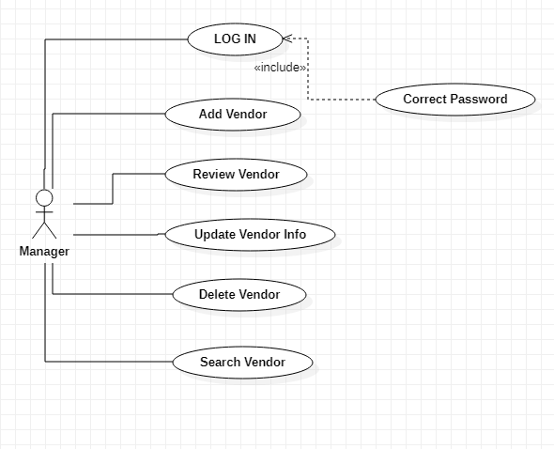

- Activity Disgram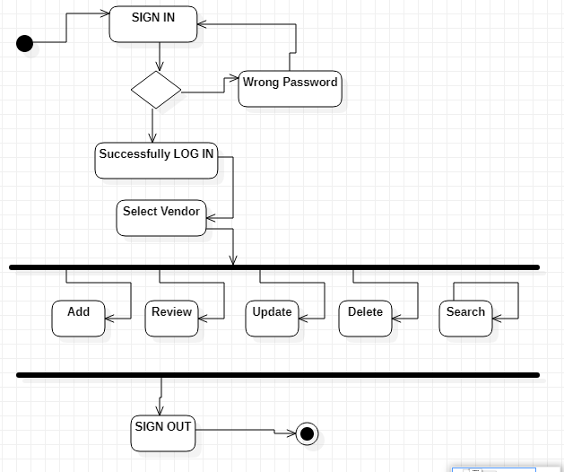

    - Module 3complete CRUD PRODUCT

- Description: This function allows the user to [make | drop | view | update] a product on a particular date. If the user does not already have a registration, then a new registration is created. If the user already has a previous item added, a new item is added to the list, and the customer account balance gets updated.

- Usage Scenario/ Use case Description/ Specification:

Description | [ make | drop | view | update] to the Product
Inputs | Name of product, quantity of product
Source | - User inputs product, quantity, date and time  - Press Button …

Alternate Case
Outputs | Added | Deleted | Viewed | Modified products
Destination | Computer screen  Reservation database  customer Account database
Precondition | Valid information; products and quantities available user does not have another registration at the same time
Post Condition | Item added to product
Side Effects | User’s current order adjusted  Balance due adjusted

- Use case Diagram: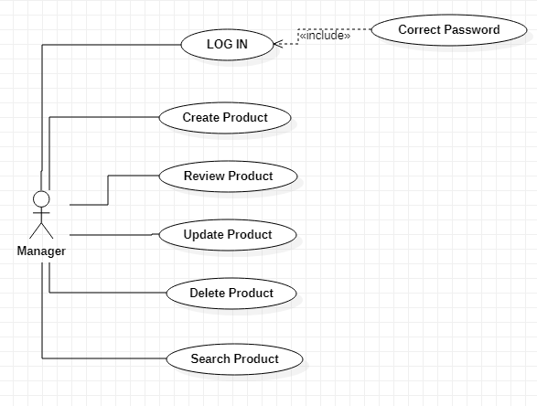

- Activity Diagram: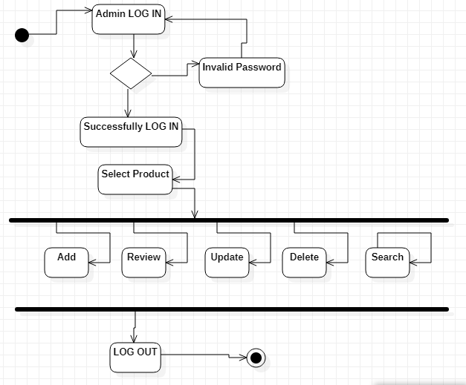

3.1.5 Module 4 complete CRUD CATEGORIES OF ITEMS

3.2. External Interface Requirements
3.2.1 User Interfaces

First the user interface is a login page .User first login in the inventory management system .Then he will do work on this management system.So login is a mandatory part or interface of this management system.

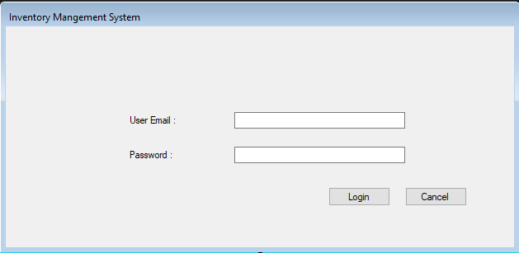
After done with login then use will switch towards add customer form and adding and inserting new customers into the system. For inserting new customers ,user have to insert some information regarding customers like name,date and status.

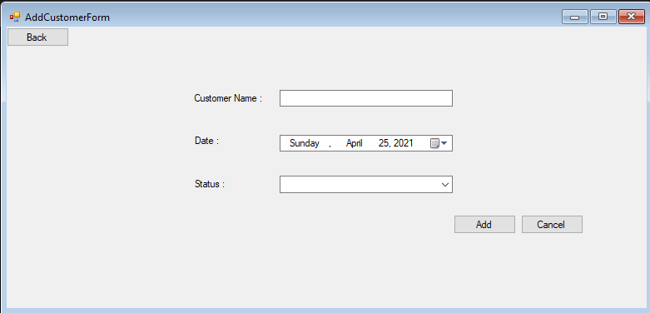
After that the user will add or insert vendor record into the system.For inserting vendor records user must required some data like name,email,address,date and status.

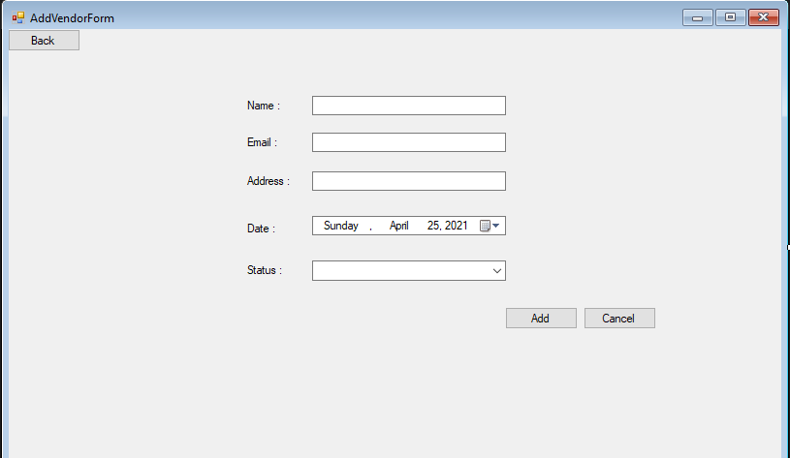

Further more ,there is a display form in which user can display customer data altogether and can view this data anytime.

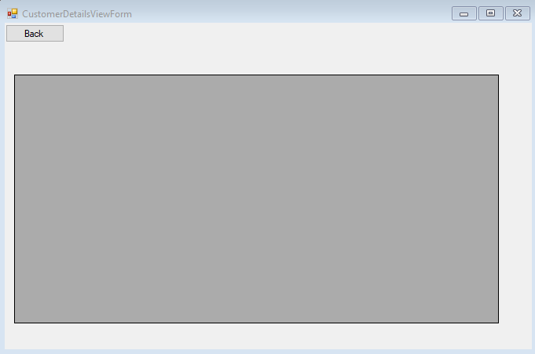

The following page allows the user to work and view them. Now, this page is part of Purchase , and it is used here to make purchasing details for the products selected. This makes it easier for the user since they do not have to go back to the main menu and to access their account.

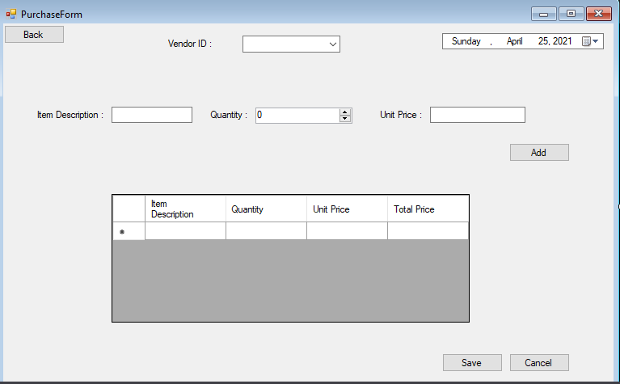

Finally, the save button displays the sales page as shown below with a button to go to the main menu.
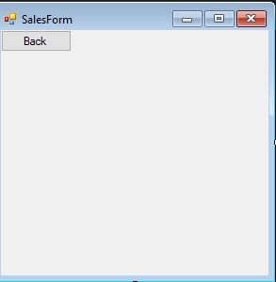

The above illustration has shown a brief overview of the user interfaces involved for the normal and clerk users. However, the Paf-Kiet have specifically requested a number of reports, and they must be able to adjust their product details at the time of purchasing. Therefore, the Paf-Kiet interface is able to access all functionalities . Once the Paf-Kiet selects the Reports function, all information will be appeared. And the user can update customer data . This is shown in the diagram below:

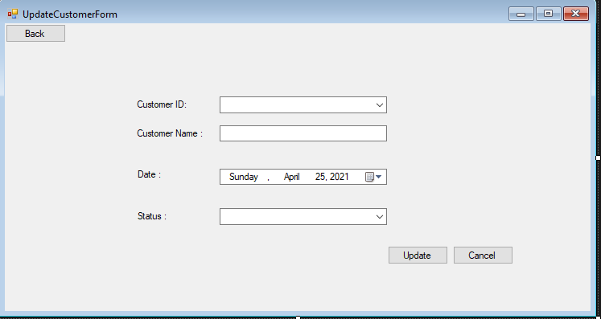

.The diagram below shows the vendor details view form:
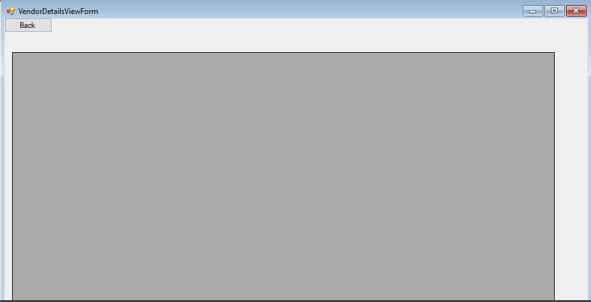

As mentioned earlier, the system can also be accessed through the wireless phones. In that case, the overall system will be the same as the above presentation except that the format will be simplified, since the phones do not have graphic support. The phones will have access to the purchasing ,however it is difficult to display the reports and all customer information on a small screen for the Paf-Kiet.

3.2.2 Hardware Interfaces
The ARRS includes two major hardware components: cellular phones and regular PC's. The cell phones require WAP (wireless application protocol) network protocol, which is already programmed in the latest phones.
The second component involves the regular PC’s, which communicate with the server. The server then communicates with the database. The protocol involved between the PC's and the server is the HTTP protocol, which allows communication between the PC's and the Server. The remote PC's, such as someone accessing the ARRS from home using the Internet, are able access the information through the CGI. The requests come in through the HTTP protocol, and using an ODBC the database results are returned and processed using Perl to give an HTML web page. The format of the output is displayed as web pages.

3.2.3 Software Interfaces
An Oracle DBMS will be used to manage the database and any changes made to it. Furthermore, the DBMS will make regular backups of the database and generate reports regularly so that they can be accessed by the Paf-Kiet. The Apache server between the client and the database will handle all communication, and the server will run on a Linux operating system. Furthermore, the HTML pages must be implemented such that they can be displayed on two common browsers: Netscape and Internet Explorer.

Information about the products used for the ARRS:

(1) Name: Oracle
(2) Mnemonic: Oracle
(3) Version Number: ?
(4) Source: Oracle

(1) Name: Linux
(2) Mnemonic: Linux
(3) Version Number: 6.2
(4) Source: Unix

(1) Name: Internet Explorer
(2) Mnemonic: IE
(3) Version Number: 5.00
(4) Source: Microsoft

(1) Name: Apache
(2) Mnemonic: Apache
(3) Version Number: 1.3.14
(4) Source: Apache Software Foundation

3.3 Performance Requirements
The following sections list the performance requirements for the system.

3.3.1 User Requirements

User Requirements | Description of Requirement For Design Environment
Location(s) and Number(s) of Users | Karachi,Pakistan
Expected Growth in Number of Users
After 1 Year | 50%
After 2 Years | TBD
After 3 Years | TBD
User Expectation
Interactivity | User expect that it provides a very easy to use graphical user interface
Reliability | For some applications, reliability must be 100% during the application session
Adaptability | Network must adapt to user additions, deletions and changes
Security | Encryption software would be used for Credit Card transactions
Cost / Funding | Less than $250K

3.3.2 Application Requirements

Since no specified service is indicated, then we have listed the applications as best – efforts. This may change as we learn more about the application.

The communication package is determined to be bursty in nature, with small data sizes and frequent transmissions. We can consider this application to be interactive-burst, while the database transaction-processing application is described by the Paf-Kiet as transferring large amounts of data (initial estimates are 1 MB/transaction), we have listed this application as interactive-bulk.

Categorizing  Applications | Best-Efforts | Application  Locations
Communication | 100 Kb/s | Karachi,Pakisatn
Database Access | 400 Kb/s | All Locations
Database Transaction processing | 1.5 Mb/s | All Locations

3.3.3 Host Requirements

 | Type of Host or  Equipment | Numbers and  Locations
Host A | PC | Karachi (10), Islamabad(7), Lahore(10)
Host B | Database Server | Islamabad
Host C | Application Server | Lahore

3.4.1 Standards Compliance
There are no design constraints that can be imposed by other standards limitations.

3.4.2 Software Limitations
• must be able to run Internet Explorer or Netscape Communicator web browsers to access the system.
• must have cell-phone web based capability to access the system from a mobile phone.

3.4.3 Hardware Limitations
• Input/Output: One or two-button mouse, keyboard, cell-phone, or touch screen required.
• Network card required at thin-client terminals to make communication with server possible.

3.5 Quality Characteristics
There are a number of quality characteristics that apply to the ARRS software system.

3.5.1 Portability
The ARRS system will be developed using HTML and Java so that it can be accessed from any type of system using just a regular web browser. It will also be available to users that have web access on their cellular phones. The system will be tested on all types of hardware before being released to ensure that is it compliant with this requirement.

3.5.2 Reliability

The system should be capable of processing a given number of purchasing within a give time frame with no errors and the system should be available and operational all the time. During the development of the prototype for the 3 cities, the system will be tested in its actual environment to ensure that it can handle the load of reservations that occur during a regular workday.

3.5.3 Usability
The ARRS system will be developed so that it is an easy to use system that requires the least amount of user input possible. Every input will be validated. The user should only have general computer use knowledge. Error messages will be displayed if the user enters an invalid value or tries to access a function without the required permissions. An easy and well-structured user manual will be provided to the Paf-Kiet and the system will include descriptive help for all operations allowed.
3.5.4 Correctness
The ARRS system will be considered correct when the Paf-Kiet approves the prototype presented and agrees that all the functions they require are implemented as stated in the Software Requirements Specification.
3.5.5 Flexibility
The ARRS system should be developed in such a way that it is easily customizable. If new functions are required by Paf-Kiet, there will be little effort required to update the system to support new cities or new transactions.
3.5.6 Security

The ARRS system should not compromise the customer information at any time. The user information will never be sold to other parties and will be kept secure at all times. Users will be authenticated to ensure that no unauthorized users gain access to private information.

3.5.7 Maintainability
The ARRS source code will be kept well structure and documented so that it is easier to maintain and extend the system. All changes to the system shall be documented.

3.6 Other Requirements
Certain requirements may, due to the nature of the software, the user organization, etc., be placed in separate categories such as those below.

3.6.1 Data Base

The Inventory Management System will have one main database. One is the inventory Database. These database will be created with Oracle8i (Client/Server) version 8.1.6.0.0 Release 2. The following are the requirements for these databases that are to be developed as part of the product. They include:

Inventory Database
Types of information | Schedule information for the purchasing, customers and vendors
Frequency of use | Depends on the vendor demand, which may reach 25,000 per day during peak periods
Accessing capabilities | The database should allow access to at least 1,000 people at once; the users will have a general access to the information about the purchasing schedule, and a secure access to the reports (available only to Pa-Kiet officials) using a username and a password
Data element and file descriptions | To be determined
Relationship of data elements, records and files | To be determined
Static and dynamic organization | To be determined
Retention requirements for data | Purchasing schedule information will be available as for long time. The reports information will be available at least for 5 years

3.6.2 Operations
The normal operations required by the user can be viewed as the following:
User-initiated Operations:
These operations include the login operation, which is initiated by the users. Also, the process of becoming a new user is in this category. Building, changing, and viewing itineraries, as well as paying for the itinerary are all initiated by the users. The user initiates the report generation activity, as well as changing train schedules.
Interactive Operations and Unattended Operations:
The users initiate all the operations mentioned above, and almost all of them are somehow interactive. Displaying the train schedule is non-interactive. The report display is a non-interactive operation, although selecting the desired reports will require user input.

Data Processing Support Functions:
The user account data is used to create new accounts, as well as to validate user id's during login functions. For building itineraries, user input, user account data, and train schedule data are used, and processed. User data along with final results of user interaction. Administrative users' inputs are collected in order to modify and present schedules.
Backup and Recovery Operations:
Both databases used (inventory database) is production database. The main operation used for the backup and recovery is Oracle's built-in cold backup, which is also known as the "archive mode". Depending on the customer's needs and budget, additional redundancy can be added using systems like RAID 5 and tape backup.
3.6.3 Site Adaptation Requirements
There are no site adaptation requirements for this project.

4. Supporting Information.
There is no supporting information required for this project.

<Insert your checked github by individual Members here>
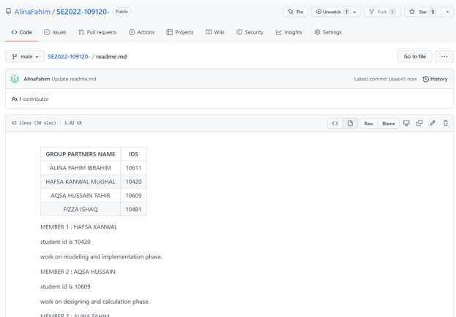
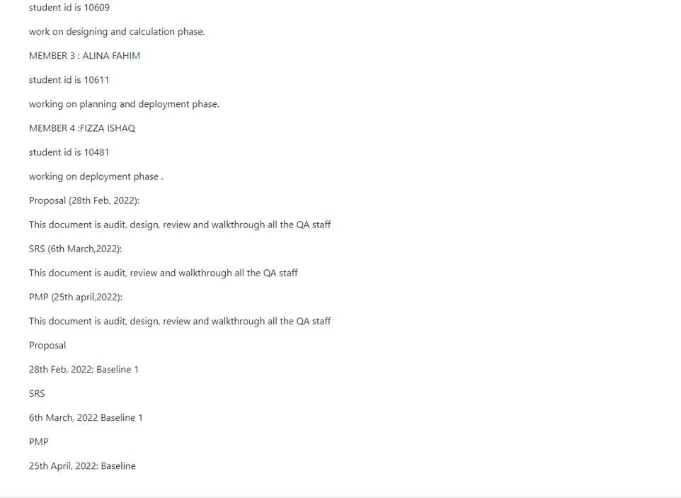
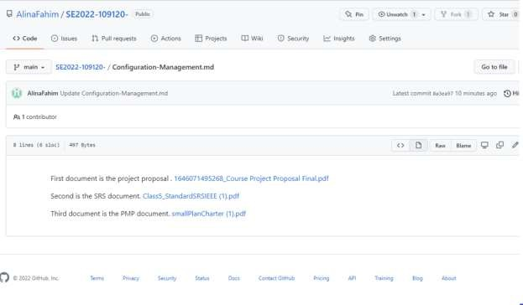
Github repository link: https://github.com/AlinaFahim/SE2022-109120-

HAFSA KANWAL_10420
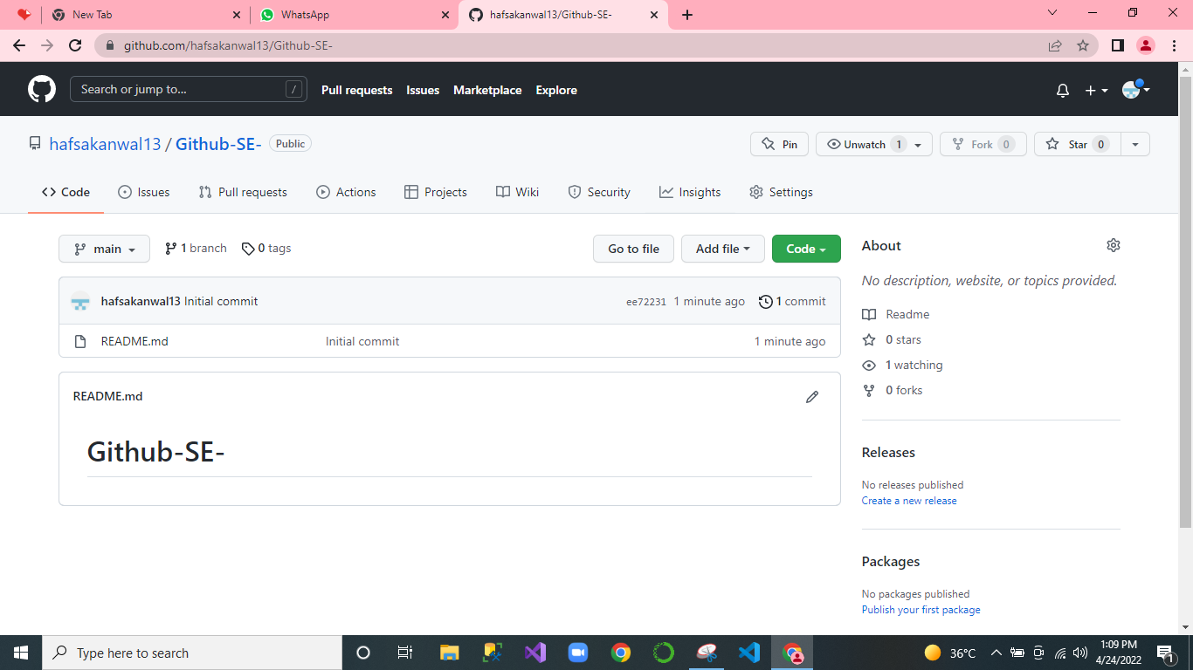

ALINA FAHIM_10611

AQSA HUSSAIN_10609

FIZZA ISHAQ_10481
- PROJECT MANAGEMENT AND RISK MANAGEMENT
Page VI
<Copy and Paste PMP document here, clearly mention individual member’s names in bracket in front of each heading >

Project Management Plan/Charter

By: Syeda Umema Hani

Project Management Plan:
GI’s HRPRL
PROJECT MANAGEMENT PLAN TEMPLATE

Date: 4/December/ 2021 Release #: 1st
Project Manager: Syeda Umema Hani
Approvals:

Project Manager

State Organization Management User
Management- HR

Department of Finance Other:
- Project Summary (hafsa)
Information in the project summary areas was started during the project concept phase and should be included here.

Project Name: Start Date:
Inventory Management system
01/March/2022

State Organization::

Submitted by:

Prime Contractor:
Aqsa Hussain
PAF Kiet University

Date Awarded:

Current Stage of Project:
Yes:
Comments: Project is going within the budget.
Development Life Cycle - RAD
17/May/2022
University

Project is On Schedule:
Yes
Details: Project will be delivered on time.
Project is within Budget:

Project Summary – Continued (alina)
Points of Contact (Stake holder)
This should be the list of individuals that will be involved with the project during the execution phase.
Position | Name/Organization | Phone | E-mail
Project Manager | Dr. Umema Hani/ PAF KIET |  | Dr.umema@pafkiet,edu,pk
Sponsor | PAF KIET
Customers: | Companies carrying Goods
Other Stakeholders: | Hafsa Kanwal | +92-333-3555784 | mughalkanwal8@gmail.com
 | Aqsa Hussain | +92-317-2831696 | haqsa2216@gmail.com
 | Alina Fahim | +92-316-2512299 | alinafahim761@gmail.com
 | Fizza Ishaaq | +92-334-3271978 | Fizzaishaq3@gmail.com

Project Charter(hafsa)
Business Problem.
All projects start with a business problem/issue to solve.

Conduction of business tasks manually, lack of efficiency, low performance time consuming activities.

Statement of Work (Goal).
The statement should be short and to the point. It should not contain language or terminology that might not be understood.

This product aims to replace the current manual system with the automated solution. The main system will comprise of 6 major sub-systems or Modules the integration of theses sub-system will form the main system. All the sub-systems will be tightly integrated so as to give unanimity to user. The current client setup does not have any automation. Therefore, every department and the section will be developed from scratch as all departments are currently working manually. In this document we are covering “Inventory Management System” only.
- Module 1 Login
- Module 2 Customers
- Module 3 Vendors
- Module 4 Products
- Module 5 Categories of items

2. Project Charter, continued(hafsa)
Project Objectives:
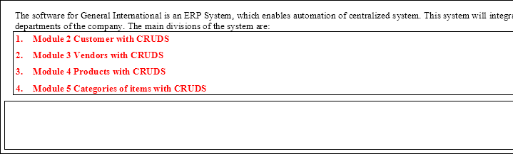
Provide a brief, concise list of what the project is to accomplish.

Success Factors:
List factors that will be used to determine the success of the project.
- Complete deployment of all 4 modules
- Smooth integration between all systems
- A Tested Product

Project Dependencies/Constraints:
- Project completion is expected in less than 3.5 months duration
- All requirements will be 100% available during requirement phase
- Maximum team strength 4,
- Average loading = 4 ,
- 16(4+4+4+4) = E <Write only one after calculating from COCOMO model>

Project Tradeoff Matrix & Status Summary

Schedule/Time | Scope/ Modules | Resources/Effort/People
CONSTRAINED | CONSTRAINED  / ACCEPTED | CONSTRAINED / Need to be IMPROVED (need reduction) / ACCEPTED  (Cocomo Effort = 10 -15 not acceptable our constraint is max 4 members in 3 months)
 |  | E = 16, S = 7.182, per month 2 persons, 3 months 5 to 6 persons = est 7 person
Identify variable to be CONSTRAINED, IMPROVED, ACCEPTED

Comments:

Accepted

Project Organization(fizza)
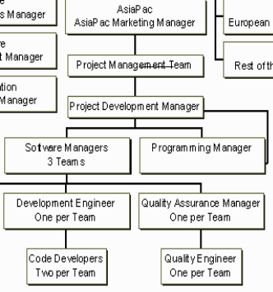

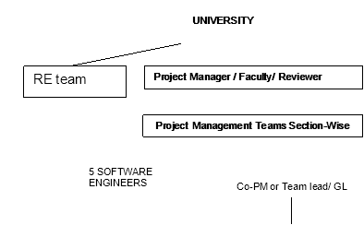
Provide an organization chart that defines the person responsible for at least the following functions: project manager, development manager, quality assurance, and configuration management.
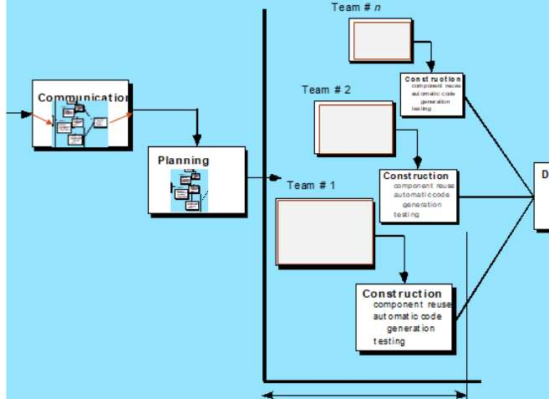
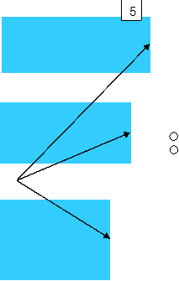

SDLC Process Model:

Activity List (Work Breakdown Structure)(aqsa)
B) B) Unadjusted Function Point Value calculation
Definition of Complexities: Your Transactions which are derived from only from 1 Table are to be categorized as Low and if they are derive from 2 tables they can be categorized in Mid-level complexity, and in case of >= 3 they will be placed under High level of complexity.
 | Count for | Multiplier | V1 | Count for | Multiplier | V2 | Count for | Multiplier | V3 | Category
 | screens of | Low level | = | screens of | Mid-level | = | screens of | High-level | = | wise sum
 | Low level | complexity | C | Mid-level | complexity | C | High-level | complexity | C | V1+V2+V3
 | complexity | (M) | * | complexity | (M) | * | complexity | (M) | *
 | (C) |  | M | (C) |  | M | (C) |  | M
EI | 3 | 3 | 9 | 1 | 4 | 4 |  | 6 | - | 13
EO | 3 | 4 | 12 | 1 | 5 | 5 |  | 7 | - | 17
EQ | 3 | 3 | 9 |  | 7 | - | 1 | 6 | 6 | 15
ILF | 3 | 7 | 21 | 1 | 0 | 0 |  | 15 | - | 21
ELF | 0 | 5 | 0 |  | 7 | 0 | 1 | 10 | 10 | 10
Unadjusted Function Point Value = |  |  |  |  |  |  |  |  |  | 76

Provide an activity list (work breakdown structure) that describes each task required by the project, with a reference to the statement of work. For large projects, work packages might be included that describe in detail how specific tasks will be completed by specific project teams. These work packages describe required schedule, identify requirements to be completed and describe specific work to be performed
- First Estimating FP then from it E and S. <Correctly Re calculate for your Project>

Software Size Estimation using Function Point Method
 | A) A) Detail of 5 Transaction Types, at most 5 under each category
 |  | Write down exact Screen or Forms names, or Tables, or Reports name for each count value.
 | EI | 1. | user | 2. M2 | 3. M3 | 4 | M4 |  | 5. M5
 | EO | 1. | user | 2. M2 | 3. M3 | 4 | M4 |  | 5. M5
 | EQ | 1. | user | 2. M2 | 3. M3 | 4 | M4 |  | 5. M5
 | ILF | 1. | user | 2. M2 | 3. M3 | 4 | M4 |  | 5. M5
 | ELF | 1. | - | 2. - | 3. - |  |  | 4. | - | 5. -
 | C) Value Adjustment Factor (VAF) calculation

Note: Calculate Value Adjustment Factor, where any 5 "General System Characteristics (GSC) must have a value above
2. Also show respect Quality Characteristic mapping of these 5 factors.
 |  |  | Quality Characteristic | Weight (0-5) |  | Quality Characteristic | Weight (0-5)
 | 1. |  | Data Communication | 4 | 8. | Online Update | 0
 | 2. |  | Distributed Data Processing | 3 | 9. | Complex Processing | 2
 | 3. |  | Performance | 3 | 10. | Reusability | 1
 | 4. |  | Heavily used Configuration | 1 | 11. | Installation Ease | 0
 | 5. |  | Transaction Rate | 5 | 12. | Operational Ease | 3
 | 6. |  | Online Data Entry | 3 | 13. | Multiple Sites | 0
 | 7. |  | End User Efficiency | 2 | 14. | Facilitate Change | 1
 | Value Adjustment Factor (VAF) = 28
D) Technology Complexity Factor calculation

TCF = 0.65 + (VAF * 0.01)
= 0.65 +(28*0.01)
= 0.93
E) Adjusted Function Point Value (AFPV) or Function Point Value (FP) Calculation

AFPV = _ Unadjusted Function Point * TCF
= 76 * 0.93
= 70.68
F) Conversion of AFPV in to LOC Size metric

the number of LOCs per FP for C# language 54 and check other languages from https://www.qsm.com/resources/function- point-languages-table, ASP 51 and VB.net 52, python 48

Project Size in LOC = AFPV * LOC/FP
Project Size in LOC = 70.68 * 54 = 3816.72 LOC
G) Software Size: 3816.72
Software Size for COCOMO: 3.816 KLOC
Software Type: Business/ Utility/Embedded
Model Mode: Cocomo I – Basic – ORGANIC (0 – 50 KLOC) / Semi detached/ Embedded
a) a) Effort Estimation: Equation
3.0 * 3.816 ^ 1.12 = E = 13 persons month
b) b) Schedule Estimation: Equation 2.5 * E ^ 0.35 months = S = 6 months
 | c) c) | Productivity Estimation: Equation

Loc/E = 293.5
d) | d) Average Loading Estimation: Equation E/S =2
e) | e) Average Salary of Technical Staff (AS): Equation Assume = 50,000 RS
f) | f) Cost for Salary (Cs): Equation E * Avg salary = 650,000
g) | g) Budgeted Cost of Project (Cb): Equation Cs + Cs * X% = 975,000
- Calculate the phase-wise percentage distribution wise E and S values as given in detailed COCOMO detailed model.
H) Distribution of Effort and Schedule among Different phases of SDLC
E = 13 S = 6
Plan and Requirement (E | S) |  | Modeling / System Design & Detailed Design (E | S) |  | Module Coding and Unit Testing (E | S) |  | Integration & D
0.06 * 13 = 0.78 | 0.10 * 6 = 0.6 | (0.16+0.26) * 13 =5.46 | (0.19+0.24) 6  =2.58 | 0.42 * 13 =5.46 | 0.39 * 6 =2.34 | 0.16 * 13 =2.08

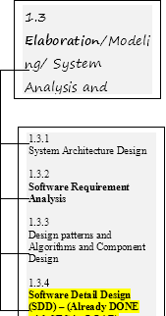
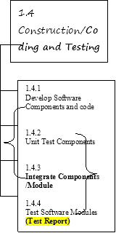
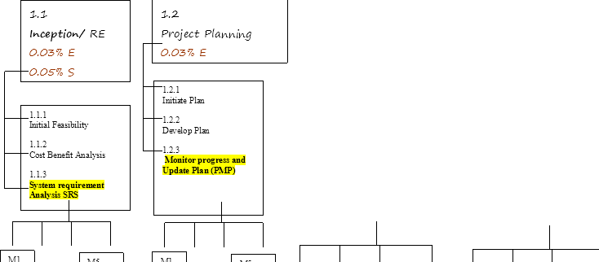
- Now adding percentage distribution as given in detailed COCOMO model in the WBS phase-wise. <Write exact E/S values after multiplying with distribution percentages>(fizza)


Now convert above WBS contents in a Tabular format in order to make a GANTT CHART. <Complete>
22 days are taken from COCOMO detailed model’s Schedule Distribution done in Class for Project Planning and Requirement Engineering Phase. Where 40% of 22 goes in RE and 60% in Planning.(aqsa)
ActivitActivity Name y #
Activity Name Description
# of Day s
Start Date
RE
Requirement Engineering
6-758/2/2022
Dependenc y on previous tasks
none
Mileston e
1.1
16/2/202
2
Initial Feasibility
Cost Benefit Analysis 1.1.3
1.1.3.1
1
2
3
3
1.1.3.2
System requirement Analysis SRS
System requirement Analysis SRS for Module 1
System requirement Analysis SRS for Module 2
System requirement Analysis SRS for Module 3
System requirement Analysis SRS for Module 4
System requirement Analysis SRS for Module 5
Merging of all parallel Modules 1,2,3,4,5
Milestone (SRS) and Review meeting
Project Planning
3
1.1.3.3
3
1.1.3.4
3
1.1.3.5
3
1.1.3.6
1.1.4
1.2
Project Management
1-2
0
14
Day
5/4/20221.1
20/4/202
2
 |  | Planning | s
1.2.1 | Planning For Module 1
1.2.2 | Planning For Module 2
1.2.3 | Planning For Module 3
1.2.4 | Planning For Module 4
1.2.5 | Planning For Module 5
1.3 | Modeling | Done in SRS now ERD with Implementatio n | 7  Day s | 21/4/202  2 | 1.2 | 26/4/202  2
1.3.1 | Modeling For Module 1
1.3.2 | Modeling For Module 2
1.3.3 | Modeling For Module 3
1.3.4 | Modeling For Module 4
1.3.5 | Modeling For Module 5
1.4 | Implementation and Testing | Database and Code, Test Report | 10  Day s | 27/4/202  2 | 1.3 | 6/5/2022
1.4.1 | Imp & Testing For Module 1
1.4.2 | Imp & Testing Module 2
1.4.3 | Imp & Testing For Module 3
1.4.4 | Imp & Testing For Module 4
1.4.5 | Imp & Testing For Module 5
1.5 | Deployment/Dem o | Demo and Report | 10  Day s | 10/5/202  2 | 1.4 | 20/5/202  2
1.5.1
1.5.2
1.5.3
1.5.4
1.5.5

Work Product Identification (alina)
Provide a list of all deliverables required by the project, the date due and the person responsible for the deliverable. Pick Last activities from each phase they are deliverables. <Complete>

Deliverable Name | Due Date | Date Delivered | Point of Contact
SRS by Member 1 (AQSA) | 19/03/2022 | 5/03/2022 | 10609
SRS by Member 2 (ALINA) | 19/03/2022 | 5/03/2022 | 10611
SRS by Member 3 (HAFSA) | 19/03/2022 | 5/03/2022 | 10420
SRS by Member 4 (FIZZA) | 19/03/2022 | 5/03/2022 | 10481
PMP by Member 1 (AQSA) | 26/04/2022 | 26/04/2022 | 10609
PMP by Member 2 (ALINA) | 26/04/2022 | 26/04/2022 | 10611
PMP by Member 3 (HAFSA) | 26/04/2022 | 26/04/2022 | 10420
PMP by Member 4 (FIZZA) | 26/04/2022 | 26/04/2022 | 10481
Design (DB+GUI) by (AQSA) | 17/05/2022 | 10/05/2022 | 10609
Design (DB+GUI) by (ALINA) | 17/05/2022 | 10/05/2022 | 10611
Design (DB+GUI) by (HAFSA) | 17/05/2022 | 10/05/2022 | 10420
Design (DB+GUI) by (FIZZA) | 17/05/2022 | 10/05/2022 | 10481

SCHEDULE
Provide the project schedule, using a Gantt chart. The schedule must include milestones, task dependencies (predecessors), task duration, work product delivery dates, quality milestones (reviews/audits/inspections), configuration management milestones, and action items (with deadlines and responsibilities). (in order to keep the project (T | C |S) in CONTROLL.
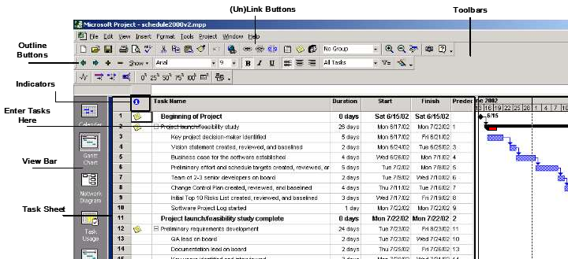
<MUST IMPLEMENT GANTT CHART ON ANY SOFTWARE OR WEBAPPLICATION>
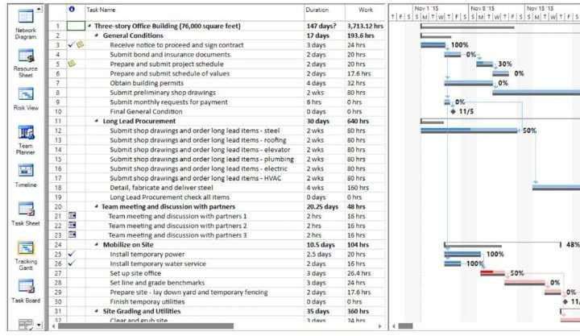
<Add % completion in it after submission of PMP expected on 18/12/2021, and also paste screen capture of Tracking Gantt Chart view>

Estimated Cost at Completion
Provide an estimated cost at completion, which is an assessment of the total effort at completion of the contract.
Analysis in Hours / Cost
WBS No. | Activity Description | Budget Hours  B | Actual Hours  A | Est. to Complete the remaining work – milestone-wise  ETC B - A  EAC – A | Est. @ Completion  EAC  A + ETC | Variance (+ = V = (A-B/A)
1st |  | 8 | 40 | 60 – 40 = 20 | 40 + 20 = 60 | (-1 -- 0 -- +1)
milestone |  | working days |  |  |  | ( 40 - 60)/ 40
 |  | 60 |  |  |  | Under the bu 50V
 |  |  |  |  |  | 60-60 / 60 = 0
 |  |  |  |  |  | 100% comple
 |  |  |  |  |  | (70 – 60)/70 =
 |  |  |  |  |  | Ahead of bud
 |  |  |  |  |  | 14V
2nd |  | 60 | 40 | 60 – 40 = 20 | 40 + 20 = 60 | ( 40-60)/ 40 =
milestone |  |  |  |  |  | Under the bu
 |  |  |  |  |  | 60-60 / 60 = 0
 |  |  |  |  |  | 100% comple
 |  |  |  |  |  | (70 – 60)/70 =
 |  |  |  |  |  | Ahead of bud

%remaining

Resource Loading Profiles – Staffing(alina)
Provide a staffing plan that shows the number of personnel, by type, that will be required on the project on a monthly basis.

Resource Loading Profiles
E = 13 S = 6

Avg Loading = 2 person per month

Since loading gives same value of effort for all months, therefore, we have used Detailed COCOMO’s Effort di already done in part 5.2
Plan and Requirement |  | Modeling / System Design & Detailed Design |  | Module Coding and Unit Testing |  | I
0.06 * E = 0.78 | 0.10 * S = 0.6 | (0.16+0.26) *  E = 5.46 | (0.19+0.24)  S = 2.58 | 0.42 * E =  5.46 | 0.39 * S =  2.34 | 0.16 *  2.08
Designation: PM, BA, Domain Expert = 0.96 (Aqsa Hussain) |  | BA, Analyst, Domain Expert = (Alina Fahim) |  | Coders and Testers (Hafsa Kanwal) |  | Senio Ishaq)
Job Description: Assisting in building SPMP, SRS and prototype, as well as doing the necessary requirement and risk analysis for the project |  | Job Description: Assisting in building SPMP, SRS and prototype, as well as doing the necessary requirement and risk analysis for the project |  | Job Description: assisting in building SPMP, SRS and prototype, as well as doing the necessary requirement and risk analysis for the project |  | Job D Assist SPMP  protot doing requir analys
Contact  information: haqsa2216@gmail.com, 03172831696 |  | Contact information: alinafahim761@gmail.com, 03162512299 |  | Contact information: mughalkanwal8@gmail.com, 03333555784 |  | Conta fizzai 03343

11. Risk Identification(fizza)
Top 10 Risk Items
Risk Items | Risk Management Techniques
Personnel Shortfalls | Staffing with top talent, job matching; team building; morale building; cross train key people
Unrealistic schedules and budgets | Detailed, multi-source cost and schedule estimation; design to cost; incremental d software reuse; requirement scrubbing
Developing the wrong software functions | Organizational analysis; mission analysis; ops-concept formulation; user surveys; users' manuals
Developing the wrong user interface | Task analysis; prototyping; scenarios; user characterization (functionality, style,
Gold Plating | Requirement scrubbing; prototyping; cost-benefit analysis; design to cost
Continuing stream of requirement changes | High change threshold; information hiding; incremental development (defer chan increments)
Shortfalls in externally furnished components | Benchmarking; inspections; reference checking; compatibility analysis
Shortfalls in externally performed tasks | Reference checking; pre-award audits; award-fee contracts; competitive design o building
Real-time performance shortfalls | Simulation; benchmarking; modeling; prototyping; instrumentation; tuning
Straining computer-science | Technical analysis; cost-benefit analysis; prototyping; reference checking

Provide a description of all risks identified for the project. A risk is anything that might detrimentally affect the successful completion of the project if left unaddressed. The contractual, management, and technical risks associated should be identified and assessed as to the probability of the risk occurring, the cost to correct if the risk occurs, the impact of the risk on the project, and the suggested mitigation activities and cost of mitigation.

Risk Worksheet

Risk Management Steps:

1 | Identify the project’s top10 risk items
2 | Present a plan for resolving each risk item
3 | Update list of top risk items, plan, and results monthly
4 | Highlight risk-item status in monthly project reviews. Compare with previous month’s ranking status
5 | Initiate appropriate corrective actions

Potential Risk
capabilities

Risk Monitoring
Risk Management and
Risk Exposure
Prioriti

Preventive measures
mitigation
= Probability of Risk
Till nex

Occurrence * Cost of Review

- Size of the software being very large and larger number of users than planned due to using eval SDLC and no confirmation of Requirements in RE phase. (Fp→Loc→Effort)
- The software not being accepted by the CRM

- Cost factor involved in this project

- Customer requirements may change

- Technology will not meet expectation

- Lack of training on tools and staff being inexperienced

- The prototype not being delivered on time

Reviewing constant feedbacks from the customers in project meetings

Response from the CRM, reviewed on every project meeting

Reviewing reports on expenditure and other cost related to the estimated cost in the SPMP
CRM participation in design process and reviewing feedback information in group meetings
Constantly reviewing project progress reports by Project Development Manager and software managers
Reviewing progress report by software managers to determine the status of the project
Constant reviews among team members to ensure continuous progress on the prototype

Being flexible in the software design to accommodate the necessary changes

Early and intensive interaction with the customer for the success of project.
Have additional funding allocated for it in advance and using it in case of emergencies.

A new prototype will replace the previous one to accommodate the change

Exploring alternatives for the outdated technologies

Providing adequate training that is necessary for the completion of the project
Setting deadline before the actual time for submission of the project
Risk
Cost * Probability of Risk Occurrence
= Salary for 2 programmer for 1
month * 0.8
= 60000 *0.8 | 0.4
=48000 | 24000

  - Configuration Management Plan(hafsa)
Provide a configuration management plan that defines the person responsible for project configuration management, the procedures that will be used, the planned configuration items, planned release dates for configuration items, and resources required to conduct CM.

CCB members: Aqsa Hussain , Alina Fahim, Hafsa Kanwal, Fizza Ishaq

Configuration Items: Ensure that CM is implemented throughout the project’s life cycle.
No. | Item | Comments
1. | Proposal | 28th Feb, 2022: Baseline 1
2. | SRS | 6th March, 2022 Baseline 1
3. | PMP | 25th April, 2022: Baseline

Ensure that project has a repository for storing configuration items and associated CM records. Briefly describe.
Git hub repository

Quality Plan(alina)
Provide a quality plan that defines the person responsible for project quality assurance, the procedures that will be used and resources required to conduct quality assurance.
QA Manager and Staff:
Manager: Aqsa Hussain that responsible for project quality Staff: Alina Fahim, Hafsa Kanwal, Fizza Ishaq

Planned Quality Event: Ensure that QA is implemented throughout the project’s life cycle.
Dates include QA audits and reviews, design walkthroughs and other project activities that QA staff will participate in.
No. | Item | Comments
1. | Proposal (28th Feb, 2022) | This document is audit, design, review and walkthrough all the QA staff
2. | SRS (6th March,2022) | This document is audit, review and walkthrough all the QA staff
3. | PMP (25th april,2022) | This document is audit, design, review and walkthrough all the QA staff

Ensure that project has a repository for storing configuration items and associated QA records. Ensure that QA audits the baselines and CM activities on a regular basis.

- MODELING (ANALYSIS & DESIGN)
Page VII

- Architecture diagram (3 Tire) – Done in SRS
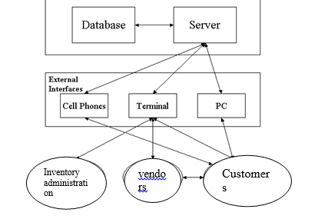
- Class Diagram/ERD – Done in SRS
- Final Interface design (Member module wise, covering all CRUDS)
Hafsa Kanwal_10420 (Vendor)
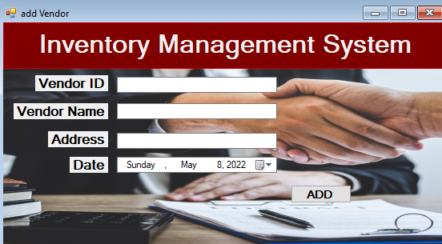
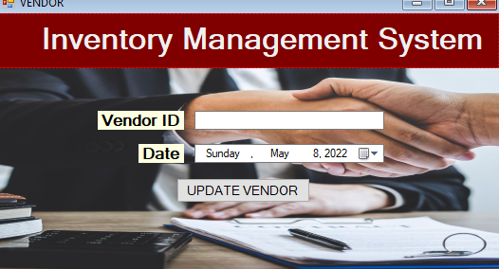
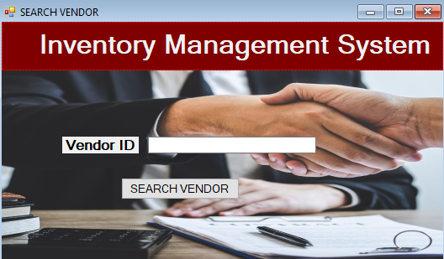
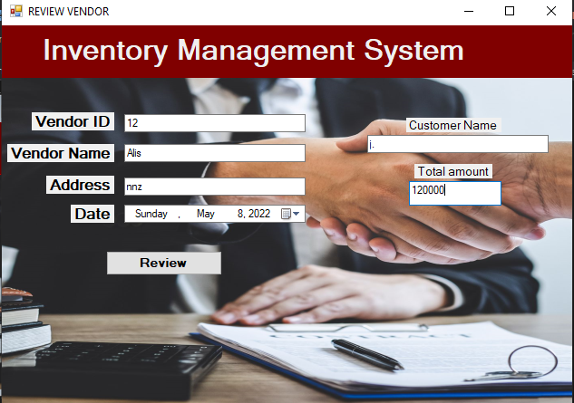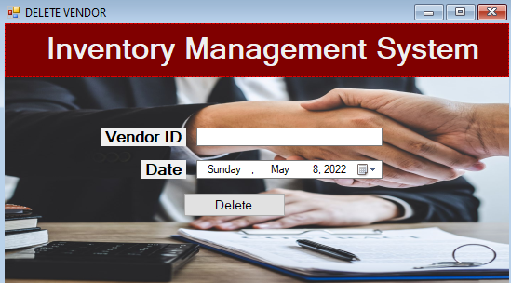

- TESTING
Page VIII

- Write detailed manual “Test Cases” for your selected Modules, keep the Login Test case as it is. Also Execute above developed “Test cases” on your project code and Observe (Pass/fail) Status. Complete <Test Report> by marking “Pass/Fail” status against each executed Test Case
Login Module 1 is a default module and common for all Members – it is completely done already. Attempt your individual modules
Test Strategy: Unit and Debugging Testing Done
Test Strategy: Integration Testing and Regression Testing
Aspects to be covered: ( System – Functional Testing, GUI, Performance, Security, Usability, Compatibility, Error Handling, Volume, Scalability, Installation, Maintenance, Reliability, Recovery)
 |  | TC1.1-1.5 | Purpose: The user should be able to go to the Home page | Pre-requisite:  S/w should be compatible with the Operating system.  Login page should appear.  User Id and Password textboxes should be available with appropriate labels.  Submit and Cancel buttons with appropriate captions should be available.
Sr. No | Test Case Id |  | Test Case Name | Requirement Number | File path | Steps/Action | Expected Results | PASS-FAIL
1. |  | TC1.1 | Checking User Interface requirements. | User views the page to check whether it includes UserId and Password textboxes with appropriate labels. Also expects that Submit and Cancel buttons are available with appropriate captions | Screen displays user interface requirements according to the user. | PASS
2. |  | TC1.2. | Textbox for UserId should:  i) allow only alpha-numeric characters{a-z, A-Z}  ii) not allow special characters like {'$','#','!','~','*',...}  iii) not allow numeric characters like{0-9} | i) User types numbers into the textbox. | i) Error message is displayed for numeric data. | FAIL
 |  | TC1.2. |  | ii ) User types alphanumeric data in the textbox. | ii) Text is accepted when user enters alpha-numeric data into the textbox.
3. |  | TC31.3 | Checking functionality of the Password textbox:  i) Textbox for Password should accept more than/minimum 6 characters and maximum 10 Characters  ii) Data should be displayed in encrypted format. | ia) User enters less than 6 characters in the password textbox.  EBV: partition 0-5 | i) System should not accept.  Error message is displayed when user enters less than 6 or greater than 10 characters in the password textbox.
 |  | TC31.3 |  | Ib) User more than 10 characters in the password textbox.  EBV: partition 11-14
 |  | TC31.3 |  | ii) User enters more than 5 characters and less than 11 in the password textbox.  EBV: partition 6-10 | System accepts data when user enters more than 5 characters and up to 10 characters into the password textbox.
 |  | TC31.3 |  | ii) User checks whether his data is displayed in the encrypted format. | System accepts data in the encrypted format else displays an error message.
4. |  | TC1.4 | Checking functionality of 'SUBMIT' button. | i) User checks whether 'SUBMIT' button is enabled or disabled. | i) System displays 'SUBMIT' button as enabled
 |  | TC1.4 | Checking functionality of 'SUBMIT' button. | ii) User clicks on the 'SUBMIT' button and expects to view the 'Home' page of the application. | ii) System is redirected to the 'Home' page of the application as soon as he clicks on the 'SUBMIT' button.
5. |  | TC1.5 | Checking functionality of 'CANCEL' button. | i)User checks whether 'CANCEL' button is enabled or disabled. | i)System displays 'CANCEL' button as enabled.
 |  | TC1.5 | Checking functionality of 'CANCEL' button. | ii)User checks whether the textboxes for UserId and Password are reset to blank by clicking on the 'CANCEL' button. | ii)System clears the data available in the UserId and Password textbox when user clicks on the 'CANCEL' button.
6. |  | TC1.6 | Checking Decision functionality of Input boxes userID and Password | Required list of variables and their values should be available For example:  [User Id, Password]  a. valid, valid;  b. valid, invalid ; c. invalid, valid;  d. invalid, invalid;  e. empty, empty;
Test Strategy: System – Functional Testing: GUI, Performance, Security, Usability, Compatibility, Error Handling, Volume, Scalability, Installation, Maintenance, Reliability, Recovery
Test Strategy: User Acceptance Testing: Alpha
Test Strategy: User Acceptance Testing: Beta

TEST CASE BY Hafsa Kanwal FOR MODULE 2 Vendors
Pre-requisite: 1
A successful Login.
Login page should appear.
User Id and Password textboxes should be available with appropriate labels.
Submit and Cancel buttons with appropriate captions should be available.
Sr. NoTC2Purpose: The user should be able to perform vendor Function and go to the Home page |  | Test Case Id | Test Case Name | Requirement Number | File path | Steps/Action |  | Expected Results
PASS-FAIL 2 | TC2.1 |  | Add vendor | Vendor id, vendor name, vendor address  a. empty,empty,empty  b. empty, valid, valid  c. valid, empty, valid  d. valid, valid, empty  e. valid, valid | a. error message, to enter data  b. error message, enter id  c. error message, enter name  d. error message, enter address  e. vendor added successfully | a.pass  b.pass  c.pass  d.pass  e.pass
 |  | TC2.2 | update vendor | Vendor id, date  a. empty,empty,  b. empty, valid  c. valid, empty  d. valid, valid | a. error message, to enter data  b. error message, enter id  c. error message, update date  d. vendor updated successfully | a.pass  b.pass  c.pass  d.pass
 |  | TC2.3 | Delete vendor | Vendor id, date  a. empty,empty,  b. empty, valid  c. valid, empty  e. valid, valid | a. error message, to enter data  b. error message, enter id  c. error message, update date  d. vendor deleted successfully | a.pass  b.pass  c.pass  d.pass
 |  | TC2.4 | Search vendor | Vendor id, date  a. empty,empty  b. empty, valid  c. valid, empty  e. valid, valid | a. error message, to enter data  b. error message, enter id  c. error message, update date  d. vendor searched properly | a.pass  b.pass  c.pass  d.pass
 |  | TC2.5 | Review vendor | Vendor id, name, address, customer name, total amount  a. empty,empty,empty, empty,empty  b. empty, valid, valid, valid, valid  c. valid, empty, valid , valid, valid  d. valid, valid, empty, valid,valid  e. valid, valid, , valid ,empty, valid  f. valid, valid, , valid , valid, empty  g. valid, valid, , valid , valid, valid | a. error message, to enter data  b. error message, enter id  c. error message, enter name  d. error message, enter address  e. error message to enter customer name  f. error message to enter total amount  g. successfully reviewed | a.pass  b.pass  c.pass  d.pass  e.pass  f.pass  g.pass
TEST CASE BY MEMBER 2 FOR MODULE 3

 |  | TC3 | Purpose: The user should be able to perform MODULE 2 Function and go to the Home page | Pre-requisite:  A successful Login.  Login page should appear.  User Id and Password textboxes should be available with appropriate labels.  Submit and Cancel buttons with appropriate captions should be available.
Sr. No | Test Case Id |  | Test Case Name | Requirement Number | File path | Steps/Action | Expected Results | PASS-FAIL
6. |  | TC2.6. | Checking Decision functionality of MODULE X  Input boxes XXX and YYY | Required list of variables and their values should be available For example:  [XXX, YYY]  a. valid, valid;  b. valid, invalid ;  c. invalid, valid;  d. invalid, invalid;  e. empty, empty;
TEST CASE BY MEMBER 3 FOR MODULE 4
 |  | TC2 | Purpose: The user should be able to perform MODULE 2 Function and go to the Home page | Pre-requisite:  A successful Login.  Login page should appear.  User Id and Password textboxes should be available with appropriate labels.  Submit and Cancel buttons with appropriate captions should be available.
Sr. No | Test Case Id |  | Test Case Name | Requirement Number | File path | Steps/Action | Expected Results | PASS-FAIL
6. |  | TC2.6. | Checking Decision functionality of MODULE X  Input boxes XXX and YYY | Required list of variables and their values should be available For example:  [XXX, YYY]  a. valid, valid;  b. valid, invalid ;  c. invalid, valid;  d. invalid, invalid;  e. empty, empty;
TEST CASE BY MEMBER 4 FOR MODULE 5
 |  | TC2 | Purpose: The user should be able to perform MODULE 2 Function and go to the Home page | Pre-requisite:  A successful Login.  Login page should appear.  User Id and Password textboxes should be available with appropriate labels.  Submit and Cancel buttons with appropriate captions should be available.
Sr. No | Test Case Id |  | Test Case Name | Requirement Number | File path | Steps/Action | Expected Results | PASS-FAIL
6. |  | TC2.6. | Checking Decision functionality of MODULE X  Input boxes XXX and YYY | Required list of variables and their values should be available For example:  [XXX, YYY]  a. valid, valid;  b. valid, invalid ;  c. invalid, valid;  d. invalid, invalid;  e. empty, empty;

CONCLUSION OF WHOLE PROJECT
Page IX

This report covers major "Software Engineering" activities on selected Project. This project activity lasts for duration of 3.5 month time.

