SauceDemo — AI-Assisted QA Submission
Tasks A–D · Defect Report · Automation · AI QA Strategy
App: https://www.saucedemo.com/ | Account: standard_user / secret_sauce
Date: 6 October 2026 | Automation: Playwright (TypeScript)

1. Executive summary
AI accelerated risk discovery and automation drafting for SauceDemo. Ideas were challenged against the live app on standard_user. Five high-impact defects were confirmed; unsupported AI suggestions (real payments, stock, i18n, etc.) were discarded. One maintainable Playwright E2E covers the critical purchase path.

2. Task A — AI-Assisted Exploratory Testing
Goal: use AI to accelerate exploration of SauceDemo — not to dump a traditional test-case list. AI proposed risks and edge cases; each idea was converted into a live check, then kept, changed, or discarded based on what the app actually does for standard_user.

2.1 Approach
- Explore live app at https://www.saucedemo.com/ with standard_user / secret_sauce.
- Ask AI for high-risk journeys, functional risks, edge cases, UX/a11y, performance, and follow-up questions.
- Execute useful suggestions as real tests in the browser.
- Challenge or discard ideas that are irrelevant, wrong, redundant, or unsupported by the app.

2.2 Highest-risk user journeys identified
Journey | Why it mattered | Session outcome
Purchase / checkout integrity | Money, order completion, and validation sit here | Highest risk — multiple critical defects (see Task B)
Cart state (add/remove/empty/badge) | Empty-cart checkout and no qty control change purchase semantics | High risk — empty checkout confirmed
Dynamic Catalog (Lazy / Spinner / Slider) | Newer surface with loading, duplicates, a11y, browse-only UX | High risk — duplicate SKUs confirmed
Auth + session guards | Protects all post-login pages | Medium — mostly passed (guards + locked_out_user)
Catalog browse + sort | Core discovery path | Lower risk — sort/tax healthy for standard_user

2.3 What was actually tested (live)
- Login: empty submit, username-only, password-only, locked_out_user.
- Inventory: price sort low→high and high→low; add/remove; cart badge.
- Cart: quantity editability, localStorage cart model, empty-cart checkout.
- Checkout: whitespace-only names/zip, invalid zip (!!!), tax math, Finish, Back then re-Finish.
- Order complete: thank-you page; Generate PDF order button state.
- Auth guards: logout then direct URL to /inventory.html and /checkout-step-one.html.
- Dynamic Catalog: Lazy Load scroll/duplicates, Spinner page, Slider dots/a11y.

2.4 Exploration outcomes (summary)
Confirmed bugs (detail + evidence in Task B):
- Empty cart can complete a $0 order.
- Whitespace-only First/Last/Zip accepted.
- Postal code accepts “!!!” with no format check.
- Browser Back after Thank You still allows Finish.
- Lazy Load catalog duplicates Test.allTheThings() T-Shirt (Red) (L).
Confirmed passes:
- Tax math at 8% correct ($29.99 → tax $2.40 → total $32.39; multi-item $79.98 → $6.40 → $86.38).
- Price sort lohi/hilo correct; cart badge increments on Add.
- Route guards after logout; locked_out_user blocked.
Limitations (not filed as defects):
- Dynamic Catalog pages are browse-only (no Add to cart).
- Cart quantity cannot exceed 1 (localStorage stores product ID array only).

2.5 Representative AI prompts (Task A deliverable)
Five prompts used to accelerate exploration. For each: purpose, useful AI output, and what was tested / changed / rejected / validated against the live app.

Prompt 1 — Risk prioritization
Prompt:
“For SauceDemo (saucedemo.com), identify the highest-risk user journeys for standard_user. Prioritize by business/impact risk, not by page count. Challenge assumptions that only apply to real e-commerce backends.”
Purpose: Focus the session on risk instead of generating a generic test-case list.
Useful AI output: Ranked checkout/cart as top risk; auth/session next; warned payment may be mocked.
What I tested / changed / rejected / validated: Validated checkout + cart as highest risk in the live app. Kept auth as medium after logout/direct-URL checks. Rejected deep payment/fraud testing after confirming SauceCard is fake.

Prompt 2 — Checkout edge cases
Prompt:
“Generate functional risks and edge cases for SauceDemo checkout (info form → overview → finish). Include empty cart, whitespace, postal formats, back-button after complete, and tax math. Mark which need live proof.”
Purpose: Convert AI edge-case ideation into concrete checkout experiments.
Useful AI output: Suggested empty-cart checkout, whitespace names, invalid zip, tax rounding, re-submit via Back.
What I tested / changed / rejected / validated: Validated as bugs: empty cart $0 order, whitespace accepted, zip “!!!” accepted, Back+Finish replay. Validated as pass: 8% tax. Tax idea confirmed correct — no change needed.

Prompt 3 — Dynamic Catalog scout
Prompt:
“After login, the menu has Dynamic Catalog → Lazy Load / Spinner / Slider. What should I explore for data integrity, loading UX, a11y, and purchase flow gaps? Discard ideas if those pages are browse-only.”
Purpose: Investigate a less obvious, higher-novelty surface with AI as a scout.
Useful AI output: Flagged infinite-scroll duplicates, spinner leftovers, slider keyboard/a11y, missing Add to cart.
What I tested / changed / rejected / validated: Validated duplicate Red T-Shirt (L); all slider dots a11y-current; browse-only. Treated missing Add to cart as limitation, not defect. Keyboard ArrowLeft did not move slider — kept as open follow-up.

Prompt 4 — Login / session risks (scoped)
Prompt:
“Propose login/UX and session risks for SauceDemo: empty fields, partial credentials, locked_out_user, and direct URL access after logout. Ignore SQL injection unless the UI gives a real reason to prioritize it.”
Purpose: Cover auth without wasting time on generic security folklore.
Useful AI output: Required-field messaging, locked-out persona, route guards, misleading error chrome.
What I tested / changed / rejected / validated: Validated required-field errors, locked_out_user blocked, route guards. Confirmed UX issue: both fields show red X when only one is wrong. Rejected SQL-injection deep dive as out of scope.

Prompt 5 — Explicit discard pass
Prompt:
“Which of these AI ideas should I discard for SauceDemo and why: multi-currency, stock limits, email confirmation, multi-user cart sync, real card processing? Base the answer on what the app actually exposes.”
Purpose: Force explicit rejection of AI noise before writing findings.
Useful AI output: Discard list with rationale tied to missing UI/capabilities.
What I tested / changed / rejected / validated: All five discarded after live observation (no locale/currency, no stock, no email at checkout, cart is localStorage ID array, payment mocked). Prevented false findings in the report.

2.6 AI suggestions discarded
Suggestion | Why discarded
Deep payment / fraud / card-processor tests | Payment is mocked (“SauceCard #31337”); no real processor or card form
SQL injection / auth bypass fuzzing as primary focus | Demo credential list + cookie session-username; not worth session budget
i18n / multi-currency checkout | No locale or currency switcher found
Inventory stock / oversell limits | No stock counters or purchase limits in UI or cart model
Multi-user cart sync / concurrency | Cart is localStorage product-ID list on the client only
Email / order confirmation delivery | Checkout collects name + zip only; no email field

3. Task B — Defect report (top 5)

DEF-01 — Empty cart can complete checkout ($0 order)
Field | Detail
Severity / Priority | Critical / P0
Steps to reproduce | 1) Login as standard_user. 2) Open empty cart. 3) Click Checkout. 4) Enter any First/Last/Zip. 5) Continue → Finish.
Expected | Checkout blocked when cart is empty; order cannot complete.
Actual | Checkout proceeds. Overview: Item total $0 / Tax $0.00 / Total $0.00. Finish shows “Thank you for your order!”
Business / user impact | Meaningless successful orders; broken purchase invariant; pollutes metrics.
Classification reasoning | Reproduced on standard_user. Not a persona quirk. Empty-cart Checkout is a rule failure.

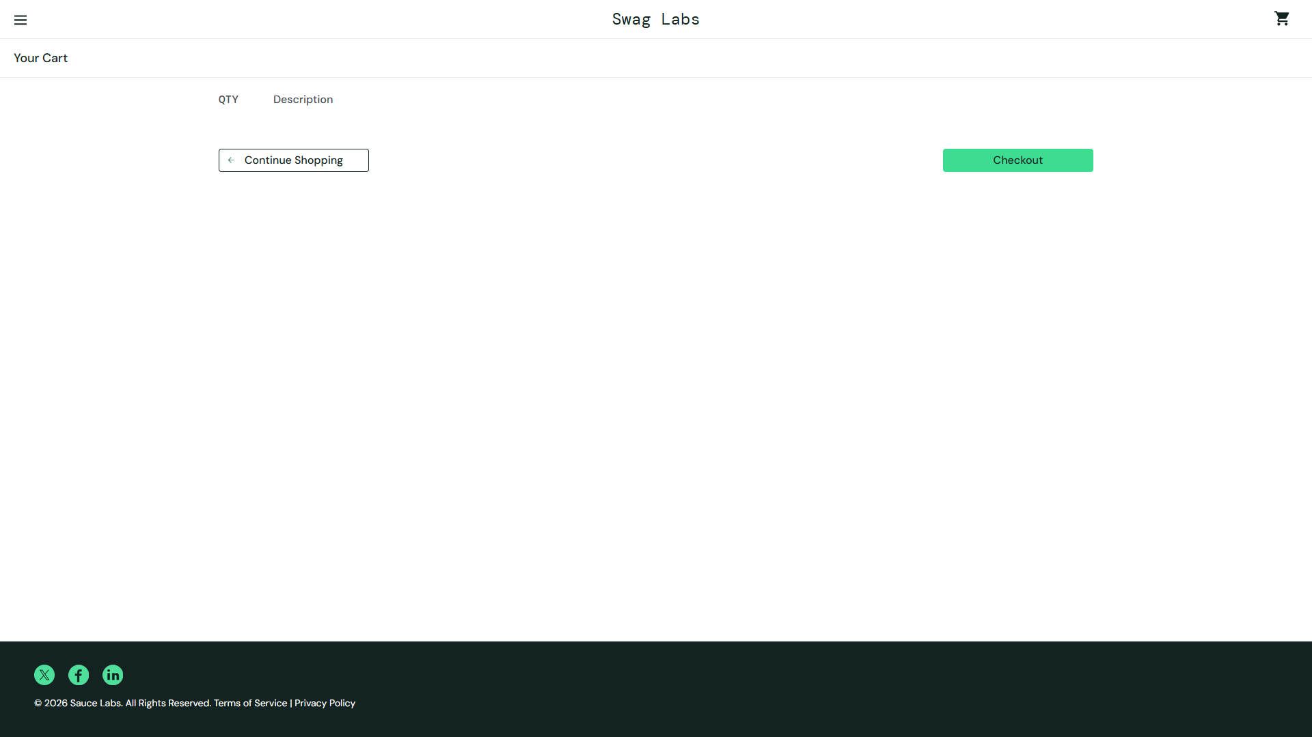
Fig. DEF-01a — Empty cart with Checkout enabled
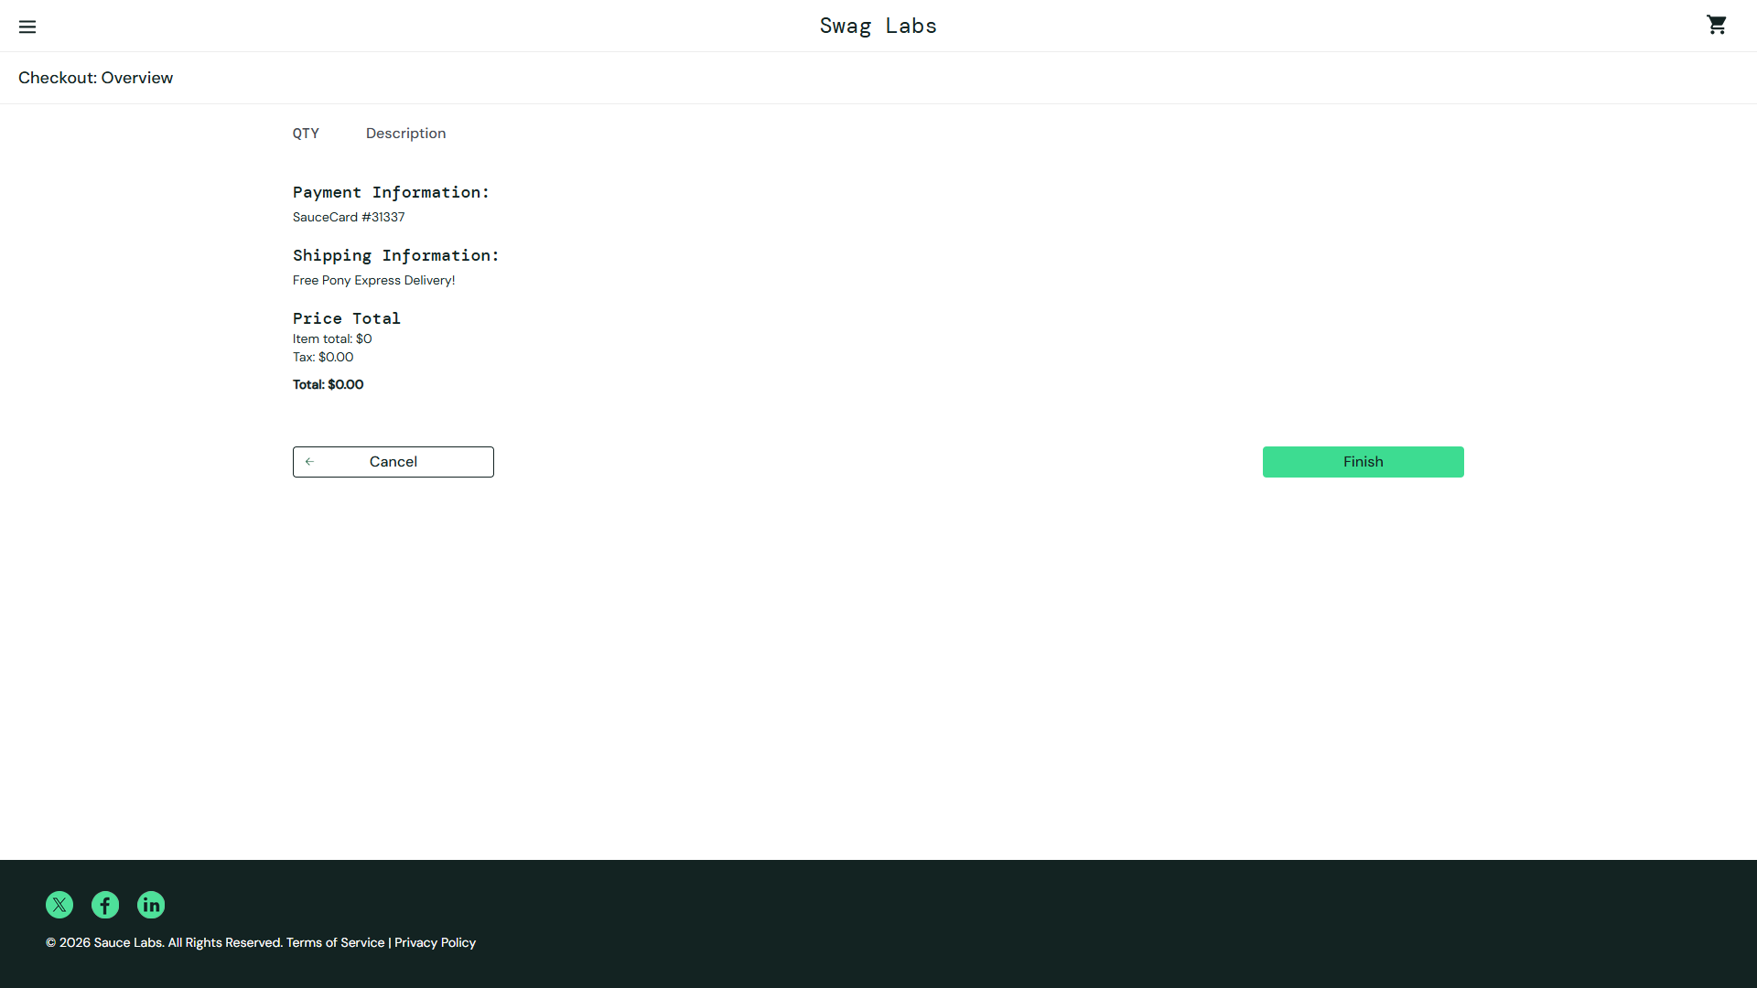
Fig. DEF-01b — Overview totals $0.00
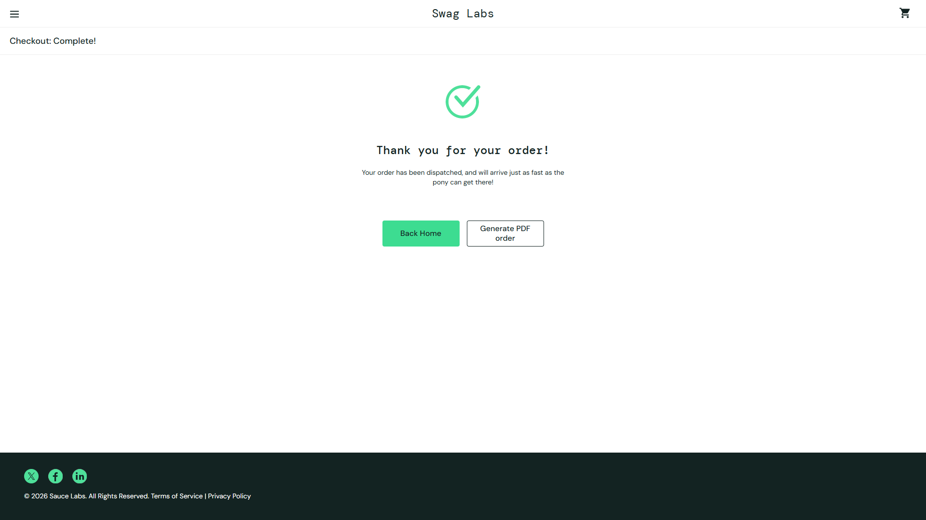
Fig. DEF-01c — Thank-you after empty order

DEF-02 — Whitespace-only checkout identity accepted
Field | Detail
Severity / Priority | Critical / P0
Steps to reproduce | 1) Login, add item, Checkout. 2) Enter spaces only in First/Last/Zip. 3) Continue.
Expected | Validation error after trim; spaces-only rejected.
Actual | Advances to Overview with no error.
Business / user impact | Orders with unusable customer identity; fulfillment would fail in a real system.
Classification reasoning | Truly empty fields are validated (“is required”), so accepting spaces is incomplete validation — not “no validation by design.”

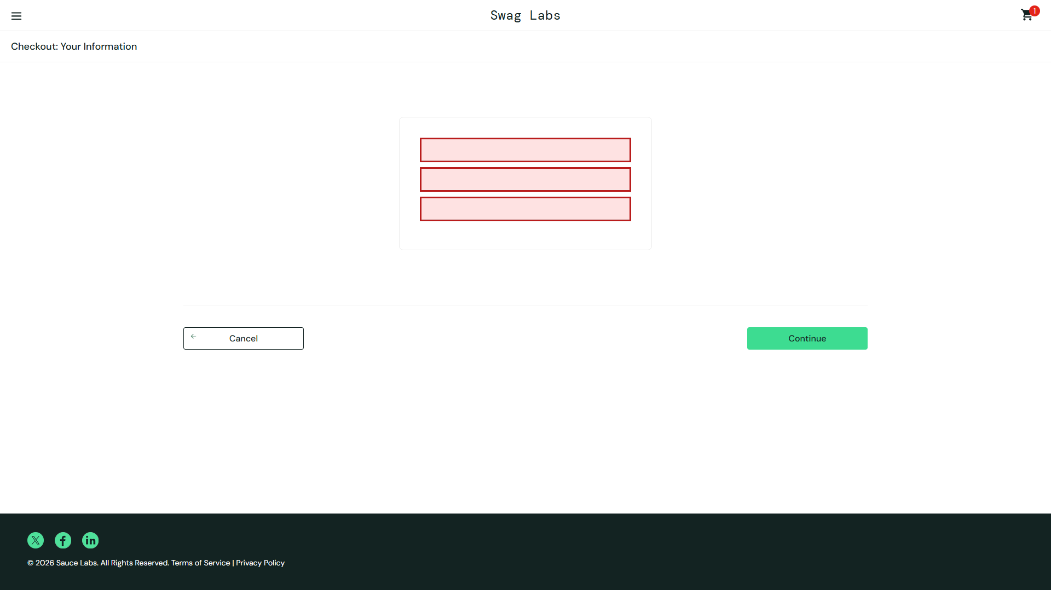
Fig. DEF-02a — Fields contain only spaces
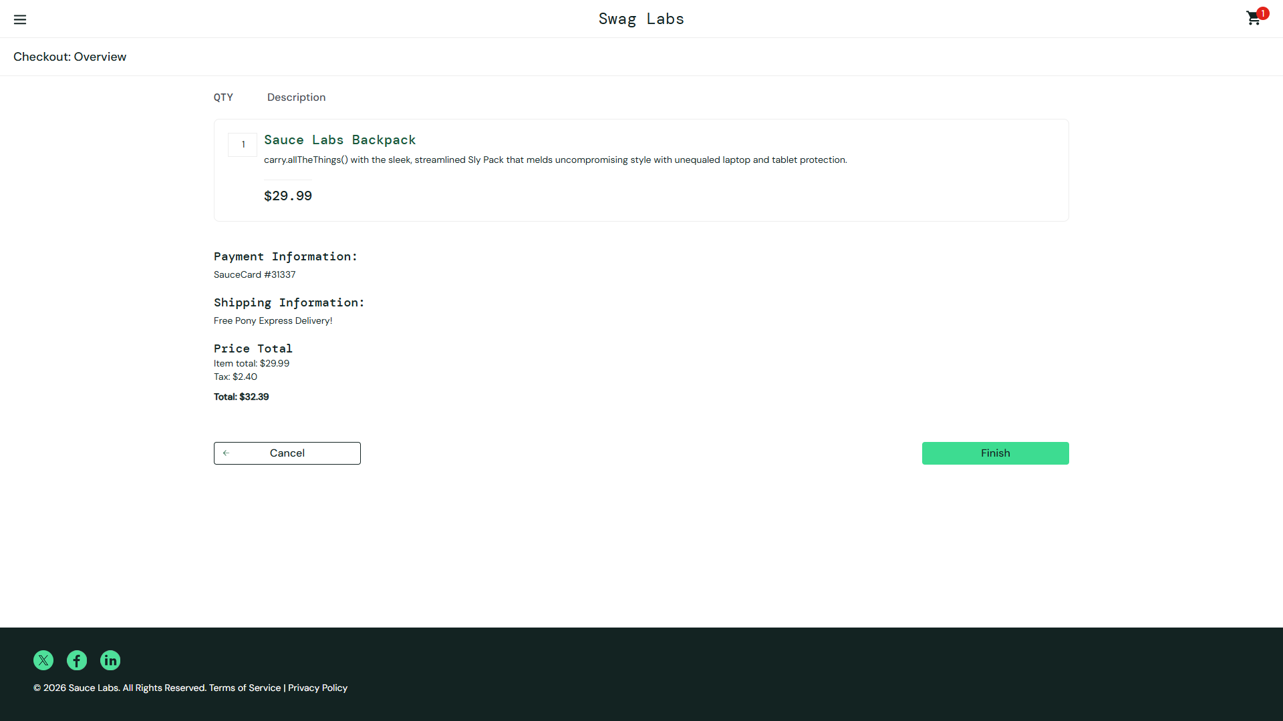
Fig. DEF-02b — Overview reached after whitespace submit

DEF-03 — Postal code accepts invalid format (!!!)
Field | Detail
Severity / Priority | High / P1
Steps to reproduce | 1) Login, add item, Checkout. 2) Valid names + Zip “!!!”. 3) Continue.
Expected | Format validation rejects non-postal values.
Actual | Accepted; Overview reached.
Business / user impact | Invalid shipping addresses; support/return cost.
Classification reasoning | Field is labeled Zip/Postal Code and other fields are validated — format check is reasonable.

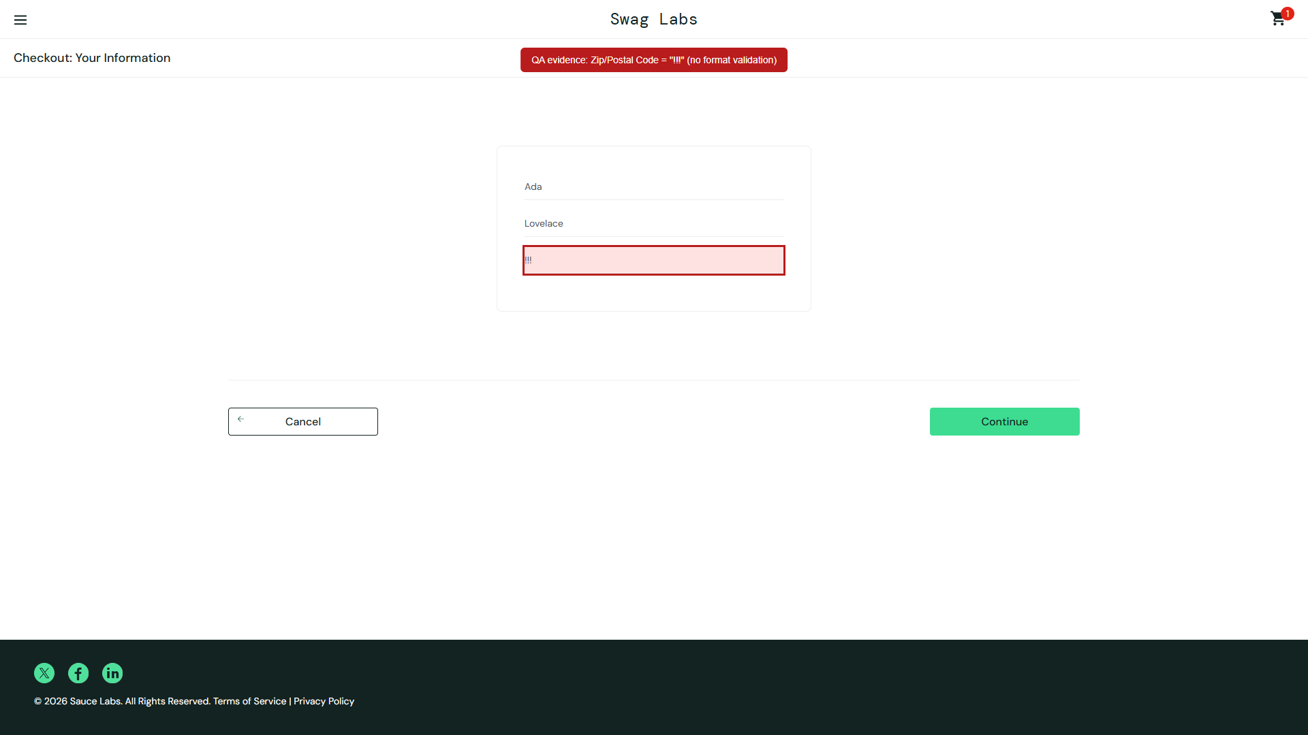
Fig. DEF-03 — Zip value “!!!” accepted on the form

DEF-04 — Browser Back after completion allows re-Finish
Field | Detail
Severity / Priority | High / P1
Steps to reproduce | 1) Complete checkout to Thank You. 2) Browser Back. 3) Finish still available; click again.
Expected | Overview invalidated; Finish cannot re-submit.
Actual | Overview + Finish remain usable (duplicate completion path).
Business / user impact | Duplicate submissions; confused order state.
Classification reasoning | Classic history/state bug on standard_user — not an exotic persona issue.

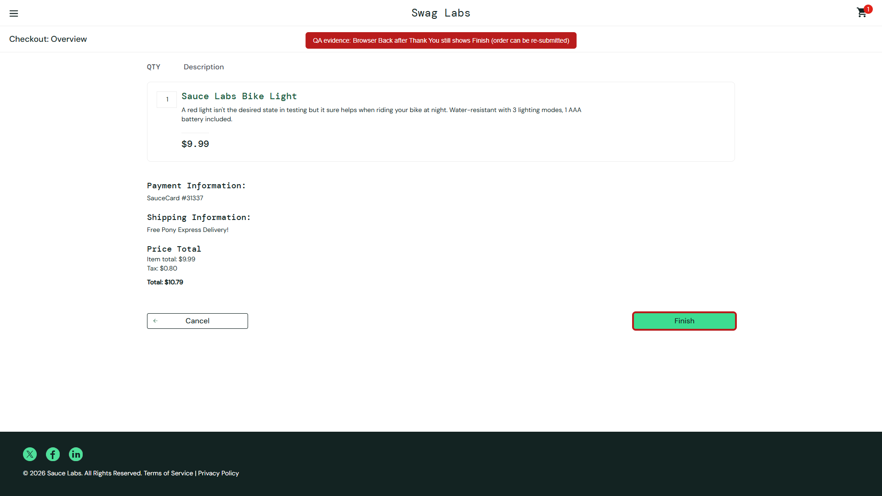
Fig. DEF-04 — Back returns to Overview with Finish active

DEF-05 — Lazy Load catalog duplicate SKUs
Field | Detail
Severity / Priority | High / P1
Steps to reproduce | 1) Login. 2) Menu → Dynamic Catalog → Lazy Load. 3) Scroll to load items. 4) Observe Test.allTheThings() T-Shirt (Red) (L).
Expected | Each size/SKU appears once.
Actual | Duplicate cards for the same name/size (worsens with further lazy loads).
Business / user impact | Catalog data integrity; user confusion; analytics/automation uniqueness breaks.
Classification reasoning | Main inventory has unique items; bug is specific to Dynamic Catalog Lazy Load. Browse-only (no Add to cart) is a limitation, not this defect.

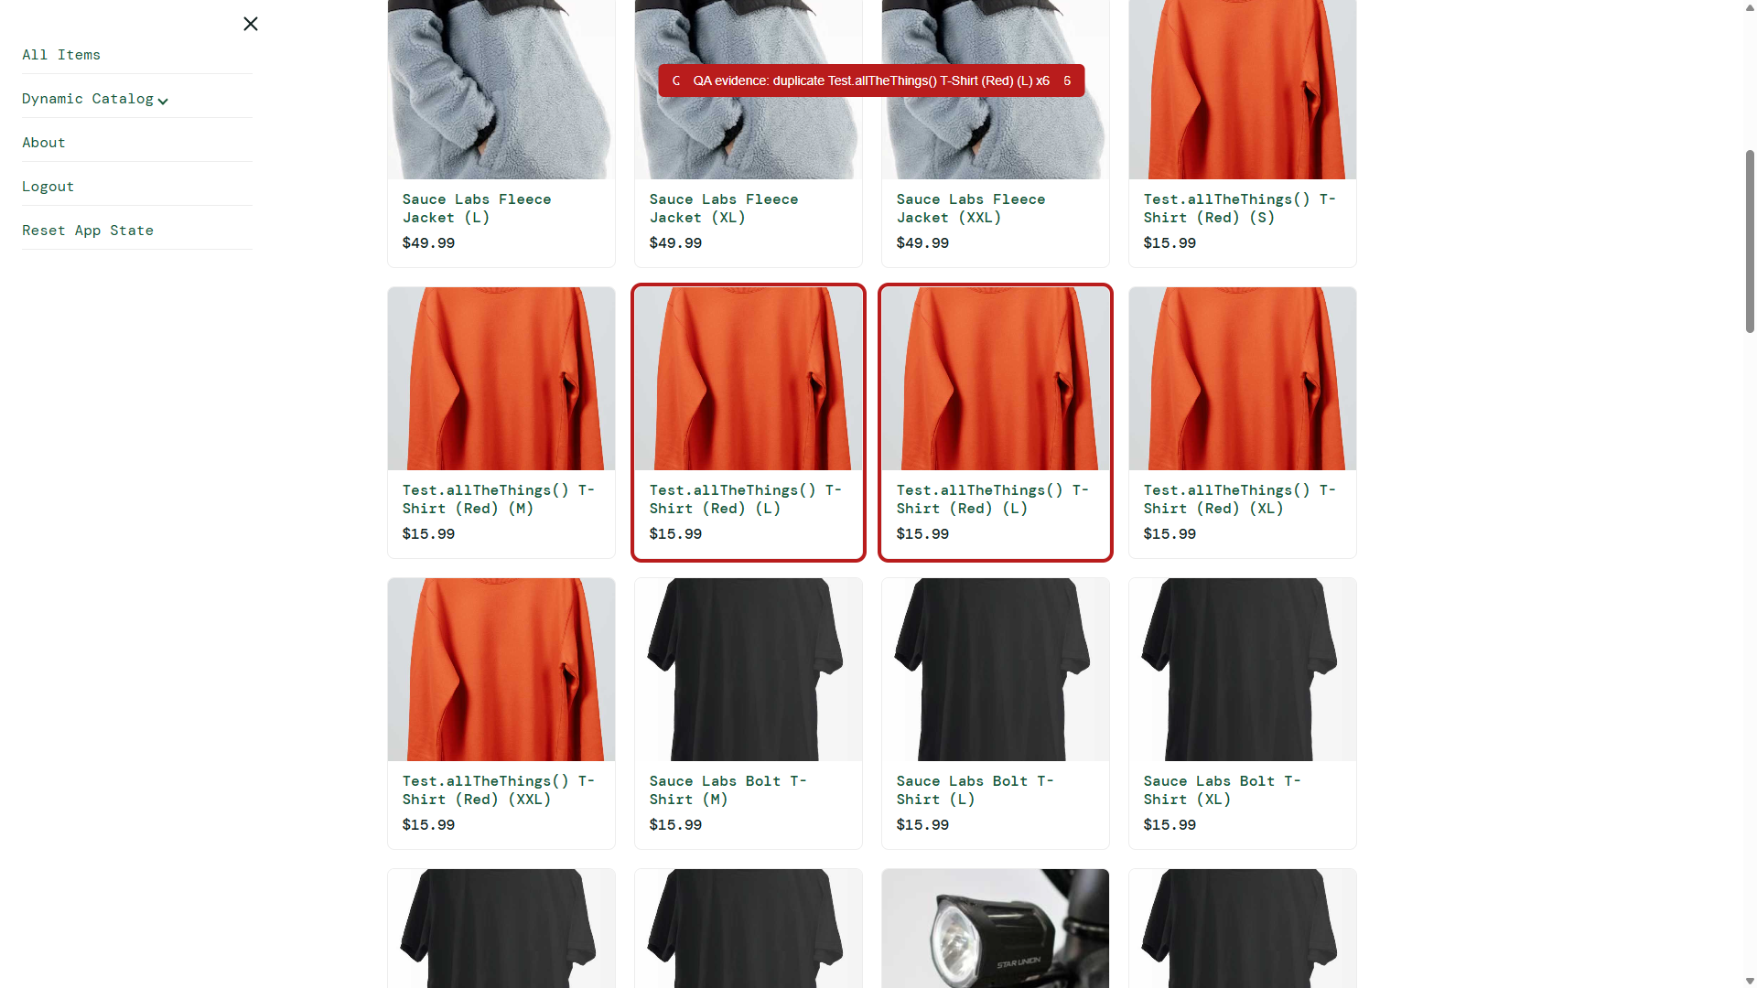
Fig. DEF-05 — Duplicate Red T-Shirt (L) highlighted

Not reported as defects (reasoning)
- Dynamic Catalog has no Add to cart → feature limitation / separate surface.
- Cart qty cannot exceed 1 → demo localStorage ID-array model.
- SauceCard #31337 mock payment → intentional demo behavior.
- problem_user / visual_user quirks → persona-specific, not primary-account defects.

4. Task C — Automated test
Framework: Playwright (TypeScript). Flow: Login → add Sauce Labs Backpack → cart → checkout info → overview (assert totals) → finish → assert thank-you + cleared cart badge.

Setup & run
Repository folder: saucedemo-ai-qa (public GitHub — see README after publish).
- npm install
- npx playwright install chromium
- npm test # or: npm run test:headed
Credentials: standard_user / secret_sauce (public demo credentials).

AI assistance vs manual changes
Topic | Detail
AI assisted | Playwright+TS choice; happy-path structure; data-test/role locators; price assertions; storage isolation idea.
AI incorrect / brittle | Assumed data-testid (SauceDemo uses data-test) → 60s timeout; early draft used hard waits; nth button locators.
Manual fixes | testIdAttribute: 'data-test'; removed hard waits; product-specific data-test IDs; exact tax/total asserts; clear cookies+storage in beforeEach.
Limitations / risks | Depends on live SauceDemo; single persona; does not encode known demo defects as expected failures; network flakiness possible.

Test file: tests/checkout-happy-path.spec.ts — verified locally: 1 passed (~3s).

5. Task D — AI-driven QA approach (1 page)
When developers use AI to generate code, tests, and docs, QA shifts from writing every case by hand to risk ownership, oracle definition, and gatekeeping.
Where AI adds value:
- Planning: risk heatmaps, journey candidates, ambiguity questions.
- Design: boundaries/negatives, state-transition gaps.
- Authoring: draft automation, locator suggestions, fixtures.
- Execution: flake clustering, failure summarization, log/trace triage.
- Reporting: defect drafts, release risk summaries.
Where human review is mandatory:
- Acceptance criteria / product oracles (“what is correct?”).
- Severity & release-risk decisions.
- Security, privacy, payments, compliance-sensitive flows.
- Any AI claim not reproduced on a real build.
- Final sign-off that a finding is a real defect (not persona/env quirk).
Reviewing AI-generated tests before regression:
- Map each test to a risk/requirement; reject orphans.
- Assert outcomes (URL, totals, persistence, errors), not only clicks.
- Prefer data-test / roles; ban brittle nth/XPath unless justified.
- Prove isolation; ban unnecessary hard waits.
- Run locally + CI; human marks “promotion approved.”
Defect analysis, coverage, regression optimization:
- AI clusters failures; humans confirm root cause.
- AI maps changed files → impacted journeys for regression subsets.
- AI finds coverage gaps vs critical journeys; humans prioritize.
- Optimize: quarantine flakes; keep critical path green.
CI/CD quality gates:
- PR: lint + unit + smoke E2E (purchase-class).
- Nightly: broader regression; AI summarizes failures with owners.
- Release: critical-path pass required; AI drafts risk note from open defects.
- AI never auto-closes a failing gate without human override policy.
Key risks & mitigations:
Risk | Mitigation
Wrong oracle in AI tests | Human AC review; tie tests to requirements
Brittle selectors / env | data-test contract; target-env CI runs
Hallucinated defects | Require live repro + evidence
Security blind spots | Mandatory human/security review on auth/PII
Automation theater | Track escaped defects; keep exploratory charters
Secret leakage in prompts | Redact secrets; use public demo accounts in examples

Bottom line: AI accelerates ideation and drafting; humans own correctness, risk, and promotion into the regression suite.

6. Tools used
- Cursor Agent / Composer — ideation, coding, packaging
- Cursor IDE Browser — live exploratory validation
- Playwright + Chromium — E2E automation
- Node.js / npm
- python-docx — Word submission export
- SauceDemo public web application

7. Evidence & repo index
Artifact | Location
Automated test | tests/checkout-happy-path.spec.ts
Run instructions | README.md
AI usage detail | docs/AI-USAGE.md
Markdown narrative | docs/SUBMISSION.md
Screenshots | evidence/DEF01–DEF05*.png
This Word document | SauceDemo-AI-QA-Submission.docx

