FAST NUCES Chiniot-FSD Campus



AI 2002 – Artificial Intelligence
Dynamic Pathfinding Agent Using Informed Search Algorithms
Submitted by:
HAFSA SAJJAD 23F-0721
Submitted to:
Dr. Rabia Maqsood
Department of Computer Science

Contents
1
1. Introduction 2
2. Environment Design 3
3. Algorithmic Implementation 3
3.1 Greedy Best-First Search (GBFS) 3
3.2 A* Search Algorithm 3
3.3 Heuristic Function 4
4. Dynamic Obstacles and Re-planning 4
5. Graphical User Interface and Visualization 4
6. Experimental Evaluation 5
Best-Case Scenario 5
Worst-Case Scenario 5
7. Comparative Analysis 5
8. Conclusion 6
9.Code: 6
10.Outputs 11

1. Introduction
Pathfinding is a core problem in Artificial Intelligence in which an agent must determine an efficient route from a starting position to a desired goal. While many classical approaches assume static environments, real-world systems such as autonomous robots and navigation software operate in dynamic settings where obstacles may appear unexpectedly. In such cases, the agent must not only find an initial path but also adapt its plan during execution.
The primary objective of this project is to design and implement a Dynamic Pathfinding Agent capable of operating in a grid-based environment using informed search techniques. The system integrates real-time visualization, dynamic obstacle generation, and an intelligent re-planning mechanism. Two widely used informed search algorithms—Greedy Best-First Search (GBFS) and A*—were implemented and comparatively evaluated.

2. Environment Design
The environment is modelled as a two-dimensional grid where each cell represents either free space, an obstacle, the start node, or the goal node. The design emphasizes flexibility and user interaction.
The application supports dynamic grid sizing, allowing users to specify the number of rows and columns before execution. At the start of each episode, the start and goal nodes are clearly defined and remain fixed unless explicitly modified by the user.
To support diverse testing scenarios, a random map generator was implemented. This module creates mazes based on a user-defined obstacle density, enabling both sparse and highly congested environments. Furthermore, an interactive map editor allows users to manually place or remove obstacles via mouse input. This ensures that the system can handle arbitrary configurations without relying on static text-based maps.
Overall, the environment was designed to be flexible, interactive, and suitable for both controlled experiments and dynamic simulations.

3. Algorithmic Implementation
Two informed search strategies were implemented to compute paths from the start node to the goal node.

3.1 Greedy Best-First Search (GBFS)
Greedy Best-First Search is a heuristic-driven algorithm that expands the node estimated to be closest to the goal. It evaluates nodes using only the heuristic function:
f(n)=h(n)
where h(n) represents the estimated distance from node $n$to the goal.
Because GBFS focuses solely on the heuristic, it often reaches the goal quickly in simple environments. However, it ignores the actual cost already incurred, which may lead to suboptimal paths or unnecessary exploration in complex maps.
Observation: GBFS demonstrated high speed but inconsistent path optimality during experiments.

3.2 A* Search Algorithm
A* Search is a more robust informed search technique that balances the actual path cost and the estimated remaining cost. It evaluates nodes using:
f(n) = g(n)+h(n)
where:
- g(n)is the cost from the start node to node $n$
- h(n) is the heuristic estimate to the goal
This combination enables A* to guarantee the optimal path when the heuristic is admissible. Although A* typically explores more nodes than GBFS, it provides significantly more reliable results.
Observation: A* consistently produced optimal paths across all tested scenarios.

3.3 Heuristic Function
The Manhattan distance heuristic was selected:
h(n)=|x1-x2|+|y1-y2|
This heuristic is well-suited for grid environments with four-directional movement. It is computationally efficient, admissible, and ensures the optimality of A*.

4. Dynamic Obstacles and Re-planning
A key contribution of this project is the implementation of a dynamic mode that simulates real-world uncertainty.
When dynamic mode is enabled, new obstacles may spawn on the grid at each time step with a small, predefined probability. This mechanism introduces environmental unpredictability while the agent is already in motion.
The agent continuously monitors its planned path. If a newly generated obstacle blocks the current route, the system immediately triggers a localized re-planning process from the agent’s current position rather than restarting the entire search. If the path remains unaffected, the agent proceeds without precomputation.
This selective re-planning strategy significantly improves efficiency and demonstrates adaptive intelligent behaviour suitable for real-time navigation systems.

5. Graphical User Interface and Visualization
A graphical user interface provide clear and intuitive visualization of the search process.
The interface highlights different search states using distinct colors:
- Frontier nodes are displayed in yellow
- Expanded nodes appear in red/blue
- The final path is shown in green
- Obstacles are rendered in black
In addition to visualization, a real-time metrics dashboard reports:
- Total number of nodes visited
- Final path cost
- Execution time in milliseconds
These metrics enable meaningful comparison between algorithms and provide insight into search efficiency.
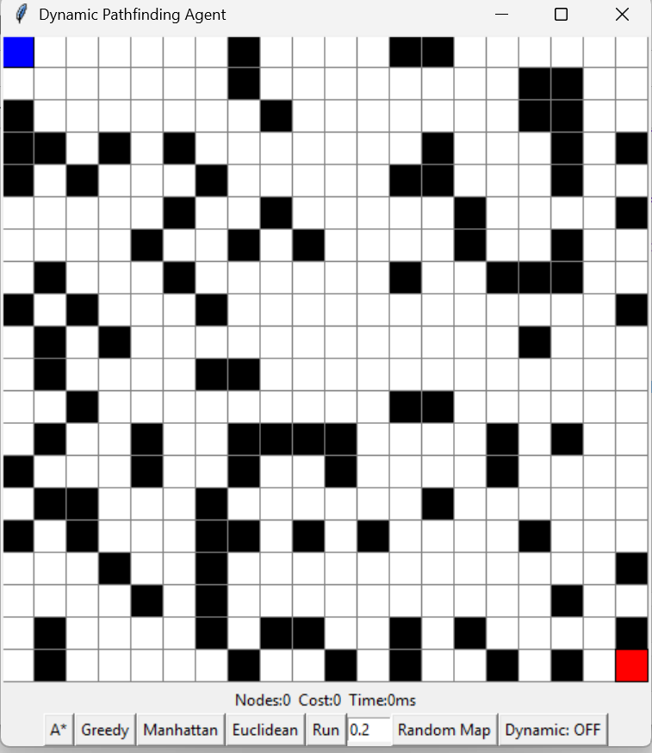

6. Experimental Evaluation
Extensive testing was conducted under both favourable and challenging conditions.

Best-Case Scenario
In environments with low obstacle density, both algorithms performed efficiently. GBFS typically reached the goal faster due to its aggressive heuristic-driven behaviour, while A* maintained optimality with only slightly higher computation.

Worst-Case Scenario
In dense or maze-like environments, GBFS frequently explored misleading paths and sometimes produced longer routes. In contrast, A* consistently identified the optimal path, though at the cost of increased node expansion. Dynamic mode further highlighted the importance of real-time re-planning when unexpected obstacles appeared.

7. Comparative Analysis
The experimental results indicate clear trade-offs:
- GBFS offers faster execution but lacks optimality guarantees.
- A* provides optimal and reliable paths at the expense of higher memory and computation.
- The dynamic re-planning mechanism substantially enhances system robustness in changing environments.

8. Conclusion
This project successfully developed a dynamic pathfinding agent capable of intelligent navigation in both static and evolving environments. The integration of GBFS and A* within an interactive visual framework provided valuable insights into their behavioral differences.
The results demonstrate that while greedy strategies may be suitable for simple scenarios, A* remains the preferred choice for reliability and optimality in complex or dynamic settings. The implemented re-planning mechanism further strengthens the system’s applicability to real-world navigation problems.

9.Code:
import tkinter as tk
import random
import heapq
import time
import math

ROWS = 20
COLS = 20
CELL = 25
SPAWN_PROB = 0.08

WIDTH = COLS * CELL
HEIGHT = ROWS * CELL

counter = 0
mode = "astar"
heuristic_mode = "manhattan"

last_expanded = 0
last_cost = 0
last_time = 0

class Node :
def __init__(self, r, c) :
self.r = r
self.c = c
self.wall = False
self.parent = None
self.visited = False
self.frontier = False

def make_grid() :
return [[Node(r, c) for c in range(COLS)]for r in range(ROWS)]

grid = make_grid()

start = grid[0][0]
goal = grid[ROWS - 1][COLS - 1]
agent_pos = start

def manhattan(a, b) :
return abs(a.r - b.r) + abs(a.c - b.c)

def euclidean(a, b) :
return math.sqrt((a.r - b.r) * *2 + (a.c - b.c) * *2)

def h(a, b) :
if heuristic_mode == "manhattan" :
return manhattan(a, b)
else :
return euclidean(a, b)

def neighbors(n) :
dirs = [(1, 0), (-1, 0), (0, 1), (0, -1)]
result = []
for dr, dc in dirs :
r = n.r + dr
c = n.c + dc
if 0 <= r < ROWS and 0 <= c < COLS :
if not grid[r][c].wall :
result.append(grid[r][c])
return result

def reset_nodes() :
for row in grid :
for n in row :
n.parent = None
n.visited = False
n.frontier = False

def build_path(end) :
path = []
while end.parent :
path.append(end)
end = end.parent
path.reverse()
return path

def astar() :
global counter
reset_nodes()
openq = []
g = { agent_pos: 0 }

counter += 1
heapq.heappush(openq, (0, counter, agent_pos))

expanded = 0
t0 = time.time()

while openq:
_, _, cur = heapq.heappop(openq)
if cur.visited :
continue

cur.visited = True
expanded += 1

if cur == goal:
return build_path(goal), expanded, (time.time() - t0) * 1000

for nb in neighbors(cur) :
newg = g[cur] + 1
if nb not in g or newg < g[nb] :
g[nb] = newg
f = newg + h(nb, goal)
nb.parent = cur
nb.frontier = True

counter += 1
heapq.heappush(openq, (f, counter, nb))

return[], expanded, 0

def greedy() :
global counter
reset_nodes()
openq = []
visited = set()

counter += 1
heapq.heappush(openq, (h(agent_pos, goal), counter, agent_pos))

expanded = 0
t0 = time.time()

while openq:
_, _, cur = heapq.heappop(openq)
if cur in visited :
continue

visited.add(cur)
cur.visited = True
expanded += 1

if cur == goal:
return build_path(goal), expanded, (time.time() - t0) * 1000

for nb in neighbors(cur) :
if nb not in visited :
nb.parent = cur
nb.frontier = True

counter += 1
heapq.heappush(openq, (h(nb, goal), counter, nb))

return[], expanded, 0

def random_map() :
global agent_pos, running

agent_pos = start
running = False

try :
density = float(density_entry.get())
except :
density = 0.3

for row in grid :
for n in row :
if n not in(start, goal) :
n.wall = random.random() < density

reset_nodes()
draw()

def draw(path = None, expanded = 0, cost = 0, ms = 0) :
canvas.delete("all")

for row in grid :
for n in row :
x1 = n.c * CELL
y1 = n.r * CELL
x2 = x1 + CELL
y2 = y1 + CELL

color = "white"
if n.wall:
color = "black"
elif n.visited :
color = "lightblue"
elif n.frontier :
color = "yellow"

canvas.create_rectangle(x1, y1, x2, y2, fill = color, outline = "gray")

if path :
for p in path :
canvas.create_rectangle(
p.c * CELL, p.r * CELL,
p.c * CELL + CELL, p.r * CELL + CELL,
fill = "green"
)

canvas.create_rectangle(agent_pos.c * CELL, agent_pos.r * CELL,
agent_pos.c * CELL + CELL, agent_pos.r * CELL + CELL,
fill = "blue")

canvas.create_rectangle(goal.c * CELL, goal.r * CELL,
goal.c * CELL + CELL, goal.r * CELL + CELL,
fill = "red")

info.config(text = f"Nodes:{expanded} Cost:{cost} Time:{int(ms)}ms")

def click(event) :
c = event.x // CELL
r = event.y // CELL
node = grid[r][c]
if node not in(agent_pos, goal) :
node.wall = not node.wall
draw()

def set_mode(m) :
global mode
mode = m

def set_heuristic(m) :
global heuristic_mode
heuristic_mode = m

current_path = []
agent_index = 0
running = False

def run_search() :
global current_path, agent_index, running
global last_expanded, last_cost, last_time

if mode == "astar" :
path, exp, ms = astar()
else:
path, exp, ms = greedy()

current_path = path
agent_index = 0
running = True

last_expanded = exp
last_cost = len(path)
last_time = ms

draw(path, last_expanded, last_cost, last_time)
move_agent()

def move_agent() :
global agent_index, running, agent_pos

if not running :
return

if agent_index >= len(current_path) :
running = False
return

next_node = current_path[agent_index]

if next_node.wall:
run_search()
return

agent_pos = next_node
agent_index += 1
draw(current_path, last_expanded, last_cost, last_time)

root.after(200, move_agent)

dynamic_on = False

def toggle_dynamic() :
global dynamic_on
dynamic_on = not dynamic_on
dynamic_button.config(text = "Dynamic: ON" if dynamic_on else "Dynamic: OFF")

def dynamic_step() :
if dynamic_on and running :
if random.random() < SPAWN_PROB :
r = random.randint(0, ROWS - 1)
c = random.randint(0, COLS - 1)
node = grid[r][c]
if node not in(agent_pos, goal) :
node.wall = True
draw(current_path, last_expanded, last_cost, last_time)

root.after(300, dynamic_step)

root = tk.Tk()
root.title("Dynamic Pathfinding Agent")

canvas = tk.Canvas(root, width = WIDTH, height = HEIGHT)
canvas.pack()
canvas.bind("<Button-1>", click)

frame = tk.Frame(root)
frame.pack()

info = tk.Label(frame, text = "Ready")
info.pack()

tk.Button(frame, text = "A*", command = lambda: set_mode("astar")).pack(side = "left")
tk.Button(frame, text = "Greedy", command = lambda: set_mode("greedy")).pack(side = "left")

tk.Button(frame, text = "Manhattan",
command = lambda: set_heuristic("manhattan")).pack(side = "left")

tk.Button(frame, text = "Euclidean",
command = lambda: set_heuristic("euclidean")).pack(side = "left")

tk.Button(frame, text = "Run", command = run_search).pack(side = "left")

density_entry = tk.Entry(frame, width = 5)
density_entry.insert(0, "0.2")
density_entry.pack(side = "left")

tk.Button(frame, text = "Random Map", command = random_map).pack(side = "left")

dynamic_button = tk.Button(frame, text = "Dynamic: OFF",
command = toggle_dynamic)
dynamic_button.pack(side = "left")

draw()
dynamic_step()
root.mainloop()

10.Outputs
A*
Manhattan

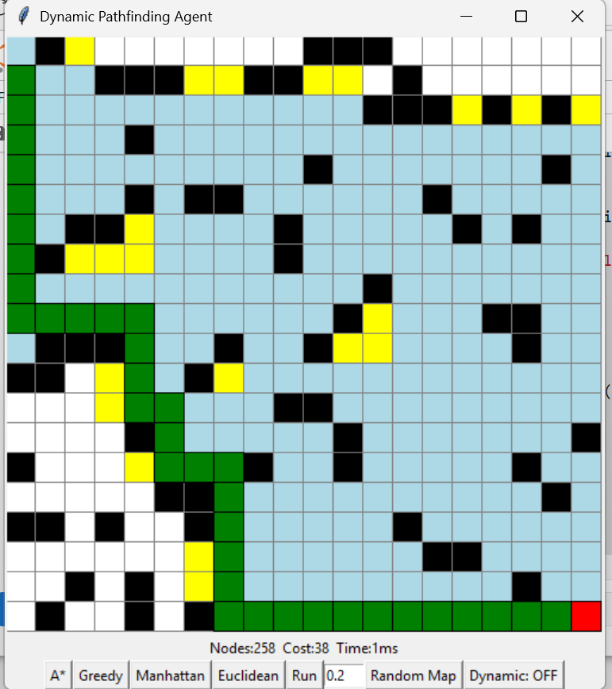

Euclidean
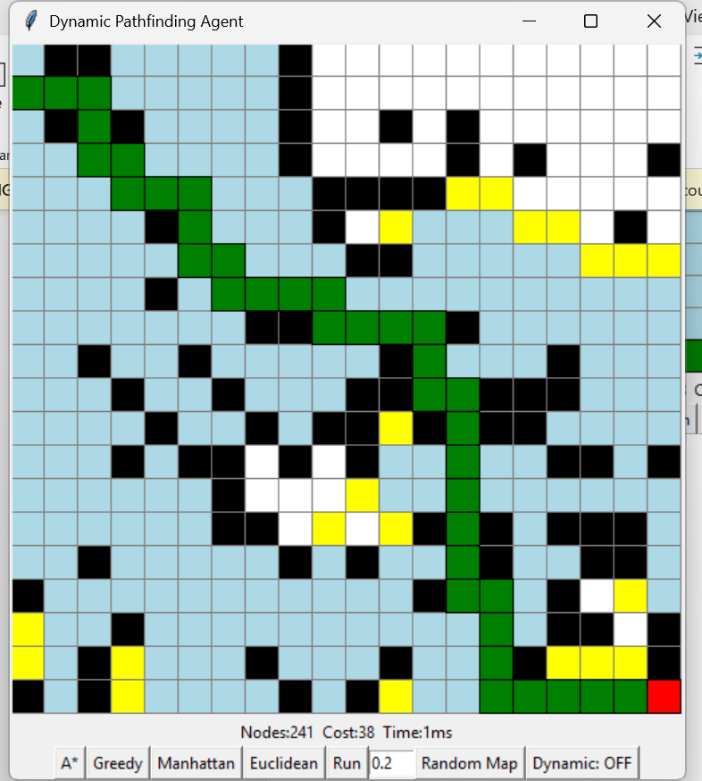

Greedy
Manhattan
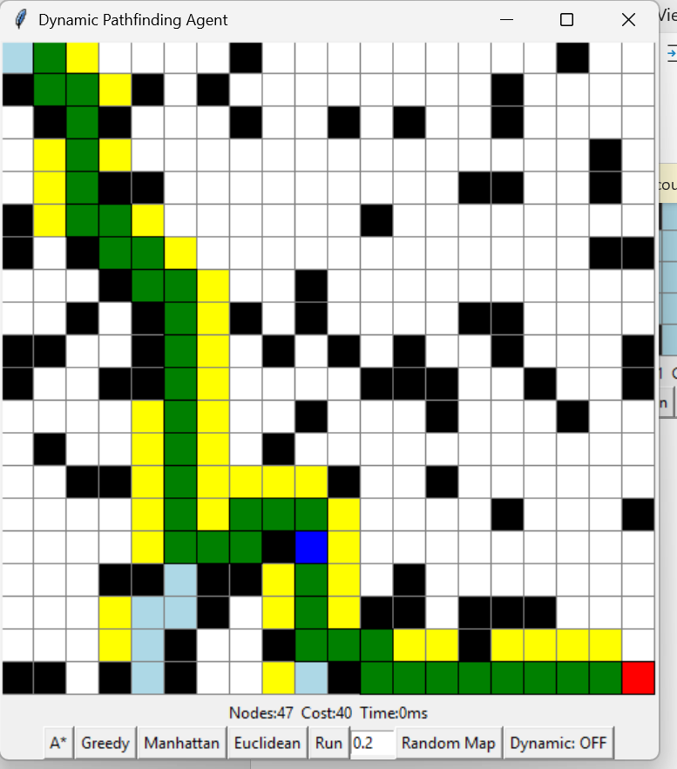
Euclidean
