TEAM NAME NN2 – E-PROJECT(2605E1)
DEVELOPER GUIDE
ALBERTO WATCHES

Submitted by:
Name | Student ID
Hafsa Saleem | 1728973
Hooria Danish | 1729957
Tuba Jamil | 1728975
Alishba Irfan | 1726973
Mubashir Irfan | 1726972
Group: B – CPSIM

Table of Contents
1. Introduction
2. Project Overview
3. Objectives
4. Technologies Used
5. System Requirements
6. Project File Structure
7. Website Pages
8. Home Page Development
9. Products Page Development
10. Cart and Payment
11. Visitor Counter
12. Store Locator
13. Technology, Gallery, Support and About
14. JavaScript Functions
15. CSS and Responsive Design
16. Navigation Flowchart
17. Developer Flowchart
18. Testing Checklist
19. Maintenance and Future Updates
20. Screenshot Section

1. Introduction
Alberto Watches is a luxury watch website developed as an E-Project. The website presents Alberto Watches and a collection of selected watch brands in a modern online interface. It provides product browsing, brand and category filtering, product details, cart functionality, payment-option selection, store location information, technology information, gallery, support and about sections.
This Developer Guide explains the structure of the website, the technologies used, the main files, page functionality, JavaScript features, navigation flow and basic maintenance steps.

2. Project Overview
Project Name: Alberto Watches
Project Type: Luxury Watch E-Commerce / Product Showcase Website
Development Type: Front-end website
Main Pages: Home, Products, Technology, Gallery, Store Locator, Support and About.
Main Product Features: Product cards, brand filtering, category filtering, details modal, shopping cart and payment option selection.

3. Objectives
- Create a professional luxury-watch website.
- Present Alberto Watches products and selected watch brands.
- Allow visitors to browse products by brand and category.
- Provide product details through an interactive interface.
- Allow users to add products to a cart and manage quantities.
- Provide store locations and support information.
- Make the website responsive for different screen sizes.
- Use animations, videos and images to improve the visual presentation.

4. Technologies Used
Technology | Use | Purpose
HTML5 | Page structure | Creates the website pages, sections, cards, forms and content.
CSS3 | Design and layout | Controls colors, spacing, typography, animations, cards and responsive styling.
JavaScript | Interactivity | Controls cart, visitor counter, product details and other dynamic functions.
Bootstrap | UI framework | Supports responsive layout, navbar, grid, buttons, modals and other components.
Local Storage | Browser storage | Can retain browser-side values such as cart/visitor-related data when implemented.
MP4 / Images | Media | Used for hero sections, watch presentations and product visuals.

5. System Requirements
- Windows, macOS or another operating system with a modern browser.
- Google Chrome, Microsoft Edge, Mozilla Firefox or another modern web browser.
- Internet connection for external libraries/CDN resources and online media.
- Visual Studio Code or another code editor for development.
- All project files should remain in the same folder so image, video, CSS and JavaScript paths work correctly.

6. Project File Structure
The supplied project contains the following main pages and supporting files:
File / Folder Item | Type | Role
index.html | HTML | Home page
product.html | HTML | Products, brands, categories and product interaction
technology.html | HTML | Technology/watch movement information
gallery.html | HTML | Watch image gallery
store-locator.html | HTML | Store locations
support.html | HTML | Customer support information
about.html | HTML | About the website/brand
css.css | CSS | Common styling
style.css | CSS | Additional page styling
main.js | JavaScript | Main website interactions
cart.js | JavaScript | Cart-related functions
counter.js | JavaScript | Visitor counter functionality
*.jpg / *.jpeg / *.png | Images | Watch and website visuals
*.mp4 | Video | Hero and watch showcase videos

7. Website Pages

Home Page (index.html)
Introduces Alberto Watches through the hero section, watch visuals, video content and links to the main website sections.

Products Page (product.html)
Displays Alberto Watches products and selected brands. Users can select brands/categories, view details and add products to the cart.

Technology Page (technology.html)
Provides information related to watch technology and craftsmanship with visual content.

Gallery Page (gallery.html)
Displays a collection of watch images in a visual gallery.

Store Locator (store-locator.html)
Provides store/location information for customers.

Support Page (support.html)
Provides customer support/service information.

About Page (about.html)
Provides information about Alberto Watches and the website.
Screenshot Placeholder – Website Home Page
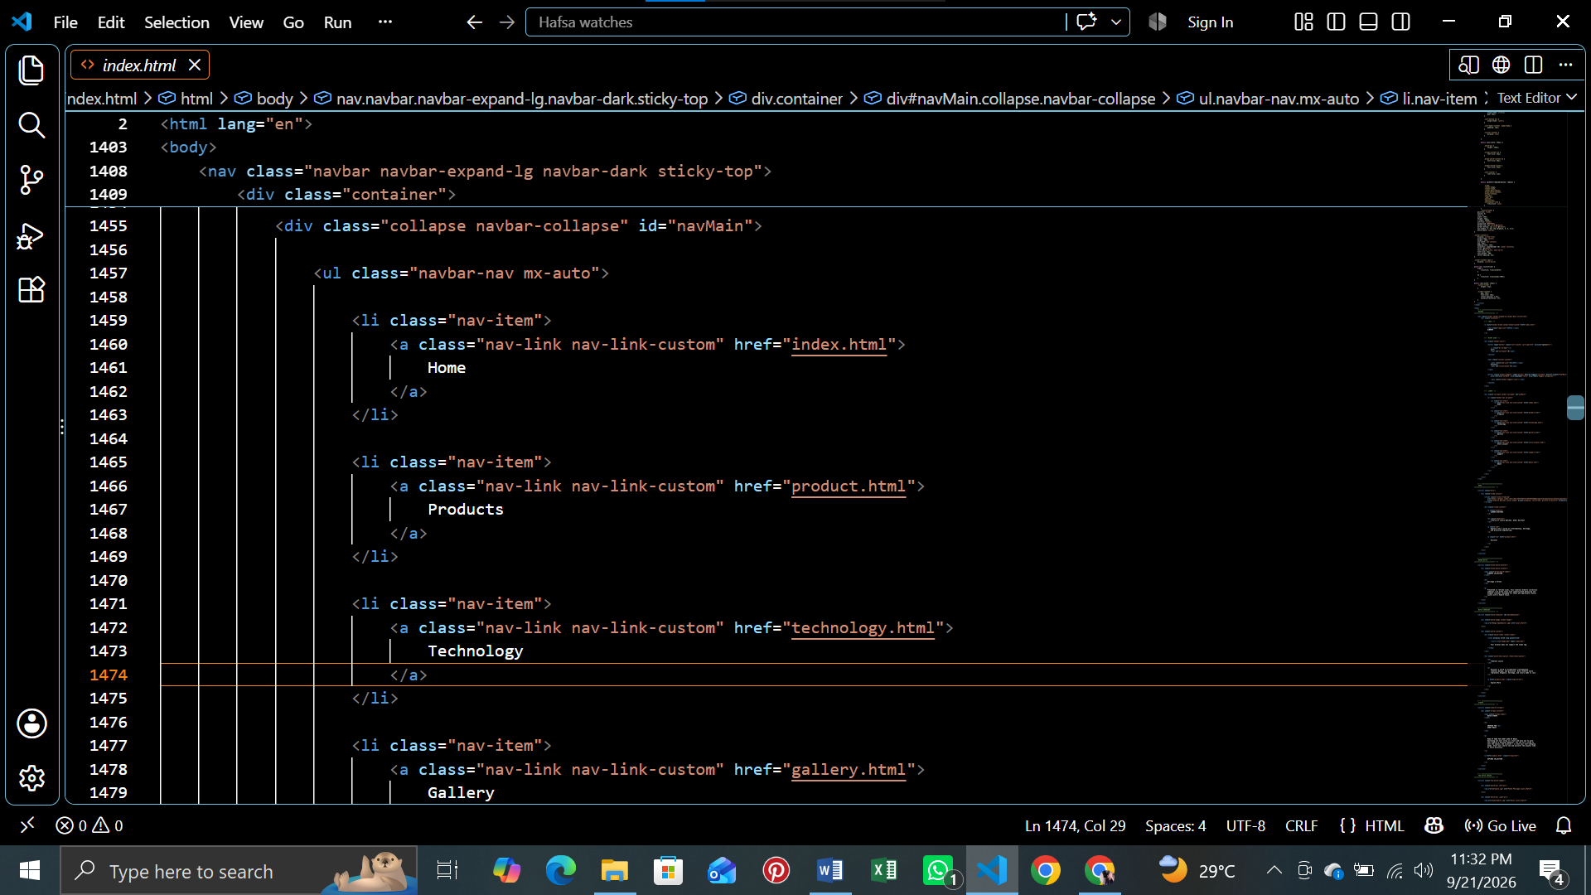

8. Home Page Development
The Home page is the first page of the website. It is designed to introduce the luxury-watch theme and direct visitors to other pages.
- Luxury hero section with visual/video presentation.
- Navigation bar for moving between website pages.
- Alberto Watches branding and introductory content.
- Watch showcase sections using images and video.
- Links/buttons that guide visitors to the product collection.
- Responsive layout for desktop and smaller screens.
Screenshot Placeholder – Home Page Hero Section
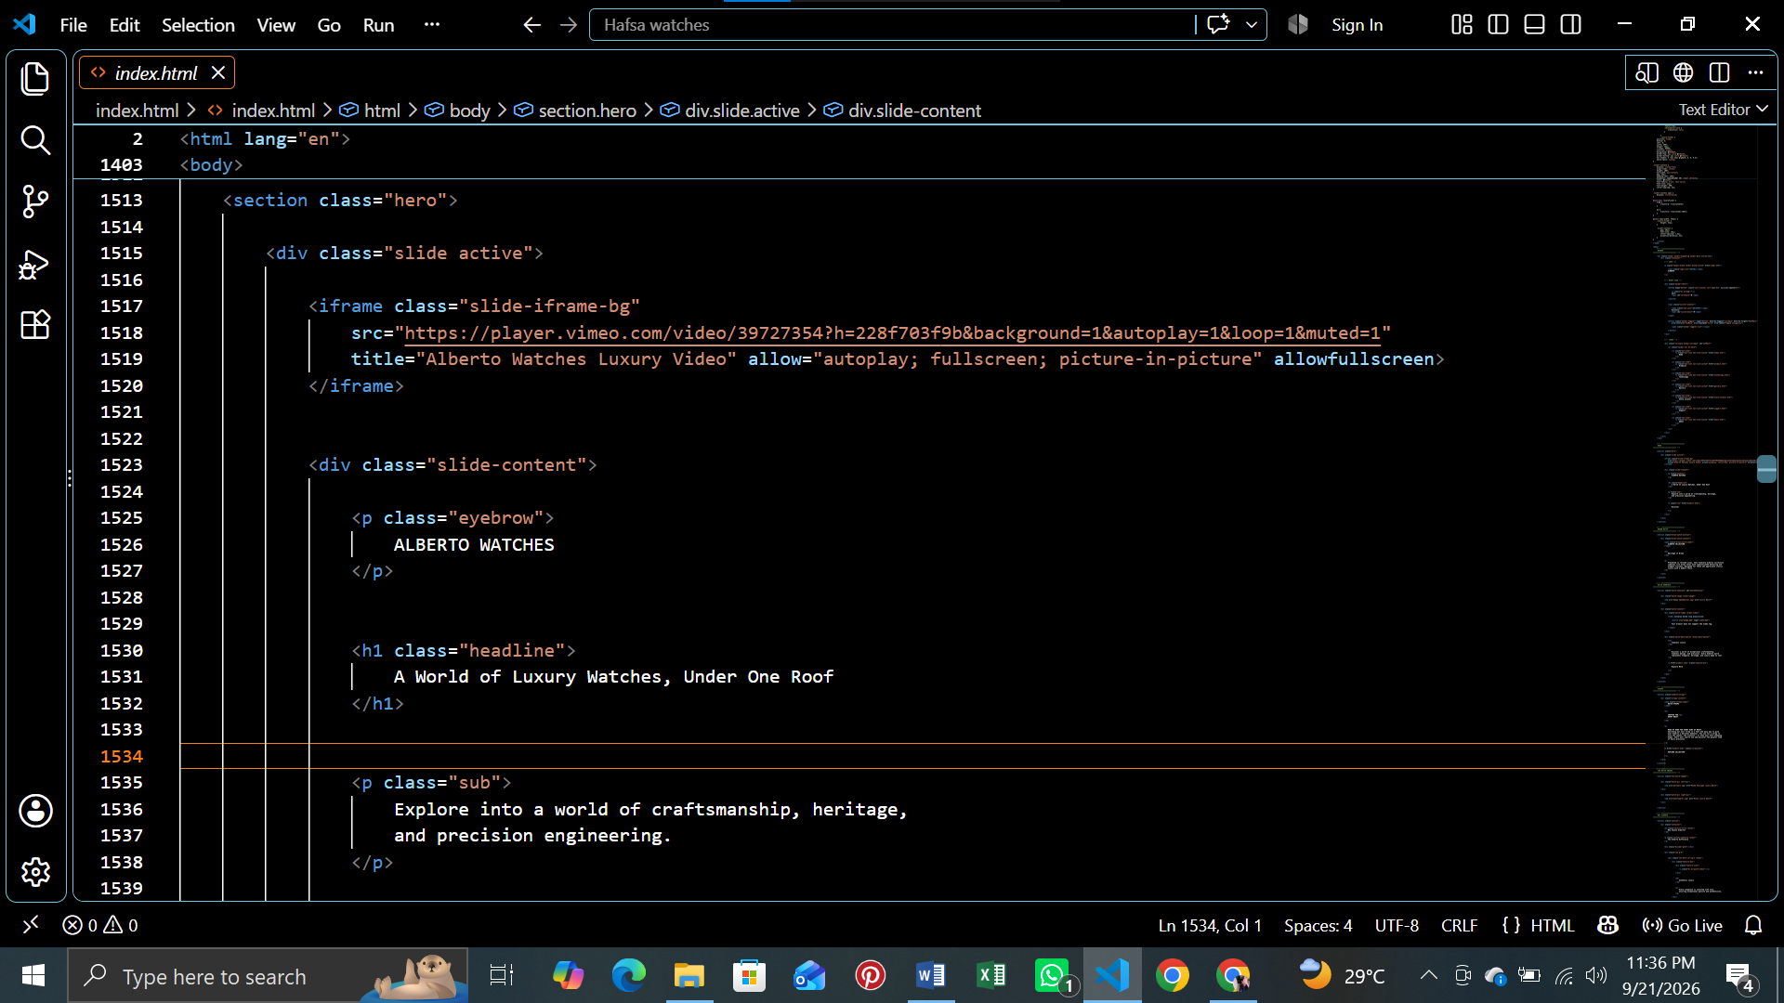

9. Products Page Development
The Products page is the main product browsing section. It contains Alberto Watches products and products grouped by selected brands.
- Brand selection buttons for available brands.
- Product cards with watch image, name, price/details and action buttons.
- Category options such as Luxury, Vintage and Smart where provided.
- Product details modal for additional information.
- Add to Cart functionality.
- Animated/reveal presentation of product cards.
Screenshot Placeholder – Products Page
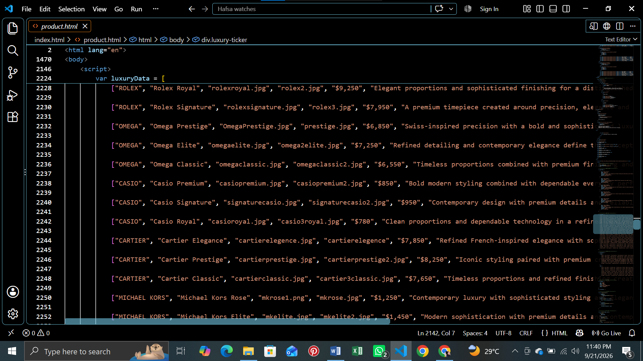

Screenshot Placeholder – Brand / Category Filter
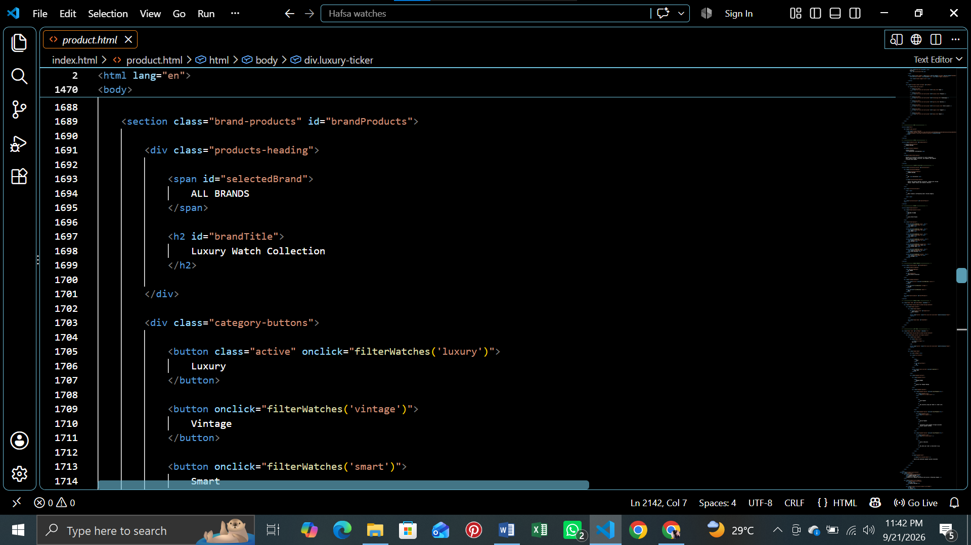

10. Cart and Payment
The website includes a client-side shopping cart. Users can add products, view selected items, change quantities, remove items and view the total.

Cart Functions
- Add a selected product to the cart.
- Display the number of selected cart items.
- Increase or decrease product quantity.
- Remove an individual product.
- Clear the cart.
- Calculate and display the cart total.
- Display selected payment options.

Cart File
cart.js is included in the project for cart-related JavaScript functionality. Product-page JavaScript works with the cart interface to transfer selected product information.
Screenshot Placeholder – Cart
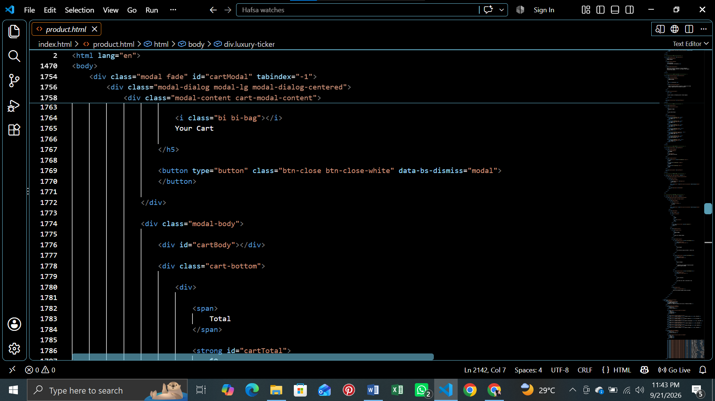

Screenshot Placeholder – Payment Options
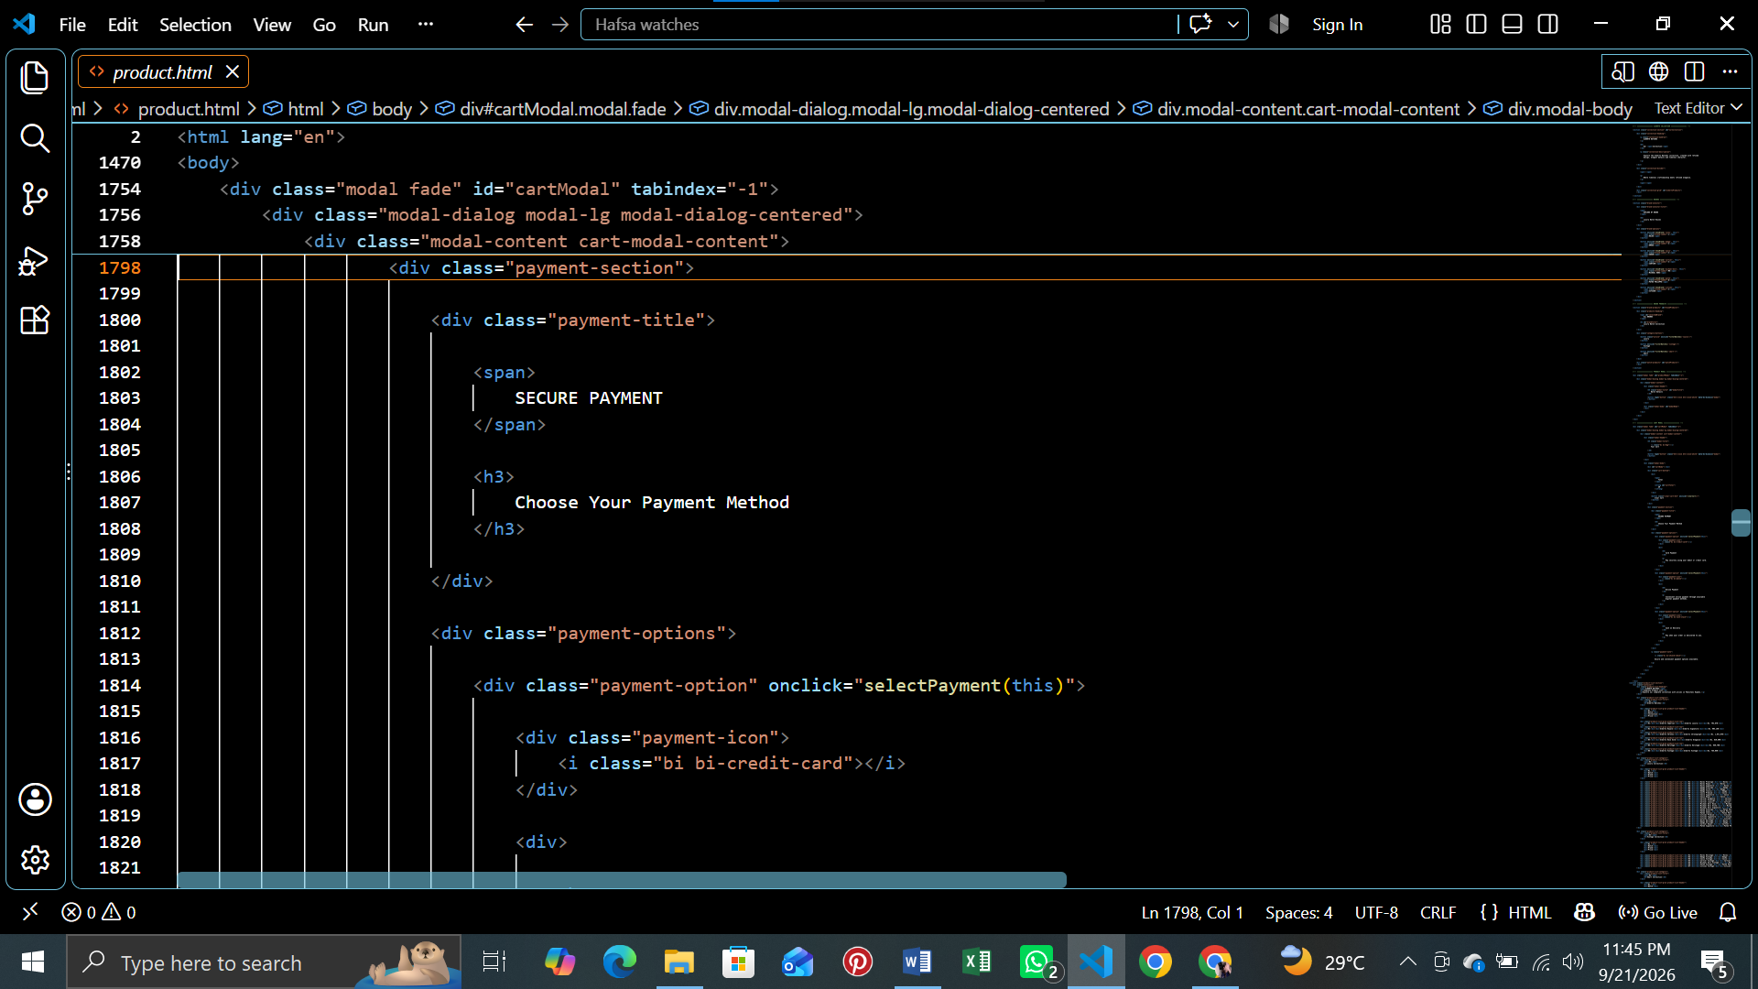

11. Visitor Counter
The project contains counter.js for the visitor counter. The counter is displayed in the website navigation/interface where implemented. It is a browser-side feature and should be tested after loading the website and moving between pages.
Screenshot Placeholder – Visitor Counter in Navbar
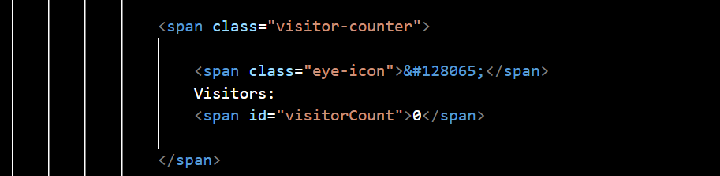

12. Store Locator
The Store Locator page provides customers with information about physical store locations. The supplied project includes store-location content for major Pakistani shopping locations.
- Store name/location information.
- Location cards or sections.
- Customer-facing location details.
- Navigation back to other website pages.
Screenshot Placeholder – Store Locator
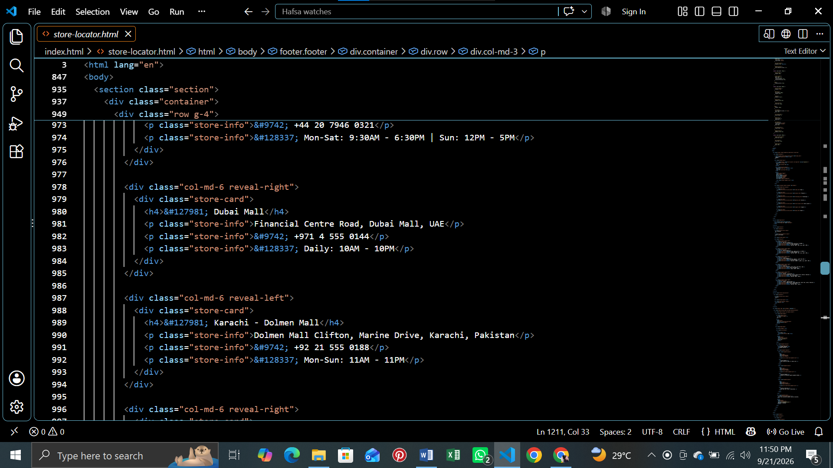

13. Technology, Gallery, Support and About

Technology
Explains watch technology/craftsmanship and presents supporting visuals or media.

Gallery
Presents watch images for visual browsing.

Support
Provides customer assistance/service-related information.

About
Provides background information about Alberto Watches and the website.
Screenshot Placeholder – Ticker in technology page
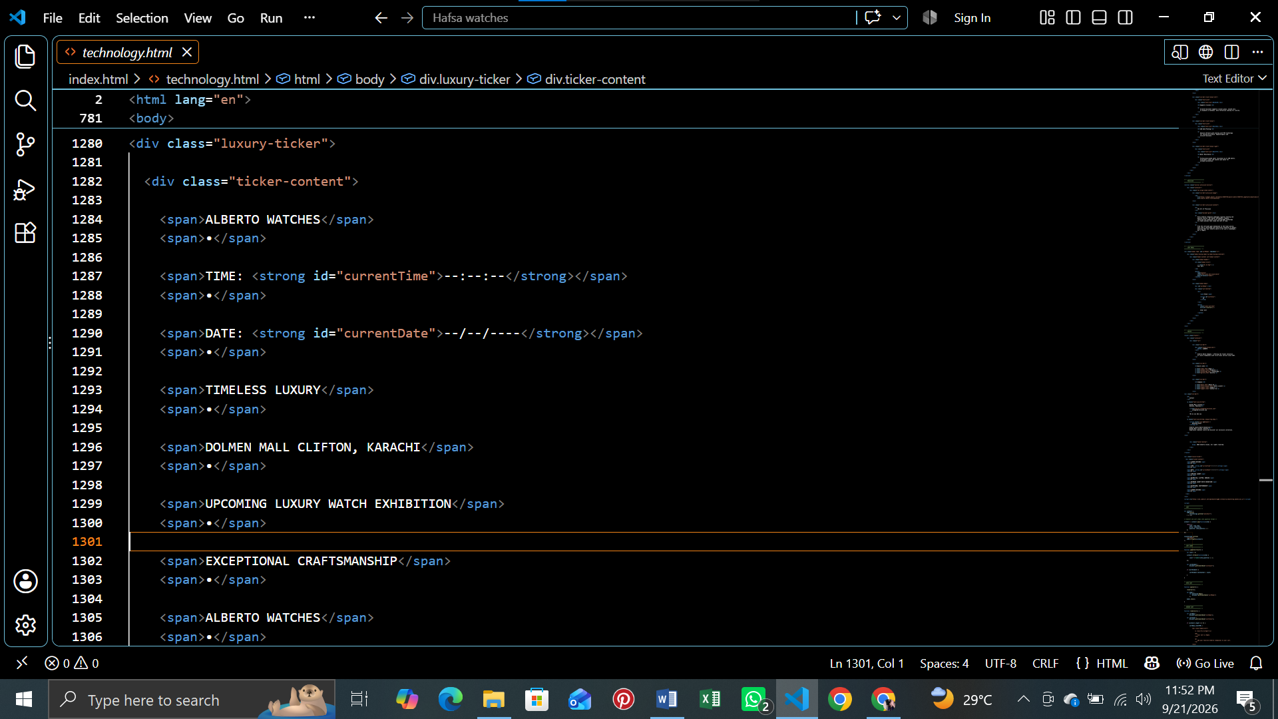

Screenshot Placeholder – Gallery Page
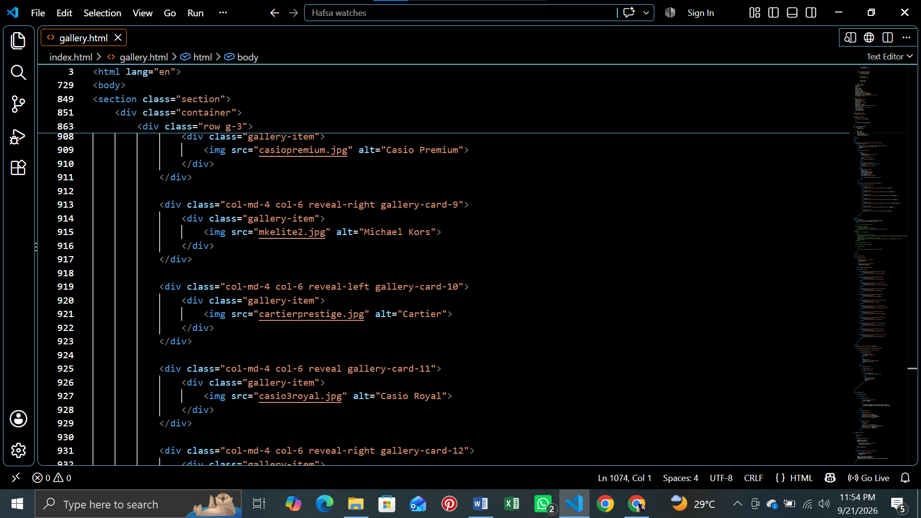

Screenshot Placeholder – Support / About Page
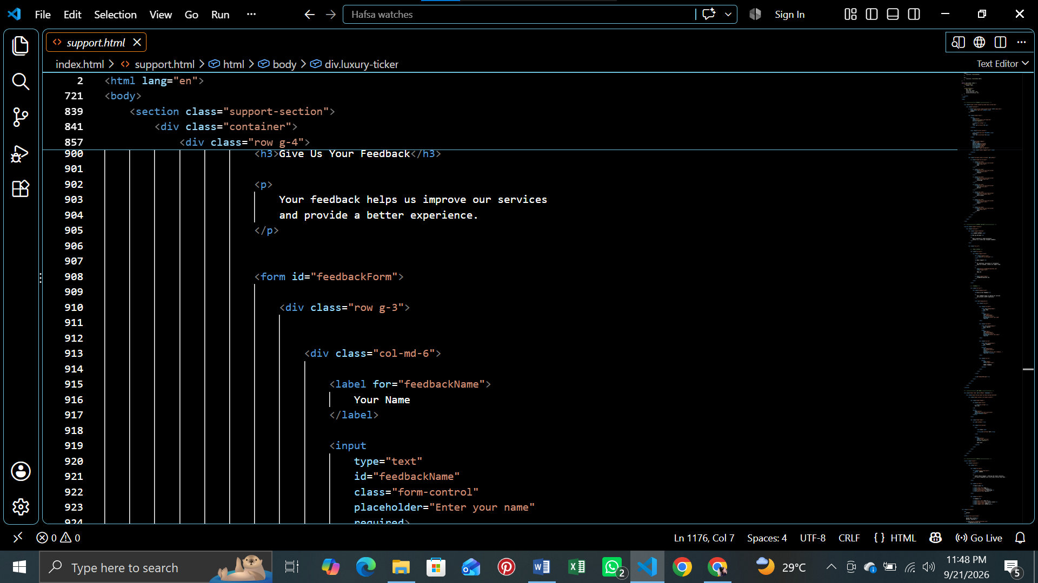

14. JavaScript Functions
The website uses JavaScript for interactive features. The main JavaScript responsibilities in the supplied project include:
Feature | File | Function in Website
Cart management | cart.js | Add, update, remove and clear cart items.
Visitor counter | counter.js | Handles the visitor-count display.
Page interactions | main.js | Supports common dynamic website behavior.
Product details | product.html / JavaScript | Shows product information in a details interface/modal.
Payment selection | product.html / JavaScript | Changes the selected payment option in the interface.

15. CSS and Responsive Design
CSS is used to create the dark luxury theme, gold/green/white accents, typography, product cards, buttons, spacing, animations and responsive behavior.
- CSS variables are used for repeated theme values where defined.
- Cards and sections use spacing and visual hierarchy for a luxury appearance.
- Hover and transition effects improve product interaction.
- Bootstrap grid/components help with responsive page layout.
- Media queries and responsive classes allow the interface to adapt to different screen sizes.

16. Navigation Flowchart
The main website navigation can be represented as follows:
START
↓
Home Page
↓
Choose Website Section
↓
Products | Technology | Gallery | Store Locator | Support | About
↓
If Products → Select Brand → Select Category → View Product
↓
View Details → Add to Cart → Open Cart → Manage Quantity
↓
Select Payment Option
↓
END
Screenshot Placeholder – Navigation / Flowchart

17. Developer Flowchart
Developer opens project folder
↓
Check HTML pages and linked CSS/JS files
↓
Load website in browser
↓
Test navigation and responsive layout
↓
Test product filtering and product details
↓
Test Add to Cart / Cart / Payment selection
↓
Test visitor counter and other dynamic features
↓
Check images and videos
↓
Fix errors and save changes
↓
Final browser testing
↓
END

