TEAM NAME NN2 – E-PROJECT(2605E1)
USER GUIDE
ALBERTO WATCHES

Submitted by:
Name | Student ID
Hafsa Saleem | 1728973
Huria Danish | 1729957
Tuba Jamil | 1728975
Alishba Irfan | 1726973
Mubashir Irfan | 1726972
Group: B – CPSIM

Table of Contents
1. Introduction
2. How to Open the Website
3. Website Navigation
4. Home Page
5. Products Page
6. Selecting a Brand
7. Selecting a Category
8. Viewing Product Details
9. Adding Products to Cart
10. Managing the Cart
11. Payment Options
12. Visitor Counter
13. Technology Page
14. Gallery Page
15. Store Locator
16. Support Page
17. About Page
18. User Flowchart
19. Basic Troubleshooting
20. Screenshot Section

1. Introduction
Alberto Watches is a luxury watch website created to allow visitors to explore watches, view product information, browse different brands and categories, use the shopping cart and view other website sections such as Technology, Gallery, Store Locator, Support and About.
This User Guide explains how a normal website visitor can use the main features of Alberto Watches. The instructions are written step-by-step so that a user can easily move through the website.

2. How to Open the Website
- Open the Alberto Watches project folder.
- Open the main index.html file in a modern web browser.
- Wait for the Home page and its media to load.
- Make sure the navigation bar is visible at the top of the page.
Screenshot Placeholder – Opening the Website
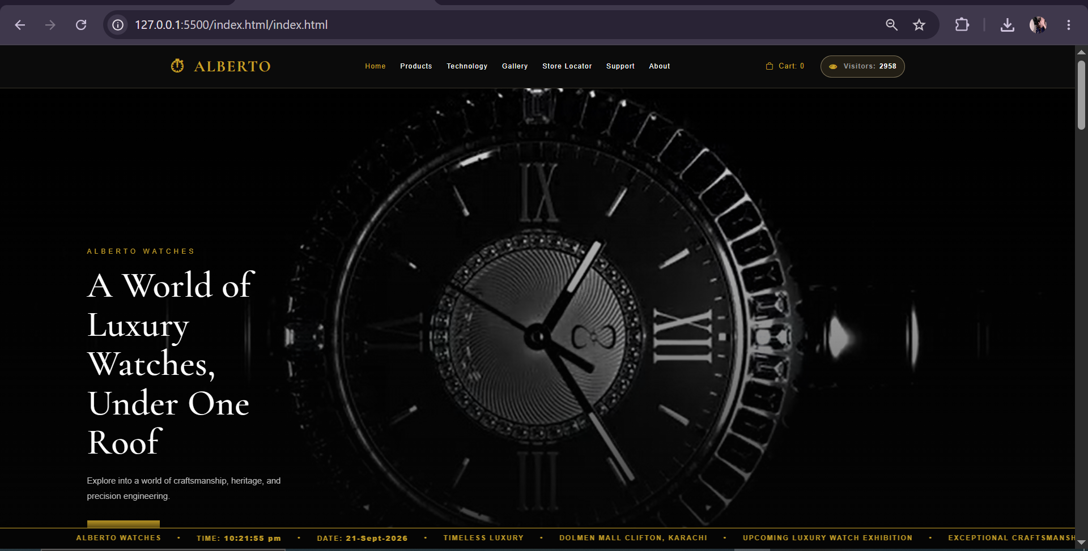

3. Website Navigation
The navigation bar provides access to the main pages of the website. Users can select the required section from the navigation menu.
Page | What the User Can Do
Home | View the main luxury presentation and introductory content.
Products | Browse watches, brands and categories; view details and use the cart.
Technology | Read about watch technology and craftsmanship.
Gallery | View watch images.
Store Locator | View store/location information.
Support | View customer support information.
About | Read about Alberto Watches.
Screenshot Placeholder – Navigation Bar

4. Home Page
The Home page is the starting point of the website. It presents the Alberto Watches identity and luxury-watch theme.
- View the hero section and video/visual presentation.
- Read the introductory content.
- Scroll through the watch showcase sections.
- Use the available buttons or links to move to the Products page or other sections.
Screenshot Placeholder – Home Page
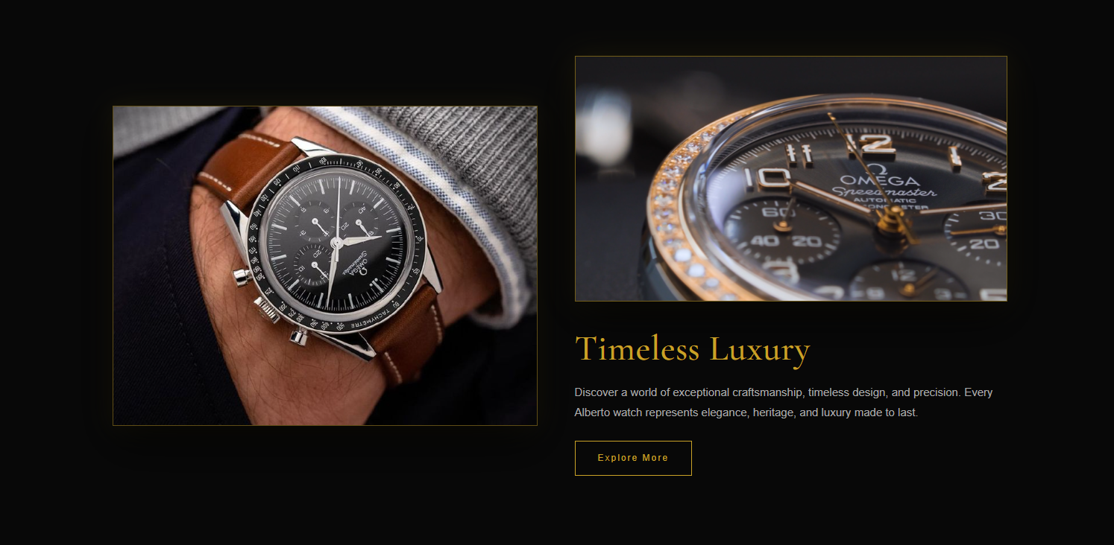

5. Products Page
The Products page is used to browse watches. Product cards provide the main information and actions available to the user.
- Open Products from the navigation bar.
- Scroll through the available product cards.
- Use brand buttons to select a specific brand.
- Use category buttons when available.
- Select Details to view more information about a watch.
- Select Add to Cart when a product is required in the shopping cart.
Screenshot Placeholder – Products Page
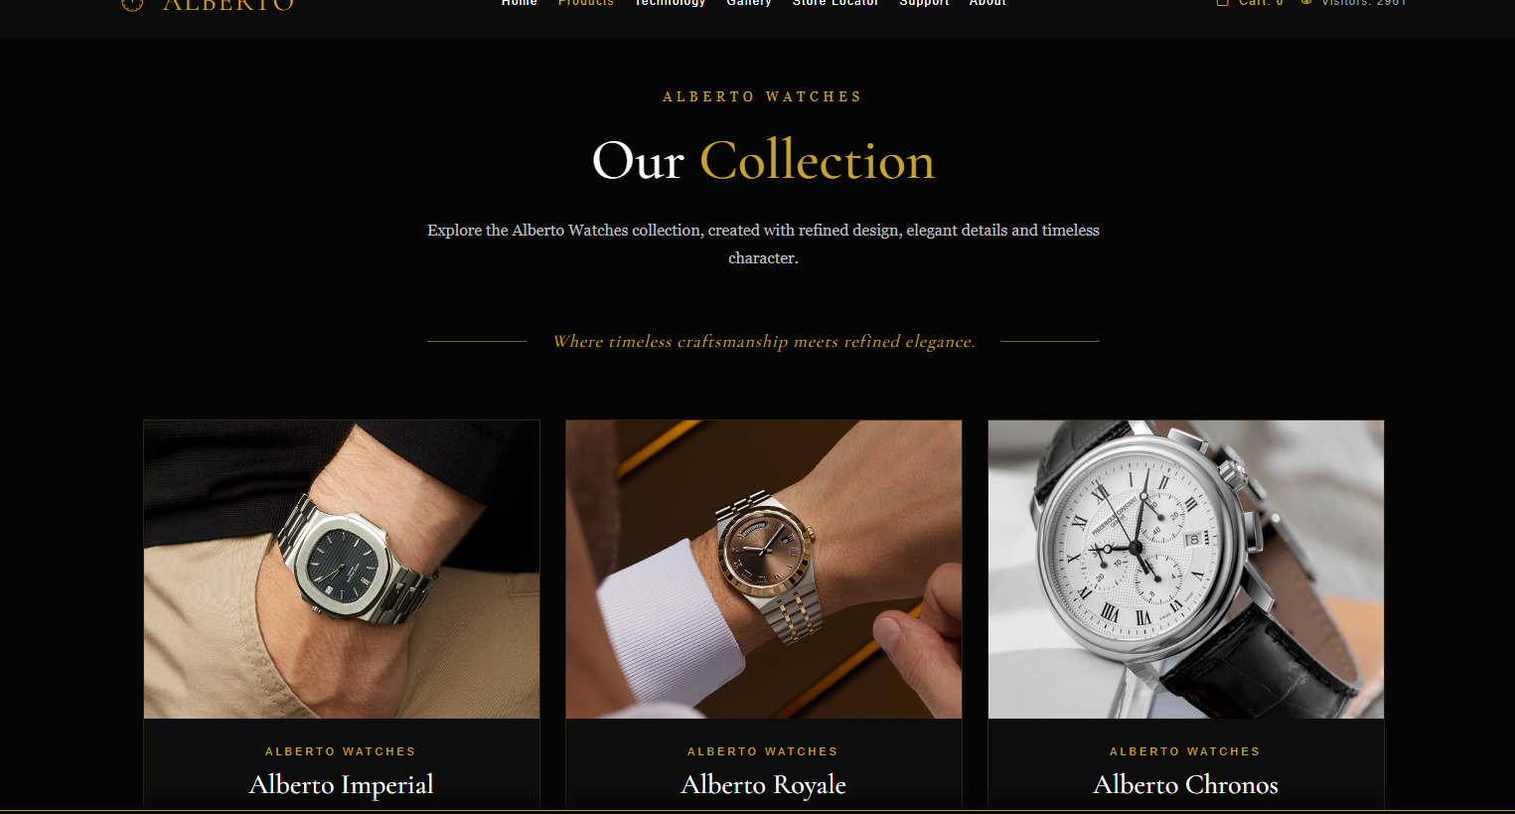

6. Selecting a Brand
Brand buttons allow users to display products belonging to a selected watch brand.
- Go to the Products page.
- Find the brand selection section.
- Select the required brand button.
- The relevant products are displayed.
- Select another brand to change the displayed products.
Screenshot Placeholder – Brand Selection
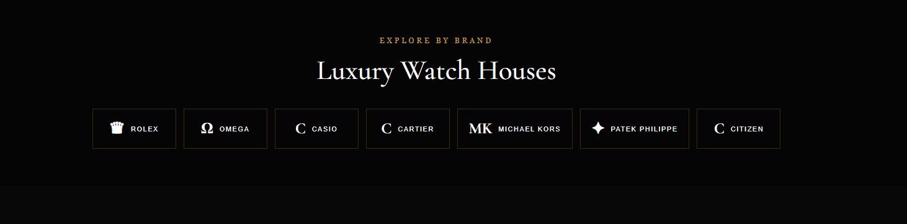

7. Selecting a Category
Category buttons can be used to narrow the product display according to the available categories.
- Select a brand if required.
- Choose Luxury, Vintage or Smart where available.
- Review the displayed products.
- Change the category whenever required.
Screenshot Placeholder – Category Selection


8. Viewing Product Details
The Details button opens the product information interface/modal.
- Select Details on the required product.
- Read the watch name and product information.
- Check the available image(s), price and description.
- Review other information such as brand, category, movement or case information when provided.
- Close the details window to return to the Products page.
Screenshot Placeholder – Product Details
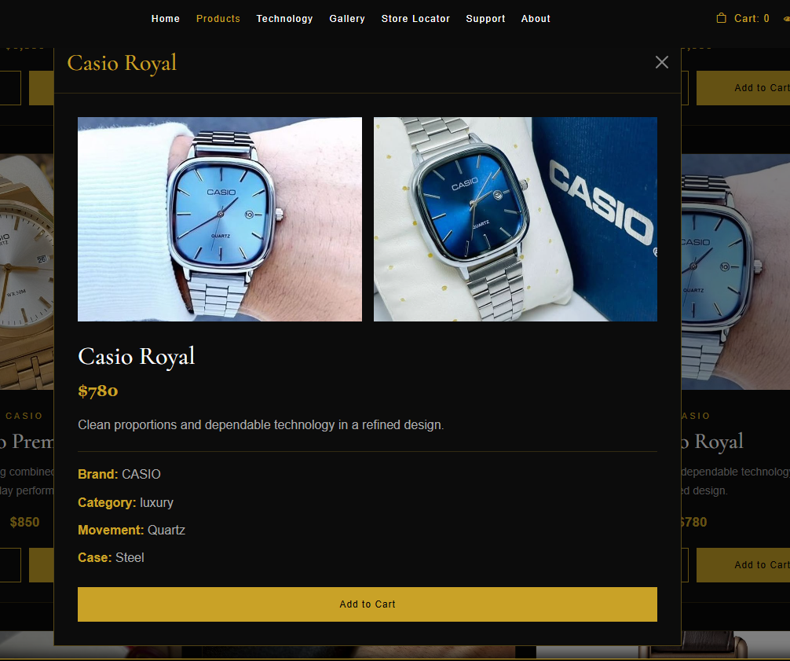

9. Adding Products to Cart
- Find the required product.
- Select Add to Cart.
- The product is added to the shopping cart.
- The cart counter is updated.
- Open the cart to review the selected product.
Screenshot Placeholder – Add to Cart
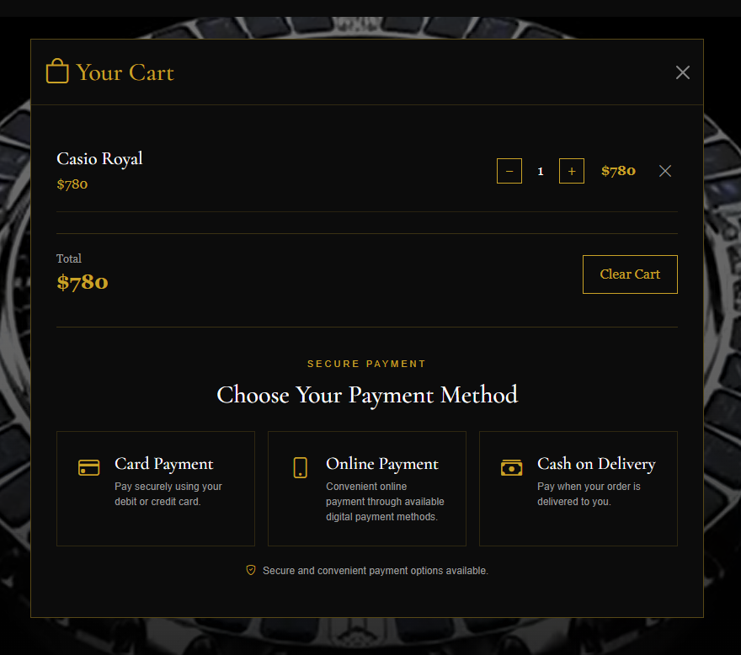

10. Managing the Cart
The cart allows users to review and manage selected products.
- Open the cart using the cart button/icon.
- Check the product name, quantity and price.
- Use the plus button to increase quantity.
- Use the minus button to decrease quantity.
- Use Remove to delete an individual product.
- Use Clear Cart to remove all selected products.
- Check the total amount displayed by the cart.
Screenshot Placeholder – Shopping Cart
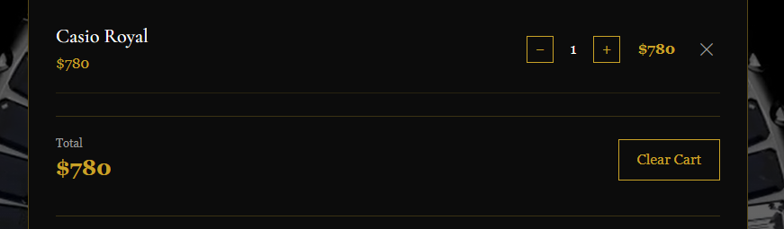

11. Payment Options
After reviewing the cart, the available payment options can be selected in the payment section.
- Open the payment section.
- Review the available payment options.
- Select the required payment option.
- The selected option is highlighted in the interface.
Screenshot Placeholder – Payment Section
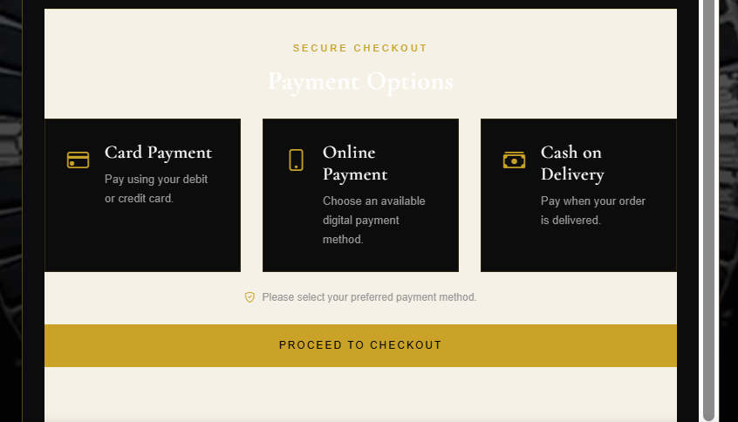

12. Visitor Counter
The visitor counter is displayed in the website interface/navigation. It provides a visitor-count display while browsing the website.
- Open the website.
- Look at the navigation bar.
- Check the Visitors counter.
- Continue browsing the website normally.
Screenshot Placeholder – Visitor Counter
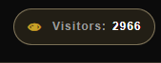

13. Technology Page
The Technology page provides information about watch technology and craftsmanship.
- Select Technology from the navigation bar.
- Scroll through the information and visual sections.
- Read the technology/craftsmanship details.
- Use the navigation bar to move to another page.
Screenshot Placeholder – Technology Page
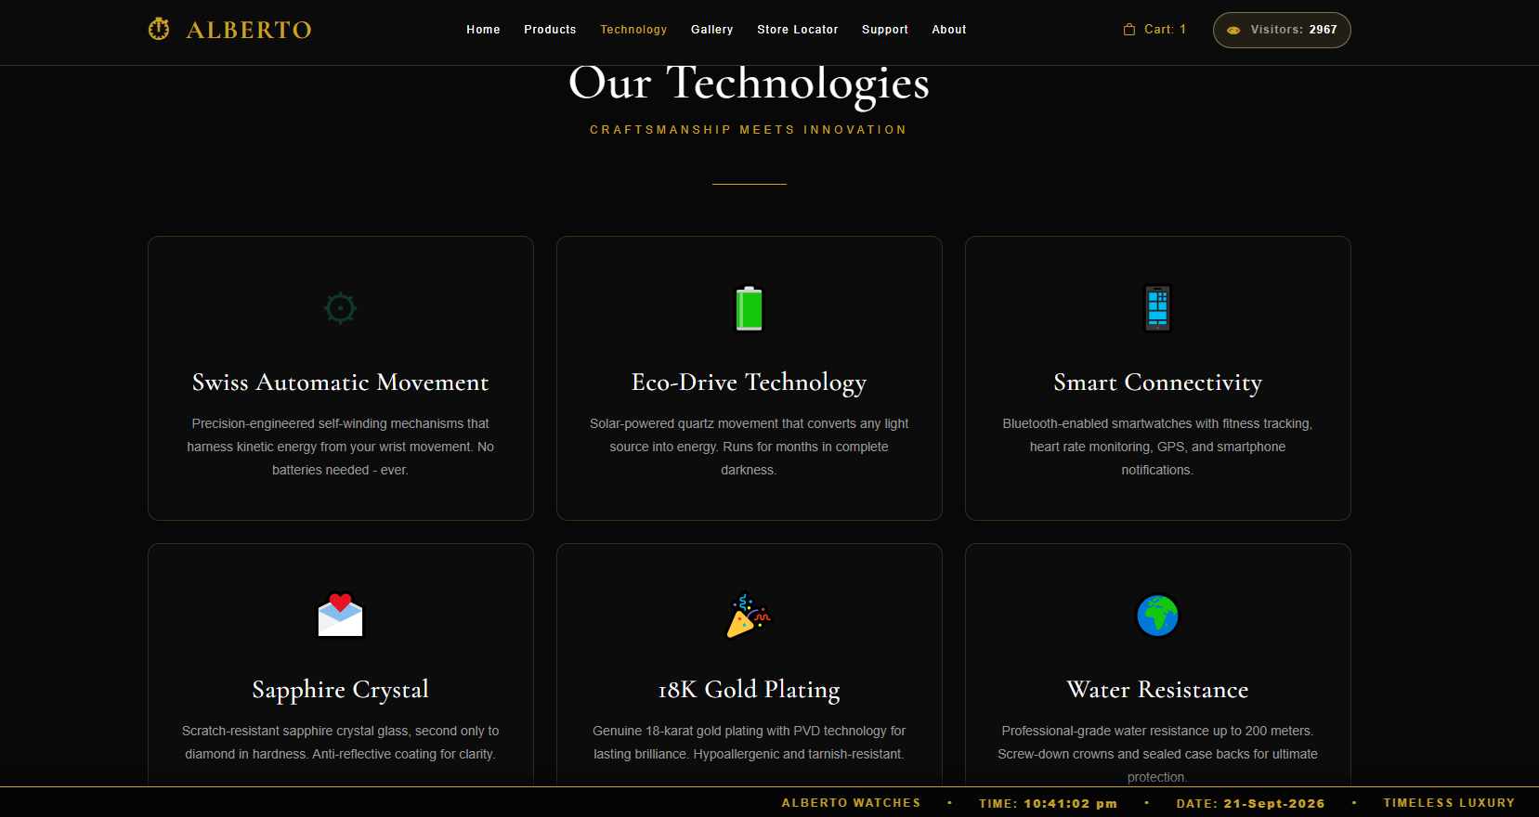

14. Gallery Page
The Gallery page allows users to view watch images.
- Open Gallery from the navigation bar.
- Scroll through the watch images.
- View the available gallery content.
- Return to the navigation bar for another page.
Screenshot Placeholder – Gallery Page
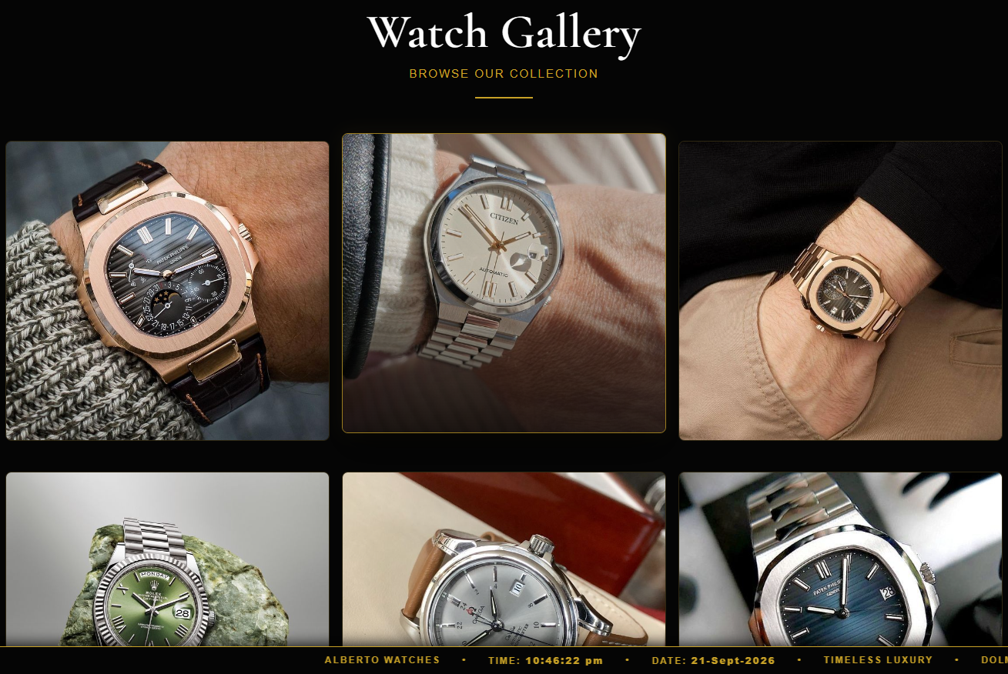

15. Store Locator
The Store Locator provides information about available Alberto Watches store locations.
- Select Store Locator.
- Review the listed store/location cards.
- Read the location information.
- Use the navigation bar to return to another section.
Screenshot Placeholder – Store Locator
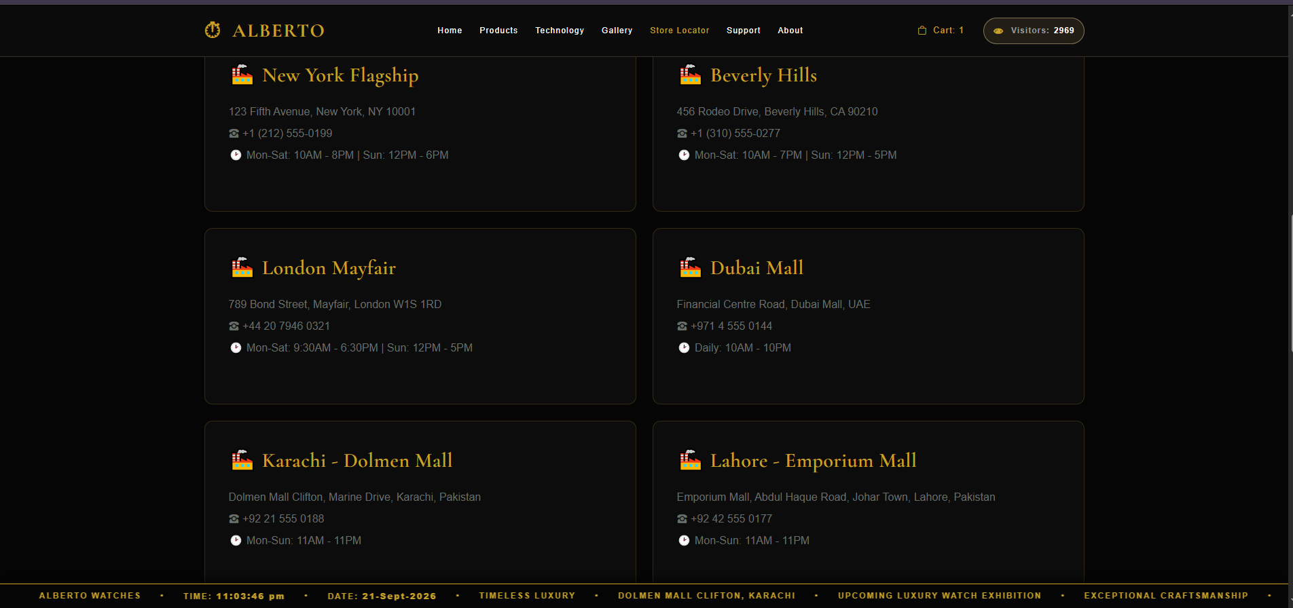

16. Support Page
The Support page provides customer-facing support and service information.
- Open Support.
- Read the available support/service information.
- Use the provided website controls or contact information where available.
Screenshot Placeholder – Support Page
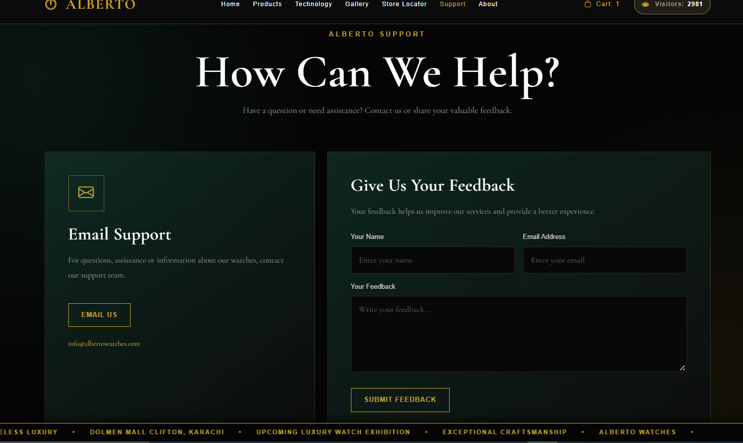

17. About Page
The About page provides information about Alberto Watches and the website.
- Select About from the navigation bar.
- Read the information presented on the page.
- Return to another page using the navigation bar.
Screenshot Placeholder – About Page
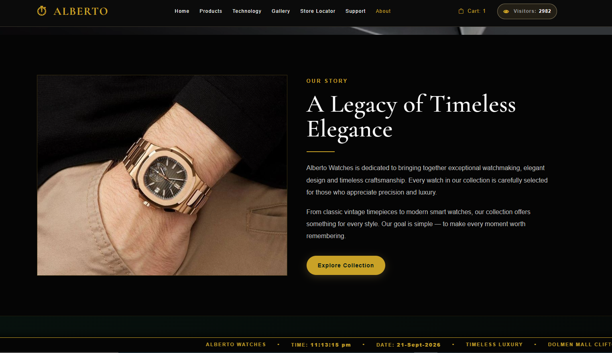

18. User Flowchart
The following flow shows the normal path a visitor can follow while using the website.
START
↓
Open Alberto Watches
↓
Home Page
↓
Products Page
↓
Select Brand / Category
↓
Select Product
↓
View Details
↓
Add to Cart?
↓
Open Cart
↓
Change Quantity / Remove Product
↓
Review Total
↓
Select Payment Option
↓
END

