Cloud computing
Name: Hafsa Tariq
Fa24b1-se-071
Assignment
Section B

Getting Started
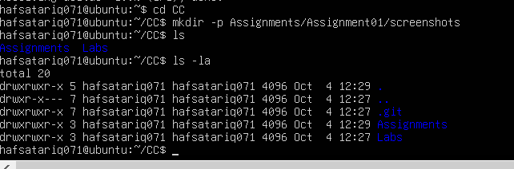
Task 1: Install Gitea and Push a Repository from the Ubuntu Server
Step 1.1: Install and Run Gitea on the Ubuntu Server
2.
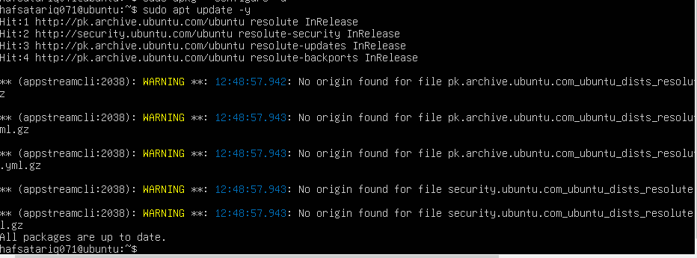
3.
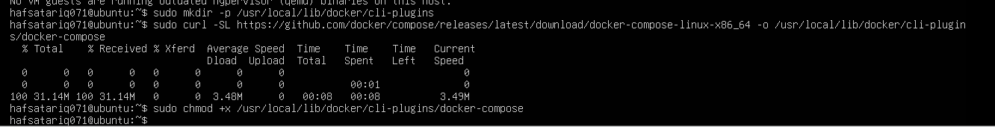
4.
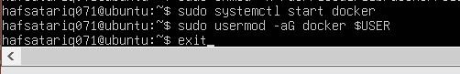
5.
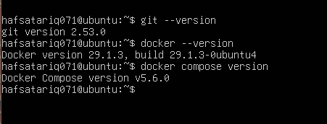
6.
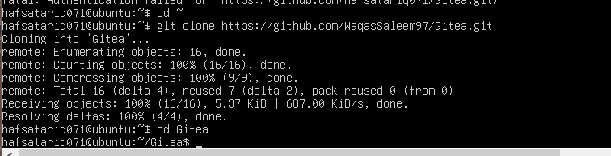
7.
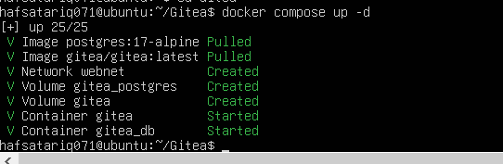
8.
9.

10.
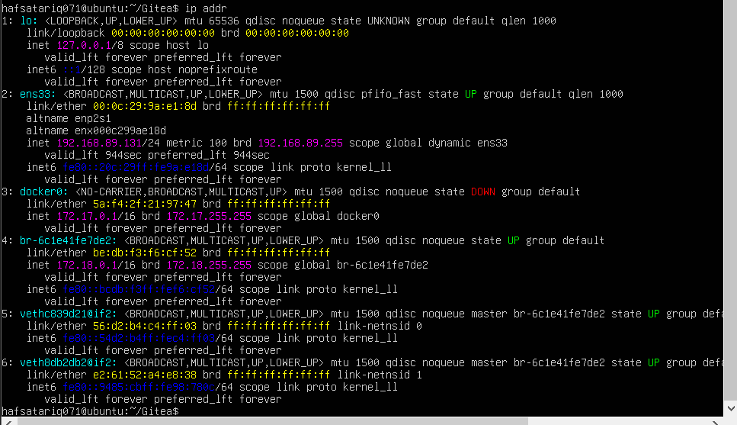
12.
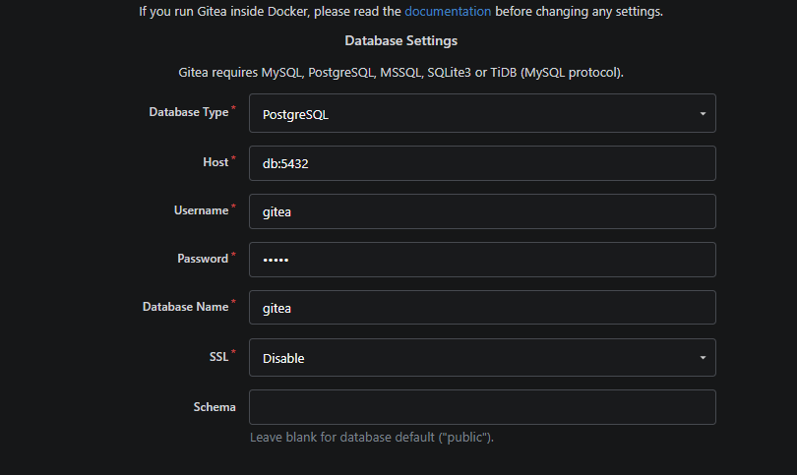

13.
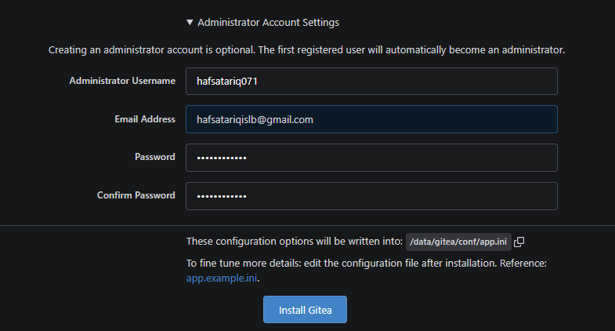
task1_gitea_running.png
Step 1.2: Create and Push the Initial Repository

1.
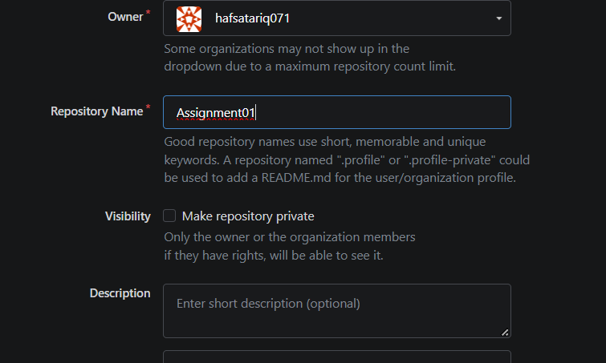
2.
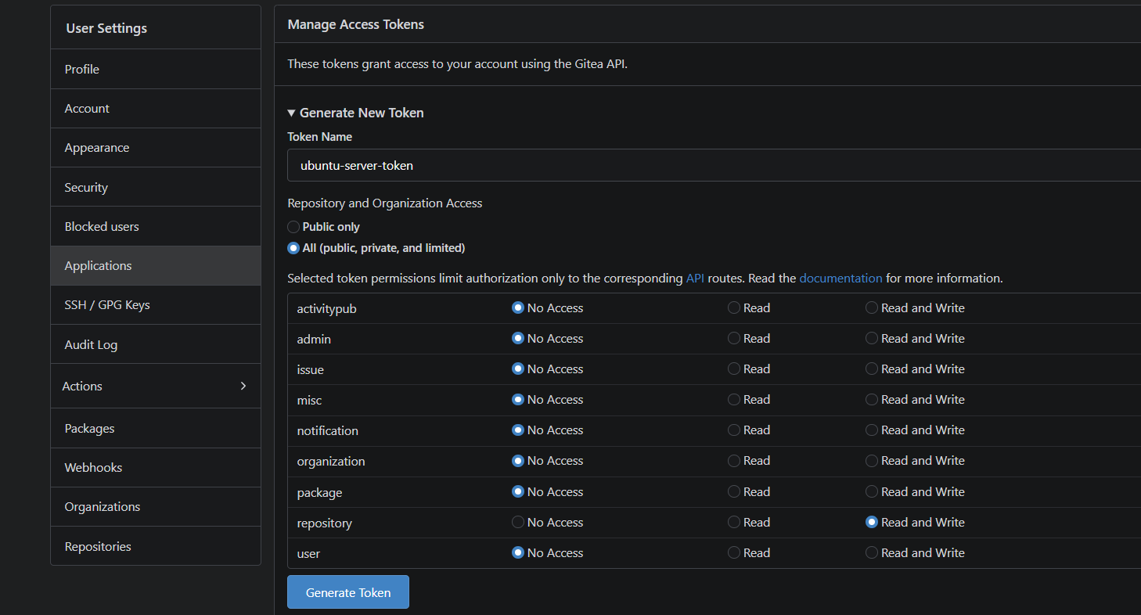

3.
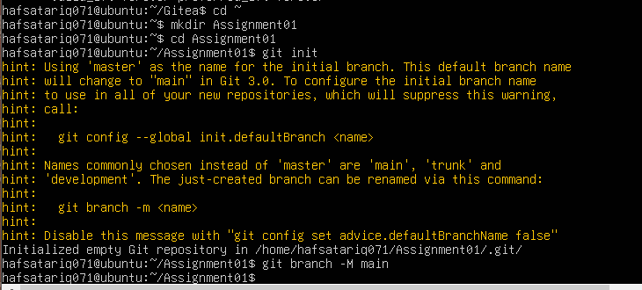
4.
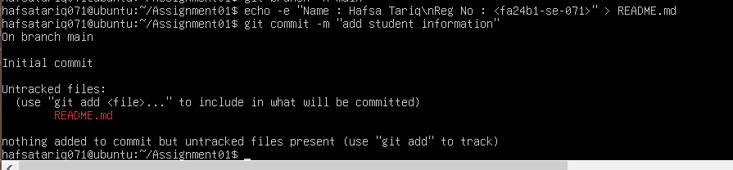
5.
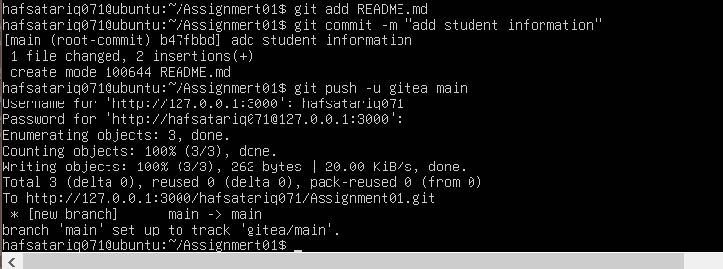
7

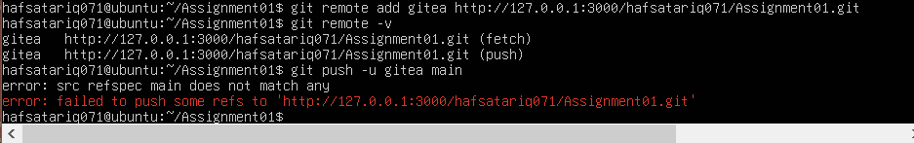
8
9
task1_gitea_push.png

Step 1.3: Verify the Gitea Repository
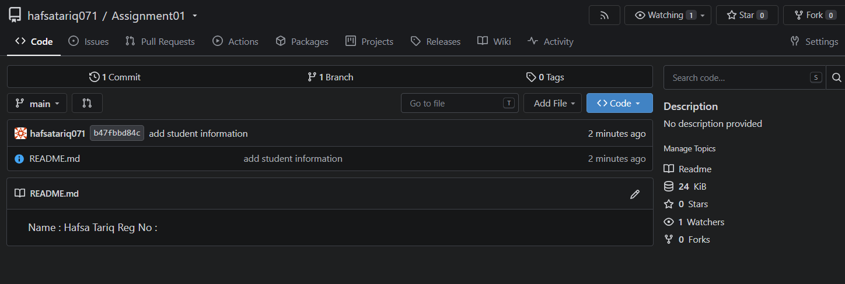
task1_gitea_repository.png
Task 2: Push the Same Repository to GitHub
Step 2.1: Create the GitHub Repository and Verify Both Remotes
1.

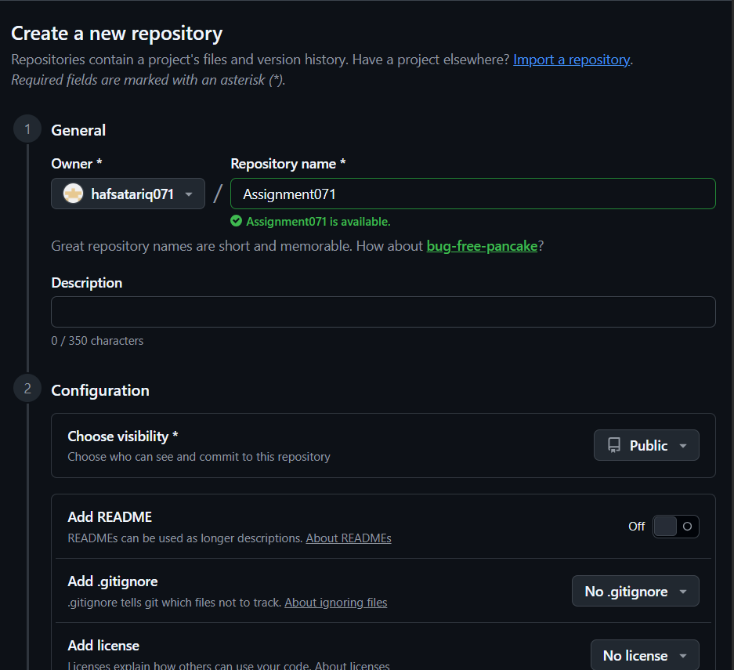
2.
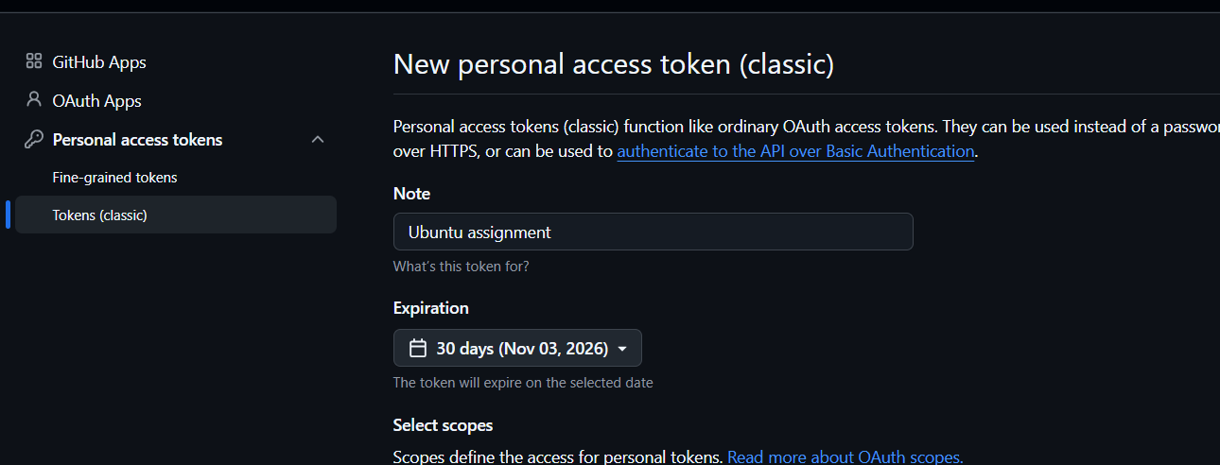

4.
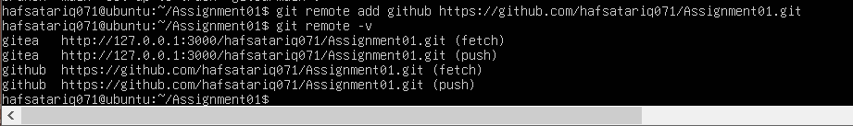
5.
task2_remotes.png
Step 2.2: Push to GitHub
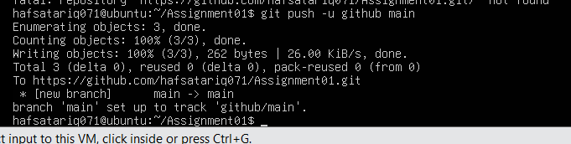
task2_github_push.png
Step 2.3: Verify the GitHub Repository
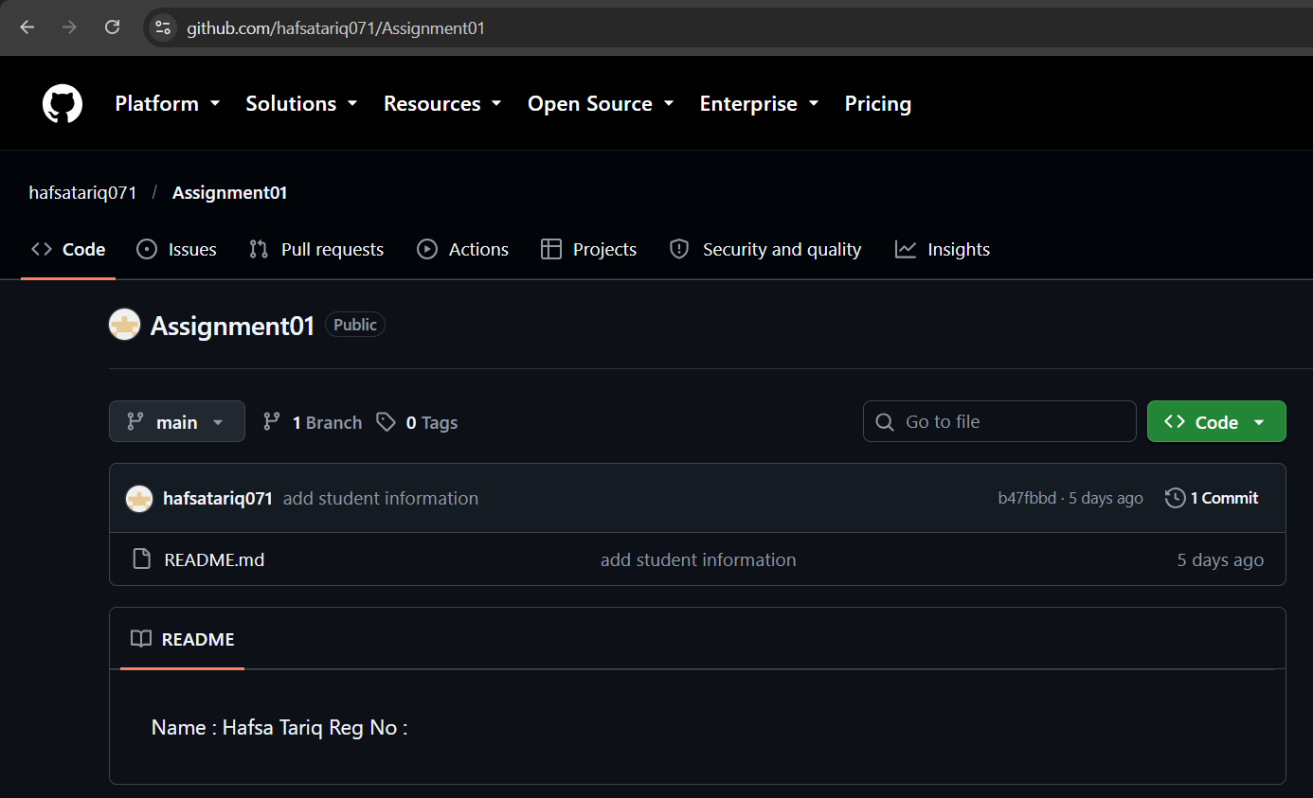
task2_github_repository.png

Task 3: Track Three Large Files with Git LFS
Step 3.1: Configure Git LFS
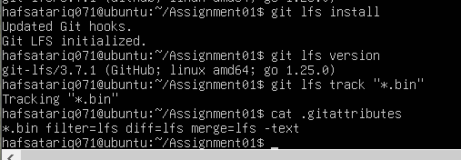
task3_lfs_setup.png
Step 3.2: Create and Verify Three LFS Files
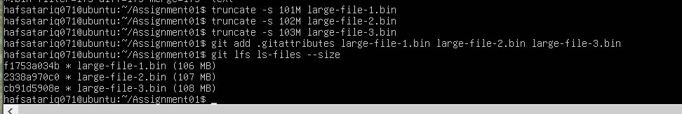
task3_lfs_files.png
Step 3.3: Commit and Push the LFS Filess
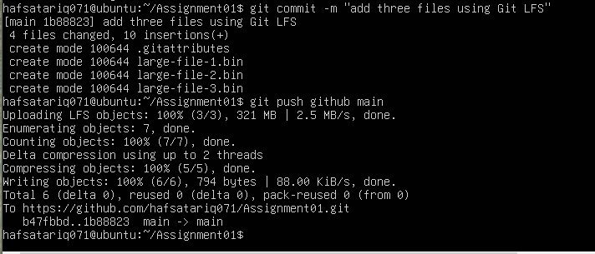
task3_lfs_push.png

Task 4: Create a Portfolio or CV with GitHub Pages
Step 4.1: Create and Push the Portfolio Repository
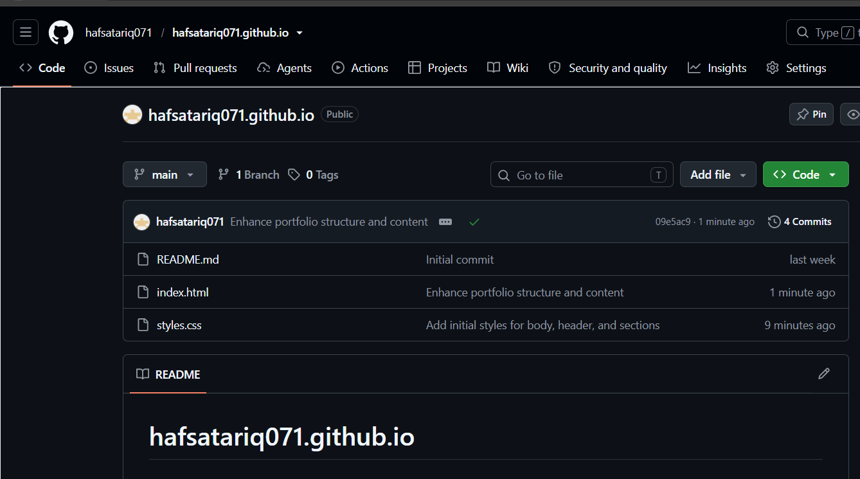
task4_pages_repository.png
Step 4.2: Publish with GitHub Pages
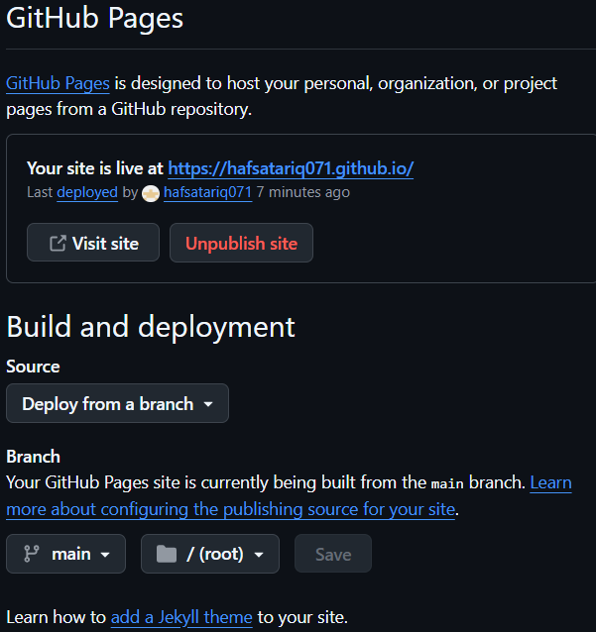
task4_pages_deployment.png
Step 4.3: Verify the Live Portfolio
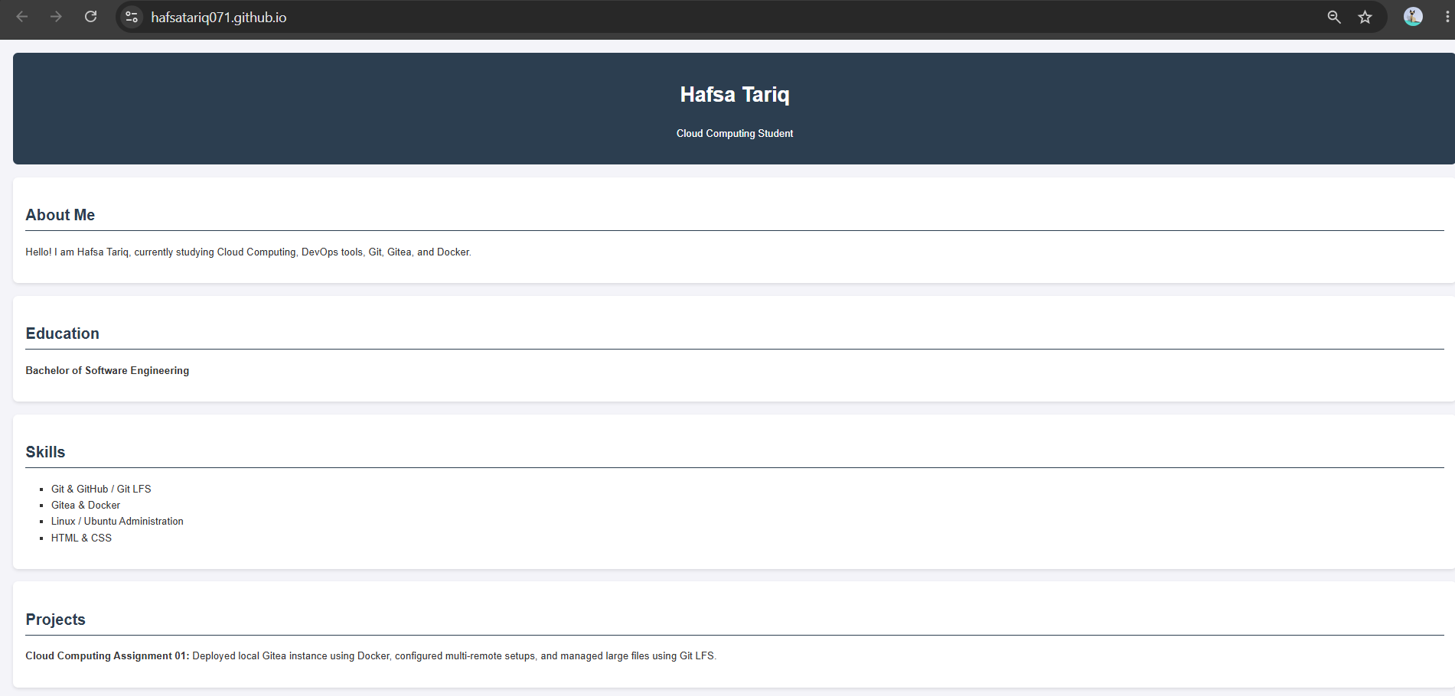
task4_portfolio_live.png

