**Achievements**

**Three Projects of IC Design /RFCS2 Selected in IEEE Solid State Circuit Society (SSCS) PICO International Open Source Tapeout Contest 2021**

Three integrated circuit (IC) designs proposal from the ICD research group got selected in the prestigious IEEE solid-state circuit society (SSCS), platform for IC design outreach (PICO) program 2021. The participants from more than 152 countries applied in the contest. Finally, 18 projects got selected for the tapeout, out of which, three projects are from ICD research group FAST-NU, Isb, three from India, four from the United States, one each from Canada, Nepal, Brazil, Vietnam, Chile, and Hong-Kong. The titles of the projects selected from FAST-NU are “Backscattering Integration for On-Chip Wireless Power Transfer (WPT) Receivers, **Engr. Hamza Atiq”**, ‘Variable Precision Fused Multiply Add Unit, **Engr. Muhammad Usman”,** and “Inductor-Less Low Noise Amplifier for 5G Applications, **Engr. Shahid Jameel”.** The tapeout and packaging cost will be bear by the SSCS under this program, which is around 11,000 US$ per shuttle.

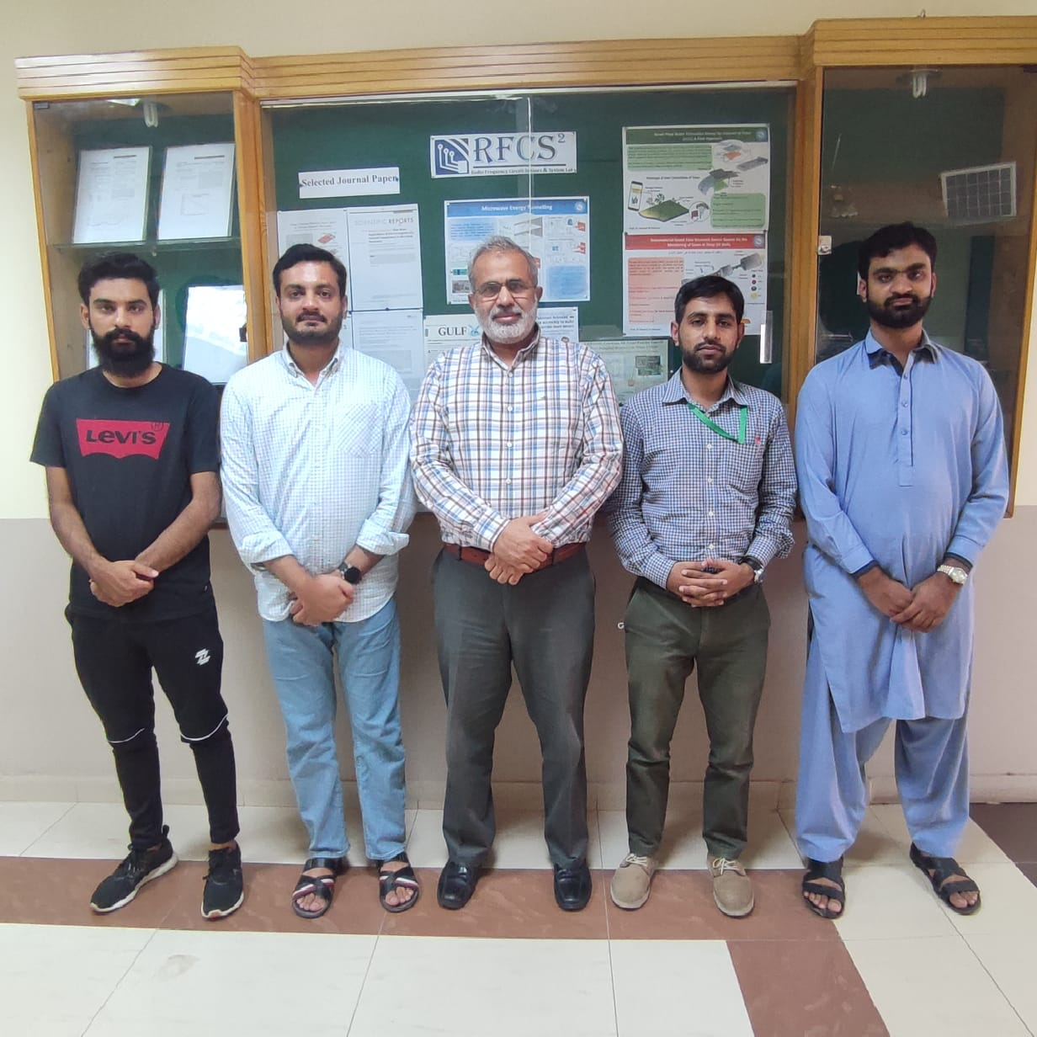

**Research Centers**

**MS IC Design Tapeout Projects Spring 2021**

ICD Lab at FAST-NU Isl offers a unique MS program with expertise in Integrated Circuits and Systems. The program offered in the Lab is unique of its kind. ICD Lab at NU-Isl is equipped with licensed CAD tools along with the most advanced TSMC 65nm PDK currently available in Pakistan. 25 graduate students at ICD lab are working on their first IC tapeout project using TSMC 65nm technology. Eight projects will be taped out in August 2021 on two 1x1mm2 ICs, Each IC will have four projects intelligently integrated on it. The projects cover the scope of; Digital, analog, Mixed-signal, and RF IC domains.

