 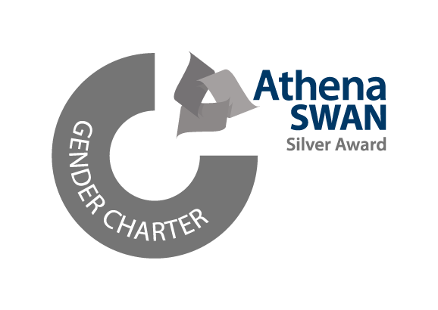

|  |  |
| --- | --- |
|  |  |

6th September 2020

Dear Sir/Madam,

I am writing to express my interest in applying for the NSF AI Institute for Artificial Intelligence and Fundamental Interactions (IAIFI) Fellows program. I am a PhD Candidate at the University of Glasgow in the third year of my program. I plan to submit my thesis in October of 2021 (with a viva ~1-3 months following my submission). I believe that I would be ideally suited for the IAIFI Fellows program because of my extensive interdisciplinary experience in the use of novel AI approaches to solve complex problems in gravitational wave science and industry.

Over the course of my PhD I have been working on the application of machine learning techniques to the Laser Interferometer Gravitational Wave Observatory ([LIGO](https://www.ligo.caltech.edu/)) compact binary coalescence search for gravitational waves under my supervisor Dr. Chris Messenger. I have also had the opportunity to carry out an industry placement at a space engineering practice, [Craft Prospect](https://craftprospect.com/), where the outcome of my work was partially used to win a £100,000+ industry-government grant on the subject. In my initial PhD project, I showed for the first time that the efficiency of the standard detection method used in LIGO could be matched by a convolutional neural network with orders of magnitude increase in speed over existing techniques (see our [paper](https://journals.aps.org/prl/abstract/10.1103/PhysRevLett.120.141103) in Physical Review Letters). In collaboration with researchers in the University of Glasgow School of Computing Science, I demonstrated that a form of machine learning can infer the correct Bayesian posterior distributions on gravitational wave parameters almost instantaneously, potentially revolutionizing how parameter estimation is done (with referees at Nature Physics [ArXiv 1909.06296](https://arxiv.org/abs/1909.06296)). I believe that such interdisciplinary collaborations, involving the combination of knowledge from diverse subject and sector domains is key to solving the most difficult problems in physics and machine learning. I am therefore particularly attracted to the IAIFI mission as an organisation which promotes multifaceted, unexpected and inventive approaches to research.

Following my fellowship, I plan to continue as a physics and AI researcher in either academia, a government lab, or industry. I am pleased to submit my application for the IAIFI Fellows program and look forward to hearing from you soon. Thank you for your consideration.

Kind regards

Hunter Gabbard

PhD Candidate

School of Physics & Astronomy

|  |  |
| --- | --- |
|  | Kelvin Building, University of Glasgow, University Avenue, Glasgow, G12 8QQ. Direct Line +44 (0) 775 475 0201  Email: h.gabbard.1@research.gla.ac.uk  The University of Glasgow, charity number SC004401 |