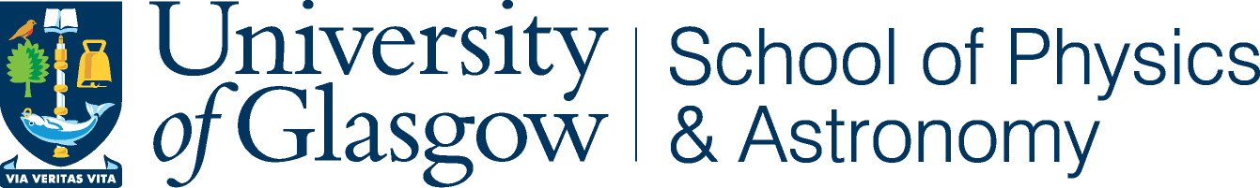

15 December 2017

Dear Editor,

The detection of gravitational waves from binary black hole mergers and more recently, the merger of a binary neutron star system, marks a monumental scientific achievement. This week our LIGO colleagues were in Stockholm receiving their much deserved Nobel prize for this scientific breakthrough, specifically “for decisive contributions to the LIGO detector and the observation of gravitational waves”.

The Advanced LIGO and Virgo gravitational wave detectors are yet to reach their design sensitivity potential and yet the rate of detections and the physics extracted from these signals has invigorated the astrophysical community. This has specifically been the case for the binary neutron star detection GW170817 from which hundreds of papers have been produced from both gravitational wave collaborations and, more importantly, vast numbers of electromagnetic astronomers. This event and the science behind it is a shining example of multi-messenger astronomy.

The future of gravitational wave astronomy is very bright but there are still many challenges to overcome. One of which is the ability to deal with significantly more detections as the instruments become more sensitive. Our current data analysis techniques are based on highly optimised matched filtering algorithms followed by sophisticated Bayesian parameter estimation. Such techniques are continually being optimised, but with decreasing low frequency detector noise resulting in longer detectable waveforms, there is a significantly higher computational cost. This burden is compounded by the need to produce results extremely rapidly for use in electromagnetic follow-up observations.

We believe that the future of gravitational wave analysis could depend upon the increasingly relevant field of machine learning. Today’s cutting-edge deep learning algorithms have the potential to replicate and possibly exceed the performance, speed and cost of existing methods. We are therefore pleased to submit our original research on the topic of deep neural network analysis for identifying compact binary signals in simulated gravitational wave detector noise. Our primary result is that a network can be trained to match the sensitivity of the standard matched filtering analysis used at the core of gravitational wave searches.

We hope that you would consider this for publication in Physical Review Letters.

Yours sincerely,

Hunter Gabbard, Michael Williams, Fergus Hayes, and Chris Messenger

|  |  |
| --- | --- |
|  | SUPA  School of Physics & Astronomy |
|  | Kelvin Building, University of Glasgow,  University Avenue, Glasgow, G12 8QQ.  Direct Line +44 (0)141 330 3536  Email: Christopher.Messenger@glasgow.ac.uk  The University of Glasgow, charity number SC004401 |