# MAR440 Cruise Report: Hydrography, Nutrients, Oxygen

Authors: Anna Buchwald, Casper Ekberg, Linnea Henriksson, Hanna Kaliff, Dániel Kácsor, Tilda Karström Hettman, Alex Larsen, Anja Lindfors, Julia Mari Murata, Anna Olsson, Tove Rundberg, Janne Scheffler

Department of Marine Sciences, University of Gothenburg, Carl Skottsbergs gata 22 B, 413 19 Göteborg, Sweden

Email: [gusbuchwan@student.gu.se](mailto:gusbuchwan@student.gu.se), [guscasek@student.gu.se](mailto:guscasek@student.gu.se), [gushenlid@student.gu.se](mailto:gushenlid@student.gu.se), [guskacsda@student.gu.se](mailto:guskacsda@student.gu.se), [guskaliha@student.gu.se](mailto:guskaliha@student.gu.se), [gushetti@student.gu.se](mailto:gushetti@student.gu.se), [guslarseal@student.gu.se](mailto:guslarseal@student.gu.se), [gusglilgan@student.gu.se](mailto:gusglilgan@student.gu.se), [gusmuratju@student.gu.se](mailto:gusmuratju@student.gu.se)**,** [gusolsande@student.gu.se](mailto:gusolsande@student.gu.se), [gusrundbto@student.gu.se](mailto:gusrundbto@student.gu.se), [gusschefja@student.gu.se](mailto:gusschefja@student.gu.se)

## Summary of cruise aim

The By Fjord and the Havsten Fjord have oxygen-poor (anoxic) deep water. These anoxic conditions are responsible for phosphorus leakage and lead to an excess in phosphorus. This in turn leads to cyanobacteria blooms during summer. This phenomenon is known from the Baltic Sea because of its fjord-like characteristics and has been the subject of scientific research for decades. Small scale experiments involving artificially oxygenating the deep-water have been performed in fjords at the Swedish west coast before as part of the BOX project, but no large-scale experiments have been approved as of now because of environmental concerns. The aim of this research was to compare the By Fjord and Havsten Fjord, by investigating water column hydrography, vertical stratification, dissolved oxygen distribution, and water exchange within and between the fjords. Our results mostly lined up with our expectations. Oxygen levels were close to 0 in the deeper layers of the By Fjord, declining more rapidly with depth than in the Havsten Fjord. Phosphate levels increased with depth in the By Fjord, while it remained stable in the Havsten Fjord. Nitrate levels increased by depth in the Havsten Fjord, while there could be an indication of a decrease in the By Fjord.

**Keywords:** phosphate, nitrate, oxygen, By Fjord, Havsten Fjord, hydrography

Gothenburg University 21-10-01

## 1. Cruise personnel

Both crew members on the ship R/V Skagerak and scientific personnel were recorded including names, roles, organizations etc., see table 1 and 2.

Table 1. Crew members on R/V Skagerak.

|  |  |  |  |
| --- | --- | --- | --- |
| **Crew members** | **Roles** | **Participation in particular cruise legs** | **Organization** |
| Joakim | Captain | Navigation | R/V Skagerak |
| Anders | Crew | CTD sampling | R/V Skagerak |
| Christian | Crew | CTD sampling | R/V Skagerak |
| Hasse | Crew | CTD operator | University of Gothenburg |

Table 2. Scientific personnel on the cruise.

|  |  |  |
| --- | --- | --- |
| **Scientific personnel** | **Roles** | **Organization** |
| Marcel Du Plessis | Supervisor | University of Gothenburg |
| Elizabeth Robertson | Supervisor | University of Gothenburg |
| Anna Buchwald | CTD operator | University of Gothenburg |
| Casper Ekberg | CTD sampling | University of Gothenburg |
| Linnea Henriksson | CTD operator | University of Gothenburg |
| Hanna Kaliff | CTD sampling | University of Gothenburg |
| Dániel Káscor | CTD operator | University of Gothenburg |
| Tilda Karström Hettman | Communication and organization | University of Gothenburg |
| Alex Larsen | CTD sampling | University of Gothenburg |
| Julia Mari Murata | CTD operator | University of Gothenburg |
| Anna Olsson | Communication and organization | University of Gothenburg |
| Tove Rundberg | Communication and organization | University of Gothenburg |
| Janne Scheffler | CTD sampling | University of Gothenburg |

## 2. Scientific objectives

The Baltic deep water oxygenation project (BOX project) was implemented between 2010 and 2012 to test engineered oxygenation in the By Fjord at the west coast of Sweden. Over a period of 2.5 years, a pump system moved surface water rich in oxygen to deep anoxic water layers. Initially, the experiment led to a drastic biochemical change in deep-water (e.g., increase of oxygen and nitrate, decrease in phosphate). However, examinations from previous years showed that the By Fjord resumed its pre-experimental status.

The By Fjord and Havsten Fjord are located on the west coast of Sweden. The Havsten Fjord stretches from the Skagerrak, the open sea, to Uddevalla towards the By Fjord, which the Bäve river flows into. The By Fjord and the Havsten Fjord are separated by a sill that has an approximate depth of 12m. The deepest point of the By Fjord is about 50m. The shallow area running above the sill is constantly replaced by fresh water from precipitation and inflow from land (e.g., from Bäve river). The vertical water exchange is inhibited by the sill, which in turn leads to a lack of oxygen in deep water layers.

As fresh water from run-off and precipitation mixes with the saline water from Skagerak flowing in over the sill, salinity decreases in the top layer. The salinity difference between the top and bottom layers impedes deep-water exchange due to a change in density, leading to the deep-water becoming stagnant. Microbes use up dissolved oxygen in the water during aerobic respiration, and as organic matter sediments microbes in the deep-water eventually use up all available oxygen. Anoxia leads to the absence of macrofauna and to multiple biogeochemical changes, for example, an impeded N cycle, and phosphate that was previously bound to oxygen being released into the water.

Primary production is limited by light during autumn and winter, and nutrition during spring and summer. Phytoplankton blooms largely occur during spring, and to a lesser extent during autumn. During summer, cyanobacteria blooms extensively emerge as a result of phosphate release in deep-water and nitrogen fixation. A generalized marine organic matter molecule, see reaction 1, explains the relationship of organic matter produced by the primary production and what components are being accumulated after degradation of organic matter, including nitrate and phosphate. Primary producers (i.e., chlorophyll) and organic matter both have fluorescent properties determining the emission of light.

(CH2O)106(NH3)16(H2PO4) + 138 O2 -> 106 CO2 + 16 H+ + 16 NO3- + H3PO4 + 122 H2O re. 1

The aim of the project was to compare the long-term status of the By Fjord with the Havsten Fjord following the BOX project, and therefore, to analyze hydrography, nutrients, and fluorescence in water of both fjords. The following research questions guided the cruise project:

1. How does water column hydrography differ between the two fjords? Can you observe a difference in the vertical stratification between the two fjords? Is there any evidence of water exchange over the sill?
2. Without counting or identifying any phytoplankton (e.g., microalgae), what is the role of phytoplankton in structuring the water column? How does the vertical distribution of phytoplankton impact profiles of nitrate, phosphate, and fluorescence?
3. What is the distribution of dissolved oxygen (DO) in depth and space, and between the two fjords? What can be said about the connection between DO and fjord “health” (e.g., hypoxia)?

## 3. Cruise overview

We departed with R/V Skagerak from Uddevalla Hamnterminal at 10.00 am on 21:st of September 2021, with an expected arrival back at the harbor at 15.00 pm. The ship route included eleven sampling spots in a transect with six major sampling spots including CTD data and water samples, taken on the way out. Five were taken on the way back to the harbor, including CTD data only. The transect included the river outlet, the deepest points of the two fjords, both sides of the sill, and one point further out in the Havsten Fjord (Fig. 1).

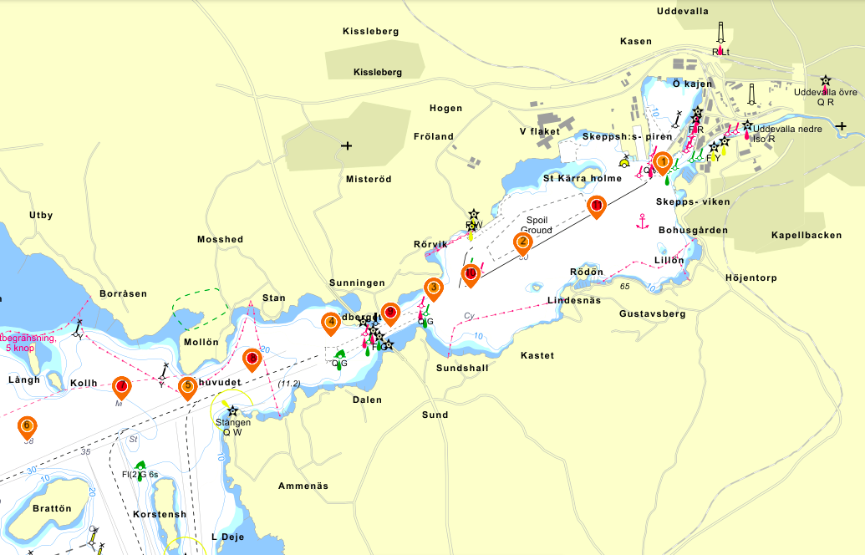

Fig. 1. Map of sampling points in the By Fjord and the Havsten Fjord. Stations 1-6 (orange spots) are the major sampling points, including water samples and CTD data. Station 7-11 (red spots) are the extra sampling points, with CTD data only.

## 4. Diary cruise narrative

During the cruise we experienced low southerly winds of 2 m/s which later changed to speeds of 5m/s during the end of the cruise. Temperature ranged from 9 -11°C with waters being calm, and visibility varying between 5-10 and 10-20 km during the day. It rained throughout the journey, with an average of 0.55 mm per hour.

We encountered problems at station 6 with a string that snapped which was tied to a niskin bottle. This did not, however, affect our results because it was easily fixed by replacing the niskin bottle. At station 4 we missed closing one bottle and had to go back down approximately 20 m. This could stir the water, however the data should not be affected by it.

On the cruise we divided ourselves into 3 groups with 3 different tasks which were rotated between the groups after 2 stations. The first group began with CTD operations, the second with CTD sampling and the third began with communications and organization.

## 5. Station log

Details of all sampling stations are summarized in table 3, including date, time, coordinates, maximum depth, and what kind of samples were collected.

Table 3. Station log with coordinates and details about depth and activities for each sampling station.

|  |  |  |  |  |  |  |  |
| --- | --- | --- | --- | --- | --- | --- | --- |
| **Station number** | **Time ISO3166** | **Latitude** | **Longitude** | **Maximum depth [m]** | **No. oxygen water samples** | **No. nutrition water samples** | **CTD samples** |
| 1 | 2021-09-21 10:43 | 58.342233 | 11.903433 | 13.9 | 2 | 5 | Yes |
| 2 | 2021-09-21 11:07 | 58.33355 | 11.874717 | 45.0 | 2 | 5 | Yes |
| 3 | 2021-09-21 11.31 | 58.32865 | 11.8564 | 21.5 | 2 | 5 | Yes |
| 4 | 2021-09-21 11:52 | 58.324917 | 11.835283 | 12.5 | 2 | 5 | Yes |
| 5 | 2021-09-21 12:32 | 58.317967 | 11.805867 | 27.0 | 2 | 5 | Yes |
| 6 | 2021-09-21 12:55 | 58.313717 | 11.7729 | 38.0 | 2 | 5 | Yes |
| 7 | 2021-09-21 13:23 | 58.318017 | 11.7923 | 30.7 | 0 | 0 | Yes |
| 8 | 2021-09-21 13:43 | 58.325967 | 11.84755 | 24.2 | 0 | 0 | Yes |
| 9 | 2021-09-21 14:03 | 58.321033 | 11.8191 | 13.5 | 0 | 0 | Yes |
| 10 | 2021-09-21 14:21 | 58.330133 | 11.864017 | 44.3 | 0 | 0 | Yes |
| 11 | 2021-09-21 14:42 | 58.337517 | 11.88985 | 41.2 | 0 | 0 | Yes |

## 6. Results

### 6.1 CTD measurements

CTD measurements for temperature, fluorescence, salinity, and oxygen were obtained at stations 1-10, and are presented in figure 2. CTD data interpolated using Ocean Data View are presented in figure 3-6.

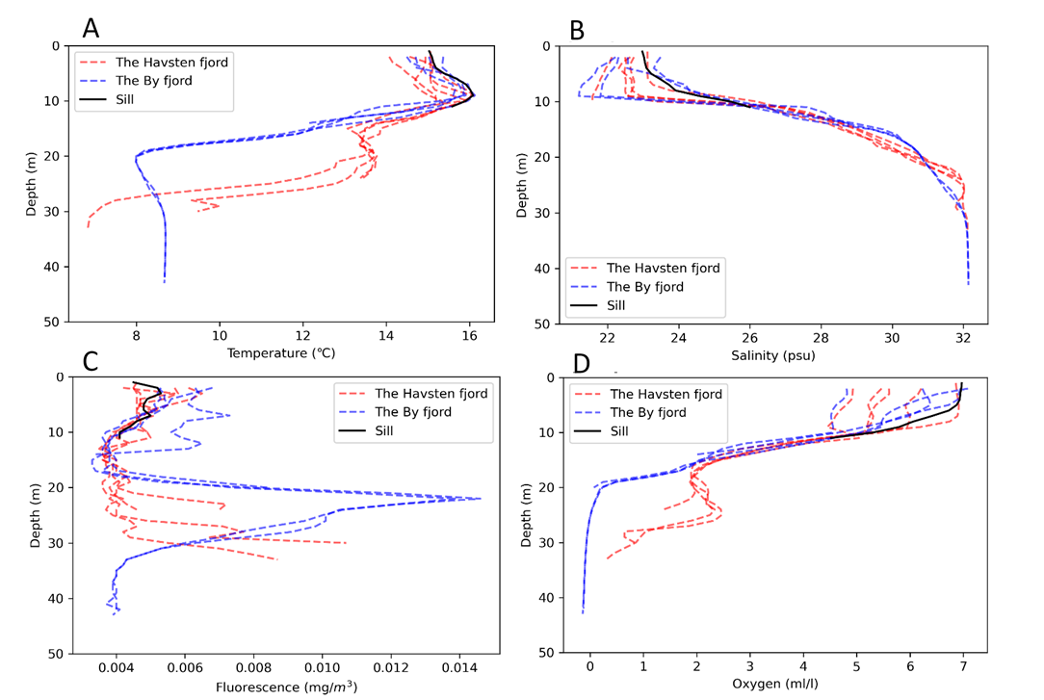

Fig. 2. Different variables with depth compared between the Havsten Fjord, By Fjord and sill. Temperature (A), salinity (B),fluorescence (C), and oxygen (D).

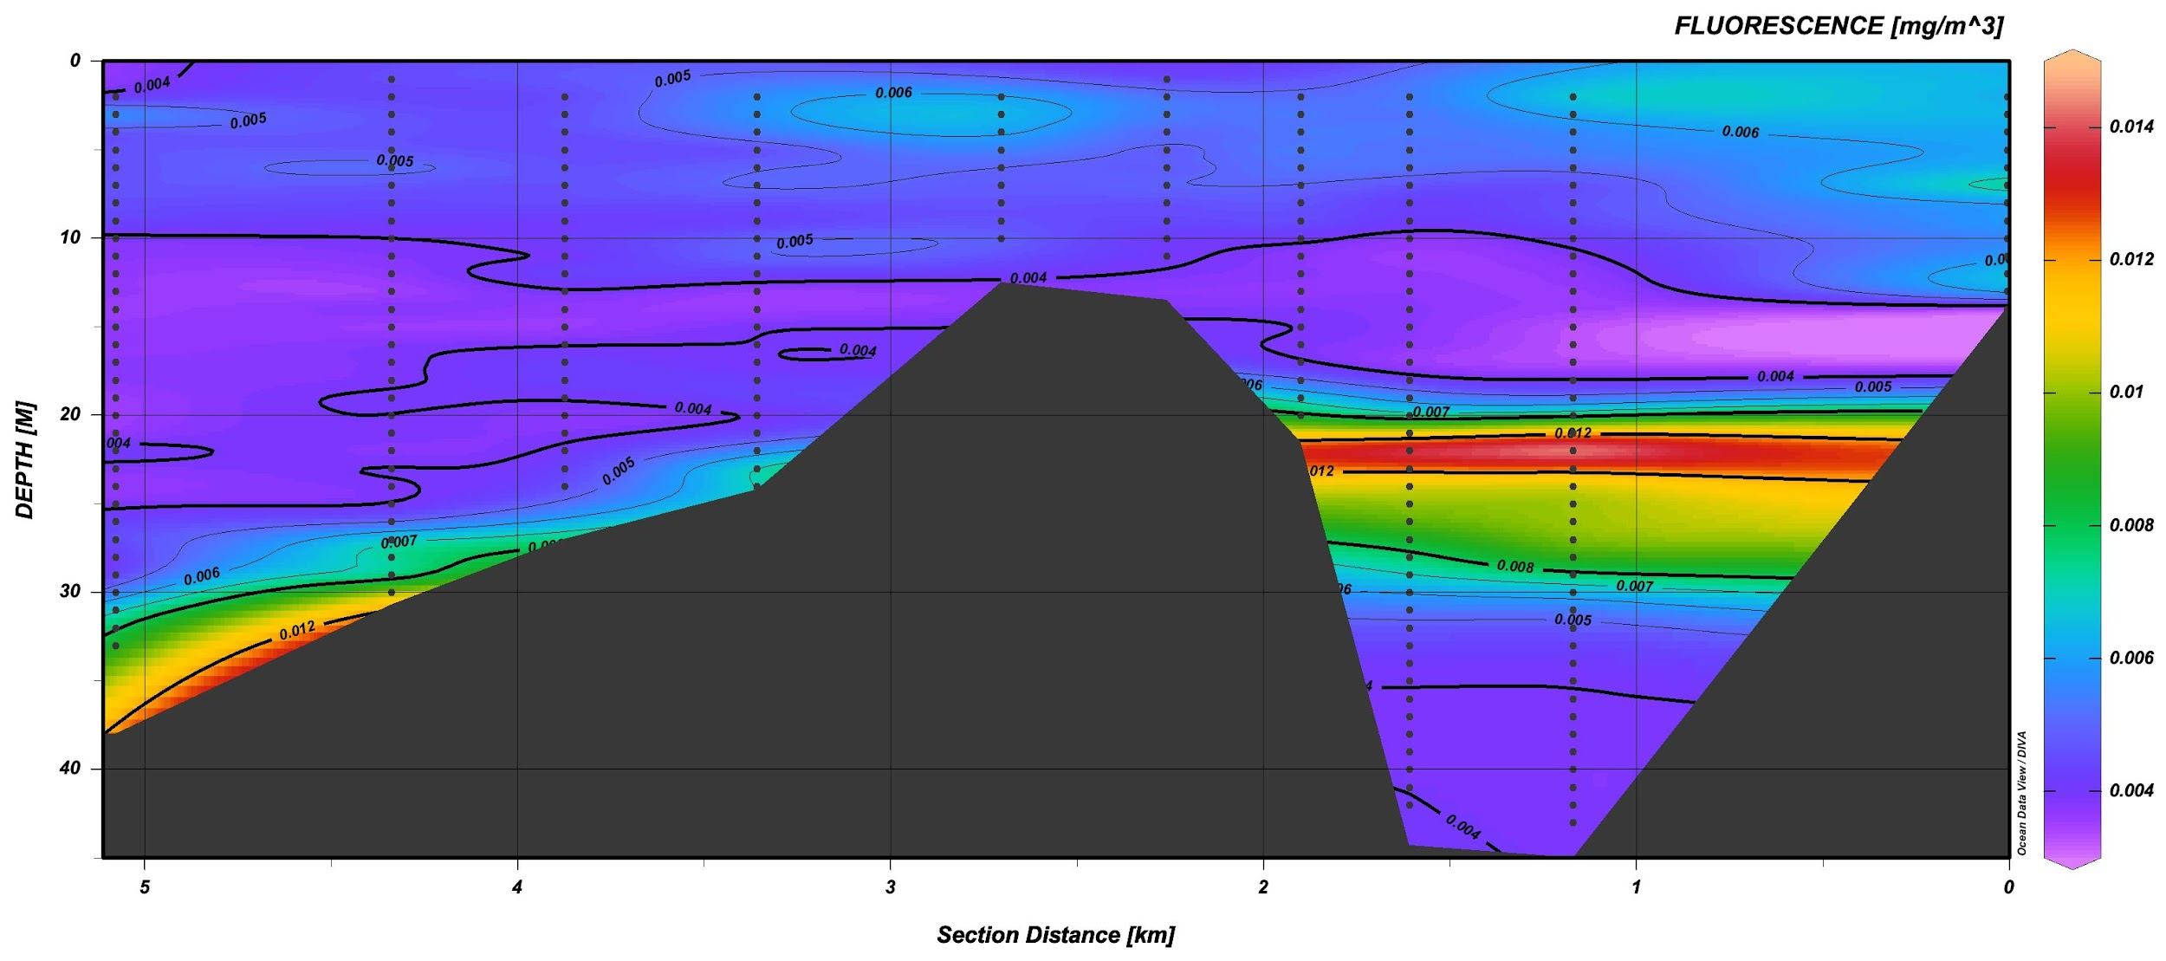

Fig. 3. ODV graph of fluorescence by depth.

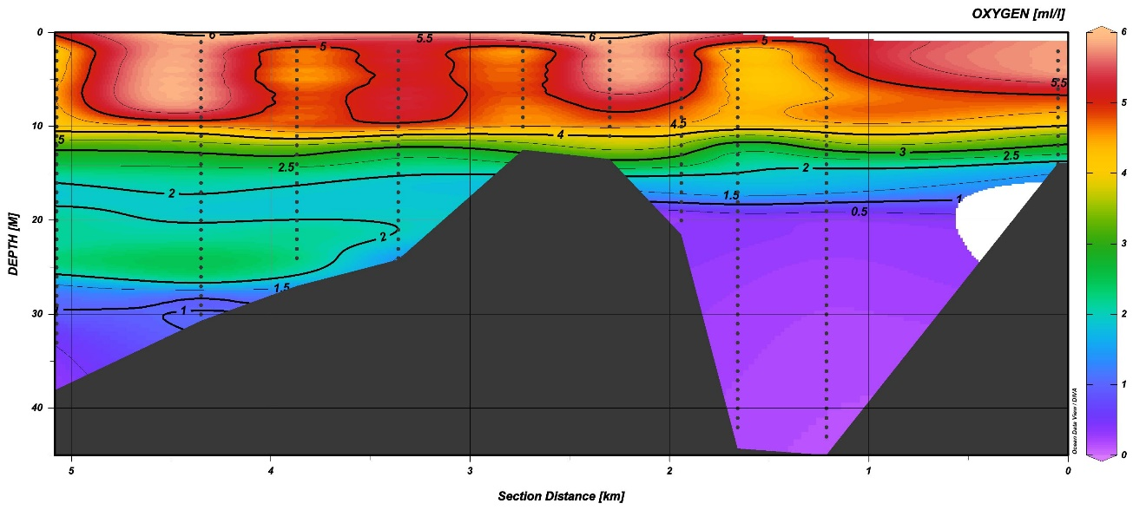

Fig. 4. ODV graph of oxygen by depth.

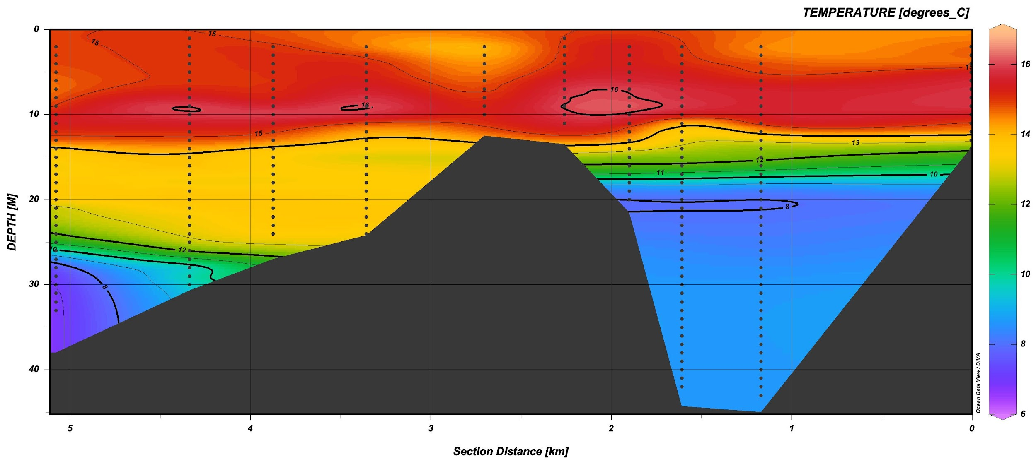

Fig. 5. ODV graph of temperature by depth.

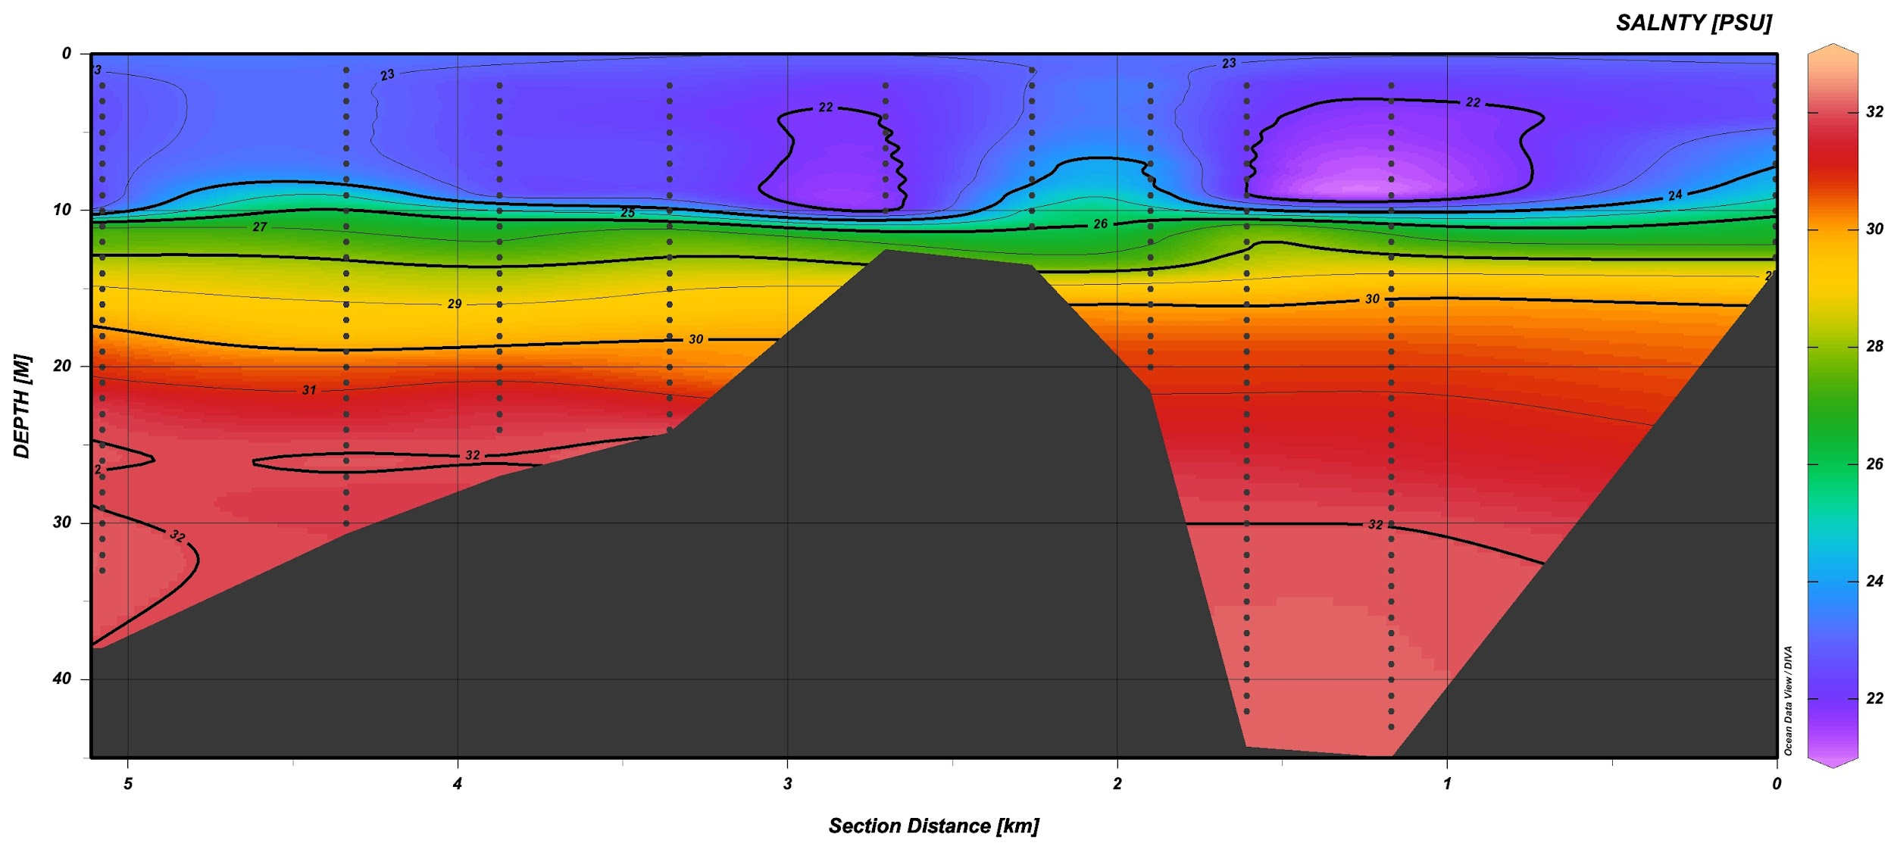

Fig. 6. ODV graph of salinity by depth.

### 6.2 Nutrient data

Nutrient measurements for phosphate and nitrate were sampled and filtered at station 1-6, and then analyzed by spectrophotometry, see figure 7.

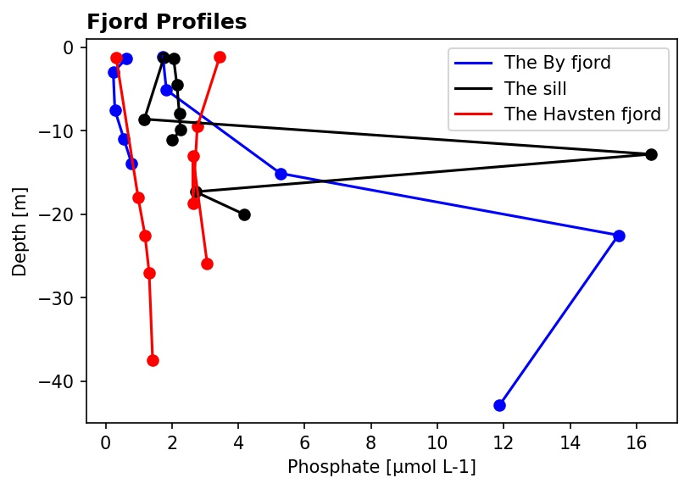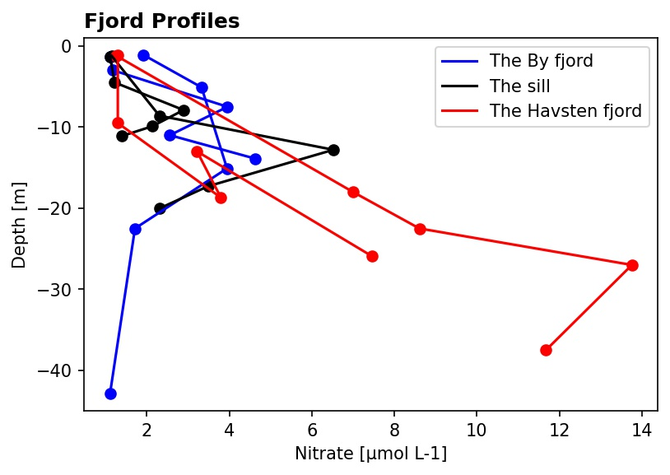

**A B**

Fig. 7. Phosphate (A) and nitrate (B) with depth compared between the Havsten Fjord, By Fjord, and the sill.