Lab 9

------------------------------------------------------------------------------------------------------------------------------------------

Task 1: Using GitHub.

* Go to tools -> Extensions and Updates
* Select ‘online’ on left hand side pane. Type ‘GitHub’ on search bar on TopRight. Once found, click ‘Download’. After download finishes restart VS studio.

You have added GitHub extension to your VS studio now.

* After restarting click ‘Team explorer’ right next to solution explorer on the right-hand pane.
* Clink ‘Connect’ on GitHub. Provide the credentials. You don’t have an account with GitHub create one.
* Once connected click ‘Create’

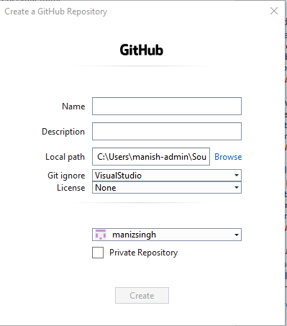

Fill in the details. Name is just your new project name. You may change local path to point out where your local repository resides. You may choose ‘private repository’ if you don’t want it to be public i.e. seen by others.

* Now go on your GitHub page and verify that a new repository with the name you have before is created.
* Go back to Team Explorer on Visual Studio. Scroll down, find Solutions. Click on new and select the type of project you want to create.
* You can check the ‘solution explorer’ and see it is just like the project you use to create earlier. Go back to team explorer and click on ‘Changes’. You can see a lot of changes (12) in my case. These are the record of changes which you have done so far.
* Now on the top of the ‘Changes’ write a message to commit

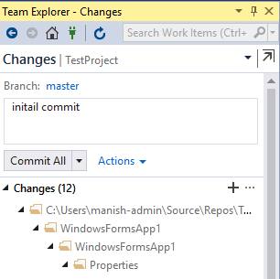

You will the ‘Commit ALL’ selection activated. Click on that, you will get three options

* Commit All: Committing changes to Local Repository
* Commit All and Push: Committing to Local as well as GitHub Repository.
* Commit All and Sync: Committing to local and push up to GitHub also pull up any changes that might have done from other Repo.
* Select ‘Commit All and Sync’

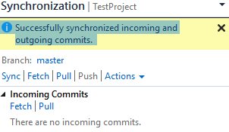

* Go back to GitHub website and see commits for your projects. You should two: one was done when you created the project the other one just now in above step. It is good practice that you put a descriptive commit message so that everyone else using this project will understand what changes you have made and committed.
* You can now code your project by going back to ‘solution explorer’ but every time you are done with changes (coding adding files and all…) you should go to ‘team explorer’ and commit the changes. ‘’ Commit All and Sync” is the best option as you may have ‘Cloned’ this ‘Repository’ to multiple locations (home computer and/or lab computer etc.). Again, remember to put descriptive commit message so that you or anyone else can understand the change without looking at the code.
* We will look at ‘clone’ in next lab.

Task 2:

Try all the queries from the lecture slides (Week11). Use the data source: the anonymous array given in the same lecture.

Task 3:

Work on your project.