**a. Identify classes (5-6 or more), methods (messages) and attributes. Show all the steps involved. Give reason for your choices of class and methods. [10 Marks]**

In terms of identify the classes first thing that I read the scenario and found there are many nouns in the scenario that could be potential classes. The nouns that I identified below:

Nouns: Card, Game, Players, Point, House, Value, Deck, Suits, Ranks and Total Blackjack etc.

Then, I found that there are some properties in the Nouns, it could be the property of potential classes like Point, Value and total suit, rank etc.

So, finally I got the potential classes and attributes, method below.

**Class One: Card**

Attributes: suit, rank, cardShape, cardValue

**Class Two: Deck (Derived Class: base Card)**

Attributes: suit, rank, cardShape, cardValue, allCard

Method: shuffle (), dealCard ()

**Class Three: Game (Derived Class: base Deck)**

Attributes: playerName, playerNumbers, temp, isHouse, totalScore, totalCard, players

Method: startGame ()

**Class Four: Player (Derived Class: base Game)**

Attributes: playerName, playerNumbers, temp, isHouse, totalScore, totalCard, players, houseName, tCard

Property: setPlayerName, setPlayernumber, GetCards, setHouseName

The reason why I create the Card class that because it is a card game, and each of card should has one suit and one value.

Then, I think about where we can put these cards, I decided to create another class called Deck which is a Derived Class because it is a ‘Relationship’ between card and deck, and it has its methods called shuffle and dealcard, these two methods will be callable by player, which means, once the game start, players can access these two method to get the proper cards.

The Game class is a very import class, in this class, I am expected to start game, and dealt cards to each player, and finally parse the attributes of game class to the new game, and add the new game with attributes to a list.

**Class Five: Program**

Main method the main logical of the game, every console application starts from here, I will create a new object using Game constructor, and use the new game object to access the method, fields. For example, I may use the new game object to access the start game function from the Game class to start the game, and so on.

**b. List CRC cards for each classes you identified. [5 Marks]**

**Class One: Card**

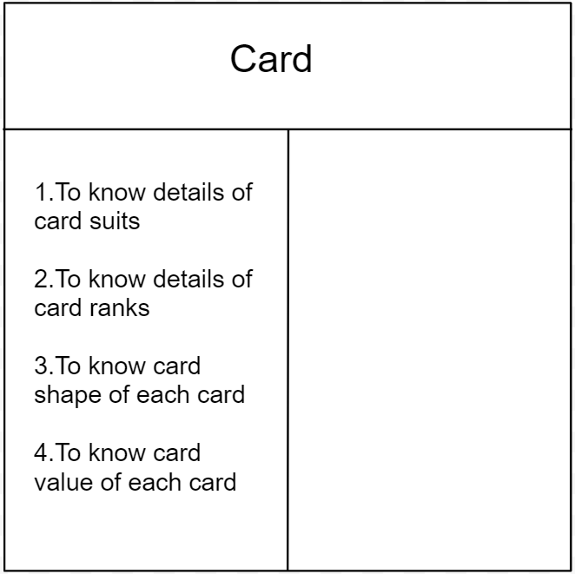

**Class Two: Deck (Derived Class: base Card)**

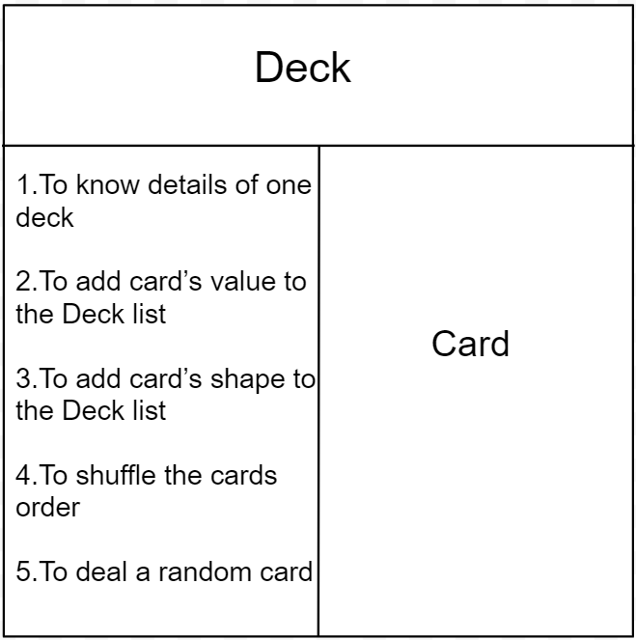

**Class Three: Game (Derived Class: base Deck)**

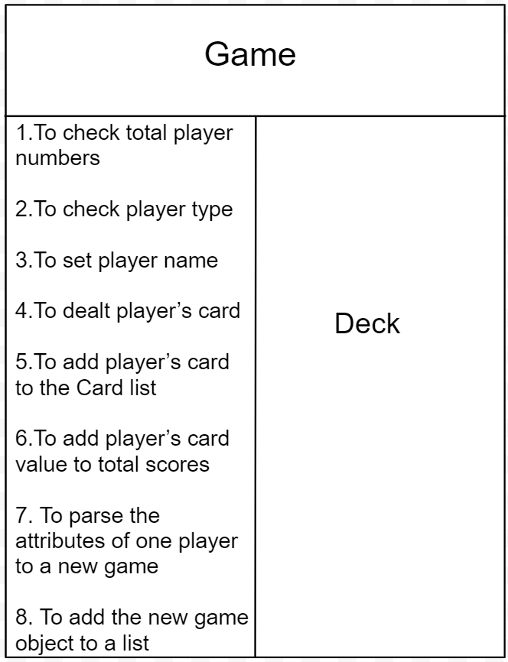

**Class Four: Player (Derived Class: base Game)**

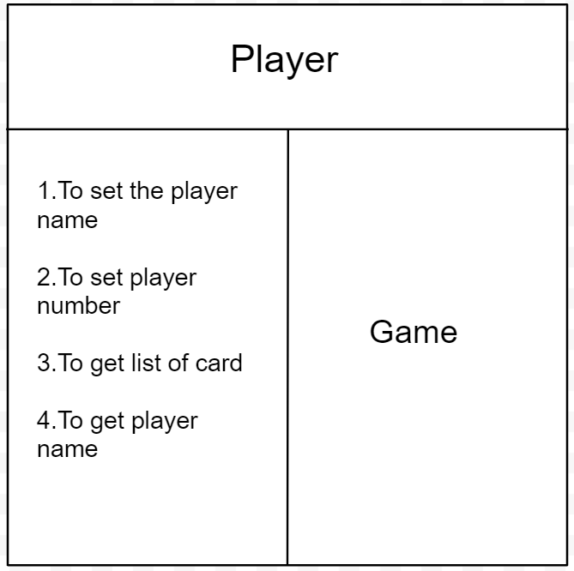

**c. Give Class diagram**