

**College of Computer Science and Information Technology**

**-Smart Village Campus-**

**Web Programming**

**12th Week Project**

**Submitted To**

**Dr. Mohamed El Taweel**

**TA Amr Daba**

**Submitted By**

**Hana Ahmed Mohamed**

**Kenz Mohamed Kamal**

**Hagar Mahmoud Soliman**

**Shehab Hatem**

**Ahmed Reda**

**Website Name and Description**

**Website Name:**

Fitness Fusion Gym.

**Description of Website:**

Welcome to Fitness Fusion, where fitness meets community, and goals become achievements. Our gym is dedicated to elevating your fitness journey to new heights, providing a welcoming and inclusive environment for individuals of all fitness levels. At Fitness Fusion Gym, we believe in a complete approach to wellness. We focus on not just physical strength, but also mental toughness and balanced nutrition. Our comprehensive packages offer personalized nutrition guidance tailored to your dietary preferences and fitness goals, along with individualized exercise routines designed to maximize results.

**Users Characteristics:**

1. Customer:

Users visit the website to view packages and services available.

1. Employee/ Staff:

Update information on website.

1. Managers:

Managers use the website to update packages and prices, analyze traffic, and optimize operations.

1. Fitness Professionals:

Fitness professionals, including trainers and instructors, register on the website to view gym facilities.

**ERD:**

**USE CASE DIAGRAM:**

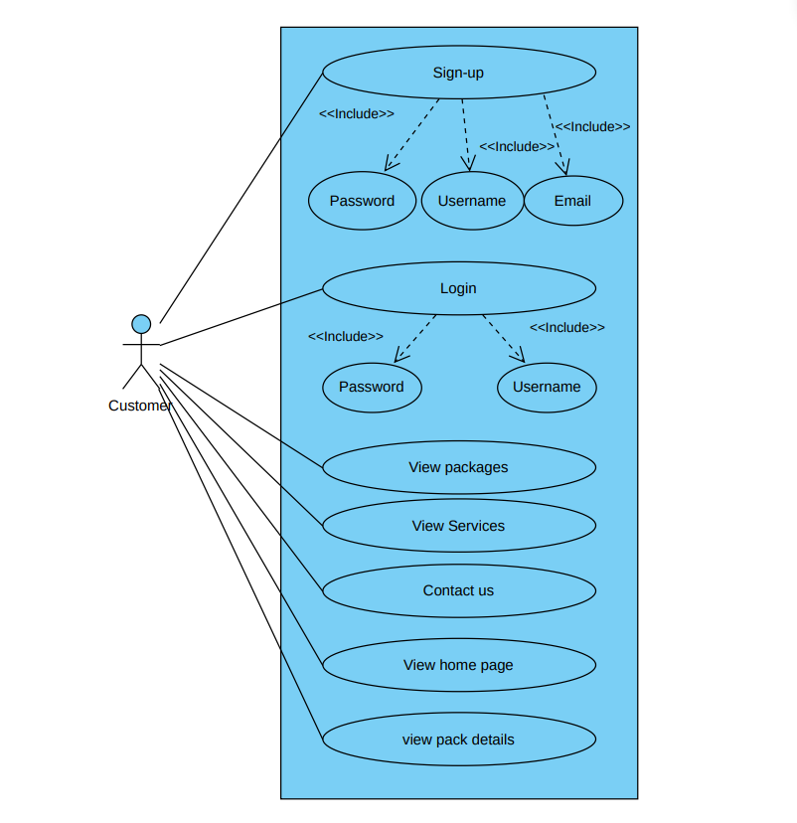

**Functional Requirements**

|  |  |
| --- | --- |
| Name | Sign up Page |
| ID |  |
| Goal | Allow new users to register for gym membership easily. |
| Triggers | New user want to register for membership |
| Input | Username, email and password |
| Output | Successful sign up |

|  |  |
| --- | --- |
| Name | Login Page |
| ID |  |
| Goal | Allows user to enter username & password to access his profile |
| Triggers | User wants to access membership –exclusive content or make purchases |
| Input | Username and password |
| Output | Successful log in |

|  |  |
| --- | --- |
| Name | Home Page |
| ID |  |
| Goal | Provide an overview of gym services and promotions to guide user navigation. |
| Triggers | User visits the website |
| Input | N/A |
| Output | Overview of gym services, and links to other pages like packages |

|  |  |
| --- | --- |
| Name | Packages Page |
| ID |  |
| Goal | Display membership packages with clear benefits and pricing information for user selection. |
| Triggers | User wants to view available membership packages |
| Input | N/A |
| Output | List of membership packages with details on benefits and pricing |

|  |  |
| --- | --- |
| Name | Services Page |
| ID |  |
| Goal | Present a list of gym services with brief descriptions for user understanding. |
| Triggers | User wants to explore available services |
| Input | N/A |
| Output | List of services offered by our gym with description |

|  |  |
| --- | --- |
| Name | Pack Details Page |
| ID |  |
| Goal | Display membership packages with detailed benefits and pricing information for user selection. |
| Triggers | User wants to view detailed information about available packages |
| Input | N/A |
| Output | List of membership packages with more details on benefits and pricing |

**Website’s Main Pages**

**Home Page:**

Landing Page when a user visits the website. Users can access various sections of the website from the home page, including information about the gym, and contact details.

**Log in / Sign up Page:**Sign in / Sign up page is where the user logins into his account if he’s an existing user or where the user will register for the first time if he doesn’t have an account.

**Services Page:**

Our services page provides detailed insights into the array of specialized offerings available.

**Packages Page:**

The package page provides information about our offerings, helping you find the perfect fit for your needs.

**Pack Details:**

The pack details page displays detailed information about our available packages. From standard options to premium programs. Each package is designed to address specific fitness needs and preferences. Discover what's included, pricing details, and how each package can benefit your fitness journey.