Introduction
AlarmPi is a headless Raspberry Pi powered alarm clock with the following features:
- controls up to 2 high-power LEDs to light up the room using PWM for dimming
- uses HiFiBerry (https://www.hifiberry.com) to play internet radio, alarm sounds and read announcements
- setup of the alarm clock thru an Andropid App
- connects to Google Calendar to read announcements for the day
- connects to openhab to control or announce other parts of a smart home
- connects to OpenWeatherMap (www.openweathermap.org) to read weather forecast for the day
The AlarmPi software is written in Java and consists of 2 parts:
- the actual alarm clock running on a Raspberry Pi as a headless deamon that gets started automatically when the Pi boots up (no display connected)
- the remote control GUI which is an Android App
The daemon uses the following open source libraries:
- ini4j (http://ini4j.sourceforge.net)
Used to read configuration files in .ini format. Licensed under the Apache License, Version 2.0 (http://www.apache.org/licenses/LICENSE-2.0)
- Pi4J (http://pi4j.com)
Used to interface with Raspberry Pi GPIOs from Java. Pi4J itself depends on WiringPi (http://wiringpi.com) licensed under GNU LGPLv3 license (http://www.gnu.org/copyleft/lesser.html)

The hardware
Alarmpi uses only off the shelf components and thru-hole components to make soldering easy. The following HW components are used:
- Raspberry A+, B+, 2 or 3
- HiFiBerry DAC+ (http://www.hifiberry.com)
- PCA9685 PWM module, available on eBay
- LED driver constant current source, e.g. http://www.leds.de (1 or 2)
- high-power LED, e.g. http://www.leds.de (1 or 2)
- (USB powered) active speaker
These modules are held together by a simple PCB which addes a few discrete, thru-hole components.

Power
To allow headroom for the power LEDs, Alarm Pi is powered by 12V. On the PCB there is a DC/DC converted that generates 5V for the Raspberry and the speaker. If you check the Raspberry power requirements you will notice that the DC/DC actually is not able to fulfill them as it only delivers 1A. However, I have not seen any problems so far as Raspberry is basically idling all the time. But you should not run any additional, power hungry applications as this will likely cause issues.

The PCB
The AlarmPi PCB holds some very simple circuits and basically serves as mechanical fixture for the various components like LED constant current source(s) or the PCA9685 module which creates the PWM signal to control the LED brightness. It sits on top of the HiFiBerry PCB, which in turns sites on top of the Raspberry Pi.
The PCB was designed using fritzing (http://fritzing.org) and also manufactured using the fritzing PCB manufacturing service.
Schematics:
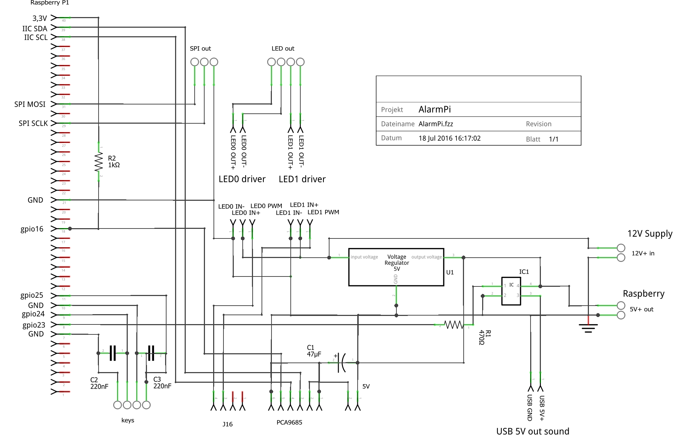

PCB layout (without copper fill):
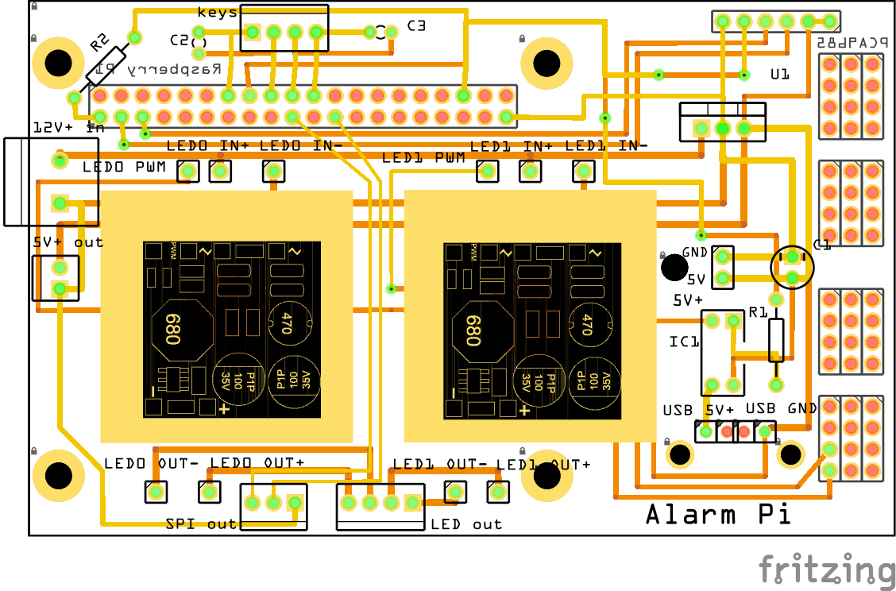
Picture of PCB before assembly:
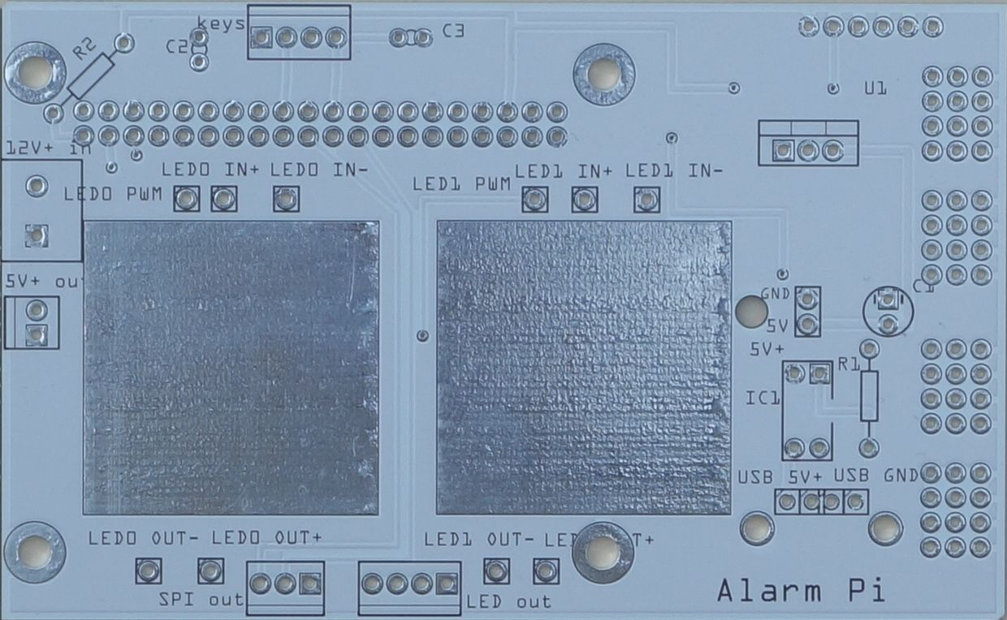

Parts List (BOM)
Amount | Description | Supplier
1 | Raspberry Pi 2/3
1 | HiFiBerry DAC+ standard - Phone jack version | hifiberry.com
4 | 2mm Nylon spacer + screw (M2.5) | hifiberry.com
1 or 2 | Constant current LED driver module, PWM dimmable  e.g. leds.de P/N 95068 (800 mA) | leds.de
1 or 2 | High-power LED  e.g. Citizen Chip on Board LED Module 7W, white | leds.de
1 | PCA9685 16-Channel 12-bit PWM I2C Module | Ebay
1 | Stiftleiste (Standard) Anzahl Reihen 2 Polzahl je Reihe 20 | Conrad 737575 - 62
2 | Stiftleiste (Standard) Anzahl Reihen: 1 Polzahl je Reihe: 8 | Conrad 737352 - 62
1 | Buchsenleiste (Präzision) Anzahl Reihen 2 Polzahl 40 | Conrad 738472 - 62
2 | Schraubklemmblock 1.50 mm² Polzahl 2 | Conrad 731986 - 62
2 | Schraubklemmblock 0.75 mm² Polzahl 4 | Conrad 567658 - 62
1 | Schraubklemmblock 0.75 mm² Polzahl 3 | Conrad 567615 - 62
1 | Schraubklemmblock 0.75 mm² Polzahl 2 | Conrad 731986 - 62
1/2 | Kühlkörper 31x31x10 mm | Conrad 181182 - 62
1 | DCDC converter TracoPower TSR 1-2450 24 V/DC 5 V | Conrad 156673 - 62
1 | PhotoMOS-Relais AQY_EH-Serie Panasonic AQY212GH | Conrad 504873 - 62
1 | USB Type A Buchse, horizontal | Conrad 1088207 - 62
1 | Resistor 1K0Ohm (PCA9685 OE/ 3.3V pull-up)
1dds rto | Resistor 470Ohm (PhotoMos LED forward current)
1 | Electrolytic Capacitor 47uF (PWM module decoupling)
2 | C 220nF (input keys debouncing)

Raspberry GPIOs
The following Raspberry Pi pins from header P1 are used by AlarmPi:
pin# | RPI name | WiringPi | Used For
3 | gpio2, I2C SDA | gpio8 | HiHiBerry and PCA9685 I2C control
5 | gpio3, I2C SCL | gpio9 | HiHiBerry and PCA9685 I2C control
12 | gpio18 | gpio1 | HiFiBerry sound interface
35 | gpio19 | goio24 | HiFiBerry sound interface
38 | gpio20 | gpio28 | HiFiBerry sound interface
40 | gpio21 | gpio29 | HiFiBerry sound interface
16 | gpio23 | gpio4 | USB Audio Power on/off
22 | gpio25 | gpio6 | Input key 1
18 | gpio24 | gpio5 | Input key 2
36 | gpio16 | gpio27 | LED PWM OE
19 | gpio10 | gpio12 | SPI MOSI (typically not used)
23 | gpio11 | gpio14 | SPI SCLK (typically not used)

Assembly
- Assemble all the components
- Set a valid I2C address on the PCA9685 module thru the A0...A5 jumpers
- Remove the decoupling Elco and the supply connector from the PCA9685 module and solder short wires for the supply. Route these wires thru the hole on the PCB and solder to the 5V pads. Solder the module to the PCB
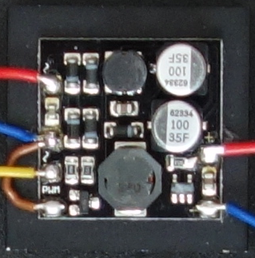
- Solder wires to the constant current driver module and connect GND to LED in -
- mount the constant current module to the heat sink
- solder the wires from the constant current module to the PCB and mount the heat sink to the PCA
- tbd

Installation
The following instructions are based on the Raspbian Jessie Lite image Version May 2016 (Kernel version 4.4) and assume that the network setup is working in your environment

General installation
- run raspi-config
sudo raspi-config
and make sure the following settings are done:
  - 1 Expand Filesystem
  - 3 Boot Options -> B1 Console
  - 5 Internationalisation Options -> I2 Change Timezone to you locale timezone
  - 9 Advanced Options -> A4 SSH enabled
  - 9 Advanced Options -> A5 SPI enabled
  - 9 Advanced Options -> A6 I2C enabled
- Make sure all packages are up to date
sudo apt-get update
sudo apt-get upgrade
- Update the Raspberry firmware
sudo apt-get install rpi-update
sudo rpi-update
- reboot
sudo reboot
- Install the Music Player Daemon (mpd)
sudo apt-get install mpd mpc alsa-utils
- Install Java8 runtime environment
sudo apt-get install openjdk-8-jre

Installation of debug tools
- i2c tools might be needed to debug PCA9685 issues
sudo apt-get install i2c-tools
- wiringpi is helpfull for gpio debugging
sudo apt-get install wiringpi

HiFiBerry Installation
This is based on the manual on
https://support.hifiberry.com/hc/en-us/articles/205377651-Configuring-Linux-4-x-or-higher
- Remove drivers from the blacklist by removing the following lines from /etc/modprobe.d/raspi-blacklist.conf if they exist:
blacklist i2c-bcm2708
blacklist snd-soc-pcm512x
blacklist snd-soc-wm8804
Note: This file was already empty on my installation
- Remove the driver for the onboard sound by removing this line from /etc/modules:
snd_bcm2835
Note: This file was already empty on my installation
- Configure the device tree overlay file /boot/config.txt:
add the line
dtoverlay=hifiberry-dacplus
and comment out the line
#dtparam=audio=on
- Configure ALSA by creating the file /etc/asound.cfg with the following content:
pcm.!default {
type hw card 0
}
ctl.!default {
type hw card 0
}
- Reboot
- Test it with
aplay -l
which should return
**** List of PLAYBACK Hardware Devices ****
card 0: sndrpihifiberry [snd_rpi_hifiberry_dacplus], device 0: HiFiBerry DAC+ HiFi pcm512x-hifi-0 []
Subdevices: 1/1
Subdevice #0: subdevice #0

Configuration of mpd
- Configure mpd by editing /etc/mpd.conf and set this audio_output configuration:
audio_output {
type "alsa"
name "HiFiBerry"
device "hw:0,0"
mixer_type "software"
# mixer_device "default" # optional
# mixer_control "PCM" # optional
# mixer_index "0" # optional
}
- make sure mpd log directory exists
as we will move /var/log to a tmpfs filesystem, we have to make sure the mpd log directory exists before mpd gets started. Add the following line to the file /lib/systemd/system/mpd.service in the [Service] section (before ExecStart):
ExecStartPre=-bin/mkdir /var/log/mpd

Configuration of Alarm Pi
- Create directories required by AlarmPi:
sudo mkdir /opt/alarmpi
sudo mkdir /etc/opt/alarmpi
sudo mkdir /var/lib/mpd/music/tmp
sudo chown -R mpd:audio /var/lib/mpd/music
- copy the alarmpi files to their target folders:
sudo cp alarmpi /etc/init.d
sudo cp alarmpi.jar /opt/alarmpi
sudo cp alarmpi.cfg /etc/opt/alarmpi
sudo cp alarmpi.logging /etc/opt/alarmpi
sudo cp alarm*.mp3 /var/lib/mpd/music
- adopt the settings in /etc/opt/alarmpi/alarmpi.cfg and try to start AlarmPi by
sudo chmod +x /etc/init.d/alarmpi
sudo /etc/init.d/alarmpi start
- check the logfiles in /var/log/alarmpi for errors and fix them if needed. Use
sudo /etc/init.d/alarmpi restart
to restart alarmpi after a change in the configuration file
- check the communication to the AlarmPi TCP server
nc 127.0.0.1 3947
connected to AlarmPi
command:
help
should return a list of commands supported by alarmpi
- Create a set of alarms
Creation of alarms is not supported by the App and must be done manually. Create any number of alarms with
alarm add – 00:00 0
terminate the connection to AlarmPi with
exit
- Configure init.d to start AlarmPi automatically during system boot with
sudo update-rc.d alarmpi defaults

Connect to Google calendar (Optional)
Alarm Pi can be connected to a Google calendar to read the entries for the current day at the start of an alarm. To enable this feature, a n entry
summary = <name>
must exist in the [calendar] section of the configuration file, specifying the summary name of the calendar to connect to. Connect to AlarmPi and get the URL to authorize connection to your calendar:
nc 127.0.0.1 3947
connected to AlarmPi
command:
calendar geturl
this will return an URL starting with https://accounts.google.com/o/oauth2/auth?. Copy this URL into a browser and accept to allow AlarmPi access to your Google clendar. This will return an authentification code. Copy this code and continue with the authentification:
calendar setcode <code>
Authorization successfull.
Command:
You can now query the entries for today with
calendar?
<list of entries>
OK
terminate the connection to AlarmPi with
exit

Prepare mpd to play music files (Optional)
- Add a directory to store regular mpr music files
sudo mkdir /var/lib/mpd/music/songs
sudo chown -R mpd:audio /var/lib/mpd/music/songs
- copy (mp3) music files into this directory, using any folder structure
- Use any mpd client to organize your music, create playlists, ... e.g. "MPD remote" on Android

Reduce risk of filesystem corruption
The internet is full of reports that the SD card can easily get corrupted during a power outage und otherwise unclean shutdown, and in fact it also happened to one of my Raspberries once. The best way to avoid this is to change to a completely read-only filesystem. I did not go that far but took some actions to at least minimize the risk of corruption (based on many guides you will find on the web)
- Direct system logging into a circular memory buffer with
sudo apt-get install busybox-syslogd
sudo dpkg –purge rsyslog
log messages can now be read using logread.
- Create RAM (tmpfs) filesystems for directories that are frequently written, but the content does not need to survive reboots of the system.
Add the following lines to /etc/fstab:
tmpfs /var/log tmpfs defaults,noatime,nosuid,mode=0755,size=10m 0 0
tmpfs /tmp tmpfs defaults,noatime,nosuid,mode=0755,size=10m 0 0
tmpfs /var/lib/mpd/music/tmp tmpfs defaults,noatime,nosuid,mode=0755,size=10m 0 0
- disable swapping by adding noswap to the end of /boot/cmdline.txt
- remove some not needed SW
sudo apt-get remove --purge triggerhappy cron logrotate dbus dphys-swapfile fake-hwclock
sudo apt-get autoremove
- more...

Start using it

