Hardware

PicturePi with Projector
This variant is based on a RaspberryPi Zero and a TI DLP LightCrafter Display 2000EVM projector. A simple PCB was designed based on the Pi Projector project that can be found here: https://www.tindie.com/products/mickmake/pi-projector/

Raspberry Pi Zero pinout:

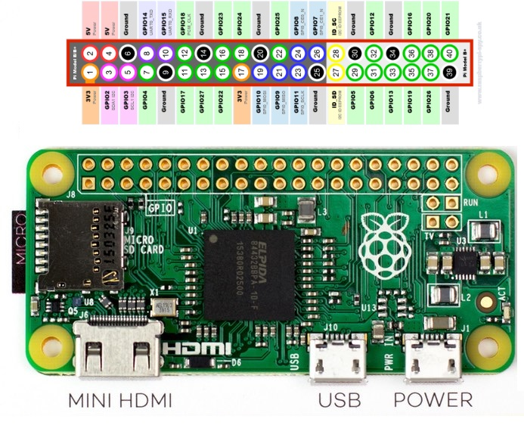
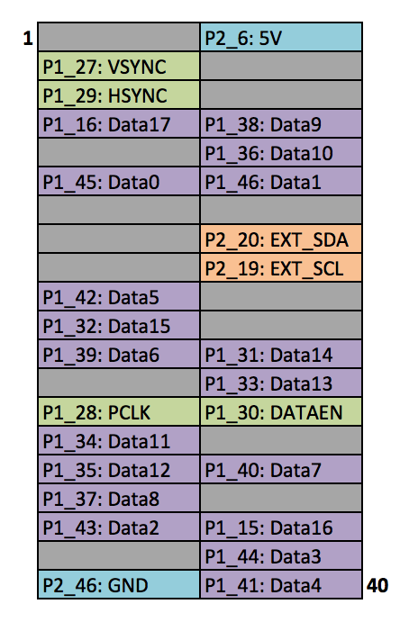

DLP pinout:
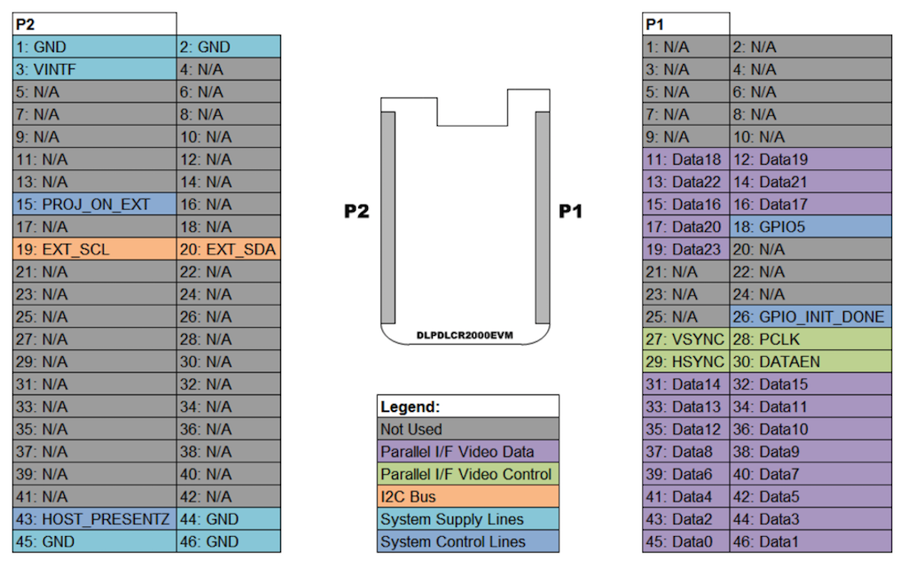

GPIOs used to control the DLP
- POWER_ON: BRCM gpio 27, pin 13 => enables DLP power thru FET
- PROJ_ON: BRCM gpio22, pin 15 TBD: Seems not to have any effect ?
- INIT_DONE: BRCM gpio26, pin 37

GPIOs used to control extra HW
A light sensor BH1750 is connected to
- 3.3V: Raspberry pin 1
- i2c SDA: BRCM gpio23, pin 16
- i2c SCL: BRCM gpio24, pin 18
- ADDR: GND (slave address 0x23)
A HC SR501 motion detection sensor is connected to
- 3.3V: Raspberry pin 1
- motion detected: BRCM gpio 25, pin 22

Picture of the adapter board

Manually controlling the HW (outside of PicturePi):
- Enabling 5V (powers the DLP)
gpio mode 2 out
gpio write 2 1
- Enabling output to the projector
sudo i2cset -y 3 0x1b 0x0c 0x00 0x00 0x00 0x13 i
sudo i2cset -y 3 0x1b 0x0b 0x00 0x00 0x00 0x00 i
- Controlling brightness
sudo i2cset -y 3 0x1b 0x12 0x00 0x00 0x00 <brightness R> i
sudo i2cset -y 3 0x1b 0x13 0x00 0x00 0x00 <brightness G> i
sudo i2cset -y 3 0x1b 0x14 0x00 0x00 0x00 <brightness B> i
sudo i2cset -y 3 0x1b 0x3a 0x00 0x00 0x00 0x01 i
sudo i2cset -y 3 0x1b 0x38 0x00 0x00 0x00 0xd3 i
- reading brightness
i2cset -y 3 0x23 0x20
i2cget -y 3 0x23 0x00 w

Software

Installation of Raspberry Pi OS
This document was written using Raspberry Pi OS release date 2020-08-20 (based on Debian Buster).
- Use image with desktop (most of recommended SW is not needed)
- I use balenaEtcher (https://www.balena.io/etcher) to flash the image onto the SD card
- To enable WLAN immediately on the image:
  - create an empty file ssh
  - create a file wpa_supplicant.conf in the boot partition with the following content:
# file wpa_supplicant.conf in the boot partition
country=DE # replace with your coutry code
ctrl_interface=DIR=/var/run/wpa_supplicant GROUP=netdev
update_config=1
network={
ssid="wlan SSID"
psk="password"
key_mgmt=WPA-PSK
}
- run sudo raspi-config and adopt defaults
  - B4: Boot into Desktop with auto-login
  - P3: Enable VNC
  - P5: Enable I2C
  - A1: Expand filesystem
- Update installed SW by
sudo apt-get update
sudo apt-get upgrade
- Install Java 11 JRE
  - sudo apt install openjdk-8-jdk

Setup when using the TI DLP 2000 projector
These settings are required when using the DLP 2000 projector with the adapter board:
- add the following lines to boot/config.txt:
# Add support for software i2c on gpio pins
dtoverlay=i2c-gpio,i2c_gpio_sda=23,i2c_gpio_scl=24,i2c_gpio_delay_us=2
# DPI Video Setup
dtoverlay=dpi18
overscan_left=0
overscan_right=0
overscan_top=0
overscan_bottom=0
framebuffer_width=854
framebuffer_height=480
enable_dpi_lcd=1
display_default_lcd=1
dpi_group=2
dpi_mode=87
dpi_output_format=458773
hdmi_timings=854 0 14 4 12 480 0 2 3 9 0 0 0 60 0 32000000 3

Setup when using the HDMIPI HDMI Display
These settings are required when using the HDMIPI Display:
- add the following lines to boot/config.txt:
# HDMIPI settings
hdmi_group=2 # HDMIPi for 1280 x 800
hdmi_drive=2 # for alternative modes get sound
hdmi_mode=28 # 1280 x 800 @ 60 Hz Specifcations
hdmi_ignore_edid=0xa5000080

Installation of PicturePi
- create user and group picturepi. HOME directory gets set to /etc/picturepi to store Java preferences. Add user picturepi as sudoer
sudo useradd -M picturepi
sudo usermod -a -G gpio picturepi
sudo usermod -a -G i2c picturepi
sudo adduser picturepi sudo
- enable sudo rights without password for user picturepi
sudo cp /etc/sudoers.d/010_pi-nopasswd /etc/sudoers.d/010_picturepi-nopasswd
sudoedit /etc/sudoers.d/010_picturepi-nopasswd
and change pi to picturepi
- Create directories required by PicturePi:
sudo mkdir /opt/picturepi
sudo mkdir /opt/picturepi/bin
sudo mkdir /opt/picturepi/lib
sudo mkdir /etc/picturepi
sudo mkdir /var/lib/picturepi
sudo chown -R picturepi:picturepi /opt/picturepi
sudo chown -R picturepi:picturepi /etc/picturepi
sudo chown -R picturepi:picturepi /var/lib/picturepi
sudo usermod --home /etc/picturepi picturepi
- change password for user picturepi:
sudo passwd picturepi
- change autologin to user picturepi:
sudo nano /etc/lightdm/lightdm.conf
change autologin-user=picturepi
- install xscreensaver
sudo apt install xscreensaver
- disable the screensaver and set picturepi as autostart application
mkdir -p /etc/picturepi/.config/lxsession/LXDE-pi
sudo nano /etc/picturepi/.config/lxsession/LXDE-pi/autostart
@lxpanel --profile LXDE-pi
@pcmanfm --desktop --profile LXDE-pi
@point-rpi
@xset s noblank
@xset s off
@xset -dpms
@xscreensaver -no-splash
@/opt/picturepi/bin/picturepi
- XXX

