Connection with TI's DLP LightCrafter Display 2000 EVM

DLP 2000 EVM board connectors:
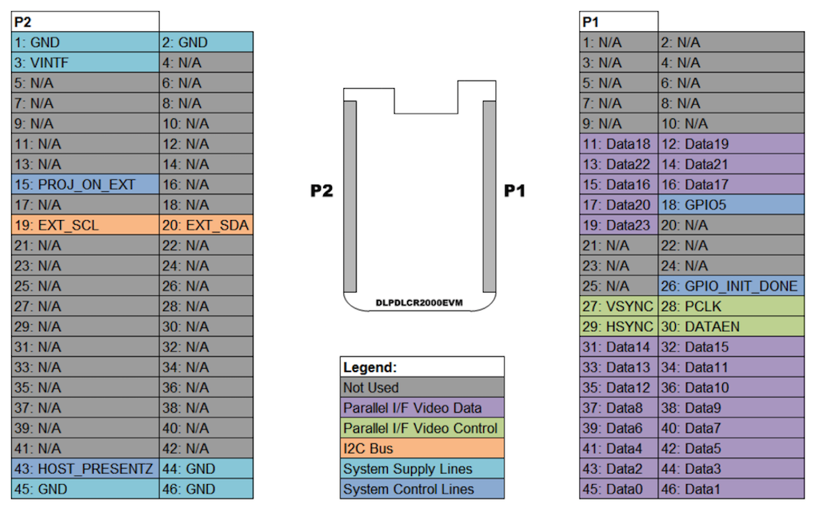

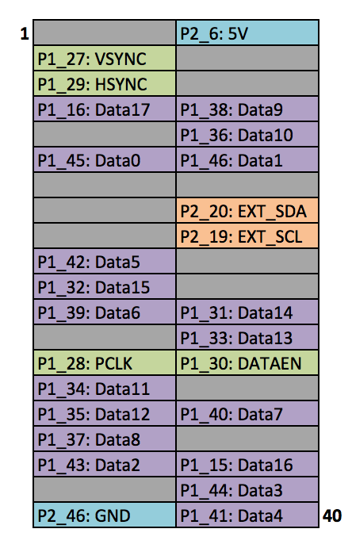
RaspBerry Pi
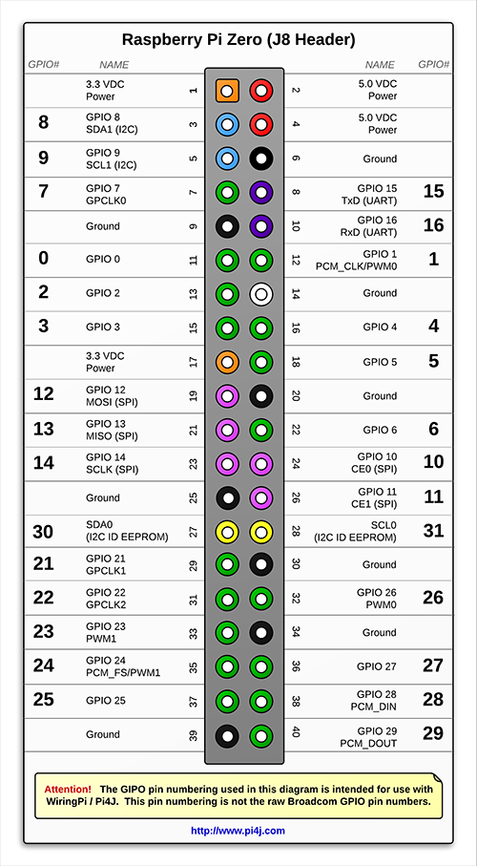

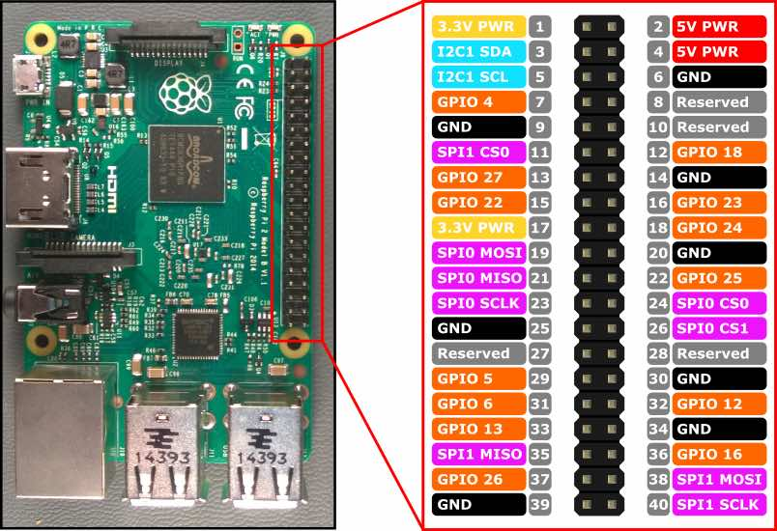

Installation
Place a file wpa_supplicant.conf in /boot with this content:
ctrl_interface=DIR=/var/run/wpa_supplicant GROUP=netdev
update_config=1
country=DE
network={
ssid="<SSID>"
psk="<password>"
key_mgmt=WPA-PSK
}
create an empty file ssh in /boot

Default
enable I2C support

edit /boot/config.txt and append

# Add support for software i2c on gpio pins
dtoverlay=i2c-gpio,i2c_gpio_sda=23,i2c_gpio_scl=24,i2c_gpio_delay_us=2

# DPI Video Setup
dtoverlay=dpi18
overscan_left=0
overscan_right=0
overscan_top=0
overscan_bottom=0
framebuffer_width=854
framebuffer_height=480
enable_dpi_lcd=1
display_default_lcd=1
dpi_group=2
dpi_mode=87

dpi_output_format=458773
hdmi_timings=854 0 14 4 12 480 0 2 3 9 0 0 0 60 0 32000000 3

add this to /etc/rc.local before the "exit 0" command:

sudo i2cset -y 3 0x1b 0x0c 0x00 0x00 0x00 0x13 i
sudo i2cset -y 3 0x1b 0x0b 0x00 0x00 0x00 0x00 i
exit 0

Jeandre,
In order to change the system brightness, you need to do two things. First, you need to adjust the LED current register settings. These are located at register addresses 0x12, 0x13, and 0x14. You can write to these registers in the same manner as you would for the video source selection register, as referenced in section 2.1 of the DLPDLCR2000EVM User's Guide, located at: www.ti.com/.../dlpu049c.pdf
When writing to these three registers, you can simply follow the i2cset command format seen in the User's Guide but switch out the "Device Register" and "Data" fields.
The LED brightness won't immediately change after writing to these registers. You need to send a compound command to the DLPC2607 after completing these changes in order to "propagate" the new settings to the LEDs themselves. The compound command consists of a handshake at address 0x3A followed by an ICP command at 0x38 (normally a data payload is supplied at 0x39 but we are simply sending a command and no data). This process can be a bit confusing so I will show you an example of how to do this for the LEDs below:
(In your Terminal):
>debian@beaglebone: ~$ i2cset -y 2 0x1b 0x3A 0x00 0x00 0x00 0x01 i
>debian@beaglebone: ~$ i2cset -y 2 0x1b 0x38 0x00 0x00 0x00 0xD3 i
The first line tells the controller to listen for a compound command, and the second tells the system to issue the "LED current set" command. More information on compound commands can be found in the DLPC2607 programmer's guide, which can be located at: www.ti.com/.../dlpu013.pdf
As a side note, it is advised that you employ additional cooling if you choose to run your system at 30 lumens. The heatsink provided by default has not been rated for the higher temperatures sustained by this operation.
I hope this helps. Let me know if you have any trouble with your implementation.

pi@raspberrypizero:~ $ sudo i2cset -y 3 0x1b 0x12 0x00 0x00 0x00 0x08 i
pi@raspberrypizero:~ $ sudo i2cset -y 3 0x1b 0x13 0x00 0x00 0x00 0x08 i
pi@raspberrypizero:~ $ sudo i2cset -y 3 0x1b 0x14 0x00 0x00 0x00 0x08 i
pi@raspberrypizero:~ $ sudo i2cset -y 3 0x1b 0x3a 0x00 0x00 0x00 0x01 i
pi@raspberrypizero:~ $ sudo i2cset -y 3 0x1b 0x38 0x00 0x00 0x00 0xd3 i
pi@raspberrypizero:~ $

turning on 5V:
wiringPi GPIO 2 = BRCM GPIO 27, pin 13
gpio mode 2 out
gpio write 2 1

light sensor BH1750
3.3V = raspi pin 1
i2c SDA = BRCM gpio 23 raspi pin 16
i2c SCL = BRCM gpio 24 raspi pin 18
ADDR = L, slave address = 0x23

i2cset -y 3 0x23 0x20
i2cget -y 3 0x23 0x00 w

Screen resolution for HDMIPI
The native resolution for the LCD panel is 1280×800, although is capable of handling up to 1920×1080 – Unless instructed to within the config.txt file, the Raspberry Pi will default to this resolution.
To lower the resolution on a Raspberry Pi, open the config.txt file located on the SD card, or in the folder /boot/config.txt if you are using the Pi at the time of writing.
At the bottom of the file, add the following lines;
hdmi_group=2 # HDMIPi for 1280 x 800
hdmi_drive=2 # for alternative modes get sound
hdmi_mode=28 # 1280 x 800 @ 60 Hz Specifcations
hdmi_ignore_edid=0xa5000080

Creation of user picturepi
- Create user and group picturepi. HOME directory gets set to /etc/picturepi to store Java preferences. Add user picturepi as sudoer
sudo useradd -M picturepi
sudo usermod -a -G gpio picturepi
sudo usermod -a -G i2c picturepi
sudo adduser picturepi sudo
- Enable sudo rights without password for user picturepi
sudo cp /etc/sudoers.d/010_pi-nopasswd /etc/sudoers.d/010_picturepi-nopasswd
sudo nano /etc/sudoers.d/010_picturepi-nopasswd
and change pi to picturepi
- Create directories required by PicturePi:
sudo mkdir /opt/picturepi
sudo mkdir /opt/picturepi/bin
sudo mkdir /opt/picturepi/lib
sudo mkdir /etc/picturepi
sudo mkdir /var/lib/picturepi
sudo chown -R picturepi:picturepi /opt/picturepi
sudo chown -R picturepi:picturepi /etc/picturepi
sudo chown -R picturepi:picturepi /var/lib/picturepi
sudo usermod --home /etc/picturepi picturepi
- Change password for user picturepi:
sudo passwd picturepi
- Change shell to BASH for user picturepi
sudo nano /etc/passwd
change last column of user picturepi (last entry) to /bin/bash
- change autologin to user picturepi:
sudo nano /etc/lightdm/lightdm.conf
change autologin-user=picturepi
- install xscreensaver
sudo apt install xscreensaver

Configure the desktop behavior

create a directory /etc/picturepi/.config/lxsession/LXDE-pi
sudo nano /etc/picturepi/.config/lxsession/LXDE-pi/autostart
@lxpanel --profile LXDE-pi
@pcmanfm --desktop --profile LXDE-pi
@point-rpi
@xset s noblank
@xset s off
@xset -dpms
@xscreensaver -no-splash
@/opt/picturepi/bin/picturepi

Download of required libraries
- download Google Calendar API Client libraries for Java from
https://developers.google.com/api-client-library/java/apis/calendar/v3
copy the zip file into the lib directory and unzip (Version 1.23.0 when writing this)
cd /opt/picturepi/lib
sudo mv /tmp/google-api-services-calendar-v3-rev263-java-1.23.0.zip .
unzip google-api-services-calendar-v3-rev263-java-1.23.0.zip
- download Pi4J from
http://pi4j.com/download.html
Tu support latest kernel versions, it must be snapshot release 1.2 or later. Copy the zip file into the lib directory and unzip (Version 1.2 snapshot when writing this)
cd /opt/picturepi/lib
unzip pi4j-1.2-SNAPSHOT.zip
mv pi4j-1.2-SNAPSHOT pi4j
- download ini4j from
https://sourceforge.net/projects/ini4j/files/
copy the zip file into the lib directory and unzip (Version 0.5.4 when writing this)
cd /opt/picturepi/lib
unzip ini4j-0.5.4-bin.zip
mv ini4j-0.5.4 ini4j
- download the paho MQTT client library from
https://repo.eclipse.org/content/repositories/paho-releases/org/eclipse/paho/org.eclipse.paho.client.mqttv3/1.2.0/
copy the zip file into the lib directory and unzip
cd /opt/picturepi/lib
sudo -u picturepi mv org.eclipse.paho.client.mqttv3-1.2.0.jar org.eclipse.paho.client.mqttv3.jar
- download the metadata extractor
copy the zip file into the lib directory and unzip
cd /opt/picturepi/lib
unzip metadata-extractor-2.9.1.zip
mv metadata-extractor-2.9.1.jar metadata-extractor.jar
mv xmpcore-5-1-2-jar xmpcore.jar
- download javax.json from https://download.oracle.com/otndocs/jcp/json_p-1_1-final-spec/index.html
get javax.json-api-1.1.jar and rename to javax.json-api.jar
- download javax.json from https://repo1.maven.org/maven2/org/glassfish/javax.json/1.1.2/
get javax.json-1.1.2.jar and rename to javax.json.jar

Configuration of PicturePi
- sudo -u picturepi mv picturepi /opt/picturepi/bin
sudo -u picturepi mv picturepi.jar /opt/picturepi/bin
sudo -u picturepi mv picturepi.ini /etc/picturepi
sudo -u picturepi mv picturepi.logging /etc/picturepi

Installation of fliclib (if needed)
- download fliclib from https://github.com/50ButtonsEach/fliclib-linux-hci
- unzip to /opt/flic
- create directory for database file: sudo mkdir /var/flic
- create directory for log file: sudo mkdir /var/log/flicd
- create a file flicd.service in /usr/lib/systemd/system with this content:
# systemd service file for flicd
# place in /usr/lib/systemd/system
[Unit]
Description=flic daemon
After=hciuart.service
[Service]
User=root
Group=root
WorkingDirectory=/opt/flic/bin/armv6l
#PermissionsStartOnly=true
ExecStart=/opt/flic/bin/armv6l/flicd -f /var/flic/sqlite_db_file.db –log-file
/var/log/flicd/flicd.log –wait-for-hci
# ExecStop=
# Shutdown delay in seconds, before process is tried to be killed with KILL (if configured)
# TimeoutStopSec=120
Restart=on-failure
[Install]
WantedBy=multi-user.target

connection of a flic buttont (if needed)
- start simpleclient in (build before using make)
- type startScanWizard
- click the button
- note the MAC address

