How to program the ESP8266 module using the Arduino IDE
Taken from http://www.instructables.com/id/ESP8266-WiFi-Module-for-Dummies/#intro

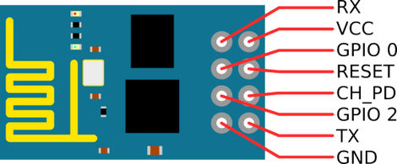
The picture above of the ESP8266 pinouts is found all over the net. I think it may have originated from Neil “Kolban’s Book on ESP8266”. This is a fantastic resource and is available as a pdf download from: https://leanpub.com/ESP8266_ESP32. It’s 400 pages long, was updated in November 2016, and if you’re into serious ESP8266 development then this is the book to get. It’s free but make a donation if you can.
Breadboard wiring notes:
- The wires are shown connecting to the front of the ESP-01 for clarity. Attach them to the same pins from behind. The ESP-01 is not breadboard friendly and JST connector male-female jumpers are handy for connecting it.
- GPIO 0 must be held low for programming. This should be removed if you remove the FTDI and operate the ESP8266 on its own power supply.
- CH_PD should be held high at all times.
- The RESET pin is held high with a 10k ohm resistor and brought to ground by the RESET button which will reboot the chip. Press RESET every time before you upload code, and every time you connect or disconnect GPIO 0. The reset button will save you a lot of hassle.
When you power the circuit up the red LED on the ESP-01 should light up and the blue LED should flash briefly. Later when uploading code to the ESP the blue LED should flash continuously during the process. Any other LED combinations suggests that there is a problem.
NB: If you want to remove the Serial programmer and run the ESP on its own, make sure you disconnect GPIO 0 from ground and push the RESET button otherwise the ESP may not work properly.
asd

