Supplemental Figures for
A Foxglove Genome-Scale Metabolic Model Reveals the Cost of Herbivory Defense
Rachael Hageman Blair*², Emily Carroll¹, Tiange Shi², Zhen Q. Wang*¹
- Department of Biological Sciences, University at Buffalo, The State University of New York, Buffalo, NY 14260, United States
- Department of Biostatistics, University at Buffalo, The State University of New York, Buffalo, NY 14260, United States
*Corresponding authors: Zhen Q. Wang (zhenw@buffalo.edu) and Rachael Hageman Blair (hageman@buffalo.edu).
Supplemental Figure 1: Sensitivity of predicted fluxes to objective-function weighting. The biomass objective weighting coefficient was fixed at 1, while the relative weight assigned to each of the three fully coupled cardiac glycoside objective reactions was varied from 0 to 1. The dashed vertical line indicates the weighting used in the model (100/693 = 0.144 per cardiac glycoside reaction). Predicted biomass flux decreased as we placed more weight on cardiac glycoside production, while cardiac glycoside pathway flux increased and eventually plateaued. Because flux through cardenolide biosynthetic reactions, including Add_Card13_c, Add_Card14_c, and Add_Card15_c, was identical across solutions, a single representative cardiac glycoside pathway flux is shown.

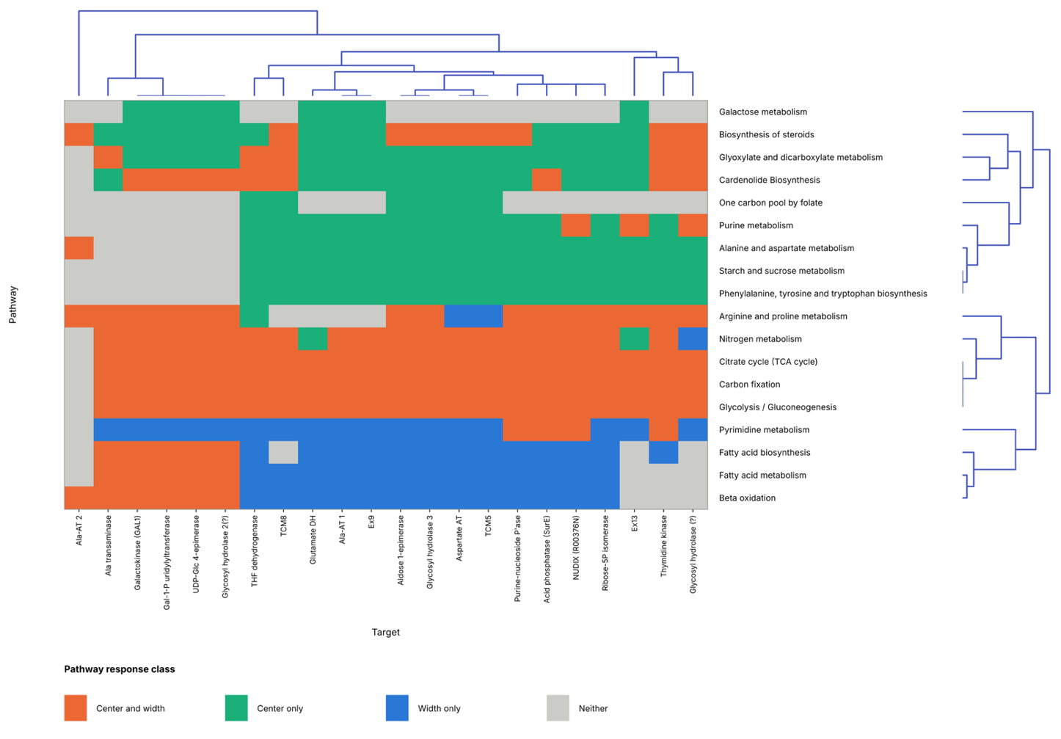

Supplemental Figure 2: Clustering of pathway responses across model targets. Heatmap showing pathway response classifications for each model target, with targets clustered by similarity across pathways and pathways clustered by similarity across targets. Response classes indicate whether pathway changes were observed in the center_{FC} and width_{FC}, center_{FC} only, width_{FC} only, or neither, as indicated by the legend. Dendrograms show hierarchical clustering of targets and pathways based on these response patterns.

