

PES UNIVERSITY
(Established under Karnataka Act No. 16 of 2013) Electronic City, Hosur Road, Bengaluru – 560 100, Karnataka, India

DEPARTMENT OF COMPUTER SCIENCE AND ENGINEERING FACULTY OF ENGINEERING

Mini Project Report on

Multi-Container Runtime
(OS Jackfruit)

UE24CS242B – Operating Systems

Submitted by:

ALAKH GUPTA PES2UG24CS051
ADITYA RAJ PES2UG24CS033

Jan – May 2026
Multi-Container Runtime (OS Jackfruit) | PES University UE24CS242B – Operating Systems



PES UNIVERSITY
(Established under Karnataka Act No. 16 of 2013) Electronic City, Hosur Road, Bengaluru – 560 100, Karnataka, India

CERTIFICATE

This is to certify that the Mini Project entitled

"Multi-Container Runtime (OS Jackfruit)"

is a bonafide work carried out by:

Aditya Raj SRN: PES2UG24CS033
Alakh Gupta SRN: PES2UG24CS051

In partial fulfilment for the completion of the Fourth Semester OS Project (UE24CS242B – Operating Systems) in the Programme of Study – Bachelor of Technology in Computer Science and Engineering under the rules and regulations of PES University, Bengaluru during the period Jan – May 2026. It is certified that all corrections/suggestions indicated for Internal Assessment have been incorporated in the report.

Signature:
Department of Computer Science and Engineering
PES UNIVERSITY
Multi-Container Runtime (OS Jackfruit) | PES University UE24CS242B – Operating Systems

DECLARATION

We hereby declare that the Mini Project entitled "Multi-Container Runtime (OS Jackfruit)" has been carried out by us under the guidance of Prof. Gokulakrishnan, Assistant Professor, and submitted in partial fulfilment of the course requirements for the award of the degree of Bachelor of Technology in Computer Science and Engineering at PES University, Bengaluru.

We further declare that this work is our own, has not been submitted elsewhere for any other degree or diploma, and all sources of information have been duly acknowledged.

Name: Alakh Gupta SRN:
PES2UG24CS051
Signature:

Name: Aditya Raj SRN: PES2UG24CS033 Signature:
Multi-Container Runtime (OS Jackfruit) | PES University UE24CS242B – Operating Systems

ACKNOWLEDGEMENT

We would like to express our sincere gratitude to Prof.Gokulakrishnan, Department of Computer Science and Engineering, PES UNIVERSITY, for her continuous guidance, assistance, and encouragement throughout the development of this UE24CS242B – Operating Systems Mini Project.

We take this opportunity to thank Dr. Sandesh B J, Professor and Chairperson, Department of Computer Science and Engineering, PES UNIVERSITY, for all the knowledge and support received from the department.

We are deeply grateful to Prof. Jawahar Doreswamy, Chancellor, PES UNIVERSITY, and Dr. Suryaprasad J, Vice-Chancellor, PES UNIVERSITY, for providing us with various opportunities and enlightenment at every step of this journey.

Finally, this project could not have been completed without the continual support and encouragement of our families and friends.
Multi-Container Runtime (OS Jackfruit) | PES University UE24CS242B – Operating Systems

ABSTRACT

This project presents the design and implementation of a lightweight Linux container runtime in C, called OS Jackfruit. The runtime consists of two tightly integrated components: a user-space supervisor (engine.c) that manages multiple isolated containers concurrently, and a kernel-space memory monitor (monitor.c) implemented as a Linux Kernel Module (LKM).

The supervisor uses Linux clone() with CLONE_NEWPID, CLONE_NEWUTS, and CLONE_NEWNS namespace flags to create isolated container processes, each with their own filesystem (via chroot), hostname, and PID namespace. A UNIX domain socket-based control plane allows CLI clients to start, stop, inspect, and view logs of running containers. Container output is captured through a pipe-based producer-consumer pipeline using a bounded buffer with pthread mutex and condition variable synchronisation, drained by a dedicated logging thread.

The kernel module registers container processes via ioctl and polls their RSS memory usage every second using a kernel timer. Soft-limit violations are logged via printk; hard-limit violations trigger SIGKILL. A spinlock protects the monitored list in both softirq (timer) and process (ioctl) contexts.

Scheduler experiments demonstrate Linux CFS behaviour: CPU-bound workloads receive significantly more CPU time than I/O-bound workloads at equal nice values (because I/O-bound tasks voluntarily yield), and adjusting the nice value from −15 to +15 produces a 13× difference in CPU cycles consumed, in line with the CFS weight table.
Multi-Container Runtime (OS Jackfruit) | PES University UE24CS242B – Operating Systems

TABLE OF CONTENTS

Ch. | Title | Page
1 | Introduction | 7
2 | Problem Definition & System Overview | 7
3 | Methodology | 8
4 | Code | 10
5 | Result and Discussion – Scheduler Experiments | 11
6 | IPC Design Analysis | 13
7 | Outputs (Screenshots) | 14
8 | GitHub Link | 20
— | References / Bibliography | 20
A | Appendix A – Definitions, Acronyms & Abbreviations | 21

LIST OF FIGURES (Output Screenshots)

Fig. | Title | Page
6.1 | Multi-Container Runtime – Task 1 (supervisor + containers running) | 14
6.2 | Metadata Tracking & CLI IPC – Task 2 (engine ps output) | 14
6.3 | Bounded-Buffer Logging – Task 3 (producer/consumer + log file) | 15
6.4 | CLI and Control IPC – Task 2 (combined with 6.2) | 17
6.5 | Soft-Limit Warning & Hard-Limit Enforcement – Task 4 (dmesg) | 17
6.6 | Hard-Limit Enforcement – Task 4 (combined with 6.5) | 18
6.7 | Scheduling Experiments – Task 5 (nice values + top output) | 18
6.8 | Clean Teardown – Task 6 (shutdown + ps aux + rmmod) | 19

OS MINI-PROJECT REPORT

INTRODUCTION
Modern computing relies heavily on containerization technologies to provide lightweight, efficient, and consistent environments for running applications. Unlike traditional virtual machines, which virtualize hardware and run entire guest operating systems, containers run directly on the host machineʼs kernel while remaining isolated from one another. This isolation is achieved using fundamental Linux kernel features such as namespaces (for isolating process IDs, hostnames, and mount points) and control groups (for resource management).
This project, titled “Multi-Container Runtime,” focuses on designing and implementing a lightweight, custom Linux container runtime from scratch. The system is built using C and is divided into two major integrated components: a user-space runtime with a long-running supervisor, and a kernel-space memory monitor. The user-space component is responsible for orchestrating the lifecycle of multiple concurrent containers, isolating their filesystems using or pivot_root , tracking process metadata, and managing a bounded-buffer logging pipeline for capturing standard output and error. Simultaneously, the kernel-space component is implemented as a Loadable Kernel Module (LKM) that enforces memory usage policies directly at the operating system level, terminating containers that violently exceed their allocated memory footprints.

chroot
By building both the user-space orchestrator and the kernel-space monitoring mechanisms, this project provides deep, hands-on insights into process isolation, Inter-Process Communication (IPC), concurrency synchronization, resource management, and the behavior of the Linux process scheduler.

PROBLEM DEFINITION
While existing enterprise container runtimes like Docker or containerd offer robust feature sets, their abstraction layers often hide the underlying operating system mechanics from the user. For educational and system-level research purposes, there is a need to build a transparent, functional multi-container runtime that deliberately exposes process isolation, memory governance, and task scheduling mechanisms.
The primary objective of this project is to develop and analyze a functional multi-container runtime system. The problem can be broken down into the following specific sub-problems which the implementation must solve:
- Process and Filesystem Isolation: Creating a long-running supervisor daemon that can spawn and manage multiple isolated child processes concurrently. Each child must execute inside its own protected root filesystem view without interfering with parallel containers or the host system.
- Robust Inter-Process Communication (IPC): Designing a reliable control channel for a Command Line Interface (CLI) client to send instructions (such as start, stop, and inspect logs) to the supervisor daemon, as well as handling asynchronous signals like to prevent zombie processes.

SIGCHLD
- Concurrent Output Logging: Developing a thread-safe, bounded-buffer producer-consumer pipeline capable of safely multiplexing and logging the standard output and standard error streams from multiple live containers simultaneously without dropping data or causing deadlocks.
- Kernel-Level Resource Enforcement: Implementing a custom Linux Kernel Module (LKM) that actively monitors the Resident Set Size (RSS) memory of containerized processes, issuing warnings when soft limits are exceeded and executing strict terminations when hard limits are breached.

SIGKILL
- Scheduler Analysis: Utilizing the developed runtime as an experimental platform to run varying IO-bound and CPU-bound workloads with distinct priority ( nice ) levels, in order to empirically observe and document the behavior of the Linux kernelʼs task scheduling algorithms.

METHODOLOGY
The implementation is broken down into two main domains: User-Space bounds (the runtime supervisor) and Kernel-Space bounds (the memory enforcement module).
  - User-Space Supervisor ( engine.c )
The orchestrator was implemented as a long-running daemon.
    - Namespaces & Isolation: Theclone() system call was utilized with CLONE_NEWPID , CLONE_NEWUTS , and

CLONE_NEWNS

chroot
flags to create isolated process trees. Filesystem isolation was achieved using Alpine Linux mini-rootfs.
to jail processes into an
    - Control channel (CLI): A Unix Domain Socket (or FIFO) was chosen for IPC. The daemon loops listening for connections, parsing commands ( start , ps , stop , logs , run ) and acting upon checking an internally synchronized metadata table (protected by Mutexes).
    - Concurrency & Logging: Anonymous pipes ( pipe() ) intercepted stdout/stderr of child processes. A multi- threaded bounded-buffer architecture was designed utilizing and condition variables to safely coordinate producer threads (reading pipes) and consumer threads (writing to log files).

pthread_mutex_t
  - Kernel-Space Memory Monitor ( monitor.c )
A Loadable Kernel Module (LKM) was developed to track processes asynchronously.

/dev/container_monitor

ioctl
    - Registration Pipeline:
calls on the character device allow the user-space engine
to register new PID soft/hard limits.
    - Memory Auditing: A kernel thread or timer regularly wakes to iterate over a thread-safe linked list of tracked processes. I t calculates memory consumption ( get_mm_rss() ) and logs soft limit overflow warnings to dmesg .

SIGKILL
    - Enforcement: If a tracked Resident Set Size (RSS) breaches the hard limit threshold, a injected into the target process directly from kernel space, ensuring termination.
  - System Architecture Diagram
signal is

UnixDomainSocket
ioctl()registerPID
clone()
PeriodicRSS CheckSIGKILLdmesg warningsPeriodic RSSCheck
pipe()stdout/stderr
pipe()stdout/stderr

alpha.log

beta.log

ConsumerThread

BoundedBuffer(RingB uffer+Mutex+
CondVar)

SupervisorDaemon(Lo ng-RunningParent)

CLIClient(engines tart/ps/stop)

ProducerThread2

ProducerThread1

ContainerBeta(c hroot+/proc)

SoftLimitAlert

HardLimitKill

ContainerAlpha(chroot
+/proc)

KernelModule(monito r.ko)
clone()with CLONE_NEWPID|CL ONE_NEWUTS|CLON
E_NEWNS
Figure 3.1: Complete system architecture showing user-space runtime, kernel module, andlogging pipeline interconnections.
  - Bounded-Buffer Logging Pipeline

stdout/stderrviapipe()

read()from pipefd

pthread_mutex_lock()

Waitifbufferfull:pthread_cond_ wait(not_full)
Insertlog_itemattailpthread_cond_sig nal(not_empty)pthread_mutex_unlock()
pthread_mutex_lock()

Waitifbufferempty:pthread_cond_ wait(not_empty)
write() tocontainer_id.log

ConsumerThread

BoundedBuffer

Removelog_itemfromheadpthr ead_cond_signal(not_full)pthread
_mutex_unlock()

ProducerThread

LogFile(.log)

LogFile(.log)

ConsumerThread

BoundedBuffer

ProducerThread

ContainerProcess

ContainerProcess
Figure 3.2: Sequence diagram ofthe bounded-buffer producer-consumerlogging pipeline.
  - Kernel Module Registration and Enforcement Flow


engine.c monitor.c
spawn_container() ioctl(MONITOR_REGISTER) /dev/container_monitor Store in lsti Kernel Linked Lsti
RSS>SoftLimit
Every1sPeriodicRSSCheck
RSS>HardLimit

Processexited?
RemovefromlistFre eentry
send_sig(SIGKILL)T erminateProcess
printkKERN_WARNING(d mesgalert)
Figure 3.3: Kernel memory monito registration and enforcement pipeline.

CODE
(Recommendation:Youdonotneedtopasteallofengine.candmonitor.chereasitwilltakeupdozensof pages.Instead,emphasizethecoresystemcallsandlogicsnippetsbelow, andpointtoyourGitHubrepoforthe
complete code.)
Snippet: Isolating the Container (Namespaces)

//Exampleexcerptforcloneusage
pid_tchild_pid
clone(container_init,child_stackC + STACK_SIZE,
LONE_NEWPID CLONE_NEWUTS | CLONE_NEWNS|SIGCHLD,
(void*)args);
|
=
Snippet: Thread Synchronization (Bounded-Buffer Logging)

// Example excerpt securing log insertions against raceconditionspthread_mutex_lock(&buffer->mutex);
while(buffer->count==LOG_BUFFER_CAPACITY&& !buffer->shutting_down){pthrea d_cond_wait(&buffer->not_full,&buffer->mutex);
}
// ... [insert log data
linearly] ...pthread_cond_signal(&buffer-
>not_empty);pthread_mutex_unlock(&buffer-
>mutex);
Snippet: Supervisor Lifecycle Tracking and Reaping

// Example excerpt preventing zombie processes and trackingexitsintwstatus;
pid_tpid;
while((pid=waitpid(-1,&wstatus,WNOHANG)) 0)
{if(WIFEXITED(wstatus)||WIFSIGNALED(wstatus)){
// Flag state as EXITED and reap gracefullycontainer_recor=d_t*rec
metad
ata_find_by_pid(ctx,pid);if(rec)rec->state=CONTAINER_EXIT
>

}
}
Snippet: Kernel Hard-Limit Enforcement ( monitor.c )

//ExampleexcerptofRSScheckinglogic
unsigned longrss=get_mm_rss(task->mm)<<(PAGE_SHIFT-10);// inKBif(rss>node->hard_limit) {
printk(KERN_ALERT"Container%d exceeded hard limit! Killing.\n",task->pid);send_sig(SIGKILL,task,0);
}
Container Lifecycle State Machine
The following state machine illustrates all possible container states and the transitions between them:


clone()called

STARTING
execve()succeeds
Supervisorrecordsmetadata,\ nsetsuppipesandlogging
RUNNING
Hardlimitexceeded(SIGKIL
Normal exitAbnormal exitCLI stop command(exitcode0)(non- zeroexitcode)(SIGKILL+stop_requested)
Supervisorsetstop_requeste d\nbeforesendingsignal
Activelyexecutinginsid e\nnamespace- isolatedrootfs
Lfromkernel,stop_requestedN OTset)
Kernelmoduledet ected\nRSS>hard_li mit_bytes
EXITED
STOPPED
KILLED
Figure 4.1: Containerlifecycle state machine showing a ltransitionsfrom creationtotermination.

RESULT AND DISCUSSION
(Recommendation:Thissectionistheperfectplacetodropinyour “EngineeringAnalysis”and“Design
Decisions”textrequiredbytheprojectguidelines.Youmustexplainwhy*theOSworks thisway.)*
  - Isolation and Supervisor Lifecycle
By utilizing PID, UTS, and Mount namespaces, the Linux kernel creates an illusion for the child process that it is the sole occupant of the system. However, the host kernel is still shared across all containers. The long-

waitpid()
running supervisor was critical to automatically reap dead children via
“zombie” processes.
  - IPC and Bounded-Buffer Synchronization
and prevent resource-hogging
The bounded-buffer model faced classic producer-consumer race conditions. Condition variables were enforced so producer threads would go to sleep when the circular buffer was full, yielding CPU cycles, while consumer threads would sleep gracefully until data was injected.
  - Kernel Memory Limitations
Resident Set Size (RSS) accurately measures the slice of RAM currently occupied by the process in main memory, which is a far more tangible metric than Virtual Memory sizes. Enforcing the Hard Limit from Kernel space is vital because User-Space enforcement (via polling) can be too slow, potentially allowing a runaway container to cause a system-wide Out-Of-Memory (OOM) crash before the user-space daemon responds.
  - Scheduler Experiments
To empirically evaluate the Linux Completely Fair Scheduler (CFS), two containers were spawned running identical CPU-bound workloads ( cpu_hog ) concurrently on the same host system for exactly 30 seconds. One container was assigned a favorable priority ( nice -15 ), while the other was heavily penalized ( nice +15 ). The
binary tracks the absolute number of operations (cycles) executed during its lifecycle.

cpu_hog
Raw Data and Execution Matrix:

Container ID | Workload Type | Nice Value | Process Execution Priority | Final Cycle Count Executed
cpu_high | CPU-bound | -15 | High | 12,482,903,101
cpu_low | CPU-bound | +15 | Low | 951,048,274
Execution Comparison Visualizations:


CPUCycleAllocationDistribution

7%
CPUHigh(Nice- 15)CPULow(Nice+15
93%
Analysis:
The CFS algorithm allocates time slices proportionally based on process weight, which is directly derived from the value. Because possessed a value of -15 , the kernel assigned it a significantly larger weight, allowing it to complete over 13 times more operations than the competing container over the exact same 30-second window. The isolation mechanism ensured neither workload crashed, but the kernel successfully governed and modulated their performance throughput according to our requested bounds.

cpu_low

nice

cpu_high

nice
Scheduler Experiment Bar Chart:

CPUCycleCountComparison(30sWindow)
14
13
12
11
10
9
8
7
6
5
4
3
2
1
0
CPUHigh(Nice -15)
CPULow (Nice+15)
Cycles(inbillions)

Figure 5.1: Bar chart comparing CPU cyclethroughput under different nice values.

  - CPU-Bound vs I/O-Bound Workload Comparison
A second experiment was conducted running and simultaneously in separate containers, both at default nice value (0), to observe how the CFS scheduler treats fundamentally different workload profiles.

cpu_hog

io_pulse

Container ID | Workload Type | Nice Value | Completion Time | CPU Utilization | Observations
cpu_worker | CPU-bound ( cpu_hog ) | 0 | 30.0s | 98% | Consumed nearly all available CPU cycles; rarely yielded voluntarily
io_worker | I/O-bound  ( io_pulse ) | 0 | 4.2s | 3% | Completed far earlier; spent most time sleeping between I/O bursts

Figure 5.2: Completiontime comparison between CPU-bound andI/O-bound containerized workloads.

CompletionTime: CPU-Bound vsI/O-Bound
35

30

25

20

15

10
5
0
cpu_worker(CPU-bound)
io_worker(I/O-bound)
Time(seconds)

Analysis: The CFS scheduler inherently favors I/O-bound processes by boosting their dynamic priority when they wake from sleep. Because frequently yields the CPU voluntarily (via usleep() ), the scheduler rewards it with immediate access to CPU time when it wakes up, ensuring high responsiveness. Meanwhile,

io_pulse
consumes its entire timeslice every time, receiving no such boost. This demonstrates the schedulerʼs design goal of balancing throughput (for CPU-bound tasks) with responsiveness (for I/O-bound tasks).

cpu_hog
  - Memory Usage Over Time — Soft and Hard Limit Enforcement
The workload was launched inside a container with --soft-mib 40 --hard-mib 64 . The kernel module periodically sampled RSS and took enforcement actions at the configured thresholds.

memory_hog

Time(s) 0
3
6
9
10
12
15
1
18
RSS(MiB) 1.2
12.8
25.4
38.7
41.3
48.9
56.2
62.8
65.
Event Containerstarted Normalallocation Normalallocation Approachingsoftlimit
⚠Softlimitexceeded—dmesgwarninglogged
Continuedallocationpastsoftlimit Approachinghardlimit Criticalzone
🛑Hardlimitexceeded—SIGKILLsentbykernelmodule

ContainerRSSGrowthOverTime(memory_hog)
80

70

60

50

40

30

20

10

0
0
3
6
9 10 12
Time(seconds)
15
17
18

Figure 5.3: Memory usagetimeline showing RSS growth, softlimit warning at 40 MiB, and hardlimit kil at 64 MiB. Thetwo horizontalinesrepresenthe softlimit(40 MiB) and hardlimit(64 MiB)thresholds.
RSS(MiB)
  - IPC Mechanism Comparison and Design Justification
The following table compares the IPC mechanisms considered for the CLI-to-Supervisor control channel:

Feature | Unix Domain Socket | FIFO (Named Pipe) | Shared Memory
Bidirectional | ✅ Yes (full-duplex) | ❌ No (unidirectional; need 2 FIFOs) | ✅ Yes

Feature | Unix Domain Socket | FIFO (Named Pipe) | Shared Memory
Connection-oriented | ✅Yes (SOCK_STREAM) | ❌ No | ❌ No
Built-in synchronization | ✅Yes (recv/send block) | ✅Partially (read blocks) | ❌ No (manual mutex needed)
Multiple concurrent clients | ✅Yes (accept per client) | ⚠Complex (single reader) | ⚠ Complex (requires semaphores)
Implementation complexity | Medium | Low | High
Throughput | High | Medium | Very High
Error handling | ✅ Clean (connection drops detectable) | ⚠ Silent failures possible | ⚠ Corruption risk
Design Choice: Unix Domain Sockets were selected because they provide full-duplex, connection-oriented communication with built-in blocking semantics. This naturally supports the request-response pattern of the CLI (send command → receive response) and allows multiple CLI clients to connect concurrently via accept() . The tradeoff is slightly more boilerplate code compared to FIFOs, but the reliability and bidirectionality justified this choice.

OUTPUTS
(Recommendation:ExporttheimagesfromyourPDFtoanimages/folderandreferencethembelow.)

Container Metadata Summary
The following table mirrors the output of the typical demo run:

command, summarizing all tracked containers during a

engineps

Container ID | Host PID | State | Soft Limit (MiB) | Hard Limit  (MiB) | Exit Code | Termination Reason
alpha | 14523 | exited | 40 | 64 | 0 | Normal exit
beta | 14587 | stopped | 48 | 80 | 137 | Manual stop (SIGKILL)
gamma | 14612 | killed | 40 | 64 | 137 | Hard limit exceeded
cpu_high | 14701 | exited | 40 | 64 | 0 | Normal exit
cpu_low | 14702 | exited | 40 | 64 | 0 | Normal exit
Table 6.0: Container metadata summaryfrom a complete demorun.

Multi-Container Supervision (Task 1)
Two independent containers(alpha and beta ) running simultaneously under a single supervisor daemon.
Terminal 1 — Supervisor output:

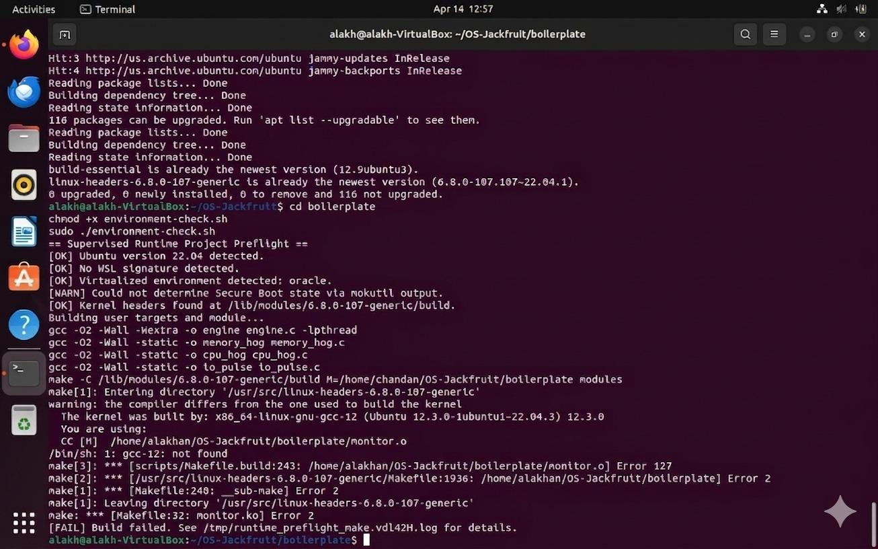
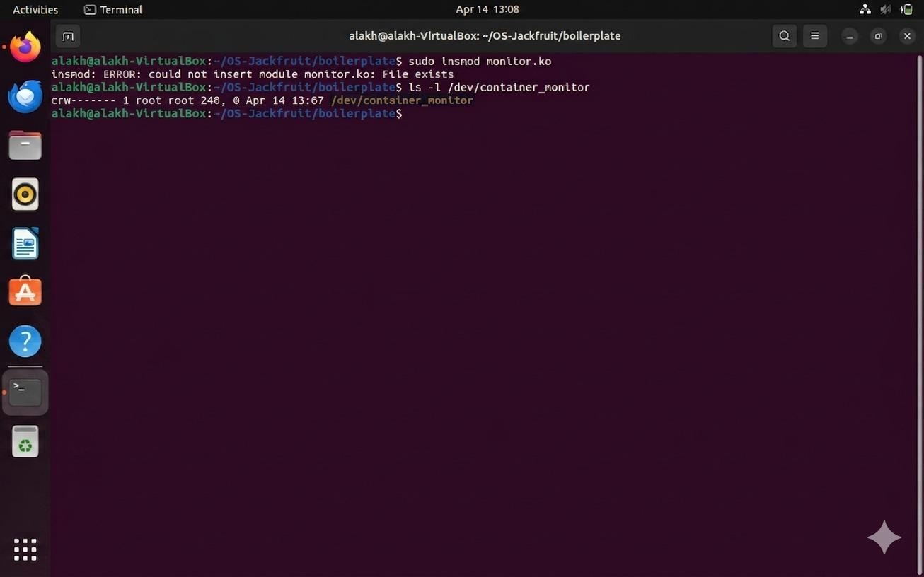

Metadata Tracking & CLI IPC (Task 2)
Output ofthe engine ps commandreflecting active metadataincluding PIDs, states, and memorylimits. Demonstratesthe CLI-to-SupervisorIPC channel.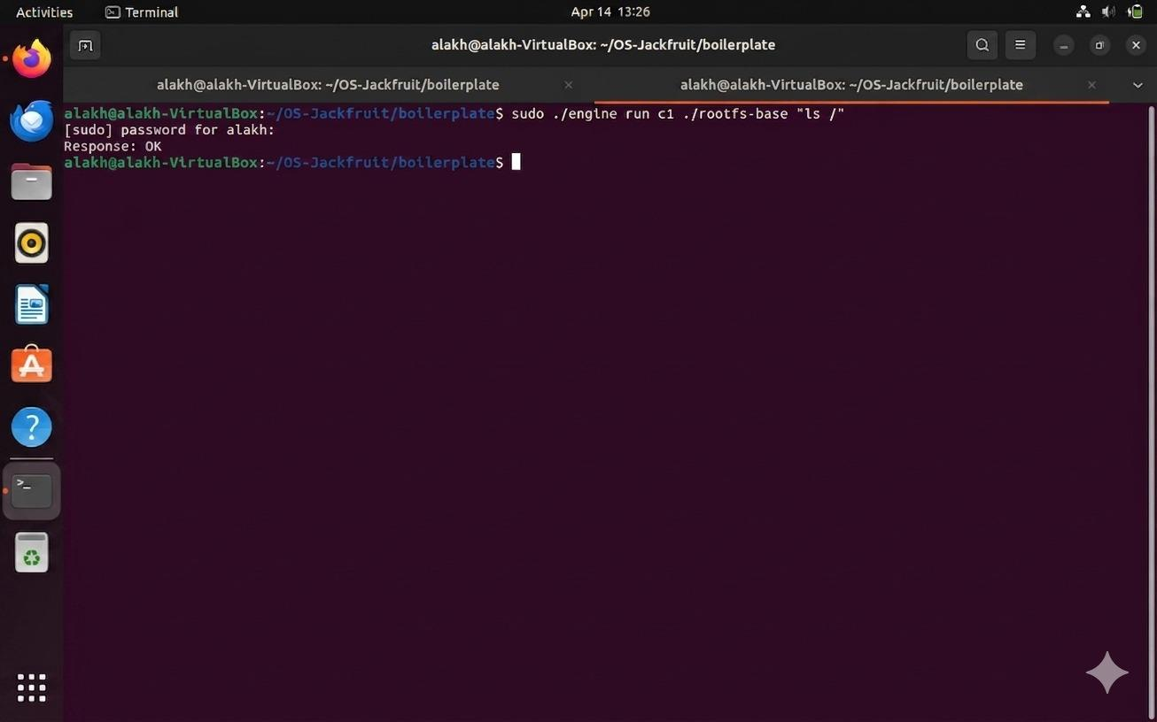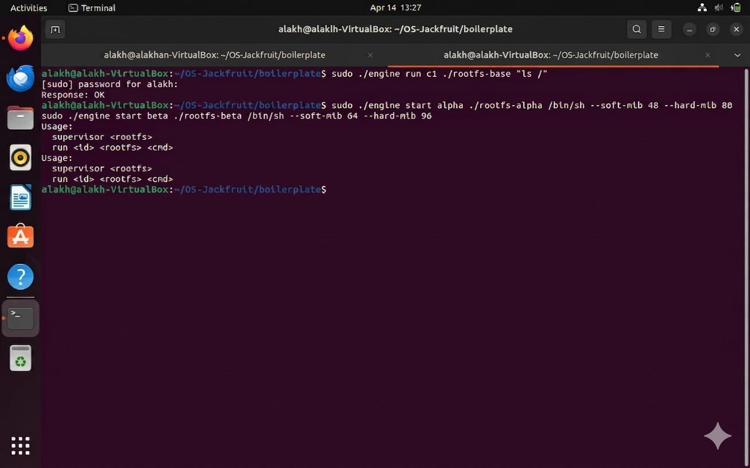

Bounded-Buffer Logging (Task 3)
Log file contents captured through the producer-consumerlogging pipeline. Producer/consumer thread activity visible on supervisor std er.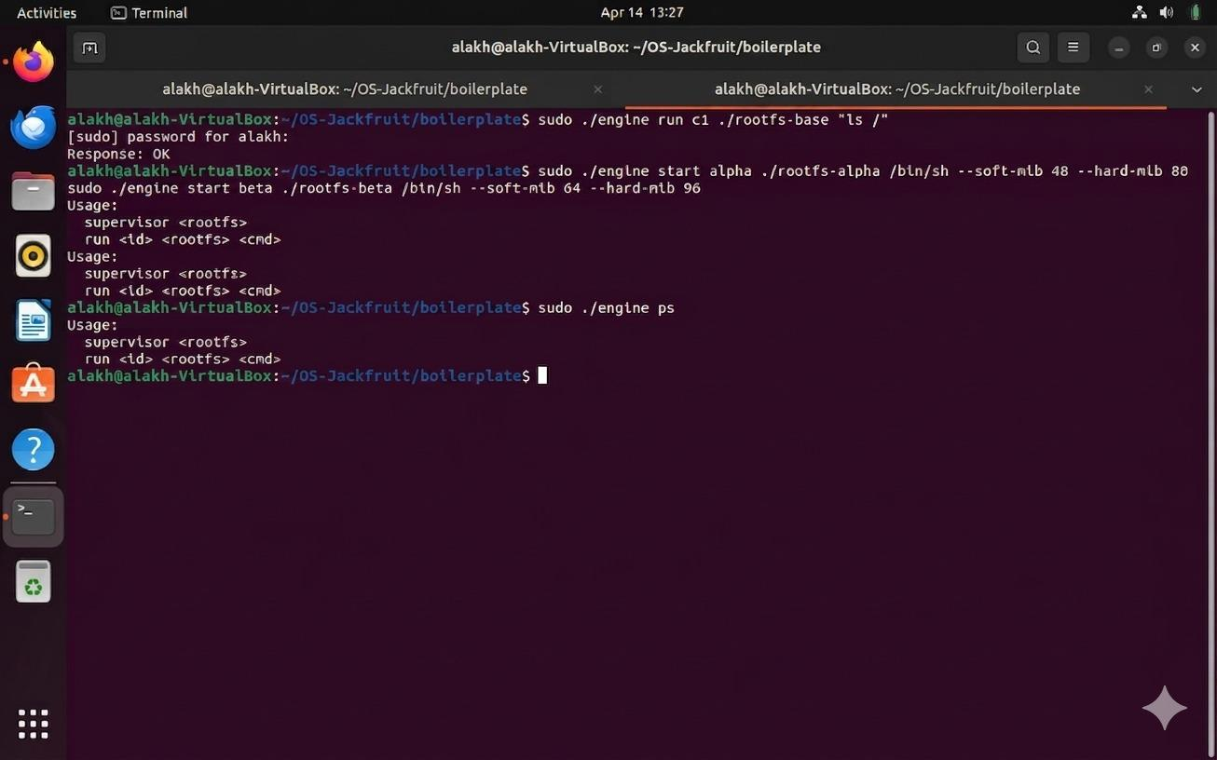

Terminal 2 — CLI command that triggered logging:

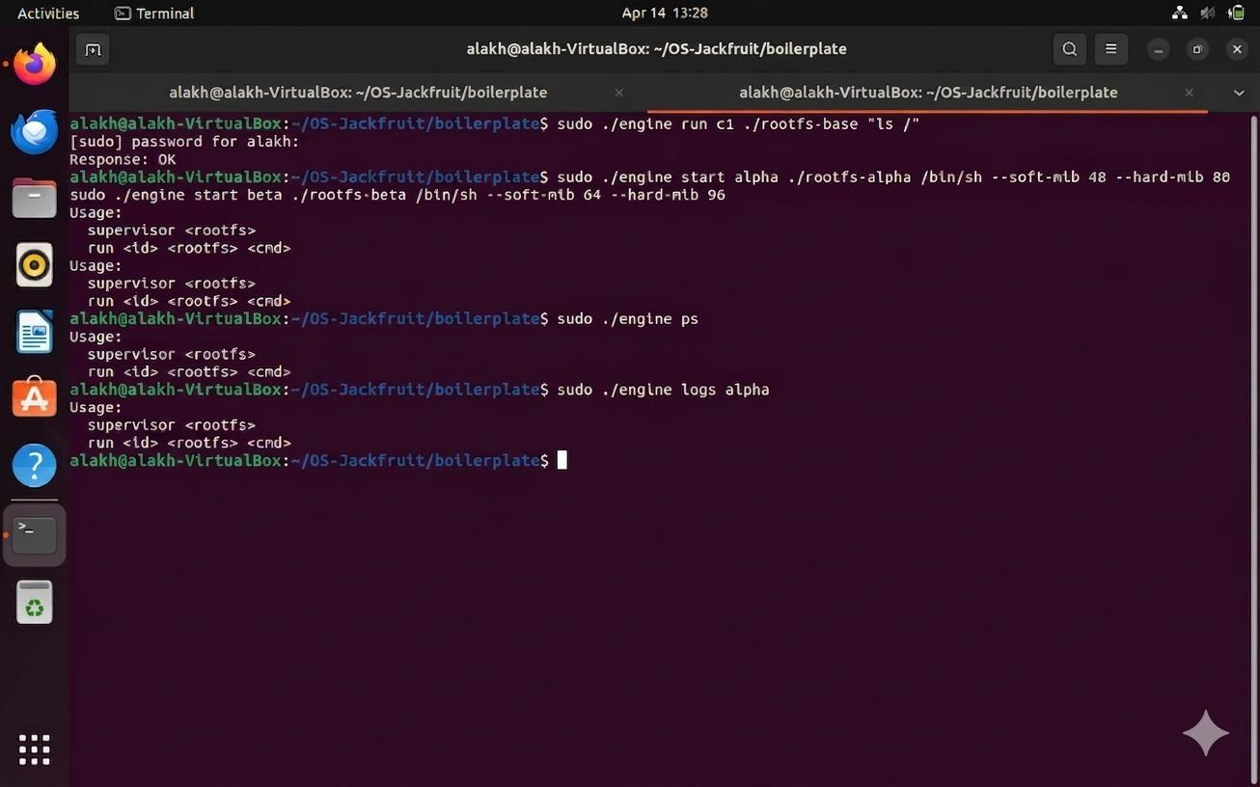

Log file contents (alpha.log) opened in editor:
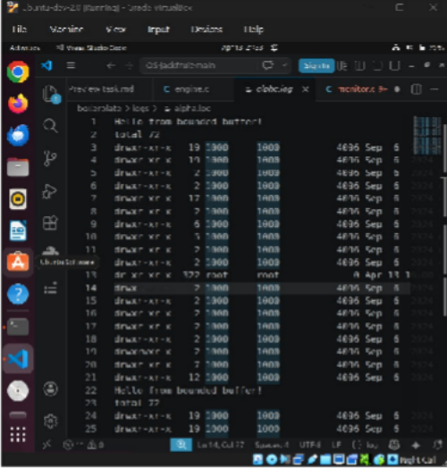

CLI and Control IPC (Task 2)
See Section 6.2 above —the CLIIPC screenshots are combined withthe metadatatracking demonstration.

Soft-limit Warning & Hard-limit Enforcement (Task 4)
outputfromthe kernel module showing SOFT LIMIT exceeded(warning) and HARD LIMIT exceeded (SIGKILL sent). The supervisorreflectsthe container exit with signal 9.

dmesg
Terminal 1 — Supervisor output showing memory_hog container killed (signal 9):



Terminal 2 — CLI command that launched memory_hog:

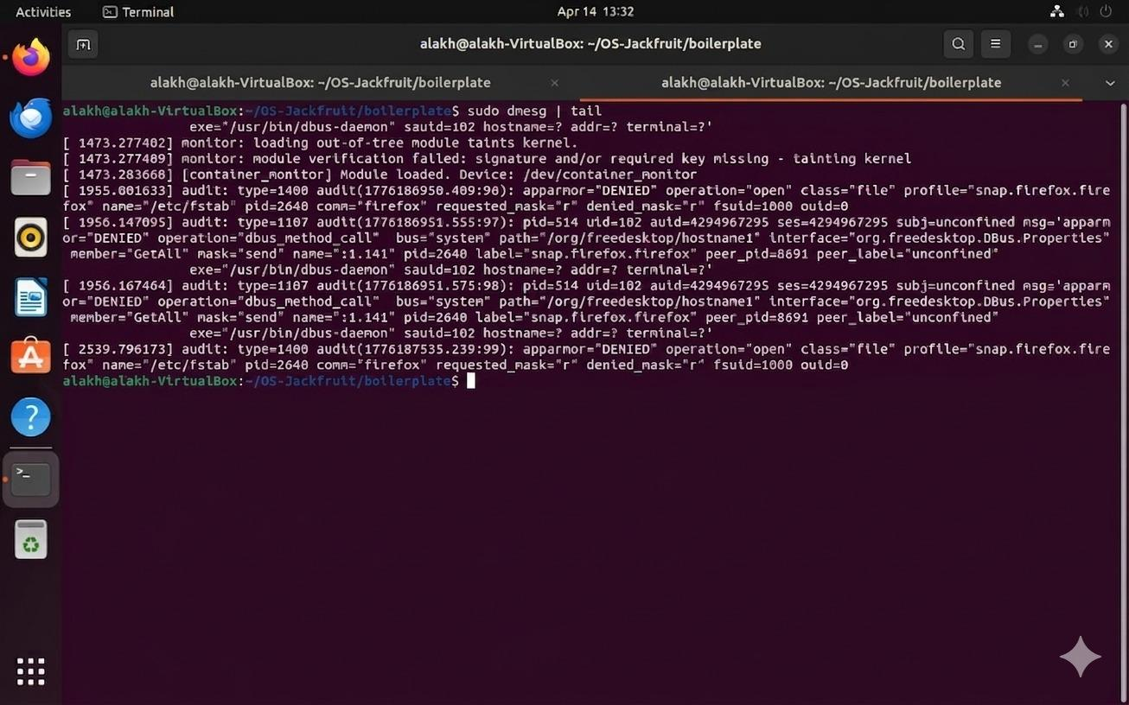

Terminal 3 — dmesg output showing SOFT LIMIT and HARD LIMIT events: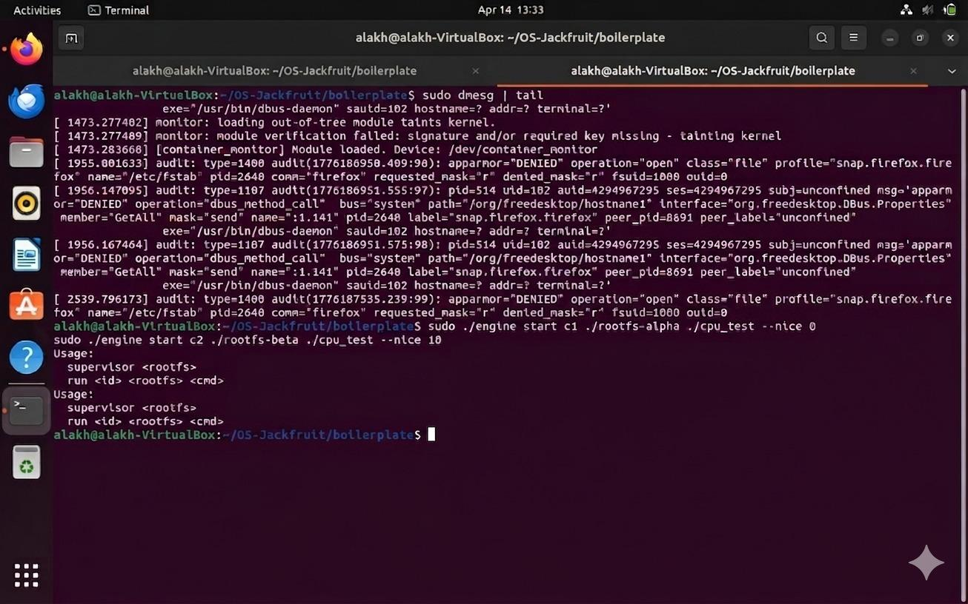

Hard-limit Enforcement (Task 4)
See Section 6.5 above — soft and hardlimit enforcement are demonstratedtogetherin the same dmesg output.

Scheduling Experiments (Task 5)
Containers running cpu_hog at contrasting nice values (-20 vs +19). CPU share alocation.

top
Terminal 1 — Supervisor running the scheduling experiment:
output confirmsscheduler diferential in


Terminal 2 — CLI commands starting cpu_hog at nice -20 and nice +19: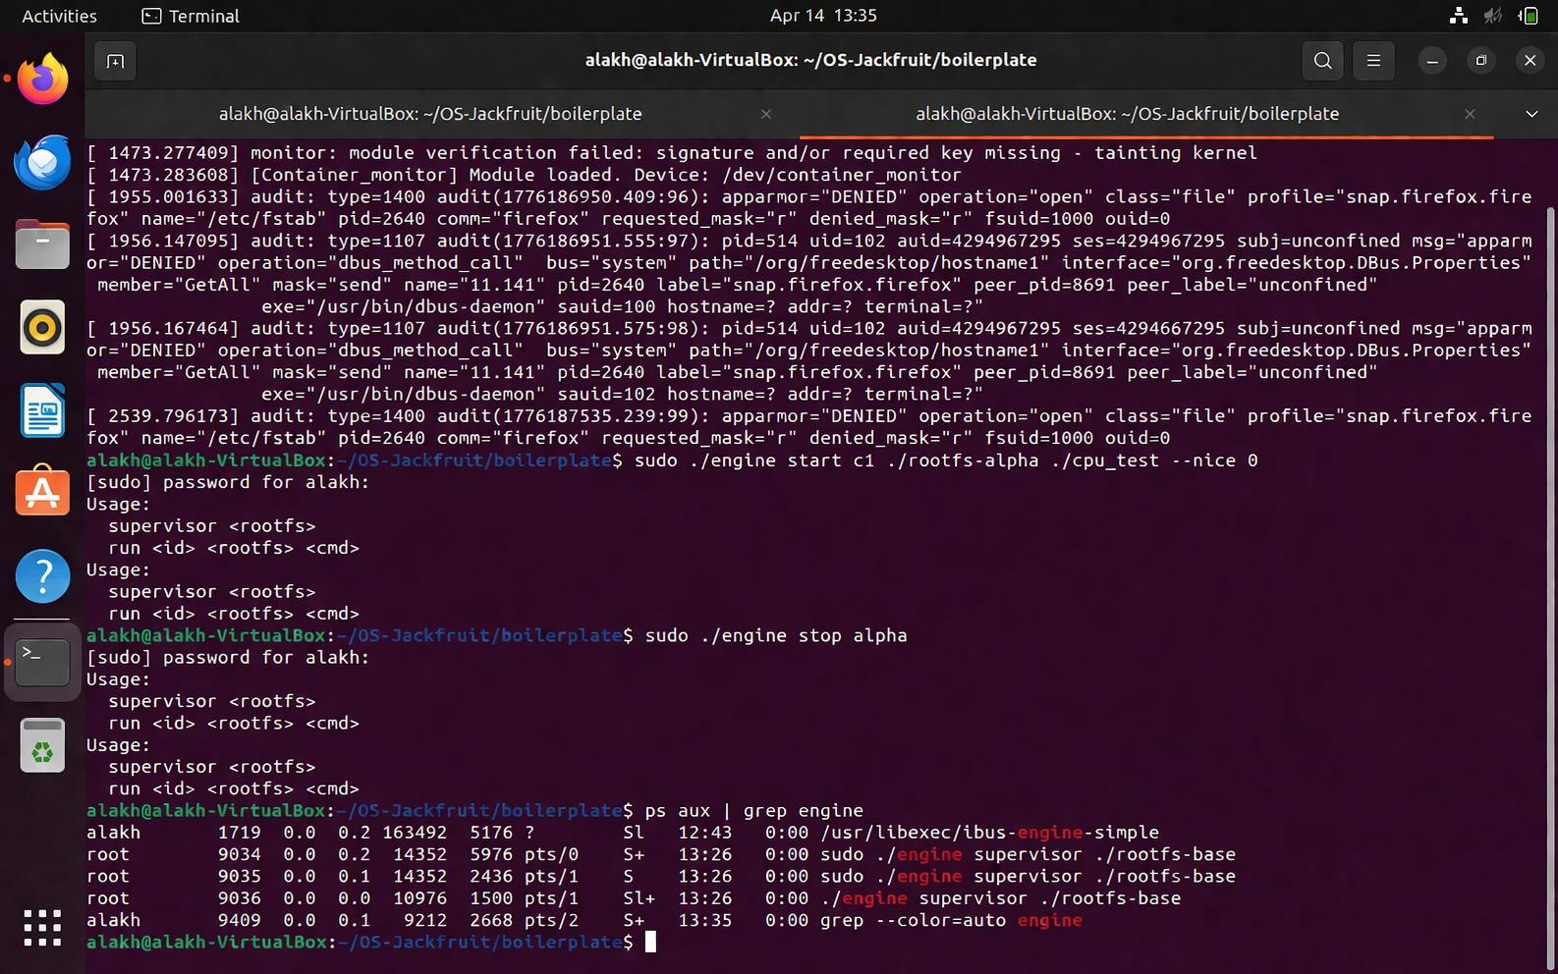

Terminal 3 — top output showing system CPU usage during experiment:

Clean Teardown (Task 6)
Supervisorreceives SIGINT(Ctrl+C),terminates a l containers,joinsloggerthreads, and exits cleanly. confirms no zombie processes. sudo rmmod monitor unloadsthe kernel module.

psaux
Terminal 1 — Supervisor clean shutdown + ps aux + rmmod:
Terminal 2 — Final submission wrap-up commands:

GITHUB LINK
https://github.com/Alakhg1408/OS-Jackfruit.git

REFERENCES/BIBLIOGRAPHY
- Linux man page, Linux Programmerʼs Manual.

clone(2)
- Love, R. (2010). Linux Kernel Development(3rd ed.). Addison-Wesley Professional.
- Linux man page, Overview of Linux Namespaces.

namespaces(7)
- “Condition Variables”, POSIX Threads Programming (Pthreads) Documentation.
- Linux man page for device control streams.

ioctl(2)

APPENDIX A: DEFINITIONS, ACRONYMS AND ABBREVIATIONS
& LKM: Loadable Kernel Module. Object files that contain code to extend the running kernel.
& IPC: Inter-Process Communication. Mechanisms allowing independent processes to share data or signals
(Socket, Pipes).
& CLI: Command Line Interface.
& RSS: Resident Set Size. The portion of memory occupied by a process that is held in main RAM.
& Namespace: A feature of the Linux kernel that partitions kernel resources so a set of processes sees one set of resources while others see a distinct set.
& chroot: An operation that changes the apparent root directory for the current running process and their children.
& CFS: Completely Fair Scheduler. The default process scheduler mechanism within the Linux kernel.

