الاسم : هاجر سلامة سليمان بيومي

رقم السكشن : 45

رقم الجلوس :1004

Topic: Internet of Things

Git up link:

Application Brief:

The internet of things, or IoT, is a system of interrelated computing devices, mechanical and digital machines, objects, animals or people that are provided with unique identifiers (UIDs) and the ability to transfer data over a network without requiring human-to-human or human-to-computer interaction.

A thing in the internet of things can be a person with a heart monitor implant, a farm animal with a biochip transponder, an automobile that has built-in sensors to alert the driver when tire pressure is low or any other natural or man-made object that can be assigned an Internet Protocol (IP) address and is able to transfer data over a network. Increasingly, organizations in a variety of industries are using IoT to operate more efficiently, better understand customers to deliver enhanced customer service, improve decision-making and increase the value of the business.

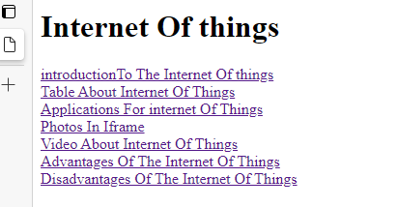Screenshots:

