RED

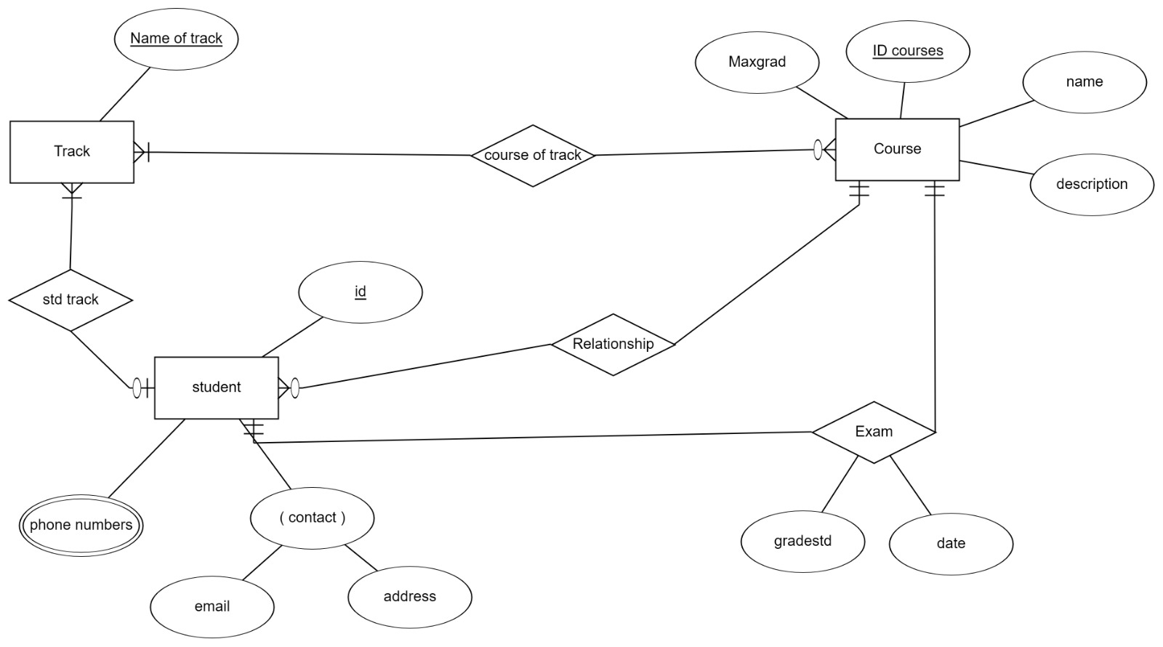

Mapping:

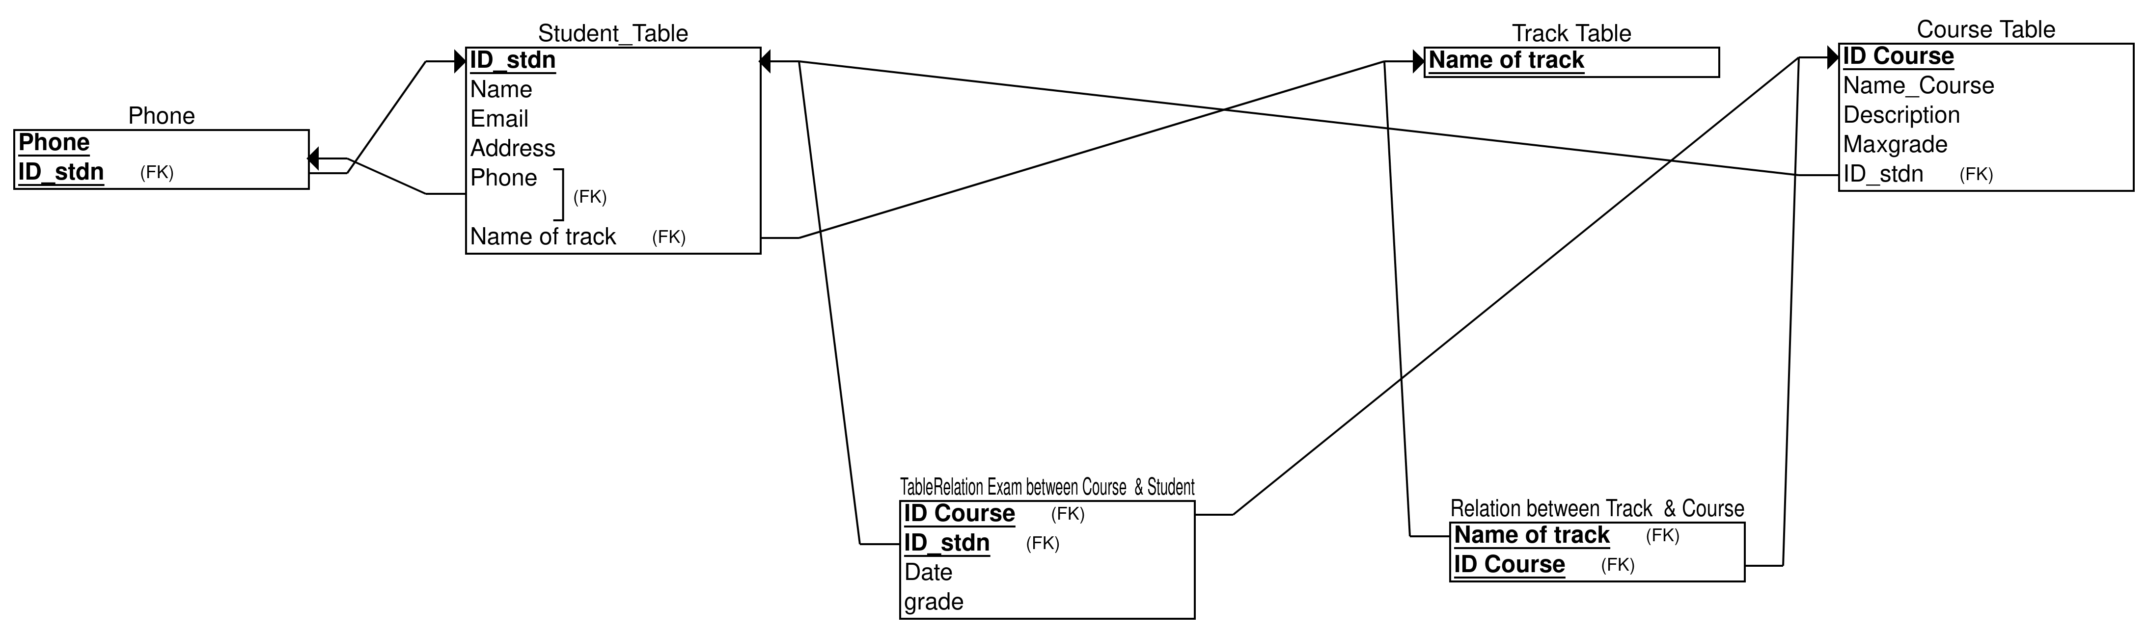
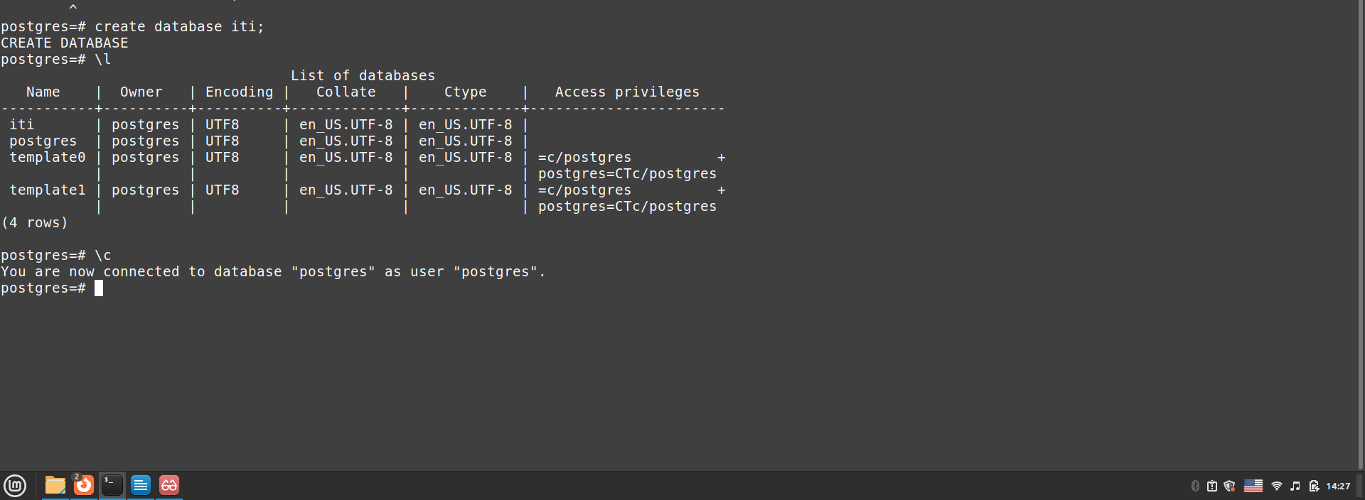
Create database iti:

create table Tracks
(TrackName text PRIMARY KEY not null);

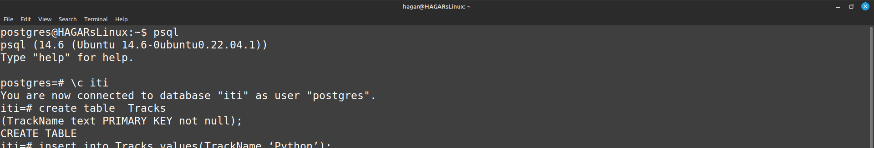
---
INSERT INTO tracks values('WebDevelop'),('Network'), ('AI'), ('Database');
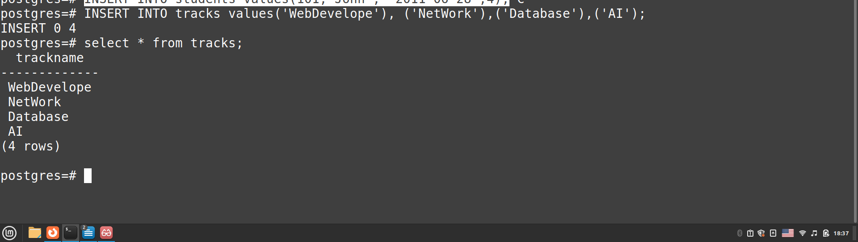
--------------------

create table student
(
ID serial PRIMARY KEY not null,
Name text not null,
Address text,
Email text not null,
Track_Name text references Tracks(TrackName) on delete cascade);

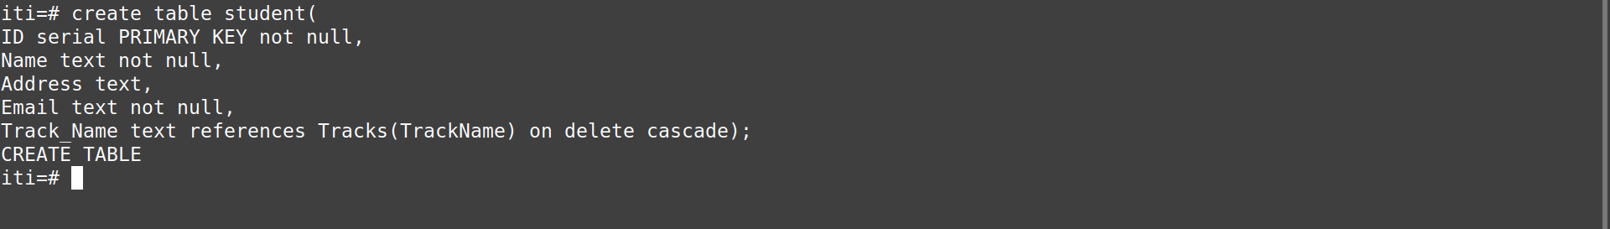
------

INSERT INTO student values(2,'ali', 'giza', 'ali@'), (3,'kareem', 'minia', 'karem@'), (4,'ziad', 'aswan', 'ziad@');
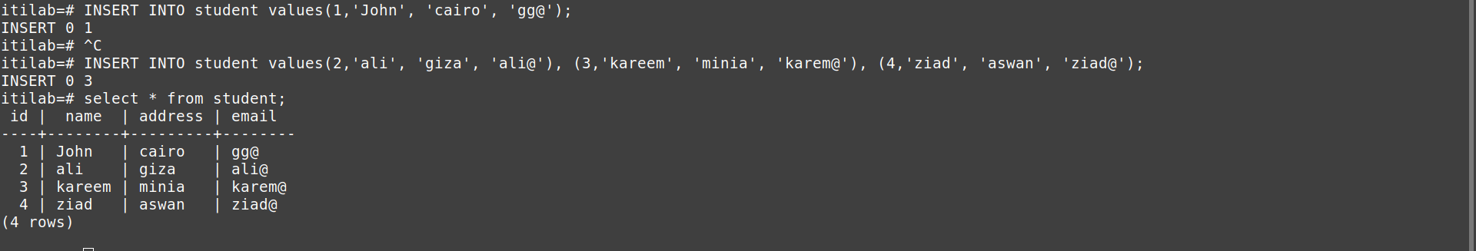
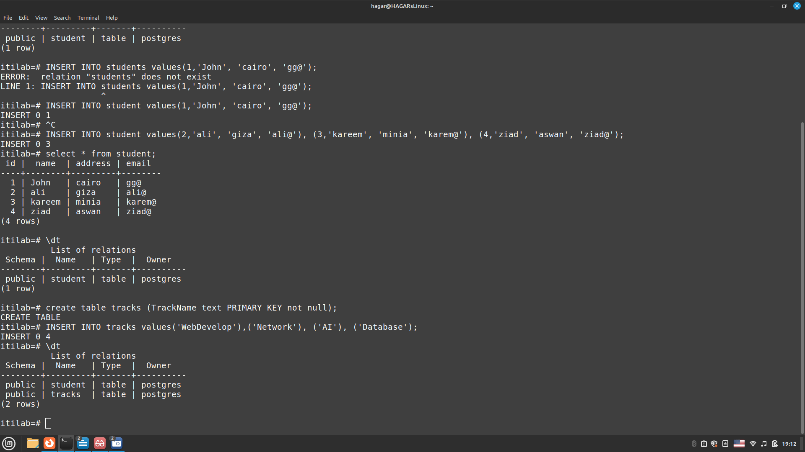

-------------------------

CREATE TABLE Courses(IdCourse int not null, NameCourse varchar(30) not null,description text null, maxGrade int not null, PRIMARY KEY(IdCourse));
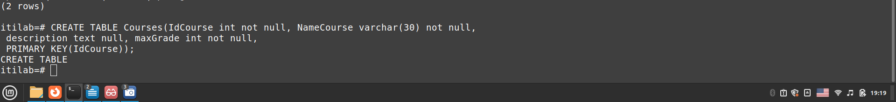
-------------------------

INSERT INTO courses values(1,'pyton', 'fundemental', 75), (2, 'Redhat', '',100),(3,'HTML', 'html&css', 100), (4,'React', '', 75);

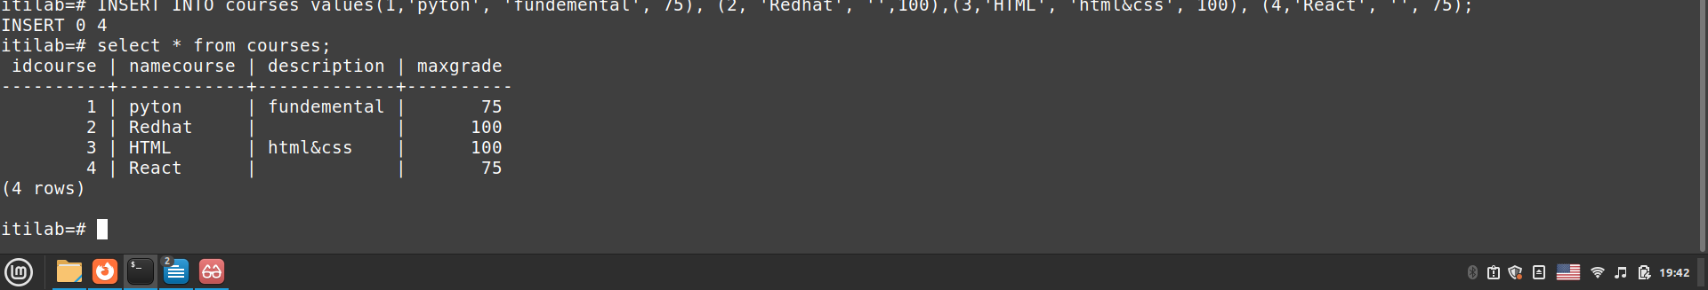

create table phone(id int references student(id) on delete cascade, phonNum int, primary key (id,phonNum));

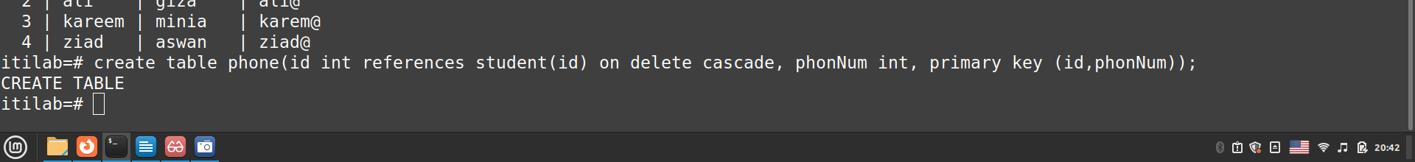
----
INSERT INTO phone values(1,01075), (2,012100),(3,01100), (4,01575);
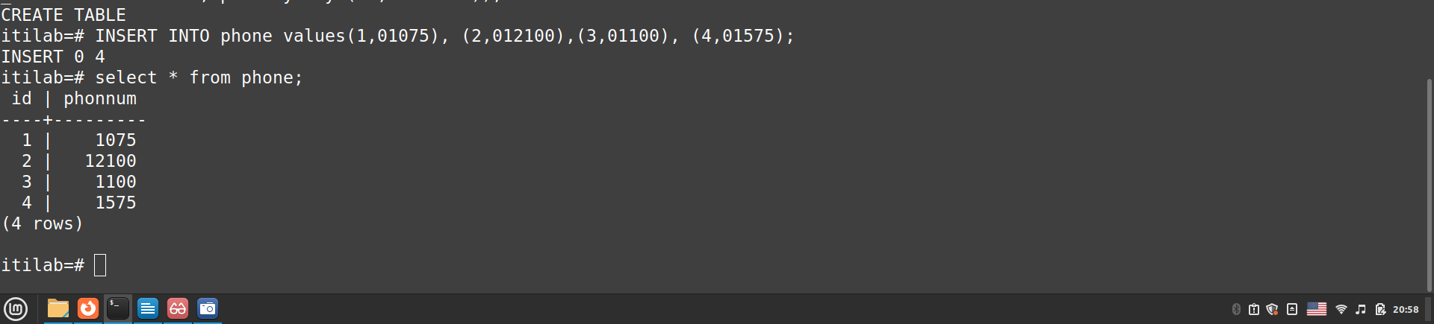
-----------------
create table Exam(id int references student(id) on delete cascade,IdCourse int references courses(IdCourse), grad_std int, date_exam date not null, primary key (id,IdCourse));

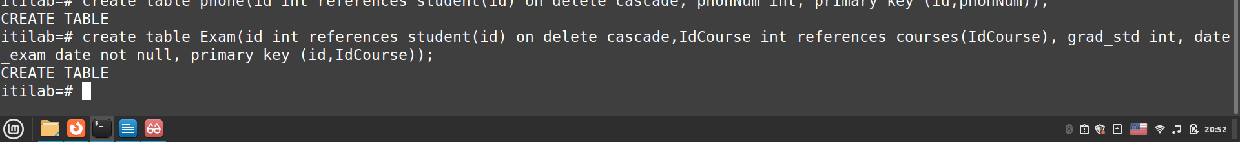
----
insert into exam values(1,1,55,'2011-06-28'),(2,2,60,'2011-06-28'),(3,3,75,'2011-06-28'),(4,4,69,'2011-06-28');
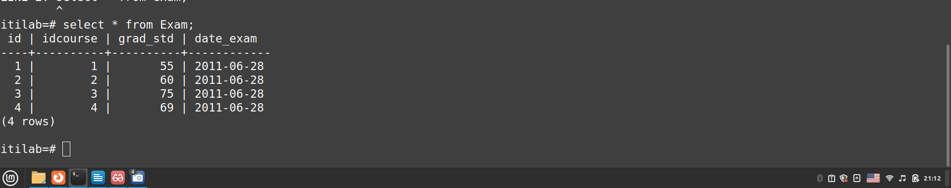

-------------------------
create table relTRcCrs(IdCourse int references courses(IdCourse),TrackName text references tracks(TrackName) on delete cascade , primary key (IdCourse,TrackName));

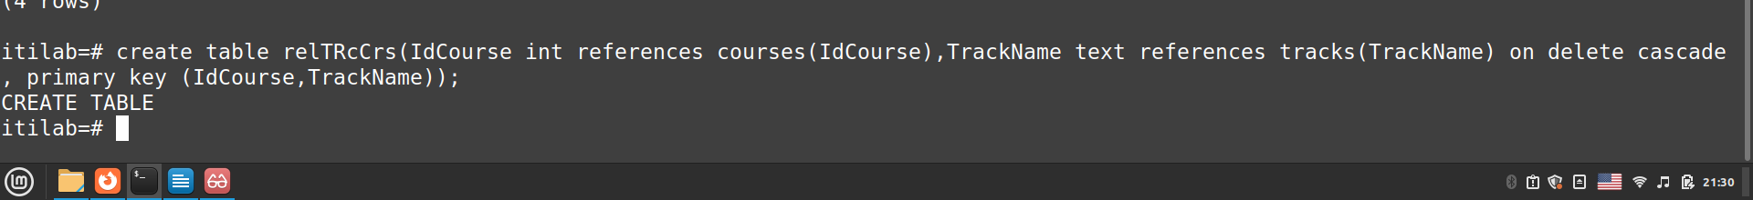

Types of DBMS
The types of DBMS based on data model are as follows −
- Relational database.
- Object oriented database.
- Hierarchical database.
- Network database.

Relation Database
A relational database management system (RDBMS) is a system where data is organized in two-dimensional tables using rows and columns.
This is one of the most popular data models which is used in industries. It is based on SQL.
Every table in a database has a key field which uniquely identifies each record.
This type of system is the most widely used DBMS.
Relational database management system software is available for personal computers, workstation and large mainframe systems.
For example − Oracle Database, MySQL, Microsoft SQL Server etc.
Std ID | Name | City
201 | Bob | Hyderabad
204 | Lucky | Chennai
205 | Pinky | Bangalore
In the above student table Std ID, Name and city are called as attributes and their values. Std ID is a primary key attribute which uniquely identifies each record in the student table.

Object Oriented Database
It is a system where information or data is represented in the form of objects which is used in object-oriented programming.
- It is a combination of relational database concepts and object-oriented principles.
- Relational database concepts are concurrency control, transactions, etc.
- OOPs principles are data encapsulation, inheritance, and polymorphism.
- It requires less code and is easy to maintain.
For example − Object DB software.
The object oriented database is represented in diagram format below −
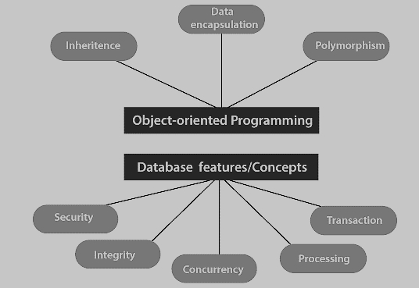

Hierarchical Database
It is a system where the data elements have a one to many relationship (1: N). Here data is organized like a tree which is similar to a folder structure in your computer system.
- The hierarchy starts from the root node, connecting all the child nodes to the parent node.
- It is used in industry on mainframe platforms.
For example− IMS(IBM), Windows registry (Microsoft).
An example of a hierarchical database is given below −
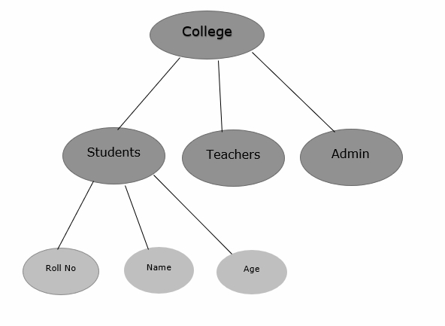

Network database
A Network database management system is a system where the data elements maintain one to one relationship (1: 1) or many to many relationship (N: N).
It also has a hierarchical structure, but the data is organized like a graph and it is allowed to have more than one parent for one child record.
Example
Teachers can teach in multiple departments. This is shown below −
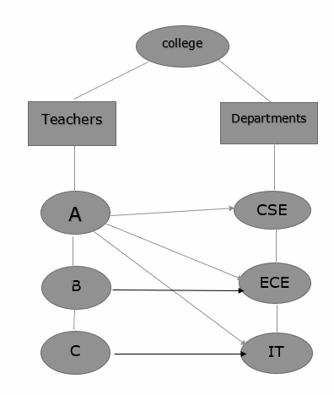

What is a NoSQL database?
When people use the term “NoSQL database,” they typically use it to refer to any non-relational database. Some say the term “NoSQL” stands for “non SQL” while others say it stands for “not only SQL.” Either way, most agree that NoSQL databases are databases that store data in a format other than relational tables.

