**LAB1**

1. **What is Jenkins used for?**

Jenkins is an open source continuous integration/continuous delivery and deployment (CI/CD) automation software DevOps tool written in the Java programming language. It is used to implement CI/CD workflows, called pipelines.

Pipelines automate testing and reporting on isolated changes in a larger code base in real time and facilitates the integration of disparate branches of the code into a main branch. They also rapidly detect defects in a code base, build the software, automate testing of their builds, prepare the code base for deployment (delivery), and ultimately deploy code to containers and virtual machines, as well as bare metal and cloud servers. There are several commercial versions of Jenkins. This definition only describes the upstream open source project.

**02) What is Jenkins agent? What is Jenkins executor (Build Executor)?**

A Jenkins executor is one of the basic building blocks which allow a build to run on a node/agent (e.g. build server). Think of an executor as a single "process ID", or as the basic unit of resource that Jenkins executes on your machine to run a build. Please see [Jenkins Terminology](https://www.jenkins.io/doc/book/glossary/) for more details regarding executors, nodes/agents, as well as other foundational pieces of Jenkins.

**3)Explain Jenkins master-slave architecture?**

The Jenkins master acts to schedule the jobs, assign slaves, and send builds to slaves to execute the jobs.

It will also monitor the slave state (offline or online) and get back the build result responses from slaves and the display build results on the console output. The workload of building jobs is delegated to multiple **slaves**.

A Jenkins master comes with the basic installation of Jenkins, and in this configuration, the master handles all the tasks for your build system.

* If you are working on multiple projects, you may run multiple jobs on each project. Some projects need to run on some nodes, and in this process, we need to configure slaves. Jenkins slaves connect to the Jenkins master using the Java Network Launch Protocol.

**04) Install jenkins with docker image.**

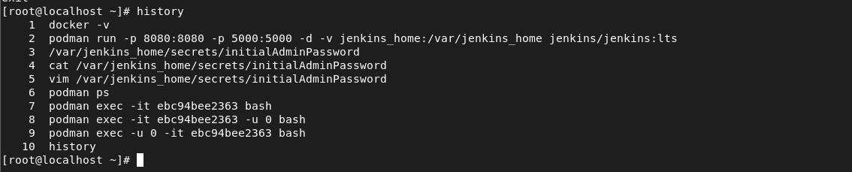

Run Jenkins as a container and created a persist volume .

