**LAB2**

What is a Jenkins Pipeline?

Jenkins Pipeline (or simply "Pipeline") is a suite of plugins which supports implementing and integrating continuous delivery pipelines into Jenkins.

A continuous delivery pipeline is an automated expression of your process for getting software from version control right through to your users and customers.

Jenkins Pipeline provides an extensible set of tools for modeling simple-to-complex delivery pipelines "as code". The definition of a Jenkins Pipeline is typically written into a text file (called a Jenkins file) which in turn is checked into a project’s source control repository. [[1](https://www.jenkins.io/doc/pipeline/tour/hello-world/#_footnotedef_1)

02) What scripting language is Jenkins pipeline syntax based on? **groovy**

03) What are the ways you can write pipeline in Jenkins? Declarative vs Scripted

The same, but different

Scripted vs. declarative pipelines are different only in their programmatic approach. One uses a declarative programming model, while the other uses an imperative programming model.

But they both run on the same Jenkins pipeline sub-system. There are no differences in the runtime performance, scalability and problem solvability perspective in the declarative vs. scripted pipeline debate. They only differ in the syntactic approach used to achieve an end goal.

**04) Create jenkins pipeline for your repo and use script file (jenkinsfile) to write pipeline syntax ?**

**(Sorry for change your code , it was by mistake☺ )**

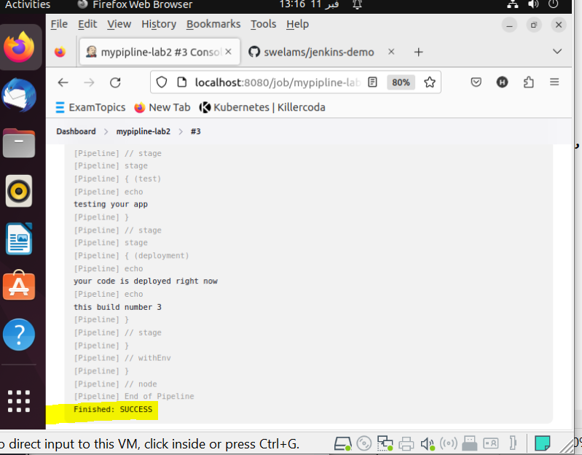

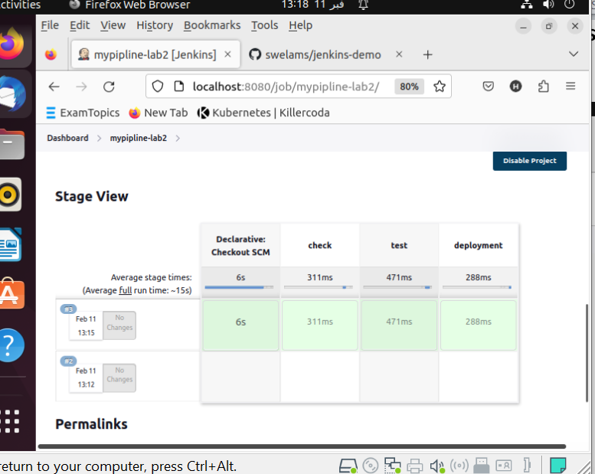

Create another multibranch pipeline and filter branches to contain only (master , dev , test ) ?

