**LAB3**

what are different method to trigger pipeline in jenkins ?

These are the most common Jenkins build triggers:

Trigger builds remotely

Build after other projects are built

Build periodically

GitHub hook trigger for GITScm polling

Poll SCM

1.Trigger builds remotely :

If you want to trigger your project built from anywhere anytime then you should select Trigger builds remotely option from the build triggers

2. Build after other projects are built

If your project depends on another project build then you should select Build after other projects are built option from the build triggers.

3.Build periodically:

If you want to schedule your project build periodically then you should select the **Build periodically**option from the build triggers.

4.GitHub webhook trigger for GITScm polling:

A webhook is an HTTP callback, an HTTP POST that occurs when something happens through a simple event-notification via HTTP POST.

5.Poll SCM:

Poll SCM periodically polls the SCM to check whether changes were made (i.e. new commits) and builds the project if new commits were pushed since the last build.

what is the benefit of using master-slave architecture rather than building on master only ?

In this complex technical world, a Tester is expected to validate application with maximum coverage by adopting risk based techniques. Tester also needs to assure cross-browser and cross-platform environment testing for every new frequent builds for zero defect leakage, hence it is not cost effective to verify every committed builds on different environment manually. Jenkins is used for Scheduled/Non Scheduled execution. Jenkins can handle 100+ machines and distributes the workload to them automatically. This can create various build sections that supports all the environments that you need to run build/test within. It has the capability to configure slaves on cloud platform (like Amazon EC2/SaaS) and build the test. Better ROI is achieved after this implementation.

Authentication and authorization are two vital information security processes that administrators use to protect systems and information. Authentication verifies the identity of a user or service, and authorization determines their access rights. Although the two terms sound alike, they play separate but equally essential roles in securing applications and data. Understanding the difference is crucial. Combined, they determine the security of a system. You cannot have a secure solution unless you have configured both authentication and authorization correctly.

What is Authentication (AuthN)?

Authentication (AuthN) is a process that verifies that someone or something is who they say they are. Technology systems typically use some form of authentication to secure access to an application or its data. For example, when you need to access an online site or service, you usually have to enter your username and password. Then, behind the scenes, it compares the username and password you entered with a record it has on its database. If the information you submitted matches, the system assumes you are a valid user and grants you access. System authentication in this example presumes that only you would know the correct username and password. It, therefore, authenticates you by using the principle of something only you would know.

## What is the Purpose of Authentication?

The purpose of authentication is to verify that someone or something is who or what they claim to be. There are many forms of authentication. For example, the art world has processes and institutions that confirm a painting or sculpture is the work of a particular artist. Likewise, governments use different authentication techniques to protect their currency from counterfeiting. Typically, authentication protects items of value, and in the information age, it protects systems and data.

## What is Identity Authentication?

Identity authentication is the process of verifying the identity of a user or service. Based on this information, a system then provides the user with the appropriate access. For example, let's say we have two people working in a coffee shop, Lucia and Rahul. Lucia is the coffee shop manager while Rahul is the barista. The coffee shop uses a Point of Sale (POS) system where waiters and baristas can place orders for preparation. In this example, the POS would use some process to verify Lucia or Rahul's identity before allowing them access to the system. For instance, it may ask them for a username and password, or they may need to scan their thumb on a fingerprint reader. As the coffee shop needs to secure access to its POS, employees using the system need to verify their identity via an authentication process

what is the benefit of making organization job in Jenkins

* It is an open-source tool with great community support.
* It is easy to install.
* It has 1000+ plugins to ease your work. ...
* It is free of cost.
* It is built with Java and hence, it is portable to all the major platforms

**make jenkins-shared-library and make your jenkinsfile which you used in lab2 to point to this library**

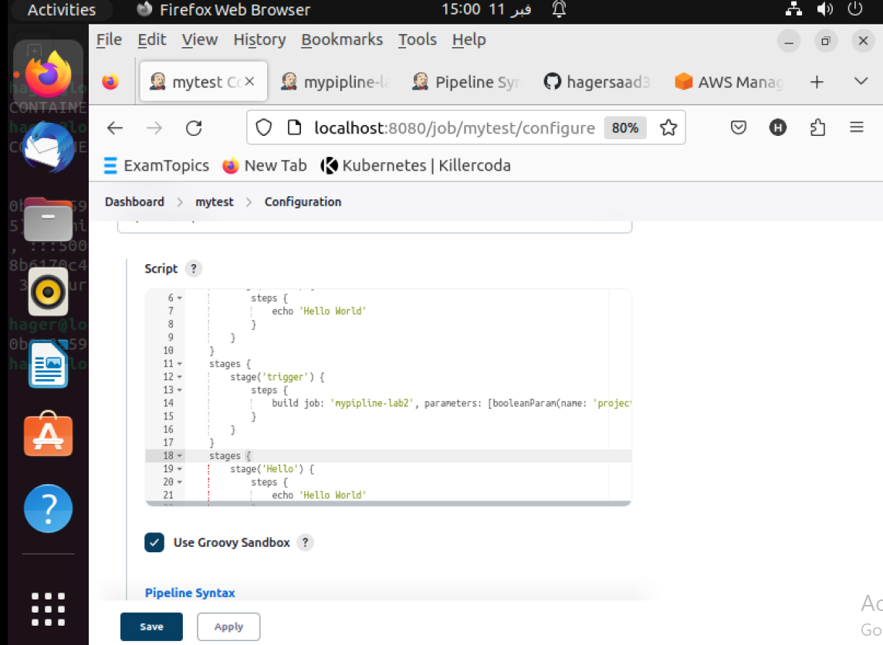

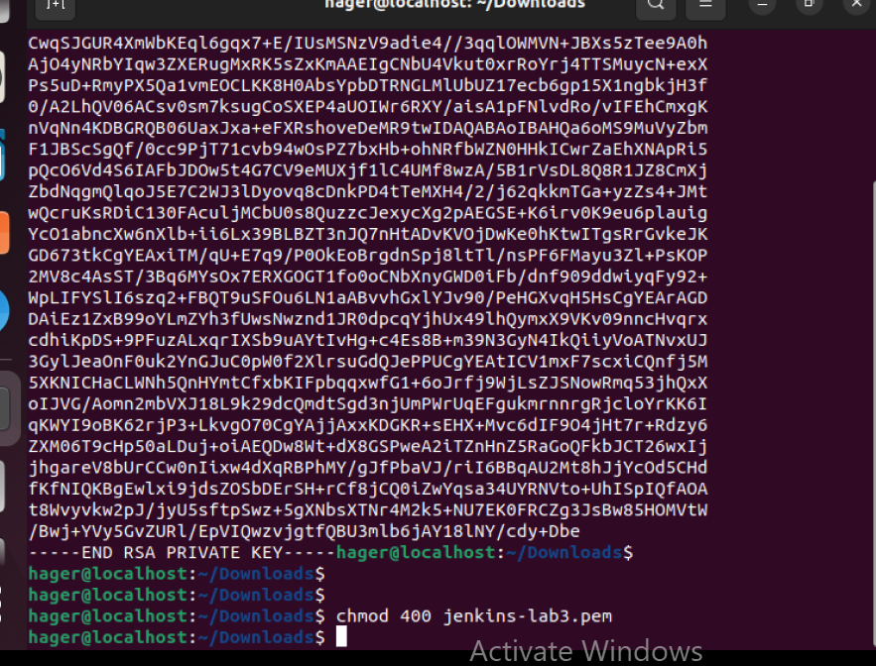

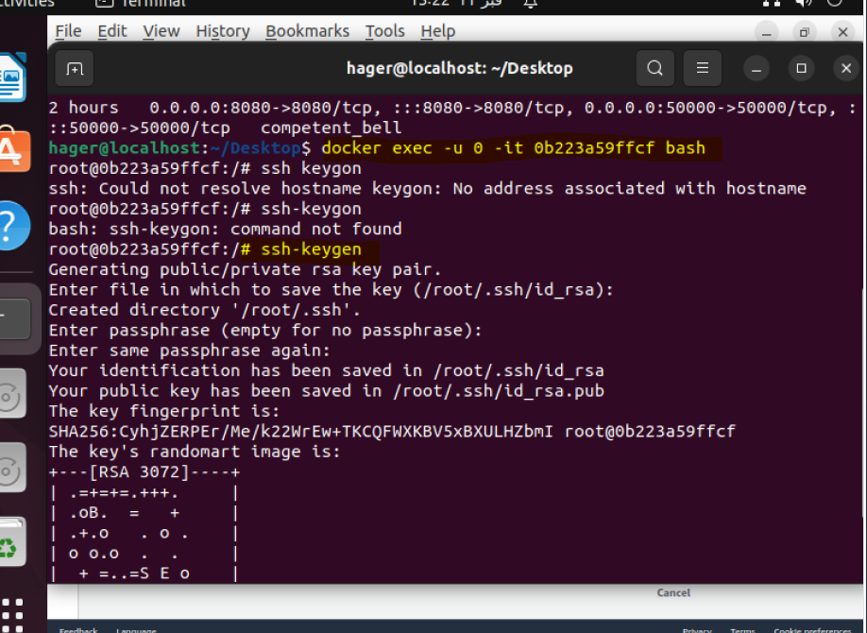

bonus >>>>> try to make new slave as container and configure master to use it

SSh from master to slave :

