LAB2

**1- How many Namespaces exist on the system? 5**

**2-How many pods exist in the kube-system namespace? 9**

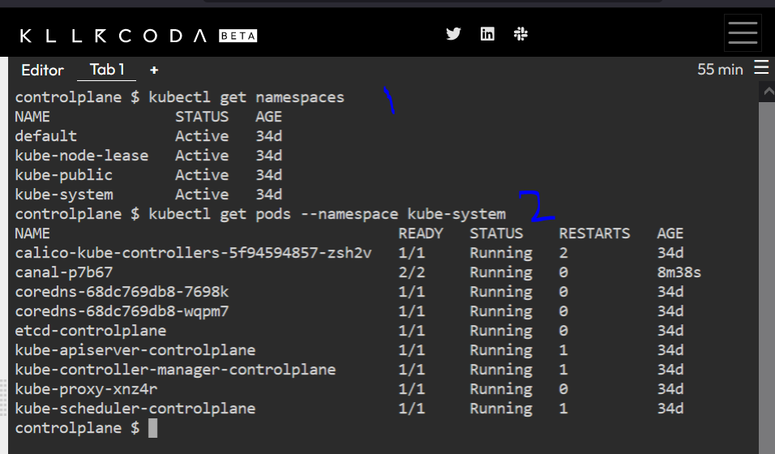

**3- create a Deployment with**

**name= deployment-1**

**image= busybox**

**replicas= 3**

**4- How many Deployments and ReplicaSets exist on the system now?**

**5- How many pods are ready with the deployment-1?**

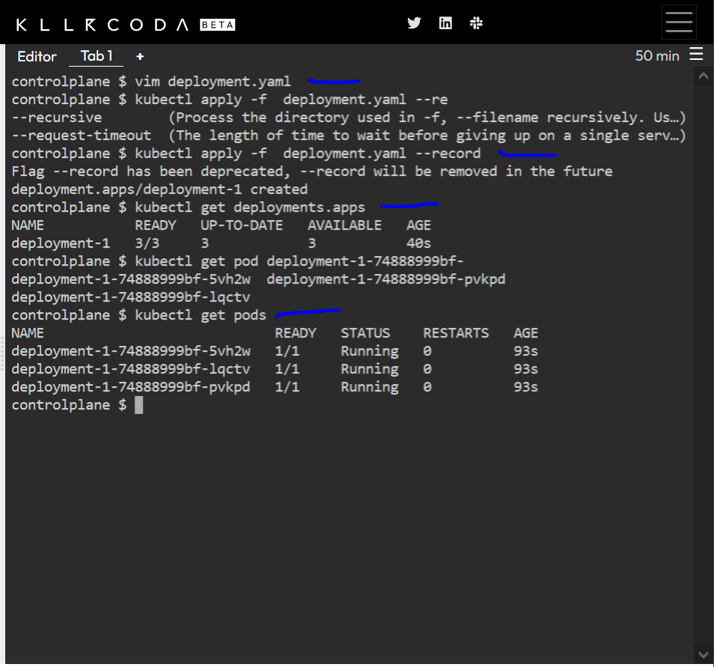

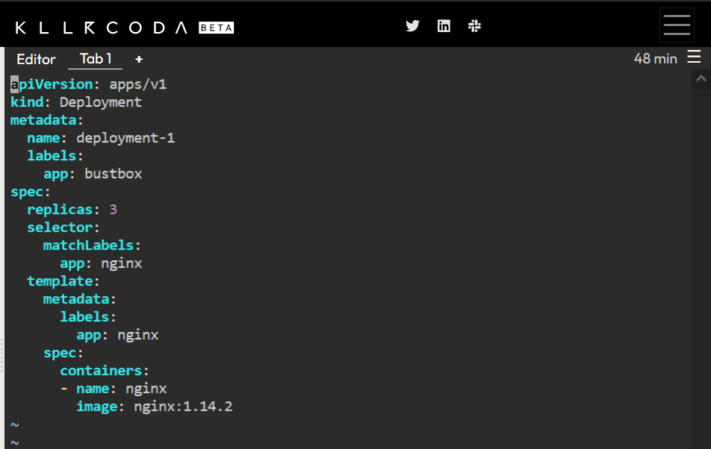

6- Update deployment-1 image to nginx then check the ready pods again

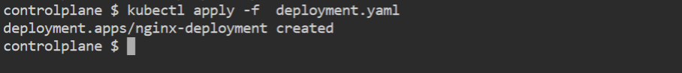

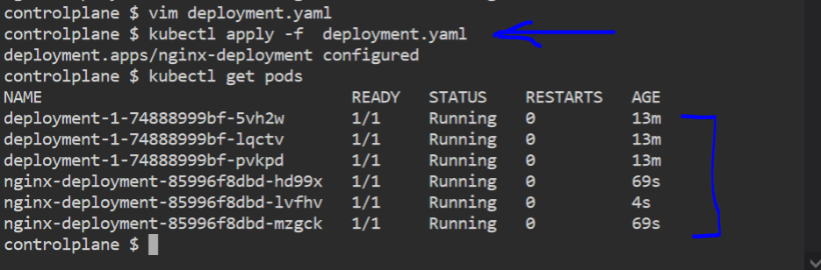

7- Run kubectl describe deployment deployment-1 and check events

What is the deployment strategy used to upgrade the deployment-1?

8- Rollback the deployment-1

What is the used image with the deployment-1?

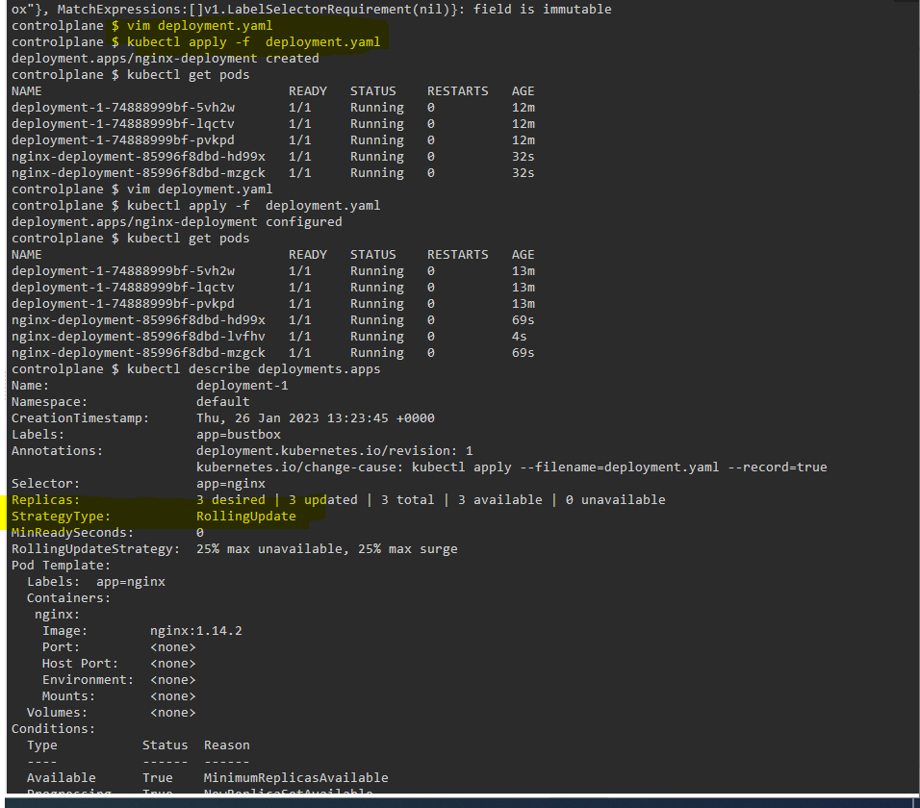

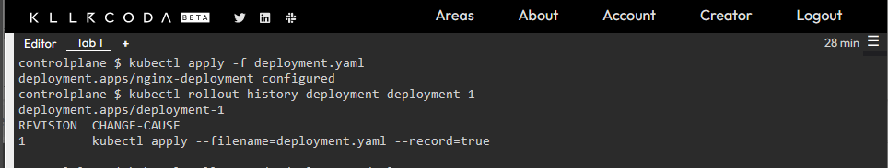

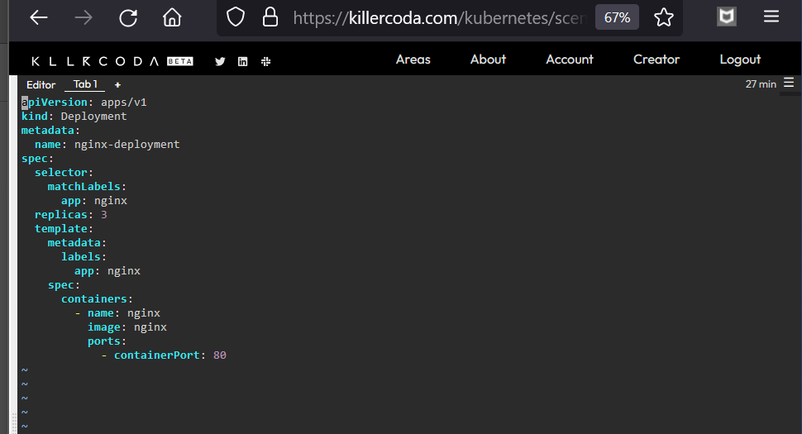

10- Create a deployment with

Name: dev-deploy

Image: redis

Replicas: 2

Namespace: dev

Resources Requests:

CPU: .5 vcpu

Mem: 1G

Resources Limits:

CPU: 1 vcpu

Mem: 2G

