1)

Create a pod with the name “imperative-nginx”

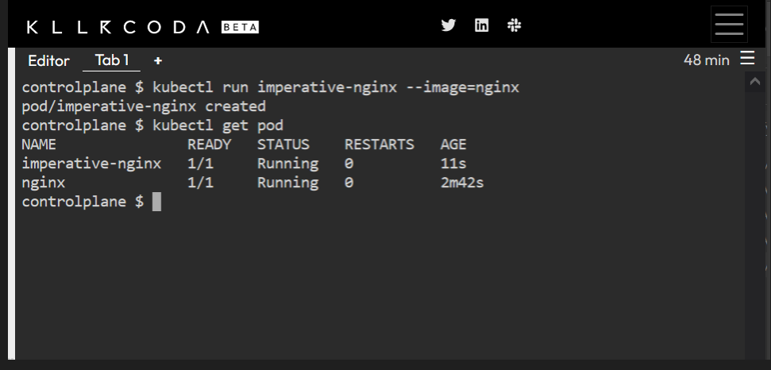

2- Create a pod with the name webserver

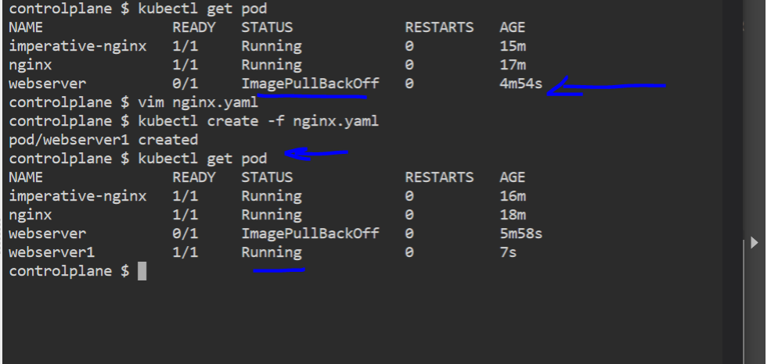

3- What is the nginx pod status? Image pull backoff

4- Change the nginx pod image to “nginx” check the status again running

5- How many pods are running in the system? Type the command to show this 4

6- What does READY column in the output of get pods command indicate? It’s valid or not

7- Delete first pod named imperative-nginx you just created. Type the command to do this

8- Which node is pod named webserver running on (list two commands to do this)

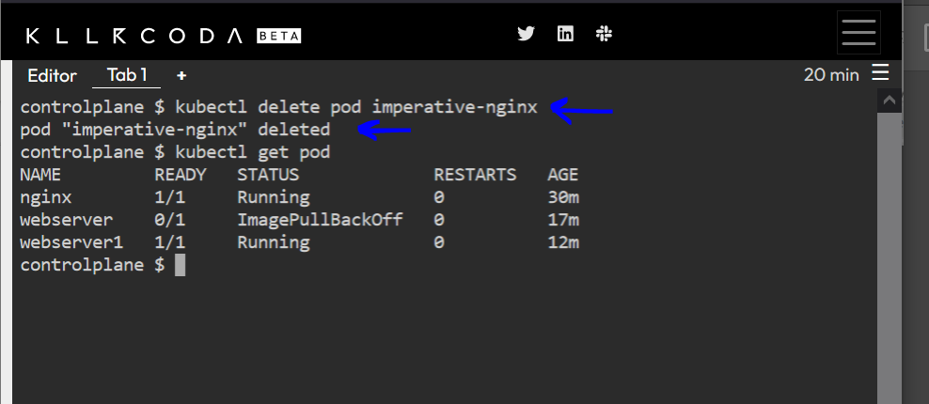

9- Get a shell to the running container i.e ssh into it (figure out the command)

10- Run cat /etc/os-release inside the container

11- Exit from the shell (/bin/bash) session

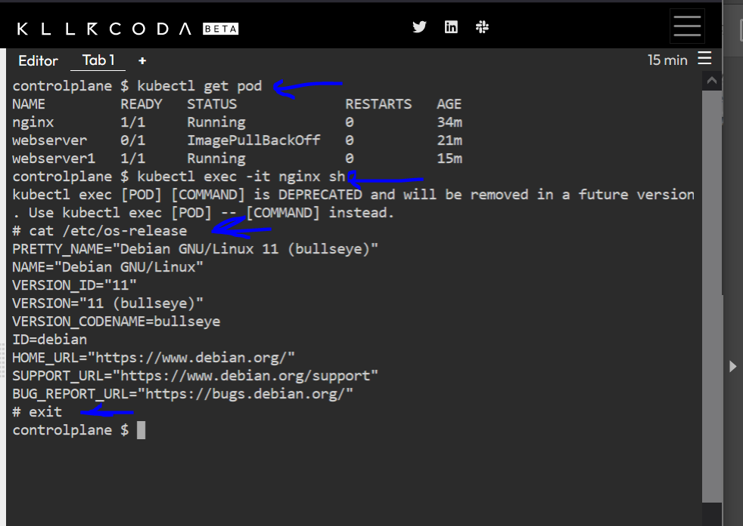

12- Get logs of pod, what are logs and what they are used for? To get all history

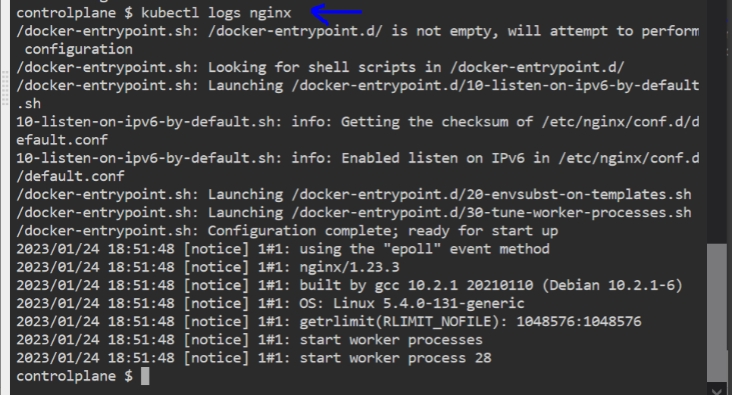

13- How many ReplicaSets exist on the system? Zero

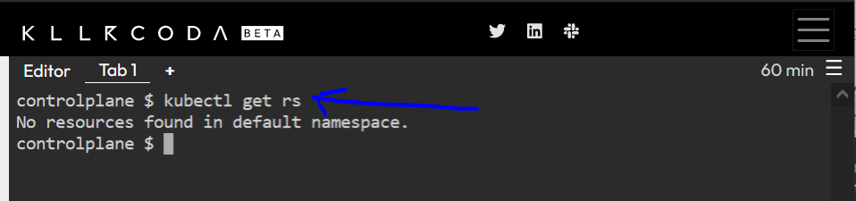

14- create a ReplicaSet with name= replica-set-1 image= busybox replicas= 3

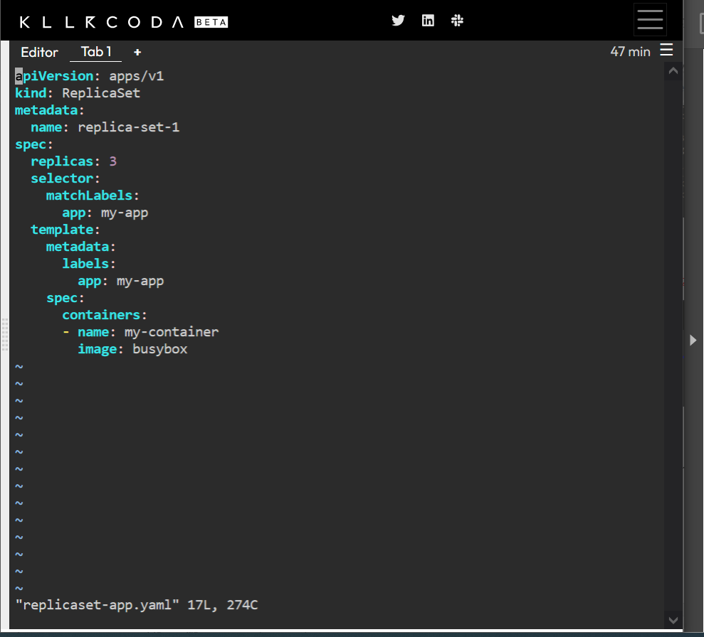

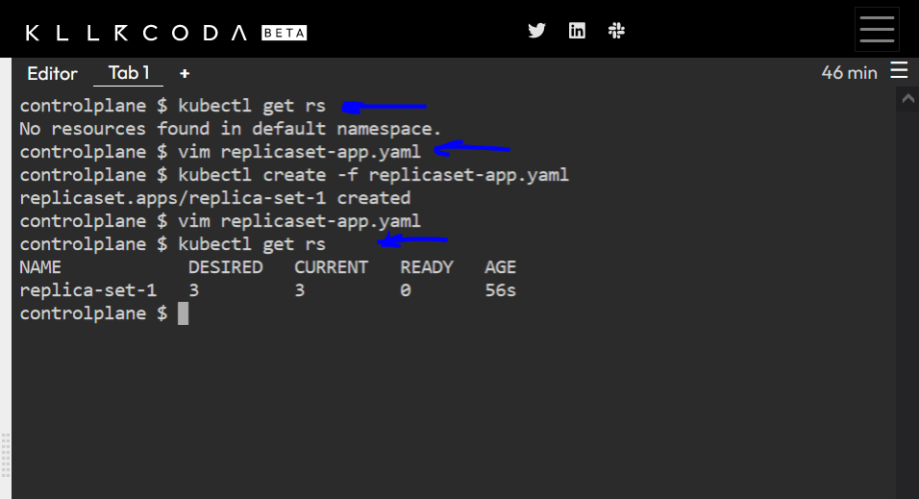

15- Scale the ReplicaSet replica-set-1 to 5 PODs.

16- How many PODs are READY in the replica-set-1?

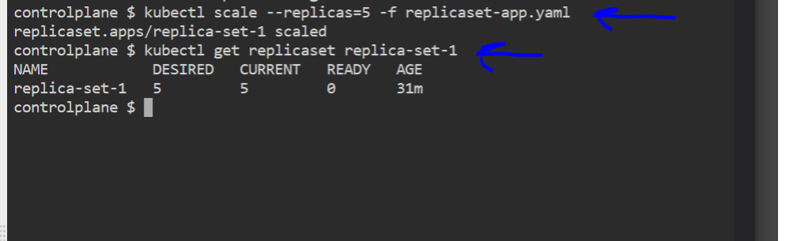

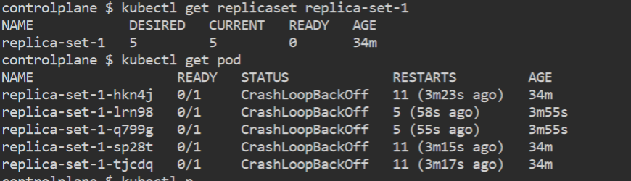

17- Delete any one of the 5 PODs then check How many PODs exist now?

Why are there still 5 PODs, even after you deleted one?

It’s replaced scaled automatically

