**LAB4**

1- Create a pod red with redis image and use an initContainer that uses the busybox image and sleeps for

20 seconds

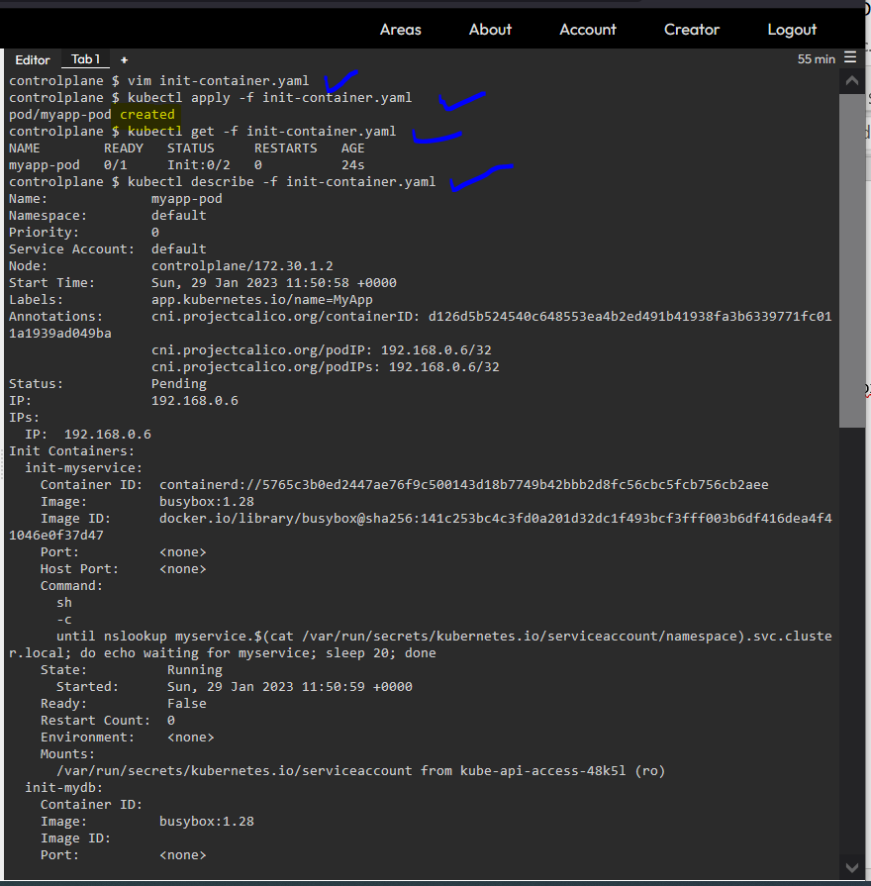

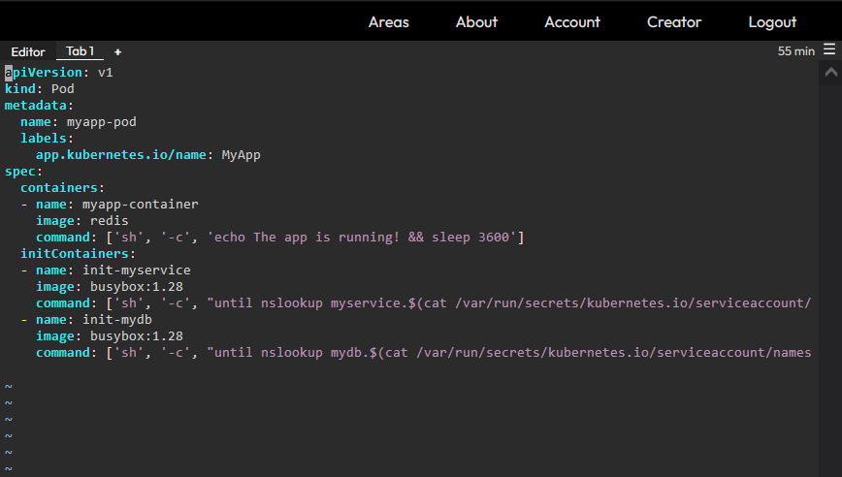

2- Create a pod named print-envars-greeting.

1. Configure spec as, the container name should be print-env-container and use bash image.

2. Create three environment variables:

a. GREETING and its value should be “Welcome to”

b. COMPANY and its value should be “DevOps”

c. GROUP and its value should be “Industries”

3. Use command to echo ["$(GREETING) $(COMPANY) $(GROUP)"]

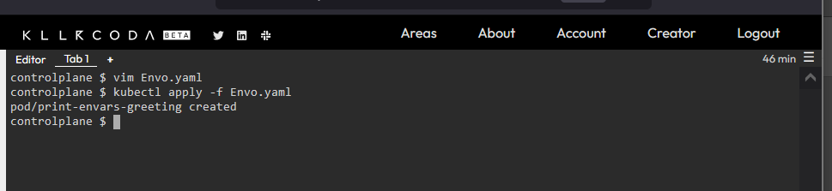

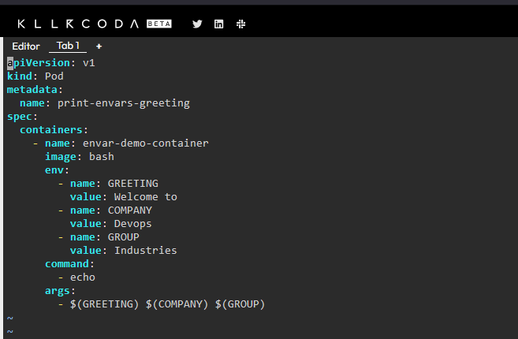

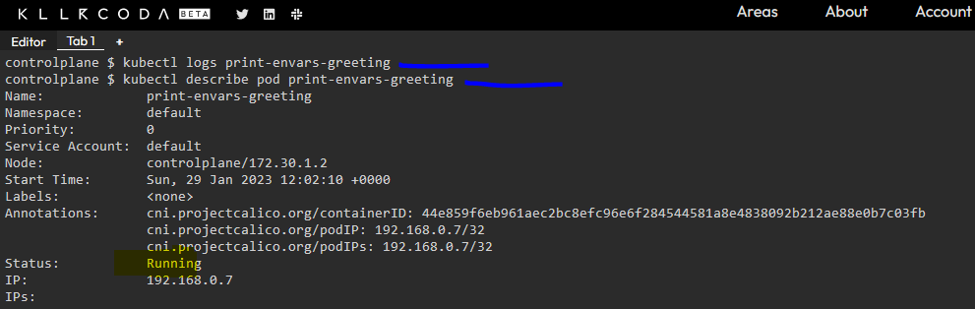

3- Create a Persistent Volume with the given specification.

Volume Name: pv-log

Storage: 100Mi

Access Modes: ReadWriteMany

Host Path: /pv/log

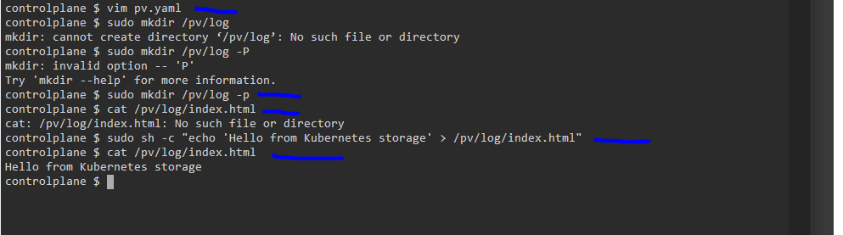

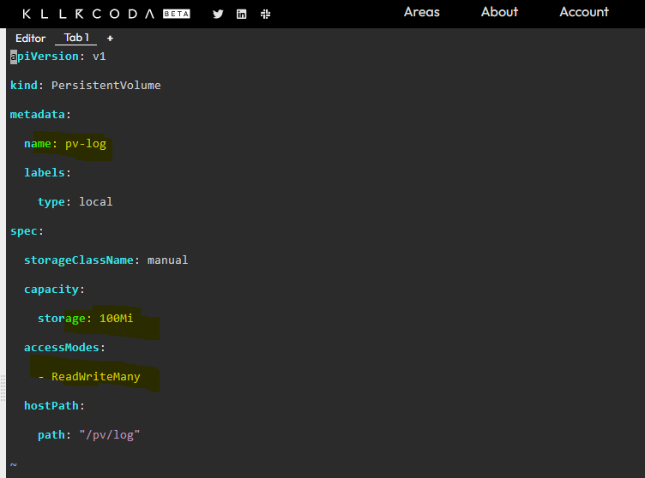

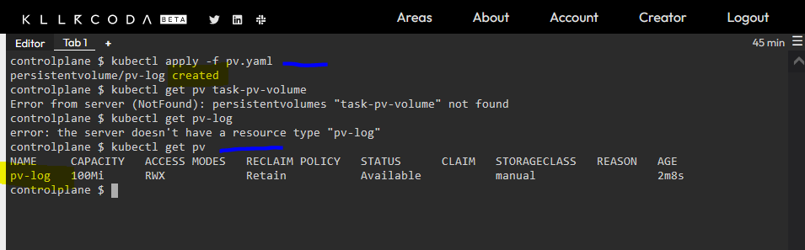

4- Create a Persistent Volume Claim with the given specification.

Volume Name: claim-log-1

Storage Request: 50Mi

Access Modes: ReadWriteMany

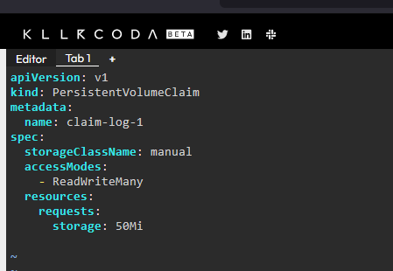

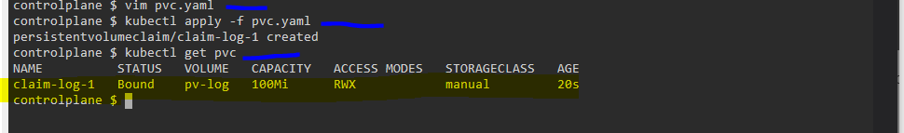

5- Create a webapp pod to use the persistent volume claim as its storage.

Name: webapp

Image Name: nginx

